APPLICATION FOR ETHICAL APPROVAL

In order for research to result in benefit and minimise risk of harm, it must be conducted ethically.

The University follows the OECD Frascati manual definition of research activity: “creative work undertaken on a systematic basis in order to increase the stock of knowledge, including knowledge of man, culture and society, and the use of this stock of knowledge to devise new applications”. As such this covers activities undertaken by members of staff, postgraduate research students, and both taught postgraduate and undergraduate students working on dissertations/projects.

The individual undertaking the research activity is known as the “principal researcher”.

This form must be completed and approved prior to undertaking any research activity.

SECTION A: About You (Principal Researcher)
1 | Full Name: |  | Tegan Cartlidge
2 | Tick all boxes that apply: |  | Member of staff: |  | ☐ | Honorary research fellow: |  | ☐
2 | Undergraduate Student | ☒ | Taught Postgraduate Student |  | ☐ | Postgraduate Research Student |  | ☐
3 | Faculty/School: |  | School of Social Science – Psychology
4 | Campus: |  | Swansea, SA1 dd
5 | E-mail address: |  | 1400899@student.uwtsd.ac.uk
6 | Contact Telephone Number:
7 | Project Title |  | An exploration of student-parent perspectives of the various applications for trauma-informed approaches in educational settings
8 | Proposed Start Date |  | Nov 2026 | Proposed End Date |  |  | July 2027
For students:
9 | Student Number: |  | 1400899
10 | Programme of Study: |  | Psychology and Counselling
11 | Supervisor: |  | Karen Eaton-Thomas

SECTION B: Internal and External Ethical Guidance Materials
 | Please list the core ethical guidance documents that have been referred to during the completion of this form (including any discipline-specific codes of research ethics, location-specific codes of research ethics, and also any specific ethical guidance relating to the proposed methodology). Please tick to confirm that your research proposal adheres to these codes and guidelines. You may add rows to this table if needed.
1 | UWTSD Research Ethics & Integrity Policy | ☒
2 | UWTSD Research Data Management Policy | ☒
3 | UWTSD Open Access Publications Policy | ☒
4 | British Psychological Society Code of Ethics and Conduct (2021) | ☒
5 | British Psychological Society Code of Human Research Ethics (2021) | ☒
6 | British Psychological Society Ethics Guidelines for Internet-Mediated Research (2021) | ☒
7 | Other guidance Documents (Add here) | ☐
SECTION C: Details of Research Activity
Introduction to the Research (maximum 300 words per section)
Ensure that you write for a Non-Specialist Audience when outlining your response to the points below:
- Purpose of Research Activity
- Proposed Research Question
- Aims of Research Activity
- Objectives of Research Activity
Demonstrate, briefly, how Existing Research has informed the proposed activity and explain:
- What the research activity will add to the body of knowledge
- How it addresses an area of importance.
1 | Purpose of Research Activity  Children and Young People (CYP) who witness or experience traumatic events can be impacted adversely (Riley et al., 2026: Walker et al., 2021). Preventative trauma-informed models aim to reduce the number of CYP who are hypervigilant to a perceived ever-present danger in the world (Janoff-Bulman, 2002), and who struggle to develop or maintain social identity and belonging with others (Tajfel & Turner, 1979). Education settings are important places to enact this trauma-informed practice as those CYP that have been impacted by traumatic events are more likely than their peers to experience cognitive and educational impairments (Rizeq & McCann, 2023). Other areas of their lives are also affected, they may experience attachment and social barriers, as well as a heightened risk of developing long-term psychiatric disorders (Rizeq & McCann, 2023).  The Welsh Government has co-produced a trauma-informed framework, designed to guide Wales’s public, private and third sectors (ACE Hub Wales [ACE HW] & Traumatic Health Wales [THW], 2022). Within this framework are five practice principles; a universal approach that does no harm, person centred, relationship-focused, resilience and strengths focused and inclusive (ACE HW & THW, 2022). This rights-led, multi-agency commitment to trauma-informed practice across all sectors is, in part, due to the United Nations Conventions for the Rights of the Child (UNCRC) that is enshrined in Welsh Law (Social Services and Wellbeing Act (Wales), 2014).  Research suggests that trauma-informed schools, who follow such principles, see improvements in school outcomes and emotional wellbeing of the CYP who attend (Mendelson et al., 2015). However, such research often focuses on the perceptions and/or measures of teachers or social workers (Mendelson et al., 2015; Riley et al., 2026; Watson et al, 2026). A trauma-informed approach should involve an integrated, collaborative and comprehensive response (Champine et al., 2022), as such this study will be focusing on the perceptions of parents on these principles. CYP may spend most of their time at school, but parents are uniquely places to comment on the likelihood of the five principles being affective in their experiences of their child/children, and of the education settings in their area. Equally, if there is no comprehension of the layman-termed principles and how they could help effectively support CYP, then this calls into question just how collaborative the five practice principles will be between school and home.  ---------------------  ACE Hub Wales & Traumatic Health Wales (2022). Trauma-informed Wales: A societal approach to understanding, preventing and supporting the impacts of trauma and adversity. https://traumaframeworkcymru.com/wp-content/uploads/2022/07/Trauma-Informed-Wales-Framework.pdf  Champine, R. B.., Hofman, E. E., Matlin, S. L., Strambler, M. J., & Tebes, J. K. (2022). What does it mean to be trauma-informed? A mixed-methods study of a trauma-informed community initiative. Journal of Child and Family Studies, 31(2), 459-472. https://doi.org/10.1007/s10826-021-02195-9  Janoff-Bulman, R. (2002). Shattered assumptions: Towards a new psychology of trauma. Free Press.  Mendelson, T., Tandon, S. D., O’Brennan, L., Leaf, P. J., & Ialongo, N. S. (2015). Brief report: Moving prevention into schools: The impact of a trauma-informed school-based intervention. Journal of Adolescence, 43, 142–147. https://doi.org/10.1016/j.adolescence.2015.05.017  Riley, H. O., Miller, A. L., Chang, Y., Sherman, B. A., Stein, S. F., McMiller, K. C., Yang, S., Moore, A., Vachhani, S. S., & Herrenkohl, T. I. (2026). Perspectives on a System-Oriented Trauma-Informed Approach in Schools: A Qualitative Study Using the Trauma-Informed Programs and Practices for Schools (TIPPS) Framework. American Journal of Orthopsychiatry, 96(1), 61–69. https://doi.org/10.1037/ort0000833  Rizeq, J., & McCann, D. (2023). The Cognitive, Emotional, and Behavioral Sequelae of Trauma Exposure: An Integrative Approach to Examining Trauma’s Effect. Psychological Trauma, 15(2), 313–321. https://doi.org/10.1037/tra0001152  Tajfel, H., & Turner, J. C. (1979). An integrative theory of intergroup conflict. In W. G. Austin & S. Worchel (Eds.), The social psychology of intergroup relations (pp. 33-47). Brooks/Cole.  Walker, A., Jones, V. J., & Hopkins, J. C. (2021). An exploration of the trauma informed terminology and approaches being used by significant projects, programmes and interventions In Wales. The Adverse Childhood Experience (ACE) Support Hub Cymru. https://acehubwales.com/wp-content/uploads/2022/07/ACEs-Terminology-and-Approaches-report-English.pdf  Watson, K. R., Astor, R. A., Capp, G. P., & Benbenishty, R. (2026). Social workers perspectives on the climate of trauma-informed and non-trauma-informed schools. Journal of Child & Adolescent Trauma. https://doi.org/10.1007/s40653-026-00857-8  (this box should expand as you type)
2 | Research Question(s)  How do student-parents feel about the various applications for trauma-informed approaches in education settings in Wales?  (this box should expand as you type)
3 | Aims of Research Activity  - The aim of this research is to explore student-parent’s perspectives about the various applications for trauma-informed approaches in Welsh education settings  - This study aims to explore how student-parents experience the five practice principles (ACE HW & THW, 2022) as concepts within the applied context of Welsh education settings  ----------  ACE Hub Wales & Traumatic Health Wales (2022). Trauma-informed Wales: A societal approach to understanding, preventing and supporting the impacts of trauma and adversity. https://traumaframeworkcymru.com/wp-content/uploads/2022/07/Trauma-Informed-Wales-Framework.pdf  (this box should expand as you type)
4 | Objectives of Research Activity  - To explore participants’ perceptions of the five practice principles (ACE HW & THW, 2022)  - To uncover patterns of meaningful insights that explore perspectives and experiences of participants through thematic analysis (Braun & Clarke, 2021)  - To compare the themes that are identified with contemporary understandings of trauma theory, and its applications, by linking findings with existing literature  - To explore the various applications of the five principles as they link to trauma-informed practice and theory in Welsh education settings as experienced by the participants of this study  --------  ACE Hub Wales & Traumatic Health Wales (2022). Trauma-informed Wales: A societal approach to understanding, preventing and supporting the impacts of trauma and adversity. https://traumaframeworkcymru.com/wp-content/uploads/2022/07/Trauma-Informed-Wales-Framework.pdf  Braun, V., & Clarke, V. (2021). Thematic analysis: A practical guide. SAGE.  (this box should expand as you type)
Proposed data collection methods (maximum 600 words)
Provide a brief summary of all the methods that may be used in the research activity to collect data, making it clear what specific techniques may be used. If methods other than those listed in this section are deemed appropriate later, additional ethical approval for those methods will be needed. You do not need to justify the methods here, but should instead describe how you intend to collect the data necessary for you to complete your project.
5 | Upon the School Research Ethics Committee (SREC)granting ethical approval for the current study, the Experiment Management System (EMS) will be used to source participants. Inclusion criteria will stipulate that participants will be current students at University Trinity Saint David (UWTSD), have a child attending a school in Wales, and over 18 years old. Participants will be excluded from taking part in this study if they do not currently have a child attending a school in Wales.  Participants will be invited to take part in semi-structured focus groups; these will be in person and conducted at the SA1 Campus of UWTSD within the Psychology Labs. Focus groups will between 4-6 participants at a time, with the aim of having 12 participants in total. The following paragraph relates to the procedural description of one of these focus  groups.  Participating in this study will be voluntary and students who sign up via EMA will earn credits for their participation. Participants will receive an email upon signing up confirming their selection.  Participants and the researcher will meet at the pre-determined room as advertised on EMS at UWTSD SA1 Campus, in the room will be a laptop that will be used as a recording device and flashcards (ACE HW & THW, 2022; see Appendix A). Participants will be greeted by the researcher and given the study information sheet (see Appendix B) and consent form (see Appendix C) to read through. At this point participants will be reminded that they can withdraw from the study at any point, or they can pause the study should they so wish.  The researcher will read out a pre-prepared introduction and the information sheet, outlining what is expected of the participants before gaining participants informed consent (see Appendix D). If informed consent is given, then the recording device will be switched on to capture audio only. Participants will be informed that their responses will be recorded. During this introduction the flashcards (ACE HW & THW, 2022; see Appendix A) that have descriptions of each of the five principles, which will be the focus of the focus group questions, and are available throughout, will be highlighted to the participants. The researcher will use the prepared questions (see Appendix D) as a guide, careful not to disrupt conversations as they occur about the five principles. The researcher will endeavour to ask all pre-prepared questions during the timeslot allocated but will take participants lead if they start to formulate answers or move themselves within the pre-prepared question areas.  There will be 13 questions asked, some of examples of questions are as follows: “what do you know (if anything) about the five principles of trauma informed practice?”, “in your opinion, what would your child’s school need to be successful in adopting the five principles?” and “if you had the opportunity, what (if anything) would you change about the way the principles are worded?”. Please refer to Appendix D for the full list of questions and the opening statement.  Upon completion of the questions, or the hour time slot, participants will be thanked for their time and given a debrief from (see Appendix E). Participants will be reminded that this is their last opportunity to withdraw from the study, as all responses will be anonymised upon transcription, which will take place within 48 hours of the focus group. Participants will then be reminded of the resources that are available to take as they leave (see Appendix F) and be informed that if they have any follow up questions that the researchers’ and supervisors’ details are on the debrief form. On this debrief form will be details of UWTSD Wellbeing services and a list of mental health helplines (see Appendix E).  A private channel on Microsoft Teams will be used to collect the audio data, with only the researcher and supervisor having access, this recording will be deleted in accordance with Article 5(1)(e) of UK GDPR data handling laws once transcribed (Data Protection Act, 2018).  ----------  ACE Hub Wales & Traumatic Health Wales (2022). Trauma-informed Wales: A societal approach to understanding, preventing and supporting the impacts of trauma and adversity. https://traumaframeworkcymru.com/wp-content/uploads/2022/07/Trauma-Informed-Wales-Framework.pdf  (this box should expand as you type)
 | Location of research activity
6 | University of Wales Trinity Saint David (UWTSD) SA1 Campus.

SECTION D: External Collaborative Research Activity
1 | Does your research involve collaborating partners at another institution or organisation? | YES | Click to continue to APPENDIX 1 | NO | Continue to the next section
2 | Have you completed appendix 2? | YES | ☐ | NO | ☒

SECTION E: Scope of Research Activity
 | Will the research activity include: | YES | NO
1 | Use of a questionnaire or similar research instrument? | ☐ | ☒
2 | Use of interviews? | ☐ | ☒
3 | Use of focus groups? | ☒ | ☐
4 | Use of participant diaries? | ☐ | ☒
5 | Use of video or audio recording? | ☒ | ☐
6 | Use of computer-generated log files? | ☐ | ☒
7 | Participant observation with their knowledge? | ☐ | ☒
8 | Participant observation without their knowledge? | ☐ | ☒
9 | Access to personal or confidential information without the participants’ specific consent? | ☐ | ☒
10 | Administration of any questions, test stimuli, presentation that may be experienced as physically, mentally or emotionally harmful / offensive? | ☒ | ☐
11 | Performance of any acts which may cause embarrassment or affect self-esteem? | ☐ | ☒
12 | Investigation of participants involved in illegal activities? | ☐ | ☒
13 | Use of procedures that involve deception? | ☐ | ☒
14 | Administration of any substance, agent or placebo? | ☐ | ☒
15 | Working with live vertebrate animals? | ☐ | ☒
16 | Procedures that may have a negative impact on the environment? | ☐ | ☒
17 | Other primary data collection methods. Please indicate the type of data collection method(s) below. | ☐ | ☒
 | Details of any other primary data collection method:  N/A  (this box should expand as you type) | ☐ | ☒

If you have ticked NO to every question, then the research activity is (ethically) low risk and you may skip section E and continue to section F.

If YES to any question, then no research activity should be undertaken until full ethical approval has been obtained.

SECTION F: Intended Participants
 | Who are the intended participants: | YES | NO
1 | Students or staff at the University? | ☒ | ☐
2 | Adults (over the age of 18 and competent to give consent)? | ☒ | ☐
3 | Children and Young People under the age of 18? (Consent from Parent, Carer or Guardian will be required) | ☐ | ☒
4 | Prisoners? | ☐ | ☒
5 | Young offenders? | ☐ | ☒
6 | Those who could be considered to have a particularly dependent relationship with the investigator or a gatekeeper? | ☐ | ☒
7 | People engaged in illegal activities? | ☐ | ☒
8 | Others. Please indicate the participants below, and specifically any group who may be unable to give consent. | ☐ | ☒
 | Details of any other participant groups:  N/A  (this box should expand as you type) | ☐ | ☒

9 | Are your participants classed as vulnerable people? | YES | Click to continue to APPENDIX 2 | NO | Continue to the next section
10 | Have you completed appendix 4? | YES | ☐ | NO | ☒

Participant numbers and source
Provide an estimate of the expected number of participants. How will you identify participants and how will they be recruited?
11 | How many participants are expected? | Thematic analysis (TA) is being utilised, Braun and Clarke (2021) state that coming up with numbers for TA is appropriately difficult as the richness of data cannot be known until after collection. However, some empirical research suggests that 80% of major themes occur within the first 2-3 focus groups (Guest et al., 2017).  By spreading out the numbers across different focus groups it allows for participants to have enough room to give their perspectives without being stifled by a larger group. Similarly, by not having too few participants there is less pressure on individuals to speak on every question.  12 participants will be recruited, across approximately 2-3 focus groups, as availability of participants/room bookings allows. Within each focus group, ideally there will be between 4-6 participants.  ----------  Braun, V., & Clarke, V. (2021). Thematic analysis: A practical guide. SAGE.  Guest, G., Namey, E., & McKenna, K. (2017). How Many Focus Groups Are Enough? Building an Evidence Base for Nonprobability Sample Sizes. Field Methods, 29(1), 3-22. https://doi.org/10.1177/1525822X16639015  (this box should expand as you type)
12 | Who will the participants be? | Participants for this study will be student-parents. They will all be 18+, attending UWTSD and able to access the Experiment Management System (EMS) advertisement for the study, and will have at least one child currently attending school in Wales.  (this box should expand as you type)
13 | How will you identify the participants? | The Experiment Management System (EMS) will be used to recruit participants. Participation will be voluntary, participants who sign up to the study, are available on the date of the focus groups and fit the inclusion criteria will be selected.  (this box should expand as you type)
14 | Will you be excluding any groups of people, and if so, what is the rationale for that? | Exclusion criteria will be necessary for this research as the purpose is to gather the perspectives of student-parents, specifically on trauma-informed approaches in education settings. Participants who do not have a child currently in an education setting (e.g. School) in Wales will not be invited to participate.  (this box should expand as you type)
15 | Will the research involve any element of deception? If yes, please describe why this is necessary and whether participants will be informed at the end of the study | This study does not involve deception.  (this box should expand as you type)
16 | Describe whether participants will be able to withdraw from the study, and up to what point (e.g., if data is to be anonymised). If withdrawal is not possible, after a certain point, explain why not. | Participants may withdraw at any time up until their data has been transcribed and anonymised. There will be no punishment for withdrawing from the study at any point.  The transcriptions will be no longer be identifiable, and in accordance with Article 5 of UK GDPR (Data Protection Act, 2018), the original recordings will be deleted from the researcher’s device. Overall, as no markers will remain, there would be no feasible way to identify and remove the data after anonymisation.  (this box should expand as you type)

 | Information for participants: | YES | NO | N/A
17 | Will you describe the main research procedures to participants in advance, so that they are informed about what to expect? | ☒ | ☐ | ☐
18 | Will you tell participants that their participation is voluntary? | ☒ | ☐ | ☐
19 | Will you obtain written consent for participation? | ☒ | ☐ | ☐
20 | Will you explain to participants that refusal to participate in the research will not affect their treatment or education (if relevant)? | ☒ | ☐ | ☐
21 | If the research is observational, will you ask participants for their consent to being observed? | ☐ | ☐ | ☒
22 | Will you tell participants that they may withdraw from the research at any time and for any reason? | ☒ | ☐ | ☐
23 | With questionnaires, will you give participants the option of omitting questions they do not want to answer? | ☐ | ☐ | ☒
24 | Will you tell participants that their data will be treated with full confidentiality and that, if published, it will not be identifiable as theirs? | ☒ | ☐ | ☐
25 | Will you debrief participants at the end of their participation, in a way appropriate to the type of research undertaken? | ☒ | ☐ | ☐
26 | If NO to any of above questions, please give an explanation
Withdrawal from the study will be available up until data has been transcribed and anonymised (please refer to box F16 above for further explanation).

(this box should expand as you type)

 | Information for participants: | YES | NO | N/A
27 | Will participants be paid? | ☐ | ☒ | ☐
28 | Is specialist electrical or other equipment to be used with participants? | ☒ | ☐ | ☐
29 | Are there any financial or other interests to the investigator or University arising from this study? | ☐ | ☒ | ☐
30 | Will the research activity involve deliberately misleading participants in any way, or the partial or full concealment of the specific study aims? | ☐ | ☒ | ☐
31 | If YES to any question, please provide full details
Audio recording will be used via a laptop on a Microsoft Teams channel. This Teams channel will only be accessible by researcher and supervisor, and any audio recordings will be deleted upon transcription and anonymisation in accordance with GDPR guidance (Data Protection Act, 2018). The transcription for each focus group will take place within 48 hours.

(this box should expand as you type)

SECTION G: Anticipated Risks

 | Outline any anticipated risks that may adversely affect any of the participants, the researchers and/or the University, and the steps that will be taken to address them.
Risks to participants
For example: sector-specific health & safety, emotional distress, financial disclosure, physical harm, transfer of personal data, sensitive organisational information. If you have identified in section D that there are no participants, then enter N/A and go skip to question 3.
1 | Risk to participants:  1.Participants may experience emotional discomfort when discussing their child’s school  2. There may be disclosure of personal or sensitive information  3. Participants could experience psychological distress at hearing that we will be discussing ‘trauma-informed practice’  4. There is a risk of disclosure of potential harm in school settings, and therefore confidentiality could be limited  5. Risk of data security breach, for example, if information stored online/electronic devices are potentially accessed by a third party  (this box should expand as you type) | How you will mitigate the risk to participants:  Mitigations for risk 1.  - BPS Code of Human Research Ethics will be adhered to; the study will endeavour to minimise harm, and avoid it as much as possible by keeping the focus group conversation around the wording of the five practice principles of TIP, and away from the closely related topic of traumatic experiences  - BPS Code of Ethics and Conduct will be adhered to; and the researcher will maintain their responsibility and accountability to the participants by respecting their experiences and responding to the participants immediate needs over the needs of the study  - UWTSD Student Charter will be adhered to; participants will be treated with acceptance and dignity, no matter their response, emotional or otherwise  - Participants will be reminded that they can withdraw at any time without giving a reason for doing so and their autonomy respected  - Participants will be provided with resources (see Appendix F) from mental health organisations upon leaving the study.  - Mental health resources will be pointed out at the start of the focus group in the introduction statement read out by the researcher (see Appendix D) in case a participant wishes to leave before the end.  - There will be helpline numbers as well as the UWTSD Wellbeing Teams contact information along with the supervisor’s details on the information sheet (see Appendix B) and debrief sheet (see Appendix E).  Mitigations for Risk 2.  - UWTSD Data Management Policy will be followed at all stages of this study  - BPS Code of Human Research Ethics will be adhered to  - Safeguarding of participants will remain paramount to the running of the focus group, with any risk reported sensitively and with immediacy through the appropriate channels  - All data will be anonymised when transcribed by researcher  - UK GDPR regulations will be followed, in accordance with the Data Protection Act (2018)  - Raw data will be kept for no longer than 48 hours, and deleted from researcher’s devices/online storage  - Participants are asked to only share what they are comfortable with at the start of the focus groups, and are advised against sharing confidential information that could identify them  - Participants are informed that any confidential/personal information given will be anonymised, so they do not feel negatively impacted, or worry, about any accidental information given  Mitigations for Risk 3.  - All questions will remain focused on the five practice principles which are positive steps to improve TIP in schools  - The researcher will step in, sensitively, to move along any harmful or upsetting topics that could potentially cause emotional distress to any participant in the space, this will be done by insisting that the focus group stays on the topic of the five practice principles of TIP  - If a participant is unable to move away from upsetting topics, or any participants become visibly uncomfortable, the focus group will stop to take care of the needs of the person/s affected  - Mental health resources, and helpline number are available at several stages of this study, and are given to take home  - Participants will be able to take pauses or withdraw from the focus group at any time, with no explanation needed. Doing so will not have consequence. Participants will be reminded of this on the consent form and during the introduction to the focus group  - UWTSD Wellbeing Support Services contact information is available across the information, debrief and resources available to participants  Mitigations for Risk 4.  - UWTSD safeguarding procedure will be followed in the event of the researcher having a disclosure made, and will inform the supervisor immediately, who will follow this procedure as appropriate  - Limits to confidentiality will be explained at the start of the focus group, including the need to break confidentiality if the researcher/supervisor feels that someone is a risk to themselves or others  Mitigations for Risk 5.  - UWTSD Data Management Policy will be followed throughout this study  - UK GDPR regulations will be follwoed throughout this study, in accordance with the Data Protection Act, 2018  - Password protected files on UWTSD OneDrive will be used to store data  - Microsoft Teams secure channels used to share and transfer data between supervisor and researcher are only accessible by the researcher and supervisor  (this box should expand as you type)
 | If research activity may include sensitive, embarrassing or upsetting topics (e.g. sexual activity, drug use) or issues likely to disclose information requiring further action (e.g. criminal activity), give details of the procedures to deal with these issues, including any support/advice (e.g. helpline numbers) to be offered to participants. Note that where applicable, consent procedures should make it clear that if something potentially or actually illegal is discovered in the course of a project, it may need to be disclosed to the proper authorities
2 | Participants will be provided with information on the limitations of confidentiality when given the consent sheet (see Appendix C), as well as when being read the opening statement (see Appendix D). It will be made clear to participants that their data will be anonymised, with any identifying information removed, however, if at any point the researcher has cause to believe that a participant or someone else is at risk of harm, then this will be reported. Any disclosure that someone is a risk to themselves or others that takes place will be reported by the researcher to the supervisor, who will then follow UWTSD Safeguarding policies and procedure, and if necessary, contact outside organisations/safeguarding bodies as appropriate.  It is important to note that no discussion of trauma, or traumatic incidents, are expected during this study. Questions will focus on the five principles of trauma-informed practice (ACE HW & THW, 2022), and the researcher will aim to move discussions away from distressing topics sensitively, if this does occur.  Participants will be provided with support resources at the end of the study due to the topic of ‘trauma-informed practice’ being central to the rationale of this study. On the information sheet, debrief sheet, and separately as physical resources (see Appendix F) at the end of the focus group, will be information about UWTSD Wellbeing Services, contact details for the supervisor in addition to charitable websites where participants can seek advice or information.  All support resources have been compiled with student-parents in mind (see Appendix F), they cover support needs ranging from support talking to a GP (Mental Health UK, 2026b) to how to have a conversation with CYP about mental health (Mental Health UK, 2026a). The resources offer a range of practical, implementable advice and signposting, and some come with a QR code that offers links to further up-to-date advice online. A list of further organisations and charities will be provided (see Appendix G), this list will also be on the information and debrief sheet, at the bottom of each sheet, to make it accessible to participants at every stage of the study.  -------------  ACE Hub Wales & Traumatic Health Wales (2022). Trauma-informed Wales: A societal approach to understanding, preventing and supporting the impacts of trauma and adversity. https://traumaframeworkcymru.com/wp-content/uploads/2022/07/Trauma-Informed-Wales-Framework.pdf  Mental Health UK (2026a, April). Conversation guide: Talking to young people about mental health. https://mentalhealth-uk.org/wp-content/uploads/2026/04/Talk_MH_Young-Person_A4L-2pp_v1_Fresh_FAW_FINAL.pdf  Mental Health UK (2026b, August). 5 tips for talking to your GP about your mental health.  https://mentalhealth-uk.org/wp-content/uploads/2026/09/GP-Visit_Tips-sheet_A4_v3_FAW_DIGI.pdf  (this box should expand as you type)
Risks to the investigator
For example: personal health & safety, physical harm, emotional distress, risk of accusation of harm/impropriety, conflict of interest
3 | Risk to the investigator:  1.Emotional strain from reading or hearing distressing materials  2.Minimal risk when conducting focus groups of misunderstanding and negative affect from questions asked/answered  3.Psychological distress from topic area focus  (this box should expand as you type) | How you will mitigate the risk to the investigator:  Mitigations for Risk 1.  - BPS Code of Research Ethics will be followed; the researcher will endeavour to acknowledge their own limitations in order to work with integrity and within their level of competency  - Supervision and regular check-ins with supervisor will be conducted throughout  - The researcher will take regular breaks and remain aware of their personal limitations by checking in with themselves and reflecting on any impact to their ability, motivation or mental health  - The researcher will maintain an ongoing professional relationship with UWTSD Wellbeing and Support Services and their own personal counselling, and access this support regularly/as needed  Mitigations for Risk 2.  - The UWTSD Student Charter will be adhered to, and the researcher will approach the focus groups with respect, integrity and the awareness that they are representing UWTSD through their conduct and approach to others and themselves  - Approach focus group with empathy, congruence and positive regard (Rogers, 1957)  - Employ counselling skills when interacting with participants; no-judgment, active listening, attuning and being aware of silence  Mitigations for Risk 3.  - BPS Code of Conduct will be followed, and the researcher will endeavour to manage their own psychological safety to ensure that they can best judge the necessary professional boundaries and assess any risks (to themselves or others) to the best of their ability  - If the research scope becomes too much, or the topic area too difficult, the researcher must be honest and open and speak to the supervisor about adjusting the scope of the study in a timely manner  - The researcher will take regular breaks between focus groups, whilst transcribing data and analysing to ensure rest and minimal impact on themselves  - The researcher will maintain relationship with personal counsellor and UWTSD Wellbeing Support, and will access support as needed, whilst simultaneously maintaining confidentiality and adhering to the Data Protection Act (2018)  - Speak to supervisor if concerns or difficulties arise regarding readiness for study/analysis  (this box should expand as you type)
University/institutional risks
For example: adverse publicity, financial loss, data protection
4 | Risk to the University:  - Breaches of data protection legislation  - Ethical or legal non-compliance  - Reputational damage  (this box should expand as you type) | How you will mitigate the risk to the University:  Mitigations for Risk 1.  - All data will be handled in accordance with UK GDPR regulations, as per the Data Protection Act, 2018  - Personal data will be deleted within 48 hours of recording  - Unique EMS codes, used for the focus groups, will not be contained, and stored separately to, this data  - Any identifiers within the personal data (audio recordings) will be removed during transcription, to ensure anonymity for the participants  - Data will only be stored within locked channels (Microsoft Teams, UWTSD OneDrive), accessibly only by researcher and supervisor.  OneDrive folders will be password protected and only accessed by a password protected device (laptop) through two-factor-authentication. This two-factor authentication also requires a separate password to unlock to access authentication for the first device.  Mitigations for Risk 2.  - BPS Code of Ethics and Conduct will be adhered to, the researcher will navigate all stages of data handling, research paperwork and written thesis work in accordance with all of the competency frameworks that apply (e.g. UWTSD Student Charter)  - The researcher will respect the autonomy, dignity and right to protection from harm/distress of all participants by following the mitigations written in the Ethics Form, and the BPS Code of Ethics and Competence, and the BPS Code of Human Research Ethics  - BPS Code of Human Research Ethics will be adhered to; the researcher will recognise the limits of their own skills and knowledge, and ask for and accept appropriate support (e.g. supervisor, Ethics panel recommendations etc.) at all times  - The researcher will conduct the study only once full ethical approval is signed off  - The researcher will share all concerns/questions about ethics/legal issues/queries with their supervisor as, and when, they occur  Mitigations for Risk 3.  - UWTSD Student Charter will be adhered to; the researcher will act with integrity, professionalism and respect everywhere they are, as they represent UWTSD as a student at all times  - No data collection will take place without ethical approval, and will be supervised regularly by the supervisor via regular meetings and contact via Microsoft Teams  “  (this box should expand as you type)
Environmental risks
For example: accidental spillage of pollutants, damage to local ecosystems
5 | Risk to the environment:  - Waste production from use of paper forms/resources  (this box should expand as you type) | How you will mitigate the risk to environment:  Mitigation for Risk 1.  - Only the necessary number of forms/resources will be printed  - Any unused mental health resources will be redistributed for use within the UWTSD wider student population  (this box should expand as you type)

SECTION H: Feedback, Consent and Confidentiality

Feedback
What debriefing and feedback will be provided to participants; how will this be done and when?
1 | Participants will receive a written debrief sheet (see Appendix E) at the conclusion of the focus group, one per participant to take home. The debrief from will outline the purposes of the study and provide researcher and supervisor contact details. Below this will be details for how to contact UWTSD Wellbeing Team to ensure that support is available after participants leave the study. There will also be resources and helplines included at the end of the debrief (see Appendix G) that are available outside of UWTSD.  (this box should expand as you type)
Informed consent
Describe the arrangements to inform potential participants, before providing consent, of what is involved in participating. Describe the arrangements for participants to provide full consent before data collection begins. If gaining consent in this way is inappropriate, explain how consent will be obtained and recorded in accordance with prevailing data protection legislation.
2 | Participants will be provided with an information sheet (see Appendix B) which clearly outlines the study before they consent. Participants will then be given a consent form (see Appendix C) to read over and sign, if they still choose to go ahead with the study. Participants will again be asked if they are happy to continue when being read the opening statement; “No name or identifying information will be sought and if by accident someone discloses something that could lead to identification, this will be redacted from the following transcript. Are you happy to continue and for the recording to start?” (see Appendix D for full statement), prior to the recording device being switched on. Throughout these informed consent procedures participants will be reminded that they can leave the study at any point, with no explanation as participation is voluntary, and no penalty, academic or otherwise, will occur if they withdraw from the study.  (this box should expand as you type)
Confidentiality / Anonymity
Set out how anonymity of participants and confidentiality will be ensured in any outputs. If anonymity is not being offered, explain why this is the case.
3 | Participants will be advised not to share confidential information during the focus group, but that any accidentally given will be removed during transcription. Audio recorded data will be treated confidentially and stored for no longer than 48 hours (Data Protection Act, 2018), after the focus group in which they were recorded. Whilst this data is stored by the researcher, it will remain in a closed, private Microsoft Teams channel that is only accessible by the researcher and supervisor.  Transcriptions of this data will be anonymised, with any identifying information removed (e.g. names of participants, names of schools).  (this box should expand as you type)
Copies of any written consent form, written information and all other explanatory material should accompany this application. If you have included these then please list the documents included here.
4 | Appendix A – Five Principles (Flashcards)  Appendix B – Participant Information Sheet  Appendix C – Consent Form  Appendix D – Focus Group Opening Statement and Questions  Appendix E – Debrief Sheet  Appendix F – Printable Mental Health Resources  Appendix G – List of Resources and Services

SECTION I: Data Protection and Storage

 | Does the research activity involve personal data (as defined by the General Data Protection Regulation 2016 “GDPR” and the Data Protection Act 2018 “DPA”)? | YES | NO
1 | Personal data means any information relating to an identified or identifiable natural person (‘data subject’). An identifiable natural person is one who can be identified, directly or indirectly, in particular by reference to an identifier such as a name, an identification number, location data, an online identifier or to one or more factors specific to the physical, physiological, genetic, mental, economic, cultural or social identity of that natural person. Any video or audio recordings of participants and transcription of such are considered to be personal data. | ☒ | ☐
 | If YES, provide a description of the data and explain why this data needs to be collected:
2 | Focus Groups will be audio recorded for the purpose of transcription and thematic analysis. This is a necessity, as accurate records of participants responses are required for thematic analysis (Braun & Clarke, 2021). This data will be held for no longer than 48 hours before transcription (Data Protection Act, 2018) and will be anonymised when transcribed by the researcher. Data will be protected for the 48 hours in a secure UWTSD Microsoft Teams channel, only accessible by the researcher and supervisor.  ----------  Braun, V., & Clarke, V. (2021). Thematic analysis: A practical guide. SAGE.  (this box should expand as you type)
 | Does the research involve the processing of special category data (as defined by the General Data Protection Regulation 2016 and the Data Protection Act 2018)? | YES | NO
3 | Racial or ethnic origin | ☐ | ☒
4 | Political opinions | ☐ | ☒
5 | Religious or philosophical beliefs | ☐ | ☒
6 | Genetic, biometric or health data | ☐ | ☒
7 | Sex life or sexual orientation | ☐ | ☒
8 | Trade union membership | ☐ | ☒
 | If you ticked YES to any of questions L3-L8, provide a description of the data and explain why this special category data needs to be collected to support the research and that it is in the public interest to do so:
9 | N/A (this box should expand as you type)

 | Will data from the research activity (collected data, drafts of the thesis, or materials for publication) be stored in any of the following ways? | YES | NO
10 | Manual files (i.e. in paper form)? | ☒ | ☐
11 | University computers? | ☒ | ☐
12 | Private company computers? | ☐ | ☒
13 | Home or other personal computers? | ☐ | ☒
14 | Laptop computers/ CDs/ Portable disk-drives/ memory sticks? | ☒ | ☐
15 | “Cloud” storage or websites? | ☒ | ☐
16 | Other – specify: | ☐ | ☒
 | For all stored data, explain the measures in place to ensure the security of the data collected, data confidentiality, including details of backup procedures, password protection, encryption, anonymisation and pseudonymisation:
17 | When identifying participants for the study (e.g. when meeting at the allocated time and room), their EMS ID numbers will be used.  Paper copies of the information sheet (see Appendix B), consent form (see Appendix C) and debrief sheet (see Appendix D) will be used for this study. No identifiable names will be collected, but a numerical code assigned to each participant, which will be replaced with a pseudonym on transcription. The returned consent form will be scanned and destroyed immediately after the focus groups; the scanned copy will be placed into a separate electronic folder within the UWTSD OneDrive of the researcher. This data will be backed up automatically by the University’s system. The OneDrive folder will be password protected.  The researcher will access this, and any information, via their personal laptop, used only for UWTSD work, that is password protected and protected by firewall, antivirus and malware software that is kept automatically up to date.  (this box should expand as you type)

 | Data Protection
 | Will the research activity involve any of the following activities: | YES | NO
18 | Electronic transfer of data in any form? | ☒ | ☐
19 | Sharing of data with others at the University outside of the immediate research team? | ☐ | ☒
20 | Sharing of data with other organisations? | ☐ | ☒
21 | Export of data outside the UK or importing of data from outside the UK? | ☐ | ☒
22 | Use of personal addresses, postcodes, faxes, emails or telephone numbers? | ☐ | ☒
23 | Publication of data that might allow identification of individuals? | ☐ | ☒
 | If YES to any question, please provide full details, explaining how this will be conducted in accordance with the GDPR and Data Protection Act (2018) (and/or any international equivalent):
24 | Data will be made accessible to the supervisor via secure Microsoft Teams Channels, and by invites into OneDrive folders as appropriate and necessary. Data will be moved from the researcher's password protected OneDrive folders into the Microsoft Teams Channels as needed for review/submission requires. Submission of chapters will also take place via Turnitin through the UWTSD Moodle page for ‘Empirical Research Project’.  Access will only take place by the researcher from their personal password protected laptop, all UWTSD documents/OneDrive files also need two-factor-authentication via a second device (mobile phone) only accessible by the researcher, again that needs a password to unlock.  Information containing participant IDs will be kept in a separate folder away from the anonymised transcriptions and all other data to ensure confidentiality is maintained. Participants will have until their data is anonymised (48 hours) to withdraw from the study, at which point, it will not be possible to separate their data from other participants due to lack of identifiers. All of this will be in accordance with the Data Protection Act, 2018.  (this box should expand as you type)
 | List all who will have access to the data generated by the research activity:
25 | The principal researcher (Tegan Cartlidge) and supervisor (Karen Eaton-Thomas).  (this box should expand as you type)
 | List who will have control of, and act as custodian(s) for, data generated by the research activity:
26 | The principal researcher (Tegan Cartlidge)  (this box should expand as you type)
 | Give details of data storage arrangements, including security measures in place to protect the data, where data will be stored, how long for, and in what form.
27 | All data will be stored in password-protected folders, secure Microsoft Teams channels, and only accessed through password-protected and secure (up to date firewall, anti-virus and malware protection) devices by the researcher. Access to the data will only be given to the supervisor. Confidential audio recordings will only be kept up to 48 hours on the secure Microsoft Teams channel that the researcher and supervisor have access to, this will then be deleted. The anonymised transcription data will be kept in password-protected folders on the UWTSD OneDrive, accessible only to the researcher.  (this box should expand as you type)
28 | Confirm that you have read the UWTSD guidance on data management (see https://www.uwtsd.ac.uk/library/research-data-management/) | ☒
29 | Confirm that you are aware that you need to keep all data until after your research has completed or the end of your funding | ☒

SECTION J: Use of AI tools
Use of generative AI and other AI-based tools  There are a number of ethical issues relating to the use of generative AI and other AI-based tools, including data security, output bias, and output errors. In general, you should assume that any generative AI or other AI-based tool that you pay to use is more secure and accurate than one which is free to use.  Will the research use AI tools to do any of the following: |  | YES | NO | N/A
1 | Capture data? | ☐ | ☒ | ☐
2 | Generate and/or edit text? | ☐ | ☒ | ☐
3 | Generate graphics? | ☐ | ☒ | ☐
4 | Generate video? | ☐ | ☒ | ☐
5 | Generate sound/music? | ☐ | ☒ | ☐
6 | Generate code? | ☐ | ☒ | ☐
7 | Generate synthetic data? | ☐ | ☒ | ☐
8 | Analyse data? | ☐ | ☒ | ☐
9 | Analyse personal or sensitive data? | ☐ | ☒ | ☐
10 | Classify data? | ☐ | ☒ | ☐
11 | Do you intend to use the free version of any AI tools? | ☐ | ☒ | ☐
If you have answered YES to any of questions O1-O11, please provide justification detailing why this is necessary for the research.
12 | N/A  (this box should expand as you type)

SECTION K: Declaration
The information which I have provided is correct and complete to the best of my knowledge. I have attempted to identify any risks and issues related to the research activity and acknowledge my obligations and the rights of the participants.

In submitting this application I hereby confirm that I undertake to ensure that the above named research activity will meet the University’s Research Ethics and Integrity Code of Practice which is published on the website: https://www.uwtsd.ac.uk/research/research-ethics/
 | 1 | Signature of applicant: | Tegan Cartlidge | Date:  19/10/2026
2 |  | Supervisor: | Karen Eaton-Thomas | Date:  24.10.2026
3 |  | Signature: | K. M. Eaton-Thomas | Date:  24.10.2026

APPENDIX 1: External Collaborative Research Activity

INSTITUTION 1
A2.1 | Name
A2.2 | Researcher name and position
A2.3 | Role in project (e.g. co-investigator)
A2.4 | Contact e-mail address
A2.5 | External Ethical Approval  Please detail the ethical approval required and arrangements for this partner. See Section 14 of the UWTSD Research Ethics and Integrity Policy. If approved, please supply confirmation. | Obtained? | YES | NO | PENDING
A2.5 |  | Obtained? | ☐ | ☐ | ☐

APPENDIX 2: Research with Vulnerable People

Will the research involve data processing involving the following data subjects: |  |  |  |  | YES |  | NO
A4.1 | Children under 16 |  |  |  | ☐ |  | ☐
A4.2 | Adults with learning disabilities |  |  |  | ☐ |  | ☐
A4.3 | Adults with other forms of mental incapacity or mental illness |  |  |  | ☐ |  | ☐
A4.4 | Adults in emergency situations |  |  |  | ☐ |  | ☐
A4.5 | Prisoners or young offenders |  |  |  | ☐ |  | ☐
A4.6 | Those who could be considered to have a particularly dependent relationship with the investigator, e.g. members of staff, students |  |  |  | ☐ |  | ☐
A4.7 | People who have not given their explicit consent to participate in the project |  |  |  | ☐ |  | ☐
A4.8 | People engaged in illegal activities |  |  |  | ☐ |  | ☐
A4.9 | Any other people who can be considered vulnerable in the context of this project |  |  |  | ☐ |  | ☐
Please justify the inclusion of the above people (if applicable), explaining why the research cannot be conducted on non-vulnerable people.
A4.10 | (this box should expand as you type)
Please give details of extra steps taken to assure the protection of vulnerable people participating in the research. You should describe any arrangements to be made for obtaining consent from a legal representative.
A4.11 | (this box should expand as you type)
It is the researcher’s responsibility to check whether a DBS check (or equivalent) is required and to obtain one if it is needed. Please confirm:
A4.12 | DBS Check required? | YES |  | NO
A4.12 | DBS Check required? | ☐ |  | ☒
A4.13 | DBS certificate obtained? | YES | NO |  |  | N/A
A4.13 | DBS certificate obtained? | ☐ | ☐ |  |  | ☒

Appendix A – Five Principles (Flashcards)

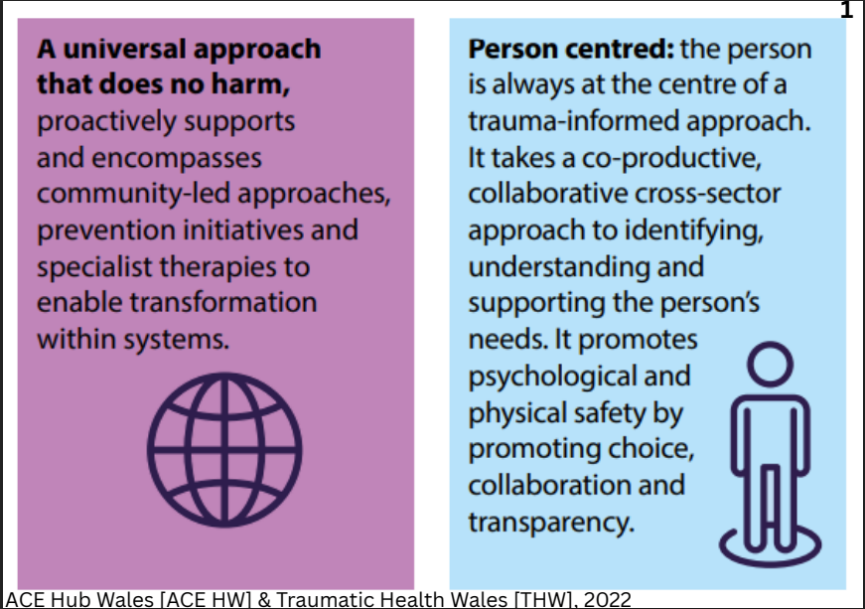

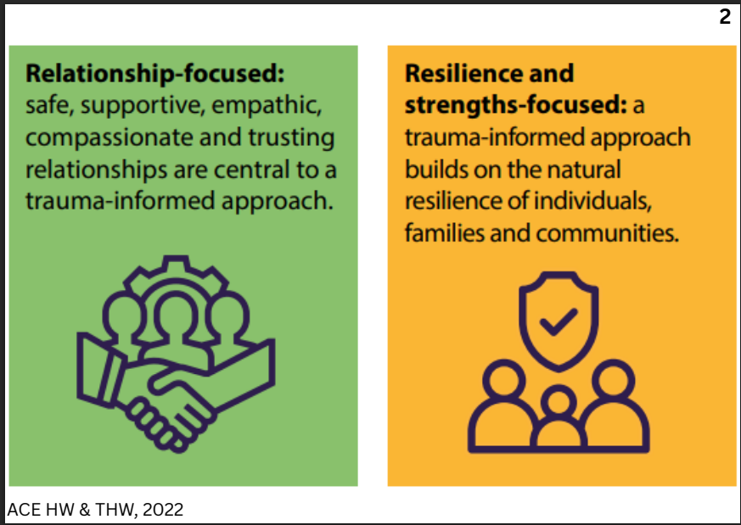

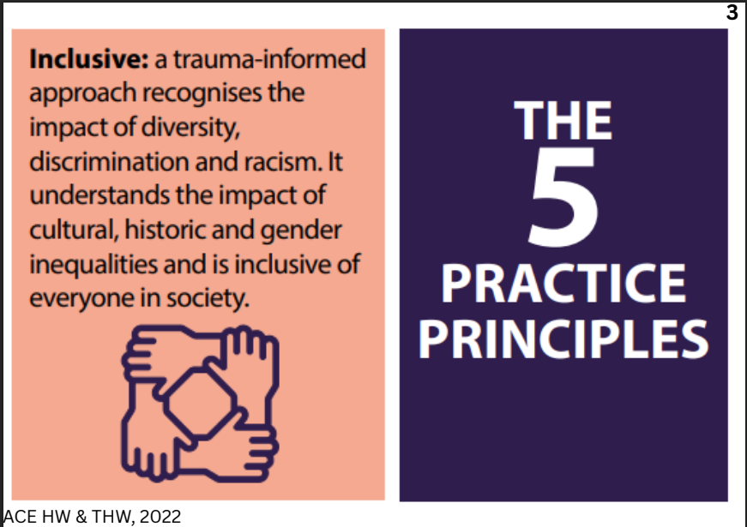

Appendix B – Participant Information Sheet


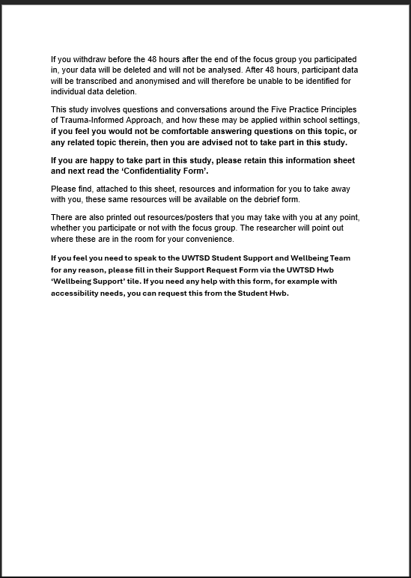

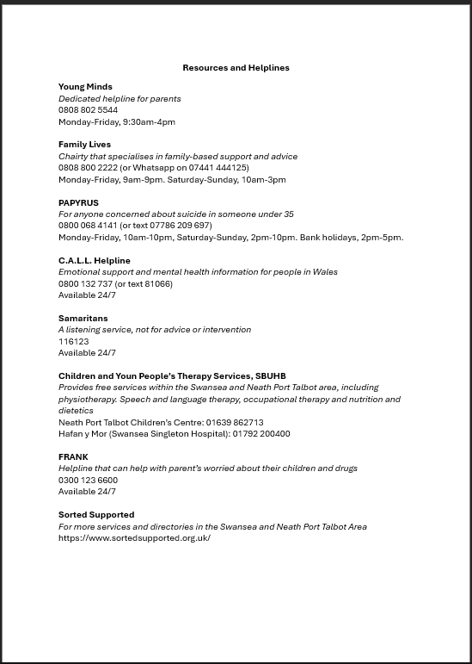

Appendix C – Consent Form
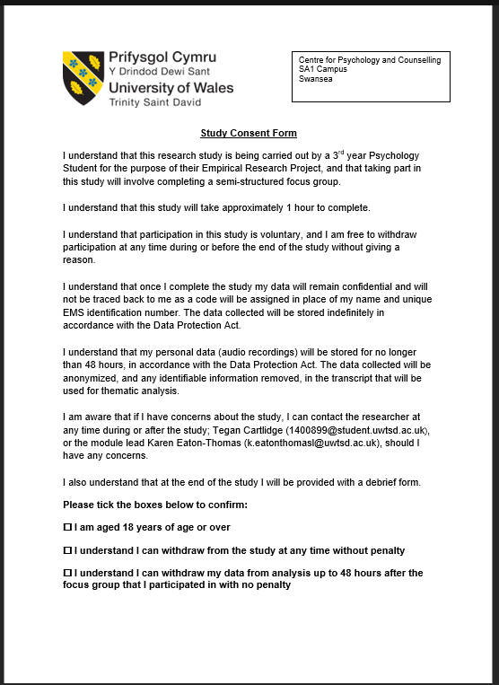



Appendix D – Focus Group Opening Statement and Questions
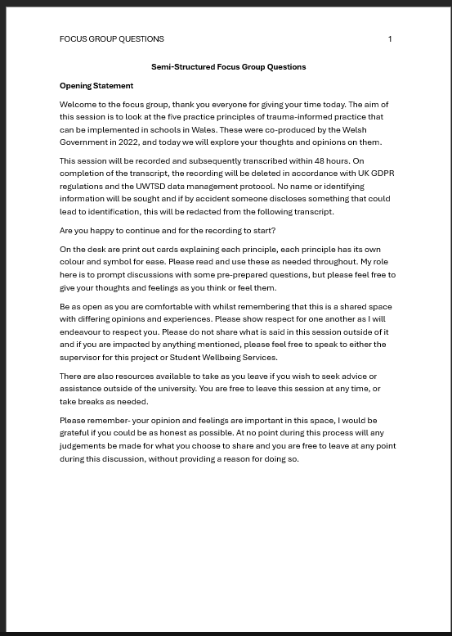

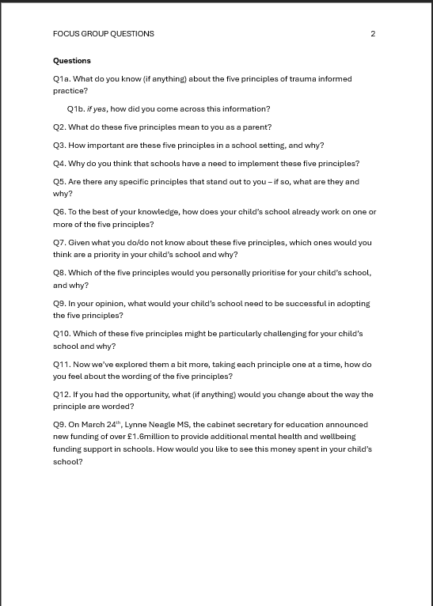

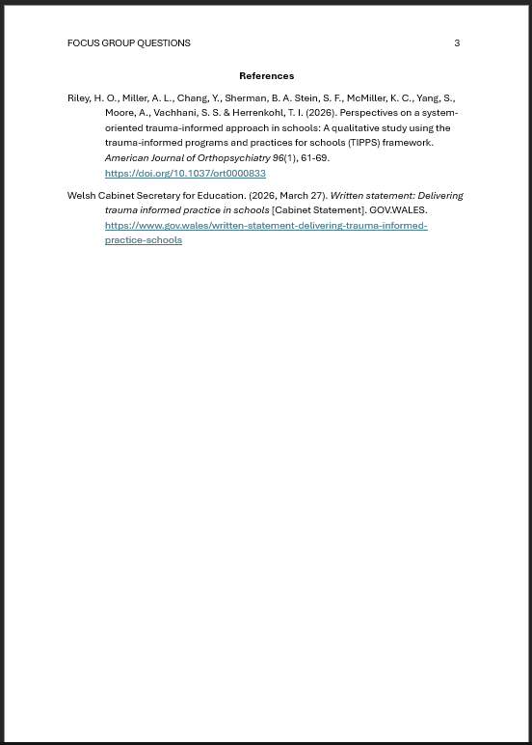
Appendix E – Debrief Sheet
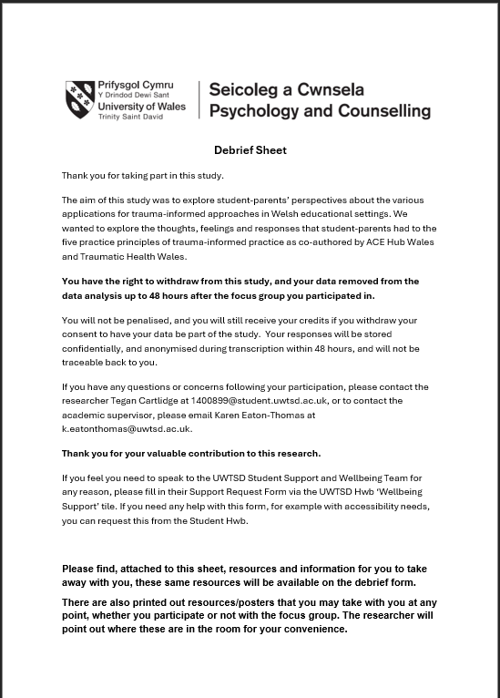

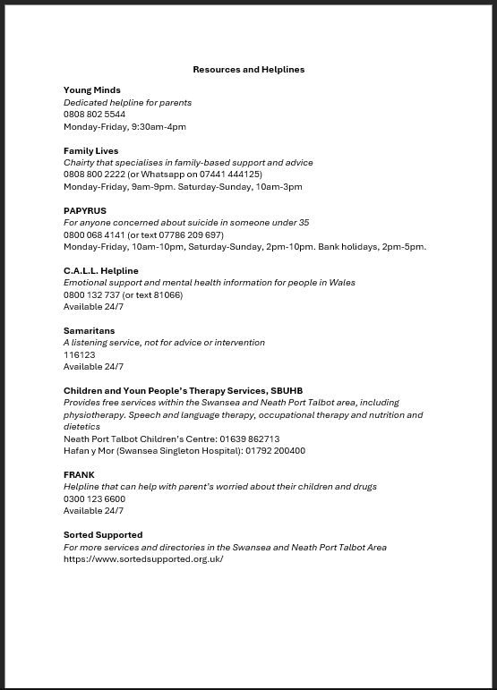

Appendix F – Printable Mental Health Resources
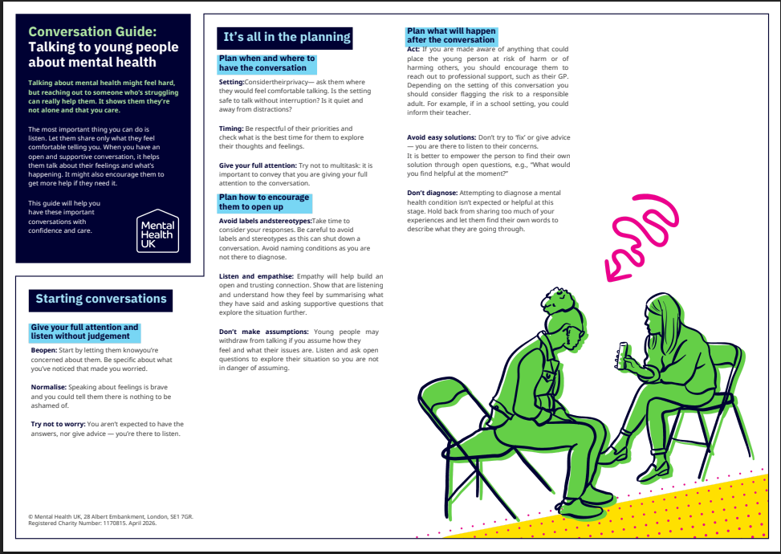
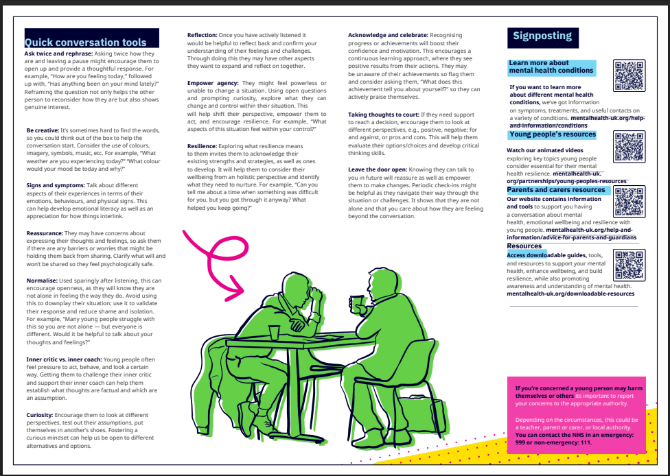

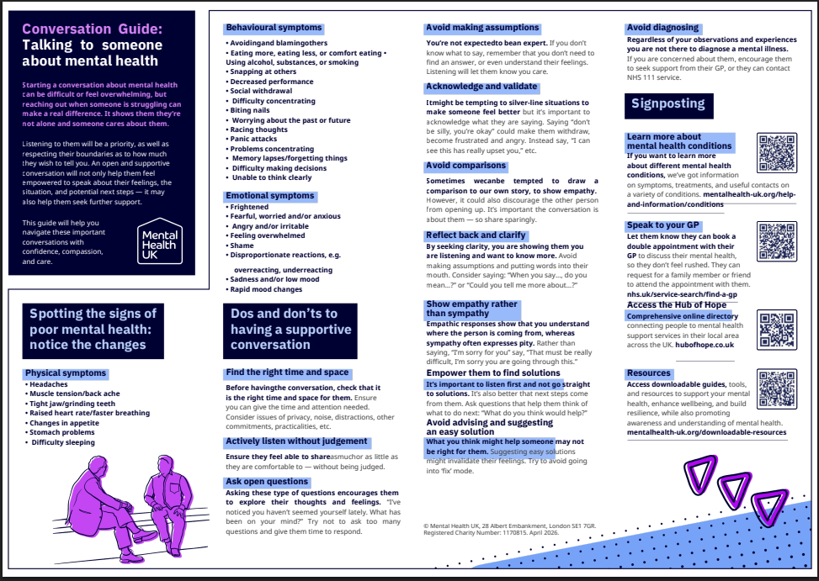
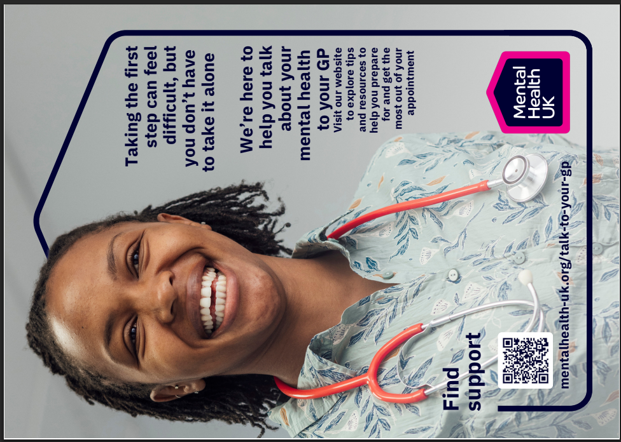

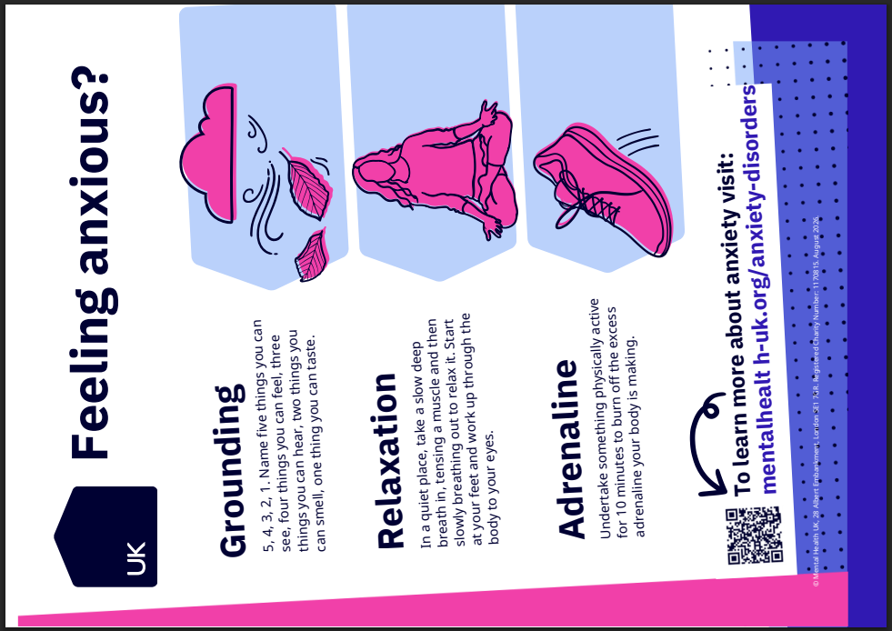
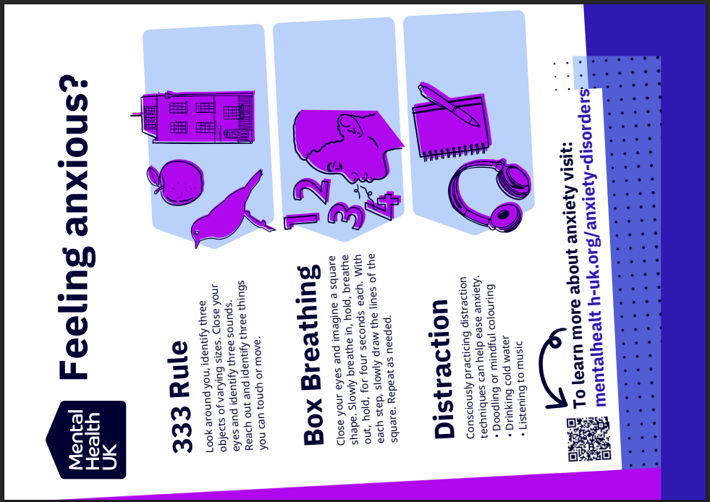

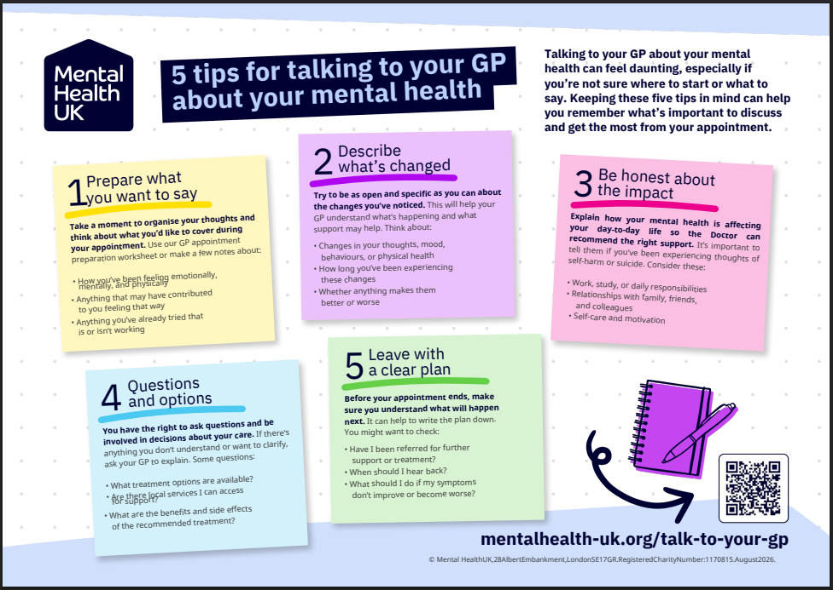

Appendix G – List of Resources and Services


