

Postgraduate/Distance Learning
Assignment coversheet & feedback form

THIS SHEET MUST BE THE FIRST PAGE OF THE ASSIGNMENT YOU ARE SUBMITTING (DO NOT SEND AS A SEPARATE FILE)

For completion by the student:
Student Name: Vadim Zaver

Student University Email: 2111154@student.uwtsd.ac.uk
Module code: HPCA7014  Module title: Sacred Geography  Word count: 5876 | Student ID number: 2111154 |  |  | Educational support needs:  Yes
Assignment title: Research project: Is Lascaux cave in France sacred?

Assignment due date: 12/02/2023
This assignment is for the 1st 2nd 3rd 4th 5th 6th module of the degree
I confirm that this is my original work and that I have adhered to the University policy on plagiarism.
Signed ……/vadimzaver/………………………………………………………
Email submission:if you are submitting this form via email, please tick this box □
(as a substitute for your signature) to confirm that you agree to the above declaration.
Assignment Mark
1st Marker’s Provisional mark
2nd Marker’s/Moderator’s provisional mark
External Examiner’s mark (if relevant)
Final Mark

NB. All marks are provisional until confirmed by the Final Examination Board.

ALL COMMENTS ARE ON THE PDF OF YOUR PAPER IN TURNITIN

For completion by Marker 1 :
Comments:

Marker’s signature: |  |  | Date:
For completion by Marker 2/Moderator:

Comments:

Marker’s Signature: |  | Date:
External Examiner’s comments (if relevant)

External Examiner’s Signature: |  | Date:

Introduction
The aim of this project is to examine politico-religious climate surrounding the cave and determine whether Lascaux cave is sacred and who it is sacred/profane to. Lascaux cave is located in France near Lascaux village (see Appendix 1), The cave is one of many survived/found prehistoric caves in Europe (see Appendix 2).
Lascaux cave and changes in politico-religious climate around it were evaluated by doing limited amount of virtual fieldwork and by literature review. With a help of self-made software application, containing a search engine, 399 sources of information about the cave were identified and reviewed. The references dates range between 1458 and 2022. The original entrance to Lascaux cave was plotted and with that it was possible to do analysis of the cave alignment with astronomical bodies. The analysis helped to find when religious ceremonies might have taken place.
I am interested in prehistoric art and modern attitude towards it. The term ‘cave man’ implies primitivity, yet the cave painting in Lascaux are beautiful works by true artists, whose civilization lasted 20,000 years, existed in harsh conditions of the Ice Age. There are two types of scholars, whose works used in this research — those who study religion and those who study prehistoric people. Unfortunately, both camps are bitterly divided, therefore a research was required. This project tried to explore the nature of sacredness through study of the Lascaux cave.
Issue of sacredness of Lascaux cave (and other prehistoric caves) is a highly contested subject. Lives of innocent people were destroyed because of politico-religious battles fought over it. The subject of sacredness of the cave art was supressed for centuries, the art destroyed on orders of the Church. In modern times the cave art was entrusted to the science for documenting, interpreting and safeguarding. But Lascaux wasn’t properly documented, interpreted and safeguarded. The question asked by Garrigou 156 years ago — what is the cave art, is still unanswered.
Literature review
Emile Durkheim (1858-1917) was a French anthropologist. In 1912, Durkheim published his ideas on religion in The Elementary Forms of Religious Life. In the book Durkheim claimed that religion has a social nature — ‘The Gods also need man; without offerings and sacrifices, they would die’.
Two main achievements of the book were a definition of religion and distinction between sacred and profane. Durkheim gave religion a sociological explanation:
A religion is a unified system of beliefs and practices relative to sacred things, that is to say, things set apart and forbidden — beliefs and practices which unite into one single moral community called a Church, all those who adhere to them. The second element thus holds a place in my definition that is no less essential than the first: In showing that the idea of religion is inseparable from the idea of a Church, it conveys the notion that religion must be an eminently collective thing.
According to Durkheim, there three necessary elements of religion: sacred objects, a set of beliefs and practices, and the existence of a moral community. The sacred objects’ location or sacred space is chosen by the community, or rather by the moral community leaders. Durkheim describes the leaders as:
[…] men of extraordinarily sensitive religious consciousness — prophets, founders of religions, great saints — often show symptoms of an excitability that is extreme and even pathological: These physiological defects predisposed them to great religious roles. The ritual use of intoxicating liquors is to be understood in the same way.
Romanian historian of religion Mircea Eliade (1907 – 1986) lived in Europe through two wars and moved to Chicago at the age of 49. Being able to read in eight languages, Eliade sifted through world mythology and realised that myths all over the world the same archetypes are present. This led him to believe that myths are in fact accounts of creation:
Every myth shows how a reality came into existence, whether it be the total reality, the cosmos, or only a fragment — an island, a species of plant, a human institution. To tell how things came into existence is to explain them and at the same time indirectly to answer another question: Why did they come into existence? The why is always implied in the how — for the simple reason that to tell how a thing was born is to reveal an irruption of the sacred into the world, and the sacred is the ultimate cause of all real existence.
Eliade invented the term hierophany, which he used for manifestation of the divine. Eliade's understanding of religion and sacredness centres on the concept of hierophany.
When the sacred manifests itself in any hierophany, there is not only a break in the homogeneity of space; there is also revelation of an absolute reality, opposed to the nonreality of the vast surrounding expanse. The manifestation of the sacred ontologically founds the world. In the homogeneous and infinite expanse, in which no point of reference is possible and hence no orientation can be established, the hierophany reveals an absolute fixed point, a center.
Sacredness by Eliade is an act of God and sacred space is chosen by God. It is a key difference with Durkheim who claims it is the society who decides what is sacred and where it is located. Another important concept connected to sacredness and sacred space is chaos. Breaking or destroying sacred things means ‘reversion to chaos’. And creation of sacred space requires bringing order into chaos of profane space:
But the irruption of the sacred does not only project a fixed point into the formless fluidity of profane space, a center into chaos; it also effects a break in plane, that is, it opens communication between the cosmic planes (between earth and heaven) and makes possible ontological passage from one mode of being to another.
Müller-Scheessel reviewed scientific and public attitude towards prehistoric people during Expositions Universelles held in Paris in 1867, 1878 and 1889:
In 1867 the archaeological objects fascinated visitors by their ability to show the great age of humanity and the low technological, intellectual and, ultimately, moral standards in prehistoric times.
One of the central messages of the expositions was the glorification of the present. Prehistoric archaeology helped to make this appear convincing by demonstrating the great progress the present had made. Connected to the belief in progress was the belief in the unilinear development and evolution of mankind, which implied that societies that had not yet achieved the high civilization of 19th-century Europe were inferior to it in industrial and, perhaps more importantly, in moral terms.
Abbé Henri Breuil (1877-1961) was the first scholar, who studied Lascaux cave in 1940. He was staying in a nearby village when Lascaux cave was discovered on 12th of September 1940 and arrived to the cave nine days later. Breuil dominated the field of prehistory for 50 years. He published over 1000 articles, almost all of these in French. He believed that cave art was connected to hunting magic. He identified ‘twisted perspective’ technique and used it for dating cave art:
A particularly characteristic feature of Perigordian art at Lascaux is the ‘twisted perspective’ of the horns or antlers of bovidae or cervidae—i.e., these are not represented in profile, as is the case with the remainder of the body, but instead are viewed from the front.
Max Raphael (1889-1952) was an outsider to the archaeology/anthropology field. He was specializing in art and philosophy, but after visiting a cave became interested in cave art. He is the author of Prehistoric Cave Paintings. In the book he suggested that cave artists society doesn’t relate to the modern ‘stone age’ societies and that cave art was not made of single images, but the images were arranged into carefully planned compositions.
If totemism existed in the palaeolithic age, it need not necessarily have the qualities and functions it displays today even among the most primitive hunting tribes. Thus, paleolithic art cannot be understood by drawing an analogy with the sculpture of the "primitive peoples," with which it has absolutely nothing in common.
Although the cave paintings appear modern to all who come in contact with them, in reality, there is no art more distant and alien to us who center our spiritual creation either on man or on man's relation to the gods he has created. Paleolithic art is centered around the animal.
Raphael influenced the change of the worldview on the cave art by sending his opinions on cave art to Laming-Emperaire, who was a student of Leroi-Gourhan, just before committing suicide. Raphael’s ideas were rejected by many in the field because he was ‘just an intellectual’.
Marie König (1899-1988) was an outsider to archaeology field. She was a housewife with keen interest in prehistory. The became interested in the subject after visiting Lascaux cave. She was married to a businessman who financed her research and publications. She published Das Weltbild des eiszeitlichen Menschen. In the book she developed two ideas which were contrarian to the existing scientific view:
König rejected the dogma of a progressive evolution of humanity along a single line of development because it resulted in “a caricature of the mental condition of Paleolithic humanity and a false argument regarding its cultural capacities.
Specifically, she first outlined her argument that the animal images were symbols that expressed the rhythms of lunar growth and decline rather than hunting or fertility magic and that the “signs” on the cave walls were also significant.
At the time, König was ridiculed for attributing to a cave man intellect of a modern scientist.
Alexander Marshak (1918-2004) was doing work for NACA as a journalist, when in 1963 he went to France for a research on origins of astronomy and mathematics. He became fascinated with prehistory. While looking at a prehistoric bone with engravings, Marshak came up with idea that engravings were used for time factoring and represent the Lunar calendar.
It is patently obvious that the documents [. . .] whether paintings, engravings or sculpture, must be deciphered.
Annette Laming-Emperaire (1917–1977) published her influential doctoral thesis La Signification de l’Artrupestre paléolithique, written under supervisioin of Leroi-Gourhan. The thesis has not been translated into English, like many other books and documents related to cave art. Laming-Emperaire shifted away from Breuil position on cave art and adopted some views of Raphael.
Leroi-Gourhan (1911-1986) was leading French scholar who dealt with cave art from structuralists position. Leroi-Gourhan initially thought that Lascaux art was linked to themes of sex and magic supporting view of Breuil:
the themes which emerge from paleolithic art more directly invite psychoanalytical invite psychoanalytical study than that of the history of religion.
But later on, he changed his opinion and even called Lascaux a temple:
One could remark that among populations at the stage of a hunting economy, the religious side is inseparable from the technological side and that it may have seemed essential to create these underground monuments, the decorated caves, in order to govern the physical world. And yet Lascaux, like Altamira or Niaux, are not only evidence of a magic activity linked to hunting, but are also, in view of the community involvement they suggest, evidence of a high cultural level of society which made the creative activity possible and, for the period of production, evidence of an economy capable of setting aside the means necessary for the realisation of masterpieces. Although it cannot be shown other than by indirect argument, Lascaux can be considered a temple.
Jean Clottes (born 1933) published Shamans of Prehistory. He suggested that cave art might be connected to shamanism.
Even people who have never visited a painted cave and are not interested in parietal an immediately recognize a photograph of a painted bison or ibex for what it is: the representation of an animal by an artist of prehistory.
Norbert Aujoulat (1946-2011) was leading French scholar who spent 20 years studying Lascaux and brought a number of new ideas on the subject of cave art. Aujoulat was the person who spent the longest time studying Lascaux — over 20 years. According to the French Ministry of Culture: ‘He possessed more knowledge than anyone else about Lascaux Cave’. Unfortunately his doctoral thesis (over 1000 pages) and his book Lascaux, le geste, l'espace et le temps, haven’t been translated into English. Aujoulat proved that there was another entrance to Lascaux by finding mice bones in a remote part of the cave. Aujoulat observes:
that the major species represented in Lascaux are all depicted in their seasonal rut. […] Three major seasons are represented by rutting animals: spring (horse), summer (aurochs), and fall (reindeer). On this basis, Aujoulat proposes that the major themes of Lascaux art are related to the seasonal cycle of life, birth, and world recreation. […] Aujoulat takes this notion further by suggesting that some of the distorted animal proportions and strange postures may have been intended to mimic star constellations conceived as animals in the sky that appeared at various rutting seasons. Aujoulat also suggested a similarity between the sky vault and the painted vaulted roofs of some cave passages.
Methodology
This research paper explores sacredness of Lascaux cave. A self-made software program allowed to use the middle ground between close reading and ‘distant reading’. Data, related to Lascaux, were loaded from 399 sources (by 147 scholars), for text analysis. Then it was possible to group/sort/extract information.
The site was surveyed using Google Earth Pro, exact coordinates and the cave altitude were found. The map of the cave, provided by Leroi-Gourhan, was used for plotting the original entrance. Using the entrance position, the dates when the cave was lit by natural lighting were calculated. The results helped to hypothesize that the cave was chosen for its orientation towards an astronomical body and that it was used for religious ceremonies. Mac Book Pro was used to take notes and screenshots while on a virtual visit to Lascaux cave. Animals counts in the cave rooms, the directions in which the animals were moving were noted. Indirect method was also used—pro/against parties were identified and position towards Lascaux sacredness analysed.
Combination of computerised literature review with limited amount of virtual fieldwork — methodology which allowed with limited amount of time to process large amounts of information, target the issue of the original entrance to the cave, which in turn allowed to positively answer the question of an astronomical body alignment with the cave. Sun likely played a role in lighting the images and in rituals held in the cave. As rituals were taking place in the cave the cave is sacred according to both, Durkheim and Eliade.
Findings/Discussion
Choice of a cave
Lascaux cave is located in southwestern France. Humans were inhabiting the region during the last four Ice Ages. The area has large limestone formations. Limestone is highly reactive when exposed to acidic rainwater, the result is erosion and formation of caves, usually in the form of a keyhole.
Lascaux cave was not the only choice of a cave available. There were literally thousands of other caves available nearby. Jean-Marie Chauvet had been unsuccessfully lurking in caves for 20 years before finding a cave, which has got his name. The length of his search confirms that there is a large number of unexplored and never used by humans caves, and that Lascaux was likely chosen for a reason, not availability.
Non-random choice of a cave complies with both Durkheim and Eliades’s definition of sacredness depending on whether the cave was chosen by ‘moral leaders’ or the choice was a result of hierophany.
Population and surroundings
Abadia and Morales summarized over 100 years of studying the Palaeolithic art and came to conclusion that: ‘Archaeologists, like other scientists, tend to forget historical origins of their concepts’. 'I have tried to see the conditions in the area around the cave during Ice Age’.
McClellan claims that population density during Palaeolithic was one person per square mile. That would make population of France around 200,000 inhabitants. There are no calculations, how this figure was produced. It might be modelled on the population density of modern hunters-gatherers, but that would be totally wrong, as Raphael stated that the Palaeolithic cannot be studied through prism of modern ethnography. Another notion is that McClellan views Palaeolithic from the same position as organizers of Universal World Fair 1876 — promoting the civilization achievements. But at the time of the fair the life expectancy in France was under 40 and one hundred years earlier just 26, but the Palaeolithic hunters are known to live to their 50s and 60s.
According to Zimov, on one square kilometre of Ice Age tundra lived: 1 mammoth, 2 volves, 5 bison, 15 reindeers and many other animals with total mass of 10,000kg. And according to McClellan the territory was also inhabited 0.4 humans with mass of 30kg.
With inhabited caves spread between around 50-250km, Lascaux might have had some 400 people who lived nearby. Some 10,000 mammoth, 50,000 bison and aurochs and 150,000 reindeer were also living in the area. With one reindeer feeding the whole population for a day, their relationship with Nature must have been stable, as they didn’t affect the herds numbers. No wonder the civilization of Cave Painters survived for over 20,000 years. With the number of hunters required to get the daily reindeer is around ten, the rest of population must have had plenty of time for creative activities. This view is supported by images of Palaeolithic women who clearly weren’t starving.
With so much resources available for increase of the population, why the civilization of cave artists didn’t expand and then collapsed, like many others? Human population in many civilizations was like yeast in sugar syrup, while there were resources available the yeast grew at tremendous speed, but once sugar was gone, and the yeast collapsed. One explanation would be that population didn’t spread evenly like the yeast in sugar syrup, but was attracted to certain points (caves?) and didn’t grow beyond the carrying capacity of the areas around these points. If they were attracted to these points/caves because these were sacred, that would support Eliade’s point of view on sacredness, as it always a result of hierophany. If Durkheim was right, then the cave artists were able to create these sacred points/caves arbitrary, and in few years’ time, there would have been a massive population growth, then shortage of resources and as a result a collapse.
Modern art
While I was doing a virtual tour in the Lascaux cave, my four-year-old daughter approached myself and started to explain what are the cave images I viewed — this is a horse, this is a cow… The cave artists used twisted perspective — depicting an animal from different angles simultaneously. The same technique is used by modern artists — Picasso for example. There are unproved rumours that Picasso visited Lascaux/Altamira cave and at the end of the visit said: ‘Humanity didn’t learn anything in 12,000 years!!!’., The rumours are unproven, but Picasso did use the technique. Peppa Pig show, first aired in 2004, also features animals depicted using twisted perspective technique.
Prehistoric cave artists were using modern art techniques and produced art which even a child today recognises for what it is. These techniques predate revolutionary Picasso art and loved by children around the world Peppa Pig show by some 18,000 years. This contradicts to Durkheim point of view on society as a straight road from a primitive society to an advanced civilization. Modern art at Lascaux supports Eliade’s view on sacredness as a result of hierophany, as it doesn’t imply linearity, but an intervention by God.
Astronomy and Calendar
Marshack suggested that Palaeolithic artists used some kind of time factoring. At the time it was believed that prehistoric humans were not capable to do such activities. Marshack who was a keen photographer, and previously worked for NACA acquired a state of art microscope capable to take photographs of microscopic objects, and became an authority for photographic microscopic research of prehistoric artefacts. He found out that on one artefact, markings were made by 30 different people, implying that not only prehistoric people were using a calendar and keeping time records, but that a large of proportion of the community were involved in these activities and were educated enough to participating in keeping track of time.
Aujoulat suggested that images in the Lascaux cave were connected to seasonal change and that three major seasons were represented in Lascaux. His claim that twisted perspective technique used by the cave artists was a necessity to ‘mimic star constellations conceived as animals in the sky’, should be taken seriously. With implied knowledge of astronomy by cave artists, the images in the cave might have astronomical alignments. But without knowing the location of original entrance to the cave it is impossible to do calculations.
The entrance to the Lascaux cave, which was found in 1940, is not the entrance used by the cave artists. The current entrance is above the cave and the water which made the original entrance was running downstream. The original entrance was likely on the level with the Hall of Bulls and likely at least as wide as the Hall of Bulls. Knowing the dimensions and location of the entrance would help to as Raphael put it ‘decipher’ Lascaux images. I plotted a line, continuing from Hall of Bulls and the elevation profile matched the entrance in 90 metres (Appendix 3). But after deduction of up to 1cm of sediment per year from the top of the hill for 18,000 years the distance between the original entrance and Hall of Bulls is likely just few metres. Therefore, Hall of Bulls was likely lit by sun in Palaeolithic. Sunlight likely played an important role in the master plan of the cave artists’.

Using Leroi-Gourhan map of the cave, I calculated the orientation of the Hall of Bulls and corrected it for magnetic declination. I found that the cave faced North-West (299 degrees, 294 degrees after correction for magnetic declination). The original entrance to the cave was at least 3x3 metres, like an entrance to a modern cathedral, letting sunlight to light the cave.
Using Starry Night software, I found that the sunlight was coming into Hall of Bulls before the sunset between 12th of April (sun azimuth at sunset 284 degrees) and 31st of August (sun azimuth before sunset 284 degrees). On 22nd of June the sun might have lighted a special animal on the right of the cave as only on this day the sun is in the most westward position (sun azimuth at sunset 305 degrees). There is only one of Aurochs, which is going not inside of the cave, but outside. There might have been connection between the incoming into the cave light and the positions the images were painted to. There might have been a connection to a calendar as every day different animals in the Hall of Bulls would be lit by incoming sunlight.
Hall of Bulls might have been a time factoring tool and sun calendar with a possibility that other astronomical bodies also played a role.
Temple
Two important characteristics of modern temples are acoustics and lighting. The sound of a sacred space is a fundamental acoustic experience of people in a society. Lascaux cave excels in both of these. Made by water dissolving the limestone, into a form of a keyhole, where each sound in the cave is reflected back. Lascaux cave might have been an ultimate sound experience for Palaeolithic people and might have been chosen for the quality. One need very little light in the cave as limestone is a natural reflector of light and even one candle is enough to view the images in a massive Hall of Bulls. With over 130 lamps found in just one remote part of the cave the cave and likely many more lost in the first days after the cave discovery and during the removal of 1.5 metre of soil one only can guess the number of people attending the cave and their activities. Superb acoustic qualities suggest music and singing. The number of found and unfound lamps suggest mass ceremonies, with number of guests perhaps in hundreds.
Sacred for Whom?
The Lascaux cave was in use between 16,600BC and 11,000BC. Archaeological evidence shows that although the cave was in use for millennia, it wasn’t used for living and other profane purposes. It seems that during that time the cave was considered sacred by successive generations of cave artists, who were taking care of images by repainting when needed. Therefor for over 5,500 years cave was sacred. Then the main entrance was sealed around 11,000BC and approximately 3,000 years later cave art stopped.
According to Durkheim the cave ceased to be sacred, as the community — necessary part of sacredness, was gone. According to Eliade, sacred stays sacred even if the community was gone. Then 9,500 years after cave art stopped, an evidence of a cave sacredness emerged:
In 1458, Pope Callixtus III decreed that the religious ceremonies held in ‘the Spanish cave with the horse pictures’ had to cease. Although it is unknown which site he referred to, it was almost certainly a site of Palaeolithic art. This decree also implies the use of the ancient rock art in religious practices in late medieval times. By the 19th century, however, all knowledge of this rock art seems to have been lost, much to the detriment of its re-discoverer.
Horse is one of three important animals painted in Lascaux cave. And a horse head painted by the entrance to the cave likely makes it the most important painted animal. Religious ceremonies mentioned by Pope, clearly make the Spanish cave sacred. For Durkheim definition of sacredness, the religious community should have survived for some 10,000 years. For Eliade definition of sacredness, new community recognised the cave as sacred. Two arguments supporting Durkheim’s position come from Rome and Niaux.
Firstly, according Cassius Dio the Roman Emperor Caligula (12 – 41) wanted to make his horse a consul and a priest. There might be some connection to the cave artists religion. Caligula spent his childhood with his father in Germany where many prehistoric caves are located. He never lost connection with Germany — his bodyguards were trusted Germans. Caligula was removing heads of Roman Gods and replacing these with his own image— which might be a a sign that he lost (or never had) faith in the Roman Gods, and that he might have believed in different Gods. With him having spent childhood in Germany, surrounded by Germans (bodyguards) and having faith in Germans and his religious beliefs might have connection to Germany and to caves. Caligula’s story might indicate that primordial religion didn’t disappear when cave art stopped and that Durkheim definition of sacredness is correct. Second argument supporting Durkheim position comes from Niaux cave:
During the XIXth century, Niaux will be the object of a tourist exploitation in particular to satisfy the curists of the thermal spa of Ussat-les-Bains. The Salon Noir then contained many graffiti which were recently erased, except that of a 1660th century visitor, Ruben de la Vialle, who left his name in XNUMX alongside prehistoric works.,
The graffiti shows that Pope Calixtus III in 1458 and Spanish Inquisition which started twenty years later succeeded in eradicating the primordial region and in the time the graffiti was left, the cave was not sacred. This clearly supports Durkheim’s point of view on sacredness, but also implies that primordial religion didn’t disappear 10,000 years ago, but was practiced until it was eradicated by the Church in fifteenth century.
Church, Science and Government
In 1878 don Sautuola visited Expositions Universelles held in Paris. He became interested in prehistoric artefacts and on return started to dig on his own land. In 1879 he discovered Altamira cave. Sautuola made drawings of the images in the cave and sent to Spanish and French authorities. Suddenly he became involved in ‘a politico-religious battle between rival doctrinal authorities’. On Spanish side his evidence was rejected by the people connected to the Church. And for the Church there were no Ice Age people, as the Ice Age wasn’t mentioned in Bible. On the French side his evidence was rejected by scientists (Darwinists). Both the Church and science were united in rejecting evidence, found and submitted by an outsider.
In 1880 the death of Paul Broca sparked a bitter factional fight for control of the French School of Anthropology, aligning de Mortillet, an opponent of the Altamira discovery, and his colleague Cartailhac (recognized as the foremost French authority on the anthropology of Spain) against others, among whom were the defenders of Altamira. Altamira sadly became embroiled in the war for succession. De Mortillets faction finally won the day, establishing themselves as the most influential of anthropologists in France, and him and Cartailhac as the two most influential prehistorians.
The life of Sautuola was destroyed he died in 1888, bitter and angry man. Carthilhac’s protégé and successor was Abbé Henri Breuil, nicknamed ‘Pope of Prehistory’. A Church representative became a leading scientist in the area highly sensitive for the Church. Abbé Henri Breuil was the one who first studied the Lascaux cave.
Lascaux was discovered in 1940. After the end of the war, the cave was converted into an attraction. Upper 1.5 meter of soil was removed and in 1948 the cave started to take up to 1,500 tourists a day. Immediately paintings started to degrade and a ventilation system was installed which reduced degradation. Then in 1963 the cave was closed to public and a replica cave was built nearby. Lascaux was still open to specialists. Then in 1994 Chauvet cave was found by Jean-Marie Chauvet. He tried to claim the cave and legally he had the right. But the French government took over. The installed stringent security and scientists (French) were not allowed in without the government representatives. Non-French scientists were not allowed in at all. Lascaux, Chauvet and other caves were managed by six French government agencies.
In 2000 strange sequence of events took place. Bahn called it ‘killing Lascaux’. It was decided to replace a working ventilation system at Lascaux. The contract was given not to a specialist company, but to a local company, which had no experience of working in caves and which left its employees unsupervised. The cave was badly contaminated, contamination rapidly spread and the cave unlikely to be ever recovered.
Here is a major inconsistency — in 1995 six government agencies didn’t allow trained, experienced, world-renowned scientists into Chauvet cave unsupervised. In 2000 the same agencies hired an unexperienced company and let its untrained and unqualified employees into Lascaux cave unsupervised. Without this inconsistency, death of Lascaux could have been called a tragic accident, but when taken into account this might be called a suspicious death.
Looking back at how Lascaux had been treated, one might say, that Lascaux story had been suppressed. There are few photographs of the cave. One of the main reasons that photography took a back seat for years in the study of cave art was the dominance of the Abbé Breuil and his tracings. Breuil was so influential in France, that in 1995, in Chauvet cave ‘scientists’ or one could call them copycat artists still were doing tracings of the cave images. After the death of Lascaux, there were left many tracings and few digital assets. Tracings as any copycat art, reflect what the person who made a copy sees or wants to see or doesn’t want to see. Digital assets on the other hand evidence the reality and on top of that reveal what is not visible to the human eye. , as archaeology adopted a backward stance towards the available technology — instead of photographing and scanning, the artefacts were manually traced and, in the process, often damaged. Approximately half of the images in Lascaux were not recognized by tracers. In pre-AI era, computers were able to put together shredded pages. In era of computer vision and AI possibilities are endless — all is required a photograph of any quality. Even from a photograph, on which is nothing is visible, modern image processing techniques allow to recover data.
The Church, the science and the government — all failed Lascaux. According to McGuire, the question ‘Is archaeology political? has only one answer: it is’.
One last supporting argument of the sacredness of Lascaux cave is repeated hierophany — outsiders to archaeology/anthropology repeatedly became fascinated with it, converted into scientists and pushed the science in the right direction. The incomplete list includes Sautuola, Raphael, König, Marshack, Chauvet.
Conclusion
It is sad to see destruction of a sacred place in modern France. It is even more sad to see that Lascaux are weren’t properly documented and many images (as much as a half) were lost forever. Politico-religious battles around Lascaux cave resulted in the cave death. The cave from the first day of its re-discovery was treated as a profane space, as an attraction firstly for locals, then for tourists. Lascaux was not an exception. French authorities treated the cave badly, but in other places things are much worse. Modern man is only happy to put graffiti over prehistorical image for sake of taking a selfie.
The aim of this project was to examine politico-religious climate around the cave and the finding is that start with modern man, who threats the cave as an attraction and profane space.
Another finding of the project is that the cave was sacred for Palaeolithic people, who kept the place in order for thousands of years and there is no evidence of profane activities. Lascaux had superb sound qualities and if Palaeolithic people had music and liked singing, the cave would be the place to do it. Modern churches mainly lit by candles. Lascaux had limestone light reflecting walls and very little light needed to light an image. But only in one part of the cave 130 lamps were found, some made not for lighting but likely for religious purposes. The most beautiful lamp was found under an image and the lamp was clearly there not for lighting. Lascaux might have been similar to modern churches, where candles are lit and music is played and people are singing.
But light from the lamps was not the only light in Lascaux cave. The original entrance, destroyed 11,000 years ago, was likely just metres away from Hall of Bulls, letting in sunlight on certain days and lighting different places of the cave on different days and months. With beginning of spring, the sun was travelling through the cave from one image to another and then on 22nd of June it reached the furthest position in the cave, which might be the aurochs walking out of the cave, and then turned back, until the images were not lit at all, which indicated the beginning of autumn. This of course depends on the location of the original entrance to the cave, which only been guessed.
Félix Garrigou, noted in his notebook on June 16 1866: "amateur artists who have drawn animals. Why that? ". Since that day, 57,164 days have passed and the science still has no answer for the question. One can speculate that the science is further away from answering the question today, than in 1866, since Lascaux cave is dead and hasn’t been properly documented.

Bibliography

Abadía, Oscar Moro, and Manuel R. González Morales, ‘Paleolithic Art: A Cultural History’, Journal of Archaeological Research, 21.3 (2013), 269–306
‘Acoustics in Sacred Buildings’, De Gruyter <https://www.degruyter.com/database/BDT/entry/BDT_08_007/html> [accessed 11 January 2023]
Aujoulat, Norbert, Lascaux: le geste, l’espace et le temps (Seuil, 2004)
Bahn, Paul, ‘Killing Lascaux’, Archaeology, 61.3 (2008), 18–70
Bahn, Paul G., Prehistoric Rock Art: Polemics and Progress (Cambridge University Press, 2010)
Bandi, Hans-Georg, Henri Breuil, Lilo Berger-Kirchner, Henri Lhote, and Erik Holm, The Art of the Stone Age: Forty Thousand Years of Rock Art (Methuen, 1961)
Callaway, Ewen, ‘Is This Cave Painting Humanity’s Oldest Story?’, Nature, 2019 <https://doi.org/10.1038/d41586-019-03826-4>
‘Cave Art Research Association (CARA) – AURANET’ <http://www.ifrao.com/cave-art-research-association-cara/> [accessed 31 December 2022]
Clottes, Jean, and David Lewis-Williams, Shamans of Prehistory (Harry N. Abrams, 1998)
Cocceianus, Cassius Dio, and Cassius (Dio), Dio’s Roman History (W. Heinemann, 1914)
Cooper, Barry, Paleolithic Politics: The Human Community in Early Art (University of Notre Dame Press, 2020)
‘France: Life Expectancy 1765-2020’, Statista <https://www.statista.com/statistics/1041105/life-expectancy-france-all-time/> [accessed 2 January 2023]
Freeman, L. G., ‘The Many Faces of Altamira (1994)’, in Anthropology without Informants, Collected Works in Paleoanthropology by L.G. Freeman (University Press of Colorado, 2009), pp. 277–94 <https://doi.org/10.2307/j.ctt46ntrt.21>
‘Grotte de Niaux: The Story of a Discovery - Ariège Tourist Sites’, Sites Touristiques Ariège, 2020 <https://www.sites-touristiques-ariege.fr/en/niaux-the-story-of-a-discovery/> [accessed 31 December 2022]
Hayden, Brian, and Suzanne Villeneuve, ‘Lascaux, Le Geste, L’Espace, et Le Temps by Norbert Aujoulat Chauvet Cave: The Art of Earliest Times by Jean Clottes’, ed. by Norbert Aujoulat and Jean Clottes, American Antiquity, 70.2 (2005), 384–88 <https://doi.org/10.2307/40035710>
III, James E. McClellan, and Harold Dorn, Science and Technology in World History: An Introduction (JHU Press, 2006)
Jones, Jonathan, ‘Did Art Peak 30,000 Years Ago? How Cave Paintings Became My Lockdown Obsession’, The Guardian, 23 April 2021, section Art and design <https://www.theguardian.com/artanddesign/2021/apr/23/cave-paintings-art-lockdown-obsession-30-000-years-lascaux> [accessed 5 January 2023]
König, Marie, Das Weltbild des eiszeitlichen Menschen (N. G. Elwert, 1954)
Laming-Emperaire, Annette, La signification de l’art rupestre paléolithique (A. et J. Picard, 1962)
Lane, Belden C., Backpacking with the Saints: Wilderness Hiking as Spiritual Practice (Oxford University Press, 2014)
Leroi-Gourhan, André, The Dawn of European Art: An Introduction to Palaeolithic Cave Painting (CUP Archive, 1982)
Leroi-Gourhan, Andre, and Annette Michelson, ‘The Religion of the Caves: Magic or Metaphysics?’, October, 37 (1986), 7–17 <https://doi.org/10.2307/778514>
Leroi-Gourhan, Arlette, ‘The Archaeology of Lascaux Cave’, Scientific American, 246.6 (1982), 104–13
Marshack, Alexander, ‘Lunar Notation on Upper Paleolithic Remains’, Science, 146.3645 (1964), 743–45
Mats Rosengren, ‘Cave Art as Symbolic Form’, in Ernst Cassirer on Form and Technology: Contemporary Readings, ed. by A. Hoel and I. Folkvord (Springer, 2012), pp. 215–32
McGuire, Randall H., Archaeology as Political Action (University of California Press, 2008)
Moretti, Franco, Distant Reading (Verso Books, 2013)
Müller-Scheessel, Nils, ‘Fair Prehistory: Archaeological Exhibits at French Expositions Universelles’, Antiquity, 75.288 (2001), 391–401 <https://doi.org/10.1017/S0003598X00061044>
‘Norbert Aujoulat (1946-2011) | Lascaux’ <https://archeologie.culture.gouv.fr/lascaux/en/norbert-aujoulat-1946-2011> [accessed 5 January 2023]
Raphael, Max, Prehistoric Cave Paintings (Pantheon Books, 1945)
Vadim Zaver, ‘Fieldwork Notes’, 2022
Зимов, Сергей, ‘Сергей Зимов: «Таяние Мерзлоты — Прямая Угроза Для Климата»’, UNESCO, 2022 <https://ru.unesco.org/courier/2022-1/sergey-zimov-tayanie-merzloty-pryamaya-ugroza-dlya-klimata> [accessed 11 January 2023]

Appendix 1

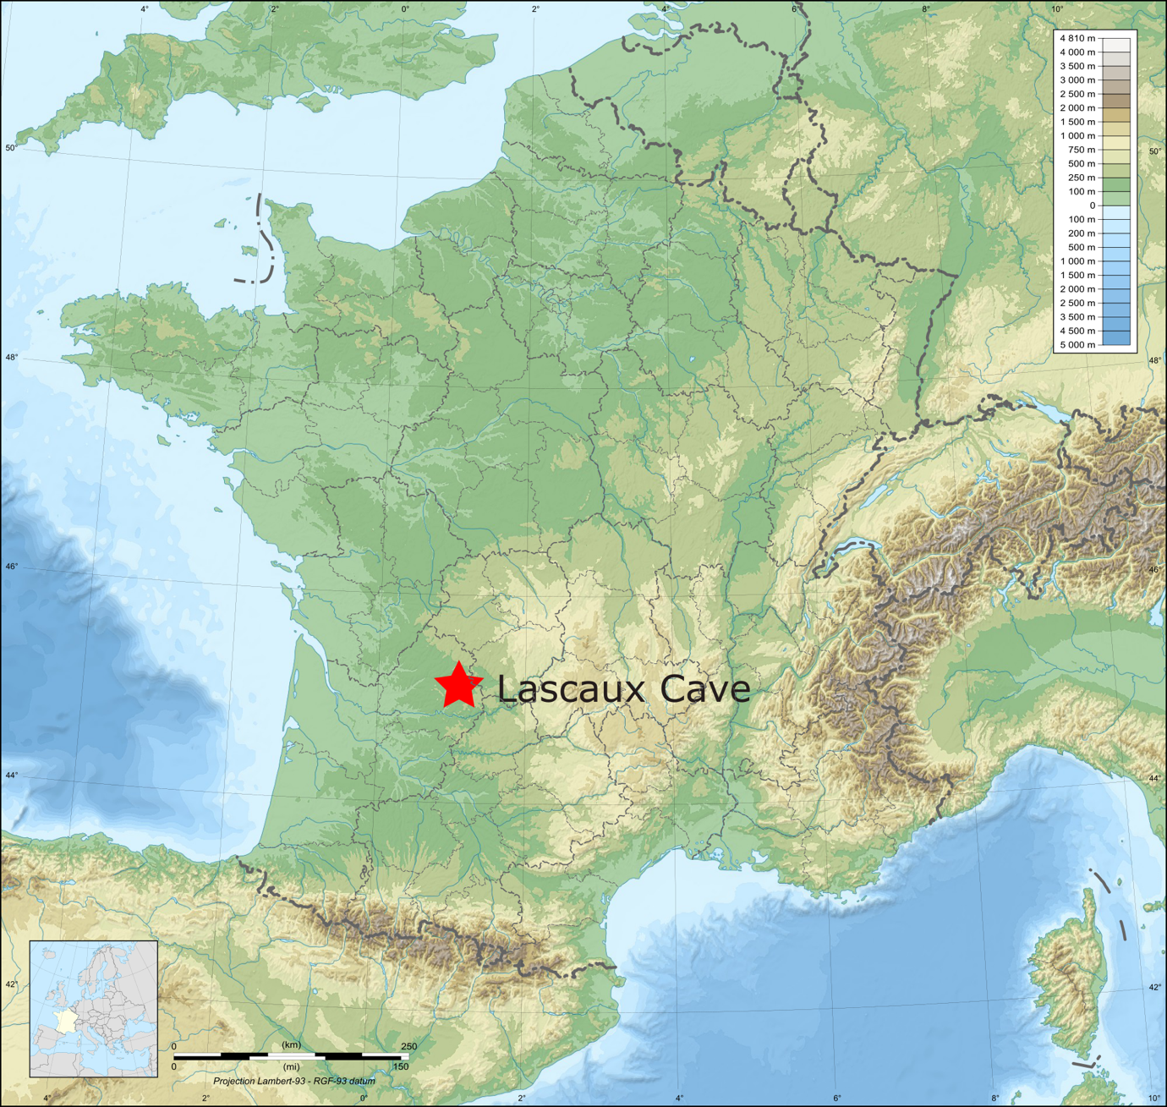
Figure 1 Location of Lascaux cave
Original image By Akiry - derivative work from File:France map Lambert-93 topographic with regions-blank.svg by Eric Gaba (User:Sting) and France map Lambert-93 with regions and departments polygons-blank.svg.Note : The entire relief is a raster image embedded in the SVG file.Note : Le relief entier est une image bitmap embarquée dans le fichier SVG.Sources of data:Topography: NASA SRTM30 (public domain);Bathymetry: NGDC ETOPO1 (public domain);Additional data: NGDC World Data Bank II (public domain)., CC BY-SA 3.0, https://commons.wikimedia.org/w/index.php?curid=22929695

Appendix 2

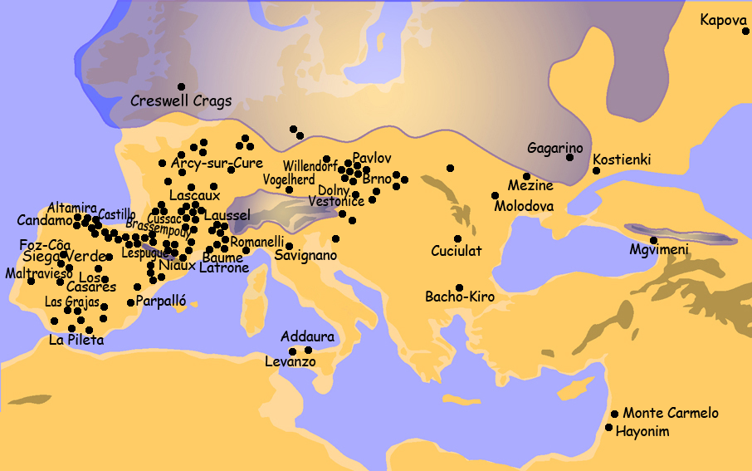
Figure 2 Map of prehistoric caves with Palaeolithic art
Creative commons licence. Created by Vincent Mourre and José-Manuel Benito

Appendix 3

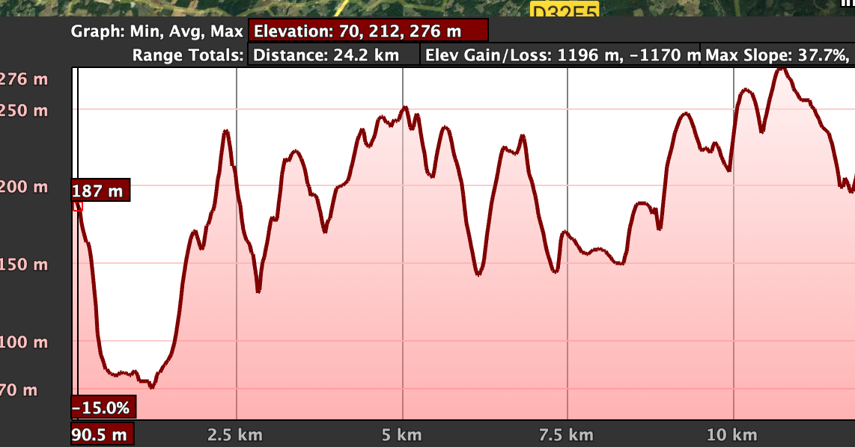
Figure 3 Elevation profile of Lascaux cave area. The original entrance was likely 90m away on today’s ground, but 18,600 years ago it likely was much close as sediment grows with each year passed.

Durkheim.
Durkheim, p. 36.
Durkheim, p. 44.
Durkheim, p. 228.
Eliade, p. 97.
Eliade, p. 21.
Eliade, p. 33.
Eliade, p. 63.
Nils Müller-Scheessel, ‘Fair Prehistory: Archaeological Exhibits at French Expositions Universelles’, Antiquity, 75.288 (2001), 391–401 (p. 399) <https://doi.org/10.1017/S0003598X00061044>.
Müller-Scheessel, p. 399.
Hans-Georg Bandi and others, The Art of the Stone Age: Forty Thousand Years of Rock Art (Methuen, 1961), p. 17.
Max Raphael, Prehistoric Cave Paintings (Pantheon Books, 1945).
Raphael, p. 3.
Raphael, p. 1.
Marie König, Das Weltbild des eiszeitlichen Menschen (N. G. Elwert, 1954).
Barry Cooper, Paleolithic Politics: The Human Community in Early Art (University of Notre Dame Press, 2020), p. 87.
Cooper, p. 88.
Alexander Marshack, ‘Lunar Notation on Upper Paleolithic Remains’, Science, 146.3645 (1964), 743–45 (p. 743).
Annette Laming-Emperaire, La signification de l’art rupestre paléolithique (A. et J. Picard, 1962).
Andre Leroi-Gourhan and Annette Michelson, ‘The Religion of the Caves: Magic or Metaphysics?’, October, 37 (1986), 7–17 (p. 17) <https://doi.org/10.2307/778514>.
André Leroi-Gourhan, The Dawn of European Art: An Introduction to Palaeolithic Cave Painting (CUP Archive, 1982), p. 75.
Jean Clottes and David Lewis-Williams, Shamans of Prehistory (Harry N. Abrams, 1998).
Clottes and Lewis-Williams, p. 41.
‘Norbert Aujoulat (1946-2011) | Lascaux’ <https://archeologie.culture.gouv.fr/lascaux/en/norbert-aujoulat-1946-2011> [accessed 5 January 2023].
Norbert Aujoulat, Lascaux: le geste, l’espace et le temps (Seuil, 2004).
Brian Hayden and Suzanne Villeneuve, ‘Lascaux, Le Geste, L’Espace, et Le Temps by Norbert Aujoulat Chauvet Cave: The Art of Earliest Times by Jean Clottes’, ed. by Norbert Aujoulat and Jean Clottes, American Antiquity, 70.2 (2005), 384–88 (p. 385) <https://doi.org/10.2307/40035710>.
Franco Moretti, Distant Reading (Verso Books, 2013).
Arlette Leroi-Gourhan, ‘The Archaeology of Lascaux Cave’, Scientific American, 246.6 (1982), 104–13 (p. 108).
Vadim Zaver, ‘Fieldwork Notes’, 2022, p. 1.
Oscar Moro Abadía and Manuel R. González Morales, ‘Paleolithic Art: A Cultural History’, Journal of Archaeological Research, 21.3 (2013), 269–306 (p. 291).
Vadim Zaver, p. 6.
James E. McClellan III and Harold Dorn, Science and Technology in World History: An Introduction (JHU Press, 2006), p. 42.
Raphael, p. 3.
‘France: Life Expectancy 1765-2020’, Statista <https://www.statista.com/statistics/1041105/life-expectancy-france-all-time/> [accessed 2 January 2023].
Сергей Зимов, ‘Сергей Зимов: «Таяние Мерзлоты — Прямая Угроза Для Климата»’, UNESCO, 2022 <https://ru.unesco.org/courier/2022-1/sergey-zimov-tayanie-merzloty-pryamaya-ugroza-dlya-klimata> [accessed 11 January 2023].
Jonathan Jones, ‘Did Art Peak 30,000 Years Ago? How Cave Paintings Became My Lockdown Obsession’, The Guardian, 23 April 2021, section Art and design <https://www.theguardian.com/artanddesign/2021/apr/23/cave-paintings-art-lockdown-obsession-30-000-years-lascaux> [accessed 5 January 2023].
Ewen Callaway, ‘Is This Cave Painting Humanity’s Oldest Story?’, Nature, 2019 <https://doi.org/10.1038/d41586-019-03826-4>.
Vadim Zaver, p. 2.
Marshack.
Hayden and Villeneuve, p. 385.
Vadim Zaver, p. 5.
Vadim Zaver, p. 4.
‘Acoustics in Sacred Buildings’, De Gruyter <https://www.degruyter.com/database/BDT/entry/BDT_08_007/html> [accessed 11 January 2023].
‘Cave Art Research Association (CARA) – AURANET’ <http://www.ifrao.com/cave-art-research-association-cara/> [accessed 31 December 2022].
Cassius Dio Cocceianus and Cassius (Dio), Dio’s Roman History (W. Heinemann, 1914).
‘Grotte de Niaux: The Story of a Discovery - Ariège Tourist Sites’, Sites Touristiques Ariège, 2020 <https://www.sites-touristiques-ariege.fr/en/niaux-the-story-of-a-discovery/> [accessed 31 December 2022].
Clumsy translation from French into English likely made by a computer. Note by Vadim Zaver
L. G. Freeman, ‘The Many Faces of Altamira (1994)’, in Anthropology without Informants, Collected Works in Paleoanthropology by L.G. Freeman (University Press of Colorado, 2009), pp. 277–94 (p. 290) <https://doi.org/10.2307/j.ctt46ntrt.21>.
Freeman, p. 291.
Paul Bahn, ‘Killing Lascaux’, Archaeology, 61.3 (2008), 18–70.
Paul G. Bahn, Prehistoric Rock Art: Polemics and Progress (Cambridge University Press, 2010), p. 37.
Randall H. McGuire, Archaeology as Political Action (University of California Press, 2008), p. 224.

