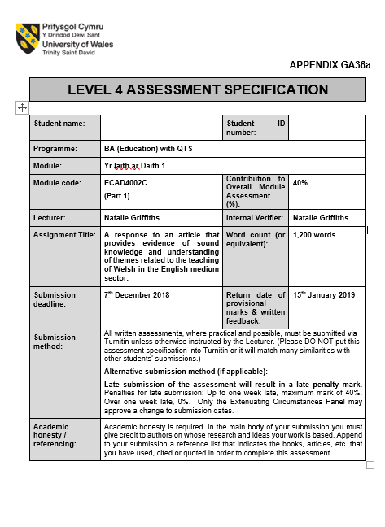

1800795
Harriet Doek

Yr Laith Ar Daith ECAD4002 – Assessment Component 1: Written Assignment
A response to an article that provides evidence of sound knowledge and understanding of themes related to the teaching of Welsh in the English medium sector.
Huw Lewis’s statement on the development of ‘Welsh Second Language within our Curriculum’ is mainly an update on the recent changes and planned developments that are being organised. Although shorter and much more summarised, this statement mirrors various publications debating on the Welsh curriculum. Professor Donaldson’s ‘Successful futures’ (2015) report is directly referenced by Lewis. Professor Donaldson (2015) also talks about the progress and future aims of Welsh second-language education. The aims mirror advice from groups like Estyn and the other reports from the Welsh Government such as ‘One Language for All’ (2013). Although the main document is about curriculum change and improvement, there are references to current curriculum documentation such as ‘Yr Curriculum Cymreig’ (YCC).
Within the statement, Huw Lewis talks about three main themes: the improvement of Welsh second language and its impact on society; the hope for everyday Welsh; and how schools/teachers will need to improve in order for Welsh second language to improve.
In terms of how better welsh language education will benefit our society, Lewis suggests 3 positive outcomes that we must strive to: adding commercial value for the jobs market; pushing the “cognitive benefits of bilingualism”; and “enabling children and young people to have a good understanding of the cultural life of Wales in the past and present”.
In terms of its benefit to jobs this is reflected across Wales not only through related publications but through the Government Sector of Wales providing Welsh second-language training to their employees. To “work with the Education Workforce Council to determine the Welsh language skills of the current workforce” is one of the Welsh Government’s additional aims. Although this only affects your local council, it’s a good start for integrating Welsh more into the workplace. Despite this it will still be very difficult to promote Welsh as feasible in the workplace when it isn’t even used in our shops, our homes, and our everyday interactions. Having opportunities to interact with other people in Welsh is just as important as learning your Welsh nouns and verbs. Luckily, Lewis and many other acknowledge this. We must “increase the opportunities for pupils to use the language in the community” (WG, 2013). This leads onto the “cognitive benefits of bilingualism”. According to Ofelia Garcia (2009), bilingualism helps students to “become global and responsible citizens as they learn to function across cultures and worlds”. This relates to one of Lewis’ aims:” I also want children and young people to see speaking Welsh, and other languages, as an attractive and worthwhile option”. In other words, bilingualism can contribute to Welsh history and Culture education, something which ‘Yr Curriculum Cymreig’ embodies.
This idea of the importance of Welsh second-language education paired with Welsh History and Culture is repeated in other documentation such as ‘One Language for All’ (WG, 2013) suggesting it should be an integral part of the curriculum across all subjects; and Estyn (2007) suggesting children should be “exploring the creative and expressive arts in Wales and in the broader Celtic tradition”.
As part of the next theme, Lewis states that Welsh should be used “primarily as a means of communication, particularly oral communication and understanding”. This aim is mirrored by Professor Graham Donaldson (2015) where he expressed the aspiration for children to acquire a wider range of welsh language skills and be able to use them in their personal lives, socially and in the workplace. One of the difficulties of learning a second language is that you can create this language bubble around your place of learning. Welsh often cannot escape the language barrier the Welsh second-language education created for itself, as Lewis admits this through the Welsh Government and the Urdd collaborating to “maintain informal activities through the medium of Welsh and to increase the use of Welsh beyond the classroom”. This idea of continuing the use of music to teach and unite children is a great idea. Additionally, this idea of collaboration can apply to schools. ‘Global Futures’ (WG, 2015) included the aim: “broker and facilitate the provision of training and materials by the language institutes who have a wealth of knowledge, resources, materials and expertise which they will share with our schools to improve the learning and teaching of languages”. This is also suggested by Professor Donaldson (2015): “Welsh-medium schools employ specialists and have a wide range of available Welsh language resources. They are well placed to act as hubs for the Welsh language”. Collaboration could create equal opportunities allowing children a better chance of communication through Welsh with others, therefore increasing the likelihood of Welsh being used in the community.
In terms of the final theme, for Welsh second language to develop schools will have to adapt and improve. As stated by Lewis: “we also need to equip our teaching profession with better skills”. I agree with this statement as it has been admitted by many, including Lewis, that despite a seemingly adequate Welsh Curriculum, “far too many young people are leaving schools without the effective Welsh language skills they need for the world of work, life and study, despite studying Welsh as a second language for many years”. Professor Donaldson (2015) interestingly outlines that one of the highlights of Welsh education is Welsh in the early years, which suggests that a majority of teachers are more comfortable in using that level of Welsh.
Relating to Lewis’ emphasis on teachers’ skills, in secondary education, due to lack of confidence in Welsh they are unable to maintain and build the welsh skills children initially come up with. In order to counteract this ‘Global Futures’ (WG, 2015) set out to “improve transition arrangements for modern foreign languages between primary and secondary schools”. However, I would argue that teachers are not the only issue. The subject itself and how it is fitted into the curriculum is also an issue. Estyn (2017) thought that schools allocate too little time to Welsh second language. ‘One Language for All’ (WG, 2013) thought that “the subject is too high brow and dry”. Lewis seems to acknowledge these statements as “a number of innovative projects are running to improving the teaching and learning of Welsh in English Medium schools in the current curriculum” especially analysing how schools are performing at key stages 2 and 3. This should hopefully include looking at how GCSE’s are devised in terms of timetables and option blocks in year ten and eleven respectively (Global Futures, WG, 2015).
In conclusion the statement accurately depicts the current debates and developments that are happening within Welsh Second Language Education and the curriculum. In the end if the Welsh Government truly aspire to make Wales a bilingual country, they must continue they must focus on the wellbeing of students and the effectiveness of their teachers. “The purposes and functions of each language in a triglossic situation are both symbolized and enacted in the school situation” (Colin Baker 2011). However, from looking at this statement, they’re on the right track.

Bibliography
References
- Lewis, H. (15 October 2015) Welsh Second Language within our new Curriculum. Welsh Government
- Welsh Government (September 2015) One Language for All: Review of Welsh second language at Key Stages 3 and 4.
- Garcia, O. (2009) Bilingual Education in the 21st Century: A Global Perspective. West Sussex: Blackwell Publishing.
- Estyn (October 2007) An Evaluation of the GCSE Welsh Language Short Course
- Donaldson, G. (February 2015) Successful Futures: Independent Review of Curriculum and Assessment Arrangements in Wales.
- Welsh Government (October 2015) Global Futures: A plan to improve and promote modern foreign languages in Wales 2015–2020.
- Estyn (Autumn 2017) Supplementary Guidance: Welsh
- Baker, C. (2011) Foundations of Bilingual Education and Bilingualism 5th edn. Canada: Multilingual Matters.

