Database Systems
  - Lecture 14 Lab Tutorial Exercise

Database Security Threats and their Impact
An organisation should have measures in place that seek to reduce the risk of the following occurring:
Theft and fraud affect not only the database environment but also the entire organization. As it is people who perpetrate such activities, attention should focus on reducing the opportunities for this occurring. Theft and fraud do not necessarily alter data, as is the case for activities that result in either loss of confidentiality or loss of privacy.
Confidentiality refers to the need to maintain secrecy over data—usually only data that is critical to the organization—whereas privacy refers to the need to protect data about individuals. Breaches of security resulting in loss of confidentiality could, for instance, lead to loss of competitiveness, and loss of privacy could lead to legal action being taken against the organization.
Loss of data integrity results in invalid or corrupted data, which may seriously affect the operation of an organization. Many organizations are now seeking virtually continuous operation, the so-called 24/7 availability (that is, 24 hours a day, 7 days a week). Loss of availability means that the data, or the system, or both cannot be accessed, which can seriously affect an organization’s financial performance. In some cases, events that cause a system to be unavailable may also cause data corruption.
Database security aims to minimize losses caused by anticipated events in a cost-effective manner without unduly constraining the users. In recent times, computer-based criminal activities have significantly increased and are forecast to continue to rise over the next few years.

Exercise
With reference to the diagram below, discuss the various types of threats and the risks they pose and the impact these threats may have, should they occur, within an organisation. Complete the table showing the area on which each of these possible threats may have an impact.

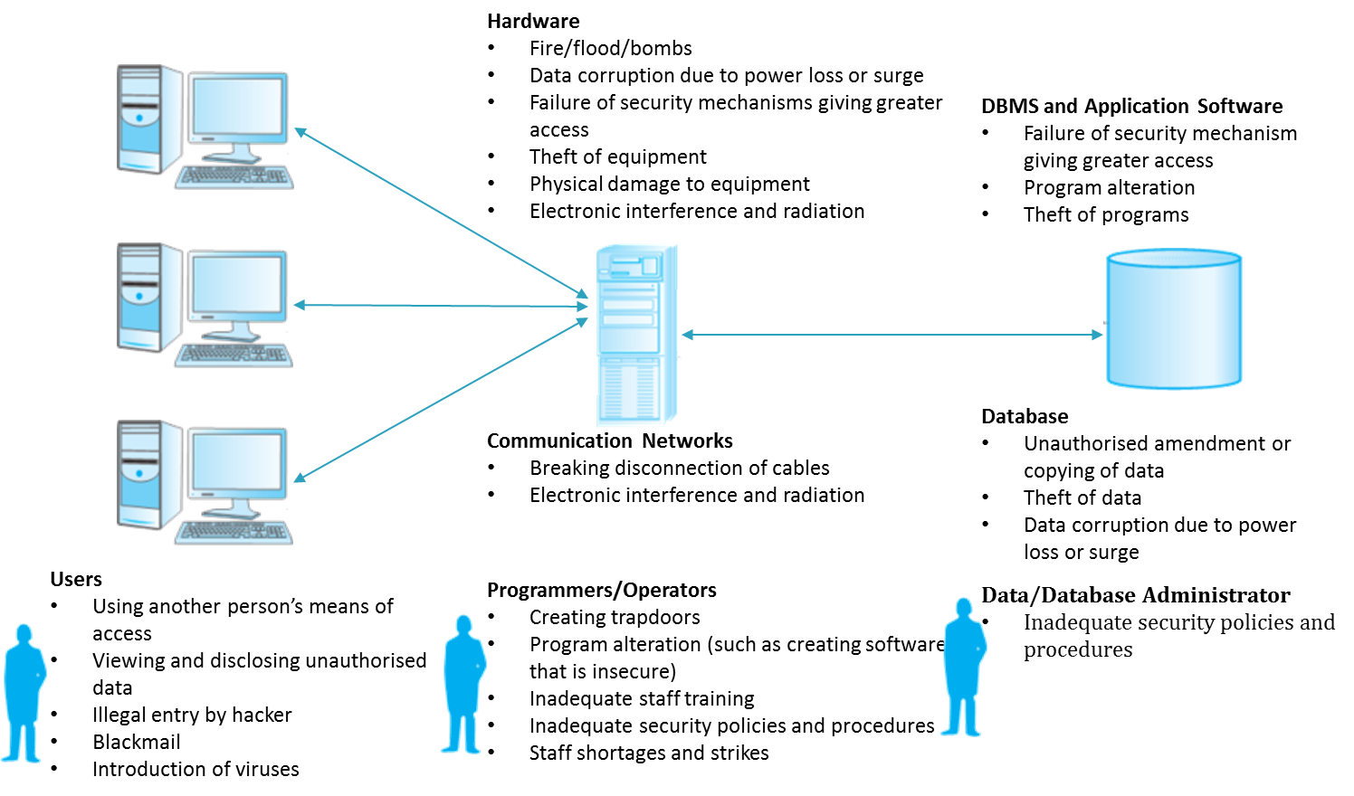

Threat | Theft and Fraud | Loss of Confidentiality | Loss of Privacy | Loss of Integrity | Loss of availability
Using another person’s means of access
Unauthorised amendment or copying of data
Program alteration
Inadequate policies that allow a mix of confidential and normal output
Wire tapping
Illegal entry by hacker
Blackmail
Creating “trapdoor” into system
Theft of data, programs and equipment
Failure of security mechanisms, giving greater access than normal
Staff shortages or strikes
Inadequate staff training
Data corruption owing to power loss or surge
Fire (electrical fault, lightning strike, arson), flood, bomb
Breaking cables or disconnection of cables
Introduction of viruses
Table 1: Examples of Security Threats and their Impact

Source: [© Pearson - Database Systems: A Practical Approach to Design, Implementation, and Management - http://app.kortext.com/read/80118/?page=609]

