Computer Aided Manufacturing and Design for Additive Manufacturing Technologies

(Task 2)

  - Manufacturing Design and technology m5x02070
Owen Bayliss 1708437 | Mechanical and Manufacturing Engineering | 23rd June 2020
Word Count - 3537

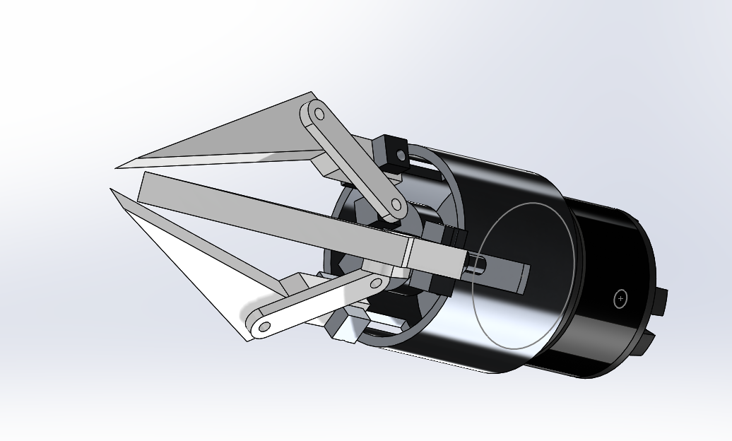
Context

- Introduction………………………………………….

- Appraisal of Original System………………………

- Design and Development Work Undertaken…….

- Manufacturing Process Proposal …………………

- Manufacturing Process Design ...…………………

- Conclusion……………………………………….…

- References…………………………………………

1. Introduction
In this report I will outline the major flaws in the current design based on the 3 jaw gripper’s functionality and manufacturability always referring back to the specification. The jaw gripper needs to uphold previously targeted attributes such as being flexible and adaptable for a wide range of “pick-and-place” operation. The concept design has been taken to a point where manufacture should begin, but it is clear that manufacturing process of the many components that come together to make the 3 Jaw Gripper have not been taken into consideration. In this report I will outline major and minor faults and flaws that have been caused due to the lack of design for manufacturability. I will do this through a number of analytical techniques, scrutinising each part in understanding how the current design works and how it will be manufactured. Ultimately coming to my own conclusion on how this design can be modified t better suit its current spec. As the Specification has only specified the one tool all my choices and key decision making will be under the understanding that there will be only 1 final 3 Jaw Gripper produced. In my appraisal of original design I will conduct a full DFMEA of the current design in order to fully understand what issues are present, also using the Lucas method in order to assign a penalty scoring system on the current parts to isolate which components are required and what can be redesigned and left out of the new revision. Continuing into my design and development section, I will take my results and findings from the previous section to produce an update design for the tool outlining previous faults and finding suitable solutions. I will also conduct sufficient research to develop my idea. My manufacture process proposal will outline how and what will need to be manufactured by myself and I will look into a variety of manufacturing techniques and decide a process that is suitable for the designs and components that I have chosen to change. Finally the manufacturing process design will follow straight and will include an expansion on the choices that were made in the previous section, outlining a full process then finally an appraisal of the new system.

2. Appraisal of Original Design
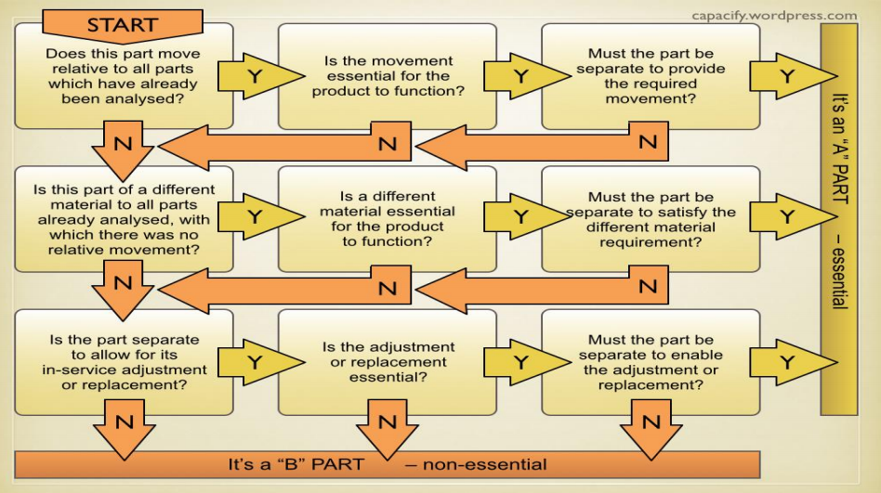
Before I can put forward a concept for a redesign I need to outline what are the main positives and negatives of the current design and then I can use that appraisal in order to redesign certain components of the 3 Jaw Gripper. The tools I will use for this appraisal will be a full Design failure mode and effects analysis or DFMEA and a root cause analysis to ensure that we had fully outlined the key issues in order to produce a high quality substantial replacement or amendment. But also before critically examining current faults or imperfections in the design, I will also need to understand what each part does and how it contributes to the finish product. Without having a full understanding of each part I will be unable to decide which components need changing and which components can be removed altogether. Firstly I began a design efficiency exercise using the Lucas method to firstly decide which parts of the part are essential or non-essentials parts. Using the chart seen here, I am able to delegate which parts are essential and which are not.
- Jaw – ‘A’ Part
- Cylinder - ‘B’ Part
- Drive Plate – ‘A’ Part
- Motor – ‘A’ Part
- Join – ‘B’ Part
- Shaft – ‘B’ Part
- Worm – ‘A’ Part
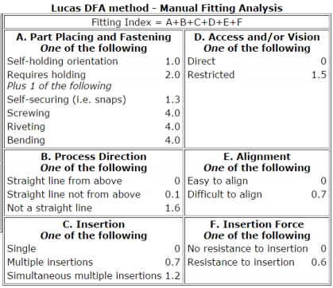
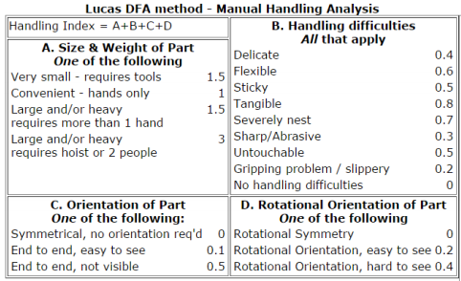
To further expand further on the Lucas method I will then analyse each parts manual handling analysis and also its manual fitting analysis. Manual handling will cover areas such as size and weight of part, handling difficulties, orientation of part and rotational orientation of part. Each of these sub sections will be given a score and the best designs will have the lowest score. To work out the score you use the formula ‘Fitting index = A+B+C+D’. Likewise the manual fitting analysis will cover, Part placing and fastening, Access and/or vision, Process Direction, Alignment, Insertion and Insertion force. Again penalty points will be decided for each component and also each category. Similarly to the handling analysis you use a formula to work out the final scores, this formula is, ‘Fitting Index = A+B+C+D+E+F’. I will also use this Lucas DFA Method on my final design to ensure that my scores have improved so then the design has improved. Below you can see Analysis subsections and what each score means in the tables that follow.

Manual Handling Analysis
Component Description | A | B | C | D
Jaw | 1.5 | 0 | 0.1 | 0.2
Cylinder | 1 | 0 | 0.1 | 0.2
Drive Plate | 1.2 | 0.4 | 0.5 | 0.2
Motor | 1.5 | 0.4 | 0.5 | 0
Join | 1.5 | 0.7 | 0 | 0
Worm | 1.5 | 0.5 | 0.5 | 0.4
Shaft | 1.5 | 0.5 | 0.5 | 0.4

Manual Fitting Analysis
Component Description | A | B | C | D | E | F
Jaw | 6 | 0 | 0.7 | 0 | 0 | 0
Cylinder | 1 | 0 | 1.2 | 0 | 0 | 0
Drive Plate | 6 | 0 | 0 | 1.5 | 0.7 | 0.6
Motor | 6 | 0 | 1.2 | 1.5 | 0 | 0
Join | 6 | 0.1 | 1.2 | 0 | 0.7 | 0
Worm | 6 | 0 | 1.2 | 1.5 | 0.7 | 0.6
Shaft | 1.0 | 0 | 0.7 | 1.5 | 0 | 0

Component Description | Component Number | Functional Analysis | Handling Analysis | Fitting Analysis
Jaw | 1 | A | 1.8 | 6.7
Cylinder | 2 | B | 1.3 | 2.2
Drive Plate | 3 | A | 2.3 | 8.8
Motor | 4 | A | 2.4 | 8.7
Join | 5 | B | 2.2 | 8
Worm | 6 | A | 2.9 | 10
Shaft | 7 | B | 2.9 | 3.2

Analysing the results from both the handling analysis and the fitting analysis it is clear that the designer of this 3 Jaw gripper hasn’t taken much consideration into the manufacture and general up keep of each component and the final product. This is shown in the components such as the worm, drive plate, shaft and joins. All of these components, though crucial to the all-round performance of the current part are poorly positioned, difficult to maintain and difficult to replace. Under the current design manufacturing costs will be very high as it is clear that all components will have to be bespoke design and manufacture. Delving into this clear problem I began a DFMEA (Design Failure Mode Effect Analysis). In doing this I can assess the clear design faults and begin to look into how to correct them. DFMEA are useful as they allow you to identify potential risks in current designs and allow you to micro manage these problems to a solution. In identifying these design faults you then must assign a severity number, occurrence and the detection to give you a final RPN number. From this you can decide suitable recommended actions then reassess your actions alongside the previous designs to understand whether your changes have been adequate. On the following page I have included the DFMEA that has outlined all major issues that I can see from the Solidworks model. As you can see I have left the second half of the DFMEA blank, I have done this so I can fill it in once I have put forward my own design outlining solutions to these problems. As for these problems many can be solved by incorporating a simple solution which is in the Design for Manufacture guidelines. This is that “the reduction of the number of parts in a product is probably the best opportunity for reducing manufacturing costs.” I see one of the best ways to cut these manufacturing costs is to outsource some of the key components such as motor and cylinder and to remove the entire worm and drive plate components. Combining all these components into a singular outsourced product, this will reduce manufacturing costs and allow me to create a bespoke jaw piece that is suitable for the grippers intended purpose.

3. Design and Development Work Undertaken
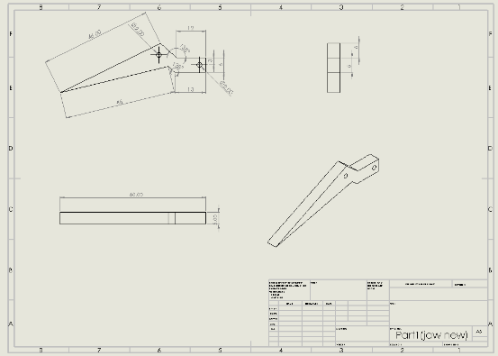
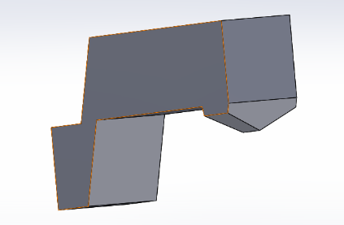
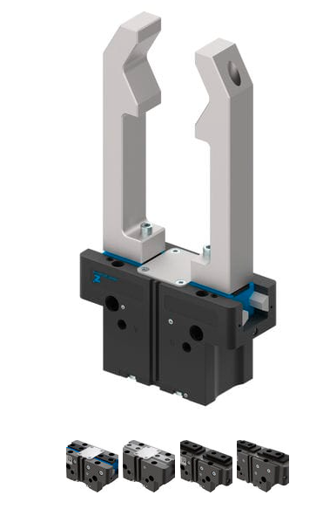
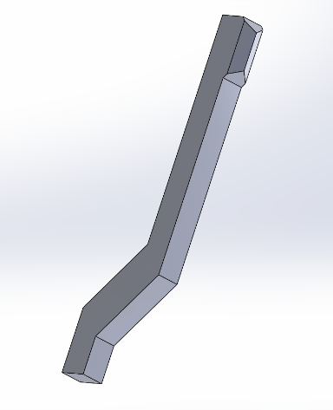
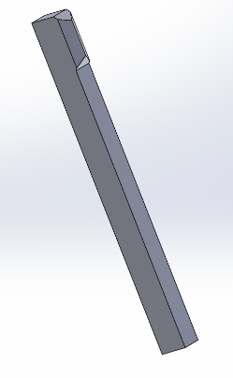
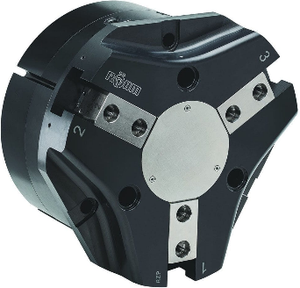
Having come to the understanding that the best course of action to take is a redesign whilst also outsourcing major components I began research and development whilst keeping some of the basic design features in mind, these being that its functions needs to remain as a 3 Jaw Gripping tool intended for “Pick and place” operations for use on robot/co-bot systems. To reduce manufacturing costs by reducing the bespoke aspects of the original design I looked into how to change the current mechanical layout of the gripper and how it worked. It is clear from the solid works model of the Gripper that the key components which allow our jaw to in theory open and close are the drive plate, the worm, the joins and the motor. Assuming that the motor is your average brushed DC electric motor, then this would be the only component of the current design that isn’t bespoke currently shown. This would mean increased manufacturing costs and also manufacturing time. Also with this current layout in place you would see and increased need for maintenance and greater time required for maintenance to be undertaken. Firstly I propose that it is necessary to remove all these mechanical components and replace them with an outsourced singular unit that will house the joints, jaws and motor. Also switching the current electric motor for a pneumatic system. The pneumatic system will allow the gripper to be precise and also compared to our current mechanical system, pneumatic systems are a lot more durable and also reliable. The pneumatic system that will be used to operate the jaws will be a two-stage system fed from an external compression tank. I believe the pneumatic system is cost effective as it is almost self-cleaning. As for the jaws themselves, they will be manufactured by myself. The reason being, the DFMEA raised some issues that can ideally fixed by a redesign by myself to allow that the grippers themselves are designed to be parallel when they meet, this will fix the issues that were marked in the previous DFMEA and the Lucas method DFA. The new jaws will be then fixed to the new pneumatic control system. How I will fix them will be decided during the design process. Currently on the market 3 and 2 Jaw Pneumatic gripper tools do exist, however it is more cost effective to just purchase the pneumatic body and manufacture my own jaws to how I need and want them. Using Solidworks I am unable to create a model manipulating the current design and creating my own, taking dimensions from a pneumatic system for a 3 jaw gripper from a current system and then producing a new design and shape for the jaws incorporating the issues raised from the DFMEA and resolving them. Firstly I created a fully dimensioned cad drawing of the original jaw, so I am able to use the basic dimensions such as width, depth and overall length of the part and then I used this to produce my own version of the gripper component and referred to this as rev 1. For rev1 I only primarily changed the shape of the end of the gripper tool keeping the same dimensions for the base of the part such as the depth and the width. The main aspect change for the end of the grip was removing the flat pointed end and making it a 120 degree point, this would mean that when all three jaws meet, they will make a parallel flush grip, allowing the gripper to not be limited in how small a part that it needs to pick up and move can be. Completing a small DFMEA on the new gripper and also creating an assembly with all three new grippers, it is now clear that there is a major flaw in the fact that when completely shut the gripper part of the jaw will not meet. In my rev2 design however I created a solution to this problem by mirroring the face that the gripper would be situated on. This fixed the problem that was previously raised but meant that now our gripper would have a 12mm travel so that could cause our tool to be limited in the size of components it could pick up once again. Also the 138 degree branch out on the gripper is only really necessary on the original design due to the direction the grippers move in order to open and close as they are in a radial direction, however with the pneumatic system the arms will now only move in a horizontal direction in order to open and close. Understanding this in my final design I looked into how the pneumatic parallel gripper is shaped in order to understand how much travel is necessary, it is clear in how the gripper operates that no travel is necessary so now the gripper shape only needs to be straight. This will reduce manufacturing time and also costs. With this final design complete I now finish my DFMEA to include the new design and specify the actions I have taken to fix the previous problems raised allowing for a more accessible tool that is simple to understand and easy to manufacture and service. The updated action results show a significant change which is what I would hope for. On the following page I have included the completed DFMEA showing all results and actions taken. For the new pneumatic gripper unit I looked into many different options that would be suitable and meet the standards set within the specification outlined in the task brief and also my introduction, taking these factors into consideration the new part that I have chosen is the 180mm series GRT Parallel Pneumatic 3-Jaw Gripper. This component is field repairable, rugged and extremely versatile and is ideal for the new jaw gripper design.

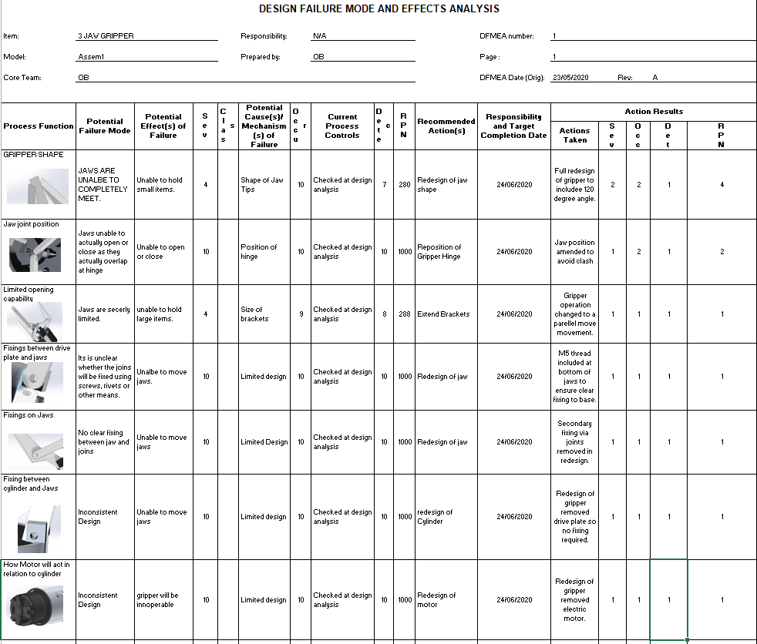

4. Manufacturing Process Proposal
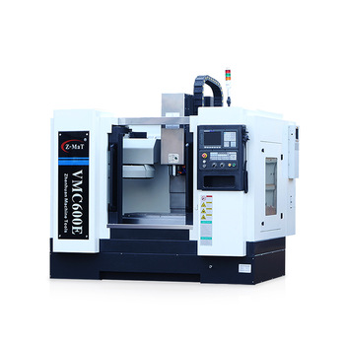
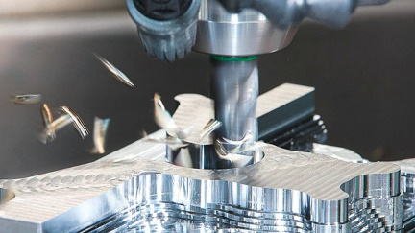
My manufacture process proposal is very simple as the only component that I will have to manufacture are the new gripper jaws. In my research for manufacture techniques in order to produce a high quality finish I looked at the 4 primary types of manufacturing techniques, Molding in manufacturing, machining in manufacture, joining in manufacture and shearing and forming in manufacture. I had to weigh up the pros and cons for each before making my selection. Molding manufacture would’ve been ideal as the gripper redesign is extremely simple for mass production as it is quick and easy but the finish may not be of the highest quality and for only 3 units the molding process would not be the most cost effective. Joining in manufacture is the process of joining multiple parts to create a singular finished article as the only parts I am manufacturing are a singular unit with fixings provided for the fix on an outsourced part this process is not suitable for my required specification. Shearing and forming manufacture primarily is used when dealing with sheet metal, cutting and bending to the required shape and only really used on metals such as aluminium, brass, bronze and stainless steel. Our part will be formed out of aluminium but will not be shaped using shearing and forming techniques so this manufacturing process will not be suitable as per our specification. Finally machining manufacturing, more specifically CNC machining is required to create a bespoke part for our singular component with a high quality finish. CNC machining is suitable as it will produce a flawless component as long as the programme is correct, so the only real problem that could arise would be user error whilst coding the programme in order to produce the grippers. CNC machine are very consistent so all three of the grippers will be exactly the same granted the programme is correct, also the machines are very easy to use and the part will be produced in a short amount of time. My spec has requested that only one 3 jaw gripper is necessary so only 3 jaws need to be produced, as this is a bespoke tool with only a singular unit the CNC machine is ideal as there will be minimal wasted materials but it also gives you the opportunity for mass production if there was a need for more 3 jaw grippers, the programming is saved and can be uploaded and stored anywhere and anytime. Also as my designs have been drawn up using CAD package Solidworks, CNC machining works directly with CAD software so I will not need to write a full programme, this is depending on the age and compatibility of the machine that will be used. Specifically the CNC machine that I will be using will be a vertical CNC milling machine. Finally to fix the new jaw grippers onto the pneumatic unit, the jaws will be machined so a thread is applied at the base of the jaws and fixed into the pneumatic unit in the holes provided.

5. Manufacturing Process Design
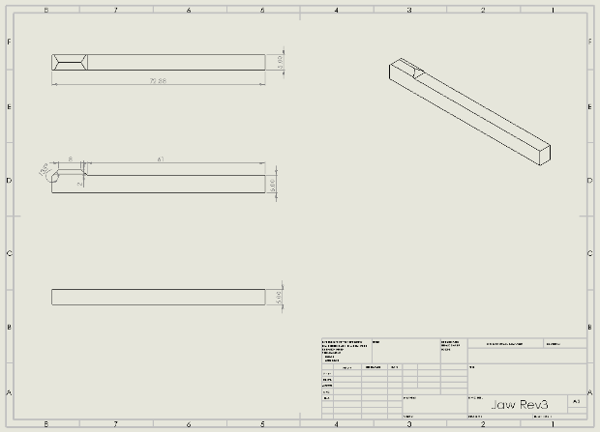
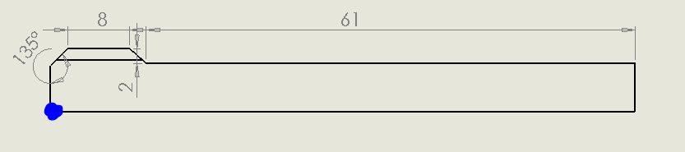
As my manufacturing process is going to be conducted using a CNC milling machine, I will need to produce a programming sheet and a cad drawing of a fully dimensioned part. Most modern CNCN machines will only require the CAD drawing but as I have not specified which CNC milling machine that I will use I have to assume that II will need to provide a manual full programmed drawing sheet. Firstly I create a fully dimensioned and defined CAD drawing of the new gripper using the solidworks package and from there I can begin to write my programme for the new part. I have made my G54 point the bottom left point shown here, labelled with a blue dot. This is where my tool will begin the manufacturing process. The tools that will be available will be a 10mm slot drill, a 4mm twist drill and a 5mm Twist Drill. However for the manufacture of the part I will primarily use the 4mm slot drill. My aluminium plate will also be positioned on a sacrificial plate allowing for the tool to penetrate the plate completely. Below you will find my CNC programming sheet for the new Jaw gripper.

Drawing Name/No. |  |  |  | Jaw Gripper REV3 |  |  |  |  | Tooling and Setup Data  T1 = 10mm Slot Drill  T5= 4mm Twist Drill  T6 = 5mm Twist Drill
Description: |  |  |  | Gripper Jaw Redesign
Program No. |  |  |  | 1
Material: |  |  |  | Aluminium Alloy
Program by: |  |  |  | OB
Date: |  |  |  | 06/06/20
N | G | M | X |  | Y | Z |  | R |  | F | Remarks
10 | G21 | G90 | G54 |  | G40
20 | M06 | T5 | M08
30 | G41
40 | M03 | S10000
50 | G00 | X0.0 | Y0.0 |  | Z-6.0
60 | G01 | X0.0 | Y73.0
70 | G01 | X 6.0 | Y73.0
80 | G01 | X6.0 | Y12.0
90 | G01 | X10.0 | Y8.0
100 | G01 | X2.0 | Y8.0
110 | G01 | X0.0 | 6.0
120 | G01 | X0.0 | Y0.0
130 | G80 | M05 | M09 |  | G40
140 | M02

Taking the newly produced gripper from the machine I will then drill a 5mm hole at the base of the jaw and then using a tap & die I will imprint the thread into the new parts. This will then be fixed upon our new pneumatic unit.

8. Conclusion
In summary, having completed my full DFMEA early on at the beginning of the report it is clear that I full redesign of the system was necessary implementing a new strategy for manufacture. Basing this full redesign on a design for manufacture system whilst applying basic DFM guidelines such as, designing a product in order to facilitate manufacturing process also simplifying the design by reducing the number of parts and also outsourcing where viable I was able to produce a strategy to create a more organised and appropriate components giving what little information in the specification. The last point in the DFM guidelines was the most necessary in my redesign as it meant that the only part that would manufactured would be the new Jaws. Outsourcing the new pneumatic unit would be simple and more cost effective compared to the original design which would have included a lot of bespoke components which would have been expensive and difficult to maintain and manufacture as so many key points were missing such as fixing options, materials and manufacturing options. As for the manufacturing process the CNC milling manufacturing process is also the most viable option as it is easy to programme having showed this in my manufacturing process design outlining materials and tools required also the quantities that will need to be produced. As I have stated in the introduction as there was no quantity specified in the specification for the component, I was under the impression that only one unit was to be produced, this will account for my choices such as a complete overhaul of the original design and to outsource major components to produce a new 3 Jaw Gripper tool that accessible, easy to manufacture (the new jaws) and also very easy to maintain. The new design is also in keeping with previously stated requirements as the new unit is flexible and adaptable, the new pneumatic unit is extremely adaptable as it can be easily removed and changed for a smaller or larger unit also given the large opening diameter of the chosen unit the range of components that the current pneumatic gripper can “pick and place” is also very vast. Comparing the results of the DFMEA from the previous unit design to the current it is clear that all problems raised have had suitable solutions established and the new penalty scoring system is showing major gains. Undertaking further development of the previous system I have no produced a much more viable manufacturability 3 Jaw Gripper tool.

7. References

Sealy, M. and Corns, S., 2002. Lucas Design For Assembly Method Applied At Hawker Siddeley Switchgear - IET Conference Publication. [online] Ieeexplore.ieee.org. Available at: <https://ieeexplore.ieee.org/document/241172> [Accessed 16 June 2020].
Quality-one.com. n.d. Design FMEA | Design Failure Mode & Effects Analysis | Quality-One. [online] Available at: <https://quality-one.com/dfmea/#What> [Accessed 16 June 2020].
Ekci.com. 2020. Advantages Of Pneumatic Valves And Pneumatic Controls. [online] Available at: <https://www.ekci.com/advantages-of-pneumatic-systems-ezp-114.html> [Accessed 17 June 2020].
Brenner, L., 2018. Advantages & Disadvantages Of Pneumatic Systems. [online] Sciencing. Available at: <https://sciencing.com/advantages-disadvantages-pneumatic-systems-7594256.html> [Accessed 17 June 2020].
gripper&nbsp;/&nbsp;parallel&nbsp;/&nbsp;2-jaw, 2020. GPP5000 Series - Pneumatic Gripper By ZIMMER GROUP | Directindustry. [online] Directindustry.com. Available at: <https://www.directindustry.com/prod/zimmer-group/product-14534-1647899.html> [Accessed 17 June 2020].
Writer, S., 2017. CNC Machining Definition, Processes, Components, & Equipment. [online] Thomasnet.com. Available at: <https://www.thomasnet.com/articles/custom-manufacturing-fabricating/understanding-cnc-machining/> [Accessed 21 June 2020].
Faris, S., 2018. Four Primary Types Of Manufacturing Processes. [online] Bizfluent. Available at: <https://bizfluent.com/info-8622375-four-primary-types-manufacturing-processes.html> [Accessed 21 June 2020].
Barbosa, R., 2019. The Pros And Cons Of CNC Machining - Ricardo & Barbosa. [online] Ricardo & Barbosa. Available at: <https://www.ricardo-barbosa.com/the-pros-and-cons-of-cnc-machining/> [Accessed 21 June 2020].

