
ASDA report a critical analysis
BMSW4004 Problem Solving

March 1, 2020
1906799
TATIANA PIRVU

Table of Contents
EXECUTIVE SUMMARY 2
INTRODUCTION 3
FINDINGS 3
OVERVIEW OF ORGANISATION 4
THE HISTORY OF ASDA 4
WHAT PRODUCTS AND SERVICES DOES IT OFFER? 4
INVESTIGATING ASDA 4
DESCRIPTION OF: Nature; Scope; Impact 6
SWOT ANALYSIS-MICRO 6
PESTLE Analysis-Macro 8
CONCLUSIONS 8
MAIN AREA OF CONCERNS 10
OPTIONS 10
OPTION 1 10
OPTION 2 10
ACTION PLAN 11
APPENDICES 11
ACKNOLEGEMENTS 13
REFERENCE LIST 14

EXECUTIVE SUMMARY
Purpose of Report-To provide an analysis of the current problems faced by ASDA by using analytical tools such as SWOT and PESTLE to gather information. To draw a conclusion and suggest options for improvement at ASDA and explain the process of communicating, monitoring and reviewing the implementation of the chosen options. To be sure that any action taken it’s aligned with ASDA missions, we will draw a short-term action plan as the dynamic of the current events require monitoring and reviewing as readjusting’s, much often than usual.
The research methods are as per suggestion, based on video documentaries or clips analysis; websites; articles analysis; books and courses compilations or extractions for exemplification; etc.
The main problem with ASDA is the competition of other supermarket that are responding faster and better to their customers. Customers are shopping in a new manner looking for the better price and best value for money. A new trend of shopping.
1.ASDA face large competition on lower prices on food and other merchandise. The competition it’s from smaller shops like Aldi and Lidl and online deals competition. (Wunsch, 2019)
2.The research shows that many ASDA’s customers want to be served by people that are well treated and respected in their jobs. (Guardian, 2019).
From the beginning of this report until the end of it, ASDA have started to improve already its weaknesses making the efforts of responding to its customers.
They are recording good feedback from political leaders which give ASDA as an example of company that is looking after community and its people. (The Highland times, 2020)

INTRODUCTION
This report was requested by the course lecturer Mrs. Melanie Squire
Date requested Is 3-rd of April 2020
Tatiana Pirvu-student number 1906799-is compiling this report and conducting an ample research and investigation in discovering what are the main problems of ASDA.
The report will be focused on analysing micro and macro environment offering viable solution and a short-term Action Plan together with Monitoring and Reviewing Progress solutions.
Date of submission is intended on 1 of April 2020.

2.0 FINDINGS

2.1 OVERVIEW OF ORGANISATION
ASDA It’s a supermarket retailer, with the main offices in Leeds, West Yorkshire.
ASDA Stores Ltd is trading like ASDA supermarket, and is the third as capacity in the top listed chain supermarkets in UK. At 31 of January 2020, ASDA counts 632 locations in UK. (ASDA, 2020)
ASDA kept its core food-based products for trade, but the company has several other products named ‘’ general merchandise ‘’ such petrol, financial or mobile phones; click and collect etc.
ASDA is facing today the same main problem as all large supermarkets, less sales and small profits due to changes in trends of shopping and large competition from other players. (Wunsch, 2019)

2.1.1 THE HISTORY OF ASDA
ASDA was born 71 years ago, in 1949 when the owners of a butcher’s store, Asquith family join their business with Associated Dairies company of Yorkshire. As such in 1965 by blending their first 2 initials, their new name become ASDA. (ASDA Corporate, 2020)
In 1963 Their first self-serve supermarket was a converted cinema in Castleford, and they call it Queens.
From 1970s and 1980s they become very successful and they start a large expansion. Core Principles of selling their goods were to sell at the lowest prices for a great value produces and get more customers to their doors.
They continued to extend until 1990s and by opening new supermarkets mainly out of town.
In 1999-ASDA was listed on the London Stock Exchange.
In 2003 -ASDA was named by market share, the second-largest supermarket chain in UK, behind Tesco and ahead of Sainsbury's, position which they managed to keep until 2014 when they fall in the 3-rd. place.
From the beginning their marketing campaigns were focused on low prices, with the main idea to offer their customers the best possible value for money. This politic attracted Walmart, the redoubtable American company which in 2015 become main stakeholder.
At that time Walmart paid for ASDA majority shares £6.7 billion.
Their long-life slogan is ‘’ASDA-Save money-leave better!’’ which is very popular and memorized very well by its loyal customers. (ASDA, 2020)
The research shows that ASDA that in 1987 they launched McLagan Investments Ltd - a property development – which is also based in Leeds.
In early 2018, ASDA had an attempt of merging with her close competitor Sainsbury’s. (Insider Media, 2019)
According their declaration, the combined assets/supermarkets would had got an estimated of 30% share on the UK supermarkets.
(their plan was refused and blocked by Competition Markets Authority though and goes no further)

2.1.2 WHAT PRODUCTS AND SERVICES DOES IT OFFER?
In January 2020 ASDA count 632 locations. ASDA operates with different store formats: Superstores; Supermarkets and Supercenters; ASDA living; Gorge stores; ASDA essentials and ASDA petrol. (ASDA Corporate, 2020)
ASDA offers groceries households; clothes general merchandise; petrol and operates with other two subsidiaries ASDA Financial-financial services and ASDA Mobile-mobile services. They have a total of 165.000 employees under their all own brands and partners like: ASDA Smart Price. Chosen by you; George clothing; ASDA mobile and ASDA money.
On top of these the company has a special parcel service named To You which is partnering with click and collect retailers such-ASOS and Ideal World. (Asda toyou Collect & Return, 2017)

2.2 INVESTIGATING ASDA

The research shows that ASDA has a too large and slow-moving infrastructure/shops and this negatively affect the way they can compete with stores like Lidl and Aldi which are capable to adapt and answer their customer needs and requests much faster. (Inside ASDA-Bigger, Better, Chipper ?, 2020)

In 2018, in their attempt to improve efficiency and profitability, they tried to change shifts schedule and to cut paying the brakes. Immediate direct consequence of these measurements was an open conflict with the employees which claim that the new terms in their contracts are ‘’inflexible especially for family with small children. (GMB union for ASDA colleagues forced to Ballot members over Contract 6 terms, 2019)

ASDA conflict with its workers:

The most affected of their personnel in general were the females. They are more affected by the new terms of the contract and that can disturb their domestic life or health do to ‘’ inflexible terms’’ of the new proposed contract

“We have always been clear that we understand people have responsibilities outside of work and we will always help them to balance these with their work life; we will not be asking them to constantly move the time they work, their days or departments.” (Guardian, 2019)

ASDA faced protests and opposition both from their own people but also their customers unhappy by the way they treated their employees. As a result, customers start avoiding shopping in ASDA and so their image they tried so hard to implement to the public of people’s champion was very much affected. (Guardian, 2019)

Customers are following very closely the events in regards with ASDA’s new policies and projects.

After a survey conducted by GMB on over 1000 ASDA shoppers has been found out that 37% - representing approximatively 7 million customers - are more likely not to shop again with ASDA after hearing the terms of the contracts.
More than 900 ASDA employees doesn’t sign up the contract at the time in November 2019 (Guardian, 2019)

CORPORATE SOCIAL RESPONSIBILITY

Research shows that starting with January 2020 ASDA together with its business partners/ suppliers is more involved in projects as combating the one use plastic. (ASDA scraps 5p carrier bags as part of war on plastic, 2018)

Other noticeable projects were transgender workers support and inclusion 2015. (ASDA-Getting to know you-our transgender colleagues, 2020)

ASDA faced another two major crises during the time, but in 2016 was the beginning of the worst one: The new trend in shopping and aggressive competition in prices and infrastructure has started.

The result of this crisis was and continue to be the recession which has a big impact in ASDA financial results. Walmart the major stakeholder is thinking to sell and opened up discussion with another two ‘ASDA principles lovers’ (Insider Media, 2019)

ASDA is a top performer supermarket in CRC Energy Efficiency Scheme-Performance League table coming up on the 37th position before Morrison, Tesco or Sainsbury’s. (Coursehero.com, 2020)
LATEST NEWS
The measurements taken and implemented by Asda in response to the COVID-19 outbreak it’s praised by the SNP leader Tom Arthur.
Asda will help its workers that are self-isolated with full pay for the duration of their time of work and will employ people that are short of work due to Covid 19 impact.
They offered 3-month holiday for rent pay to over 250 small businesses in all ASDA chain.
They also ready to pay upfront its small good suppliers in order to keep the small business operational. ASDA offers the local cafes and restaurants the chance to take on catering services for colleagues to help their businesses to stay afloat. ASDA donates 2.5 million to food bank to help people in need.
SNP MSP Tom Arthur speaks highly about ASDA leaders because they prioritiseing vulnerable customers adjusting their opening hours and call other businesses to take ASDA example. (The Highland times, 2020)
SNP’s Tom Arthur said:
“In times of crisis we all need to step up and do what we can to help.
“It’s heartening that huge business chains like Asda are choosing to back their workers, protect their customers and support smaller firms to stay afloat.’’ (The Highland times, 2020)
ASDA changes
The University of Leeds works with ASDA to Innovate UK's Knowledge Transfer Partnerships. A noticeable project (KTP) scheme. The scheme places a recent graduate or postgraduate to work in a business to tackle a strategically important issue like protecting the environment
As a result, 2 million customers changed their behavior with the information they’ve got and they are now capable of making economy of £57 per year. (ASDA-Knowllage Transfer Partnership, 2019)

2.2.1 DESCRIPTION OF:
Nature – What is the main problem ASDA faces - Changes in the way they are offering their customers shopping experience and products.
Scope- What else could be contributing to this problem. -Competition and the new trend of shopping/on-line shopping
Impact- Who/what has been impacted /affected by this problem:
- first the most impacted are the employees that are facing changings in their terms of contracts (large impact on females).
- Finances of ASDA

2.3 SWOT ANALYSIS-Microenvironment - please see the Appendix 1.

The conclusion is that there are few weaknesses but plenty of strong factors that can influence in a positive manner ASDA internal environment. In the dynamic of the latest events, two opportunities arise and are influencing the microenvironment.
- ASDA is very active and connected with its community of customers and suppliers to protect and offer quality food at the best price on time of crisis as now days.
- From the beginning of our report until now the studies show that ASDA took the opportunity to sort out majority of internal conflicts with its employees and starts to support and protect them. (The Highland times, 2020)

Other info/news about ASDA
- Starting 1st of April 2020 Asda would increase employees' basic hourly pay rate to £9.18, following an increase to £9 from 3 November. In London, which has an additional allowance to reflect the higher cost of living, basic pay will increase to £10.31 per hour. (Hotten, 2019)
- Walmart acknowledged annual pay raise come earlier than usual. -the new contract "represents an investment of over £80m and an increase in real pay for over 100,000 of our hourly paid colleagues".
- They are open to dialogue and ready to negotiate with their workers.
- the company adapted to changes in the market and competition
- BBC found out that the new retail environment, where the working practices of some online retailers were "almost Victorian", had made life extremely competitive for traditional firms.
- Differences of the prices in the shop are reflecting the battle that ASDA is taken with on-line competition
- In the name of the competition the managers take the right decision for business to survive and thrive

2.4 PESTLE Analysis-Macro Environment-See please, PESTLE analysis on APENDIX 1

Analyzing Macro environment for ASDA can lead us to some clear conclusions that can drew a short-term Action Plan which can balance its position on the retailers’ Macro environment.
Studies show that because the latest crisis of Covid 19- Great Britain spent over 2 billion pounds on groceries and drinks. ASDA has its share and is getting better and out of danger in regards with the online shopping – which was the main environment customers start to prefer and use lately. (The Guardian, 2020)
Same source shows that the supermarkets numbers swollen by 20.5 percent in less than 4 weeks, since 24 of February to 21 of March 2020. The numbers are that high that surpassed the Christmas salles ever recorded.
Social impact
These days national and global policies are focused and adapted to protect people and ASDA was one of the first retailers who implemented these policies
- to keep social distance between buyers of at list 2m in order to protect one of another.
- to ask people to buy food by having less contact with other people and/or workers.
-asking shoppers to buy responsible and not to stockpiling.
Studies of people/consumers behaviour shows that on time like these buyers changed dramatically their patterns of purchasing goods. (NIELSEN, 2020)

3.0 CONCLUSIONS
- At the microenvironment ASDA still need to soften and adjust accordingly its policies, to sort out their internal conflicts with its employees and improve even better and show they are capable to take a good care of the people which they are working with.
- ASDA starts already to adjust their infrastructure to provide rapid and prompt/ accurate service to their customers by launching smaller superstores.
- ASDA need to make known the environment and sustainable projects that are involved in by campaigning the results and attract and involve new and old customers.
- ASDA need to rethink Walmart general business policies that are known to be unfit for the moment and to implement their own values in regards with their workers. (see the workers conflict with the contract model taken from Walmart).
- ASDA must pay attention to recent events that are influencing its evolution such Brexit or Covid-19.
- ASDA need to continue to innovate its services, to maintain and straighten its name in regards with ‘Saving money’ and quality products or services for a better qualitative life.
- ASDA react promptly and positively in crisis and set up an example for other big companies (ASDA, 2020)

3.1 MAIN AREA OF CONCERNS

Political Factor. The main present concern for ASDA it’s the same many/majority of UK businesses have today. As the research shows that is the factor that are the most instable and in turmoil, with a potential devastating impact if not managed properly. Unfortunately, ASDA can’t control the political factor and that’s why it’s a major concern.

The influence of Walmart. Walmart economical evolution remains a serious concern as the research shows (Wunsch, 2019) that a negative economical Walmart result, can drag down ASDA much rapidly than they think. Walmart it’s a large global retailer and listed at the American stock market which is influenced by recent Political factors such Pandemic Covid-19.

ASDA’s relationship with its workers. The story must have a definitely happy ending as customers are following the events closely and their concerns are real. ASDA can lose clients trust that was build up with such effort in half century, by not paying attention on how they manage the situation.

4.0 OPTIONS

4.1 OPTION 1

To have it’s said in regards with the Political factor. They can campaign/lobby to influence legislation/trade in regards with Brexit new rules and regulations in case the government are failing to insure a soft exit
- To try preventing and maybe separate as much as possible Walmart influence
- To negotiate ASAP the best contract ever with all its employees and create a precedent in the industry. That can have a positive impact in their image and gain the heart of the customers and loyalty of its dedicated workers.

4.2 OPTION 2
- To create a League of the United retailers and together with other influencing top retailers, to lobby their interest and have a better say in the government next negotiation with Brussel.
- Walmart to sell their shares to safer companies-or to initiate other new companies to transfer the shares on their name and protect ASDA for future negative impact.
- To Negotiate a medium and long-term contract with its employees considering each category separately and prove inclusion for all genders.

5.0 ACTION PLAN

5.1 Communicated- to interested individuals/groups- e.g. Shareholders etc.
Step 1. To have it’s said in regards with the Political factor.
Start a National Campaign together with other large retail businesses and do the lobby to influencing legislation/trade rules and regulations in regards with Brexit.
Step 2. Preventing -separate influence from Walmart for the next 6-month period.
Step 3. Negotiate ASAP the best contract ever with all its employees and create a precedent in the industry. Gain loyalty and sympathy among the employees and customers for this step.
Due to the current situation, the 2 primarily steps of the action plan can be delayed and start with the 3-rd important one-the relation improvement with the employees.

5.2 Monitored –
    - weekly follow-ups with the chef’s officers
(In the first week after Covid 19, ASDA already start to improve its relationship with employees by helping people that are self-isolated with payed 100% of the salary -period of 12 weeks; improving working conditions during the Covid crisis.
Hayley Tatum, Asda’s Chief People Officer commented:
“Protecting our customers and colleagues has always been our main priority throughout these uncertain times and we want to do everything we can to help keep them and their families safe.’’)
- Take feedback from employees about the impact of the new measures and adjust or adapt conditions if necessary, to comply with safe environment and motivational support. Feedback should be on an app that each employee has it and log on.
- Employees are giving feedback every single time when they are working.
- Collecting the results and analyzing weekly, the level of happiness of its employees in regards with work conditions, safeties, wellbeing, occurred situations or new ideas etc. ASDA will prof that can be reliable and respond promptly and can work in partnership.

5.3 Reviewed
1. Collecting data weekly and review decisions realigning with the mission-to create a safer environment for its employees and continuity of successful ASDA.

2. De-centralize the decisions and intervention in regard with action that can be taken to improve well-being for employees; delegate and empower shops/supermarket managers to sort out individual cases in no time.

6.0 APPENDICES
APENDIX 1. SWOT and PESTLE analysis
Strong
- A large company and powerful-that attract and interest people
- Has had grate leaders and build up memorable successes
- They prove in time that they have thrive in every major crisis -very creative and hard workers
- They are enjoying a unique identity and named People’s champion
- They pay attention to people’s needs (fertility or health)
- They can build up strong competition/rivalry-they can be very creative
- They have strong supporters and experienced strategists such Walmart
- They are very modern using Data Insights Analytics to take the best decision in business in regards with client’s needs and behavior
- They have good feedback from specialists (logistics, marketers)
- They are involved in sustainable projects like ban one use plastics in partnership with their suppliers-Partnership with Leeds University in waste project
- Rapid intervention with positive impact in time of crisis -Covid 19-to help staff and small businesses, community and customers.
They are open to dialog with their workers and Unions and rise the wages
- They are willing to innovate
- They are offering grate experience to its customers value for money-Traditionally
- They are multi stores and satisfying the clients’ needs-universal shops/complete
- Offers petrol at competitive prices

Weakness
- Internal conflicts with its workers
- Large supermarkets and too many products to perform like Lidl and Aldi
- Their operations are involving expenses in logistics because of large variety of products
- They have precedents/wrongdoing in trade (see the £ 850 000 fine in dairy industry when they fixed prices) and are closely overlooked

Opportunities
- To innovate and recreate a new signature system of shopping -unique to ASDA-and launching a new trend for large shops.
- To restructured and create new logistics to serve the clients by their needs
- To reduce costs and become profitable again maybe close areas or inefficient departments or partnerships
- To bond a strong new partnership and become larger stronger and more popular.
- To convince their workers that they are really take care for them
- To make public and known their sustainable projects-see energy consumption and waste or plastic ban
- To be clearer what are they doing; what are their best products and what are they the best in as a supermarket (comparison with others).
- Latest events Covid-19 to bring record in selling as the shopper’s behavior dramatically changed

Threats
- To collapse by keeping the costs and same logistic that makes the whole process slow
- To be sold and renamed and rebrand it after new owners’ strategy
- To generate a larger conflict with its workers and loose good employees
- Damage their image and loose more clients
- To have a drop in share value that significant to bring the company in trouble as the COVID-19 crisis hit many other companies including ASDA

PESTLE analysis

Political
Until recent Political environment in Great Britain as very stable for ASDA and in regards with European laws that are applying now, they are complying, and they are aligned with all rules and regulation. (Sodry. Sewel, 2020).
Politically ASDA can influence the political environment in case they are proposing a project with large impact in environment or social maybe and that results in changes of a low.
Because the recent events in regards with COVID-19 and Brexit ASDA is affected the same as every other UK business. To buckle the impact, ASDA administration makes their effort and stays by the new policies and regulations. They comply with the Program “feed-the-nation".
As all others large supermarkets, ASDA drown up their contingency plan and come up with the strategy in accordance with the latest news. (SKY NEWS, 2020)

Economical
If ASDA have to fail it will have a large impact on the economy at the macro scale as ASDA is a very large company with a revenue of 22,92 billion in the year 2018 at 31 of December (Jahshan, 2019)
ASDA pays taxes and VAT and its contribution is significant for UK economy but especially local economy where ASDA has large number of employees.
Statistics shows that starting with 2014 ASDA register low results in selling (Wunsch, 2019) Asda was able to recover in 2017 and the worse selling month since 2017 was August 2019 (when ASDA has had the conflict with its workers)
They registered a decrease of 1,5 percent comparing with the same period a year before.
ASDA succeed to surpass a grow rate of 2,5 percent before March 2019.
‘’While the two German discounters had a significant sales growth on the British market, other competitors, such as Tesco, Morrisons, and Sainsbury’s, struggled with their sales growth as much or more than Asda.’’ (Wunsch, 2019)
As a result of the Brexit uncertainty, specialists observed an accelerated grow in sells in supermarkets, including ADSA, by analyzing the data in comparison with the same period last year. The source (Head of Retail and Consumer Insight) quantifying that quarter of British consumers are considering stockpiling as is expected a ‘chaotic trading situation’. (MCkevitt, 2019) See relevant chart in APENDIX 2
The latest global Pandemic has an important impact in ASDA too especially in the online selling that were a weakest point of the company. Recent investigations (CPG, 2020) show six key consumer behavior threshold levels See relevant chart Appendix 3 in connection with the Virus COVID-19 outbreak. The analysis looks in the spending patterns for the ‘emergency’ items. Specialist observe that people behavior is directly influenced by the health public announcements or government press. The analyse is a global one not just on UK, but especially on the affected countries such China, Italy or Korea.

Social
The investigations shows that ASDA is a very important player on the social scene as is an old company that is loved by people because its involvement in social projects that are helping people and society to resolve their health problem and to sustain the quality of life in general. (ASDA, 2020)
ASDA is one of top finalist for freshness and top-quality baked product the only one with Innovation the new Tiger Coburg and Salt and pepper baguette (British Baker , 2019)
ASDA with her Walmart main investor is involved around the world in helping families save money by create opportunities for small and medium size business associates. A total number of ‘6,200 retail units, operating under 63 banners in 27 countries outside the United States’. (ASDA Corporate, 2020). Japan, Chile etc., 800,000 associates serving more than 100 million customers every week.
Social distancing become a ‘must do’ in order to protect one of each other in those times of crisis-Pandemic.
ASDA impose measures in keeping social distancing (The SUN, 2020)by restricting the number of customers that are getting in for shopping.

Technical
ASDA innovate and has a very modern Approach in regards with technology. They are involved in mobile technology and internet also. They make a very good use of technology in offering a modern and effective experience to their customers. Asda has invested in logistic and has automated them at the highest level. (Asda Logistics Services, United Kingdom (Swisslog reference), 2014)
ASDA invested in five times faster computers than before, helping the companies to deliver a better and more efficient customer online experience. ASDA is invested in Mobile technology.

Legal
ASDA abide by the rules and regulations of its country and any breach of the law can result in penalties and punitive actions by the organizations that are closely looking into its actions. (Sodry. Sewel, 2020)
Recent conflicts with its workers attract the attention of interested organizations and they must respect the law in regards with the workers’ rights otherwise the workers can take them to the tribunal.

Environmental

Waste; pollution; green economy in general is very important for ASDA and they are invested in environmental projects that makes a significant impact in our society. (ASDA Corporate, 2020)

ASDA wants to demonstrate that operates in an environmentally friendly manner as per trend and request from society and their customers.

APENDIX 2.
‘chaotic trading situation’. (MCkevitt, 2019) See relevant chart in APENDIX 2

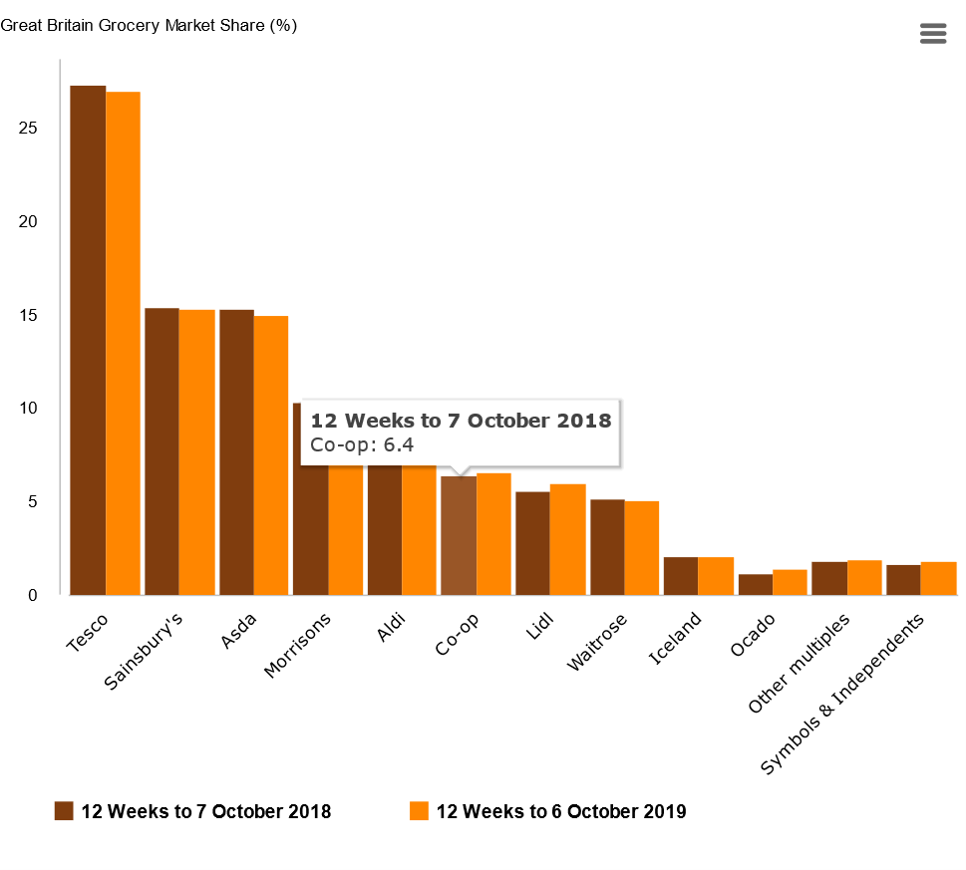

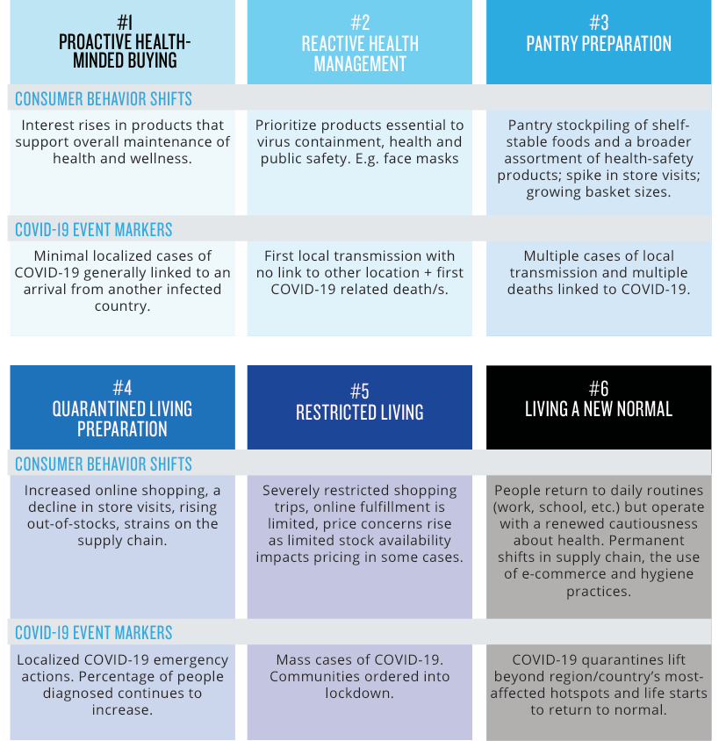

7.0 ACKNOLEGEMENTS
I will express an infinite appreciation for assistance and co-operation given to me by my lecturer and mentor Mrs. Melanie Squire who took time and risk to helping, especially in those uncertain times.
Grate recognition to my husband Paul for its patience and willing to help with ideas or corrections which were very much appreciated. Thank you.

8.0 REFERENCE LIST

References
- Anon., 2020. The Guardian. [Online]
Available at: https://www.theguardian.com/business/2020/jan/16/asda-trials-refill-points-and-bottle-recycling-in-sustainability-store
[Accessed 3 march 2020].
- ASDA Corporate, 2020. Our story. [Online]
Available at: https://corporate.asda.com/our-story/our-history
[Accessed 7 march 2020].
- Asda Logistics Services, United Kingdom (Swisslog reference). 2014. [Film] UK: s.n.
- ASDA scraps 5p carrier bags as part of war on plastic. 2018. [Film] UK: Best of news.
- Asda toyou Collect & Return. 2017. [Film] Directed by PAUL ELLIS. UK: Ellis.
- ASDA, 2020. ASDA extends pay support for colleagues Covid-19. [Online]
Available at: https://corporate.asda.com/newsroom/2020/03/27/asda-extends-pay-support-for-colleagues-through-covid-19
[Accessed 30 March 2020].
- ASDA, 2020. Our History. [Online]
Available at: https://corporate.asda.com/our-story/our-history
[Accessed 7 March 2020].
- ASDA-Getting to know you-our transgender colleagues. 2020. [Film] UK: ASDA.
- ASDA-Knowllage Transfer Partnership. 2019. [Film] UK: University of Leeds.
- British Baker , 2019. Baking industry award. [Online]
Available at: https://bakeryinfo.co.uk/news/fullstory.php/aid/21776/Baking_Industry_Awards__9219:_Supermarket_Bakery_Business_of_the_Year.html
[Accessed 15 march 2020].
- Coursehero.com, 2020. ASDA CSR-ASDA energy efficiency. ECON, Issue 1, p. 1.
- CPG, 2020. NIELSEN. [Online]
Available at: https://www.nielsen.com/us/en/insights/article/2020/key-consumer-behavior-thresholds-identified-as-the-coronavirus-outbreak-evolves/
[Accessed 15 March 2020].
- GMB union for ASDA colleagues forced to Ballot members over Contract 6 terms. 2019. [Film] Directed by GMB. UK: GMB Trade Union.
- Guardian, T., 2019. The Guardian. [Online]
Available at: https://www.theguardian.com/business/2019/nov/10/asda-faces-backlash-enforces-new-contracts
[Accessed 3 March 2020].
- Hotten, R., 2019. ASDA workers are 'terrified for their jobs'. [Online]
Available at: https://www.bbc.co.uk/news/business-50246335
[Accessed 5 march 2020].
- Inside ASDA-Bigger, Better, Chipper ?. 2020. [Film] UK: Channel 5.
- Insider Media, 2019. ASDA turnover. [Online]
Available at: https://www.insidermedia.com/news/yorkshire/asda-turnover-nears-23bn-despite-challenges
[Accessed 7 March 2020].
- Jahshan, E., 2019. Retail Gazete. [Online]
Available at: https://www.retailgazette.co.uk/blog/2019/09/asda-full-year-profit-sales-rise-despite-failed-sainsburys-merger/
[Accessed 7 March 2020].
- MCkevitt, F., 2019. UK.kantar. [Online]
Available at: https://uk.kantar.com/consumer/shoppers/2019/grocery-market-share-october-2019-supermarket-sales-growth-accelerates/
[Accessed 15 March 2020].
- NIELSEN, 2020. COVID-19: Tracking the Impact on FMCG, Retail and Media. [Online]
Available at: https://www.nielsen.com/ssa/en/insights/article/2020/covid-19-tracking-the-impact-on-fmcg-and-retail/
[Accessed 31 March 2020].
- SKY NEWS, 2020. Supermarkets are thought to be drawing up "feed-the-nation" plans to cope with potential panic buying caused by the coronavirus outbreak, with one already warning its customers to order early due to "exceptionally high demand".. [Online]
Available at: https://news.sky.com/story/coronavirus-uk-supermarkets-have-feed-the-nation-plans-to-cope-with-panic-buying-11948298
[Accessed 15 March 2020].
- Sodry. Sewel, D., 2020. PESTEL analysis -ASDA. [Online]
Available at: https://www.howandwhat.net/pestel-analysis-of-asda/
[Accessed 15 march 2020].
- The Guardian, 2020. extra grocery shops in less than a month. [Online]
Available at: https://www.theguardian.com/business/2020/mar/31/coronavirus-britons-made-80m-extra-grocery-shops-in-less-than-a-month
[Accessed 31 March 2020].
- The Highland times, 2020. ASDA praised for approach to covid 19 Impact. [Online]
Available at: www.thehighlandtimes.com/news/2020/03/20/asda-praised-for-approach-to-covid-19-impact/
[Accessed 30 March 2020].
- The SUN, 2020. restrict number of customers. [Online]
Available at: https://www.thesun.co.uk/money/11251547/tesco-and-asda-to-restrict-number-of-customers/
[Accessed 31 March 2020].
- Wunsch, G. N., 2019. Statista. [Online]
Available at: https://www.statista.com/statistics/386700/asda-sales-percentage-change-great-britain-uk/
[Accessed 7 March 2020].

