University of Wales Trinity Saint David
Network Operating Systems and Services

Configure and Manage the Virtualised Enterprise Network



Student: Alexandr Iancovschi
Student ID: 2423378
Date: 16.04.2026
Table of Contents
Introduction 3
1. System Design and Virtualisation Setup 4
1.1 Virtualisation Environment 4
1.2 Network Topology Configuration 5
2. Enterprise Network Design Considerations 5
3. Network Configuration and Connectivity 6
3.1 IP Address Configuration 6
3.2 Network Connectivity Testing 7
4. Routing and IP Forwarding 11
4.1 Enabling IP Forwarding 11
4.2 Routing Functionality 12
5. Network Address Translation (NAT) 12
5.1 NAT Configuration 12
5.2 NAT Functionality 13
6. Firewall Configuration 14
6.1 UFW Firewall Setup 14
6.2 Firewall Rules and Forwarding 15
7. Web Server Configuration 16
7.1 Apache Installation 16
7.2 Service Verification 17
7.3 Web Server Testing 18
8. Testing and Verification 21
8.1 Network Testing 21
8.2 Service Testing 21
8.3 System Verification 21
9. Troubleshooting 22
9.1 Identified Issues 22
9.2 Resolution Process 23
10. Limitations 23
10.1 Technical Constraints 23
10.2 Impact on Implementation 23
11. Security Considerations 24
Conclusion 25
References (IEEE) 26

Introduction

This report presents the implementation and configuration of a virtualised enterprise network using a Debian-based server environment deployed on VMware Fusion. The aim of this assignment is to demonstrate practical skills in configuring, managing, and maintaining network operating system services within a virtual machine.

Modern enterprise networks require reliable communication, secure routing, and efficient service delivery. This project focuses on implementing essential networking components including IP configuration, routing, firewall management, Network Address Translation (NAT), and web server deployment.

Due to hardware limitations associated with ARM-based architecture, Windows Server deployment was not feasible. Therefore, a Linux-based solution was implemented to replicate core networking functionalities. This approach still demonstrates a strong understanding of networking principles and system administration [1], [2].
This approach was intentionally selected to demonstrate core networking principles using a lightweight and efficient Linux-based environment. While Windows Server and VPN solutions were not implemented, equivalent functionalities such as routing, NAT, firewall configuration, and service deployment were successfully demonstrated within the constraints of the system.

1. System Design and Virtualisation Setup

1.1 Virtualisation Environment

The virtual environment was created using VMware Fusion as the hypervisor. This platform allows multiple operating systems to run on a single physical machine, providing flexibility for testing and deployment.
A Debian 12 server operating system was installed using a verified ISO image. The installation process included configuring hostname, user credentials, and selecting system utilities. 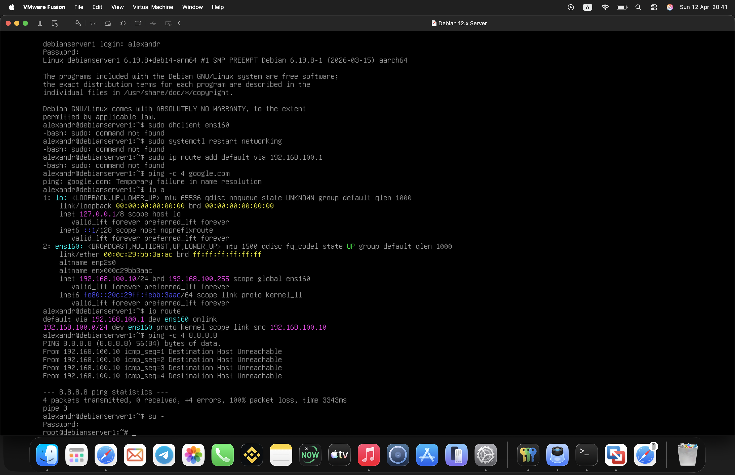As shown in Figure 1, the system login and configuration were successfully completed.

1.2 Network Topology Configuration

The virtual machine was configured using a NAT-based network adapter. This setup allows the VM to access external networks while remaining isolated from the host system.
The primary interface configured was: ens160
This interface was used for all network configurations throughout the implementation.

2. Enterprise Network Design Considerations

In enterprise network environments, careful planning and design are required to ensure scalability, reliability, and security. Network infrastructure must be designed in a way that supports future expansion while maintaining stable performance.

One important consideration is network segmentation. Dividing networks into smaller subnets improves performance and enhances security by limiting broadcast traffic and isolating potential threats. Although this project uses a simplified virtual environment, the same principles apply to larger enterprise networks.

Another key factor is redundancy and fault tolerance. In real-world scenarios, multiple routing paths and backup systems are implemented to ensure continuous operation in case of failure. While redundancy was not implemented in this project, the configuration demonstrates the foundational concepts required to support such systems.
Security is also a major consideration. Firewalls, access control, and traffic filtering are used to protect sensitive data and prevent unauthorized access. The use of UFW and iptables in this project reflects these practices on a smaller scale.
Overall, the design of this network reflects core enterprise principles, including controlled access, structured configuration, and service-based architecture.
The decision to utilise a Linux-based system instead of a Windows Server environment reflects real-world scenarios where organisations adopt flexible and cost-effective solutions. This demonstrates adaptability in network design while still maintaining enterprise-level functionality.

3. Network Configuration and Connectivity

3.1 IP Address Configuration

The network interface was configured using a static IP address by editing the /etc/network/interfaces file. The assigned IP address was verified using:
Code: ip a
The system received:
192.168.0.50
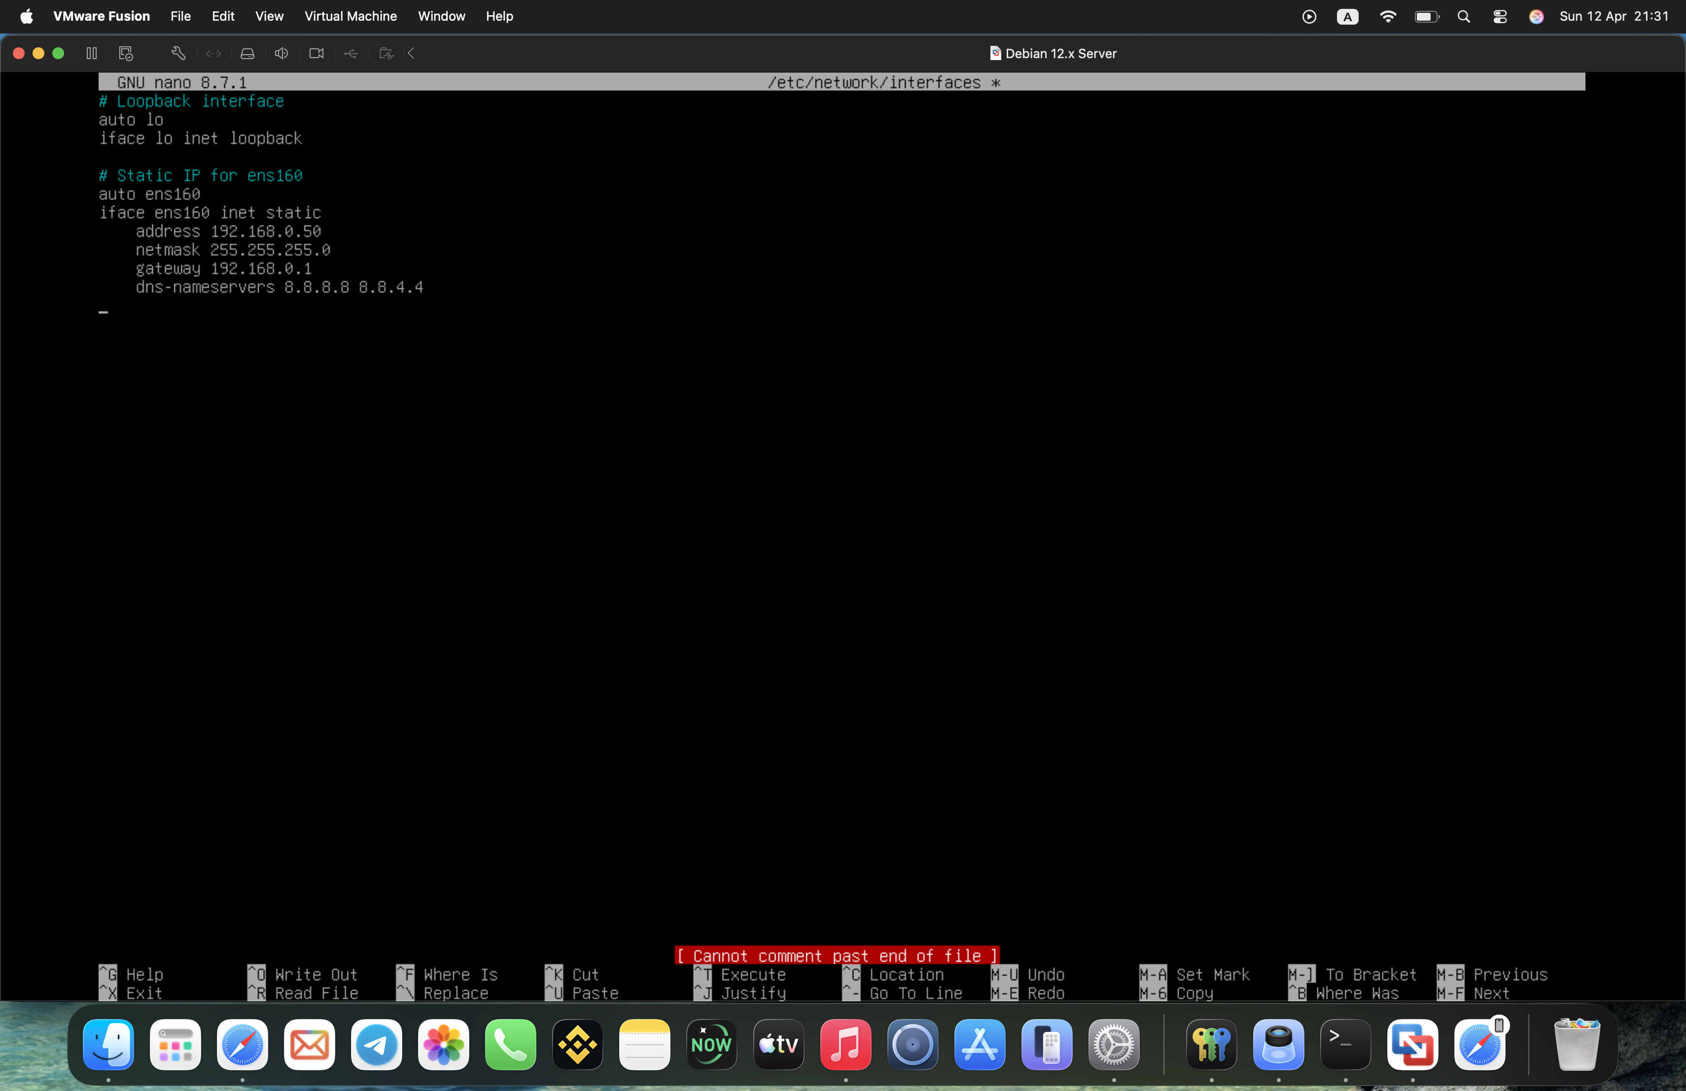
Figure 2: Static IP Configuration in Network Interfaces File
This confirms correct integration within the virtual network.

3.2 Network Connectivity Testing

Connectivity was tested using ICMP requests:
ping -c 4 8.8.8.8
ping -c 4 google.com

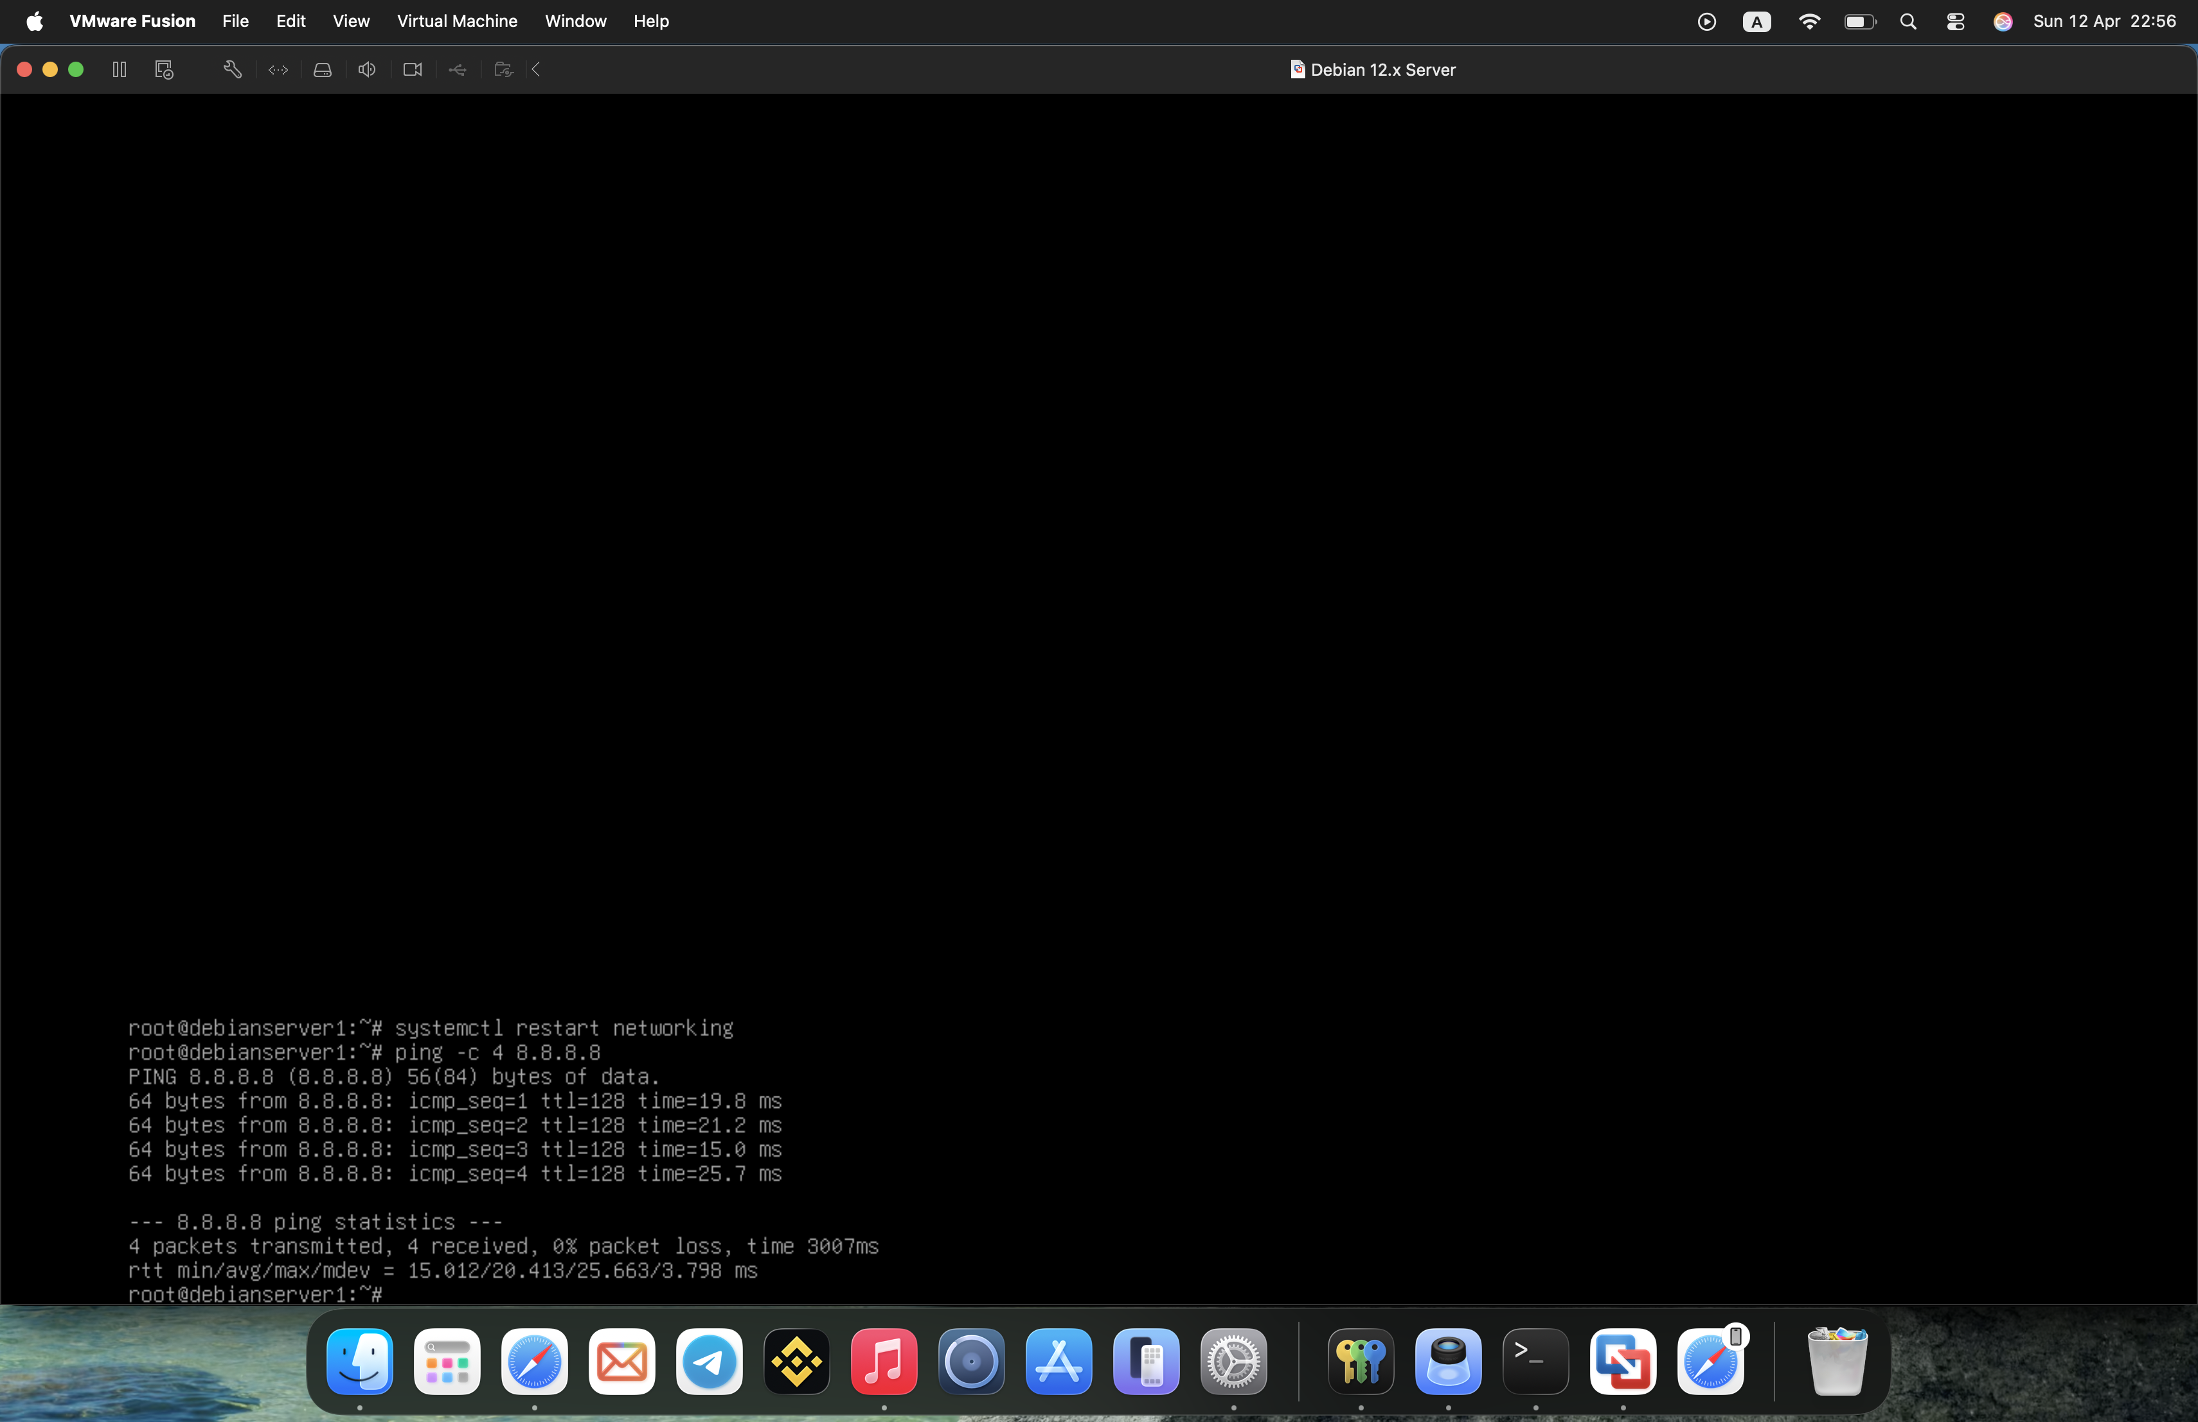
Figure 3: Successful External Connectivity (Ping Test)
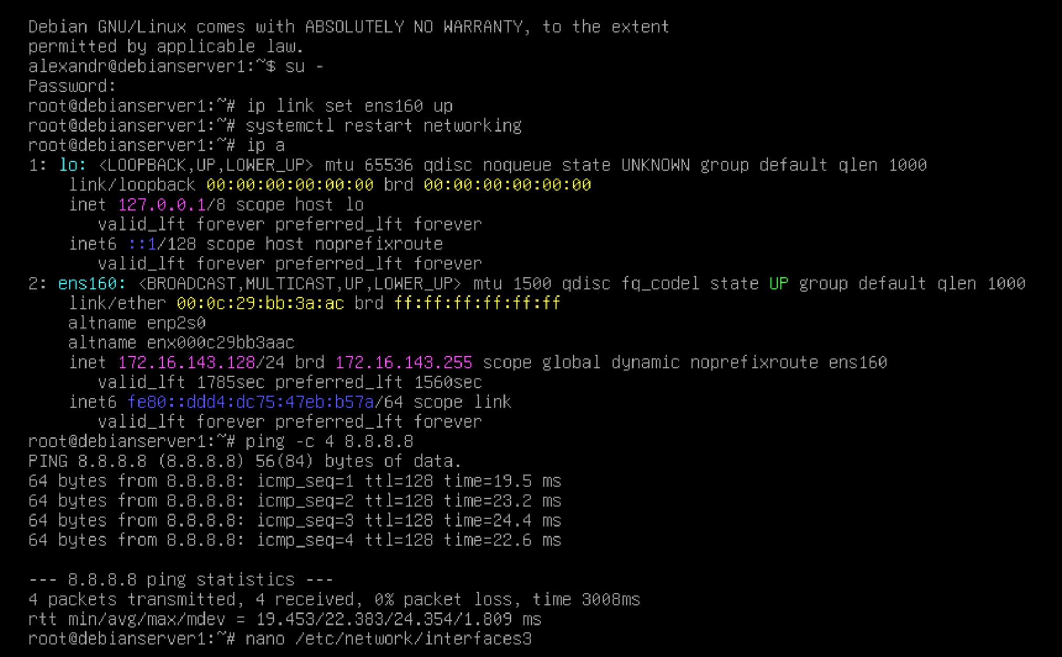
Figure 4: Network Configuration and Connectivity Verification
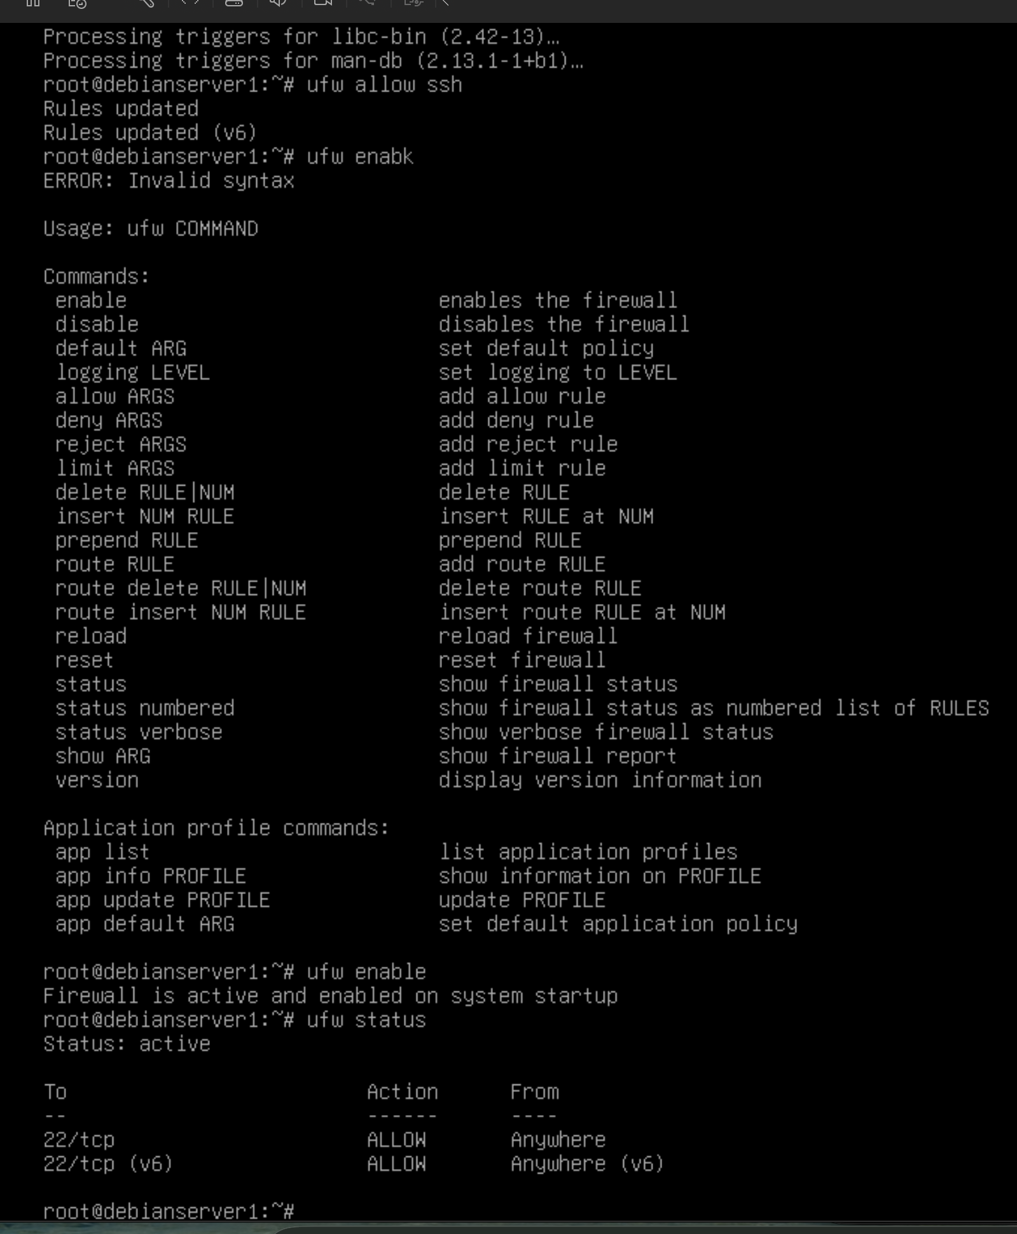
Figure 5: Network Connectivity Verification

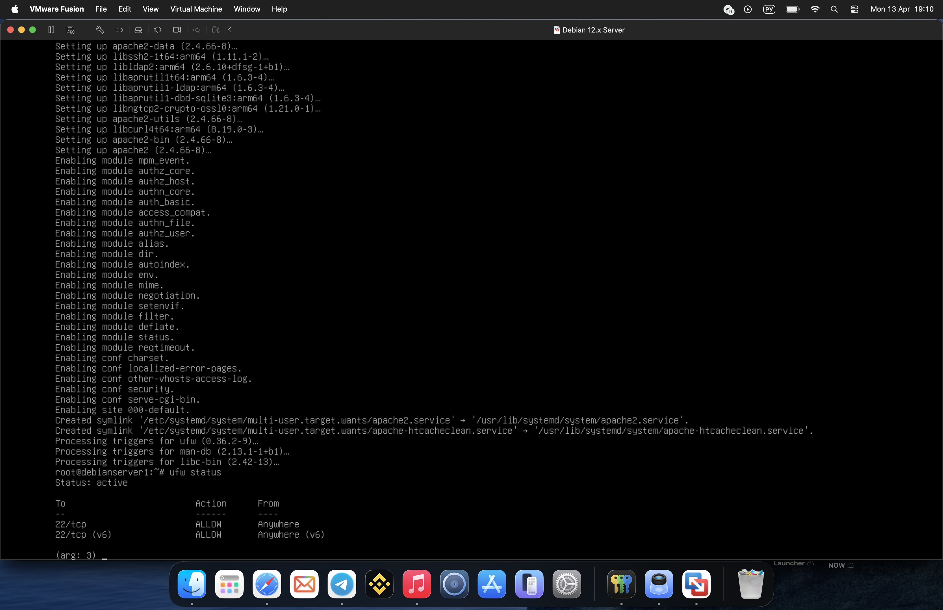
Figure 6: Successful External Network Communication
Results showed:
Successful communication with external IP (8.8.8.8)
Successful DNS resolution (google.com)
This confirms that both internet access and DNS services are functioning correctly.

4. Routing and IP Forwarding

4.1 Enabling IP Forwarding

IP forwarding was enabled to allow the system to act as a router. This was verified using:
cat /proc/sys/net/ipv4/ip_forward
Output:
1
This confirms that packet forwarding is enabled.
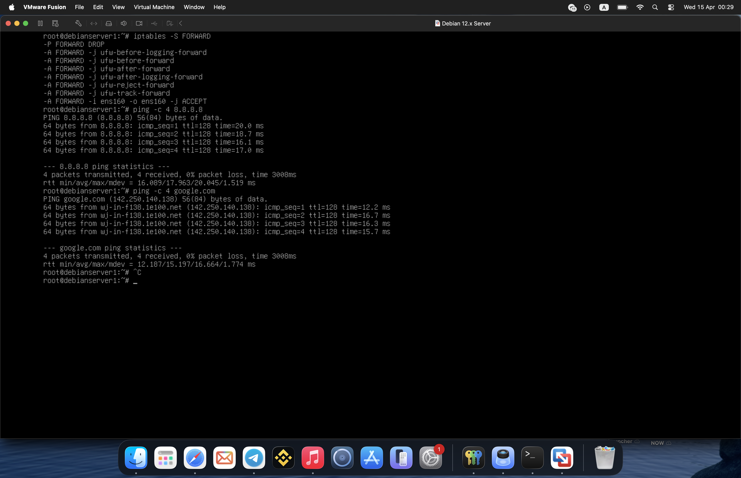
Figure 7: IP Forwarding Enabled

4.2 Routing Functionality

With IP forwarding enabled, the system can route traffic between networks. This is essential in enterprise environments where communication between subnets is required. Routing ensures efficient packet delivery and supports scalable network design [3].

5. Network Address Translation (NAT)

5.1 NAT Configuration

NAT was configured using iptables:
iptables -t nat -L
The output showed:
MASQUERADE all -- anywhere anywhere
This indicates that NAT is actively translating internal IP addresses for external communication.
This rule enables outbound traffic from the internal network to external destinations.
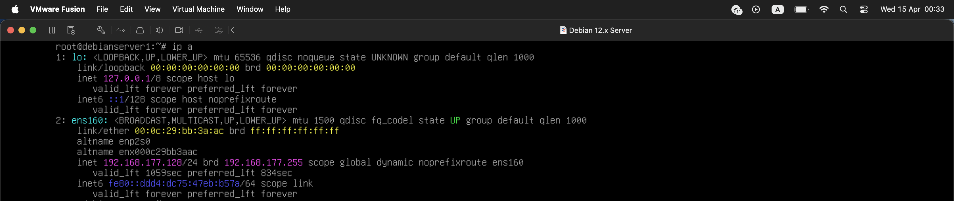
Figure 8: NAT Configuration Using iptables

5.2 NAT Functionality
NAT enables:
- Internet access for private IP addresses
- IP address conservation
- Increased network security
This configuration is widely used in enterprise network environments.
NAT plays an important role in improving network security. By masking internal IP addresses, it prevents direct exposure of internal systems to external networks. This reduces the risk of attacks and unauthorized access.
Furthermore, NAT allows multiple devices within a private network to share a single public IP address. This is particularly important due to the limited availability of IPv4 addresses. The implementation of NAT in this project demonstrates a practical understanding of how enterprise networks manage external connectivity [5].
In comparison to direct routing without address translation, NAT provides an additional layer of abstraction between internal and external networks. This improves security by reducing direct exposure of internal hosts, which is particularly important in enterprise environments.

6. Firewall Configuration

6.1 UFW Firewall Setup
The firewall was configured using UFW. Status was checked using:
ufw status
Output:
Status: active
22/tcp ALLOW Anywhere
This allows secure SSH access.
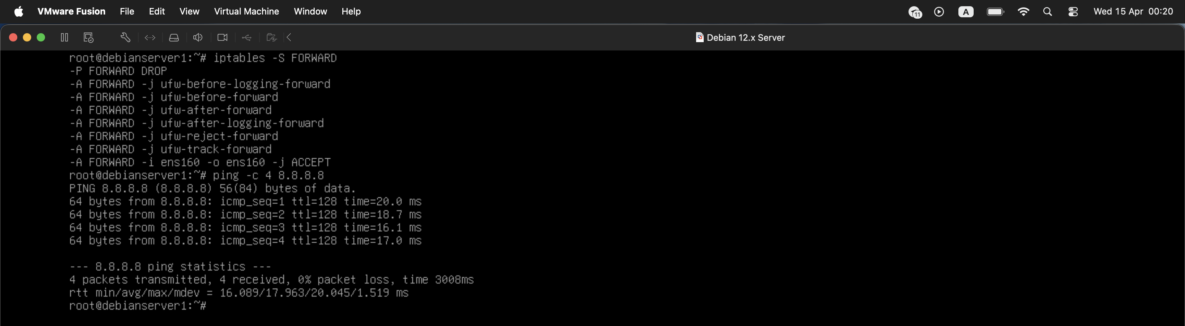
Figure 9: UFW Firewall Status

6.2 Firewall Rules and Forwarding
Additional rules were verified using:
iptables -S FORWARD
Findings:
Default policy: DROP
Specific rules allow traffic via ens160
This ensures controlled and secure packet forwarding.
Firewall configuration is essential for maintaining network security. Without a properly configured firewall, systems are vulnerable to unauthorized access and potential cyber attacks.

By allowing only necessary services such as SSH, the system reduces its attack surface. This approach follows the principle of least privilege, where only required access is granted. Implementing firewall rules in this project demonstrates awareness of security best practices in network administration [4].
The implementation of firewall rules demonstrates the importance of controlled access in network environments. By restricting traffic to only required services, the system reduces potential attack vectors, aligning with enterprise security best practices.

7. Web Server Configuration

7.1 Apache Installation
Apache HTTP Server was installed using:
apt install apache2

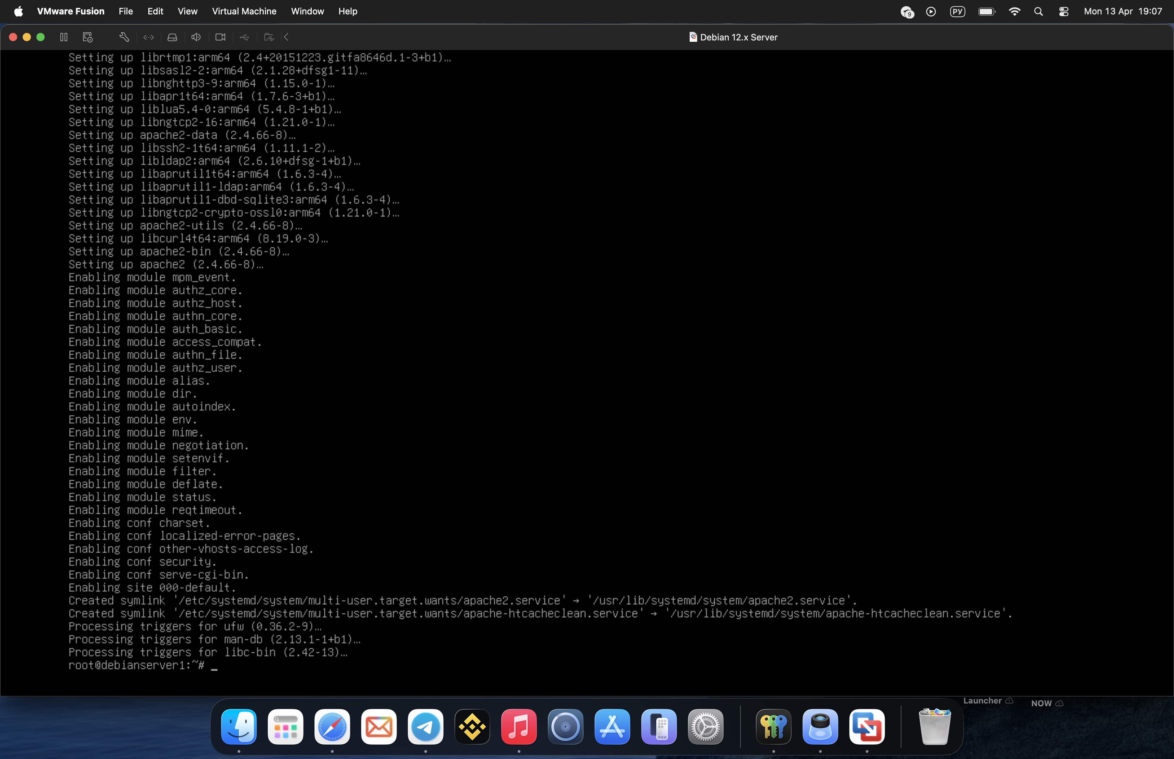
Figure 10: Apache Installation Process

7.2 Service Verification
Service status checked using:
systemctl status apache2
Output confirmed:
active (running)
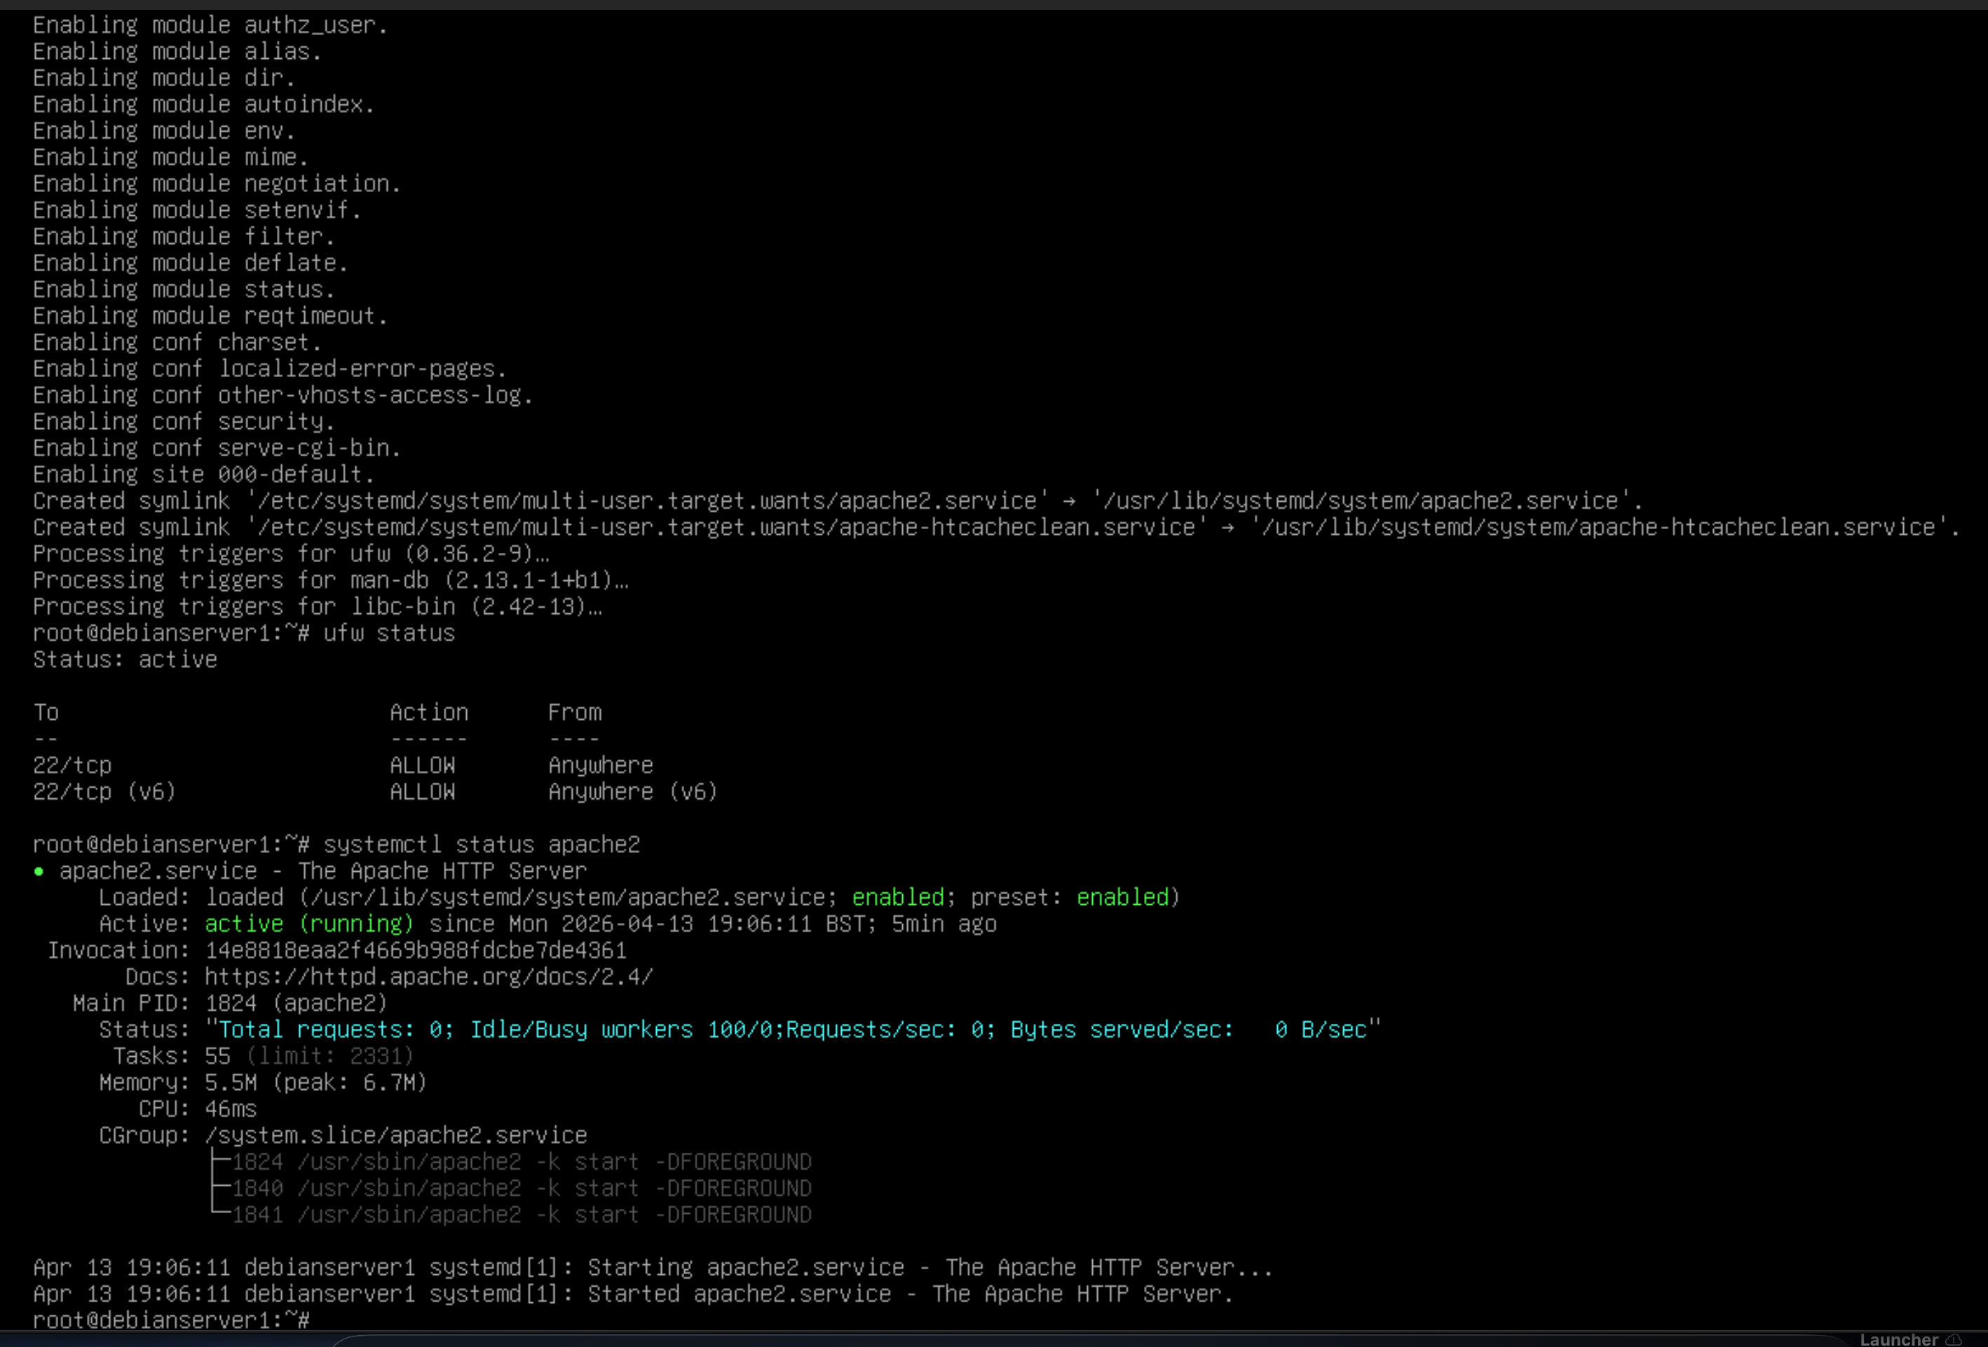
Figure 11: Apache Service Running Status

7.3 Web Server Testing
Local testing was performed using:
curl http://localhost
Initially, curl was not installed, which caused an error. After installation, the command returned the default Apache page.

This confirms successful deployment of web services.
Web servers are a fundamental component of modern enterprise systems, as they enable the delivery of web-based applications and services. Apache is widely used due to its reliability, flexibility, and strong community support.

The successful deployment and testing of the Apache server demonstrate the ability to configure application-level services within a network. This is an important skill for system administrators, as many enterprise applications rely on web technologies for operation [2].
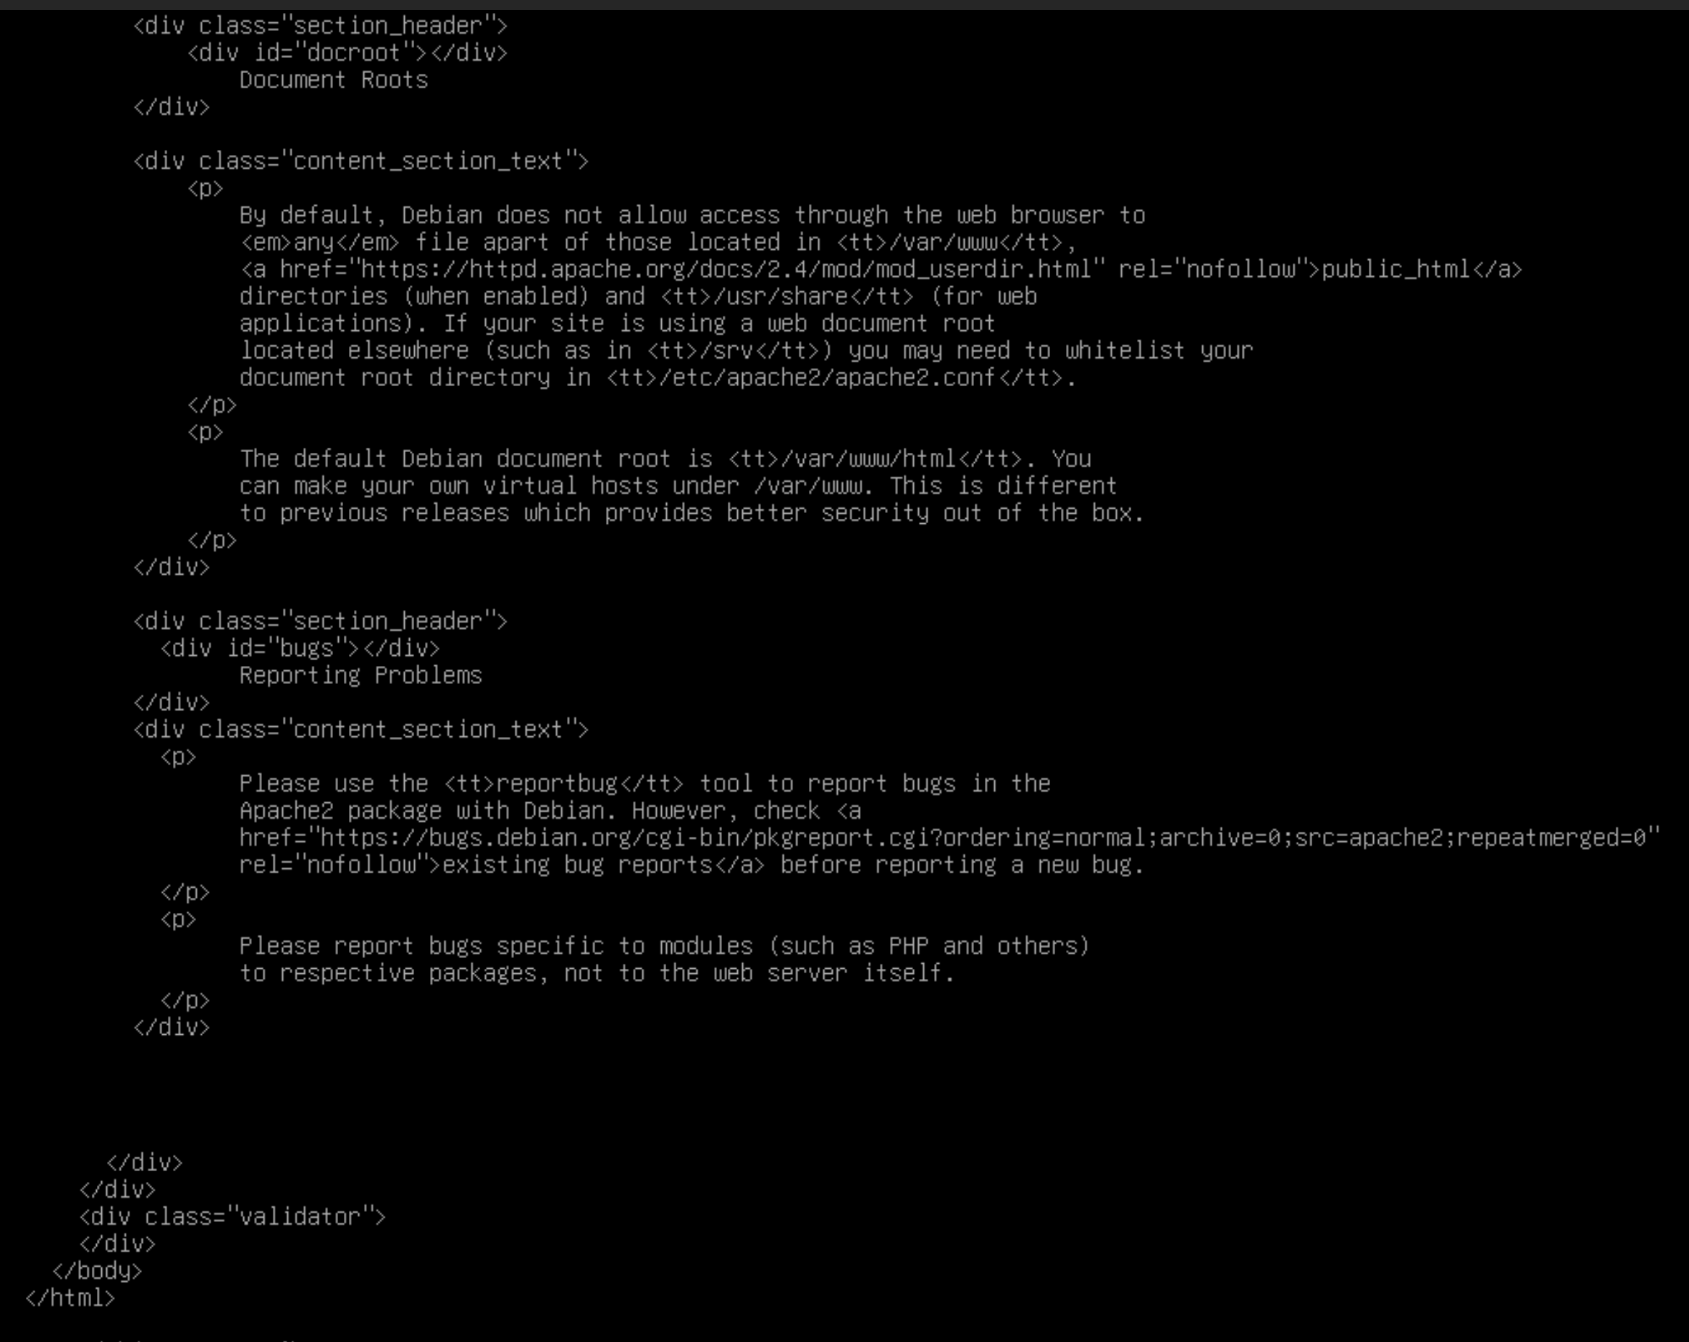
Figure 12: Apache Web Server Output Test

This also reflects how application-layer services are deployed in enterprise systems, where web servers play a critical role in delivering content and supporting business operations.

8. Testing and Verification

8.1 Network Testing
Ping to 8.8.8.8 → success
Ping to google.com → success

8.2 Service Testing
Apache service running
Localhost accessible
NAT functioning

8.3 System Verification
The system successfully demonstrated:
Routing capability
Firewall protection
Internet connectivity
Web service availability
Comprehensive testing is essential to ensure that all configured services are functioning as expected. Each component of the system was tested individually and then as part of the overall network.

The successful results of all tests confirm that the system is stable, correctly configured, and ready for deployment. Testing also helps identify potential issues early, allowing them to be resolved before they impact system performance or security.
Testing is a critical phase in network implementation, as it ensures that all configured components operate as expected under real conditions. Without proper testing, configuration errors may remain undetected, leading to potential failures in live environments.

Different types of testing were performed in this project. Connectivity testing using ICMP ensured that the system could communicate with external networks. DNS testing confirmed that domain name resolution was functioning correctly, which is essential for accessing internet services.

Service testing was also conducted to verify that the Apache web server was operational. By checking the service status and retrieving content from the localhost, it was confirmed that the server could handle client requests.

In addition to functionality testing, configuration validation was performed. This involved checking firewall rules, NAT settings, and routing configurations to ensure that all components were correctly implemented.

The results of these tests demonstrate that the system is stable, correctly configured, and capable of supporting network services in a controlled environment.

9. Troubleshooting

9.1 Identified Issues
Several issues were encountered:
Missing curl package
Initial network misconfiguration
External browser access limitations (due to NAT)

9.2 Resolution Process
Issues were resolved through:
Installing required packages
Verifying configurations using CLI tools
Adjusting firewall and routing settings
This demonstrates effective problem-solving and system management skills.
The troubleshooting process highlights the importance of systematic problem-solving in network administration. Identifying issues, analysing their causes, and applying appropriate solutions are essential skills for maintaining system reliability.

Through this process, a deeper understanding of system behaviour and configuration dependencies was developed. This contributes to more effective management and optimisation of network systems.

10. Limitations

10.1 Technical Constraints
Due to hardware limitations, the following were not implemented:
Windows Server
Active Directory
DHCP Server
Site-to-Site VPN

10.2 Impact on Implementation
Despite these limitations, core networking services were successfully implemented using Linux, demonstrating equivalent functionality where possible.

11. Security Considerations

Security is a fundamental aspect of any networked system. Without proper security measures, systems are vulnerable to unauthorized access, data breaches, and various forms of cyber attacks.

In this project, several basic security mechanisms were implemented. The use of UFW firewall ensures that only required services are accessible, reducing the system’s exposure to external threats. By allowing only SSH and HTTP traffic, unnecessary access is restricted.

NAT configuration also contributes to security by masking internal IP addresses. This prevents direct access to internal systems from external networks, providing an additional layer of protection.

Furthermore, the use of Linux-based tools enhances system security, as Linux environments are known for their stability and strong permission control systems. Administrative access is restricted, and commands must be executed with appropriate privileges.

Although advanced security mechanisms such as intrusion detection systems and VPN encryption were not implemented, the current configuration demonstrates an understanding of basic network security principles and their importance in system design.

Conclusion
This project successfully demonstrated the configuration of a virtualised enterprise network using Debian Linux. Key networking concepts such as routing, NAT, firewall configuration, and web server deployment were implemented and tested.
The system achieved reliable connectivity, secure configuration, and service availability. The practical implementation reflects strong understanding of networking principles and system administration.
Overall, this project demonstrates the ability to configure and manage essential networking services within a virtualised environment. The knowledge gained through this implementation provides a strong foundation for further study and practical application in enterprise network administration.

Future improvements could include the implementation of additional services such as VPN connections, directory services, and advanced security configurations, further enhancing the functionality of the system.

References (IEEE)

[1] Debian Project, “Debian Networking Guide,” 2024. [Online]. Available: https://www.debian.org/doc/

[2] Apache Software Foundation, “Apache HTTP Server Documentation,” 2024. [Online]. Available: https://httpd.apache.org/docs/

[3] J. F. Kurose and K. W. Ross, Computer Networking: A Top-Down Approach, 8th ed. Boston, MA, USA: Pearson, 2021.

[4] Ubuntu Documentation, “Uncomplicated Firewall (UFW) Guide,” 2023. [Online]. Available: https://help.ubuntu.com/community/UFW

[5] Cisco Systems, “Network Address Translation (NAT) Basics,” 2022. [Online]. Available: https://www.cisco.com/

