2017
Phillip Jensen
University of Wales Trinity Saint David
14-11-2017
BREEAM – Assignment 1
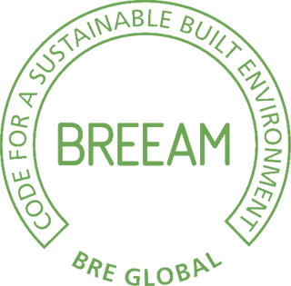

Table of Contents
Page
Table of Contents 1
Introduction 2
BREEAM 2
Introduction to BREEAM 2
Advantages 2
Disadvantages 2
Passivhaus 3
Introduction to Passivhaus 3
Advantages 3
Disadvantages 4
Comparison 4
Conclusion 4
Bibliography 5
Books 5
Articles/Websites/Other 5

Introduction
In this assignment we are going to be comparing BREEAM (Building Research Establishment Environmental Assessment Method) to Passivhaus, look at the advantages and disadvantages of each certificate and the overall differences between the two.

BREEAM

Introduction to BREEAM
BREEAM was launched in 1990, and has since then had several hundred thousands of certified developments, a couple of million buildings that have been registered for assessment and used in almost a hundred countries, with different schemes to focus on the needs of the different regions.
“water efficiency is a major issue in Dubai and Australia, but not in Scotland and nor in Wales.”
BREEAM is often considered similar to LEED, as the two are the most commonly used around the world, and they share the same focus, unlike Passivhaus, which is very much different to both of them.
The goal of BREEAM is, in short words, to make the world aware of the benefits of sustainable design, by recognizing low environmental impact buildings on the market.

Advantages
In order to do an assessment in BREEAM, you have to be qualified and have the certification, which adds a higher quality to the assessment.
Additionally, the assessments are in theory free of bias, as they are independently audited by a third party client, and having the BREEAM assessor also work on the project itself is often considered a conflict of interest, unless the BRE gets notified early on and the roles being clearly separated.
BREEAM is also known for taking into consideration much more than just the building, but everything that affects it and the occupants. Categories such as transport and taking into account, and given credits. This is important because sustainability comes

Disadvantages
BREEAM is often considered to be a “box ticking exercise”, where it does not add much to the project, but it is entirely just about checking the boxes and earning credits. This is in part due to the fact that, as mentioned, BREEAM covers a lot of categories, perhaps too many. This in turn, means a building that is otherwise excellent in its performance gap, will receive a lower rating because other, arguably less important, categories which may not matter to the overall project.
This also becomes a factor in that it does not go into as much thorough detail for the categories, so it is leaning towards a quantitative approach to sustainability, in that it does well in all categories, but does not necessarily do perfect in the important categories.

Passivhaus

Introduction to Passivhaus
Passivhaus was created in 1988, with the first construction with the scheme being built in 1991 and the Passive House Institute being founded in 1996. Since then, there are now certified projects in more than 50 countries.
Passivhaus is designed around the idea of having no thermal gaps in the insulation, to minimize the heat losses and gains. Essentially, they want to keep the building to require as little extra heating as possible, and instead keep its natural warmth through ventilation, ground heat and solar gain.

Advantages
Despite being smaller than both BREEAM and LEED, Passivhaus is still increasingly being used more and more, and is very much internationally used, with different variations for other climates than Germany, to change depending on other climate demands.
Passivhaus is also as brought up earlier, very much focused on the energy efficiency of the projects. Because of this, it is much more certain that the building will be excellent with its energy efficiency, since it is their sole focus.
Included with the energy efficiency of Passivhaus, we also have, in theory, zero thermal bridges⁴. This is something relatively difficult to achieve, so having it is very impressive for the entire project, especially with several windows, doors etc.
Passivhaus is also notorious for its low performance gap. Whereas most projects using other schemes often have a larger heat loss measured compared to their predicted value. 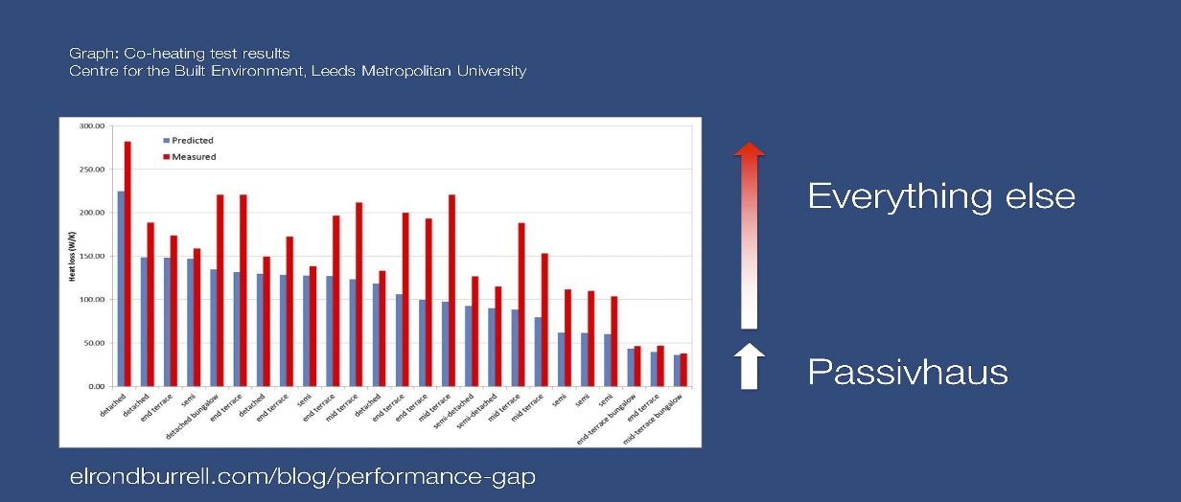
Passivhaus on the other hand as seen in the figure, is not only close to its expected performance, but also the lowest of them all.

Disadvantages
Passivhaus, although growing as mentioned, is still not quite as big as BREEAM and LEED, is still smaller, and because of that, it is often not chosen over the others, as they are much more commonly used, as seen by the number of certified buildings . This disadvantage will however slowly but surely disappear, as Passivhaus continues to grow.
Another disadvantage of Passivhaus, is that it does not take much else other than the energy efficiency in consideration. So a highly ranked Passivhaus certified construction, might end up lacking in other aspects that are also important for sustainability.

Comparison
After all this, we can see that BREEAM looks at all the aspects, but does not go into as much detail, as Passivhaus does in its fewer aspects. Each certification has this as both an advantage, but also a disadvantage, because although it is great to consider all aspects of a project, we also want a high standard in each of them. However, that is not ideal, as it would end up being too much work, having to go into as much detail that Passivhaus has with energy, in every single category of BREEAM.
This means BREEAM has a quantity approach, and Passivhaus has a quality approach to their methodology of constructing and assessing buildings.
In the future, BREEAM might increase the standard they have when possible, but at that point Passivhaus might already have gone a step up as well, so it can end up being an awkward race where Passivhaus will forever be leading in energy efficiency, but lacking in the other categories.
Until then, a combination of the two would be near perfection. We would have BREEAM to go over every single category in check, and Passivhaus to make the building itself with the best possible performance gap. However, that would be additional manpower and salaries, and with no knowledge of whether or not it would be possible or allowed, it is hard to give a proper answer.

Conclusion
To conclude, BREEAM goes over all categories tied to sustainability, but does so without going into too much detail into each of the categories, as compared to how Passivhaus goes into detail on its energy efficiency. BREEAM is all over the world in one way or another, and has plenty of schemes for most situations and climates.
Passivhaus is a growing certification which is becoming increasingly attractive for new constructions. It goes into a lot of detail to make a building need as little heating outside of passive heating from solar and ventilation, by keeping everything inside and consistent, with no thermal bridges or gaps. However, Passivhaus does not take any other categories into consideration, so it is very precise in its one area, but not necessarily in other categories.
Comparing the two, we immediately see that the two certifications are very different, and focus on different methodologies. BREEAM being a quantitative approach as they focus on many categories, and Passivhaus being a quality approach as they focus solely on the energy efficiency.
The two of them combined is possible to be the best of both worlds, but not likely to be possible for most projects.

Bibliography

Books
BRE (2014). Technical Manual SD5076: 5.0.
James, M. and Bill, J. (2016). Passive House in Different Climates. Abingdon: Taylor and Francis.
Parker, J. (2012). The value of BREEAM. Bracknell: BSRIA.

Articles/Websites/Other
Breeam.com. (2017). BREEAM Projects Beta. [online] Available at: http://www.breeam.com/projects/explore/ [Accessed 13 Nov. 2017].
Bsria.co.uk. (2009). BREEAM or LEED - strengths and weaknesses of the two main environmental assessment methods. [online] Available at: https://www.bsria.co.uk/news/article/breeam-or-leed-strengths-and-weaknesses-of-the-two-main-environmental-assessment-methods/ [Accessed 11 Nov. 2017].
Centre for the Built Environment, Leeds Metropolitan University (2015). Co-heating test results. [image] Available at: https://elrondburrell.com/wp-content/uploads/2015/11/039-Coheating-performance-gap.jpg [Accessed 13 Nov. 2017].
Kb.breeam.com. (2016). Compliance: Conflicts of interest for the BREEAM assessor – Knowledge Base. [online] Available at: http://kb.breeam.com/knowledgebase/nc14-gen-can-the-breeam-assessor-be-an-in-house-assessor-i-e-working-for-the-same-company-as-the-design-team/ [Accessed 9 Nov. 2017].
Passivhaus.org.uk. (2017). Passivhaus:. [online] Available at: http://www.passivhaus.org.uk/page.jsp?id=88 [Accessed 13 Nov. 2017].
Passivhaus.org.uk. (2017). Passivhaus:Basic Principles. [online] Available at: http://www.passivhaus.org.uk/page.jsp?id=17 [Accessed 12 Nov. 2017].
Passivhausprojekte.de. (2017). Passive House Buildings. [online] Available at: http://www.passivhausprojekte.de/index.php?lang=en#k_ [Accessed 13 Nov. 2017].

(Bsria.co.uk, 2009)
(BREEAM Technical Manual) page 4
(Kb.breeam.com, 2016)
(Parker, 2012) page 30
(James and Bill, 2016) page 10
(James and Bill, 2016) page 17
(Passivhaus.org.uk, 2017)
(Centre for the Built Environment, Leeds Metropolitan University, 2015)
(Breeam.com, 2017)
(Passivhausprojekte.de, 2017)

