Academic and Employability Skills
BMSW4001_LON
Task 1 - REWORK

Lecturer: Joanna Walsh
Student: Meliha Drenk (1922136)

Table of contents
Introduction……………….……………………………………………………….………3
Employability skills - Definition………………………………………………….…….…4
Different ways to develop and improve employability skills……………….….………6
My own employability skills………………………………………………………...…….7
Conclusion…………………………………………….……………………………………9
References…...………………………………………………………………...…………10
Appendix……………………………………………………………………………….….12

Introduction
This is an academic report that will cover and discuss employability skills, their importance as well as different activities on how to improve and develop them, and how they can increase our chances for employment. Employability skills are very important for developing people’s career because they increase the opportunities for a person and can help them evolve and advance in their career. There are various positive aspects of the career and people’s personal life, which the employability skills can help improve. At the end I will discuss and analyse my own employability skills and how the module helps me to amplify them.

Employability skills - Definition
Employability skills are very important for every job. Christine Overtoom (2000), pointed out and defined that ‘‘Employability skills are transferable core skill groups that represent essential functional and enabling knowledge, skills, and attitudes required by the 21st century workplace. They are necessary for career success at all levels of employment and for all levels of education’’
Employability skills make us more attractive for the employers or recruiters. They are often defined as ‘soft skills’. (skillsyouneed, 2020).
Bernard Marr (2019) pointed out in ‘Forbes’ that according to World Economic Forum ‘’35% of the skills that seen essential today will change’’. But there are some skills that are constantly needed and every company will be looking for them in the next years. These skills are:
Adaptability and flexibility – These are two important skills that workers must have. The workplace is full with unexpected situations, therefore it is necessary for the employees to fit in the workplace style, be able to face the challenges and find quick decisions. For most of us it is hard to make quick correct decisions, however good problem-solving and decision making skills can help to analyse the problems and find effective solutions. The ability to work in a team in any situation is one of the most significant employability skills.
Creativity – helps the employees to introduce new ideas within the workplace. This attracts the managers by providing new ideas and strategies based on the company’s needs and goals. This can help bring attention to the company which can increase their popularity and income.
Communication – good communication is a crucial skill for the workplace. It can improve company’s work atmosphere by developing awareness between management and team members. (Fallows and Steven, 2000). This is one of the most essential skills in our career. However, this is also a crucial part of our day to day life because they make us more sociable. This is a key part to having a successful staff at your companies. Effective communication with our co-workers and our ability to organise and prioritise the tasks can increase company’s productivity and can avoid wasting time and resources which cost money for the companies. The ability to communicate effectively makes us more employable and appealing to employers.
Team working – The workplace consumes team working. It is not possible for an individual to achieve workplace tasks and goals. Team work is defined as ‘’The ability to work with others in groups and teams’’ (skillsyouneed, 2020). Good team work helps achieve daily tasks and goals easier. Good interaction with your co-workers will help make you an effective team worker. Working effectively in a team is possible when you have a set of achievements and skills that are relevant to the job. (Yorke, 2006).
Learning ability - The employees learn various of skills from the workplace. The companies provide different types of trainings and development processes to improve the learning ability of the employees. Every company has different styles / ways of working that’s why the employees have to adapt and learn easily in the new workplace. (Overtoom, 2000).
Technological skills – ‘’The use of technologies can significantly improve team efficiency and increase productivity’’ (Hertel et all. (2005), quoted in Maund, 2017). The companies use various technologies to increase the productivity of the workplace. This requires the job candidates to learn how to use new technologies because this will help them ‘’stay ahead of their competitors’’ (indeed, 2020). Technological or digital skills are our ability to use different technology tools. We live in a time where they are an immutable part of our life and career. Most of the companies are looking for candidates that have strong digital skills and technological literacy because they help optimize the work process and save time and resources.
Time management – can be defined as ‘’our ability to use our time effectively’’ (Morgan, 2021. pp. 50 - 63). It is important not only for the workplace but also for our studies. There are various researches done about the relation between good time management and successful career. For instance, if we are late for work and we miss the deadlines this affects our employability. This can make our employers think that we are unreliable and untrustworthy. This is why it is very crucial to prioritise our goals. Good time management is focusing on tasks. Nowadays there are several digital tools that help us manage our time effectively such as: Outlook, Teams, Zoom help us to communicate with our colleagues and to plan our tasks. (Morgan, 2021. pp. 50 - 63).
Different ways to develop and improve employability skills
Often employers require skills that are not part of one’s core skills. Every person has skills that are limited to a certain extent. However, employees can develop their employability skills by engaging in different activities such as (skillsyouneed, 2020):
Forums, workshops and discussion groups. They are very helpful by providing proper knowledge about various businesses. Joining forums can help job candidates develop the skills that employers need and improve their employability.
‘Soft skills’ as time management, effective team working and good communication skills are some of the most important skills for the workplace. If some of them are not develop enough or are lacking it can cause difficulties for the job and have to be improved. The easiest way to boost them is by volunteering for different organisations. This will help gain experience.
The professional contacts help the job candidates develop their careers and achieve certain goals. Therefore, they can build relationships with different people who can help them make proper decisions regarding the job. It is helpful for the future employees to develop relationships with their teachers and mentors to get proper advice from them. Moreover, they can use different platforms of social media to make new contacts with experts from different organisations or industries.
The candidates need to prepare themselves properly for job interviews. They have to target the job role clearly. The candidates have to check the company’s website and read employees’ review. This will help them gain information about the strengths and weaknesses, and overall for the company.
We as students often suffer the lack of numeracy and literacy skills after being out of schools. We forgot the certain uses of mathematical formulas and that reduces our confidence (KANGAN Institute, nd). Therefore, the job candidate can join the numeracy support courses to develop their mathematical abilities.
The future employees have to modify their CV for each position that they apply for. The CV has to be adjusted and constructed with the candidate’s abilities and qualifications. Also it has to be grammatically correct with no errors.
My own employability skills
This module helped me refine my research, referencing, paraphrasing, writing skills, also my reflective, creative and critical thinking. During the module we have done a variety of different activities to help us find our strengths and weaknesses. To be a good employee we have to know our own personal advantages and disadvantages. With the help of the SWOT analysis I have discovered that I struggle with time management, paraphrasing and summarising. I have learned to plan my week appropriately- I do the hard tasks first. Another benefits from the module was how to stop procrastinating, and how to save time and use it efficiently. I have wasted a lot of time on insignificant activities but I have learned how to prioritise my tasks. As young people we spent a long time using our phones and social media but our lecturer suggested to download time management apps that help us stay concentrated on our work. We have learned to identify our learning abilities and different strategies to improve our listening and writing skills. Based on Kolb’s learning style (McLeod, 2017) I am an assimilating person who prefers to organise and analyse different situations. As a bilingual student I speak more than one language and this affects my communication skills. I am able to communicate within a few languages verbally and written. Therefore because of my good communication skills I have never had problems to communicate with my managers and colleagues from different countries. I’m a fast learner which means I am very good at rapidly thinking of useful and correct ideas that can help solve a variety of problems. This helps me adapt the team working by learning various strategies to keep balance in the workplace. I can work effectively in a team and individually. I don’t face any challenges while working in a team because I’m able to understand others point of view. I have good technological or digital skills. I don’t have difficulties to work with digital programs such as Office 365 etc. This set of skills makes me captivating and attractive for the employers. My future career plans are to become a Teaching assistant or a Family support worker, because I’m very passionate and interested about education. Both job roles link to me because I have got a supportive nature.
All employability skills are equally important. As I mentioned previously they are very crucial for every career and especially for the career that I’m going to focus on. In the professional life as a TA and Family support worker every day is a challenge and something new and unexpected could happen at any time. That’s why these set of skills are crucial - because of their various duties and responsibilities. Its challenging to plan our career especially nowadays but we have to set goals and follow them even with small steps. In a short term I’m planning to finish successfully the course and obtain in next levels. As it is seen from my PDP for the next few years (see appendix 1), I’m planning to work as a volunteer in our local schools when the pandemic is over, because this will help me gain experience. In the next months I will participate in a free online English classes to improve my communication skills.

Conclusion
In conclusion, everything that has been stated so far shows that the employability skills will increase the countless opportunities for a person which can help open different pathways for them in their future career. There are a lot of aspects of people’s personal life and career that employability skills can improve. We have to stay updated with the work market to constantly know what employers are on the search for. This will give us opportunities for better career and life.

References
Fallows, S. and Steven, C. (2000), "Building employability skills into the higher education curriculum: a university‐wide initiative", Education + Training, Vol. 42 No. 2, pp. 75-83.
Indeed(2020) ’Employability Skills:Definition and 10 Examples.’Available at: https://www.indeed.com/career-advice/finding-a-job/employability-skills (Accessed: 27th March 2021).
KANGAN Institute.(n.d.)"3 Ways to Improve your Employability." Availble at: https://www.kangan.edu.au/students/blog/improve-your-employability (Accessed : 6th April 2021).
Marr, B. (2019) ‘The 10+ Most Important Job Skills Every Company Will Be Looking for in 2020’, Forbes, 28th October. Available at: https://www.forbes.com/sites/bernardmarr/2019/10/28/the-10-most-important-job-skills-every-company-will-be-looking-for-in-2020/?sh=3ab77a3b67b6 (Accessed: 3rd April 2021).
Maund, A., Schriek, M. & Tinkler, P.K. (2017), Certificate in higher education: Skills for the workplace Student yearbook, London: Sage.
McLeod, S. (2017) Kolb’s learning style and experiential learning cycle. Simply psychology. Available at: https://www.simplypsychology.org/learning-kolb.html#:~:text=The%20assimilating%20learning%20preference%20involves,in%20a%20clear%2C%20logical%20format. (Accessed: 20th April 2021).
Morgan, P. (2021). The business student guide to study and employability. 2nd edn. London. SAGE.
Overtoom, C., (2000). ‘Employability skills: An update’ ERIC Clearinghouse.
Skills you need (2011-2020) Employability skills. Available at: https://www.skillsyouneed.com/general/employability-skills.html, (Accessed: 5th April 2021).
Yorke, M. (2006), 'Employability in Higher Education: what it is- what it is not', Higher Education Academy/ESECT, pp. 11-13. Available at: https://www.researchgate.net/publication/225083582_Employability_in_Higher_Education_What_It_Is_What_It_Is_Not, (Accessed: 5th April 2021).

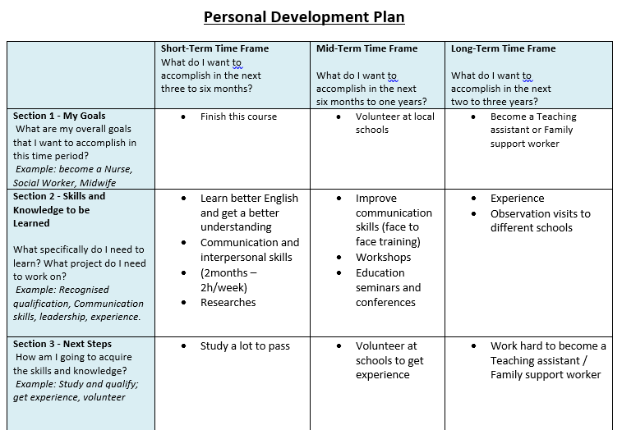
Appendix 1



