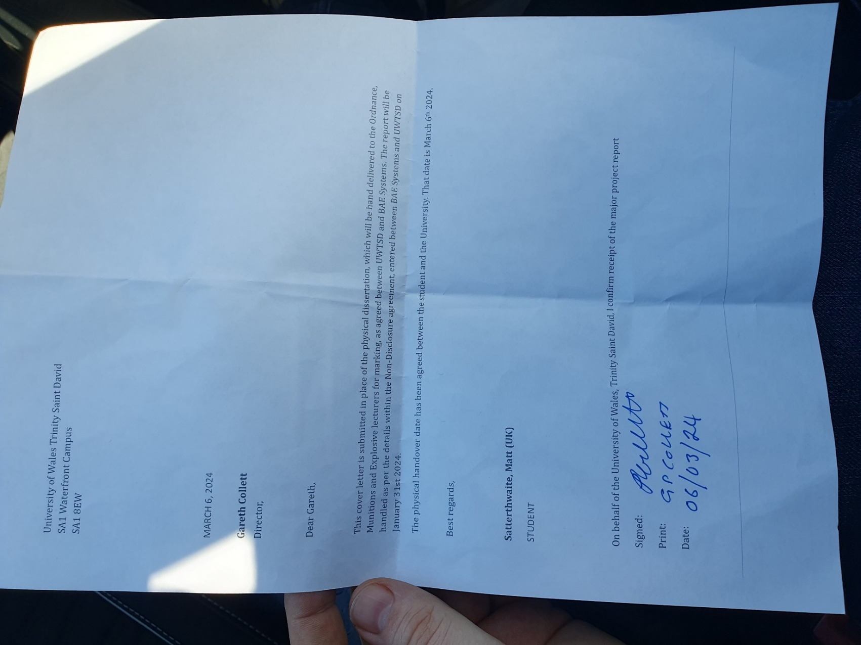
This image is a photograph taken of the receipt for my assignment which was hand delivered to the OME Lab on 6th March 2024, as agreed and detailed above.
Members of Staff present for handover : Gareth Collett, Ewa Kazimierska and Mark Broadhead.

