6/29/2026
Olamide Akintunde-Jimba (2539026)
Student uwtsd
Assignment 1
E-Portfolio
Module Name: Software Solutions for Business
Module Code: ACCA4026_LON
Student Name: Olamide Akintunde
Student ID: 2539026
Group: 1

Lecturer’s Name: Rajeev Nath

Table of Contents
Introduction 3
Task 1. e-Commerce Website builders or software solutions 3
1.1 Shopify 3
1.2 Wix 5
Task 2. Mind-map of contemporary software applications 7
a. Mind mapping and explain the benefits of using mind mapping in business operations 7
b. Created a mind map of contemporary software applications 9
Task 3. Office Applications 9
a. Four office software solutions for business operations 9
MS Word 9
MS PowerPoint 12
MS Excel 18
MS Access 24
Mail Merge 27
If Statement 38
Task 4. Communication and Collaboration applications 43
a. One contemporary Communication and one Online Collaboration applications/tools 43
MS Outlook 43
b. Test one feature of a freely available Communication (1) and one feature of a Collaboration (1) application and document several screenshots with brief accompanying descriptions to provide evidence of practical use. 46
Outlook 47
Microsoft Teams Communication and Collaboration Screenshots. 48
Conclusion 56
References 56

Introduction

In today's rapidly changing digital environment, companies need to utilise a range of software applications to stay competitive and respond to market needs. This project investigates critical software solutions, including e-commerce platforms, productivity tools, and communication applications, that collectively form the technological backbone of thriving organisations.

Firstly, this report examines e-commerce website builders such as Shopify and Wix, which help businesses establish an online presence and efficiently manage sales. Secondly, it assesses office software options, emphasising key Microsoft Office applications such as Word, PowerPoint, Excel, and Access, which support daily tasks ranging from document preparation to data analysis. Thirdly, it reviews communication and collaboration tools, including Microsoft Outlook and Microsoft Teams, that promote effective teamwork and information sharing across different work settings. Furthermore, this project features a mind map that visually depicts the current landscape of software applications, illustrating how these tools are interrelated to support daily business functions.

The purpose of this project is to analyse these software solutions, highlighting their main features, benefits, and real-world applications. By gaining insights into these tools, businesses can make informed technology investments that align with their operational requirements and growth objectives.

Task 1. e-Commerce Website builders or software solutions

Shopify
Shopify is widely recognised as a leading e-commerce platform that enables entrepreneurs and businesses to easily create and manage their online shops. This all-in-one platform offers a range of essential features, including payment processing, inventory control, and performance monitoring, to help users track their business growth effectively.
A key benefit of Shopify is its cloud-based platform, allowing users to manage their online businesses from anywhere with internet access. The Shopify app lets merchants manage store functions, track sales, handle inventory, and review analytics on the go.
Shopify provides straightforward pricing options suitable for new startups and established businesses. Users can customise their stores with a variety of services, including tailored store designs, a wide range of third-party applications, and access to Shopify experts for personalised guidance.
How Does It Work?
Supporting images that demonstrate the simple process of how Shopify works:
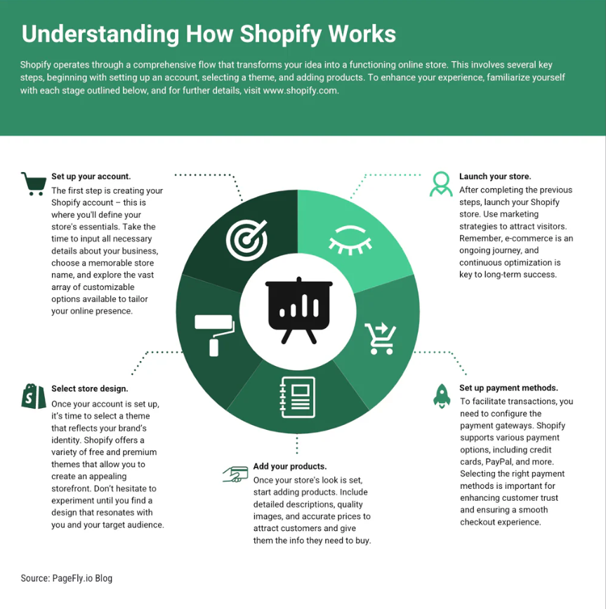 [1]
Fig 1: Understanding how Shopify works.
Shopify is an e-commerce platform that enables the sale of products online. The service helps you create an attractive website and includes a point-of-sale (POS) system as part of the setup. This POS system enables you to process both full and partial payments with credit, debit, and gift cards.

If you have a physical store, you can integrate in-store transactions with online sales using Shopify’s POS system, managing both from one platform.

Shopify streamlines sales, inventory, marketing, and payments for small businesses. It offers free customizable templates, robust security, and access to specialists for support. The platform also includes features that enhance online store visibility.
Once you've set up your products, established your sales channels, and optimised your operational tasks on Shopify, the platform supports effortless growth. This means you can easily expand your product range and explore new sales opportunities, ultimately increasing traffic and enhancing sales in a more competitive online environment. [2]

1.2 Wix

Wix is a well-known website builder that helps businesses easily create high-performance websites that meet current technical standards. Wix manages all technical aspects, allowing businesses to focus on their core operations.
In addition to simplifying website creation without requiring technical expertise, Wix has recently launched a developer-friendly headless version. [2]
Crucially, Wix not only facilitates the creation of visually appealing, professional websites but also stays current with the latest SEO standards and guidelines.
For instance, when Google updates structured data requirements that help a site rank higher in search results, Wix promptly adjusts to ensure every website complies with these changes. [2]
Wix targets business owners and individuals who want a high-performing, professional website without hiring IT personnel.
Wix makes this possible, enabling businesses to focus on what they do best.
Wix offers a wide array of services, including implementation, optimisation, SEO tools, performance enhancements, business applications, security features, and more. Moreover, users can benefit from Wix’s intuitive editor and Content Manager, allowing them to efficiently manage their website (such as adding new content, altering the design, or integrating new tools as the business expands) without any prior programming knowledge
[3].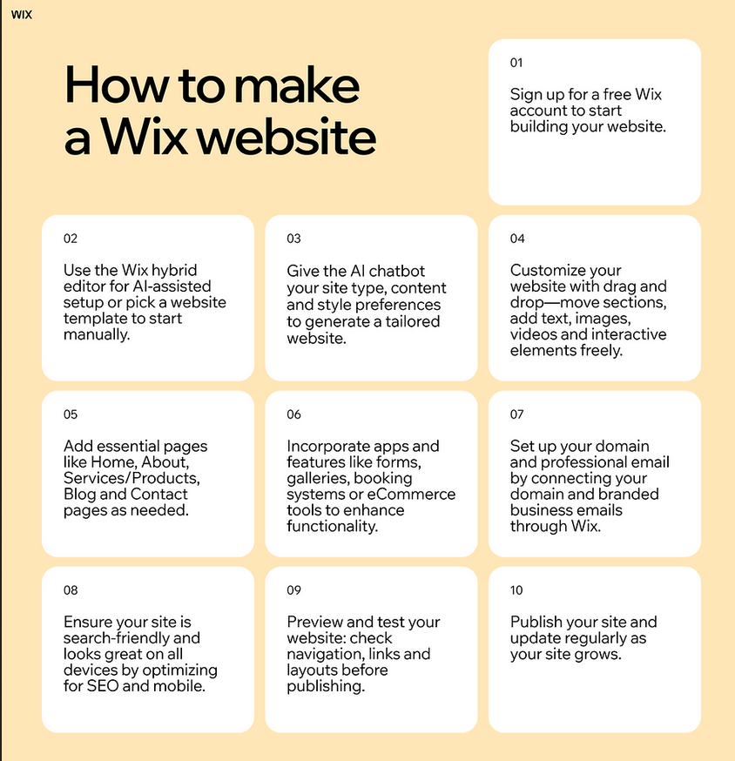
Figure1: Image showing how wix.com works [4]

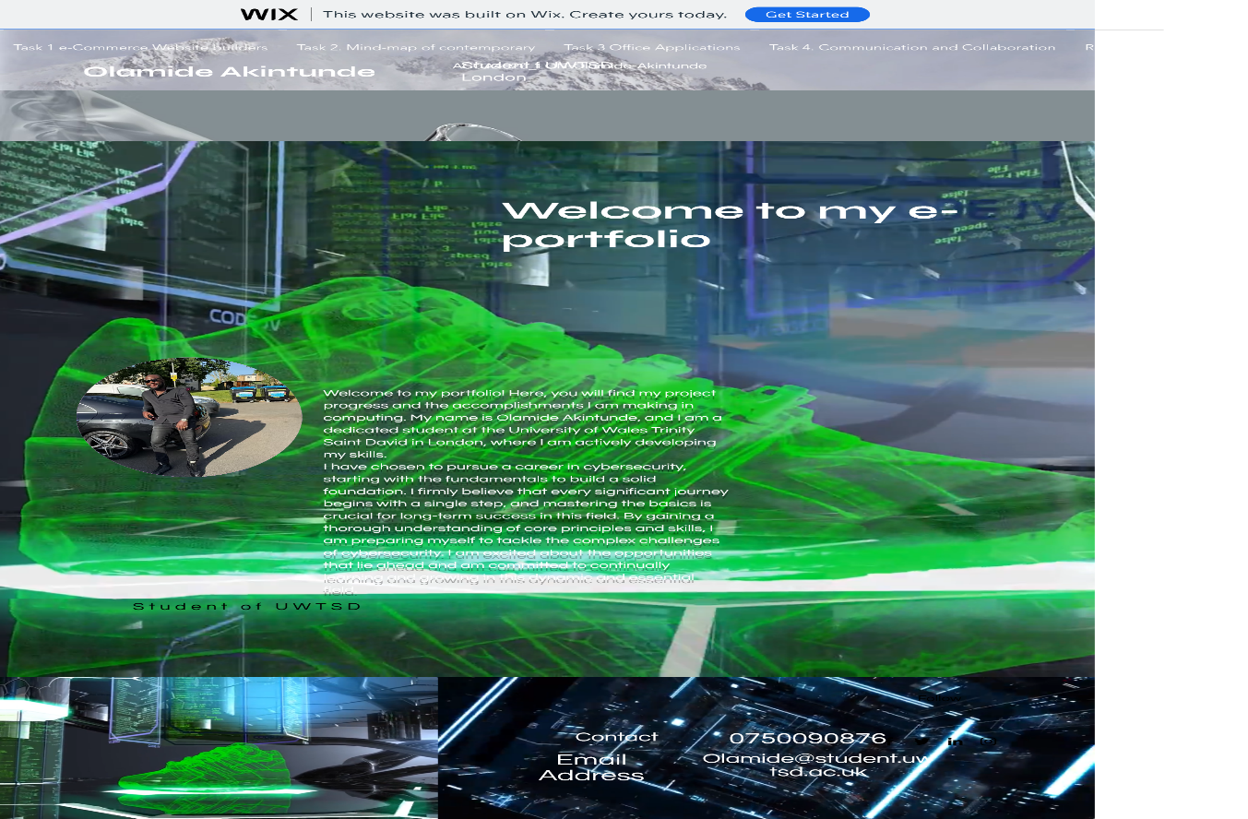
Figure 2: Example of a Portfolio Built with a Wix site.
https://25390269.wixsite.com/acca4026lonssb-olam

Task 2. Mind-map of contemporary software applications

Mind mapping and explain the benefits of using mind mapping in business operations
Mind Mapping is a remarkably effective cognitive technique that enables people to convert the various thoughts, ideas, and information in their minds onto paper. This method serves multiple purposes, with its main aim being to document and organise new insights and creative ideas. This versatile tool excels in various contexts, making it perfect not only for lively brainstorming sessions but also for systematically structuring complex concepts. Furthermore, Mind Mapping is essential for capturing detailed requirements, fostering informed decision-making, and thoroughly organising a wide range of projects, among other valuable applications. [5]
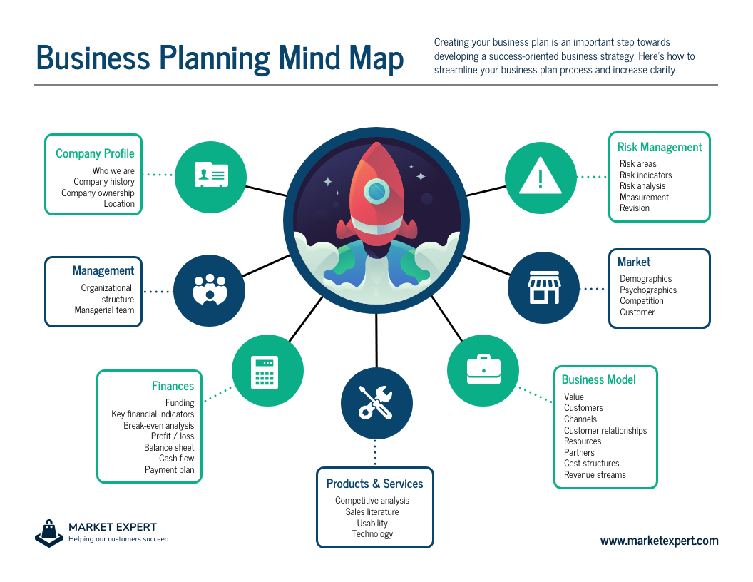Figure1: Example of a mind map platform [6].

The primary objective of this paper is to introduce a new approach designed to tap into the hidden creative potential of your team. By using Mind Mapping, you can encourage original ideas and promote diverse contributions from each member, ensuring that every voice is heard. This technique allows you to effectively organise your thoughts and those of your colleagues, thereby enhancing collaboration. [5]
Additionally, this exploration will provide practical techniques for expressing ideas clearly and engagingly. By utilising the power of Mind Mapping, you can create visual representations that allow your audience to fully understand the scope and intricate details of your project on a single page. These visuals will incorporate creative elements to set your work apart and increase engagement during your presentations. [5]
In this fascinating presentation, we will set out on a journey to discover and refine this extraordinary technique, which maximises our brain's potential. We will thoroughly examine the mechanisms behind Mind Mapping and discuss why it is such a powerful instrument for boosting both creativity and organisation. Moreover, we will outline several straightforward principles that underpin this methodology, establishing a solid foundation for effective application. [5]
Additionally, we will explore the various applications of Mind Mapping across different fields and circumstances. From project management to educational settings, the flexibility of this method will be highlighted. [5]

To conclude, we will present an innovative system that has significantly changed project management and collaboration: Mind Mapping software. This technology streamlines the entire process, enhances productivity, and offers users intuitive tools that make Mind Mapping easy and accessible, ultimately resulting in more efficient workflows and improved outcomes. [5]

Benefits of mind mapping: [5]
1. Encourages creativity and idea generation
Mind maps promote unrestricted thinking, allowing you to delve into ideas freely. By visually linking concepts, you can discover new insights and develop innovative solutions for projects, content creation, or problem-solving. [5]

2. Enhances memory and retention
Research indicates that the mix of visual elements, colours, and keywords in a mind map improves memory recall. This makes it an excellent tool for students preparing for exams, professionals working on presentations, or anyone looking to retain complex information. [5]

3. Increases productivity and organisation
Mind maps offer a clear, structured approach to breaking down intricate tasks, making them easier to address. Whether you’re planning a business project, organising an essay, or outlining a marketing strategy, a mind map helps maintain focus and efficiency. [5]

Created a mind map of contemporary software applications
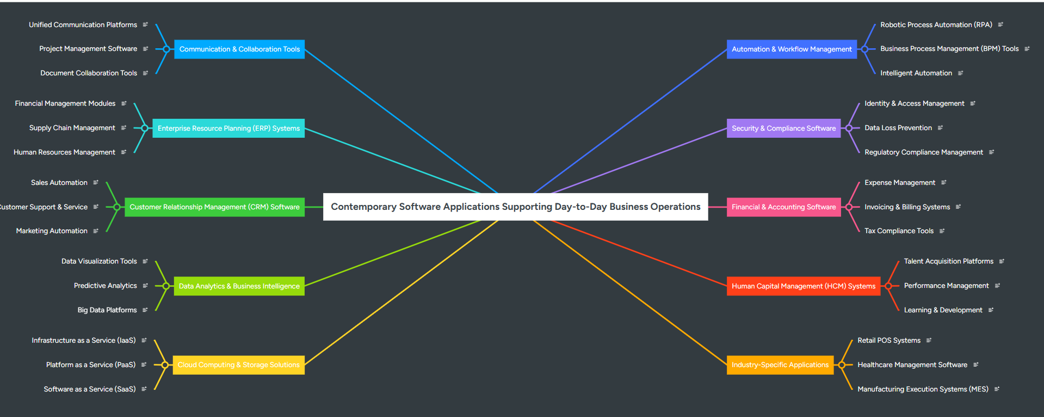
https://www.mindmeister.com/4044891857/contemporary-software-applications-supporting-day-to-day-business-operations

Task 3. Office Applications

Four office software solutions for business operations

MS Word
Microsoft Word has positioned itself as a fundamental component of office productivity software, offering a wide array of features that address diverse document creation and editing needs. This robust word processing application is not merely a space for typing; it serves as a flexible solution for professionals and individuals alike, improving how we craft written material. [7]


Figure1: Image showing the Microsoft Word logo. [8]
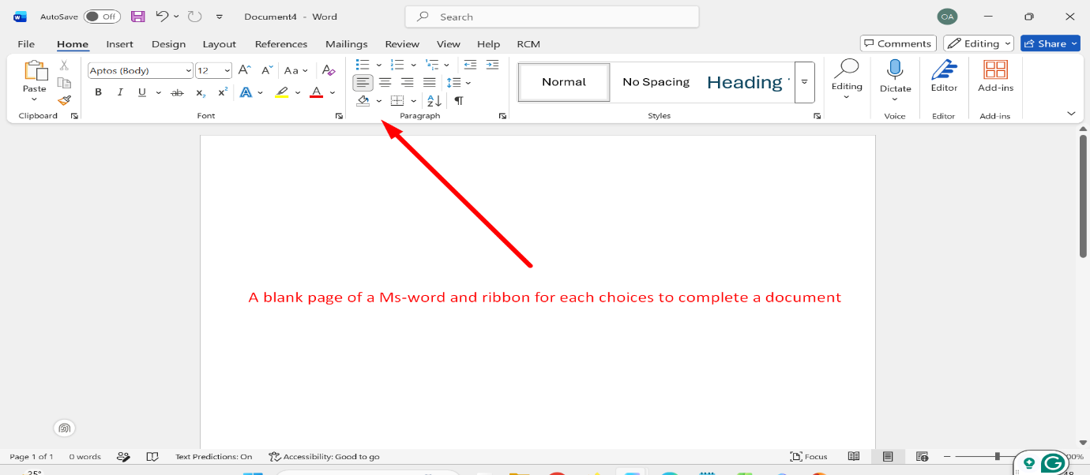
Figure 2: Image showing a Microsoft blank page to start a document and the Ribbon for each choice to complete a document. Image created by me.

Microsoft Word offers extensive formatting options, allowing users to customise text with different fonts, sizes, and colours. It supports various styles, like headings and subheadings, which improve document organisation and readability. Additionally, users can insert images, tables, graphs, and charts to enhance the visual appeal of reports and presentations, ensuring clear information communication. [7]
With a vast selection of professionally crafted templates, Microsoft Word simplifies document creation by providing ready-made formats for resumes, business letters, reports, and more. These templates help users save time and effort that would otherwise be spent starting from scratch and give documents a polished, professional look that might otherwise lack visual consistency. By utilising a template, individuals can concentrate more on the actual content rather than the layout, resulting in improved efficiency and productivity. [7]
Microsoft Word offers significant collaboration benefits that are essential in today’s teamwork-focused environment. Multiple users can simultaneously access and edit a document, facilitating group projects and brainstorming. Its real-time collaboration feature shows changes instantly, enhancing communication. The “Track Changes” function allows users to monitor edits, simplifying the review and feedback process. [7]Error correction is also made easier with the integrated spell check and grammar suggestion tools in Microsoft Word. These features help spot typographical errors and provide stylistic advice, ensuring that documents maintain a degree of professionalism and clarity. Users can refine their writing based on these recommendations, resulting in polished, error-free finished products.. [7]
Moreover, Microsoft Word shines in document organisation. Users can delete or rearrange pages with ease, enabling logical and efficient structuring of their content. This flexibility is particularly advantageous when compiling reports or extensive documents, as it facilitates modifications without the need to start from scratch. [7]
In terms of mail merging, Microsoft Word can streamline processes such as sending customised emails or invitations to numerous recipients. This functionality is especially beneficial in marketing efforts, where both efficiency and personalisation are vital.. [7]

Finally, Microsoft Word supports various file formats, including PDF conversion, ensuring that documents can be shared with individuals who might not have access to the software. This compatibility boosts its utility across numerous platforms and devices, making it a preferred application for a broad spectrum of users. [7]

Microsoft Word is more than just a basic word processor; it’s a robust tool for developing professional documents customised to individual preferences. With its extensive array of features, including formatting options, collaboration capabilities, error correction, and document management, it is an invaluable asset for both personal and professional contexts. Whether you're composing a quick letter or an extensive report, Microsoft Word offers the essential tools needed to ensure your communication is both clear and effective, making it a vital application for users of all experience levels. [7]
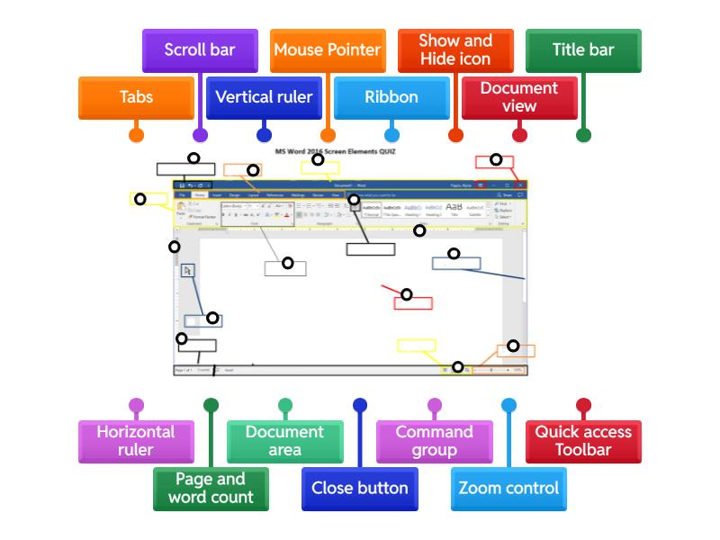
Figure 3: Image showing Parts of MS Word window - Labelled diagram [9]

MS PowerPoint
Microsoft PowerPoint is a sophisticated presentation software developed by Microsoft, designed to help users create visually appealing, highly professional presentations. Through PowerPoint, you can construct a series of slides that integrate a variety of multimedia elements, such as text, images, charts, videos, and animations. This versatility makes PowerPoint an excellent resource for communicating complex concepts in a clear, well-organised, and engaging way.

Figure 1: Showing the PowerPoint logo. [10]
PowerPoint has earned its status as the leading presentation software for several compelling reasons:

1. User-Friendly Interface:
One of the main features of Microsoft PowerPoint is its intuitive design, conceived to be simple and accessible to users, even those with minimal technical skills. The structure is well-organised and easy to navigate, allowing individuals to manoeuvre through various features and swiftly create presentations from the initial setup to the finishing touches.
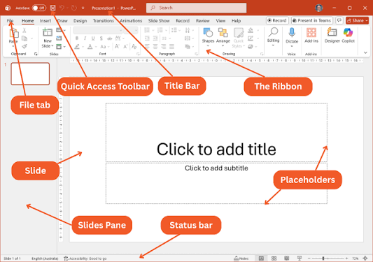
Figure2: Image showing friendly interface [11].

2. Customisation and Flexibility:
PowerPoint is notable for its customizable options that cater to personal preferences. Users can select from a wide array of professionally crafted templates and themes, enabling straightforward personalisation. Additionally, PowerPoint offers numerous font options, effects, and transitions that enhance the visual appeal of your slides. This level of customisation empowers users to tailor presentations to fit different audiences and contexts, whether they strive for a formal corporate look or a more vibrant, creative approach.
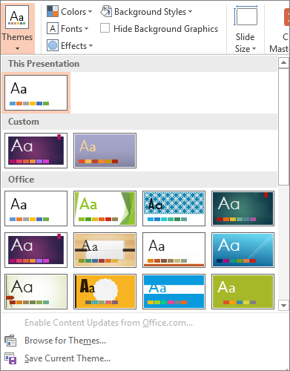
Figure 3: Image showing example of customisation, e.g. themes, background and styles and effects. [12]
3. Improved Collaboration Features:
Collaboration is made easier with Microsoft PowerPoint, particularly when using Microsoft 365. This cloud-based system allows multiple users to work together on the same presentation simultaneously, which is incredibly advantageous for teams. This feature promotes real-time teamwork by enabling team members to exchange ideas, provide feedback, and make revisions, thereby enhancing the overall process.
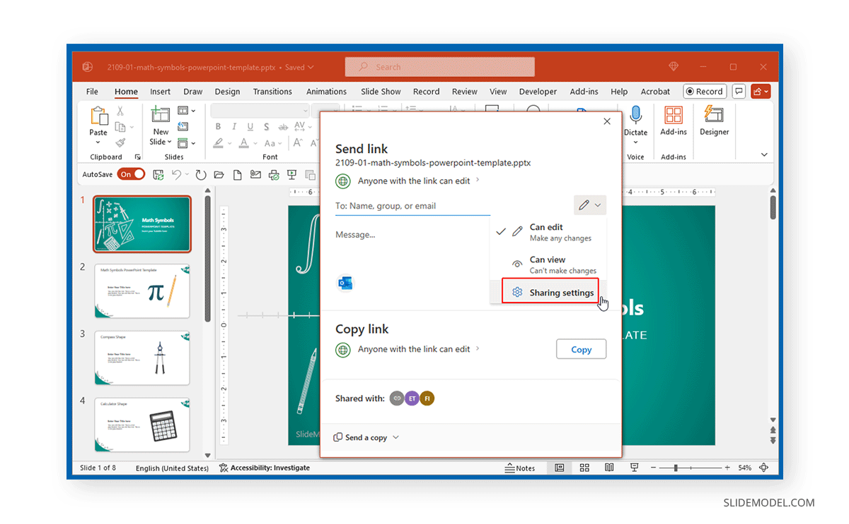
Figure 4: Supporting image showing how PowerPoint collaboration works. [13]

4. Adaptability for Different Uses:
PowerPoint is not exclusively created for business presentations; it is also widely used in educational settings, creative industries, and personal projects. The application offers a vast range of functionalities suitable for various uses, including product showcases, educational materials, training sessions, and marketing pitches. This flexibility ensures that PowerPoint can meet the distinct needs of different users and contexts.
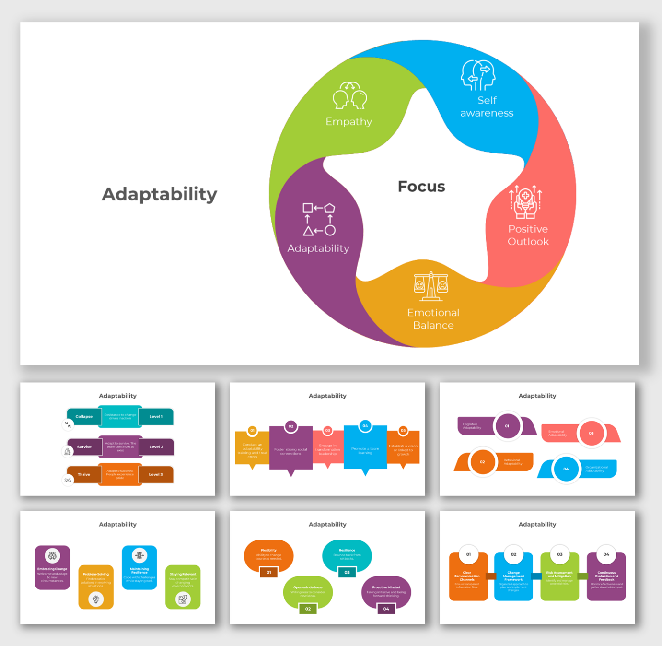
Figure 5: Image showing. Adaptability for Different Uses. [14]

There are multiple ways to obtain Microsoft PowerPoint:

1. Microsoft 365: This is a subscription service that grants you continuous access to the latest version of PowerPoint and other Office applications. With this plan, you also receive
perks such as 1 TB of OneDrive cloud storage, enabling you to store and retrieve your presentations from anywhere.
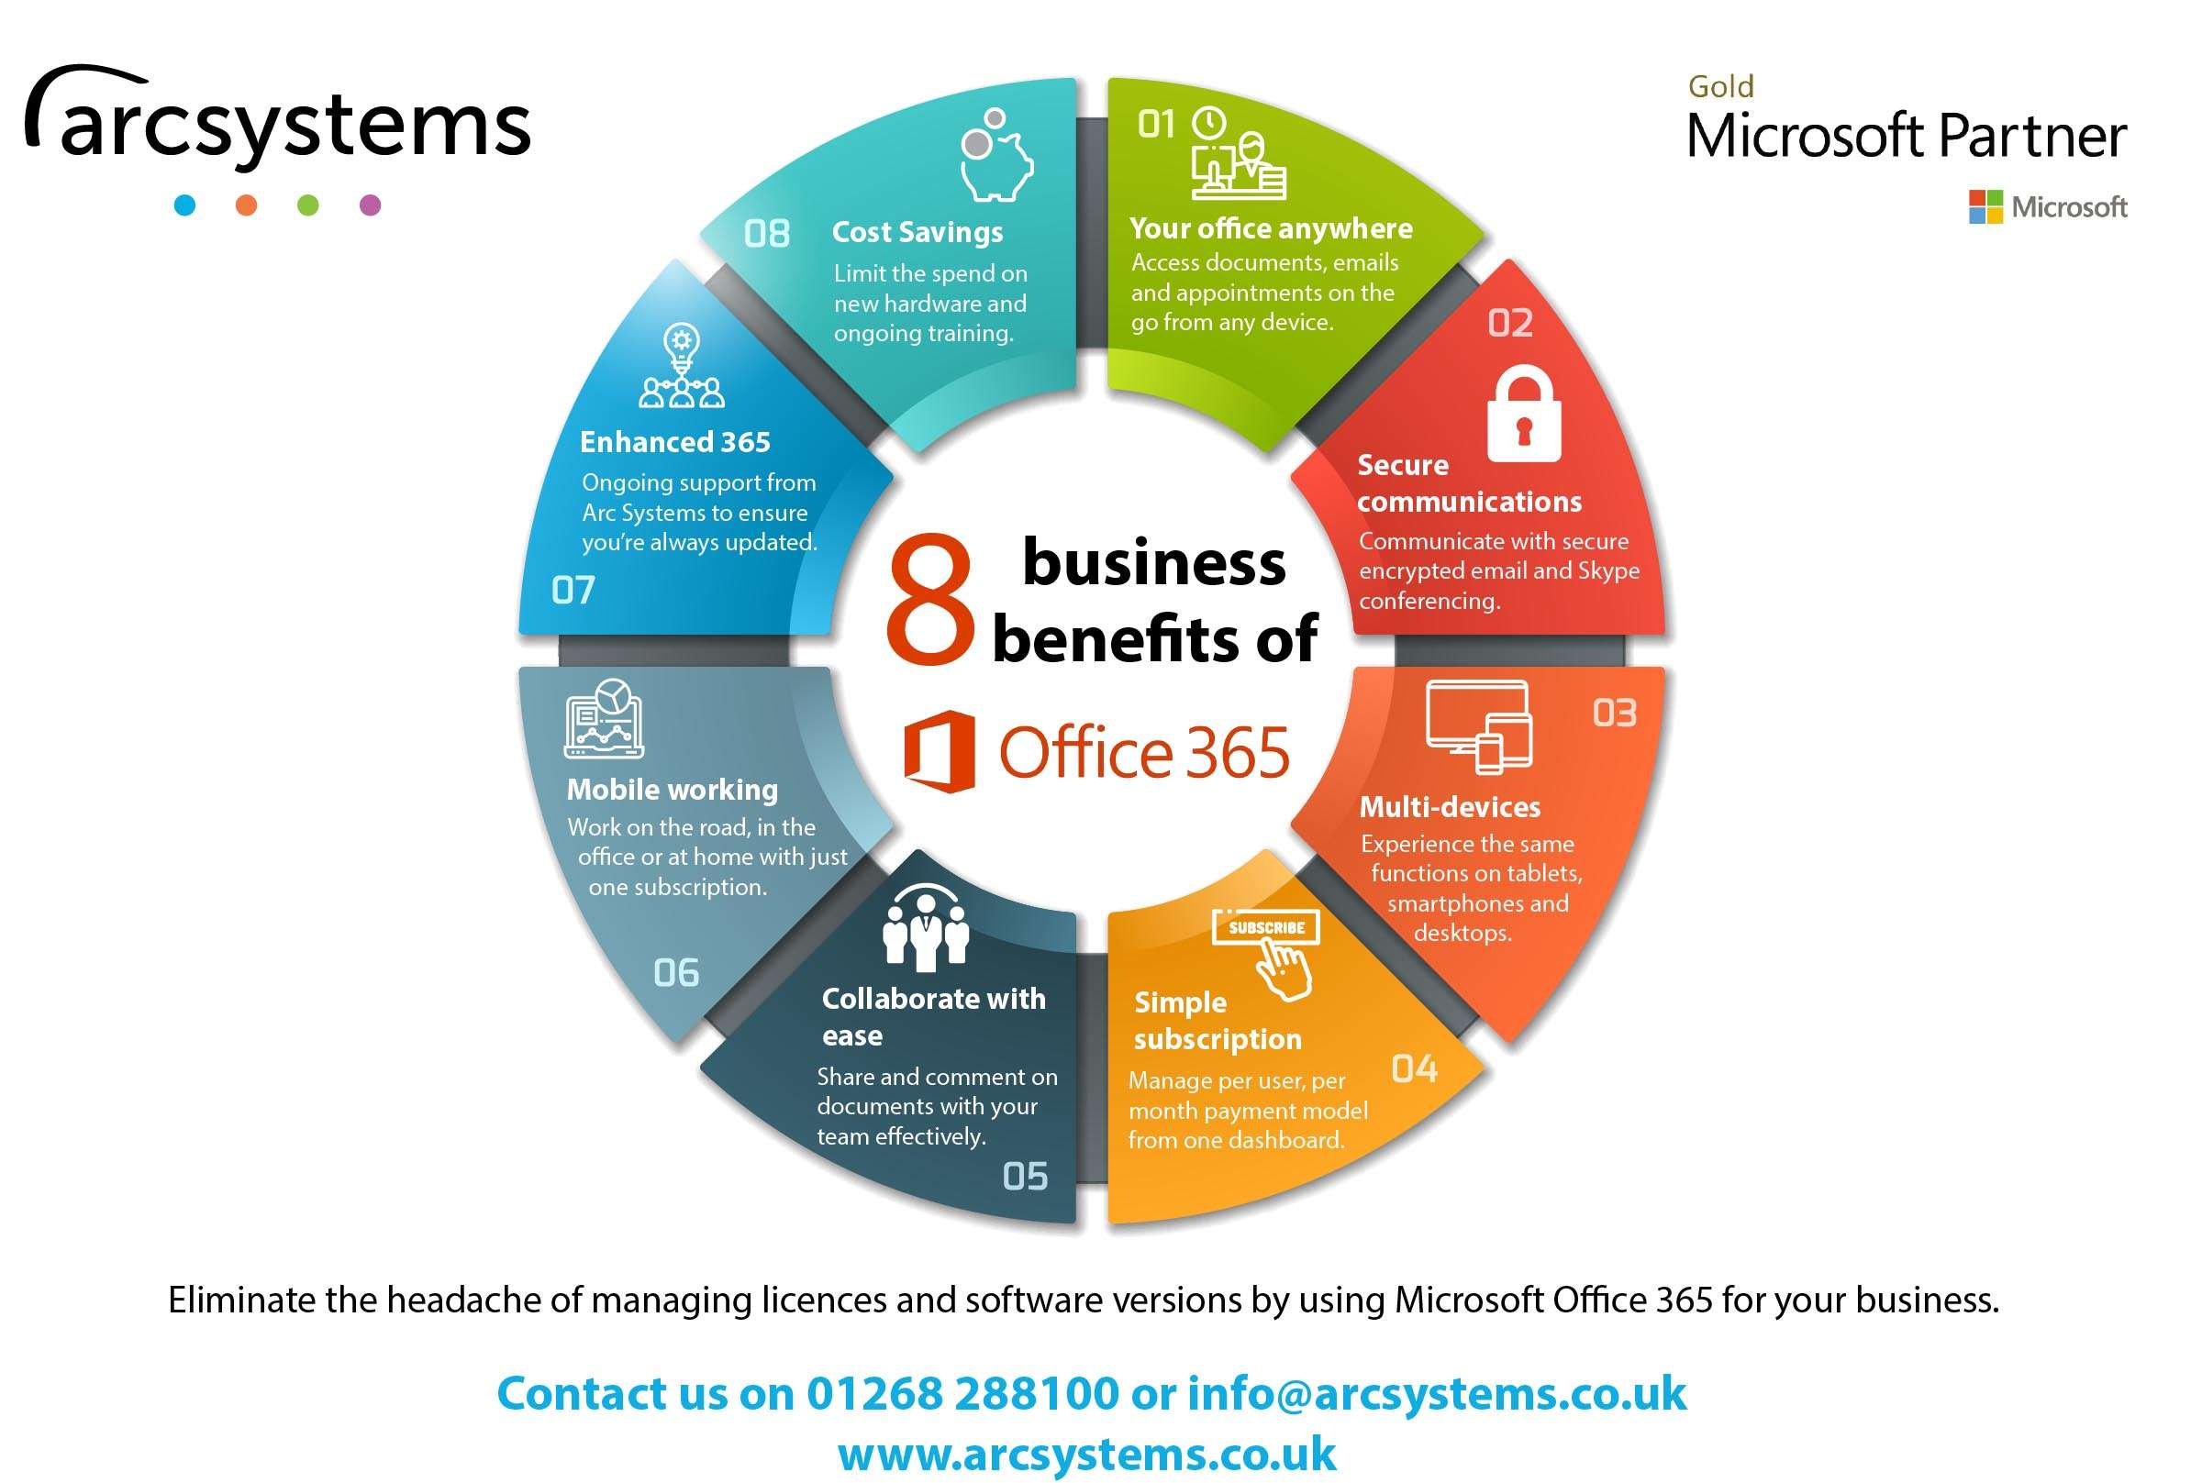
Figure6: Image showing benefits of Office365 for businesses. [15]

2. Office 2024: For individuals who prefer a one-time purchase instead of a subscription, Office 2024 is a fitting choice. This bundle includes PowerPoint and other widely used Office applications, such as Word and Excel. Office 2024 is ideal for users who want a stable version of the software without regular updates.

3. Microsoft 365 for Business: This option is crafted for companies looking for a thorough solution for their teams. Microsoft 365 for Business includes PowerPoint and all other Office applications, along with additional business-focused features, such as SharePoint and Teams.

In conclusion, Microsoft PowerPoint is an exceptional tool for anyone intending to develop engaging presentations. Its extensive features, intuitive interface, and seamless integration with other Microsoft Office applications enable users to create polished, professional content. Whether collaborating with a group or working individually, PowerPoint provides powerful tools to help you create presentations that are both informative and visually appealing. [16]

MS Excel
Microsoft Excel is a robust spreadsheet program commonly utilised by organisations and individuals alike. As an essential part of the Microsoft Office Suite, it allows users to conduct various data analyses, generate charts and graphs, manage financial plans, and perform many other functions. With Excel, users can easily create spreadsheets organised into rows and columns to present numerical data. Moreover, you can utilise formulas to compute totals, averages, and other statistics, among numerous other features.
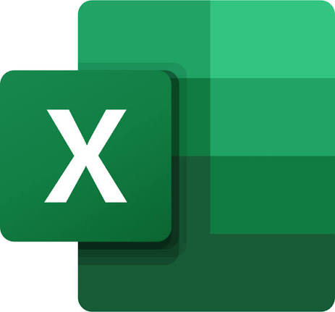

Figure 1: Image showing Excel Logo [17].

Beginning with Microsoft Excel
Embarking on your journey with Microsoft Excel is simple. First, you will need to acquire the software, either by purchasing it or downloading it. If you already have an Office 365 subscription, you can start using Excel right away. After installation on your computer or device, launch the application to discover its features. Numerous online tutorials and courses are available to help you learn to leverage its features efficiently.

What Can You Accomplish with Microsoft Excel?
The range of tasks you can perform with Microsoft Excel is wide and largely depends on your requirements. It is frequently used to design basic spreadsheets like budgets, invoices, and sales reports. However, Excel also supports more complex tasks, such as constructing detailed models for event organisation or analysing business patterns using advanced tools like pivot tables and macros. Additionally, you can connect spreadsheet data with other software applications such as Word or PowerPoint, enhancing your workflow across various platforms.
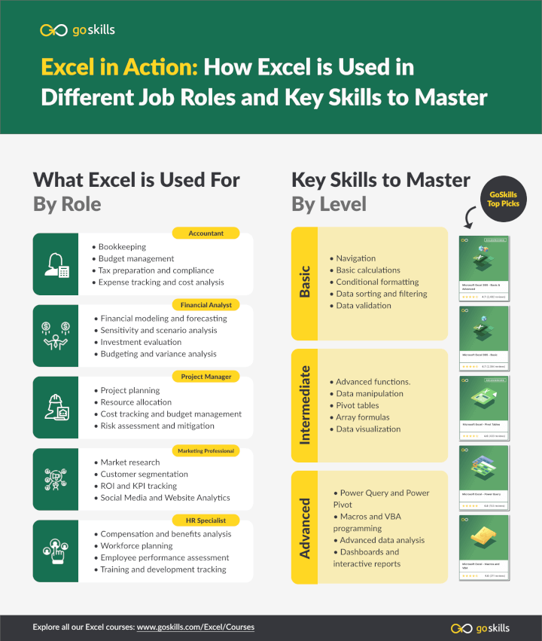
Figure1: What can be achieved with Excel and how Excel is used in businesses. [18]
Advantages of Using Microsoft Excel
Utilising Microsoft Excel to handle numerical data offers multiple benefits over alternative software or manual methods. For example, it greatly accelerates calculations and enhances accuracy. Excel also features strong security measures to safeguard sensitive information. You can effectively create tables and graphs to visualise your data for presentations or comprehensive analyses.
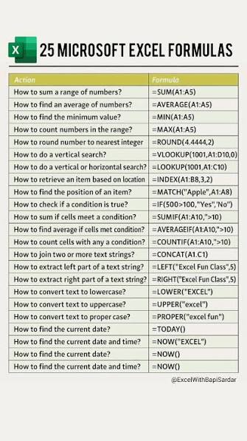
Figure2: Showing Excel 10 Formulas [19]

Tasks You Can Perform with Microsoft Excel
Microsoft Excel comes equipped with a diverse array of tools for managing numerical data, such as forming budgets or monitoring sales figures over time. Its extensive formatting and organisational capabilities enable you to compute totals or apply formulas for more complicated calculations, such as forecasting future sales trends. The various functionalities that Excel offers can significantly simplify task completion.
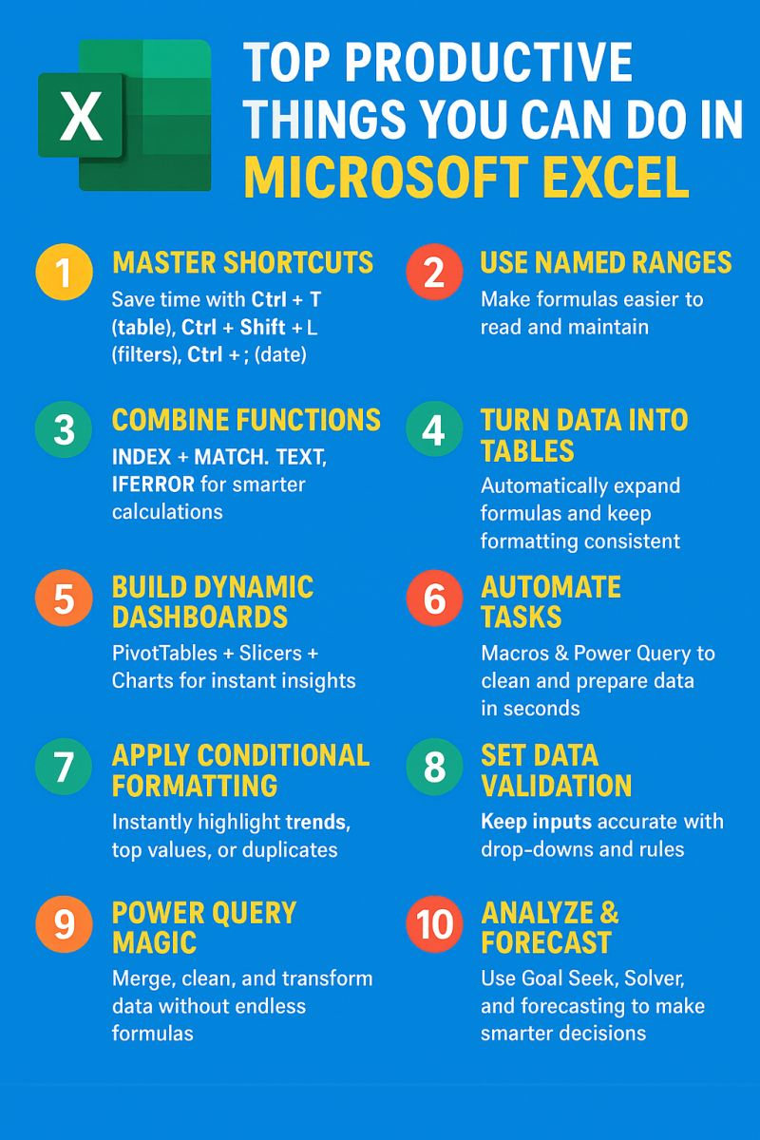
Figure 3: Supporting image showing top productive task that can be performed within Excel.

Data Protection in Microsoft Excel
Information stored in a Microsoft Excel spreadsheet is securely protected. The application provides several methods to secure files, including password protection and encryption, to prevent unauthorised access or changes made by cybercriminals or harmful software. Moreover, Excel incorporates an audit trail feature that records every modification made to the file, noting who made the changes and always ensuring accountability.

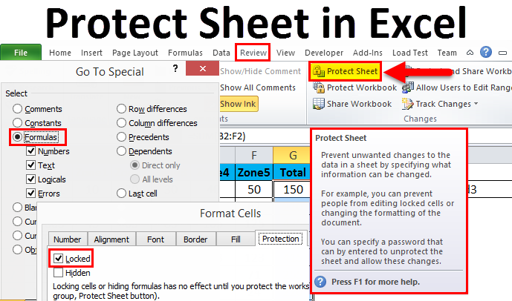
Figure5: Image showing how documents are protected within Excel to avoid GDPR violations. [20]

Using Macros and Visual Basic with Microsoft Excel
Macros allow you to streamline tasks in Microsoft Excel, such as moving information between sections with a single action, boosting efficiency and minimising errors. Visual Basic provides more precise control over specific functions through programming, making it suitable for generating reports or printing labels tailored to unique needs.

Additional Software Considerations for Microsoft Excel
No additional software is required to use the latest versions of Microsoft Office, including Excel. However, if you are using an older version, it’s crucial to confirm that your computer meets the required security standards before installing or using the software. This precaution helps prevent the exposure of personal information to potential risks posed by vulnerabilities in outdated software.

Training for Microsoft Excel Proficiency
While many fundamental commands and features are intended to be user-friendly, complex tasks that involve intricate calculations and specialised formatting may require formal training. Such training can equip you with the knowledge to utilise these functions effectively, enabling you to achieve your objectives efficiently and accurately.

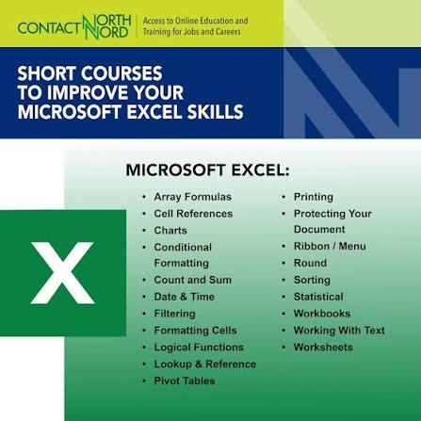
Figure6: Image showing top Courses to improve Microsoft Excel skills. [21]
Collaboration Features in Microsoft Excel
Microsoft Excel offers an array of collaborative features that enhance teamwork on spreadsheets. You can effortlessly share your workbook with others and manage who can view, edit, or comment on your content. Additionally, task assignment and reassignment promote smooth collaboration, ensuring that all participants remain coordinated.

MS Access

Figure1: Showing MS Access Logo.

Microsoft Access as a Business Office Software Solution

Microsoft Access, included in the Microsoft 365 suite, is a relational database management system (RDBMS) that combines a powerful database engine with a user-friendly graphical interface. It acts as a connector between basic spreadsheet applications like Excel and sophisticated, enterprise-level systems, allowing users to develop data-driven applications without needing extensive programming expertise. For small to medium-sized enterprises (SMEs) and departmental teams, Access provides a practical solution for managing tasks such as inventory management and customer relationship tracking.
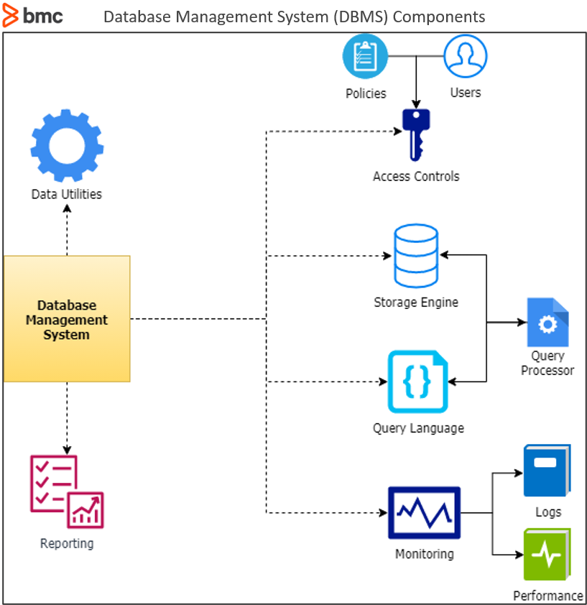
Figure2: Image supporting database management system [22].

Major Features: Access employs a relational database structure, which allows users to organise data across multiple interconnected tables. This method reduces redundancy and maintains data integrity, both essential for operations where different data types, such as clients, orders, and products, must be interrelated. The software features an integrated development environment, complete with forms for straightforward data entry, queries to retrieve specific information, and professional reporting tools for analysis. It supports automation through Visual Basic for Applications (VBA), enabling users to implement complex business logic and streamline repetitive tasks. Furthermore, Access integrates smoothly with other Microsoft Office applications, enabling data exchange with Excel for advanced analytics, Word for mail merges, and Outlook for email management.
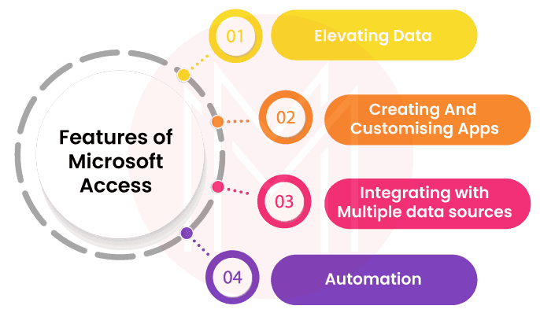
Figure3: Image supporting Features of Microsoft Access. [23]

Major Benefits: The foremost benefit of Access is its ease of use and rapid application development capabilities. Nontechnical users, known as "citizen developers," can swiftly create functional databases tailored to particular business requirements. This greatly improves workflow efficiency by minimising manual data entry and reducing errors. For SMEs with constrained budgets, Access offers a cost-effective alternative to pricey enterprise software or custom applications. A capable staff member can construct a reliable solution in days rather than months. Additionally, Access makes report generation easier with customizable, interactive drill-down features that convert raw data into actionable insights, thereby improving decision-making.

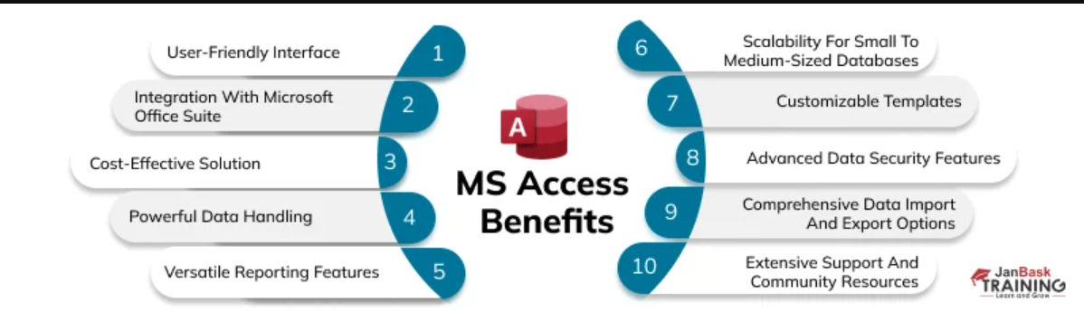
Figure4: Major Benefits of Ms Access [24]

Major Limitations: Despite its advantages, Access has some significant downsides. Its most pressing limitation is scalability: the database can only support a maximum file size of 2GB, and its performance deteriorates notably with large volumes of data or many simultaneous users. It is not suitable for environments with a high volume of transactions. Its file-based design presents vulnerabilities: since Access depends on a single .accdb file stored on a network, a poor connection or a user error can corrupt the entire database for all users. This single point of failure presents serious dangers to data integrity. Security is another issue, as Access does not provide native row-level permissions, making it difficult to limit user access to specific entries without complex VBA programming. This becomes particularly concerning for businesses handling sensitive data subject to regulations such as the GDPR. Moreover, Access is exclusively Windows-based, limiting its usability in the modern mobile-first work environment due to the lack of native mobile or web browser support. Lastly, the issue of "shadow IT" may arise when databases are created on individual computers without centralised IT oversight, resulting in unsupported, mission-critical systems that can become problematic when the original creator leaves the organisation.

Conclusion: Microsoft Access remains a worthwhile tool for SMEs and departmental teams that need quick, low-cost database solutions for moderate data volumes. However, its limitations in scalability, security, and stability mean it cannot adequately support long-term business growth. Companies anticipating growth should explore modern alternatives, such as the Microsoft Power Platform or hybrid approaches that utilise Access as a frontend to SQL Server [25].

Mail Merge
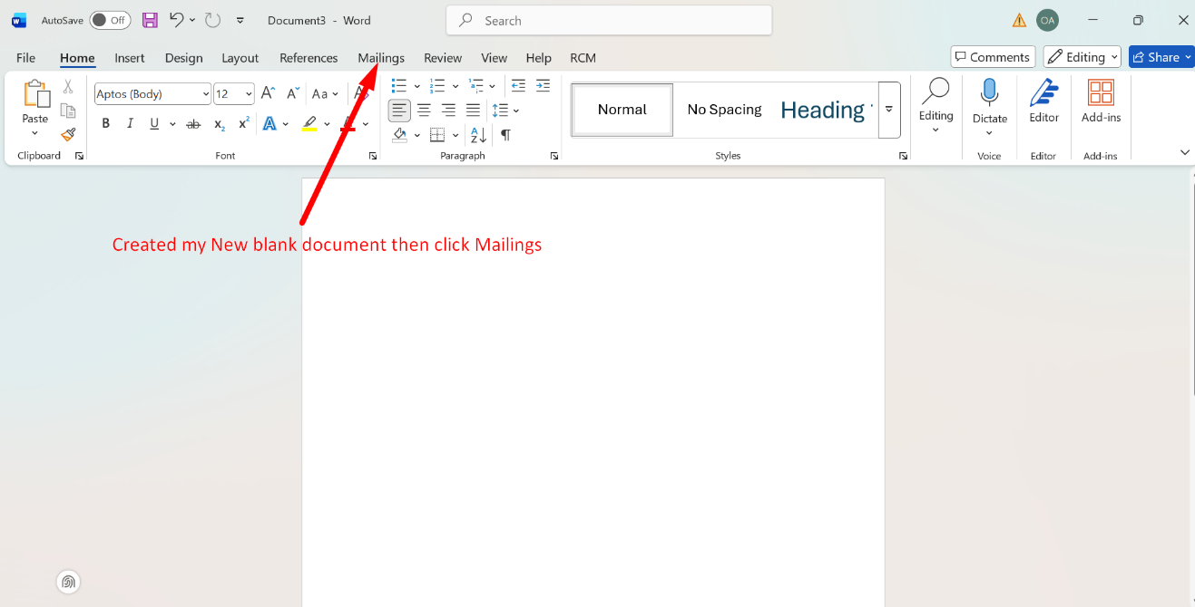

Figure 1: New blank document created
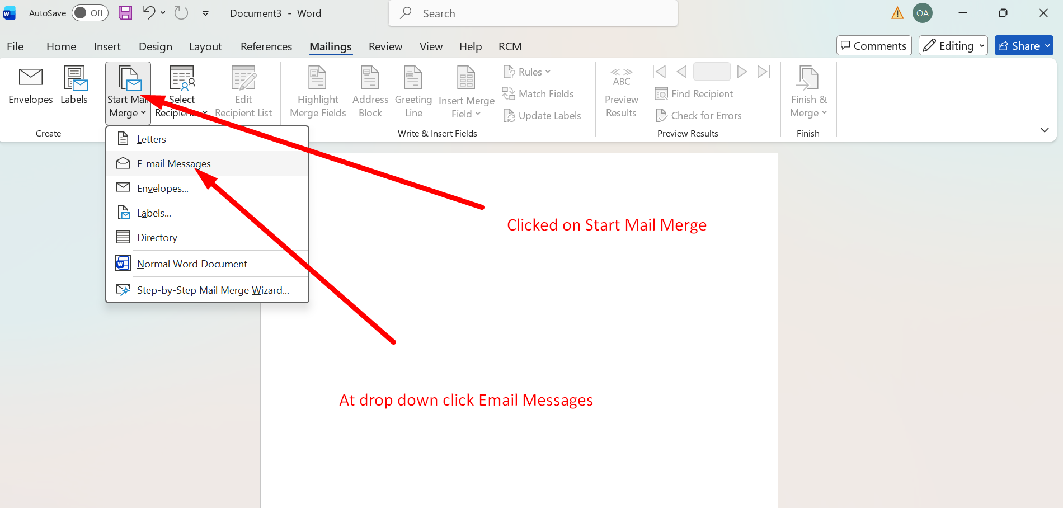

Figure 2:Start Mail Merge/ Email Message

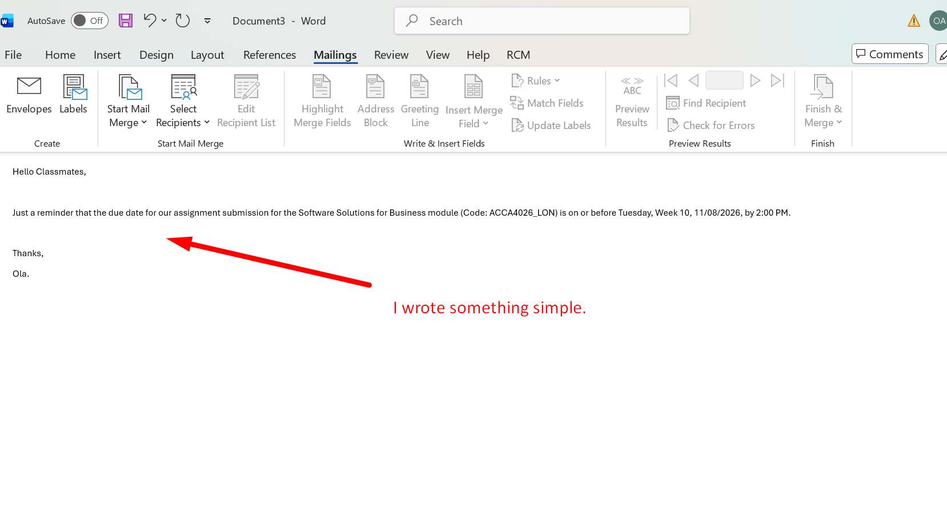

Figure 3: Typed a simple letter in my blank Word document.
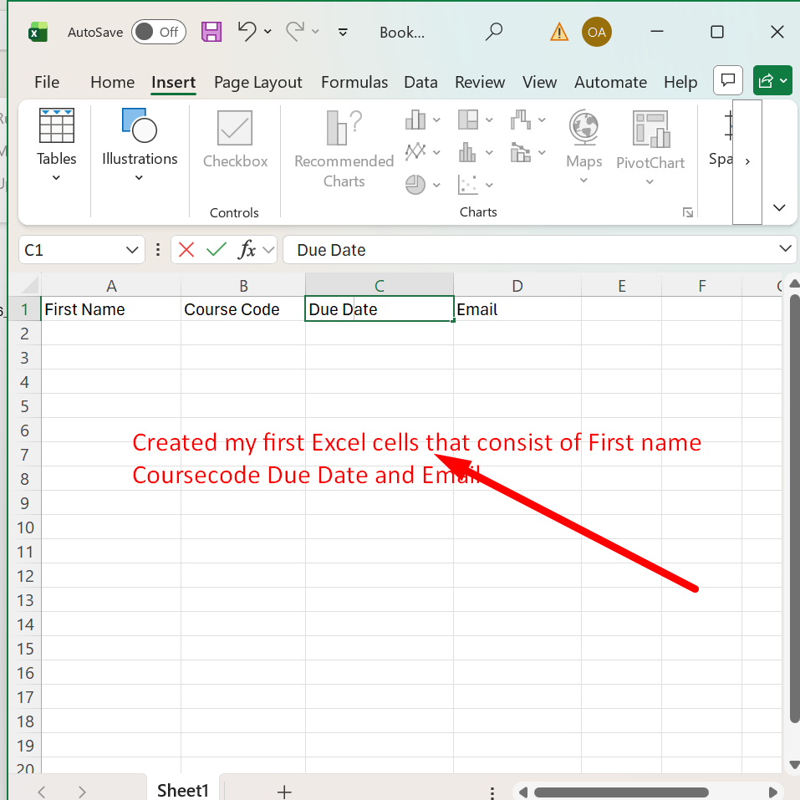

Figure 4: Created a spreadsheet in Excel.

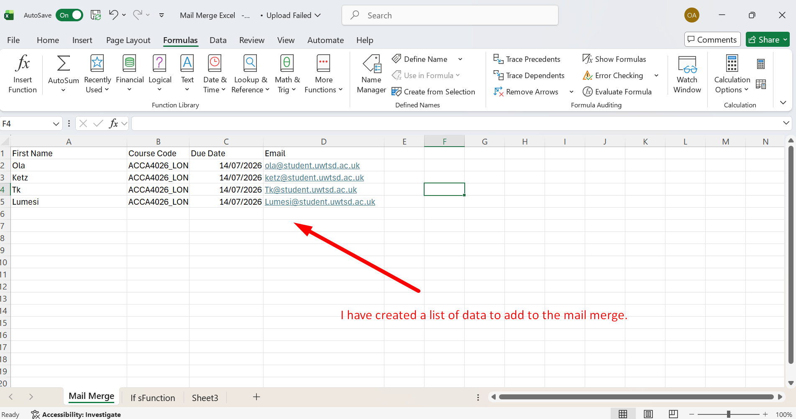

Figure 5: Added data to spreadsheet.

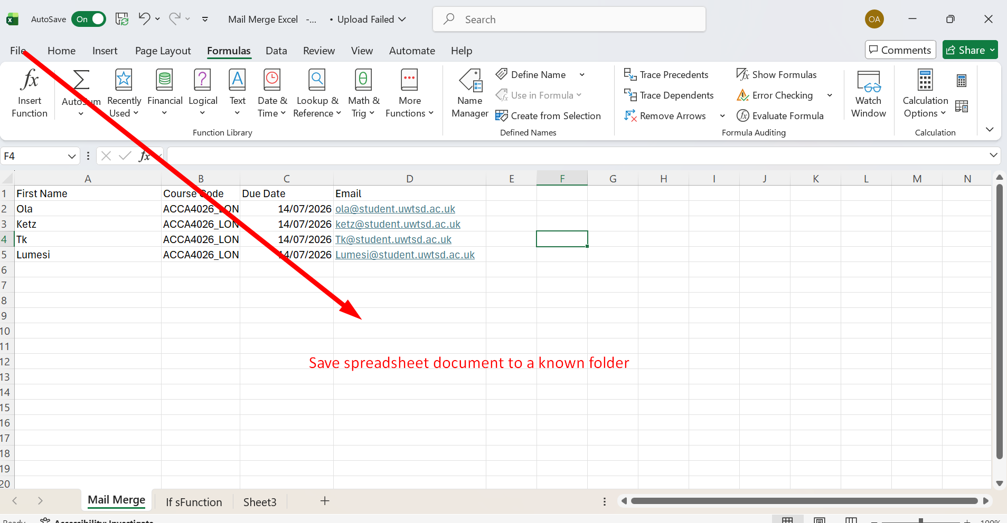

Figure 6: Saving Spreadsheet.

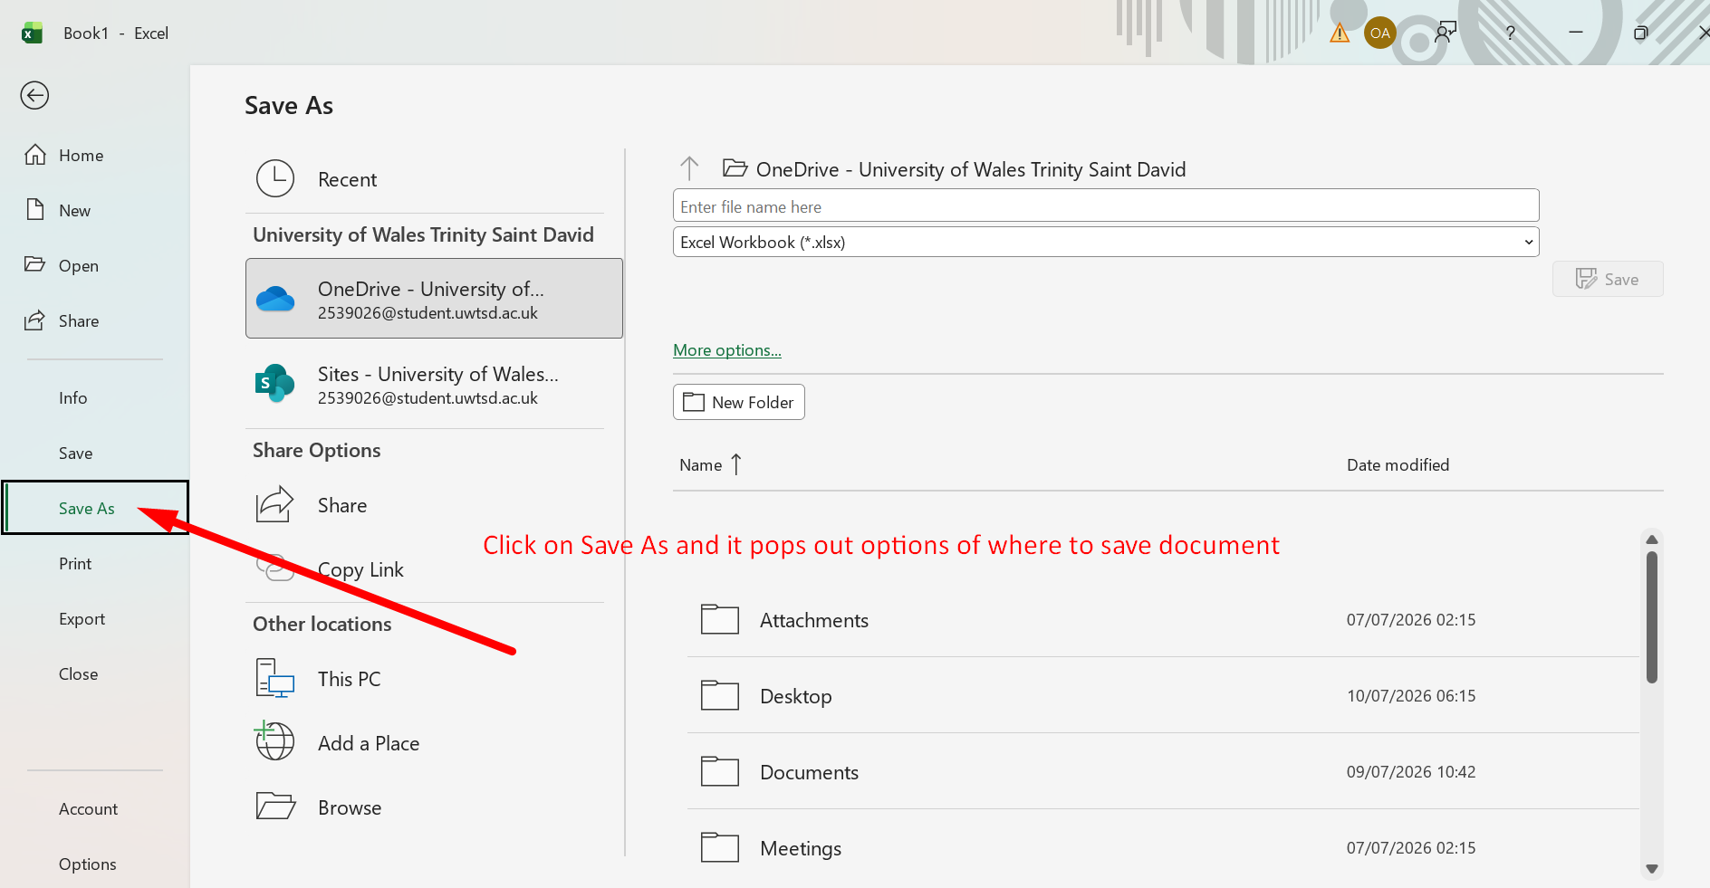
Figure 7: Clicked Save and chose a folder.
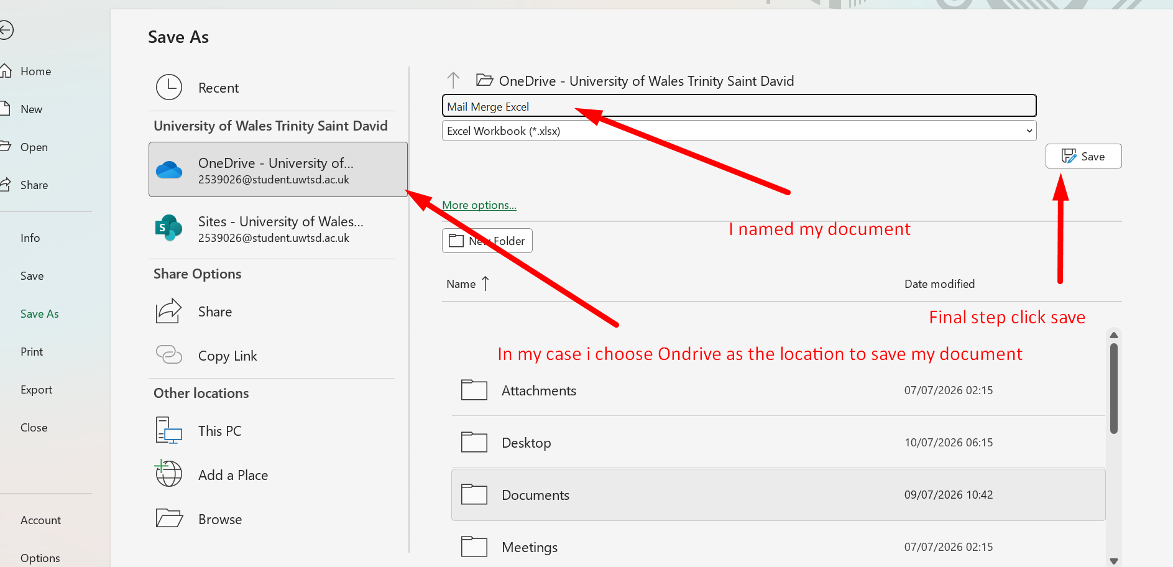

Figure 8: Choose folder location to save documents.

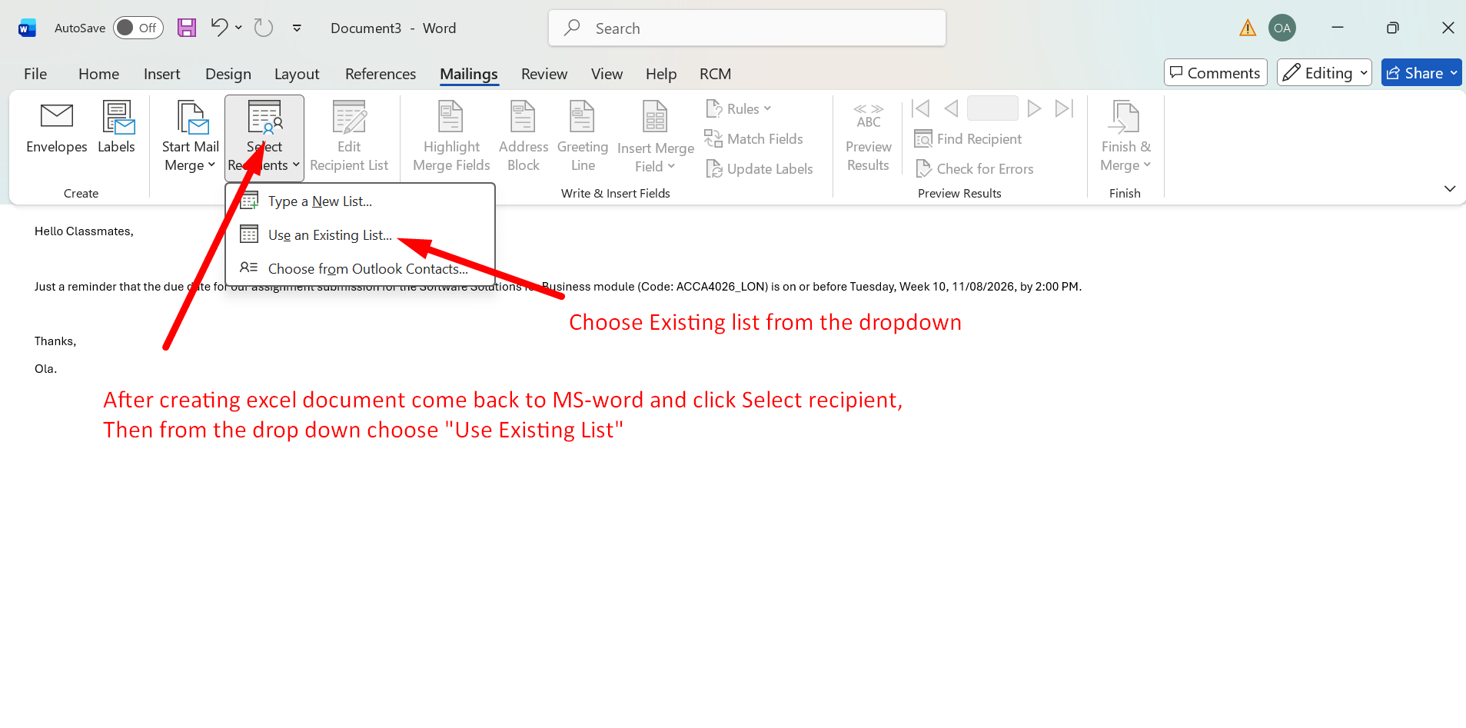
Figure 9: After creating Excel, drop down to select recipients.

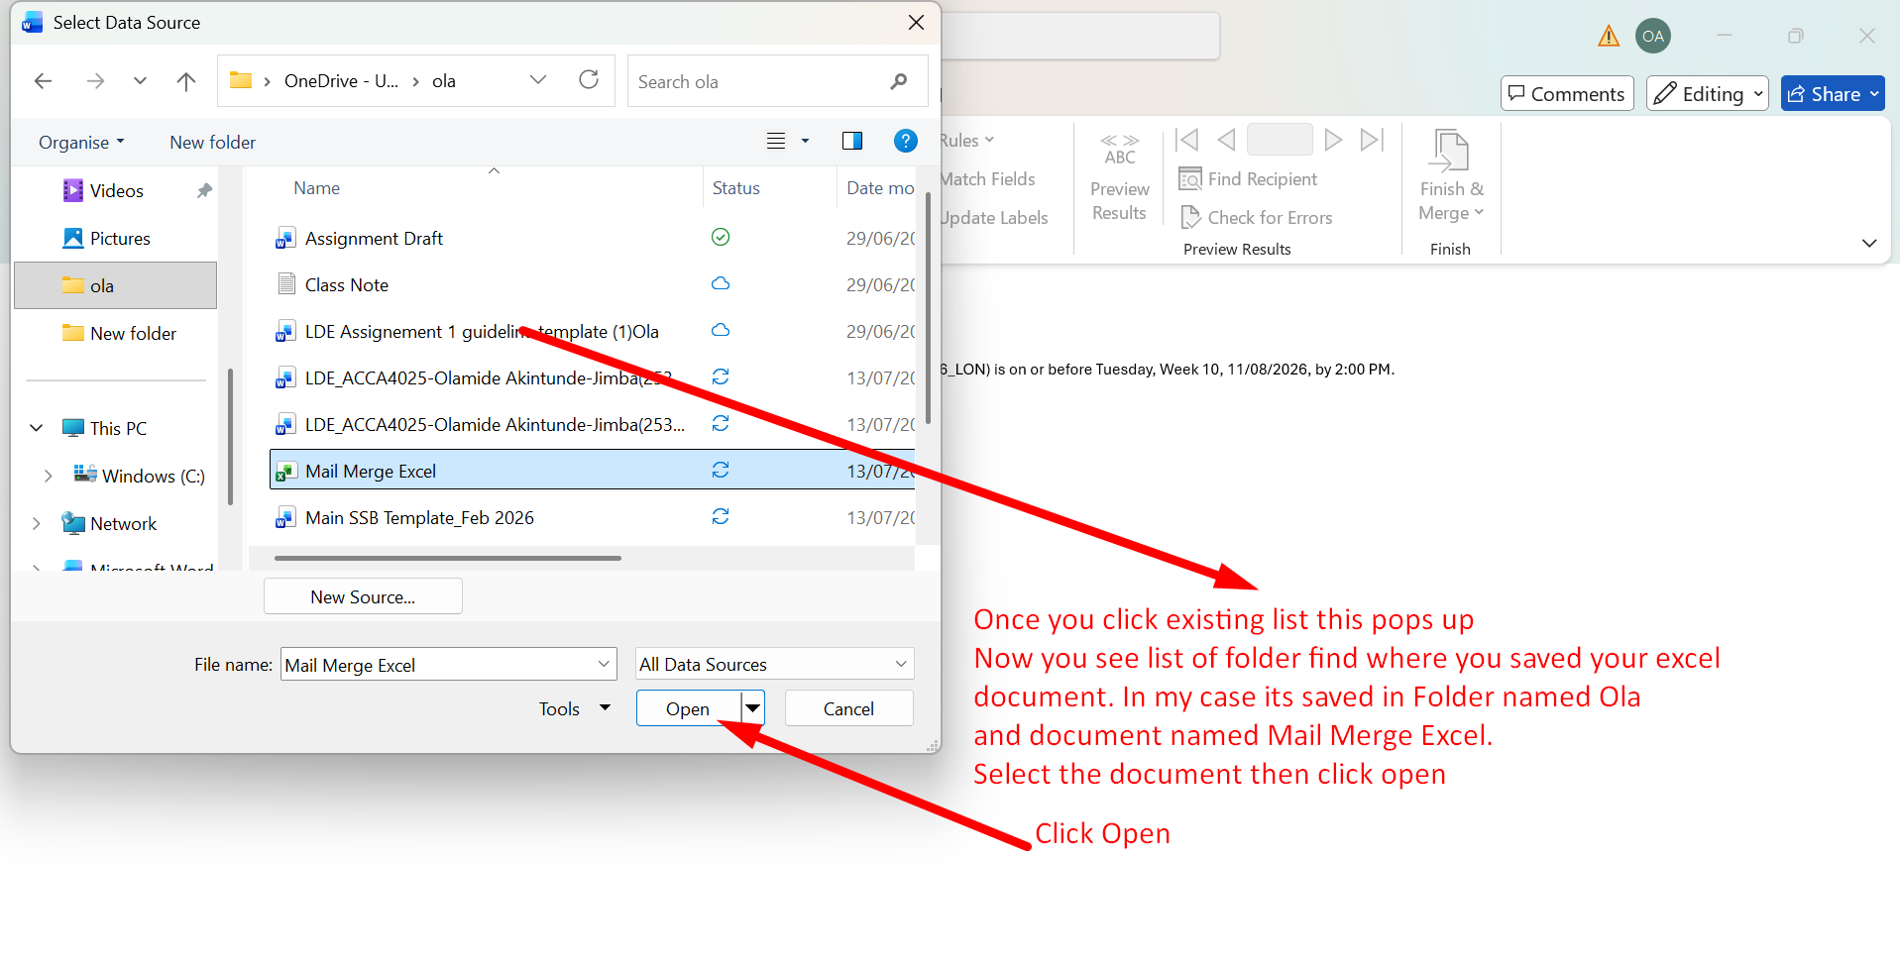
Figure 10: Folder containing Excel documents and file name.

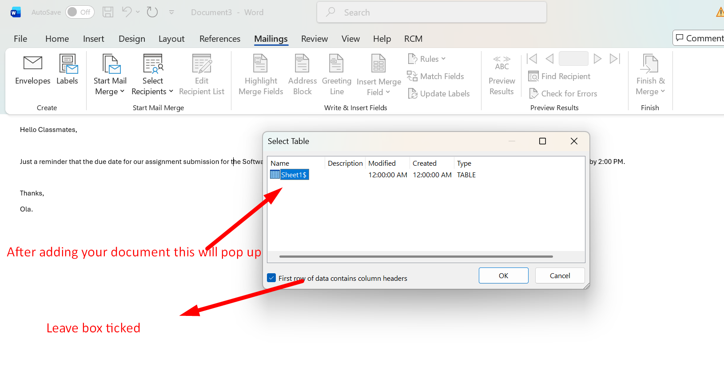
Figure 11: Adding document/ leave box ticked.

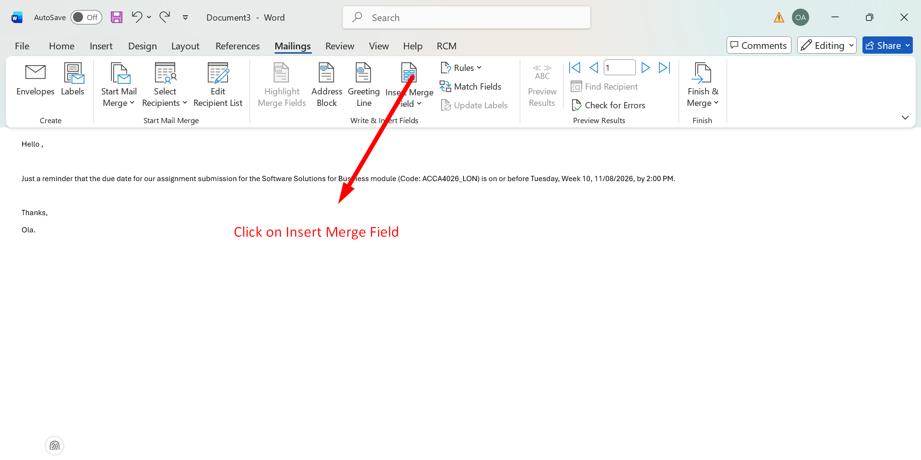

Figure 12: Click on Insert Merge Field.

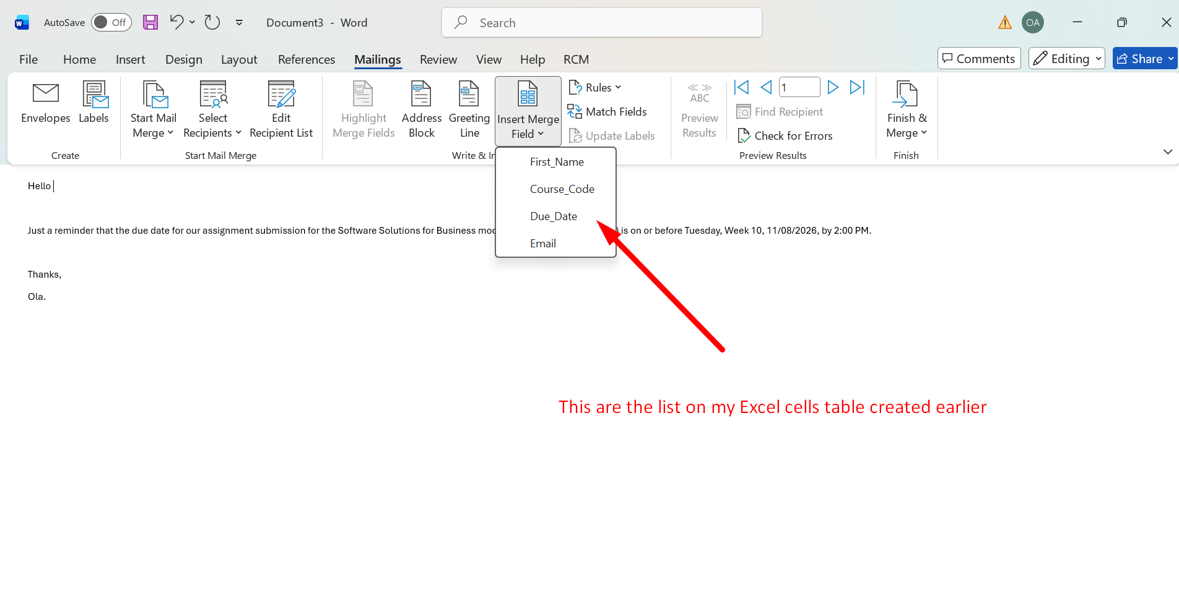
Figure 13: List from Excel spreadsheet.

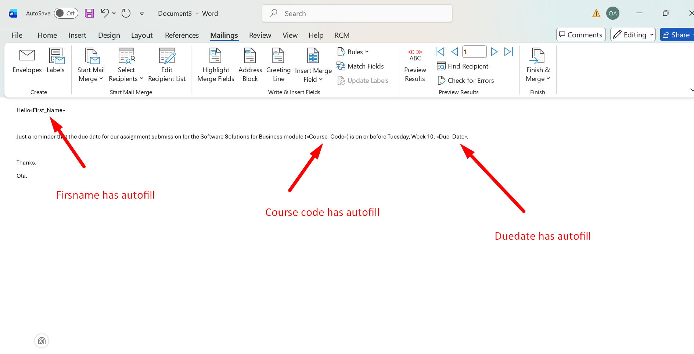
Figure 14: Placeholders updated.
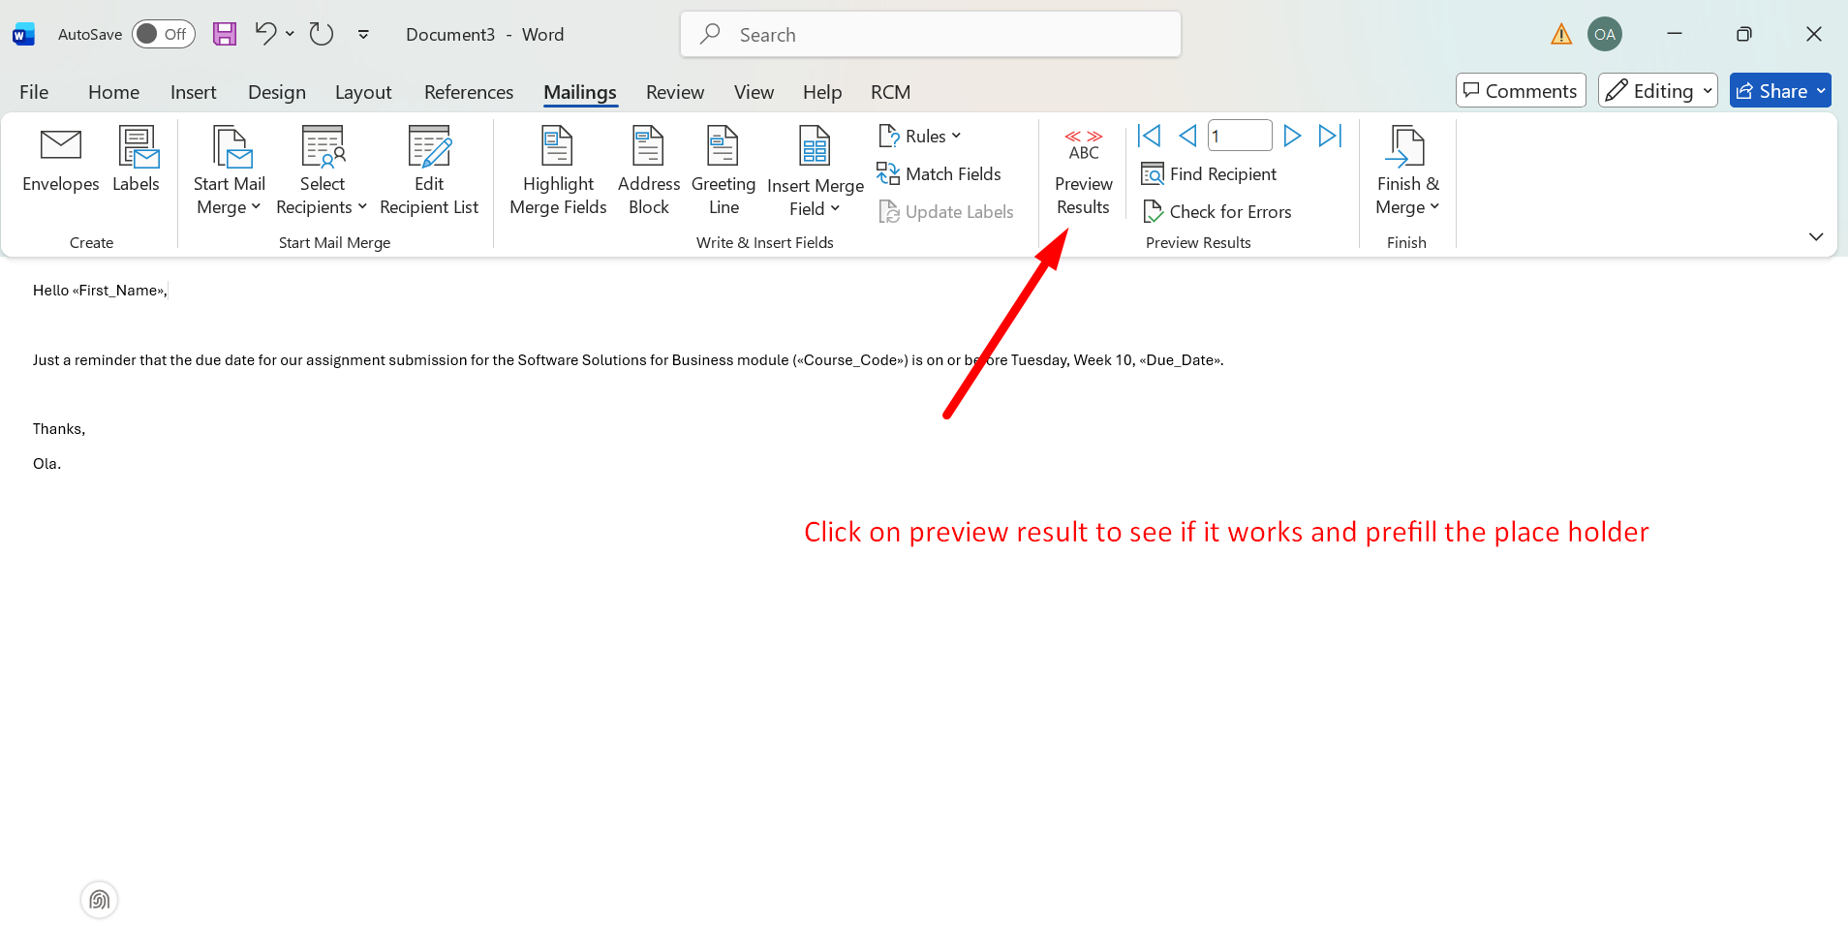
Figure 15: Click Preview result.
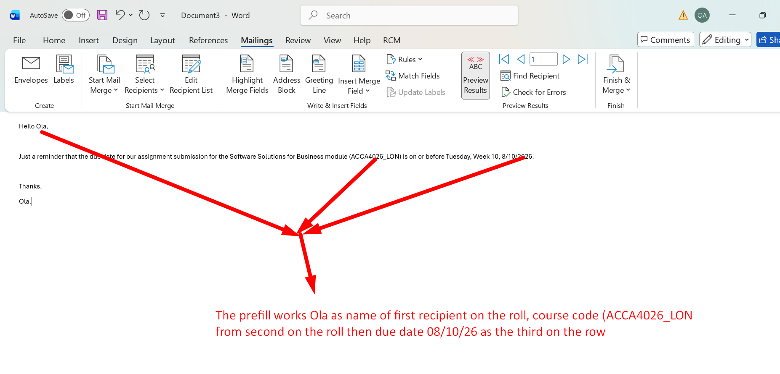
Figure 16: Preview works.
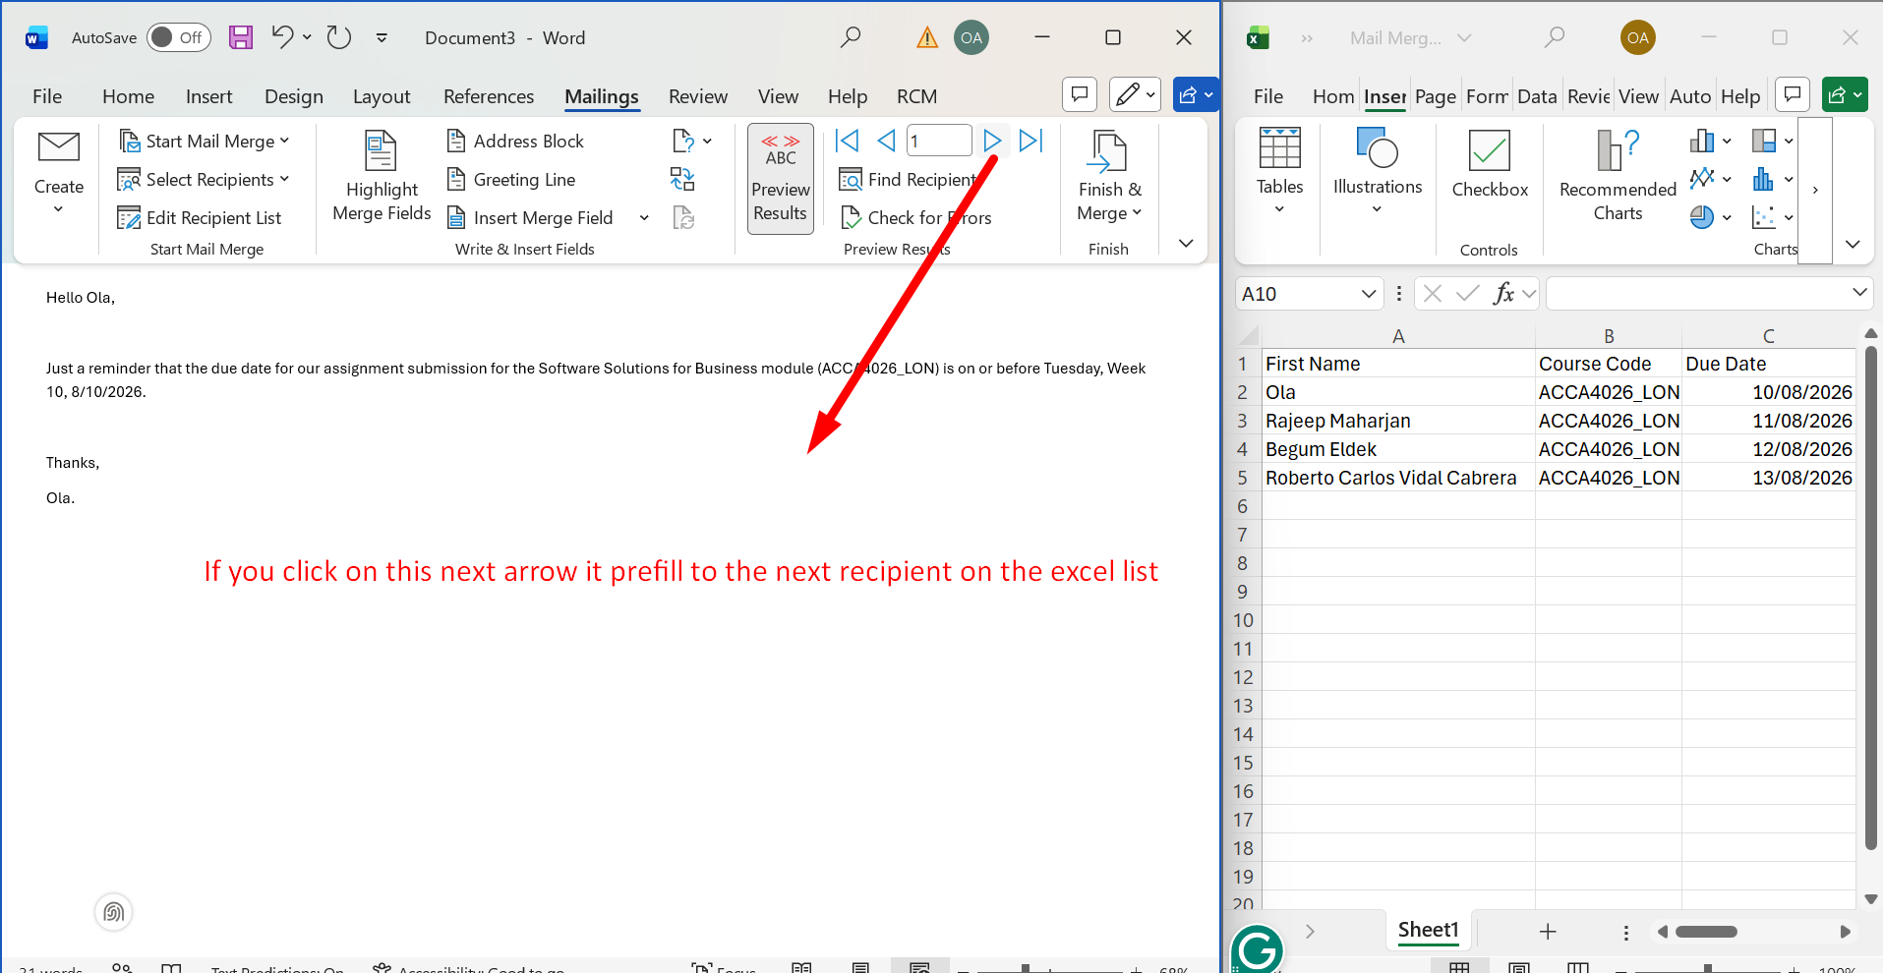
Figure 17: Click on Next arrow to automatically prefill every recipient on the spreadsheet to the document.
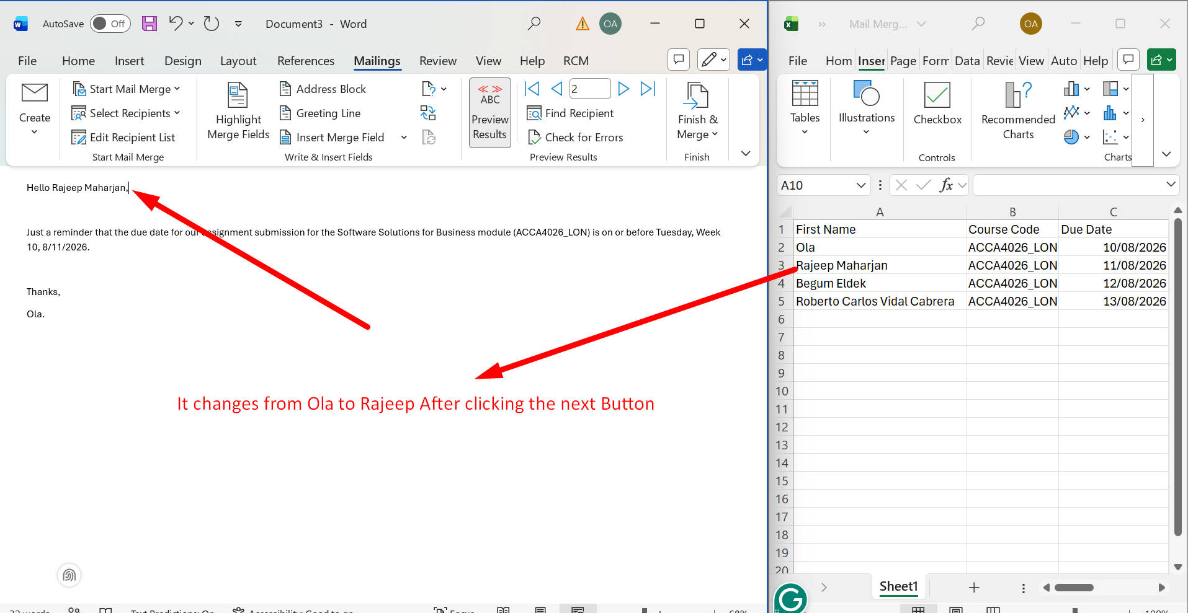
Figure 18: Automatic prefilling works.
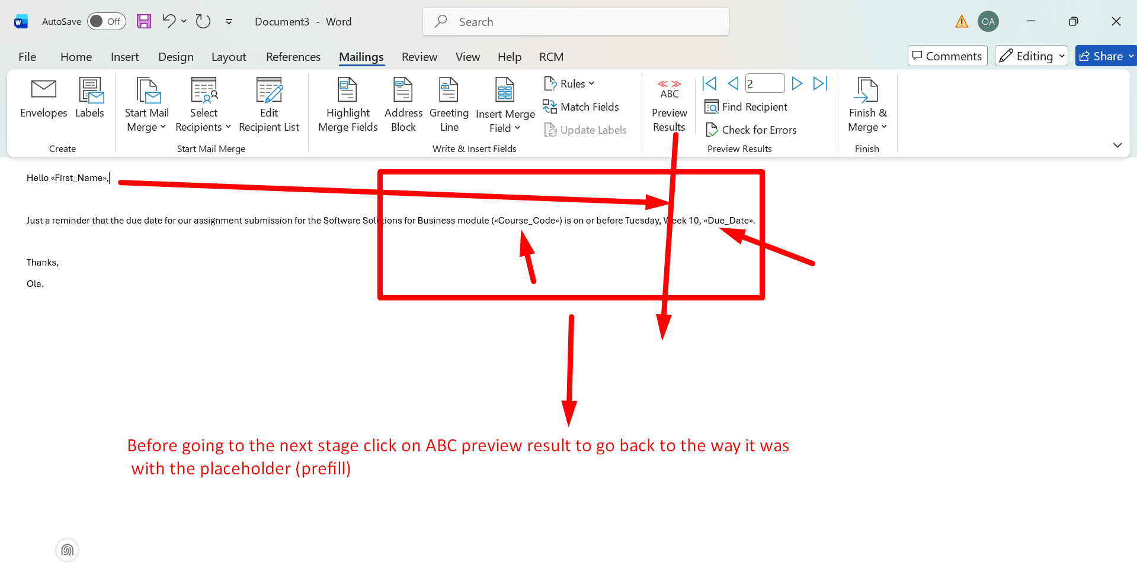
Figure 19: Click on ABC Preview Result to go back to the previous Placeholder format.
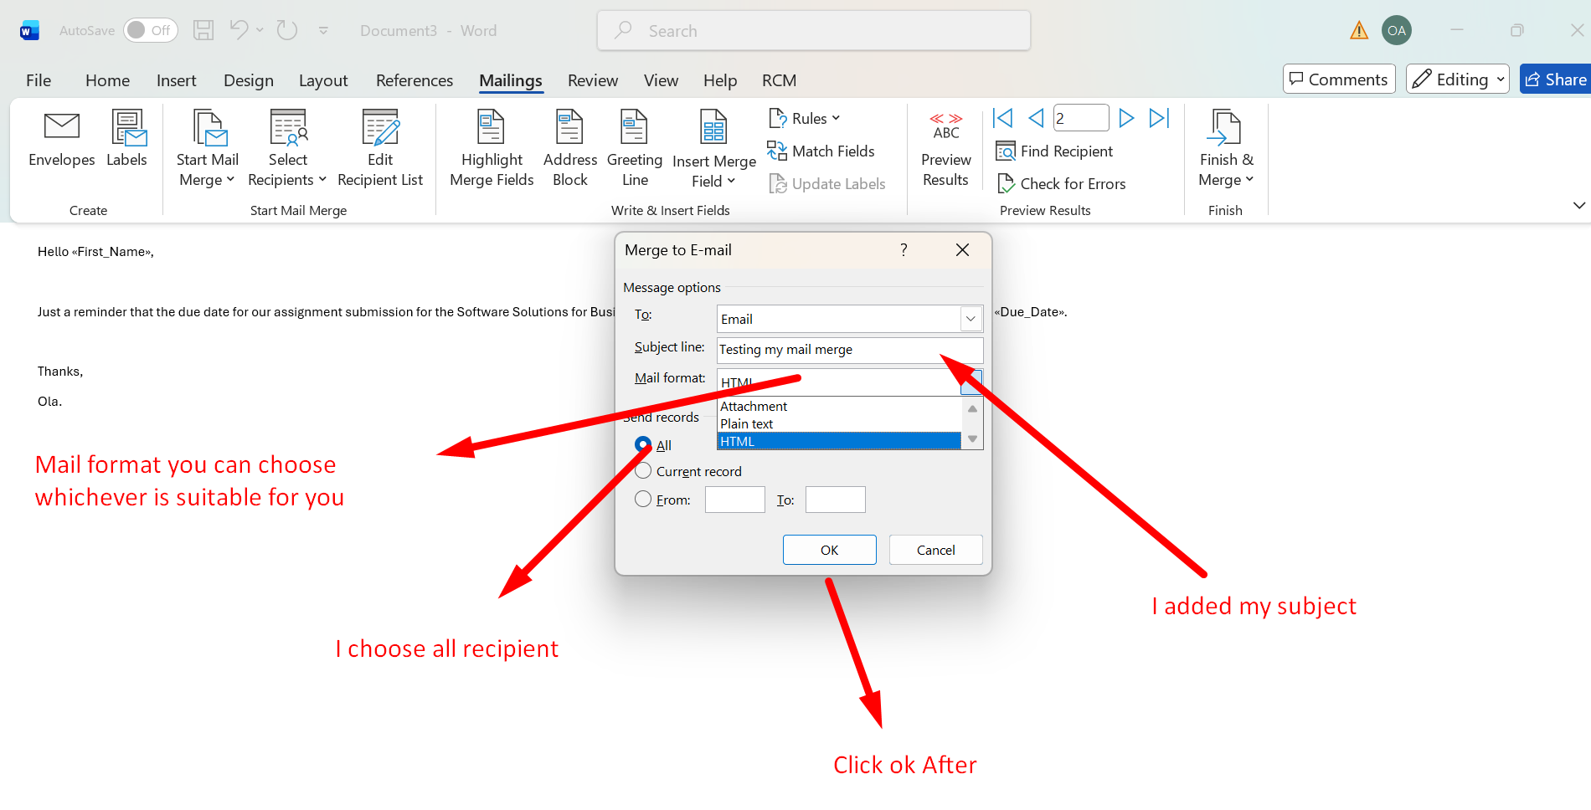
Figure 20: Pop-up showing Mail format, subject, recipient, then click ok to send Mail Merge.

If Statement
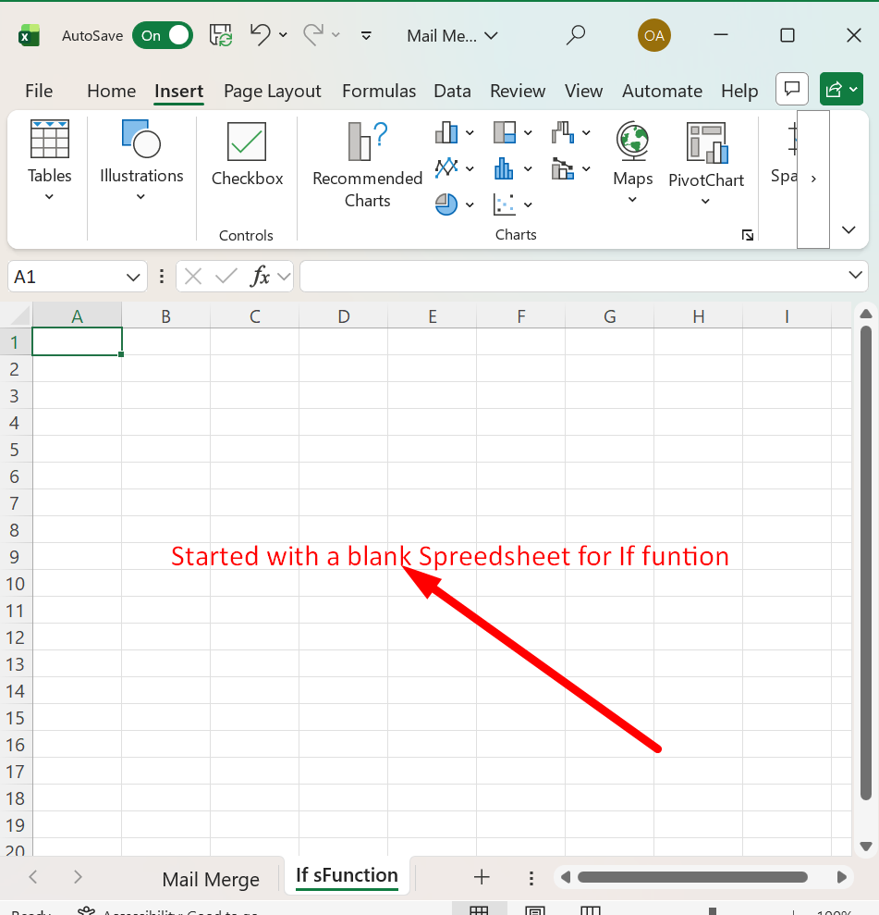
Figure1: Started with Blank Spreadsheet.
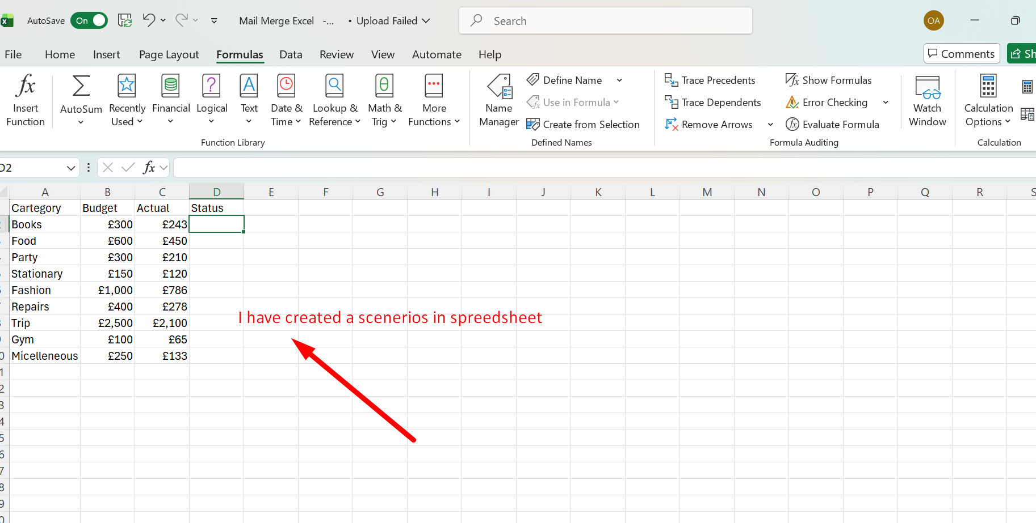

Figure 2: Created a Scenario.

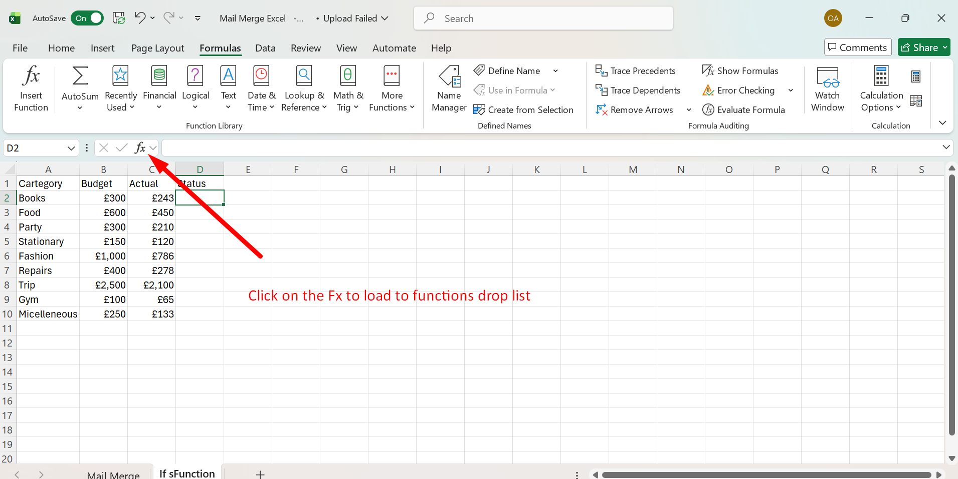

Figure 3: Clicked on Fx to load drop list.

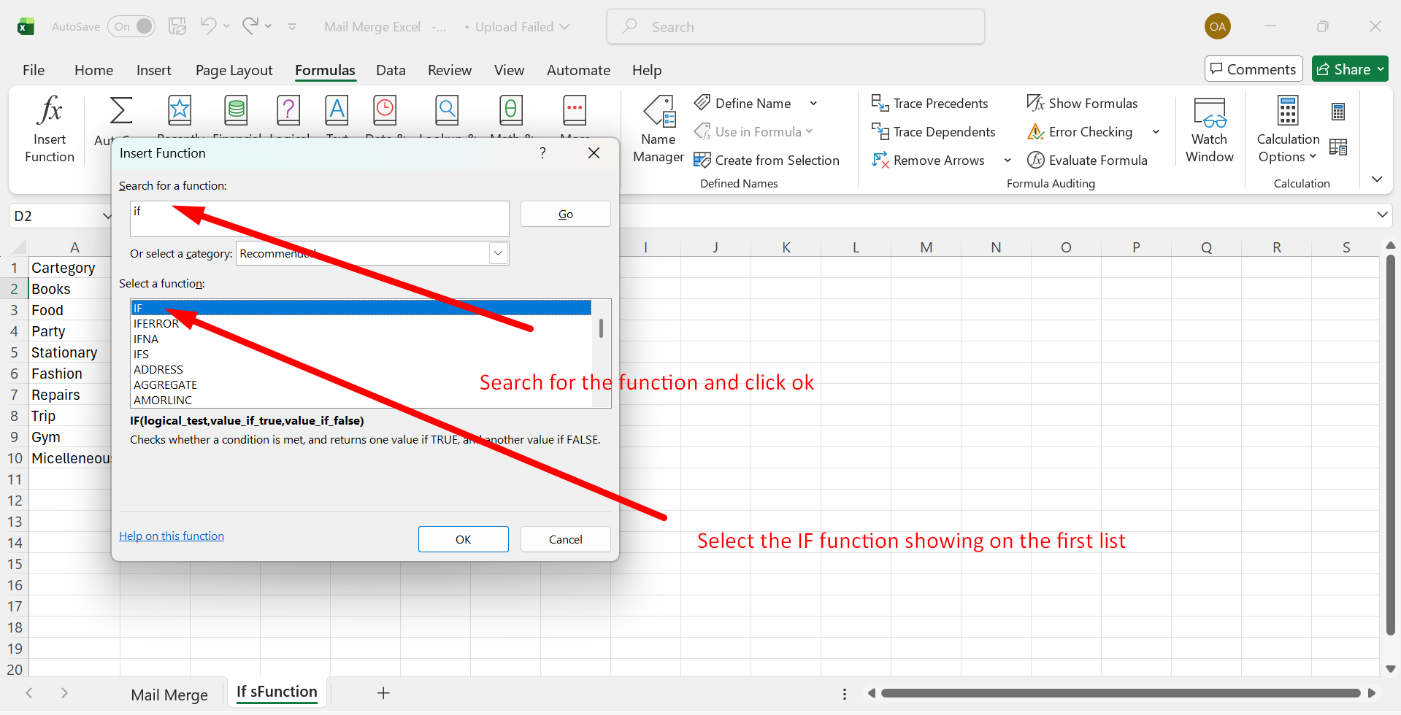

Figure 4: Searched IF from the search box and selected IF function from the list.

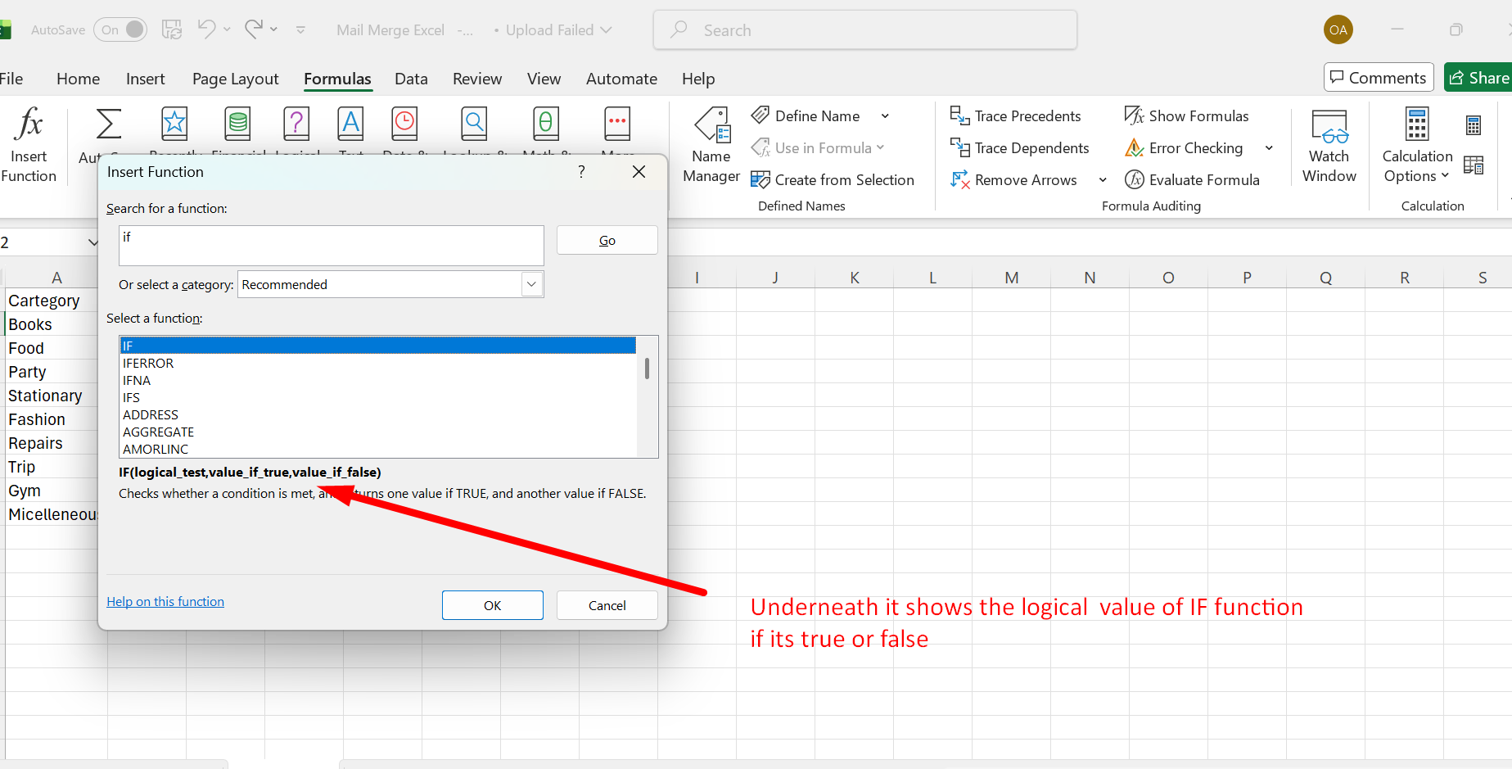

Figure 5: Logical Values.
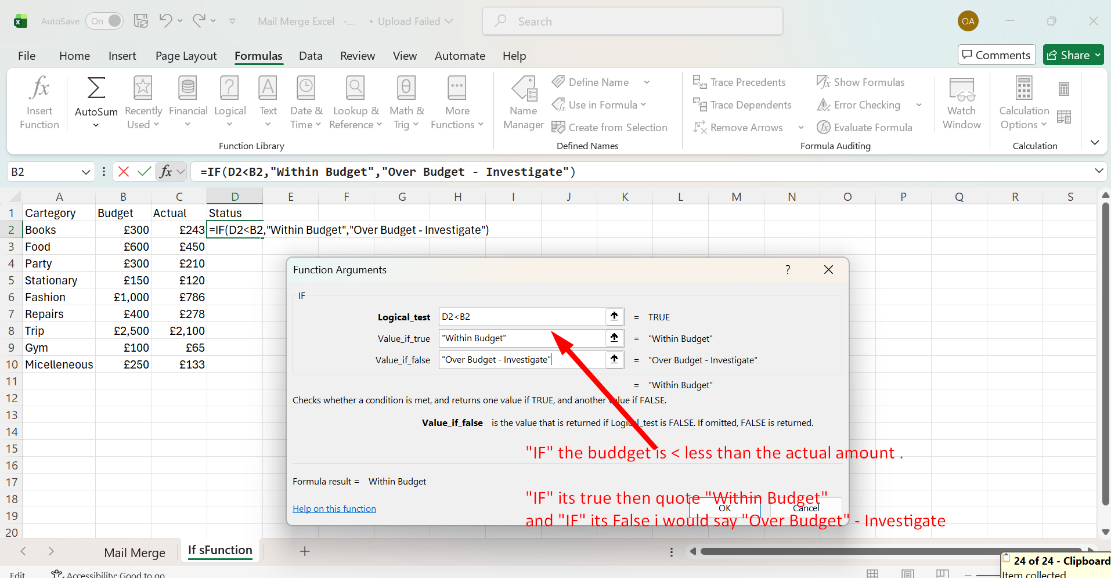
Figure 6: "IF" the budget is less than the actual amount.
"IF" it's true, then quote "Within Budget" and "IF" it's false, I would say "Over Budget" – Investigate.
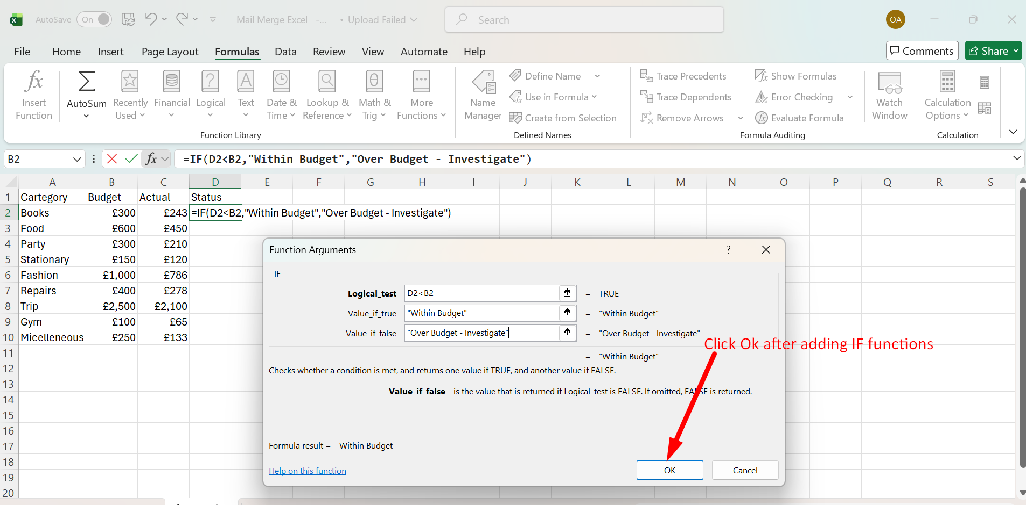

Figure 7: Click Ok after adding IF functions Value.

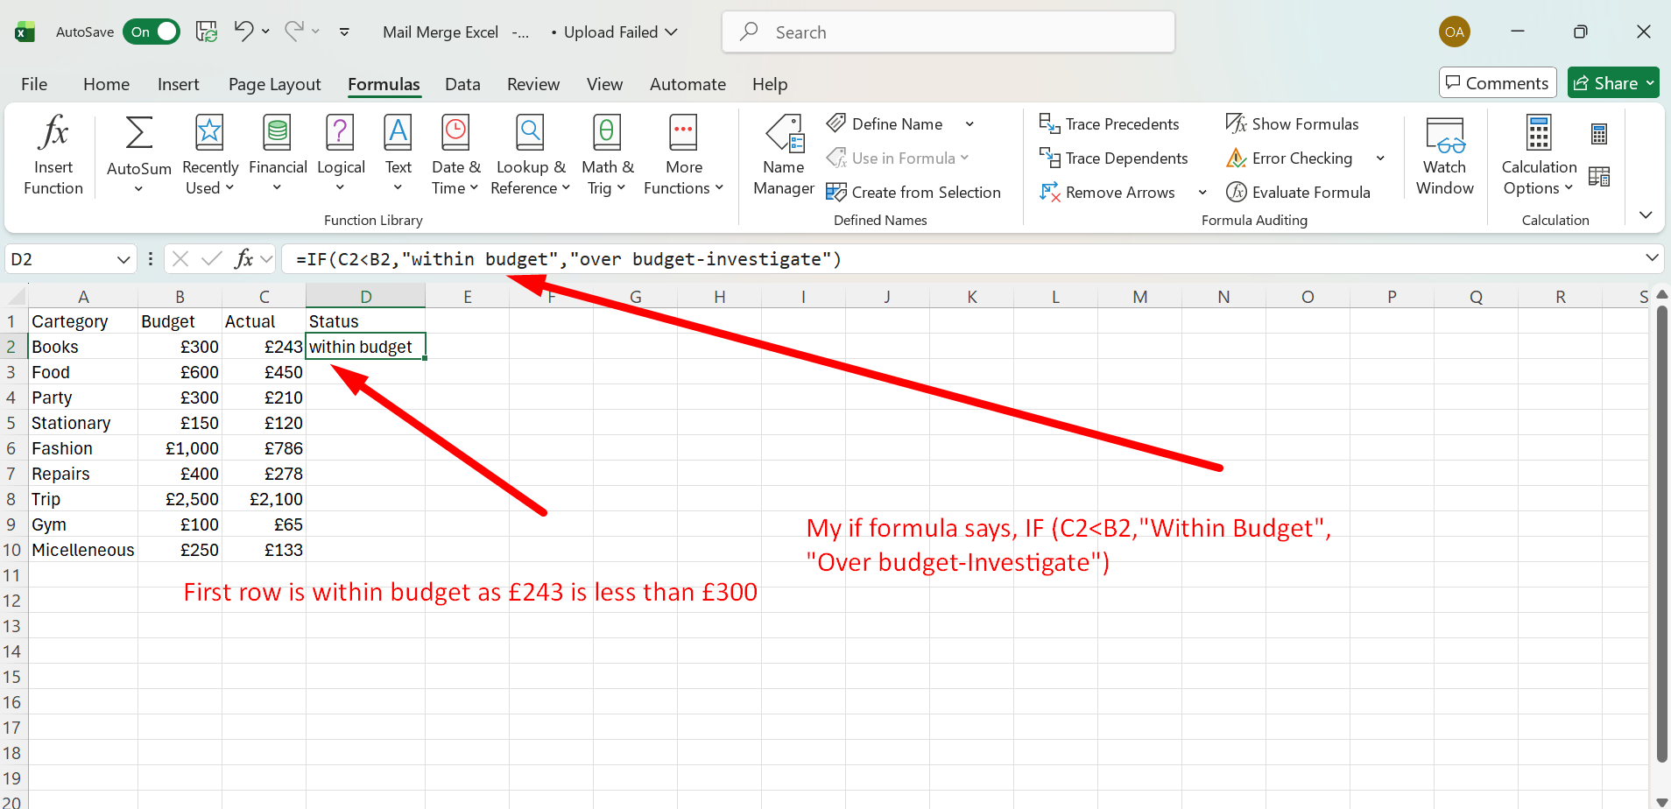

Figure 8: IF functions Value : =IF(C2<B2,"within budget","over budget-investigate")
First row is within budget as £243 is less than £300.

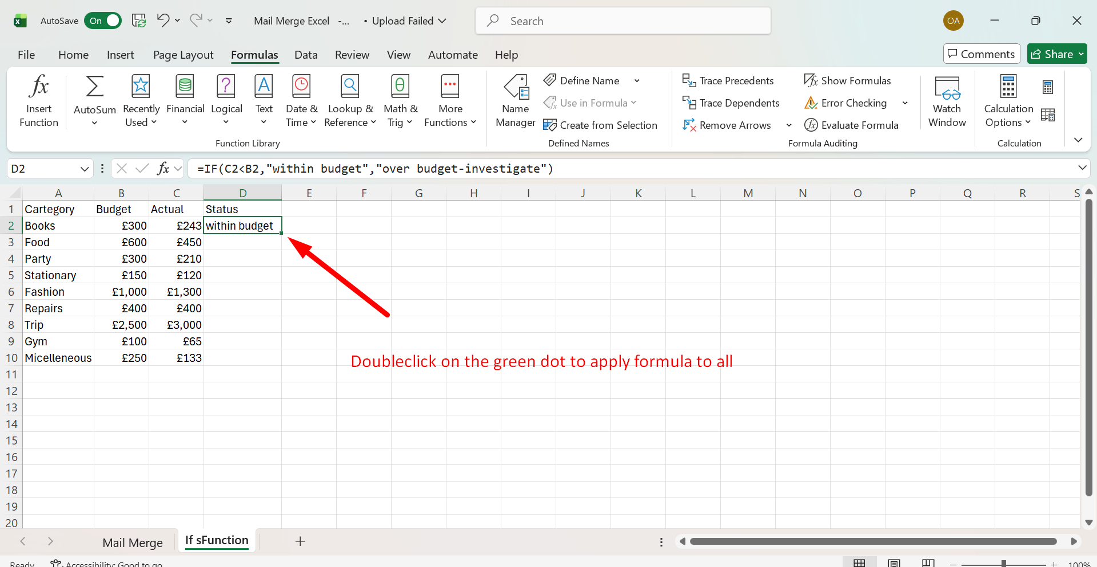

Figure 9: Double-click on the green dot to apply IF formula to all.

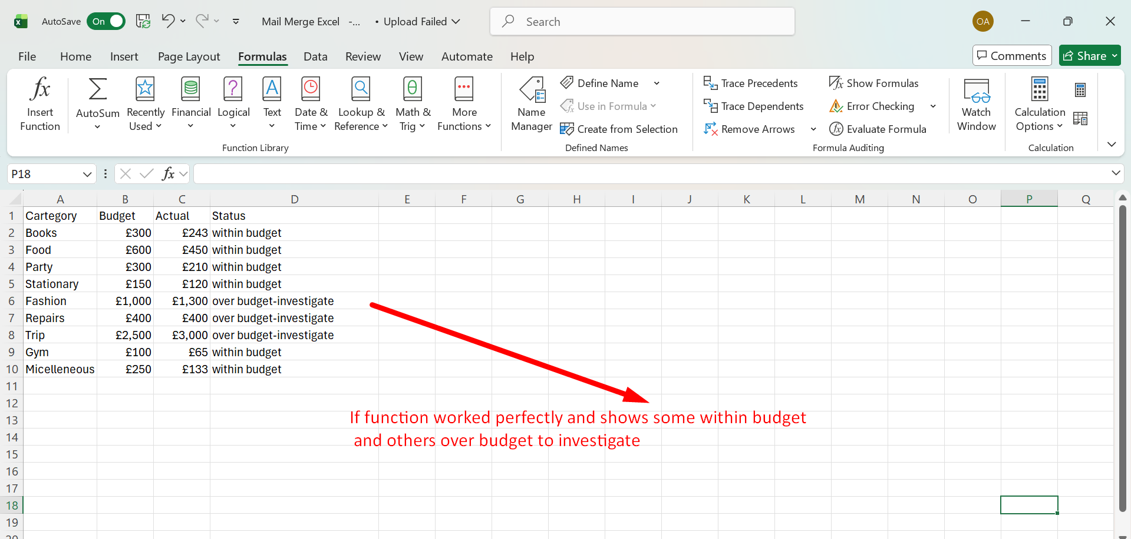

Figure 10: IF function worked perfectly and shows some within budget and others over budget to investigate.

Task 4. Communication and Collaboration applications

One contemporary Communication and one Online Collaboration applications/tools

MS Outlook
Microsoft Outlook: A Modern Communication Tool

Microsoft Outlook is a vital resource for today's business communications, serving as an all-in-one personal information manager that integrates email, calendar, contacts, and tasks into a unified platform. It serves as a central hub for professionals, enabling them to manage their digital correspondence and schedules effectively. As a contemporary communication application, Outlook excels at improving daily operations by integrating multiple communication channels and productivity tools, accommodating both individual and large-scale organisational collaboration. [26]

Key Features of Microsoft Outlook

Consolidated Inbox and Multi-Account Management:
Outlook allows users to manage multiple email accounts from different providers, including Gmail, Yahoo Mail, iCloud, and Microsoft Exchange, through a single interface. This unified inbox consolidates communications in one location, reducing the necessity to alternate between multiple applications or platforms. Users can conveniently switch between accounts or view them simultaneously, which is especially beneficial for professionals who manage multiple organisational profiles.

Calendar and Scheduling Integration:
The built-in calendar is crucial for effective time management. Users can plan appointments, organise and manage meetings with participants, and check invitee availability using the Scheduling Assistant. The calendar additionally allows users to set up Teams meetings directly from an event, enabling smooth communication and collaboration. Reminders help ensure that critical deadlines and appointments are adhered to.

Advanced Email Management and Productivity:
Outlook provides robust tools to handle inbox congestion. Users can establish custom folders, create rules to automatically sort incoming emails, and use colour-coded categories for better visualisation of related items. The Focused Inbox feature smartly separates important messages from those that are less urgent. Moreover, the "snooze" function allows users to momentarily set aside less critical emails until they’re ready to address them.

Tasks and To-Do Management:
Outlook’s task management capabilities enable users to develop and monitor to-do lists, assign tasks to others, and track progress. Emails can be flagged so they automatically show up in the To-Do list, turning correspondence into actionable items. This function works with Microsoft to Do to ensure task synchronisation across the Microsoft ecosystem.

Enhanced Communication Features:
The application includes tools to facilitate effective communication. The people card, which can be accessed by hovering over or selecting a contact's name, offers a detailed view of the individual's contact details, recent files, messages, and organisational background. For users with a Copilot license, the people card can also provide conversation summaries and context-sensitive suggestions. AI-powered features like Copilot can summarise lengthy email threads, formulate replies, and provide advice on tone and clarity, thereby significantly enhancing productivity.

Offline Functionality and Collaboration:
The new Outlook for Windows features robust offline options, enabling users to read and write emails, update their calendars, and prepare messages for dispatch once they are back online. This ensures that productivity is maintained even during internet connectivity problems. Additionally, Outlook improves team collaboration through shared mailboxes, providing a centralised email hub.

Cross-Platform Availability:
Outlook is accessible on a variety of platforms, including Windows, Mac, iOS, and Android, ensuring a consistent user experience across devices. The mobile app includes features like voice search and "Play My Emails" for hands-free use. [27]

b. Microsoft Teams: A Contemporary Online Collaboration Tool

Microsoft Teams stands out as a premier platform for online collaboration, acting as the central hub for teamwork within the Microsoft 365 suite. It aims to unite individuals across work, home, and school environments, allowing them to remain connected and complete tasks from any location. The platform facilitates instant messaging, inclusive meetings, file sharing, task management, and collaborative document work with individuals both within and outside an organisation, while upholding strong security and compliance standards. As a result, Teams has become an essential resource for modern businesses functioning in remote, hybrid, or traditional office settings.

Key Features

Teams and Channels: Teams are groups of people, content, and tools connected to various projects or objectives. Within each team, channels serve as specialised sections that keep discussions and content organised according to specific topics, projects, or fields. There are three primary types of channels: Standard channels are accessible to all team members; Private channels are limited to a select group of team members; and Shared channels allow secure collaboration with individuals inside and outside the organisation. This structure helps teams maintain focus and ensures that the appropriate individuals have access to relevant information.

Chat and Instant Messaging: Central to Teams is its chat feature, which minimises email overload and enables swift, focused conversations. Users can send messages that include files, links, emojis, stickers, and GIFs in one-on-one chats, group chats, or channel discussions. This functionality encourages open communication and immediate feedback, helping teams stay synchronised and organised.

Online Meetings and Events: Teams supports high-quality audio and video conferencing, with features such as screen sharing, background blurring, live captioning, and meeting recording. Meetings can accommodate up to 1,000 interactive participants, with a view-only option for up to 20,000 attendees. Additionally, Teams supports Webinars for structured, interactive sessions with registration and Q&A features, as well as Live Events for broadcasting to wide audiences. With Teams Premium, intelligent recap uses AI to automatically generate meeting notes, suggest tasks, and highlight personalised content.

Calls: Teams Phone offers a secure, integrated calling solution that combines traditional and modern features. Users can make and receive voice over IP calls between Teams clients, as well as calls to landlines and mobile phones via the Public Switched Telephone Network (PSTN). Features like voicemail transcription and group call pickup enhance the overall experience beyond that of traditional telephone services.

Apps and Workflows: Teams functions as an extensible platform that brings together various daily work applications into a single interface. Users can incorporate apps from the Teams App Store, develop low-code solutions through the Microsoft Power Platform, or create custom applications to fulfil organisational requirements. This integration enables teams to work with familiar tools like Planner for task management, Whiteboard for visual collaboration, and Power BI for data analysis, all without switching between applications.

Security and Compliance: Microsoft Teams delivers enterprise-level security, including two-factor authentication, single sign-on through Active Directory, and encryption of data both in transit and at rest. Its advanced compliance features encompass eDiscovery, sensitivity labels, retention policies, data loss prevention, and communication compliance, ensuring that organisations can safeguard their business data and adhere to regulatory mandates. [28]

Test one feature of a freely available Communication (1) and one feature of a Collaboration (1) application and document several screenshots with brief accompanying descriptions to provide evidence of practical use.

Outlook


Figure showing Outlook Logo: [29]

Microsoft Teams Communication and Collaboration Screenshots.

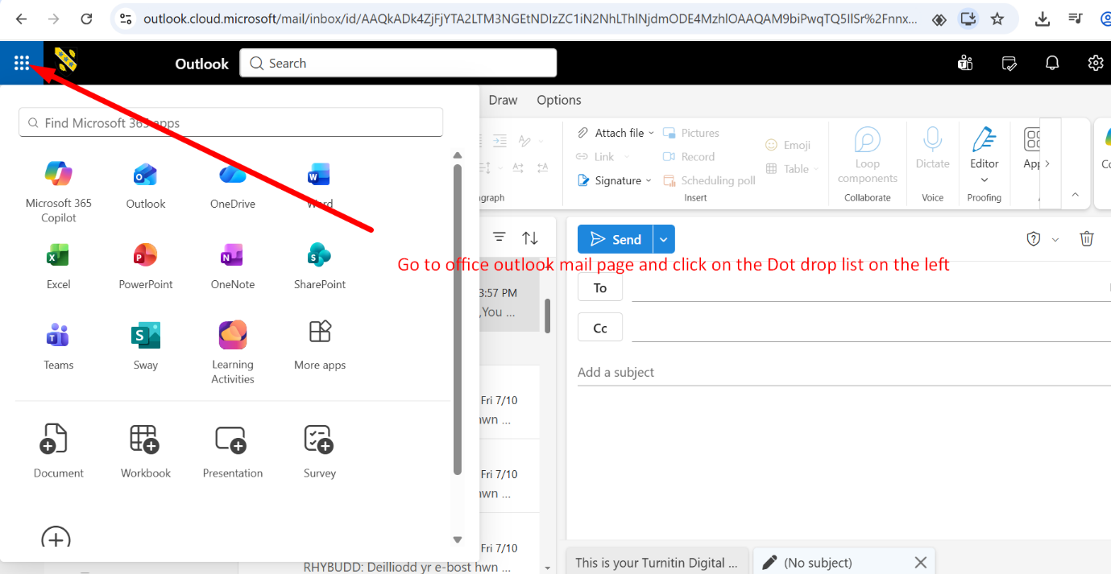
Figure1: Click dot menu
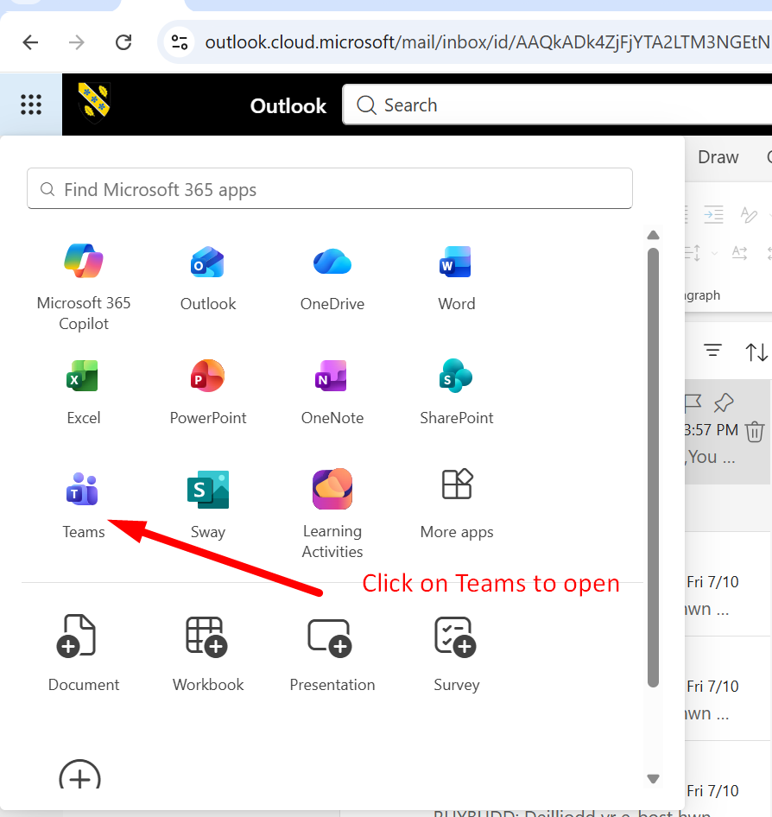
Figure 2: Click Teams to open
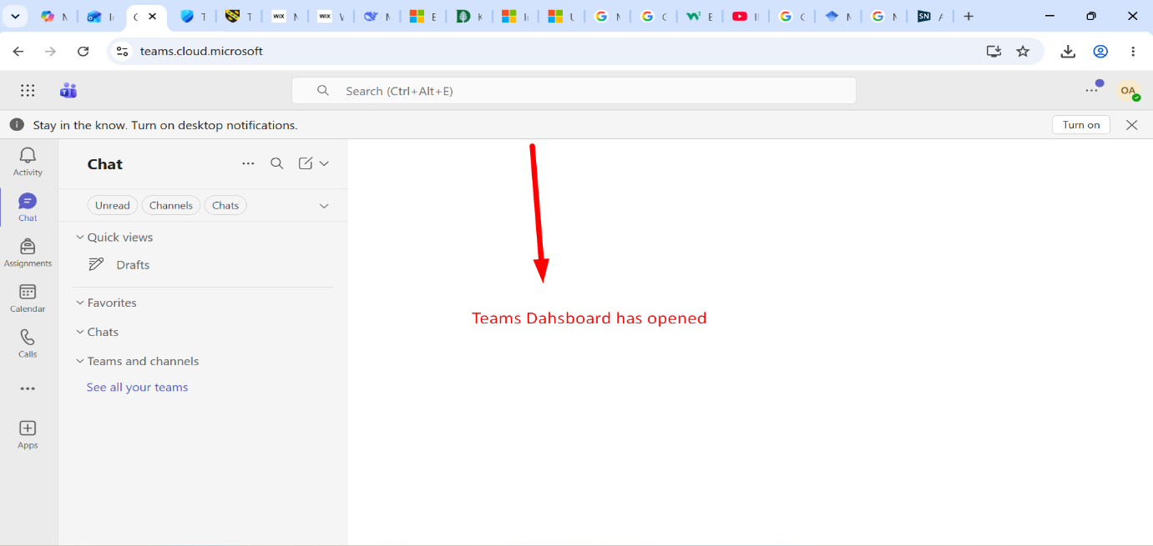
Figure3: Teams Dashboard.

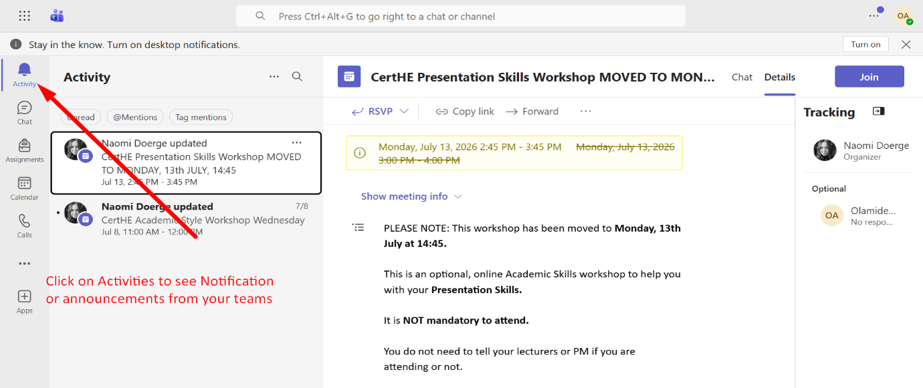
Figure4: Activities.

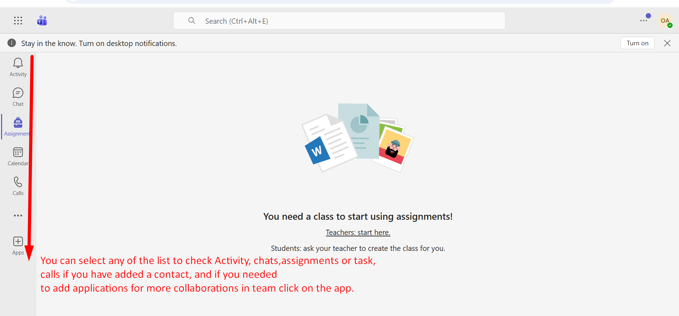
Figure 5: Select options.

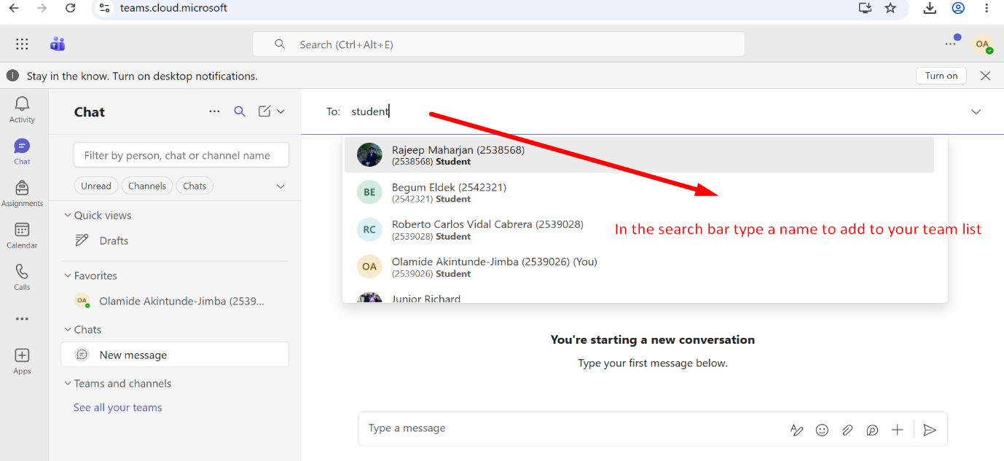
Figure 6: Search Bar.
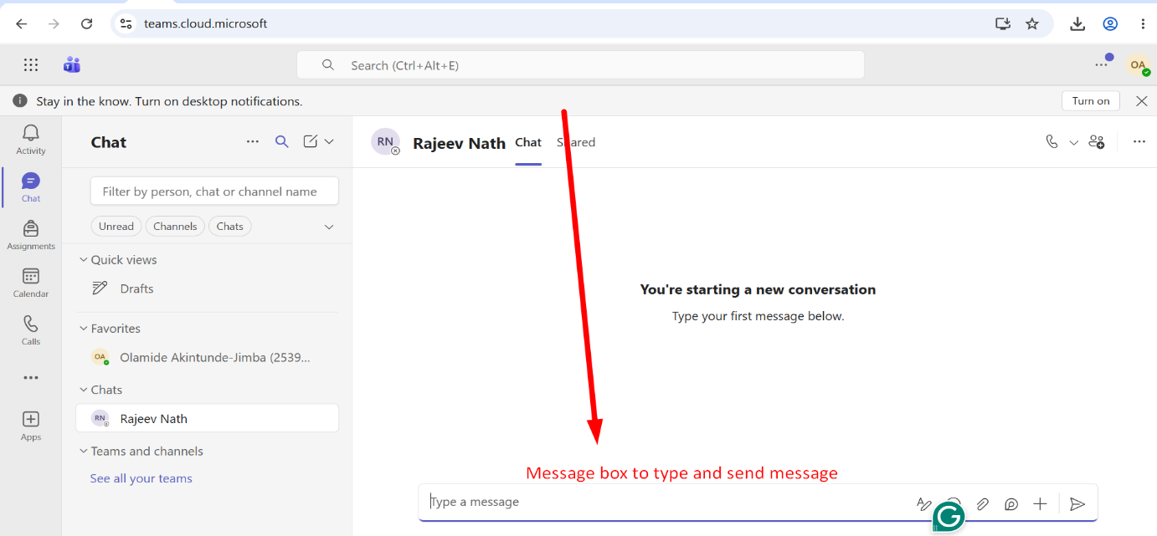
Figure 7: Message box.

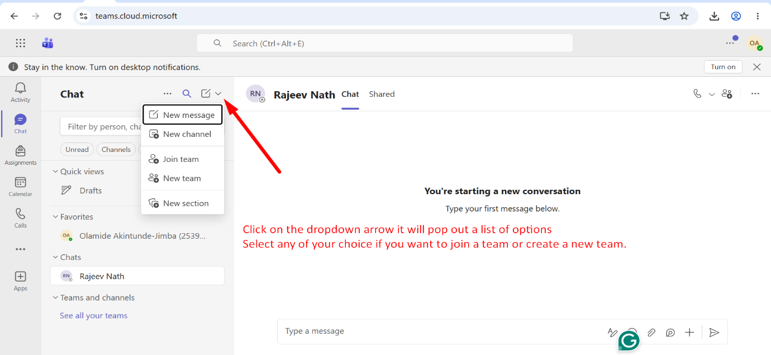
Figure 8: Dropdown List to invite Team.
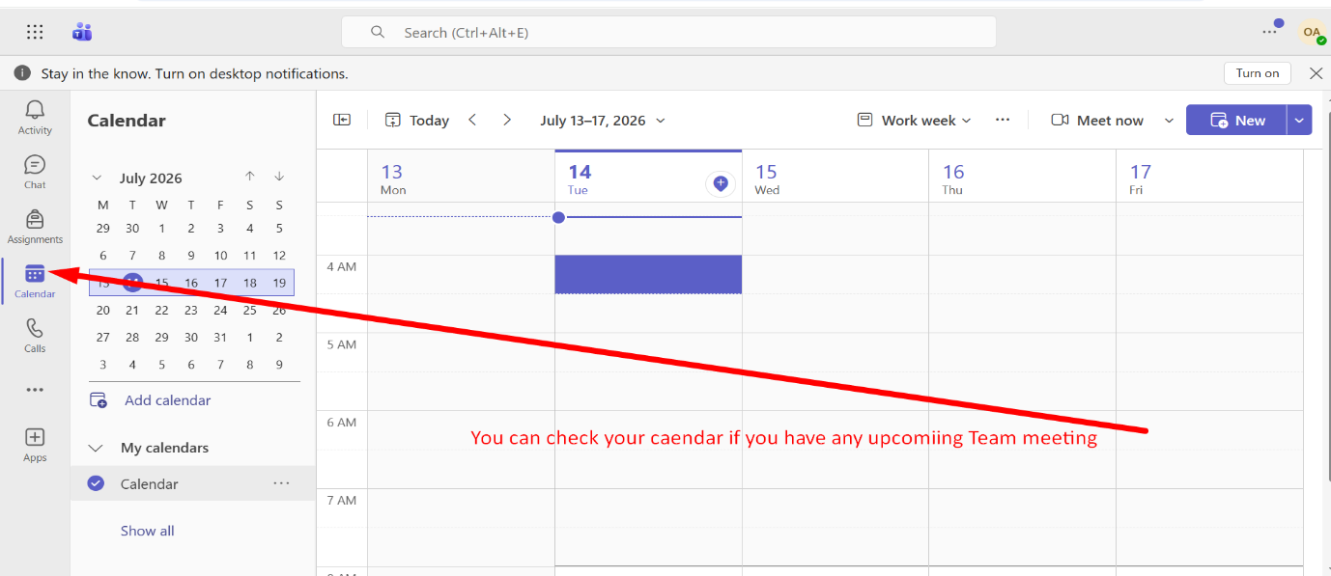
Figure 9: Calendar.

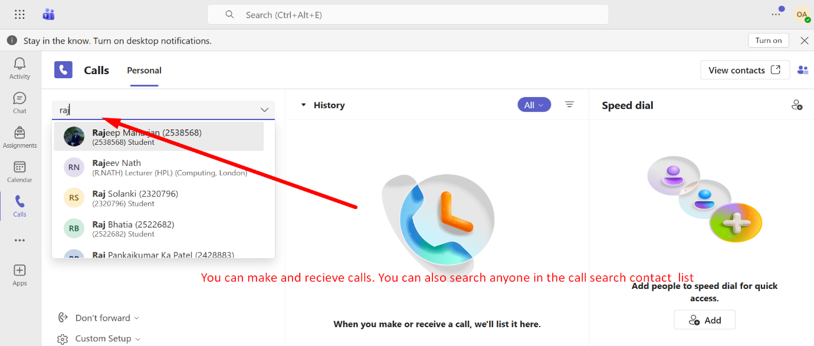
Figure 10: Calls.
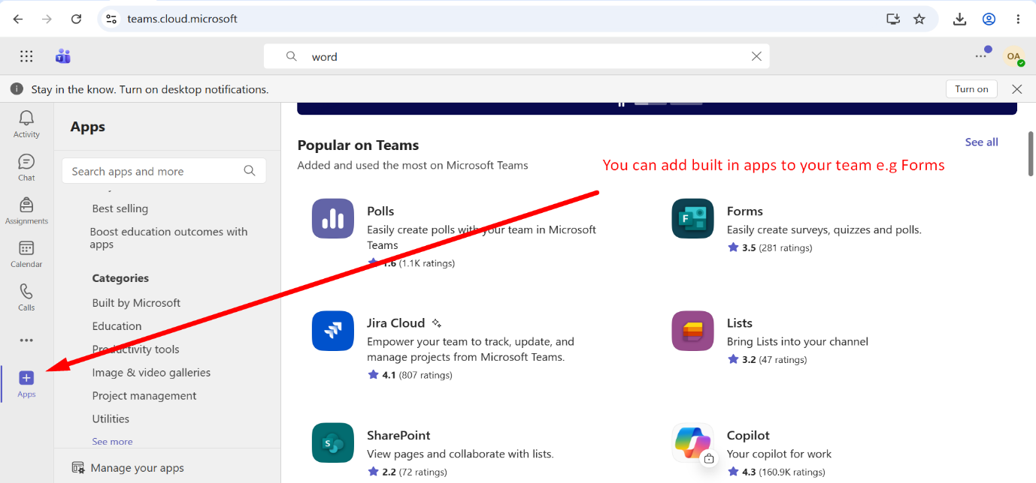
Figure 11: Apps.

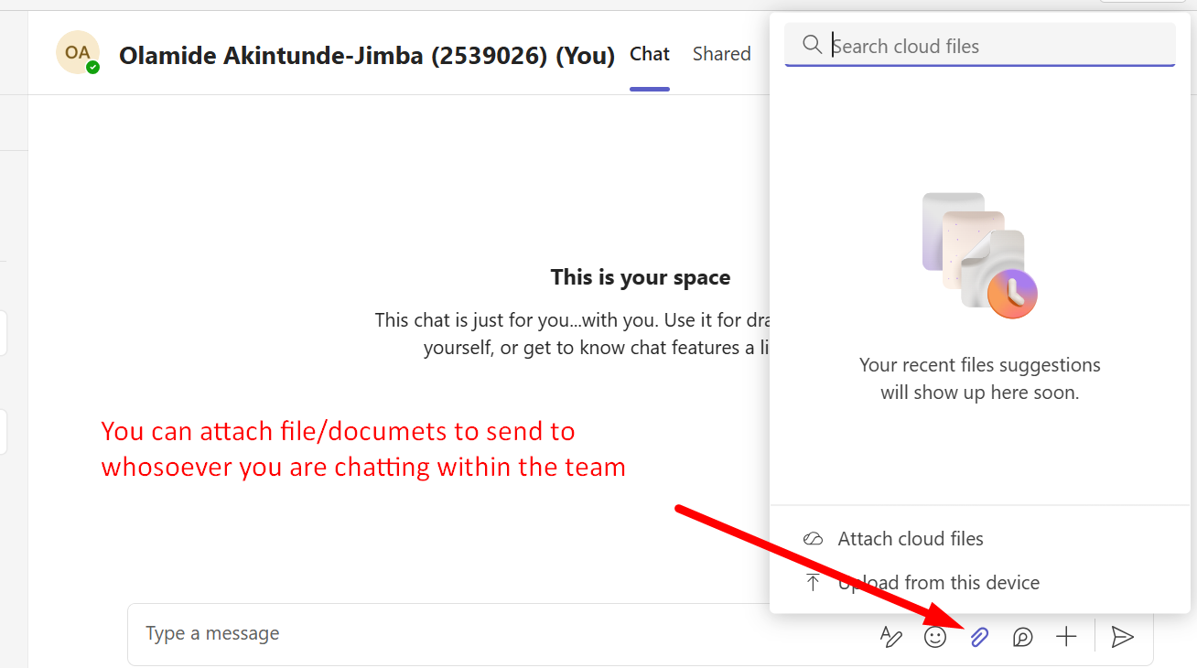
Figure 12: Attachments.

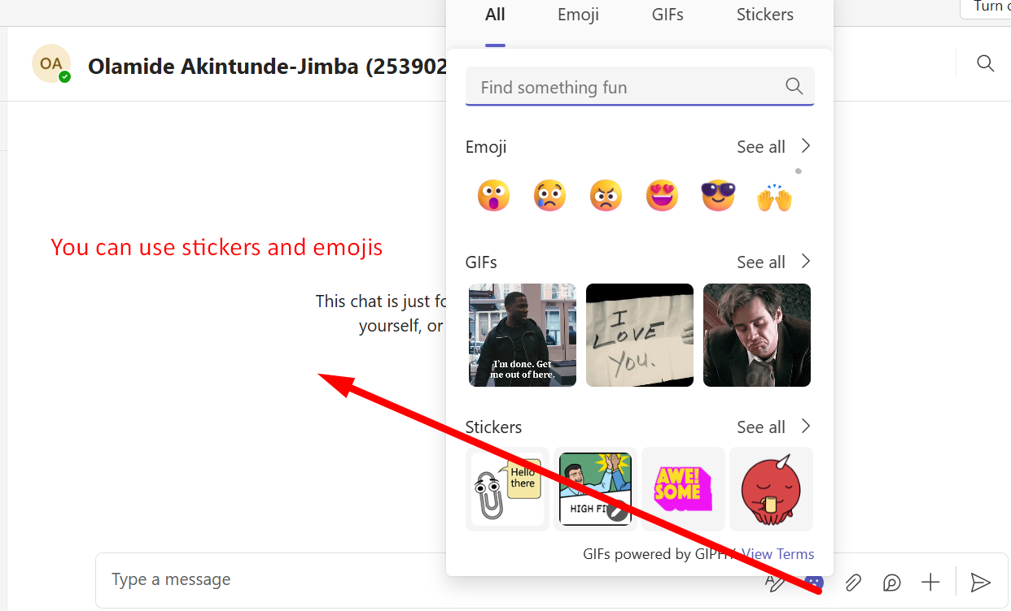
Figure 13: Emojis

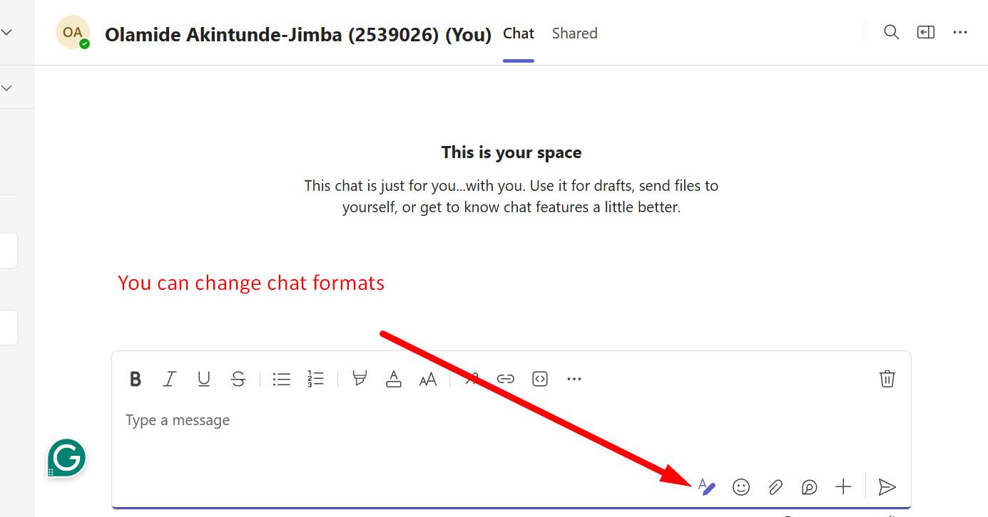

Figure 14: Change Fonts.

Conclusion
In conclusion, this project has examined a range of essential software applications that support modern business operations. The analysis covered e-commerce platforms such as Shopify and Wix, which enable businesses to create and manage online stores. It also explored key Microsoft Office applications, including Word, PowerPoint, Excel, and Access, highlighting their roles in document creation, presentations, data analysis, and database management. Furthermore, communication and collaboration tools such as Microsoft Outlook and Microsoft Teams were reviewed, demonstrating how they facilitate efficient teamwork and information sharing in today’s digital workplace.

The mind map created for this project provides a visual overview of these contemporary software applications, illustrating their interconnections in supporting day-to-day business activities. Each tool discussed offers unique features and benefits that contribute to improved productivity, efficiency, and decision-making within the organization.

Overall, this project emphasizes the importance of selecting the right software solutions to meet specific business needs. By understanding the capabilities and limitations of these applications, businesses can make informed decisions that align with their operational goals and promote long-term growth.

References

[1] | “Shopify,” 06 June 2026. [Online]. Available: https://cdn.shopify.com/s/files/1/0090/9236/6436/files/how_does_shopify_work_-_pagefly_blog_1024x1024.png?v=1729061975.
[2] | “Coursera,” 06 July 2026. [Online]. Available: https://www.coursera.org/articles/what-is-shopify.
[3] | “searchenginejournal,” 06 July 2026. [Online]. Available: https://www.searchenginejournal.com/wix-changed-how-websites-are-built-and-why-you-should-pay-attention/488221/.
[4] | “wix website builder,” Monday July 2026. [Online]. Available: https://www.wix.com/blog/how-to-make-a-nonprofit-website-for-free. [Accessed Monday July 2026].
[5] | “Adobe Ideas,” Monday July 2026. [Online]. Available: https://www.adobe.com/express/learn/blog/mind-map-ideas.
[6] | “Venngage,” Tuesday July 2026. [Online]. Available: https://venngage.com/blog/mind-map-examples/.
[7] | “theknowledgeacademy,” The Knowledge Academy Ltd , Monday July 2026. [Online]. Available: https://www.theknowledgeacademy.com/blog/what-is-microsoft-office/.
[8] | “PCMag,” Tuesday July 2026. [Online]. Available: https://uk.pcmag.com/office-suites/33886/16-microsoft-word-tips-you-need-to-learn-now?p=1.
[9] | “Wordwall,” Tuesday July 2026. [Online]. Available: https://wordwall.net/resource/97544358/parts-of-ms-word-window.
[10] | “wikimedia,” Tuesday July 2026. [Online]. Available: https://commons.wikimedia.org/wiki/File:Microsoft_Office_PowerPoint_%282025%E2%80%93present%29.svg.
[11] | “thetraininglady,” Tuesday July 2026. [Online]. Available: https://www.thetraininglady.com/powerpoint-window/.
[12] | “microsoft,” Tuesday July 2026. [Online]. Available: https://support.microsoft.com/en-us/powerpoint/create-and-save-a-powerpoint-template.
[13] | “slidemodel,” Tuesday July 2026. [Online]. Available: https://slidemodel.com/how-to-collaborate-in-powerpoint/.
[14] | “slideegg,” Tuesday July 2026. [Online]. Available: https://www.slideegg.com/adaptability.
[15] | “arcsystems,” Tuesday July 2026. [Online]. Available: https://www.arcsystems.co.uk/news/benefits-of-microsoft-office-365-for-businesses/.
[16] | I. Bekebrede, “SEA Specialist at 2GO Software,” Microsoft PowerPoint: features, benefits and where to buy?, 22 November 2024.
[17] | “codecademy,” Tuesday July 2026. [Online]. Available: https://www.codecademy.com/search?query=excel.
[18] | “goskills,” Tuesday July 2026. [Online]. Available: https://www.goskills.com/excel/resources/jobs-require-excel.
[19] | “facebook.com,” Tuesday July 2026. [Online]. Available: https://www.facebook.com/100090634735520/videos/25-excel-formulas-every-office-user-should-know-boost-productivity-save-time-and/919963571044629/.
[20] | “educba,” Tuesday July 2026. [Online]. Available: https://www.educba.com/protect-sheet-in-excel/.
[21] | “facebook.,” Tuesday July 2026. [Online]. Available: https://www.facebook.com/CNCNnortheast/posts/power-up-your-spreadsheet-skills-learn-essential-excel-techniques-in-micro-cours/1191642405942113/.
[22] | “BMC,” Tuesday July 2026. [Online]. Available: https://www.bmc.com/blogs/dbms-database-management-systems/.
[23] | “mindmajix,” Tuesday July 2026. [Online]. Available: https://mindmajix.com/microsoft-access-tutorial.
[24] | “Janbasktraining,” Tuesday July 2026. [Online]. Available: https://www.janbasktraining.com/blog/microsoft-access-intro-guide/.
[25] | “Scaler Topic,” 8 Jan 2024. [Online]. Available: https://www.scaler.com/topics/ms-access/.
[26] | “Microsft Learn,” Tuesday July 2026. [Online]. Available: https://learn.microsoft.com/en-us/training/modules/compose-send-mail-new-outlook-windows/4-advanced-mail-concepts?wt.mc_id=aihub_Outlook4Windows_webpage_wwl&ns-enrollment-type=learningpath&ns-enrollment-id=learn.wwl.discover-new-outlook-windows.
[27] | “Dartmouth Services Portal,” [Online]. Available: https://services.dartmouth.edu/TDClient/1806/Portal/KB/Article/171563/Getting-Familiar-with-Outlook-to-Help-Productivity.
[28] | “Microsoft Learn,” [Online]. Available: https://learn.microsoft.com/en-gb/training/modules/explore-teams/2-explore-teams.
[29] | “zapier,” Tuesday July 2026. [Online]. Available: https://zapier.com/blog/outlook-tips-and-tricks/.

