Jardines del Humaya
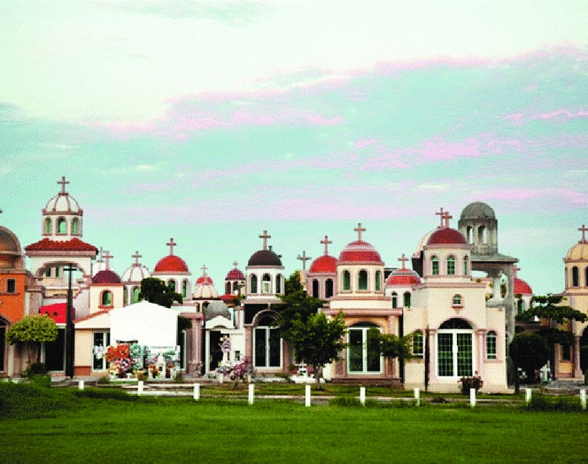
By looking at the image it can be seen that there is a cross on the highest points of all of the buildings. This shows that this is a Christian Necropolis, there are outliers to this idea as a few buildings do not have crosses on their highest point. However, this could be put down to damage over time, or due to the Context of this being a Necropolis known for dead gang members, it could be a sign of vandalism. Every building in the photo is white and almost identically shaped, this could point to there being limited designs open to each family because there is some difference in the tile colouring of the roof. Though this layout of a graveyard is atypical to the western world Christian graveyards there is similarity in the capitalism shown in the limited and not highly personalised design of each mausoleum.
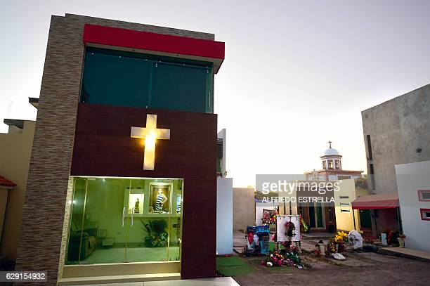
In the bottom right corner of this image there is a sofa that can be clearly seen, this suggests that there is a strong culture of visiting the deceased for long periods of time. Also, journalists state that it is common to have air conditioning in the mausoleum, this backs up the idea that those who knew the dead would visit for long periods of time the air conditioning required to keep the place cool in the hot Mexican weather. The glass that can be seen in the photo is bullet proof, this is extremely common in this graveyard all of the mausoleums have it installed, from this we can assume that there is a cultural unwritten rule that though you may respect your dead you do not have to respect the dead or grieving people.
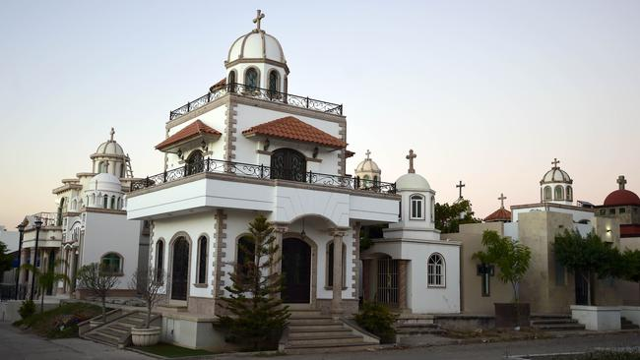
In the image, the mausoleums are shaped in a similar way to churches, with the domed roofs and the adorning cross as well as the architectural flourishes that go along with the look. This could be done to symbolise, that the person inside is akin to a saint and that their mausoleum is a tribute to their remains. By looking at the shrubbery in the photo it could be suggested that the deceased are very well looked after as the plants seem to be kept in shape and health, this suggests that these were people that either had a large amount of money or came from a large amount of money, therefore these mausoleums must be for people of upper middle class to upper class.
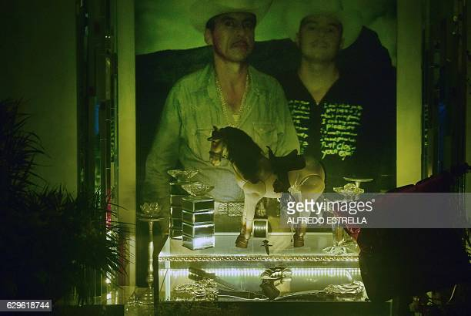
In the photo on the right the is an image of either one or two people buried in a mausoleum, with a table that has items which may show their cultural values on. The horse in the centre tells of a passion for riding given as it is equipped with a saddle, this links back to a ‘cowboy’ Heritage combined with the hats worn in the image in the photo that backs this up. Below the horse sits a model dagger made of a shiny material looking like silver, this bring connotation of wealth gained by violent means, an assumption gained by the context of the Necropolis it was taken in. we can tell that the person or people that died were young and died of violent causes as in the photo in the image both of them look to be under 40 years old. Below the horse and dagger protected by glass is a revolver with two knifes this shows us that however is buried here that these items were valuable to him, this could allow us to understand the fact that he was a violent individual from a criminal background.
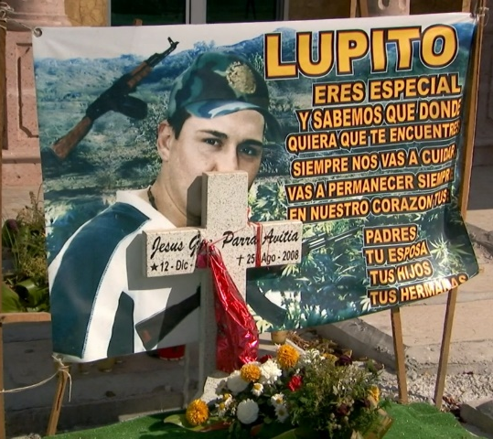
this image was found outside of a mausoleum, the translation is ‘you are special, and we know that wherever you are you will always take care of us. You will remain in our hearts your father, your wife, your children, your sisters.’ From this we are able to find out that there is leniency for personalisation as this is something that is not seen on other mausoleums. The language used is very formal still which points to a capitalistic run ‘death service’ with limited options. we can learn about the common culture from the gun in the background of the poster it would suggest a lot of violence and ‘gang’ culture which would be fitting for the graveyard it is in.

