

Name – Joseph Humphreys

Student Number – 2504075

Course – HNC Quantity Surveying

Module – Fundamentals of Construction Technology

Introduction-
This report presents a preliminary study for a proposed development at Swansea foreshore that includes a restaurant, ice cream parlour, and manager’s apartment. The project is a joint venture with Marriott Hotels. The aim is to assess the site’s suitability for construction by examining its history, ground conditions, potential risks, relevant laws, and possible foundation types. Understanding these factors is important to make sure the project is safe, cost-effective, and meets all legal requirements. This report uses historical records, specialist reports, and building regulations to provide an overview of what the development will need. The Swansea foreshore has a rich industrial and cultural history which impacts site suitability and regulatory compliance.
This building is to contain a restaurant, café bar, ice cream parlour, a fully fitted kitchen and food stores etc on the ground floor. On the second floor, there will be a self-contained managers apartment, meeting rooms and staff welfare facilities.

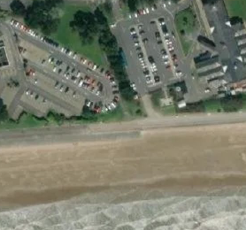
(Caldwell, 2025)
The aerial image of the proposed site at Swansea foreshore shows that the development is located directly adjacent to the coastline, with a promenade separating the land from the beach. This highlights that the site is in a coastal and exposed location, which has important implications for construction, particularly in relation to flood risk, wind exposure and saltwater corrosion.
The site is surrounded by existing development, such as the county of Swansea and the Marriot hotels which already have large existing car parking areas. This suggests that the area is already well-developed and benefits from good access, infrastructure, and foot traffic, which is highly suitable for a restaurant and ice cream parlour. The presence of nearby parking is also a major advantage, as it improves accessibility for visitors and customers.
However, the proximity to the sea introduces several challenges. The site is likely to experience high moisture levels, strong coastal winds, and salt-laden air, all of which can affect building materials and long-term durability. Materials used in construction will need to be resistant to corrosion, particularly metals and reinforced concrete elements.
History of this proposed site-
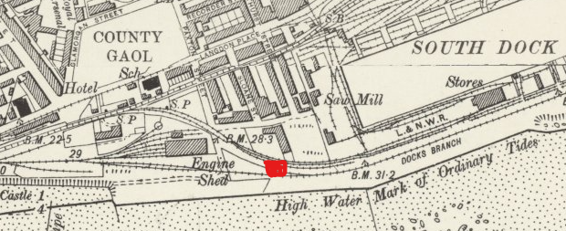
(Caldwell, 2025)
In the 19th to early 20th century, the land between what is now the Swansea Marriott Hotel and County Hall formed part of Swansea’s extensive docklands and industrial waterfront. This area was closely tied to the town’s global prominence in copper smelting and maritime trade, with wharves, warehouses, rail sidings, and industrial yards dominating the shoreline. Vessels carrying coal, copper ore, and finished metals moved through nearby docks, and the landscape would have been dense with chimneys, cranes, and workers’ infrastructure rather than open space. It was a functional, heavily industrialised environment shaped entirely by Swansea’s role as a major export hub. (University of South Wales, 2020) (Swansea Council, 2023)
By the mid-20th century, this same area had entered a period of decline. As global industrial patterns shifted and Swansea’s copper industry contracted, the docklands lost much of their commercial importance. Bomb damage from World War II had already disrupted parts of the town, and although the waterfront was not as heavily rebuilt as the city centre, the wider industrial ecosystem weakened significantly. By the 1950s and 1960s, many dockside facilities were underused or abandoned, leaving stretches of cleared or derelict land. The area that would later become car parks was likely a mix of disused industrial plots, storage yards, and leftover infrastructure awaiting a new purpose. (Swansea University, n.d) (Swansea Council, 2023)
In the late 20th century, the character of the area changed completely through deliberate redevelopment. During the late 1970s and early 1980s, Swansea Council reshaped the waterfront into a civic and leisure zone. The construction of County Hall (opened in 1982) marked a key phase in this transformation, with surrounding land laid out for access roads and surface parking. Shortly after, the Maritime Quarter development introduced hotels, a marina, and new public-facing spaces, including the Swansea Marriott Hotel. The car parks between these buildings were not accidental remnants but part of a planned modern landscape designed to support car access in an era when waterfront regeneration prioritised convenience and open space over dense urban form. (Swansea Council, 2023)
The Marriott hotel was constructed as part of this regeneration scheme, designed to support tourism and business in the area (Swansea Bay News, 2026)

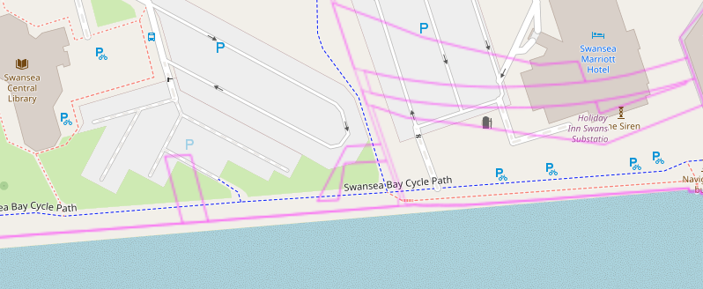
(Google Maps, 2025)

Ground conditions-
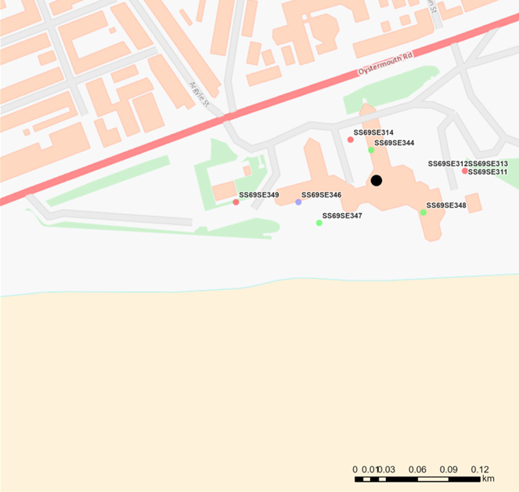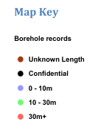(BGS, 2023)

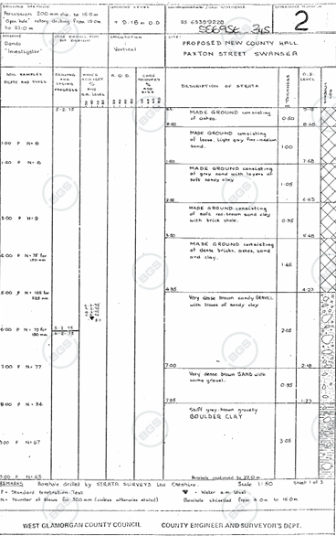
(British Geological Survey, 2016)
Borehole data from the nearby County Hall Swansea site shows a shallow layer of made ground made up of construction waste and dock-related material, over very stiff boulder clay and mudstone bedrock at about 7.6 m depth. This indicates that the area has been heavily altered through past dockland activity and redevelopment, with natural soil layers buried beneath engineered fill. The made ground is likely weak and variable, increasing the risk of differential settlement, while the clay may also be affected by moisture changes. Although the mudstone provides a strong foundation layer, its depth means shallow foundations are not suitable, so piled foundations are recommended to transfer loads safely into the competent bedrock.
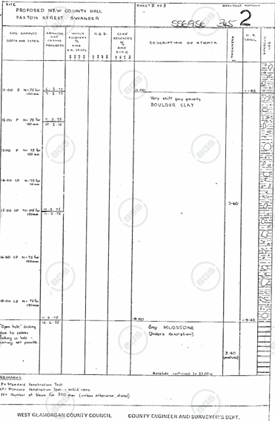
Geomorphology-
Originally, the area near Swansea Bay was flat coastal land, formed naturally by sand, gravel, and mud from the sea and the nearby River Tawe. Over time, this natural ground was changed by building docks and other industrial uses, especially around Swansea Docks. To create more usable land, materials like soil, ash, and rubble were added on top, a process called land reclamation. So today, the ground is not completely natural—it has a top layer of man-made fill, with natural sand, gravel, and clay underneath. (Coflein, no date).

Mining History-
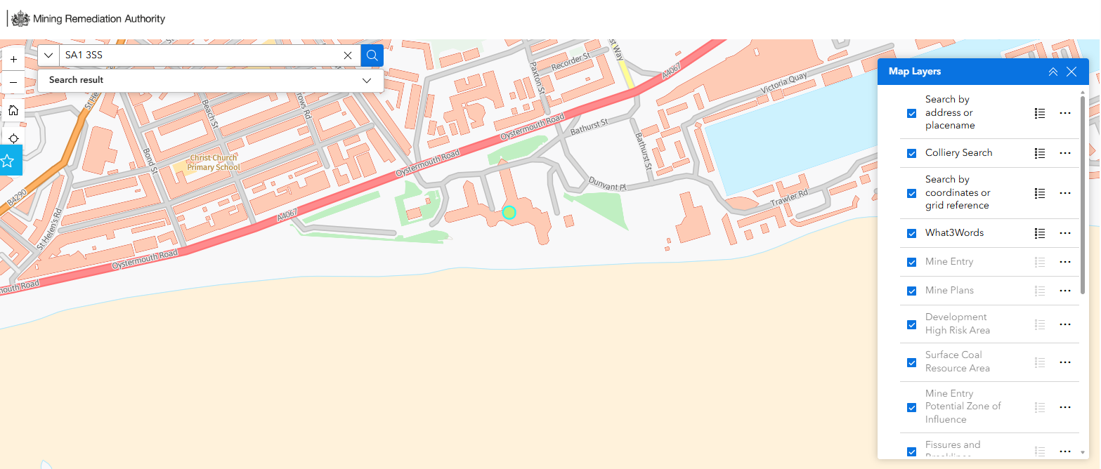
As shown above, In this proposed site, there is no evidence of direct mining shafts under that exact site, but it is heavily influenced by nearby coal mining through industrial use (gas works and dockland reclamation), resulting in artificial ground composed of industrial waste overlying natural dense sands, gravels, and clay.
mine
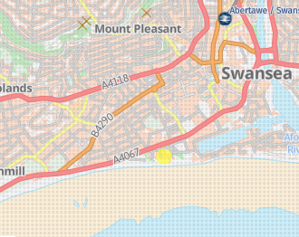
site
As shown above, labelled (x) the nearest coal mining entry to this is in mount pleasant, so there should be no threats from mining risks.
(Mining Remediation Authority, 2021)

Prior contamination in this area-
As mentioned before, there has been a lot of activity on this site through the years such as industrial use like docklands and gas associated work. Gas works sites are well known for leaving behind a lot of contaminants on site. This consists of items such as heavy metals and hydrocarbons which can stay in the ground long after redevelopment. Finally, Given the coastal location and proximity to the River Tawe, there is also potential for leaching and migration of contaminants into groundwater. As a result, the site would typically require a detailed contamination assessment, including soil and groundwater testing, and possibly remediation measures before construction to ensure it is safe for development.

Risks to economy-
When construction begins on the site, it can present risks to local ecosystems. Waste generated during works may introduce metals and hydrocarbons into nearby water systems, which can harm aquatic life. In addition, noise and vibration from construction activities may disturb or negatively affect sensitive marine species. Disturbed soil and imported construction materials can also introduce invasive species, which may outcompete native plants and animals and disrupt the ecological balance.

Subsidence risk-
Due to the history of land reclamation and industrial use, the risk of ground subsidence in the area between the car parks near Swansea Bay is moderate to high. The artificial ground may be compacted unevenly which could cause uneven settlement. Additionally, the underlying natural soils such as sands, clay and gravels may shift if groundwater levels change, particularly given the proximity to the River Tawe and the beach coast

Hydrogeology and Hydrology
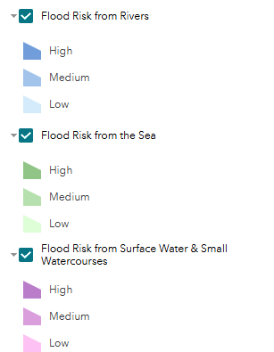
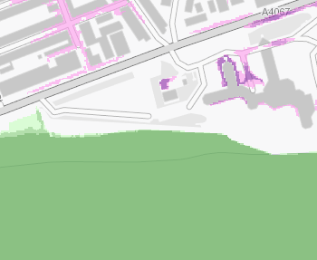
(Naturalresources.wales, 2025)

As shown in the above flood risk map above, the proposed area I have been given to work on has a moderate to high risk of flooding, mainly from the sea and heavy rainfall. Being close to the coast means it can be affected by high tides and storms, while built-up areas like roads and car parks increase the chance of surface water flooding when it rains. There is little risk from rivers, although the nearby River Tawe may have a small influence. Overall, the site is at risk of flooding because it is low-lying and close to the coast.
The artificial ground on this site, which has been constructed using a range of previously identified materials shown in the borehole logs, overlies glacial deposits such as till. These deposits contain multiple layers of clay, which have low permeability and therefore do not allow water to drain easily. As a result, water becomes trapped, leading to the formation of perched water tables above the main groundwater level.

Building regulations-
The development must comply with several key regulations and standards to ensure safety and performance.
Approved Document A (Structure) requires that the building is structurally stable and capable of safely transferring loads to the ground. This is particularly important for sites with weak or variable soil conditions. (HM Government, 2024a).
Approved Document C (Site Preparation and Resistance to Contaminants and Moisture) addresses issues related to ground contamination and moisture. It requires proper site investigation, remediation where necessary, and measures to prevent damp and water ingress. (HM Government, 2024b).
Approved Document H (Drainage and Waste Disposal) ensures that wastewater and surface water are effectively managed. This is especially relevant for a restaurant, which generates grease and high volumes of wastewater. (HM Government, 2024c)
Approved Document M (Access to and Use of Buildings) ensures that the building is accessible to all users, including those with disabilities. (HM Government, 2024d)
In addition to Building Regulations, the project must follow Eurocode 7 for geotechnical design, as well as British Standards such as BS 5930 and BS 10175. (Planning Portal, 2024).
Local authorities-
Swansea Council is responsible for granting planning permission and ensuring compliance with Building Regulations. Building Control officers will inspect the construction to ensure it meets required standards. (Swansea Council, 2024).
Natural Resources Wales oversees environmental protection and flood risk management. They may require flood risk assessments and provide guidance on contamination and water management. (Natural Resources Wales, 2024).
The Environmental Health Department ensures that the site is safe for public use, particularly in relation to contamination and public health risks. (Swansea Council, 2024).

Contact details for involvement-
Swansea Council (Local Authority)
- Website: https://www.swansea.gov.uk
- General Enquiries: +44 (0)1792 636000
- Planning Department Email: planning@swansea.gov.uk
- Building Control Email: building.control@swansea.gov.uk

Natural Resources Wales (NRW)
- Website: https://naturalresources.wales
- General Enquiries: +44 (0)300 065 3000
- Email: enquiries@naturalresourceswales.gov.uk

Environmental Health Department (Swansea Council)
- Website: https://www.swansea.gov.uk/environmentalhealth
- Phone: +44 (0)1792 635600
- Email: pollution@swansea.gov.uk

Foundation choice -draw
My foundation choice for this building at this proposed site is a pile foundation. Pile foundations are long structural elements that transfer loads from the building to deeper soil levels which are more stable as at this site, we are dealing with weak surface soils such as made ground. By transferring loads to deeper strata, they reduce the risk of settlement and improve overall stability.
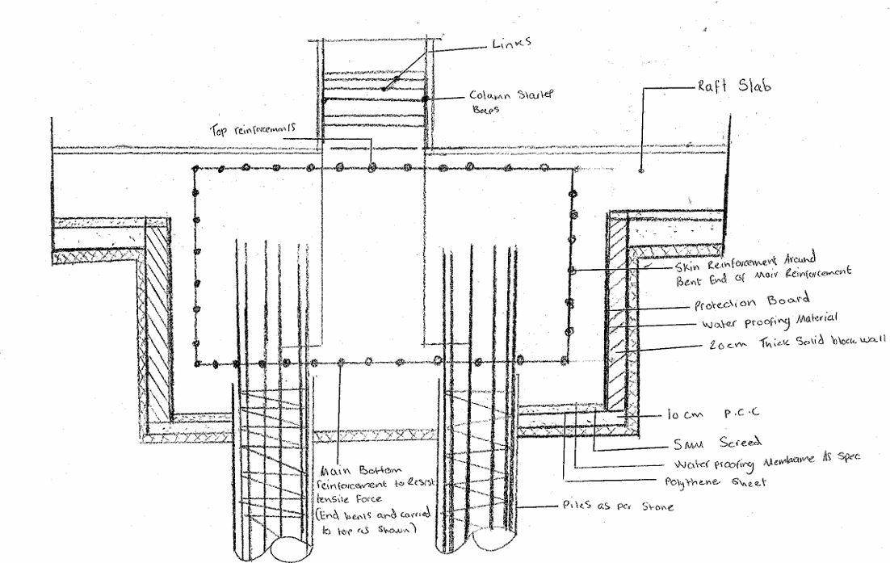

Own drawing based on (The Structural World, 2018)

Conclusion-
The Swansea foreshore site poses several challenges because of its industrial past, reclaimed ground, and coastal setting. These conditions are likely to result in inconsistent soil properties, possible contamination, and elevated groundwater levels.
A comprehensive site investigation is therefore necessary to verify ground conditions and guide the design. Piled foundations are considered the most suitable option, as they provide stability and help reduce the risk of uneven settlement.
Adhering to Building Regulations and working closely with relevant local authorities are essential for the project’s success. Addressing these requirements early in the design stage will help ensure the development is safe, compliant, and efficiently delivered.

References-
BGS (2023) GeoIndex - British Geological Survey. Available at: https://mapapps2.bgs.ac.uk/geoindex/home.html (Accessed: 23 April 2026).
British Geological Survey (2016) Borehole records. Available at: https://maps-bgs.opendata.arcgis.com/datasets/borehole-records/explore (Accessed: 23 April 2026).
Caldwell, D. (2025) SA1 3SS postcode. Available at: https://www.streetlist.co.uk/sa/sa1/sa1-3/sa1-3ss (Accessed: 23 April 2026).
Coflein (no date) Swansea Gasworks and Dockland Sites. Available at: https://coflein.gov.uk/ (Accessed: 16 April 2026).
Google Maps (2025) Google Maps. Available at: https://www.google.co.uk/maps (Accessed: 23 April 2026).
HM Government (2024) The Building Regulations 2010. Available at: https://www.legislation.gov.uk (Accessed: 23 April 2026).
HM Government (2024a) Approved Document A: Structure. Available at: https://www.gov.uk/government/publications/approved-document-a-structure (Accessed: 23 April 2026).
HM Government (2024b) Approved Document C: Site preparation and resistance to contaminants and moisture. Available at: https://www.gov.uk/government/publications/approved-document-c-site-preparation-and-resistance-to-contaminants-and-moisture (Accessed: 23 April 2026).
HM Government (2024c) Approved Document H: Drainage and waste disposal. Available at: https://www.gov.uk/government/publications/approved-document-h-drainage-and-waste-disposal (Accessed: 23 April 2026).
HM Government (2024d) Approved Document M: Access to and use of buildings. Available at: https://www.gov.uk/government/publications/approved-document-m-access-to-and-use-of-buildings (Accessed: 23 April 2026).
Mining Remediation Authority (2021) The Coal Authority Map Viewer. Available at: https://datamine-cauk.hub.arcgis.com/ (Accessed: 23 April 2026).
Natural Resources Wales (2024) Guidance and advice. Available at: https://naturalresources.wales (Accessed: 23 April 2026).
Natural Resources Wales (2025) Flood risk maps. Available at: https://flood-risk-maps.naturalresources.wales (Accessed: 23 April 2026).
Planning Portal (2024) Building regulations guidance. Available at: https://www.planningportal.co.uk (Accessed: 23 April 2026).
Swansea Council (2023) Lower Swansea Valley history and regeneration. Available at: https://www.swansea.gov.uk (Accessed: 23 April 2026).
Swansea Council (2024) Planning and building control. Available at: https://www.swansea.gov.uk (Accessed: 23 April 2026).
Swansea University (no date) A World of Welsh Copper research overview. Available at: https://www.swansea.ac.uk (Accessed: 23 April 2026).
The Structural World (2018). Pile Cap Design Assumptions & Recommendations | | The Structural World. [online] The Structural World. Available at: https://www.thestructuralworld.com/2018/07/20/pile-cap-design/. (Accessed: 23 April 2026).
University of South Wales (2020) Swansea Copper: A Global History. Available at: https://www.southwales.ac.uk (Accessed: 23 April 2026).

