

LOCATION: Swansea | LLEOLIAD: abertawe
LEVEL 7 | LEFEL 7
EXAMINATION PERIOD | CYFNOD ARHOLIADAU
may 2022 | maI 2022

MODULE CODE: ACCA7029
COD Y MODWL: ACCA7029
ENTERPRISE CORE NETWORKING
TIME
3 HOURS (including uploading all the work on Moodle)

answer ALL quESTIONs

Equipment or materials required – None
Adnoddau neu ddefnyddiau sydd eu hangen - Dim

ANSWER ALL QUESTIONS

- With a use of a simple topology/ suitable diagram, explain in detail about
  - STP operations and port roles. (12 marks)

  - CEF switching. Discuss the advantages of CEF with other switching process. (13 marks)

- Briefly explain with appropriate topology/ diagram
  - Load balancing in EIGRP. (5 marks)

  - OSPF Neighbor States. (5 marks)

  - BGP Path Attributes (5 marks)

- Refer to the Topology below
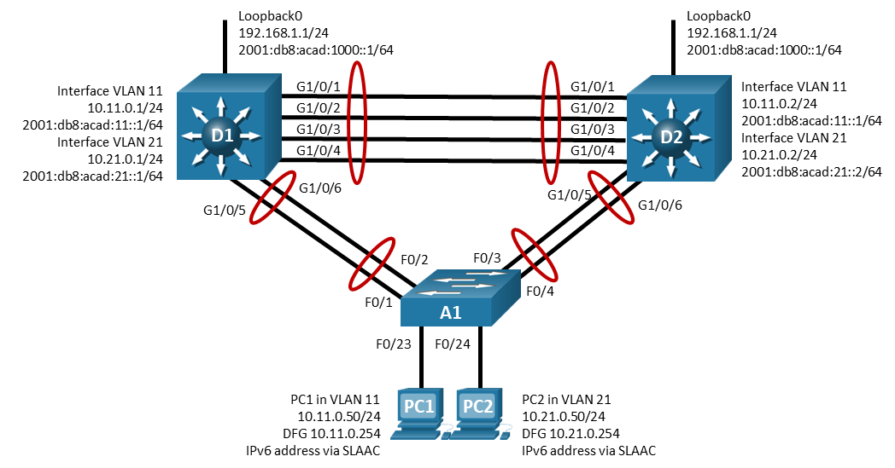

The Network Admin is configuring HSRP in D1 and D2. While configuring HSRP, the below message is displayed to the console screen.

*Jan 19 01:10:13.167: %HSRP-4-BADAUTH2: Bad authentication from 10.11.0.2

The Network Admin tries to troubleshoot the error and fix the problem. He types a command to get the following output.

D1#
Interface Grp Pri P State Active Standby Virtual IP
Vl11 11 150 P Active local unknown 10.11.0.254
Vl11 116 150 P Active local FE80::D2:1 FE80::5:73FF:FEA0:74
Vl21 21 100 P Active local unknown 10.21.0.254
Vl21 216 100 P Standby FE80::D2:2 local FE80::5:73FF:FEA0:D8

- What is the command to get the above output? (1 Mark)

From the above output,
- what is the priority value set for D1? (1 Mark)

- Is pre-emption enabled in D1? (1 Mark)

- What is the cause of the problem? (2 Marks)

The Network Admin has fixed the problem after identifying the cause of the problem. After fixing the problem, the following was the output.

Interface Grp Pri P State Active Standby Virtual IP
Vl11 11 150 P Active local 10.11.0.2 10.11.0.254
Vl11 116 150 P Active local FE80::D2:1 FE80::5:73FF:FEA0:74
Vl21 21 100 P Standby 10.21.0.2 local 10.21.0.254
Vl21 216 100 P Standby FE80::D2:2 local FE80::5:73FF:FEA0:D8

- What was the command that fixed the problem? Where was the command executed? (5 Marks)

- “Mr. Bean Corporation” is having offices at 5 different cities in Wales. They are planning to merge all their locations and bring it under one network. You have been hired as an IT Infrastructure consultant by Mr. Bean Corporation. Your task is to lead and work with the IT&S team to successfully complete this migration. The key objectives of this migration are design and implement:
    - Secure scalable network
    - Network management
    - High Availability
    - Support Digital Transformation

Your answer should include not only the technical aspects (LAN/WAN design, topology, architecture, choice of devices, redundancy, technologies, implementation, etc) addressing the key objectives but also the entire scope of the project. This should include planning, designing, project management, risk assessments, etc (50 marks)

Diwedd/End

