
BUSINESS PLAN
Moroccanado

22 august 2022
Darius HOOLE (2110931) UNIVERSITY OF WALES TRINITY SAINT DAVID

Table of Contents

Main business details 2
Mission statement and objectives 2
Product details 3
Physical details of the business 3
Human resources 4
Marketing activities 5
Financial resources 8
SWOT Analysis 8
Cashflow forecast 8
Reference List 9

Main business details

The name of the business will be Moroccanado, to express the type of clothing that I will sell and where the inspiration comes from.
In the beginning, I am planning on operating as a sole trader, because I will be the only one working on this company, and I want full control over everything (Akhmetshin et al, 2018). However, I am planning on registering the company as a limited company once I will be able to have enough capital to extend and to move the production in a factory where I will be employing more people to help me creating my jackets (GOV UK, 2017). Moreover, I am choosing the self-employment at the moment because it will be easier to keep up wait all the legal requirements, however once I will register the company as a limited company, I will need help from an accountant to keep track with all the company’s paperwork that must be submitted at the end of each financial year (Gov UK, 2022).
There is only one business owner for this company, because it was a personal idea and there are no other people participating in the opening of this business.

Mission statement and objectives
The mission statement is ‘to empower men and keep them warm’. With other words, my mission is to allow men to be fashionable even during colder times. Even more than that, I wish to bring a part of Morocco with me in the UK, and to raise awareness over their culture, which is very impressive. At the same time, because the Moroccan wool jackets were worn by men in the higher society of Morocco, this is being seen as a symbol of power, which is why this piece of clothing is empowering for men (Abramson, 1989).
The aims and objectives of the business are as follows:
- to have 15 sales within the first month
- to gain 100k subscribers on social media that will promote the company’s product
- to have partnerships with different influencers in the UK in the first five months from opening
- To reach 6 figure profit in the first year from opening
- to have 1000 customers within the first year of opening
- to register my company as a limited company in first two years
- To open a physical store in the first two years
- to employ five people within the first two years

Product details
The product that I will be launching and that I will focus my business on is the Moroccan jacket for men, which will be handmade from wool. The reason behind this decision is that I was always passionate about fashion, but within colder periods of the year, I was never able to be fashionable and warm at the same time. I have discovered the Moroccan jacket during a trip in Morocco, but in the United Kingdom, it was almost impossible to find one, so I decided to make it myself. Even more than that, I was able to create my first jacket because my passion for fashion allowed me to learn how to sew and how to create nice pieces of clothing for myself, but now I have decided to take my passion further and to try to monetise it, by creating a unique piece of clothing for those who shares the same love for fashion and are interested in the Moroccan culture. My product is unique because it is manually made from 100% wool, and it guarantees that it will make everyone who will wear it warm, especially during colder times.
To further detail why this business has all the possibilities of becoming successful, I will touch three elements, which are the quality, the competitors and my unique selling point. Starting with the quality, the Moroccan jackets produced by this me have a high quality and because the wool used is 100% natural, and the jackets are handmade from scratch. Even more than that, because each jacket is handmade, there is an increased attention to details, and each customer has the possibility of personalising the jacket, which will make each product entirely unique. By looking at the competitors of the business, after an extended research, I was able to identify the fact that there is only one other seller that offers the Moroccan jackets, through the Etsy platform, and it has more than 500 reviews, which means that people are actually interested in this kind of clothing. Because I am planning on selling online as well, the difficult part here would be to correctly advertise my business and to gain trust from my customers, which are already buying from another seller. My unique selling point is the fact that I will allow personalization on my jacket, for example names or initials, which will make the product even more unique than the fact that is handmade, and I will be able to promote it in multiple ways not only as a piece of clothing but also as possible gifts, and my target market will become wider. At the same time, I will promote the Moroccan culture, as I want to share my knowledge with others and raise awareness (Hartman, 2007).

Physical details of the business
Until I will become more popular, and I will gain customers, I will be only selling online, however I do not wish to sell on Etsy, and the reason for that is because Etsy takes a lot of taxes in order to publish the product and to promote it, but it also takes a percentage of the sales (Etsy, 2022). Because my objective is to make a six figure profit, I do not wish to pay unnecessary taxes, and for this reason I chose to create my own website, which can be done free of charge (Davies, 2022). However, after I will have enough profit, I am planning on opening a physical store or even multiple, in locations that are very popular at all times, where people can come and directly see my products.
On the other hand, because at the moment I will be self-employed and I will make the jackets myself, I will be working from home, where I already have my own atelier. However, when the profit will allow me and the sales orders will become constant, I am planning on renting a small location which I can use as a factory and hire multiple people that will create the same product as I do.
The equipment needed to create the Moroccan wool jacket is very important because the wool is a delicate fabric and it must be carefully operated, and for this reason the equipment can be expensive (Minazio, 1998). The most important equipment is the sewing machine (Fischer, 2015). However, there is also other main equipment needed such as a pressing ham, which is used for steaming shapes or collars (Fischer, 2015), a seam roll, which is necessary for tight areas (Fischer, 2015), a tailor board, very helpful when sewing the fabric (Fischer, 2015), a clapper, which is necessary when working with wool (Fischer, 2015), a sleeve board, because some areas cannot fit an iron board (Fischer, 2015), and a steam iron, because it is more efficient than a regular iron (Fischer, 2015). Apart from there pieces of equipment, I have also chosen to invest in a mannequin, because it will help to take measurements and to constantly check the work on a model (Fischer, 2015). Excluding the equipment, there are also supplies that are mandatory. Because the product is a wool jacket, the main supply needed is fabrics for shell which will be either a wool fibre and fabrics for lining, which are inside the jacket, and because wool can be a hard material, I am choosing the comfort of my customers by utilising either silk or Bemberg. In addition to this, the jacket also requires interlinings, shoulder pads, sewing threads, different buttons such as plastic horn or wooden, zippers and labels (Fischer, 2015).

Human resources
This part will be necessary when I will decide to open a physical store or to expand my business into a proper atelier and store. Given this, I am planning on having four types of roles. The first role available will the role of sewer, and this will be necessary when I will have many orders and I will not be able to keep up anymore with the making of the Moroccan wool jackets. For this position, I would need someone that has experience in sewing wool for at least two years, and someone who pays attention to details, can work fast, and can be reliable (Indeed for Employers, 2022). The next role will be for someone that will work in the store on the customer service position, who will need to greet clients explain to them about the history of Moroccan wool jackets and to be able to sell. For this role I will meet someone with experience in retail, someone who is friendly, someone that can be patient and help the customers choose the best model that is suitable for them, a person that is reliable, confident and that can take care of the store (Indeed for Employers, 2022). The next role that I will need to be filled is the administrator role, and this is someone that can be the helpline for the customers, but to also ensure that the salaries are paid and that the supplies are always ordered. For this position I will need someone wait a high level of accuracy, someone that has experience in customer service, including inbound calls, emails, and social media, someone that is familiar with payroll, and a person that is reliable and pays attention to details (Indeed for Employers, 2022). Lastly, the final position that will need to be filled is the one of an accountant, and this will be the person responsible for all the legal side of the business. This person will work on a part time basis and will be responsible of filling all the legal documents to HMRC, and to ensure that all the numbers are accurate. For this position I will need someone that has previous experience, someone that has a high level of accuracy, a reliable person, and a person that will ensure that everything is working fine on the legal side of the business (Indeed for Employers, 2022).
The hiring process will be different for every role. For the sewer role, the hiring process will consist of an initial phone interview, then the face to face interview, and lastly physical interview where the person will be asked through sew the wool just to be able to form an opinion about their experience. The retail customer service role will have a hiring process that will consist of an initial phone interview then a face to face interview, where I will try to assess the person’s skills and attitude to see if there is compatibility between the person and my business. For the administrator, the process will be simple, with an initial phone screening followed by a face to face interview where I will assess their ability to speak with customers and solve the problems as well as their capability of doing payroll and other administrative duties. Finally, for the accountant, I will conduct a phone interview followed by a face to face interview where I will try to assess their skills that knowledge.

Marketing activities
To understand my future potential customers, I have created a questionnaire that was distributed to ten people to see if there is a need or a want for this type of clothing. The answers were all positives as not many of my colleagues knew about this type of jacket, but they were really curious to try them on. In addition to this, to further support my research, I was looking online on different platforms that sell this type of jackets to check if there is a market to sell them in the United Kingdom. The results from my research showed that each store has at least 500 reviews, meaning that there are plenty of people that could be interested in this type of clothing, and this market is sufficient for me to adventure on this business.
The marketing mix is a term used in business especially when launching a new product, which focuses on different elements of that product, that will make it sell faster (Mind Tools, 2022). In this case, I will use the 7P’s marketing mix strategy. The first element is the product, which is the Moroccan wool jacket, and this will be made handmade, with a wool shell and soft interior. It comes in different colours and models, and it can be personalised with initials or name. The second element is the price, and here a research has been made to determine the current price of a jacket, which is around £100. However, I am planning on selling the jacket with £85 to gain advantage over my competitors and build awareness around my brand. The third element of the 7 P’s is promotion, and for this part I am planning on promoting my business on Instagram and TikTok, especially because there is an entire culture of supporting small businesses (TikTok, 2022), and my business can really take off and gain customers on TikTok. The next element is place, and, as mentioned before, my business will be online on its own website, where customers can choose their model, give personalisation details and place an order. For the people element, the only person that will be in charge of the business at the moment will be myself. For the process element, each piece of equipment will be constantly checked for defects, and the supplies used will be of a high quality. Because each jacket is made manually, the quality will be high because each piece will be inspected during manufacturing. For the physical evidence element, the main way of reviewing my work and to show it to other potential customers is through the reviews received from my customers.

The logo of my business is shown below:
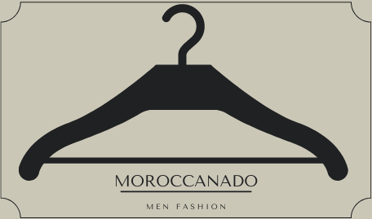
At the same time, examples of my product and different social media posts are as below:
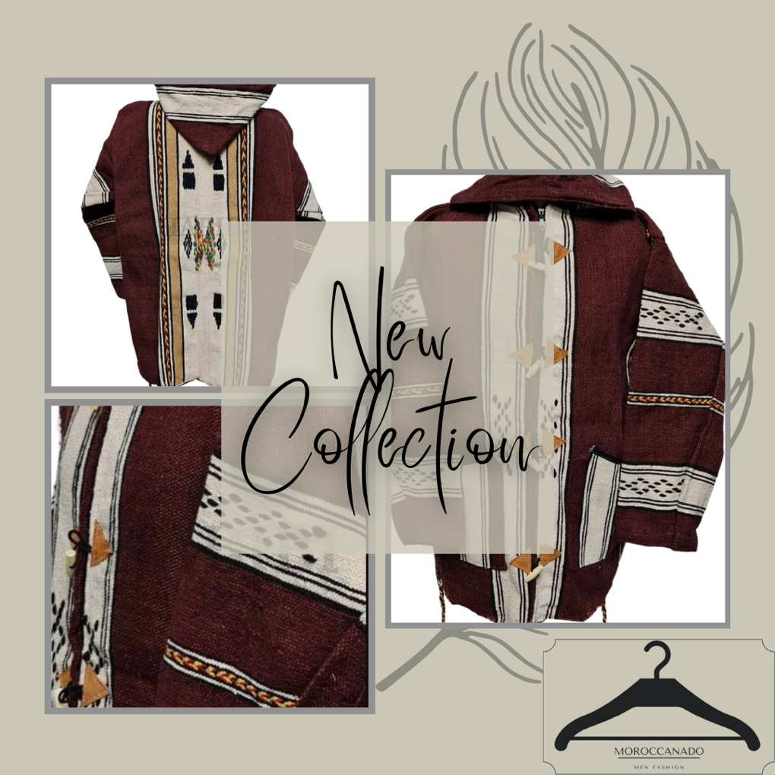

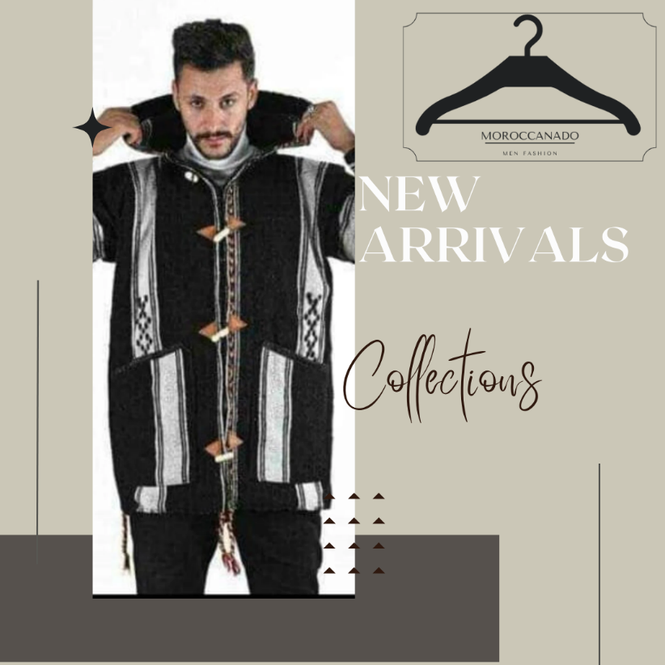

Financial resources
After doing the cashflow forecast, I have concluded that the budget for starting the business is £5,299, and because I already have savings that could cover this amount, as well as some equipment and supplies, I am able to start the business without any help. In this way, I am ensuring that every cost can be covered in case of the business not working, without being liable to anyone else or having to pay back a loan.

SWOT Analysis
STRENGHTS  - Handmade item  - Unique selling point  - Personalisation  - Lower price than the market  - Cultural item  - Inclusive size range | WEAKNESSES  - New on the market  - No customers yes  - No reviews yet  - One person only company  - Longer delivery time because each jacket is handmade by a single person  - Item suitable for colder periods of the years, which means that the sales will not be as high during summer time
OPPORTUNITIES  - TikTok, viral videos that will generate sales  - Inclusivity  - Potential of opening physical store | THREATS  - No sales  - Customers not interested  - Negative reviews

Cashflow forecast

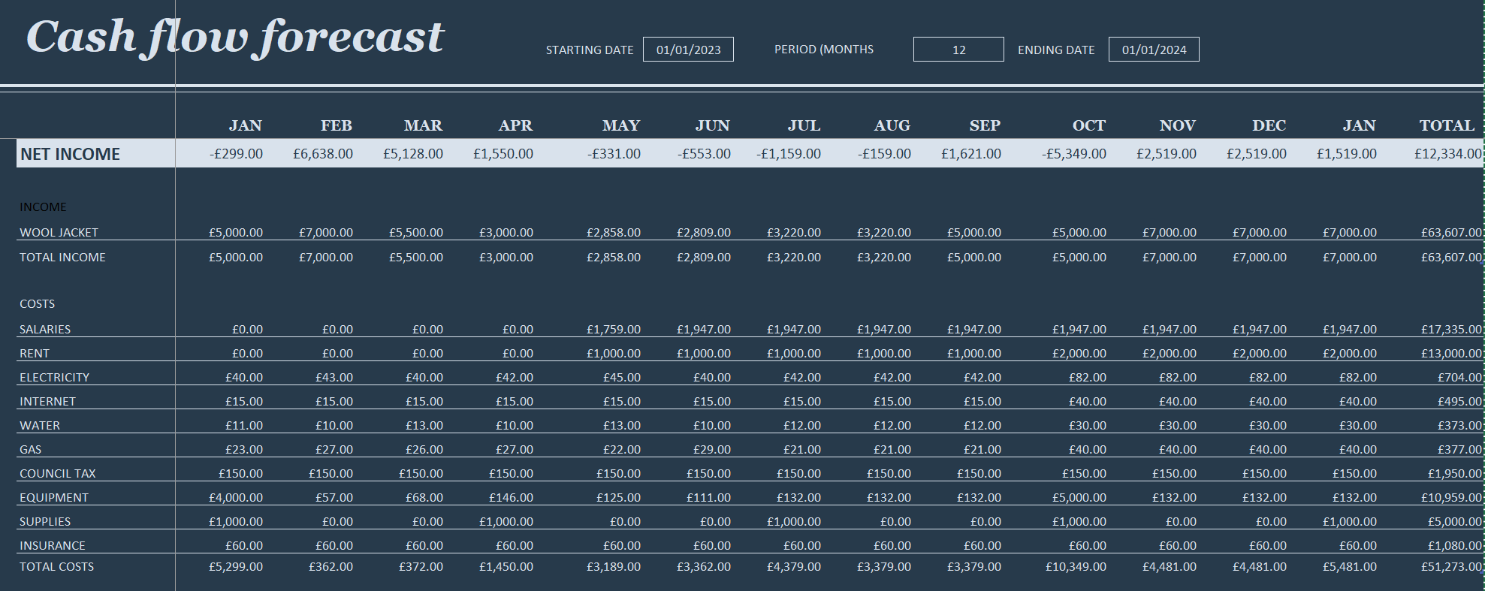

Reference List

Abramson, G. (1989) Saharan Statesmanship. Africa Report, New York, Vol. 34, Issue 2, p. 52.
Akhmetshin, E.M., Kovalenko, K.E., Mueller, J.E., Khakimov, A.K., Yumashev, A.V., Khairullina, A.D. (2018) Freelancing as a type of entrepreneurship: advantages, disadvantages and development prospects. Journal of Entrepreneurship Education, Vol. 21, Special Issue, pp. 1-4.
Davies, R. (2022) Selling on Etsy vs. Building your own website for ecommerce: the pros and cons for each. [online] Available at: https://digital.com/best-ecommerce-platforms/selling-on-etsy-vs-building-your-own-website-for-ecommerce/ (Accessed: 21 August 2022).
Etsy (2022) What are the Fees and Taxes for Selling on Etsy. [online] Available at: https://help.etsy.com/hc/en-us/articles/115014483627-What-are-the-Fees-and-Taxes-for-Selling-on-Etsy?segment=selling (Accessed: 21 August 2022).
Fischer, A. (2015) Sewing for Fashion Designers. London: Laurence King Publishing Ltd., pp. 50-55.
Gov UK (2017) Set up and run a limited partnership. [online] Available at: https://www.gov.uk/guidance/set-up-and-run-a-limited-partnership (Accessed: 21 August 2022).
Gov UK (2022) Working for yourself. [online] Available at: https://www.gov.uk/working-for-yourself (Accessed: 21 August 2022).
Hartman, S. (2007) Postcards of Us: Moroccan Textiles on the Global Market. [online] Available at: https://scholarship.tricolib.brynmawr.edu/bitstream/handle/10066/1009/2007HartmanS.pdf?sequence=6&isAllowed=y (Accessed: 21 August 2022).
Indeed for Employers (2022) How to write a job description. [online] Available at: https://uk.indeed.com/hire/how-to-write-a-job-description?gclid=Cj0KCQjwr4eYBhDrARIsANPywCiVuqpG4JfDqYk4so1eci7WoE3BJDuWcXkLVkxPp8X-kqStD_QySMMaAtBxEALw_wcB&aceid= (Accessed: 21 August 2022).
Minazio, P.G. (1998) The fabric pressing performance and its role in predicting the appearance of men’s wool suit jackets. International Journal of Clothing Science and Technology, Vol. 10, No. 3/4, pp. 182-190.
Mind Tools (2022) The Marketing Mix and the 4Ps of Marketing. [online] Available at: https://www.mindtools.com/pages/article/newSTR_94.htm [Accessed: 21 August 2022).
TikTok (2022) New study shows small businesses are finding their home on TikTok. [online] Available at: https://newsroom.tiktok.com/en-us/new-study-shows-small-businesses-are-finding-their-home-on-tiktok (Accessed: 21 August 2022).

