University of Wales Trinity Saint David

Changes in Employees’ Behaviour Shaped by the Leadership and Management Styles in Muller Factories in the UK. Responsibilities and Functions of a Line Manager in Meeting the Needs of the Organization

Nikola Chakrakchiev
Introducing the Modern Workplace (LCBB4003_BIRM)
Uju Ugochukwu
Due date: 25 Jun 2021

The company management set by the organization’s culture is the key factor of that how the employees behave in the organization and Müller Minsterley it not an exception of the rule. The management style of the different managers in the enterprise are not so different, but the slight tunes in the manner of management corresponds in shift in workers’ behaviour.

Müller Factory in Minsterley, West Midlands
Müller is a German dairy brand established in Bavaria in the 1970’s by Theobald Alfons Müller who succeeded his father in the farm business. Sixteen years later, the Müller brand has expanded to the extent that it entered the United Kingdom market for the first time. Since then Müller has turned into a favourite dairy brand supplied by 1600 farmers in Britain for the production of their products. (Müller UK&Ireland, 2021)
The brand operates in the United Kingdom and Ireland under the entity Müller UK & Ireland Group LLP. It has three business divisions respectively: Müller Yogurt & Deserts, Müller Milk & Ingredients, and Milk & More.( Müller UK&Ireland, 2021)
In January 2013 The German concern acquired the 112-years old Minsterley Creamery in Shropshire in a £4.3 million deal. It became part of the Müller Yogurt & Deserts division and along its other products it produces deserts of the Cadbury brand.(BBC News, 2012)
The factory is run by a General Manager who manages the heads of the divisions, respectively Health and Safety, Logistics, Chemicals and Safety, Quality Assurance, Engineering, Production & Dispatch.
After they took over the factory, the new management has gradually reorganized the work order into two 12-hours shifts a day distributed into 4-days shifts. Respectively, the shifts are served by four teams called Blue 1, Blue 2, Red 1 and Red 2. Each shift has its shift manager, who in his turn manages the Process Manager, the High Care Manager (High Care is the division where the products are filled in the relevant pots and sent to dispatch), and the Dispatch Manager.
Like almost every factory in the UK Müller Minsterley also uses the services of staff-leasing agencies, which, in general, provide the personnel for the most common and non-intellectual work, like packing, pallet stacking, cleaning. The ‘line managers’ are usually full-time employees of Müller UK & Ireland Group LLP (see fig. 1). However, some of the agency workers have proven themselves as loyal long-term and trust-worthy workers, and have earned to be sometimes line managers. It is important to add here that line managers are nothing more than employees who were there earlier than the others and have expressed their willingness to take the responsibility to fill in the paperwork accompanying each job. The only education that they have received is that of how to operate the line and fix any operational issue that does not require the interference of the engineering personnel. This means that they are more of senior employees with special technical training than managers.

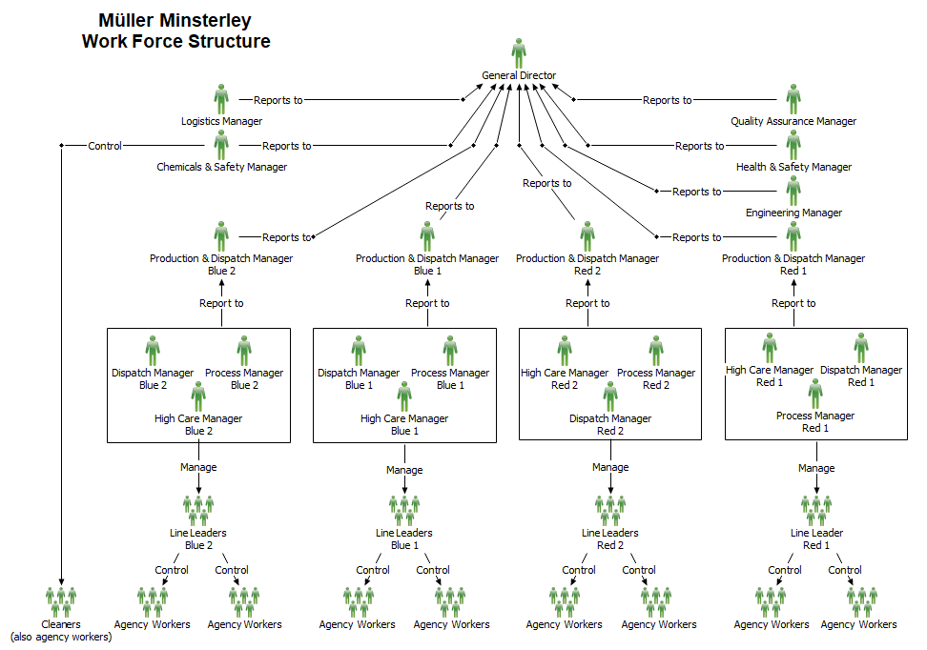
Fig. 1. Müller Minsterley Business structure (based on unofficial research)

According to internal information the executive management prefers to allocate positions to workers of the plant and this is proven by the fact that almost every manager or administrative worker there has started their career from the dispatch division of the factory. The Dispatch, Process and High Care Managers go through some training for increasing their qualification and affirming their positions as managers which, at least in theory, gives them the knowledge to manage their teams to the best of their abilities.
In order to correctly define the management styles used by the managers at Müller Factory in Minsterley I will first define the corporate culture, which determines the direction of development of each member of the personnel in any given enterprise.

Company Culture
Linnenluecke and Griffiths (2010) pointed out that definitions of organizational culture began to appear in the 1970s and the 1980s (e.g., Hofstede, 1981; Ouchi & Price, 1993; Pettigrew, 1979; Schwartz & Davis, 1981) (Linnenluecke and Griffiths, 2010, pp. 357-366), and it was not before too long when it gains influence and became one of the most disputed theory in the researches on management (Crane, 1995; Jarnagin & Slocum, 2007) (Linnenluecke and Griffiths, 2010, pp. 357-366).
As the theories about corporate culture often overlap between the different studies, several researchers have extracted and systematised the basis of the researches on organizational culture “(e.g., Hofstede, 1981; House, Javidan, Hanges, & Dorfman, 2002; Schein, 2004; Quinn, 1988)” (Linnenluecke and Griffiths, 2010, pp. 357-366)
Linnenluecke and Griffiths (2010) also point out that evaluation on organizational culture usually focuses on the values of the organization. The assessment and measurement of organizational culture has therefore typically focused on organizational values. Organizational culture also plays a key role in the process of implementing managerial or technological innovations (Linnenluecke and Griffiths, 2010, pp. 357-366).
I will use the four-cell CVF (fig. 1) published by Linnenluecke and Griffiths (2010) in order to define the leadership and management styles in Muller, Minsterley. It presents the diametrically different dimensions that define the culture models of an organization. (Quinn & Kimberly, 1984). The four-cell CVF is built on two axis - the interna-external axis, which defines the organization’s focus on either its internal activities, or it takes into account the external environment and its requirements. On the other hand, the flexibility-control axis reflect the organizational tendency to apply control, strict rule and hierarchy-obedient management style, or it tends to be flexible and allow competition among peers, “social coordination and control through internalization of beliefs, training, participation, commitment, socialization”. (Linnenluecke and Griffiths, 2010, pp. 357-366).
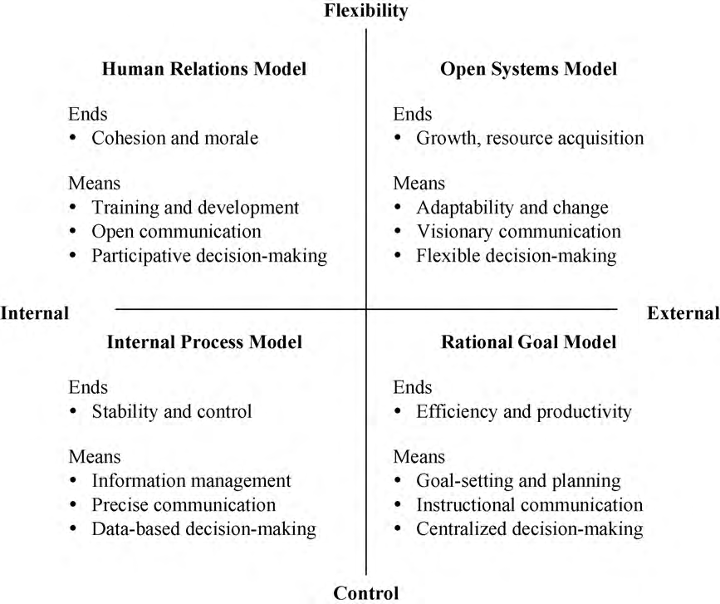
Fig. 1. Competing values framework. Source: Adapted from Linnenluecke and Griffiths (2010, pp. 357-366)

The human relations model which is the upper left side dimension is characterized by cohesion and morale among people of the organization. It is achieved by constant development through training, open communication among the people in the organization and encouraging participative decision-making (Linnenluecke and Griffiths, 2010, pp. 357-366). The open systems organizational cultures are recognizable by the constant growth and resource acquisition by giving encouraging adaptability and change, visionary communication and flexible decision-making. People are motivated by the importance or the intellectual call of their task (Linnenluecke and Griffiths, 2010, pp. 357-366).
The lower left dimension is characterized by the internal process organizational culture. Typical for it is stability and control by the means of management of information, precise communication and decision-making strictly based on the available data (Jones et al., 2005; Zammuto et al., 2000) (Linnenluecke and Griffiths, 2010, pp. 357-366). Some scholars also call this culture ‘‘hierarchical culture’’, because every aspect of the organization is regulated and conducted by rules enforced and controlled by a hierarchical chain of communication (Linnenluecke and Griffiths, 2010, pp. 357-366).
The lower right quadrant, the rational model of organizational culture, is characterized by efficiency and productivity by goal-setting and planning, centralized decision-making and communication in the form if instructions (Jones et al., 2005). Motivation in such organizational culture is the assumption that employees will receive their reward if they are performing to the set by the organization goals. (Linnenluecke and Griffiths, 2010. pp. 357-366).
These four culture types often coexist in different ratios in organizations (Quinn & Kimberly, 1984). However, the majority of the organizations adopt one of the models of organizational organization and build their organization around it. (Cameron & Quinn, 2006). Quinn (1988) claimed that for organizations that strictly keep to just one of the cultural models exist the possibility to become “dysfunctional” with time. (Linnenluecke and Griffiths, 2010, pp. 357-366)
For example emphasizing on the internal process model may lead to a bureaucracy that prevents any form of innovation (Kerr & Slocum, 1987; Zammuto et al., 2000). (Linnenluecke and Griffiths, 2010, pp. 357-366)
Linnenluecke and Griffiths (2010) suggest that organizations that practice the rational goal culture tend to prioritize on resource efficiencies as a part of their strategy for corporate sustainability. This brings the tendency among managers to pursue corporate sustainability in cutting costs and increasing operational efficiency.
The organizations which are characterized by the open systems culture are looking for introducing innovations to their processes and services in order to achieve “ecological and social sustainability” (Linnenluecke and Griffiths, 2010, pp. 357-366).
“In order to achieve ecological sustainability, organizations are challenged to move beyond pollution control or prevention and to operate within the carrying capacity of the natural environment by minimizing their resource use and ecological footprint (Hart, 1995, 1997; Linnenluecke et al., in press; Sharma, 2003)” (Linnenluecke and Griffiths, 2010).
After the conversations with the executive managers of the factory I know that a water recycling and filtration system has been installed and operates on the site that puts the plant among the enterprises that take active actions in the direction of environment protection and meanwhile they reuse one and the same water which leads to resource efficiency. In the domain of technical development, the company has its own research and development team that has its own projects on developing new technical innovations that will be implemented on a later stage in the production process.
The upper managers create a weekly plan of production that is seeded to the lower management levels who organize and utilize their resources in order to comply and fulfil.
All the information on Müller Minsterley leads to the conclusion that the factory falls into the lower right dimension of the CVF – the rational goal model of corporate culture which characterises the management styles rooted in the enterprise.

Management definition
“Management can be described as getting things done through people by exercising leadership.”(Armstrong, 2012: p.24). Armstrong (2012) also adds that managers are the people who manage not only the employees of the company, but also the business operations of the entire organization or just their part of it, the budgets, the work systems and the equipment.
The purpose of management in the private sector is to make sure that the stakeholders are satisfied, which means to secure sufficient profit for the shareholders, to produce and sell to customers the company products at a reasonable price. (Armstrong, 2012).
And this definition describes in detail the responsibilities of the managers in Müller Minsterley. The Shift Managers have a monthly budget allocated to them that should cover their expenses for the month. The executive managers seed the weekly plan of production to the If they fit into the budget, or manage to finish the month below it, they are liable to bonuses shared with the line managers. Tylor’s words are an exact fit for the Müller Minsterley management:
“The work of every workman is fully planned out by the management at least one day in advance, and each man receives in most cases complete written instructions, describing in detail the task which he is to accomplish, as well as the means to be used in doing the work ... This task specifies not only what is to be done but how it is to be done and the exact time allowed for doing it. (Taylor, 1917, p. 39)” (Boddy, 2008, p. 47)
The lower-end workers in the factory are duly instructed what and when to do strictly monitored and managed by the line and the shift managers. If we have to classify the management style according to McGregor’s theories, it corresponds to the Theory X. This theory is characteristic with managers assuming that the workers are usually “inherently lazy, requiring coercing and control, avoiding responsibilities and only seeking security” (Cole and Kelly, 2011, p. 51) as opposed to theory Y where workers are presented as more willing to perform their work and do not require intense control for as long as they are loyal to the organization. (Cole and Kelly, 2011)
However, having four different set of managers in the four separate teams in the factory, there are four different styles of management, and some of the managers in the factory even allow some flexibility in how the work is organized and leave to the workers some of the non-essential decisions. And this trend in the management style of these particular shift managers tend to attract the majority of workers who in, their turn are more willing to work in the relevant shifts. One is able to observe an increased willingness to add value to the work performed, while in the other shifts, where the management style is not so flexible and tends to enforce control on every aspect of the work, workers are more unwilling to give an extra effort to what they are doing.
The management style in Müller Minsterley is predominantly of the Theory X type, but the slight shift of some of the managers toward the Theory Y management style reflects in workers’ willingness to show more interest and engagement in their rutine work for the factory.

Reference list:
Armstrong, M. (2012). Armstrong’s handbook of management and leadership. 3rd edn. Philadelphia, London: Kogan Page
Cole G. and Kelly, P. (2011). Management theory and practice. 7th edn. United Kingdom: South-Western
Boddy, D. (2008). Management: An Introduction. United Kingdom: FT Prentice Hall.
BBC News (2012). ‘Minsterley Creamery in Shropshire taken over by Muller,’ BBC, 15th June. Available at: https://www.bbc.co.uk/news/uk-england-shropshire-18457989 (Accessed: 24 June 2021)
Linnenluecke, M. and Griffiths, A. (2010). ‘Corporate sustainability and organizational culture’, Journal of World Business, 45 (2010), pp. 357–366
Müller UK & Ireland (2021). About Müller. Available at: https://www.muller.co.uk/our-company/about-muller (Accessed: 26 Jun 2021)
Cameron, K., & Quinn, R. (2006). Diagnosing and changing organizational culture: Based on the competing values framework (rev. ed.). Reading, MA: Addison-Wesley.
Quinn, R.., & Kimberly, J. (1984). Paradox, planning, and perseverance: Guidelines for managerial practice. In J. R. Kimberly & R. E. Quinn (Eds.), Managing organiza- tional translations (pp. 295–313). Homewood, IL: Dow Jones-Irwin.

