
APPENDIX GA36c

LEVEL 6 ASSESSMENT SPECIFICATION

Student name: | Lewis Cleverdon | Student ID number: | 1901065
Programme: | Outdoor Adventure Education BA
Module: | Landscape & Sustainable Recreation
Module code: | BMOE6003 | Contribution to Overall Module Assessment (%): | 50%
Lecturer: | Anthony Burns | Internal Verifier: | Roisin Mullins
Assignment Title: | Reflective Fieldwork Journal | Word count (or equivalent): | 2,500 words
Submission deadline: | 29th April 2022 | Return date of provisional marks & written feedback: | 27th May 2022
Submission method: | All written assessments, where practical and possible, must be submitted via Turnitin unless otherwise instructed by the Lecturer. (Please DO NOT put this assessment specification into Turnitin or it will match many similarities with other students’ submissions.)  Alternative submission method (if applicable):  Late submission of the assessment will result in a late penalty mark. Penalties for late submission: Up to one week late, maximum mark of 40%. Over one week late, 0%. Only the Extenuating Circumstances Panel may approve a change to submission dates.
Academic honesty / referencing: | Academic honesty is required. In the main body of your submission, you must give credit to authors on whose research and ideas your work is based. Append to your submission a reference list that indicates the books, articles, etc. that you have used, cited, or quoted in order to complete this assessment.

Module Learning Outcomes
(From module syllabus)
Upon the successful completion of this module, the student should be able to demonstrate the ability to:

1. understand and contribute to philosophical and practical debate concerning the concept of ‘landscape’.

2. critically evaluate the role of society, history, and personal experience in contributing to perceptions of landscape.

3. critically analyse the relationship between landscape and recreation and suggest sustainable approaches to the interpretation and use of landscape for recreation.

TASK DESCRIPTION

Create a Reflective Fieldwork Journal (2,500 words)
As part of this module there will be a number of virtual/physical site visits as fieldwork. You should choose two sites of your choice from those visited and the notes you took should subsequently form the basis of a reflective and critical account of the landscape at each location, the notes you take at each location should relate to the following issues:

• Landscape Character
• Landscape Quality
• Designations
• Use
• Access
• Future Potential

Beyond your written up fieldwork notes regarding the issues above, you should explore and discuss relevant academic, and policy related literature relating to your chosen sites and also provide suggestions for sustainable approaches to recreational development at each site. Maps, sketches, and photographic evidence should be used as appropriate.

SUBMISSION DETAILS:

Submit by Turnitin on or before 29th April 2022
Feedback to be returned to student: on or before 27th May 2022

Student FEEDBACK FORM

This section details the extent to which the assessment criteria are demonstrated by you, which in turn determines your mark. The marks available for each category of skill are shown. Lecturers will use the space provided to comment on the achievement of the task(s), including those areas in which you have performed well and areas that would benefit from development/improvement.

Generic Assessment Criteria | Marks available | Marks  awarded
1. Engagement with Literature Skills
.
 |  | 10
2. Knowledge and Understanding Skills

 |  | 25
3. Cognitive and Intellectual Skills

 |  | 30
4. Practical Application Skills

 |  | 25
5. Transferable Skills for Life and Professional Practice

 |  | 10

Assessment Mark (Assessment marks are subject to ratification at the Exam Board. These comments and marks are to give feedback on module work and are for guidance only until they are confirmed. ) | Late Submission Penalties (tick if appropriate) |  | %
 | Up to 1 week late (40% Max) |  | %
 | Over 1 week late (0%) |  | %

In this journal I will be talking about two main locations Blaenavon Big Pit and Dinefwr Park, both these locations are popular tourists’ sites in Wales with very different landscapes, one being an old working mine that has been transformed into a museum and the other being a nature reserve located within 800 acres, within the park Dinefwr Castle is located along with various landscapes. When looking at the landscape of both these places Blaenavon town is a great example of the industrial period, with the workers living in terraced housing and also building a church, workers hall and a school that has since turned into the world heritage centre (UNESCO, 2020). Blaenavon has shown to be an excellent example of using material for social and economic structure in the nineteenth century. Within Dinefwr Park there is the main 18th century house, woodland areas and a river that meanders through the park, The estate slopes down to the level fields and the river Tywi floods this grassland creating a floodplain, this allows small lakes to appear and create a different landscape.

Blaenavon big pit used to be a working mine but has been converted into a tourist attraction at the peak of this mine it once employed 1,400 miners, nowadays you can take a tour down in the 90m lift shaft to the tunnels beneath the earth (Welsh Government, 2022) while above ground you can also see a selection of pit buildings, including the showers where the men would clean up after a day of work and the massive pithead machinery that powers the lift. It was a working coal mine for a hundred years from 1880 to 1980. The pit finally closed in 1980 with a loss of 250 jobs but re-opened as a museum in 1983 to showcase to a new generation the mining history of Wales, Big Pit is free to visit for all.
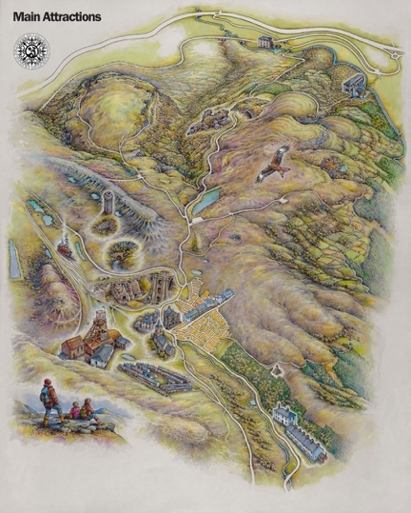
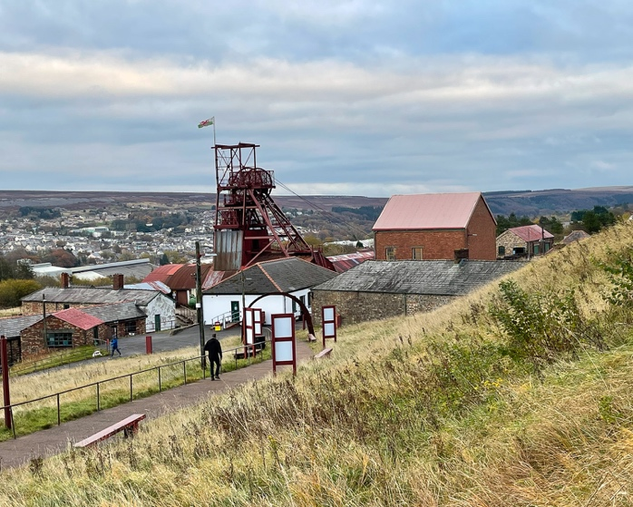

Landscape Character – The area around Blaenavon was recognised by UNESCO in 2000 as a valuable example of an industrial landscape, thanks to its well-preserved collection of ironworks, mines, and other relics. The Blaenavon landscape includes coal, iron and limestone workings and transport systems like iron railway that leads to the canal and then onto the steam railway tracks this was used to import and export all of the materials. The landscape reflects the development of the early industrial society by taking all these elements in it shows the process of the industrialisation period by the social and economic values that iron and coal produced. The Blaenavon Landscape constitutes an exceptional illustration in material form of the social and economic structure of 19th century industry. The components of the Blaenavon Industrial Landscape together make up an outstanding and remarkably complete example of a 19th century industrial landscape (Darroch, 2012).

Landscape Quality – Due to being very industrial the hillsides are becoming green again and can be enjoyed in numerous walks, like the one made on Blorenge mountain within the Brecon Beacon National Park. There majority of the area is on the hillside so there isn’t much vegetation around, most of the area has industrial buildings built on throughout the big pit area. Throughout the area there are many small forests and lakes while being on the edge of the Brecon beacons there is lots of open land.

Use – From 1880 to 1980 big pit was used as a coal mine, The South Wales Coalfield was at the height of production between 1880 and 1913. In 1913 Wales recorded its highest ever output of fifty-seven million tons of coal was produced by nearly a quarter of a million Welsh miners (Big Pit, 2020). Big Pit was a massive employer in Blaenavon, some 1,400 men worked at the mine during the early 1920s. Blaenavon coal was shipped around the world, to as far afield as South America (UNESCO, 2020). From the Great Depression of the 1920s and 1930s the British coal industry went into decline, the reduced demand for Welsh coal and the increased competition from abroad placed enormous strain on the industry (Price & Rhodes, 2020). A series of pit closures in the 1970s and 1980s had a damaging effect on communities that had, for many generations, relied on mining. Big Pit, Blaenavon’s last coalmine, closed in February 1980. Big Pit was turned into a museum to bring national attention to coalmining heritage of Wales. Since 1983 over three million people have been welcomed to the site and, with its lasting popularity, Big Pit will continue to bring global attention to the coalmining heritage of Wales for many years to come and since then in 2005 won the prestigious Gulbenkian Prize for museum of the year (Big Pit, 2020). The main use of big pit is now a tourist attraction that shows what the mine used to be like and has an underground tour as well as visiting their other buildings such as the winding house and the pits baths.

Access – Access to the big pit is accessible by car, once at the venue there is onsite parking, all adults and children are allowed to visit Big Pit. The whole site is accessible to some degree but there are steep and lengthy slopes at certain points, so assistance is strongly advised. Non-certified electrical items (including wheelchairs) cannot be used underground in the mine so it would be necessary to switch to a manual wheelchair for the underground tour, Assistance dogs are welcome on site but cannot be taken underground. At the site there are onsite toilets as well as a canteen and a shop. the walking surface both above and below ground is typical of an industrial site so sturdy shoes are recommended. The floor can be uneven in places and there are numerous steps to negotiate. Underground, there are one or two places where you will need to bend to avoid bumping your head. During the underground tour visitors will be required to walk a distance of 700 metres wearing a helmet and carrying a lamp weighing 5 kg. This lamp is approved for the purpose by the HSE, but lighting levels are generally lower than many visitors will be used to.

Future Potential – the future potential big pit is to stay as a museum and to continue to educate the visitors that visit each year. To make sure Big Pit has a sustainable future for buildings and to make sure the presentation of the area is effective it has been necessary to in some areas to provide additional structures or to make small changes to the building to make sure they are safe to use and so the building have future potential (Buchczyk, 2015), in these cases work has been carried out in accordance with conservation plans to not change the historic features, by making these changes to has allowed Big Pit to stay open and be available for many years to come for people to experience and enjoy.
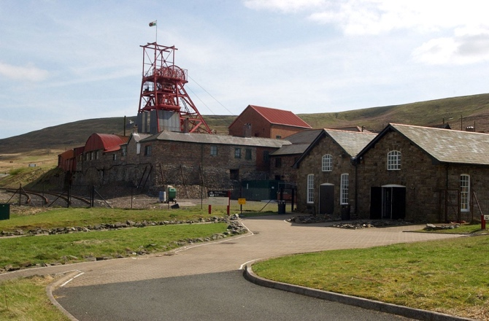
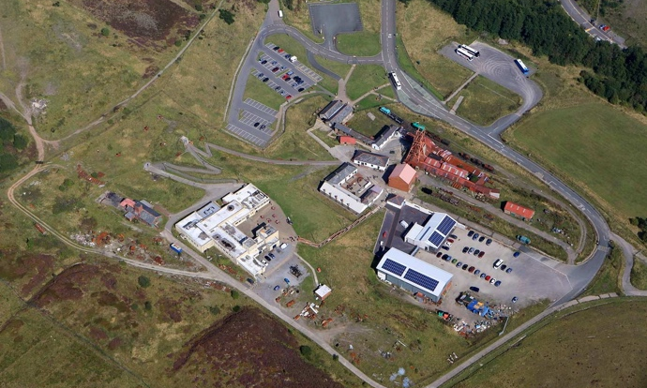

Dinefwr Park is one of the national assets of Wales, The National Trust holds part of the land in perpetuity for the nation. It recognises that the best way to safeguard this exceptional landscape is to work closely in partnership with other landholders, in particular the Wildlife Trust and West Wales. Dinefwr Park is a National Trust property near to Llandeilo in east Carmarthenshire. The house and its surrounding landscape date back to the 18th century. You can go for a walk around the grounds and take in the castle ruins, the deer park, and around the mill pond.
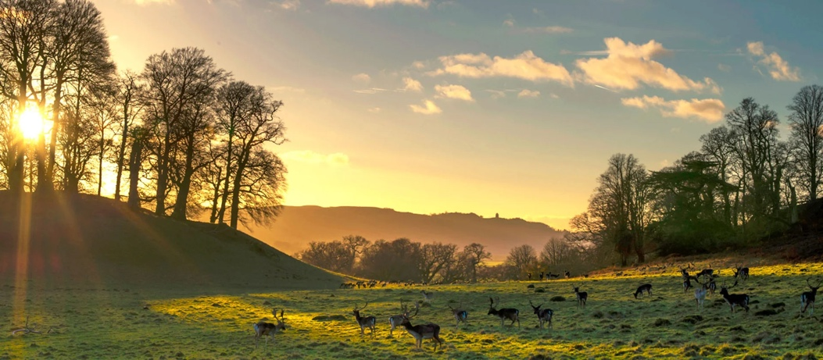

Landscape Character – The geology of Dinefwr Park consists of Ordovician rocks of the Llandeilo series formed some 470 million years ago. Rocks of the same Llandeilo type can be recognised everywhere they occur on the basis of the distinct fossil communities. Within these layers of sandy flags are occasional bands of impure limestone. Quarries and natural exposures have allowed geologists to trace the entire sequence of this series within the park. The quarry to the north of The Rookery has a particularly high fossil content. The Tywi valley is the northern border of the park with the Afon Tywi which provides the southern boundary to the property, the oxbow lakes at the western end reflect the changing course of this river and the fields at the eastern end flood in winter (Dinefwr Park, 2018). A series of wooded ridges divides this part of the park from the higher ground to the north. The gentler rolling topography that characterises the remainder of the park is divided into large fields separated by mainly modern field boundaries. To the west and southwest open spaces are enclosed with continuous woodland and if the ground was flat there would be no beauty much like to the east there are wide views over gently rolling landforms towards distant hills with trees confined to well-ordered clumps.

Landscape Quality – Several ornamental exotic trees were added to the park between 1853 and 1872 and a small arboretum created north of the rookery In Bog Wood American conifers tower over native trees, looking at a tree survey they have identified 295 ancient (predating 1600 AD) trees located throughout the estate including some in land belonging to the Woodland Trust (2016). Over 700 mature to late mature trees were also recorded there is a population of ancient maiden oaks some of these appear to be about 700 years old and therefore predate the creation of the Deer Park (The Woodland Trust, 2016). Historic accounts, paintings and maps suggest that the family have maintained and protected their trees since at least the 17th century, this explains the survival of such a large number of ancient specimens the types of trees on the estate consist of oak, beech, and sweet chestnut.

Use – The residents of Llandeilo and the surrounding area use the eastern part of the park as a recreational resource. They walk in along the Eastern Drive, often as far as the car park, and return along the same route. Those wanting a longer walk return via the South Drive through The Wildlife Trust South and West Wales woodland. National Trust visitors who pay to visit the property have travelled specifically to visit the house, castle, or Deer Park. A significant proportion restrict their interest to buildings and interiors and the facilities provided for a conventional day out. No charge is made to pedestrians visiting the Park, the Castle, or the Wildlife Trust's woodlands. The house is open to the public and one reception room has been converted into a tearoom. Visitors in vehicles approach up the single-track East Drive, which has difficulty accommodating large numbers of cars.

Access – Dinefwr is in Llandeilo, Carmarthenshire. Take the A40 from Carmarthen for 12.5 miles, turn right following the brown tourist signs through Llandeilo to Dinefwr. There is plenty of car parking at the park, with two disability spaces near the entrance to the Board Walk and Castle Walk café. Disability toilets are located within the house and at visitor reception. There is a boardwalk to the mill pond which allows part of the grounds to be wheelchair accessible, however, the walk to the castle ruins is uphill and uneven, but disabled motorists house can drive along the track to it, which has a level turning space and layby for parking which is very close to the castle ruins. The house is accessible, with a lift to the first floor.

Future Potential – The National Trust has sought to maintain the historic fabric and environmental quality of Dinefwr Park. Recent surveys have demonstrated that the essential character of most of the 18th century design remains. It is the detail that has been obscured or lost. Footpaths are overgrown and smothered by fallen trees. Part of the Brown path to the east of the castle has fallen away forcing the Wildlife Trust to alter the route (Brown, 2019). Bridges are barely visible beneath vegetation, fencing has transformed sweeping views into modern agricultural fields, trees have been felled and others have grown unchecked to mask views, water features have disappeared, refurbishment and repairs complex will need to be supported by policies to ensure that archaeological, conservation and environmental standards are upheld. The potential for future discoveries is enormous not only of buildings but also of field systems, boundaries, streets, and roads (Dinefwr Park, 2018).
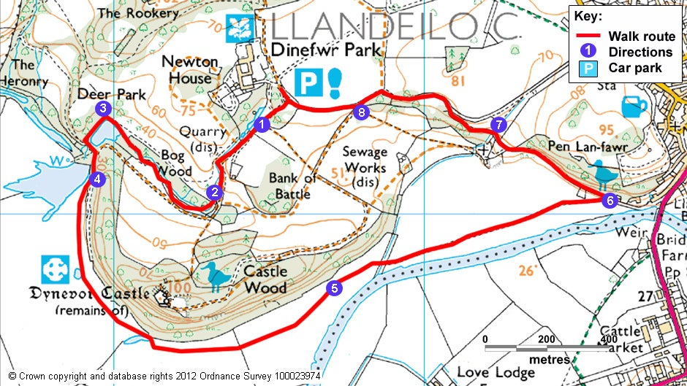
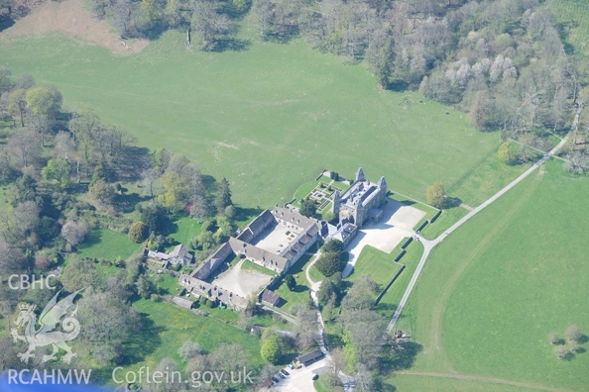

Looking back at Blaenavon Big Pit and Dinefwr Park they both very different from why tourists go there to the landscape they are, as stated Blaenavon has a very industrial landscape unlike Dinefwr Park which is much more wooded and farmed land. Big Pit is a museum that allows the general public to see what mining was like and be underground whereas the grounds at Dinefwr Park are there for everyone to enjoy, the house in the land is there to look around and have that experience. There are lots of approaches both could do in the future to increase visitors but both should continue as there are educating the visitors they do get, both places value there buildings and surrounding area so protecting them is a main priority at Dinefwr Park the groundsman take care for their trees as some are as old as 800 years at the park by taking care and planting new ones at different time periods it allows trees to continue to grow and be there for many years, one area the park are planning to plant is in the outer car park and hope to recreate old eighteenth century designs. Eventually these plantations will be managed like the deer park, as grazed wood pasture, in this way Dinefwr will always be famous for its veteran trees. Some recreational both sites could consider is an improvement to guided tours outside at Blaenavon they could have an instructor who takes them up onto the hills behind Big Pit this way the instructor would be able to educate the participants about the land more and the participants would be able to see more of the surrounding area, for example they could have a walk to higher ground and then to the canal so they are able to follow where the coal used to get shipped out to. Whereas Dinefwr Park could have an instructor guiding a group to different sections of the park another improvement the park could do is to invest into Segway’s as this offers a different approach to just walking as lots of parks tend to do this to attract more people, a different improvement is they could build a sustainable bike track and pump track in park in the wooded area would work it would also be beneficial to local community as well as offering something adventures to bring in different customers.

Word Count: 2449
References:

Big Pit. 2020. [online] Available at: https://www.visitblaenavon.co.uk/en/Publications/Blaenavon-Story/Big-Pit.pdf (Accessed 11th April 2022).

Brown, 2019. Dinefwr - Garden | Capability Brown. [online] Available at: http://www.capabilitybrown.org/garden/dinefwr/ (Accessed 11 April 2022).

Buchczyk, M. 2015. Recollecting the past in historic mines: Guido and the Big Pit. International Journal of Heritage and Sustainable Development. Vol. 4, no. 1, pp. 35-42.

Darroch, J., 2012. Big Pit: National Coal Museum, Blaenavon: From a working past to a sustainable future.

Dinefwr Park. 2018. Llandeilo History. [online] Available at: https://www.llandeilo.org/nt_intro.php (Accessed 11th April 2022).

Price, W & Rhodes, M. 2020. Coal dust in the wind: Interpreting the industrial past of South Wales, Tourism Geographies.

The Woodland Trust. 2016. The Castle Oak - Dinefwr Park. [online] Available at: https://woodlandtrust.tumblr.com/post/151138665139/the-castle-oak-dinefwr-castle-near-llandeilo (Accessed 11th April 2022).

UNESCO. 2020. Blaenavon Industrial Landscape. [online] Available at: https://whc.unesco.org/en/list/984/ (Accessed 11th April 2022).

Welsh Government. 2022. Big Pit National Coal Museum | Visit Wales. [online] Available at: https://www.visitwales.com/attraction/museum/big-pit-national-coal-museum-516409 (Accessed 11th April 2022).

