Student Name: Adam Linus Charlton

P Number: 1800663

Programme of Study: Fine Art

Module: M4X01560

Tasks in the order I received them:

Task One: Semiotic Analysis (Ryan task) = 469 words

Task Two: Manifesto (Julia Task) = 543 words

Task Three. (Jon Task) = 597 words

Semiotic Analysis

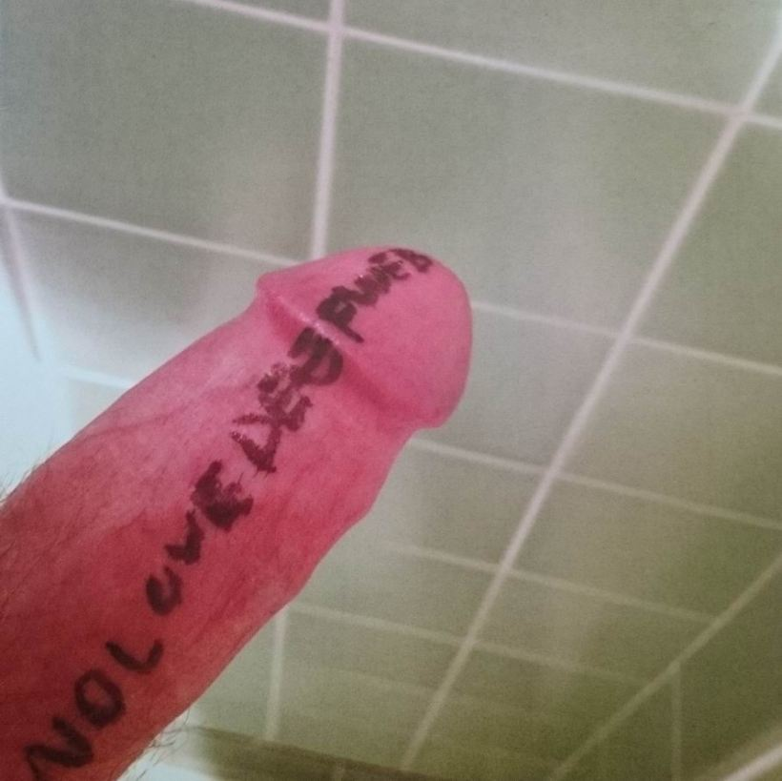

Death Grips’ music stands out but it is more than that that makes them so special. They prioritise their music, their vision and “don’t give a fuck”. In 2012, they had become signed by the famous record label “Epic Records” but got dropped due to leaking their own album- with a photograph of the drummer, Zach Hill’s, penis with the album title written on it as the cover.

Despite its crudeness, the image displays a few elements of good design composition- the asymmetry of the penis coming in from the lower-left is balanced by the lines of the bathroom tiles leading the eye back towards the focus. The angle and perspective of the shot creates a feeling that is unsettling and confusing- the low angle is a popular technique in film-making and photography of making a subject appear large and brooding. The photo appears to be in a public bathroom of some kind but tilted view makes it hard to distinguish how exactly the photo was taken. The knowledge that it was in-fact a band member’s penis adds a layer of intimacy as it is of-course quite a personal thing to be sharing: “It was difficult to do”.
This bold move from the band shows “fearlessness”, “primal energy” and dedication to the art.

The title of the album is written on the penis in marker. This connotes themes of humbleness and sacrificing oneself and identity for artistic vision.

The “dick-pic” has become an almost iconic image of modern times- a symbol of the convenient yet cold acts of modern sexual communication in the internet age and also a sign of intimidation and desperation when one is received unsolicited, which, according to a 2016 American survey, is the case for 49% of dick pics received by women. It is a common way of receiving sexual thrill as a young man however it also links with a misogynistic view of the world and one-sided unempathetic view of sex which ties in thematically with the title of the album “no love, deep web”.

In an interview, Zach Hill talks about how part of the intention of the image was to “embrace homosexuality” and challenge the view of aggressive machismo of the band that’s frequent lyrical use of the word “bitch” may lead to them seeming misogynistic- an idea they strongly disagree with as a band that believe western culture’s prevalent sexism, homophobia and hang-ups towards nudity are “toxic […] to the human mind”
The prominent colour pink also has prominent associations with gender politics historically and currently.

“At first glance,” Mark Beaumont of The Guardian writes, “it's the classic gimmicky shock tactic, but, considering the homophobia still rife in hip-hop, it's virtually the only image that could really upset the genre's old guard and prove [Death Grips] a truly subversive rap force”

Bibliography and references

https://consequenceofsound.net/2011/06/album-review-death-grips-exmilitary/

https://www.theguardian.com/music/2012/nov/08/death-grips-review

https://www.spin.com/2012/11/death-grips-artist-year-2012-no-love-deep-web/?page=3

https://pitchfork.com/features/interview/9004-death-gripz/

https://www.menshealth.com/sex-women/a29737171/why-men-send-dick-pics/

https://web.archive.org/web/20080228111428/http://www.stepinsidedesign.com/STEPMagazine/Article/28832

Task two- Manifesto

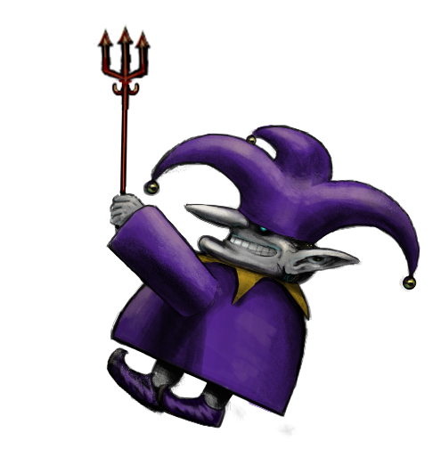
12 Rules For Life
How to be a good blackmaggit in 9 simple steps
1. Live your truth
Be the change you want to see in the world, do not be afraid of showing your position.
2. Accept people for who they are
You may wish to try and convince people to be on your wavelength at times but this is a fool’s errand and misses the point of a society. Believe in yourself and your role, do not try and change others.
3. Believe in the flow.
Do not be impatient, understand that there are things that you cannot control.
4. Be Kind
Practice love to those who reside in and outside of your vicinity. Connect with others and learn from them.
5. Experiment.
Try different approaches and methods, do not settle with one.

6. Stay close with the darkness
Remember what brought you were you are today, do not be afraid of your flaws, look them in the eye and work with them not against them. Keep the darkness close and aim to understand it.

7. Don’t forget what reality you are in.
Perform reality checks often to ensure you are not dreaming. This will increase awareness and understanding of the present moment no matter what state you are in. Present awareness is peace.

8. Trust your doctor (not your gp)
The voice of reason is often reasonable- refer to the most reliable source of information and be sure to keep your rationale consistent and logical. Be consistent in your inconsistency.

9. Serve eternally.
As an artist you have responsibility to express reality, physical reality and beyond- to package it in a way that helps others understand, to influence other artists. Remember this. Giving up is not only giving up on yourself but giving up on current and future generations of anyone who may benefit from your art.

The original title for this manifesto was “The Honest Manifesto” as honesty has always been a priority of mine in life but also in art.
Artist Ginny Sykes said art is “a commitment” that “illuminate[s] what lies hidden or repressed in the [...] shadows. New ideas [...] can lead to small or large changes in attitudes and even society.”
If an artist hopes to make a positive change in the world, it is important that they are aware of their impact and are always striving to improve. For this to happen, an artist must be honest with themselves and others.
“Artists are responsible for unearthing the truth”, Portuguese artist, Nina Fraser said, “Sometimes we will seem vulnerable […] but the main thing is not to give up.”
Another important purpose of art is to document human history- and in this current era where almost everything is archived on the internet, the honesty of an individual and the visible journey and progression of views they have had over their lifetime, are very important. Not only that but post-internet art (a term conceived by Marisa Olson, 2006) is important as it documents the ways in which the internet has changed the communication experience for humans. Being honest and open about any doubts about the status quo helps us progress.

The Darkness
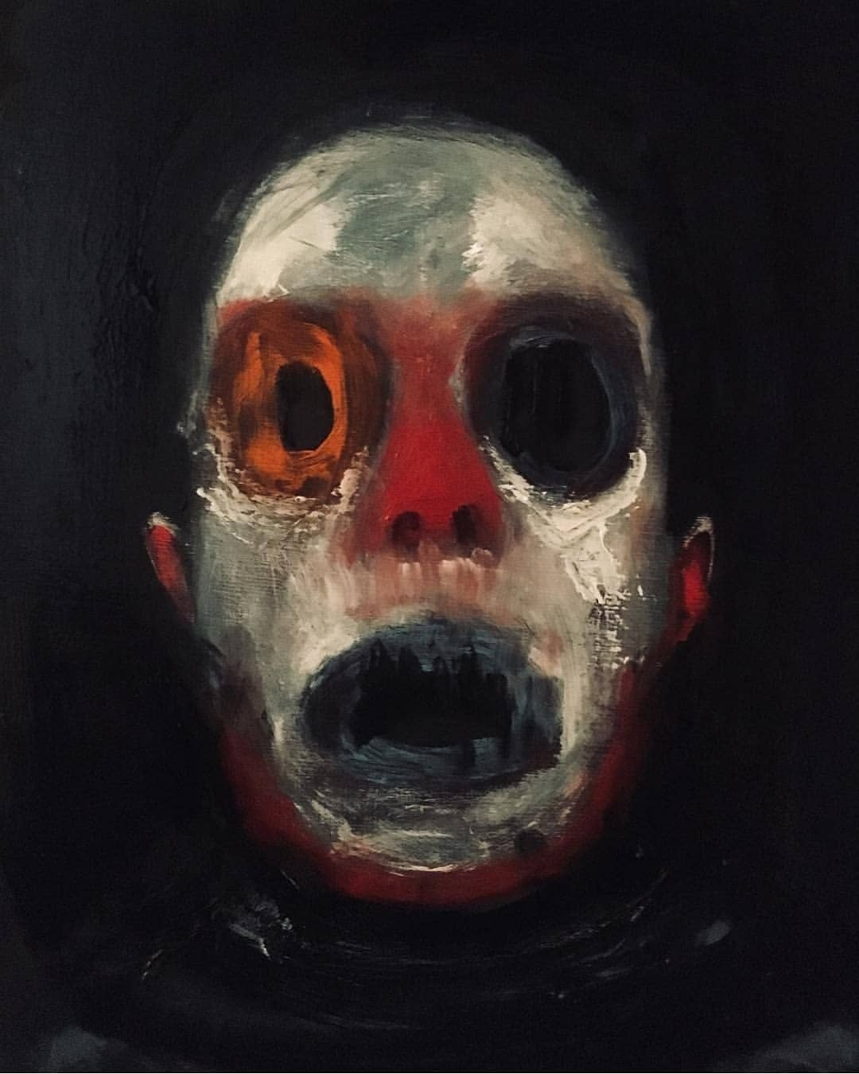

The darkness. We all know it. Some of us more than others. Its the dread, the stuff you don’t want to think about because it will suck you into a spiral of hopelessness. However, it makes us who we are.
“Art and Poetry awaken the dreams of man, and his longings, and reveal to him some of the abysses he has in himself.”-Jacques Maritain, 1960
For one to be a great artist and human being it is important that they do not try and hide from that which disturbs them but to accept it, let it be and find interest in it.
“One is a great deal less anxious if one feels perfectly free to be anxious, and the same may be said of guilt.” (Alan Watts, 1961)
When one communicates with “the darkness” one may find that its intentions are less malicious than it appears. An example of this is “Persecutor Protectors” in people with dissociative identity disorder (DID). These are, according to current DID research and models, “alters” who are persecutory in nature and bring fear and negativity to the “host” or other alters in the “system”. However, these alters tend to be the holders of trauma memories and believe that what they are telling the host is to protect them from further abuse. The best way to find peace with the self as a whole is to communicate with these alters and help them heal.
This seems to be true in all of us- showing troubled parts of oneself love and understanding is to show ones whole self love and more deeply understand ones own being. It also helps us empathise to others as higher self-esteem is linked to higher empathy (Huang et al, 2019).
“No Man is an island” (John Donne, 1624)
Artists thrive when working in a community, within a collective or in collaboration with other artists internationally. Amazing collaborations happen when artists involved are honest and understanding with each other.

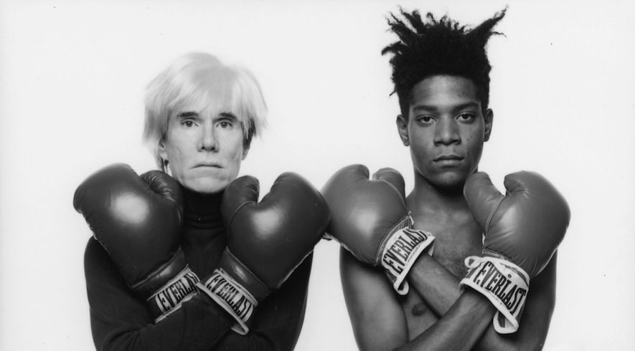
Andy Warhol and Jean-Michel Basquiat, 1985

Bibliography

Kandinsky, (Ulrike Becks-Malorny, 1994)
Responsibility of the Artist (Jacques Maritain, 1960)
No man is an Island (John Donne, 1624)

Relationship between creativity and mental health:
https://www.youtube.com/watch?v=rv5-O-jP2i8
https://blogs.scientificamerican.com/beautiful-minds/the-real-link-between-creativity-and-mental-illness/
https://www.apa.org/monitor/2014/06/arts-creativity

Role of an artist: https://www.artworkarchive.com/blog/what-is-the-artist-s-role-in-society

POSTINTERNET: https://www.academia.edu/26348232/POSTINTERNET_Art_After_the_Internet

Dissociative Identity Disorder:
http://did-research.org/did/alters/functions.html
https://www.discussingdissociation.com/2009/01/working-with-difficult-and-destructive-alters/
https://www.youtube.com/watch?v=0e-GotYK3eU
http://traumadissociation.com/alters
empathy and self-esteem:
https://www.frontiersin.org/articles/10.3389/fpsyg.2019.01921/full
artist collaborations: https://www.agora-gallery.com/advice/blog/2017/04/27/famous-art-collaborations/

Jons Task

In this essay I will provide a brief overview on the story of surrealism, my relationship with it, and what we can hope to see in the future.

"The mind which plunges into Surrealism, relives with burning excitement the best part of childhood." - Andre Breton, 1924

Surrealism emerged out of the “riotous spirit” of Dada- a movement which started in the early 20th century that sought to abandon artistic traditions using nonsense to rage against the institutions that brought about World War 1. The word ‘Surrealism’ was coined by writer Guillaume Apollinaire in 1917 to describe his ballet ‘Les Mamelles de Tiresais’ and Jean Cocteau’s ballet ‘Parade’. He described it as “truth beyond realism”.The term was later adopted by Andre Breton in his 1924 manifesto. As opposed to dada which aimed to break order, surrealism was rooted in a more romantic ethos of bringing an expanded order to reality by unearthing subconscious and unconscious desires- a concept popularised by psychoanalyst, Sigmund Freud. By some it was believed that “liberating the subconscious would have collective politically revolutionary consequences”.
Another concept popularised by Freud was that of dream analysis and the surrealists utilised dream accounts and automatic drawing and writing as ways of letting go of the control the conscious mind had and unleashing subconscious desires.
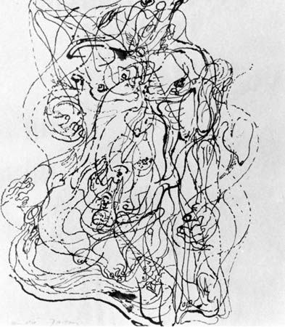 Automatic drawing by writer of Manifesto of Surrealism- Andre Breton
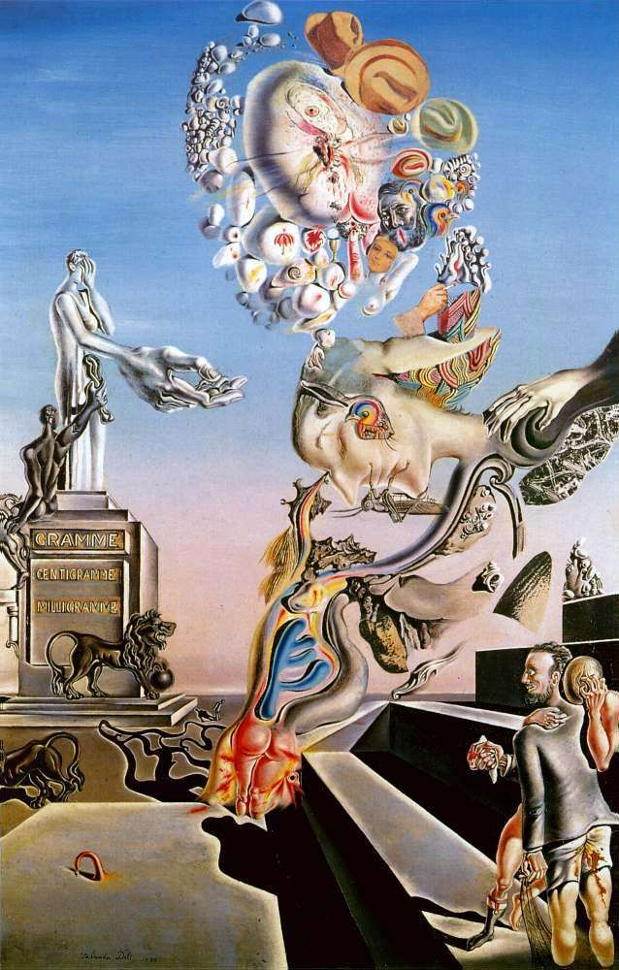 The Lugubrious Game, 1929, Salvador Dali

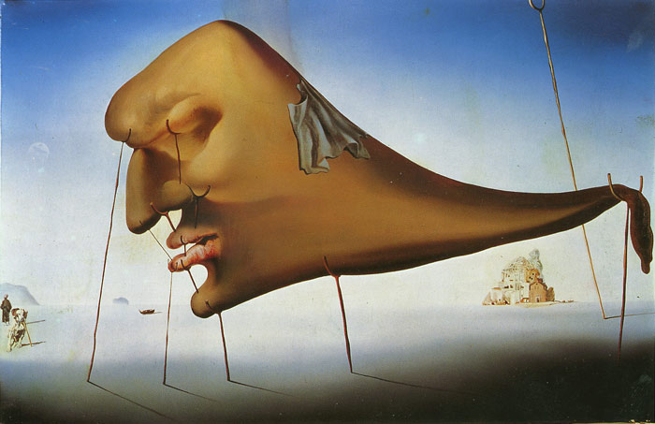 The Dream, 1937

Modern Surrealism – Miles Johnston

Miles Johnston was born in the UK in 1993. His work was popularised in recent years mostly thanks to the internet. I discovered his work first in 2016 when his graphite drawing “Thought Loops” appeared on the front page of reddit. Johnston describes his art as “using the human form as a vehicle to attempt to process the intensity and profound strangeness of the collective human experience” and that is exactly what I like about it. It’s imagery with a specific purpose of illustrating specific experiences, dissociative, meditative and emotional states. And he does all of this so well under the limitations of (usually) only using graphite and always incorporating the human form. His drawings are simple but effective and that showed me that I myself can make art like this and all I needed was a pencil and practice.

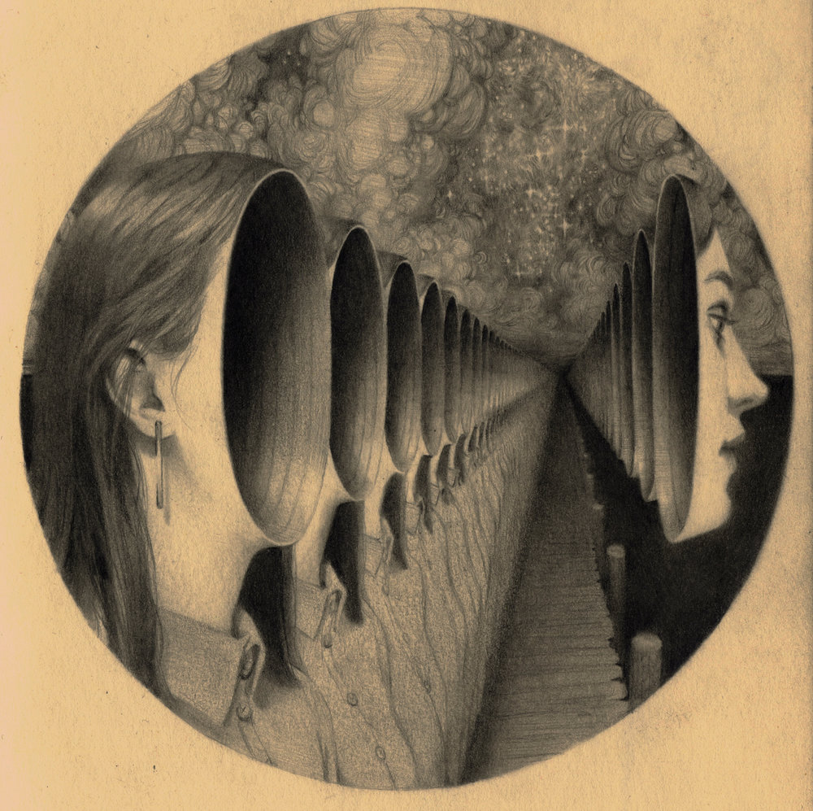 Mode of Ignoring, 2017
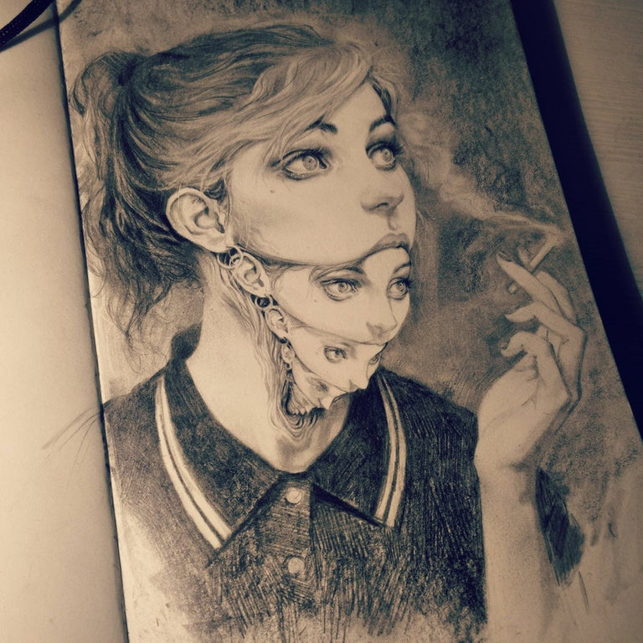Thought loops, 2016

Pop Surrealism

So, in the present day of the internet age we have surrealists like Miles Johnston who craft refined concepts directly relating to internal experiences and we also have artists like Ron English whose work more noticeably reflects society and culture.
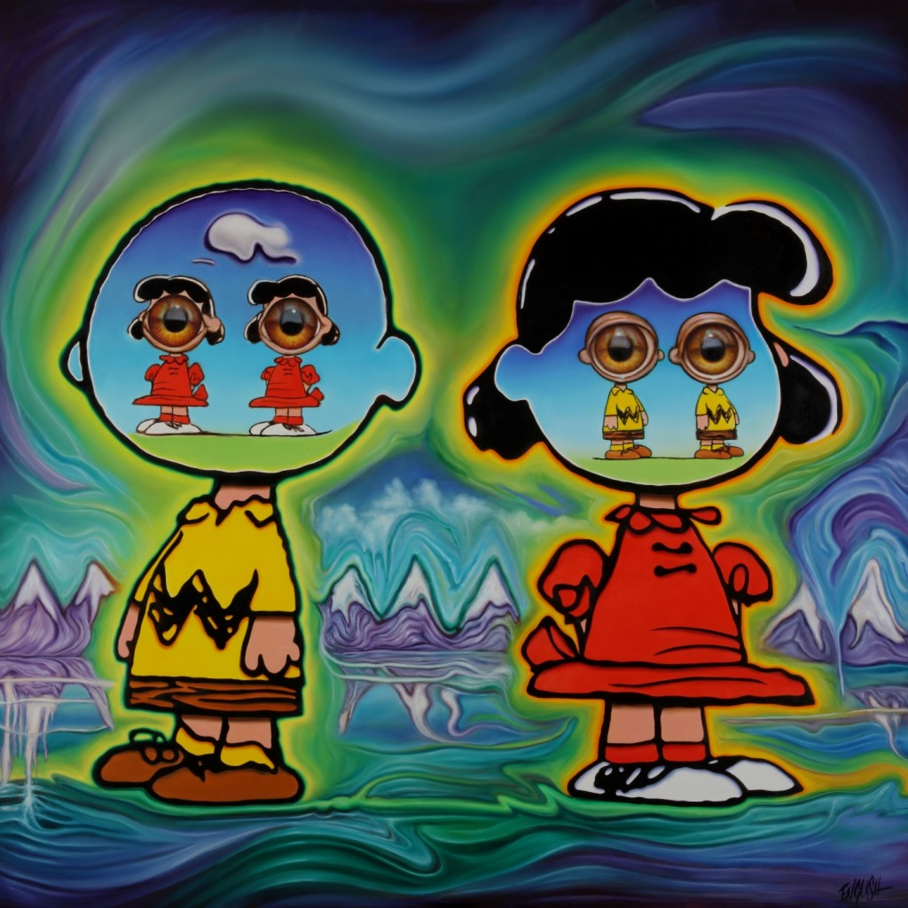 See through eachothers' eyes, Ron English. Exhibited in Allouche Gallery, New York in 2018 as part of his "Delusionville" show.

“Pop surrealism” is a term conceived by artist Kenny Scharf (1958-present) and has become a popular term to describe the surrealism of today. It is not unlike the surrealism of the 20’s- many of its contributors still make art with the aims of expressing the subconscious however, as Scharf puts it, with visual media being so prevalent in modern times, pop culture has found its way into our subconsious. Artists of his generation and onwards grew up on cartoons, the increasingly televised cult of celebrity and mass advertisements and their increasing development in psychological tricks.
Pop surrealism makes note of the psychological imprint pop culture has on us collectively.

Pay-tv is being overtaken by streaming services and general internet. Christian Rex Van-Minnen utilises this boom of information and communication by offering his Instagram followers a chance to participate in his art by commenting in his live-streams and he will “randomly” select comments to “tattoo” onto his human form paintings in real time.

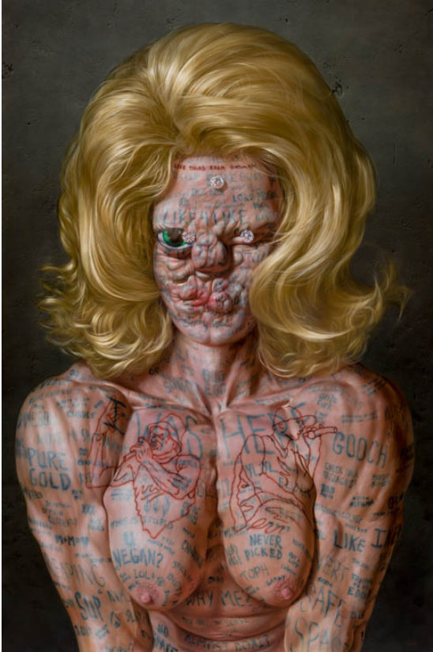Diamonds w Self Portrait Live Instagram Video Comment Tattoos and Battle Rapper Breasts 2019, Christian Rex Van-Vinnen

As a surrealist, I aim to continue unearthing the collective unconsious with the aims of connecting people spiritually and emotionally in this new age of extreme media infiltration and the decline of quiet reflection.

Bibliography

“Salvador Dali 1904-1989”, Robert Descharnes and Gilles Néret, 1989
Kandinsky, (Ulrike Becks-Malorny, 1994)
Responsibility of the Artist (Jacques Maritain, 1960)
Internet art – Rachel Greene, 2004

Surrealist manifesto http://www.exquisitecorpse.com/assets/manifesto_of_surrealism.pdf
Dadaist manifesto http://www.writing.upenn.edu/library/Tzara_Dada-Manifesto_1918.pdf
The Art Assignment- The Case for Surrealism https://www.youtube.com/watch?v=wtPBOwE0Qn0

“The Psychopathologies of Everyday life”, Sigmund Freud, 1901

https://www.biography.com/scholar/sigmund-freud
https://1stwebdesigner.com/modern-surrealism/

Roberts Psychology And Capitalism; The Manipulation Of Mind ( 2015)

ARTST TLK™ Ep. 10 https://youtu.be/24GEe2J1qkE

https://www.milesjohnstonart.com/about
http://www.popaganda.com

Decline of television:
https://www.economist.com/business/2019/05/09/american-pay-television-is-in-decline
https://www.campaignlive.co.uk/article/decline-young-tv-audiences-accelerating/1578795

What is a meme? https://www.lifewire.com/what-is-a-meme-2483702

