Understanding and engaging in the customer experience: A study on Hilton Hotels

Student Name: | Vivian Dimishkovska
Student Number: | 2010776
Module No: | BMSW5103_LON
Module Title: | Understanding and engaging in the customer experience
Lecturer: | Joy Botu

Executive summary
The research aimed to determine the impacts of internal and external factors on the customer management and quality control of Hilton Hotels.
Hilton Hotels is one of the most prestigious and renowned organisations in the tourism and hospitality industry in the entire world. It has almost 17 resorts and hotel brands under its portfolio and has multiple franchises all over the world as well. The organisation has 6,215 properties, 983,465 rooms that serve its customers. Hilton Hotels is popular for its high class and high-quality services, posh environment and the comfort that it provides to its customers. However, in a competitive industry like the tourism and hospitality industry, the decision that the customers of the hotel chain make is heavily influenced by various factors.
The research was conducted using secondary data and key marketing theories such as marketing mix, porter’s five forces model, communication mix, stakeholder map was conducted on Hilton Hotels to determine the various internal and external factors that impacts the organisation.
The report determined that Hilton Hotel is heavily impacted by these internal and external factors along with Covid-19 and determined that the organisation dealt with the situation successfully while ensuring cleanliness, rearranging the lobbies to encourage social distancing, and using modern technology to provide contactless services. However, these processes incur heavy expenses for the organisation.
Contents
Executive summary 2
Introduction 4
Hilton Hotels 4
Task- 1 5
Key marketing theories 5
Marketing Mix 5
Communication mix 7
Stakeholder map 9
Porter’s five forces 11
Findings 12
Marketing mix 12
Communication mix 13
Stakeholder map 13
Porter’s five forces 14
Task- 2 14
Evolution of the hotel design 14
Contactless experience 14
Cleanliness 15
Flexibility 15
Conclusion 16
References 17

Figures
Figure 1: Marketing mix (Van der Westhuyzen and Van der Merwe, 2017) 6
Figure 2: Communication Mix (Todorova, 2015) 8
Figure 3: Stakeholder Mapping (Civera and Freeman, 2019) 10
Figure 4: Porter's Five Forces (David and David, 2016) 12

Introduction
The increased importance on customer experience is one of the most crucial changes that happened in terms of business organisations due to the impacts of Covid-19. Covid-19 has changed the way business organisations interact with customers and how customers put value on their experiences with the business organisation. With the changing times, not only Covid-19 but also many other internal and external marketing factors affected the engagement of organisations with the customers. Due to the emerging use of technology, customers can now see what the other customers experienced with a certain brand and can take positive and negative decisions based on that as well. Hilton Hotels is such an organisation which was drastically impacted the customer engagement and experience of Hilton Hotels (Armstrong et al., 2019). The report aims to provide a brief overview of Hilton Hotels; apply key marketing theories like marketing mix, porter’s five forces analysis, Ansoff Matrix, Stakeholder map, Communication Mix to Hilton Hotel, analyse the impact of the internal and external factors on the quality and control system for customers during Covid-19, and determine the ways in which Hilton Hotels can manage and maintain good relationship with its customers during the time of Covid-19. The report will be using secondary data to conduct the research.

Hilton Hotels
Hilton Hotels is one of the biggest players in the hospitality industry around the globe with one of the biggest chain of hotels. It is a market leader in the industry which directly serves and interacts with the customers. Hilton Hotels was founded by Conrad Hilton in 1919 as a portion of his businesses in the hospitality sector. At that time, Conrad purchased his first hotel at a Mobley Hotel with 40 rooms situated in Texas, and continued to expand his hospitality business by purchasing more hotels. What started as a 40 room hotel now has 6,215 properties and 983,465 rooms which are used to serve its huge customer base (Hilton, 2022).
Hilton Hotels is a global chain of hotels with having its operations in over 118 countries all over the world. Majority of the 983,465 rooms are managed by franchisees while only 690 are managed by Hilton itself. Adding the franchised and self managed rooms of Hilton Hotels, the organisation currently has 953,946 rooms. It also has an additional of 65 rooms that are leased and 57 rooms that are completely owned or partially leased. Hilton Hotels operates in various segments within its market and has a variety of hotels that are responsible for serving all types of customers. Being one of the biggest hotels in the hospitality industry, Hilton Hotels’ revenue consists of 8.9 billion dollars. Hilton Hotels’ portfolio is very impressive that consists of 17 brands of hotels.
Hilton Hotels puts major emphasis on enhancing its customer engagement and experiences (Newsroom, 2022). The organisation’s customer management and engagement are heavily influenced by the internal and external environmental factors. The organisation was impacted by Covid-19 as well and understood the importance of customer experience and brought multiple changes in its services and customer engagement in order to create a more positive and valuable experience for the customers through its services and other operations.

Task- 1

Key marketing theories
Many key marketing theories can be applied to Hilton Hotels to understand a variety of its internal and external factors and how these factors impact Hilton Hotels.

Marketing Mix
The marketing mix consists of factors that can be controlled by the organisation in order to influence consumer experience and decision making process. Marketing mix consists of mainly 7 factors known as the 7p’s of marketing mix. Hilton Hotels’ marketing mix are-
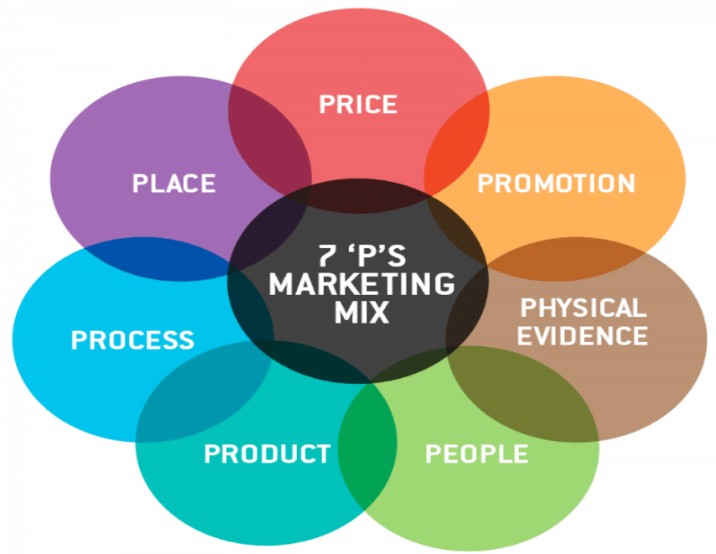
Figure 1: Marketing mix (Van der Westhuyzen and Van der Merwe, 2017)
Product: In terms of product, Hilton Hotels provides lodging and hospitality services in the entire world across 118 countries. It has a total of 17 brands that include luxury hotels, among which many of the properties are controlled by franchisees and some are leased (Van der Westhuyzen and Van der Merwe, 2017). The properties also include joint venture organisations. The brands consist of- Hilton Hotels and Resorts, DoubleTree by Hilton, Conrad Hotels and Resorts, Embassy Suites by Hilton Hotels, Canopy by Hilton, Waldorf Astoria Hotel and Resorts, Curio Collection by Hilton, Tru by Hilton, Home2 Suites by Hilton, Hilton Garden Inn, Tapestry Collection by Hilton, Signia Hilton, Hampton by Hilton, Hilton Grand Vacations, Homewood Suites by Hilton, MOTTO, LXR Hotels and Resorts.
Price: Hilton Hotel has a diverse portfolio and its price elements are also similarly diverse. It is because it has services and lodgings for customers from all types of customer segments for which reason, its pricing elements varies widely as well. The price element of Hilton Hotels ranges from luxury to midscale. Hilton Hotels has three luxury hotels where it offers a luxury price point that includes prices for wellness services and premium pricing (Dudovskiy, 2016). Tru Hotels by Hilton are for the mid level customers who require luxury at an affordable pricing. The remaining hotels under the brand’s portfolio consists of upper middle class or rich customers who take services from upper upscale, upscale and upper midscale hotels. The organisation uses price skimming and has a variety of price sensitive services for the customers.
Place: Hilton Hotel operates through both online and offline platforms for providing the best services to the customers. Its head office is situated in McLeod, Virginia, United States. It has many regional branches across UK, Japan, UAE, China, and Singapore. The brand has a total of 5685 hotels and 953,946 rooms.
Promotions: In terms of promotional activities Hilton Hotels has a strong brand presence and invests much into promotional activities for the organisation. It positioned itself in the minds of the customers as a brand that has a strong presence and provides high quality services with over 100 years of experience (Išoraitė, 2016). It focuses on word of mouth process of promotion for which reason Hilton Hotels heavily focuses on improving the customer experiences. It also uses digital marketing channels and promotes itself using social media. Hilton Hotels has a strong social media presence with a Facebook page, an official Twitter account, a LinkedIn account, and a YouTube channel. It also has a loyalty program which is targeted towards attracting and retaining customers called Hilton Honours with over 85 million members. It also receives many awards which is helpful towards organic promotion of the organisation in the minds of the customers as a well established hotel offering good services.
People: There are 169000 people working in various sectors of Hilton Hotels around the world. In terms of its employees and the workplace, Hilton Hotels manages a great work culture and is recognised by its employees as a good place to work in with award winning people management facilities (Londhe, 2014). The organisation offers competitive salary packages, paid time offs, educational assistance, health and wellness services, retirement services and provides paid paternal leaves to its employees as well. Overall, the people element of the organisation is satisfied and well managed.
Process: Hilton Hotels puts much emphasis on the ordering and booking process at Hilton Hotels to be customer friendly and convenient for the customers. Hilton Hotels uses an application which helps its customers to make reservations, select rooms, make bookings. It uses a proprietary technology platform named OnQ™ to provide their customers with their comfort and hospitality. Hilton also introduced contactless key services for the customers due to Covid-19 so that the customers are able to use their own cell phones as keys for their rooms.
Physical evidence: Hilton Hotel in order to provide services to the customers provides mainly intangible hospitality services. Hilton Hotels in terms of bills replaced its paper bills with digital services and provides paperless check ins and check outs so that the customers are able to enjoy its services without the worries of Covid-19 (Jain, 2013). In terms of its arrangement of furniture it changed its arrangements in its lobby to promote social distancing of the customers.

Communication mix
The communication mix consists of the communication methods used by organisation for effective marketing communication of the organisation. The communication mix of Hilton Hotels is as following-
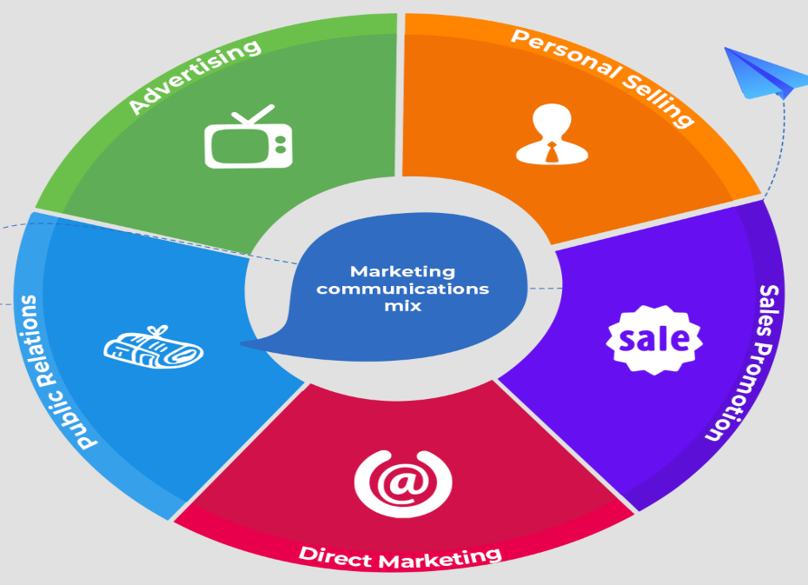
Figure 2: Communication Mix (Todorova, 2015)
Advertising: Hilton Hotels uses print and media for advertising and communicating its marketing message to its customer. Hilton Hotels marketing message expresses its high standard of services and the high quality information technology it uses. Hilton advertises itself in print media such as The Economist, Financial Times, Forbes, Fortune. It also advertises itself in various news channels where the organisation’s recent largest campaign is the ‘Stop Clicking Around’ campaign (Todorova, 2015). It also has another large scale campaign where the organisation challenges the conception that third party provides better price compared to the authentic websites. Hilton Hotels modified its advertising in the times of covid-19 by marketing itself as a contactless organisation where the customers can enjoy safe travels.
Sales promotion: In terms of sales promotion the organisation uses these its sales promotions to increase its sales by persuading potential customers and turning them into actual customers. The sales promotions activities used by Hilton Hotels consists of the HHonors loyalty programs where the organisation offers discounted prices, digital check-ins, late check outs, and free internet access to 50 million customers all over the world. The organisation also provides discount vouchers to the customers to increase sales. It also provides the customers a sense of exclusiveness through its loyalty programs.
Direct marketing: Hilton Hotels also focuses on direct marketing to increase its sales. Hilton uses direct booking strategy for increasing the sales (Genchev and Todorova, 2017). The organisation started a “Expect Better, Expect Hilton” marketing campaign in order to improve and encourage its customers to book rooms directly. The organisation uses its various social media pages to establish direct communication with its customers in order to increase its sales and to maintain and manage customer relationships.
Personal selling: The organisation has sales representatives and customer service to directly communicate with the customers to encourage them to make reservations. Hilton Hotels has dedicated representatives who directly contact potential customers or buyers and convince them to book hotel rooms. However, Hilton Hotel does not put much emphasis on personal selling and focuses its resources on to innovation and technology based marketing.
Public relations: Hilton Hotels is an organisation which puts heavy emphasis on maintaining and managing its public relationships. It has a dedicated press centre where the organisation provides clients with opportunities to advertise themselves to establish its public relations (MA, 2020). Hilton Hotels also does sponsorships to various campaigns where the organisation promotes itself through aiding various causes. In order to respond to the covid-19 situation, Hilton Hotel used its public relations to assist local and national government organisations and provided housings for first responders and frontliners in terms of health care and medical workers.

Stakeholder map
Stakeholder map identifies the important stakeholders for the organisation and makes decision about the stakeholders by categorising them based on priorities. Hilton Hotel has a separate and dedicated stakeholder engagement department in the organisation so that it is able to use its stakeholder map properly. The stakeholder map of Hilton Hotel is as following-
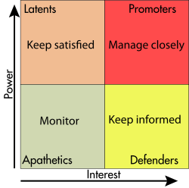
Figure 3: Stakeholder Mapping (Civera and Freeman, 2019)
The stakeholder management of Hilton Hotel is based on the priority it provides to its stakeholders based on their power and interest over the organisation. The key stakeholders of the organisation are the team members, owners, guests, employees (Civera and Freeman, 2019).
Promoters: The latent stakeholder of the organisation are the ones who hold the most power and have the high interest within the organisation as well. In terms of the latent stakeholders, the guests, investors, suppliers, and the owners of Hilton Hotels are the major stakeholders. In order to keep these stakeholders who are owners satisfied Hilton Hotels provides regular updates through the use of newsletters internally and consults the owners for any key issues. In order to keep the guests satisfied Hilton Hotel manages the customer satisfaction measurement. The organisation takes feedbacks from the customers through the use of reviews and has a 64.7% positive score with an average of 9 out of 10 in its reviews. The organisation also provides top notch guest assistance, to the customers and has its Hilton Honours and loyalty programs (Jones et al., 2017). It also arranges meetings and events for the guests and prepares top quality food and beverages. In order to keep the guests satisfied, Hilton Hotels in the time of Covid-19 provided the customers with hygiene products and free sanitary and hygiene settings in the organisation in order to manage them properly.
Latents: The latents for Hilton Hotels are the stakeholders who hold high power but less interest in the organisation. For Hilton Hotels these stakeholders are the various team members working at different owned and managed Hilton Hotels around the globe. The organisation to closely monitor them, provides them with opportunities to wellness and wellbeing through LightStay, Thrive at Hilton and many more programs. The organisation also uses Hilton Universitiy and Go Hilton and other programs that offer education and awards in the organisation to encourage the customers to perform well in the organisation (Andriof and Waddock, 2017). The organisation provides these stakeholders with key resources and regular updates in order to keep them satisfied.
Apathetics: The apathetics for Hilton Hotels are the stakeholders who hold less power and less interest in the organisation. To manage them, Hilton Hotels made decisions to monitor them closely through various ways. For Hilton Hotels, these stakeholders are the NGOs and government organisations. Hilton Hotels ensures to monitor them properly Hilton Hotels engages with these organisations through its public-private relationship and partnership ventures. It also ensures to participate in expert forums and provide dialogues and surveys to help these organisations. The hotel closely manages these organisations through strategic partnerships and consultations in terms of key issues. It has stakeholders such as UN, Department of Agriculture Food Waste, World Water Week, UN Cop 24 and many other ventures to promote itself and to keep its public relationships to manage them closely (Lynch, 2018).
Defenders: Defenders in terms of Hilton Hotels are the ones who hold less power but high interest in the organisation. These stakeholders for Hilton Hotels are the industry and related organisations it operates in. In order to properly manage the industry based stakeholders, the organisation adopted the strategy to keep informed about the changes in the industry. For this reason, the organisation collaborates with the industry in various key issues and co-creates the commitments and programs that are required in the industry. It makes sure that it is informed about any changes in the industry so that it can make quick decisions. It supported various relevant and related causes in the hospitality industry like International Tourism Partnership and its goals on various topics, the embrace of science based practices to reduce CO2 emissions, and signed an agreement in Paris (Hilton, 2018). The organisation supports and collaborates with the industry in various causes to keep informed and to be able to make quick decisions required to remain in the industry.

Porter’s five forces
The Porter’s five forces model is a model which analyses the external environment of an organisation to determine the different states of the factors of the external environment which might affect the organisation in multiple ways. Following is the Porter’s five forces analysis of Hilton Hotels-
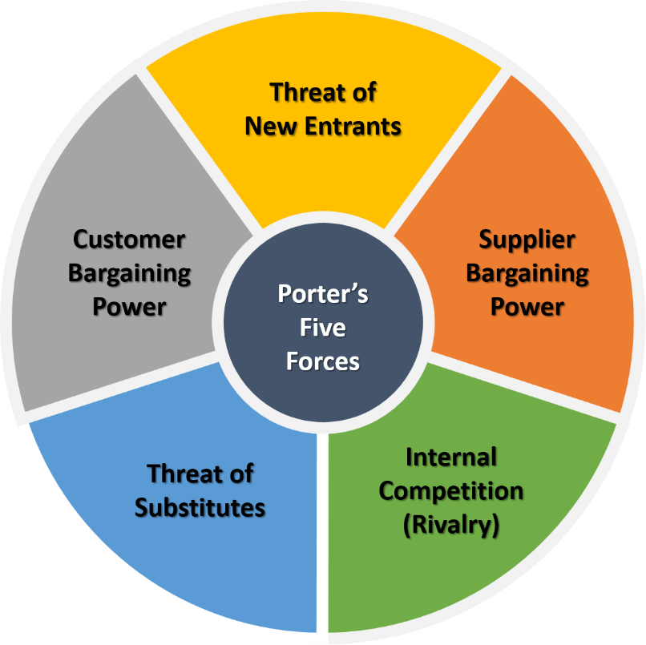
Figure 4: Porter's Five Forces (David and David, 2016)
Threat of new entrants: The threat of new entrants of the market in terms of Hilton Hotels is low as it takes a lot of investment and resources to start a hotel and lodging business. There are very few people who are able to make that kind of investments (David and David, 2016). For this reason, the entrant rate of new hotels and lodgings in the Hilton Hotel’s hospitality industry is very low. For this reason, the threat of new entrants for Hilton Hotels is low as well.
Bargaining power of suppliers: The bargaining power of suppliers for Hilton Hotels is low as well. It is because, Hilton Hotel is the market leader and has a lot of different suppliers for resources at their disposal. For this reason, switching cost for Hilton Hotels in terms of suppliers is quite low and Hilton Hotels can switch its suppliers at any given time. Due to this reason, the bargaining power of suppliers of Hilton Hotels is relevantly low.
Rivalry: The hospitality industry is a very competitive market where the rivalry is intense as well. For this reason, the rivalry of Hilton Hotels is quite high. There are a lot of major competitors in the industry who give Hilton Hotels a tough competition. Its main rivals are Hyatt Hotels, Marriott Hotels, Holiday Inn, IHG Hotels, and Loews Hotels (Comparably, 2022). The organisation faces intense competition in the market and this significantly impacts its decision making and policy making in the organisation to create competitive advantage.
Bargaining power of customers: The customer bargaining power of Hilton Hotels is quite high. It is because the organisation has a lot of competitors for which the switching cost for customers is quite low. It means that customers are able to switch any of its competitors at any required time. For this reason, Hilton Hotel faces much threat in terms of the high bargaining power of customers and it has to constantly keep its competitive advantage and keep its customers satisfied in order to ensure that the customers choose Hilton Hotels over its competitors.
Threat of substitutes: The threat of substitutes faced by Hilton Hotels is high as well. It is because there are a wide variety of motels and other alternative lodging services available at the market which can be used as substitutes for Hilton Hotels (Ansoff et al., 2018). The major substitute of the organisation is Airbnb. Airbnb’s provide a different type of lodging at a much cheaper price compared to the luxury of Hilton Hotels. For this reason, customers can often choose Airbnb as alternative lodging solution to Hilton Hotels. Thus, the threat of substitutes for Hilton Hotels is quite high.

Findings
The analysis conducted on Hilton Hotels using secondary data by applying key marketing theories such as marketing mix, stakeholder mapping, communication mix, Porter’s five forces theory determines that the various internal and external factors of the organisation affect its quality and control system for Hilton Hotels. The internal and external factors influence the ways in which the organisation manages the customers and how it provides quality control for the organisation.

Marketing mix
The marketing mix of the organisation shows that it brought many key changes in its core operations and marketing elements due to customer demands and factors like Covid-19 (Henry, 2021). It brought changes in its product or services by offering the customers contactless key using their cell phones to get into rooms. The organisation also brought changes in its physical evidence due to the requirements of the government, the customers, and overall covid-19 pandemic by rearranging its furniture in a way that promotes social distancing while maintaining the cosy feeling in a lobby (Newsroom, 2021).

Communication mix
The communication mix of the organisation shows that Hilton Hotels plans its communication and marketing efforts while keeping the various internal and external factors in mind. In terms of promotional activities, the organisation puts much emphasise on word of mouth policy where the customers themselves promote the organisation through their various activities. To achieve this, Hilton Hotels focuses on mainly improving its customer experience and by encouraging customers to leave positive reviews about the organisation. Due to this reason, the customers of Hilton Hotels also put in reviews about the organisation on different websites where when a customer is researching about lodgings, they can easily look at the reviews and make their decisions. For this reason, Hilton Hotels emphasises customer experience and uses effective customer management. It has a positive score of 9 out of 10 in its reviews from customers and an overall score of 64.7% which is a top score (Hilton, 2018). The customers who are new can just look at these feedbacks from other customers and make their decisions. To encourage positive customer experience and sales, the organisation also has Hilton Honour program, where the customers who are loyal are given preference to and customers are felt exclusive. These loyal customers get regular discounts and other exclusive services due to their loyalty cards. These policies of Hilton Hotels are heavily impacted by the demands of its stakeholders who are the guests in order to encourage them to make purchases. In the time of Covid-19 the organisation stayed true to its regular communication policies and started putting more emphasis on customer wellbeing and safety in order to encourage the word of mouth publicity. Previously, the organisation positioned itself as a high quality organisation, however, due to the pandemic, the organisation repositioned itself as a safe, hygienic and high quality organisation (Fuertes et al., 2020).

Stakeholder map
The stakeholder map shows that Hilton Hotel plans its quality control by being significantly impacted by its important stakeholders. It wishes to manage its Promoters who are the owners, guests, investors, and suppliers. These are the most important stakeholders for the organisation who must be managed well and kept satisfied. Hilton Hotel provides regular updates, and consults them in any key decision making. In order to design its quality control and services for the customers of the organisation, Hilton Hotels ensures that it conducts regular surveys for its customers to respond to (Hill et al., 2014). In the surveys the customers state their complaints and expectations and Hilton Hotels comes up with policies that are relevant and desired by the customers. It designs its quality control by ensuring that the customers are satisfied and conducts regular surveys to bring any required changes.

Porter’s five forces
Hilton Hotels is also heavily influenced by its external activities. It prepares and designs its policies by keeping in mind the threat of substitutes, rivalries, and the bargaining power of customers in mind. For this reason, Hilton Hotels provides services that are of high quality which cannot be replaced by substitutes. The overall external environmental factors that impact the organisation are managed by gaining competitive advantage. Due to its diverse portfolio, Hilton Hotel is able to grasp any kind of customers at any level (David and David, 2016). For this reason, customers from any segment are able to enjoy the luxurious or luxury in budget policies of the organisation. Hilton ensures that its services are competitive and on par with the services provided by its competitors.

Task- 2
Hilton Hotels is one of the market leaders in the hospitality industry and with the changing times due to the covid-19 pandemic, Hilton Hotel significantly changed the ways in which it provides services to its customers. With the shift in the demands of the customers and the demands of the environment, the organisation brought many major changes to its operations. The following re the changes brought by Hilton Hotels in response to the covid-19 changes-

Evolution of the hotel design
Previously, Hilton Hotels’ lobbies were designed to provide customers with a positive experience which encouraged conversations and socialising (Newsroom, 2021). However, due to the shift in the demand of the customers and of the situation, the organisation responded to the changes by redesigning and evolving it designed. It changed its marketing mix and reorganised its physical evidence by altering the settings of the lobby in a way which will promote social distancing while providing a cosy feeling to the customer. The organisation focused on improving the safety of the customers while maintaining a good relationship with them.

Contactless experience
The organisation in response to the Covid-19 changes and due to the customer requirements provided contact fewer billing services for the organisation. the customers can pay their bills and receive online bills through online services. The organisation also has its state of the art Digital Key Services where the customers can request digital key through their Honour application which can be used to open doors to rooms, gyms, and other services (Armstrong et al., 2019). The application also provides the customers opportunity to redesign and personalise their room settings through the application. However, to encourage customer experience and loyalty and to build good relationship with the customers, these services can only be availed through the Honour application which is exclusive to loyal customers.

Cleanliness
The organisation in response to the Covid-19 puts much emphasis on ensuring the cleanliness of the organisation and hotel premises as well. The organisation ensures that all of the hotel premises, furniture, kitchenware and all aspects of the organisation are cleaned. In response to the public demands and covid-19, the organisation is working with its engineers to develop devices that provide clean air, clean environment and other aspects that are required to be clean in the organisation.

Flexibility
Hilton Hotels also responded to the corporate demands of flexibility. The organisation decorated and set up its auditoriums with large screen where online meeting can be held with ease (Hilton, 2022). The organisation provides flexible meeting opportunities to the organisation so that the customers can easily any kind of corporate meeting at the organisation.
However, developing and maintaining these customer relationships for Hilton Hotels incurs much expense. The investment in technology and the overall renovation of the organisation made it significantly expensive for the organisation to manage the good relationships with the customers. The Honour application and the overall changes brought in the organisation as a response to changing customer demands and the overall situation incurred much expenses for the organisation. This investment in return increased the pricing for the services for the hotel which had a negative impact on the customer relationship with the organisation (Dudovskiy, 2016).
The internal and external factors of Hilton Hotel significantly impact the quality control and customer relationship of the organisation. These internal and external factors influenced the organisation to bring many changes in its operations. However, the Hilton Hotels was able to deal with the shift in customer demands and overall external situation of the organisation due to the global pandemic successfully. The organisation even in the time of Covid-19 was able to secure a revenue of 22.8% per room (Simon, 2020). The quarter 1 report of the organisation shows that Hilton Hotel thrived in its business even in the midst of a global pandemic. It is because, the organisation was able to utilise the modern technology properly and was able to fulfil the customer demands of safety and social distancing. However, despite all its efforts, Hilton Hotels was not able to achieve the same success in its hotels in the Asian region of the world. Hilton Hotels was unable to understand the Asian market properly and failed to respond to the customer demands in this sector.

Conclusion
In conclusion, it can be seen that, Hilton Hotels is the market leader and it is able to respond to the customer needs and changing internal and external factors properly. Hilton Hotels adjusted many of its quality control and customer management systems due to the covid-19 pandemic and due to the various factors, that impact the organisation such as key stakeholders, competitors, substitutes, customer demands. Hilton Hotels also puts significant emphasis on developing and managing its relationship with the customers. To achieve this, the organisation invests more in improving customer experience as opposed to promoting or advertising the organisation intensively and utilises the word of mouth promotional technique mainly. However, managing and improving customer experience is a highly expensive process for the organisation which is a negative impact of customer management.

References
Andriof, J. and Waddock, S., (2017). Unfolding stakeholder engagement. In Unfolding stakeholder thinking (pp. 19-42). Routledge.
Ansoff, H.I., Kipley, D., Lewis, A.O., Helm-Stevens, R. and Ansoff, R., (2018). Implanting strategic management. Springer.
Armstrong, G., Kotler, P. and Opresnik, M., (2019). Marketing. Harlow, United Kingdom: Pearson Education, Limited.
Civera, C. and Freeman, R.E., (2019). Stakeholder relationships and responsibilities: A new perspective. Symphonya. Emerging Issues in Management, (1), pp.40-58.
Comparably, (2022). Hilton Competitors. [online] comparably.com. Available at: <https://www.comparably.com/companies/hilton/competitors>.
David, F. and David, F., (2016). Strategic Management. Harlow, United Kingdom: Pearson Education Limited.
Dudovskiy, J., (2016). Hilton Marketing Communication Mix. [online] Research methodology. Available at: <https://research-methodology.net/hilton-marketing-communication-mix/>.
Fuertes, G., Alfaro, M., Vargas, M., Gutierrez, S., Ternero, R. and Sabattin, J., (2020). Conceptual framework for the strategic management: a literature review—descriptive. Journal of Engineering, 2020.
Genchev, E. and Todorova, G., (2017). Sales promotion activities–effective tool of marketing communication mix. Available at SSRN 3089894.
Henry, A., (2021). Understanding strategic management. Oxford University Press.
Hill, C.W., Jones, G.R. and Schilling, M.A., (2014). Strategic management: Theory & cases: An integrated approach. Cengage Learning.
Hilton, (2018). Corporate Responsibility Report. [online] Cr.hilton.com. Available at: <https://cr.hilton.com/wp-content/uploads/2019/05/2018_Hilton_Stakeholder_Engagement.pdf>.
Hilton, (2022). About. [online] Hilton.com. Available at: <https://www.hilton.com/en/>.
Išoraitė, M., (2016). Marketing mix theoretical aspects. International Journal of Research-Granthaalayah, 4(6), pp.25-37.
Jain, M.K., (2013). An analysis of marketing mix: 7Ps or more. Asian Journal of Multidisciplinary Studies, 1(4), pp.23-28.
Jones, T.M., Wicks, A.C. and Freeman, R.E., (2017). Stakeholder theory: The state of the art. The Blackwell guide to business ethics, pp.17-37.
Londhe, B.R., (2014). Marketing mix for next generation marketing. Procedia Economics and Finance, 11, pp.335-340.
Lynch, R., (2018). Strategic management. Pearson UK.
Newsroom, (2021). A Decade of Innovation in Just One Year: Seven Surprising Ways the Pandemic Has Changed Hotels Forever. [online] Hilton Press Center. Available at: <https://newsroom.hilton.com/corporate/news/hilton-many-pandemic-safety-innovations-to-remain>.
Newsroom, (2022). History. [online] Newsroom.hilton.com. Available at: <https://newsroom.hilton.com/assets/BCM/images/Hilton100/Docs/Hilton-History-Timeline.pdf>.
Simon, E., (2020). Hilton shares Q1 impact of COVID-19. [online] Hotel Management. Available at: <https://www.hotelmanagement.net/own/hilton-shares-q1-impact-covid-19>.
Stead, J.G. and Stead, W.E., (2014). Sustainable strategic management. Routledge.
Todorova, G., (2015). Marketing communication mix. Trakia Journal of sciences, 13(1), pp.368-374.
Van der Westhuyzen, B. and Van der Merwe, J., (2017). The marketing mix. Mowbray, South Africa: Future Managers.
КАЛИНИНА, М.А., (2020). Retaining customers through digital communication mix. Экономика. Бизнес. Банки, (6), pp.75-83.

