Module: Digital skills and resource methods
Module code: BMSW4003
Lecturer: Ejiro Esohwode
Student name: Alessio Manigrasso
Student code:(2019791)

DSR ASSESSMENT 2 INDIVIDUAL REPORT
Table of Contents
Introduction 2
Literature review 2
Research methodology 3
Data collection and analysis 3
Conclusion 8
References 9
Appendix 10

Introduction
The major purpose of the particular research project is to determine the impact of Virtual Learning Environment (VLE). In the following project a complete understanding will be gained on Virtual Learning Environment (VLE) through conducting research. In the following project various methods will be used for collecting the appropriate and relevant data associated with the study and the results will be analysed and discussed. Questions will also be prepared for the purpose of gathering useful information regarding the particular topic. With the help of these questions it will be easier to stay focused on a particular study that will allow obtaining only useful information. Furthermore, with reference to the findings and discussion a proper conclusion will be drawn in order to reflect the knowledge and understanding that has been gained through conducting this research.

Literature review
Virtual Learning Environment (VLE)
Virtual Learning Environment (VLE) has been explained as a unique and innovative way of learning that provides learning material through the internet (Herrera Mosquera, 2017). It is a system that consists of many features such as assessments, tracking students, collaborations as well as communication tools. It is considered to be a useful system as it allows the student to access learning from anywhere. It helps in learning from the campus as well as off the campus. It allows the teachers to teach the students who cannot come regularly to the universities. It is considered to be really helpful for distance learning where there is a lack of educational institutions. With the help of Virtual Learning Environment (VLE) students can access learning and education while being remote (Global.oup.com. 2021).
Increase necessity of Virtual Learning Environment (VLE)
In today’s time it has been seen that the need for the use of virtual and digital tools has increased significantly. The research for the increase in the use of VLE is due to the pandemic caused by COVID-19. It has been seen that due to this epidemic the whole world is in lockdown and all the business and schools are shut (Bonacini et al., 2020). Therefore, due this reason it has been seen that people are now working from goes as well as students are learning from. The Internet and technology has the most important role to play in this process. It has been stated that education is one of the sensitive areas that has been affected extremely. The closure of all tee educational institutions has forced the institution to take another measure to continue providing education to the students. Therefore, due to this reason various educational systems have been motivated and encouraged due to the introduction of the online education system. It is believed that through virtual learning educating the students will become easier (Surkhali and Garbuja, 2020).
Pros and cons of Virtual Learning Environment (VLE)
Due to this new way of learning many of the people we really benefited. It has been seen that the students were able to study without even leaving their house and were also able to keep themselves safe. Further it has also been seen that the educational institution is able to provide education to the students without hampering their career. It has been found that there were many advantages of VLE such as it was easily accessible, location of the person did not play any role, it was flexible, affordable as well as convenient. However, apart from these advantages there were many disadvantages as well that the students have faced such as solo learning, lack of engagement, isolation, technological issues and so on (CIF Training. 2021).

Research methodology
It is crucial to determine how VLE has impacted the lives of the students as it has been understood it has advantages as well as disadvantages. Hence, the research methodology that will be used in the particular research is both qualitative as well as quantitative. Therefore, with reference to these methodologies primary data as well as secondary data will be collected. In order to collect such data surveys will be conducted for primary data as well as available data and information will be obtained through secondary data collection. Therefore, for the purpose of survey questionnaires will be prepared that will help in gathering primary data from the participants. The survey will be conducted online considering the restriction and safety due to the pandemic caused by COVID-19. The sample size that has been selected for the particular survey is a group of 30 people.

Data collection and analysis
Primary data
Survey has been conducted online where all the 30 participants have answered the prepared questionnaire. Below are the data that has been gained through primary sources
1. How far do you agree that VLE was helpful or your education?
Strongly agree | Agree | Neutral | Disagree | Strongly disagree
15 | 7 | 3 | 1 | 4
Table 1: Questionnaire 1
(Source: Created by self)
With respect to the first question, it has been seen that the majority of the people agree that VLE was really helpful in the time of their need. Hence, it can be stated that VLE has made a positive impact on the life of people however, it has been seen that some of the people disagree with this question which indicate that they have faced issues due to VLE. in addition, it has also been seen that some people do not have any clue whether it was helpful or not. Hence with the help of these data or can be stated that VLE was helpful to most of the people however, for understanding the issues of some people further research will be conducted.
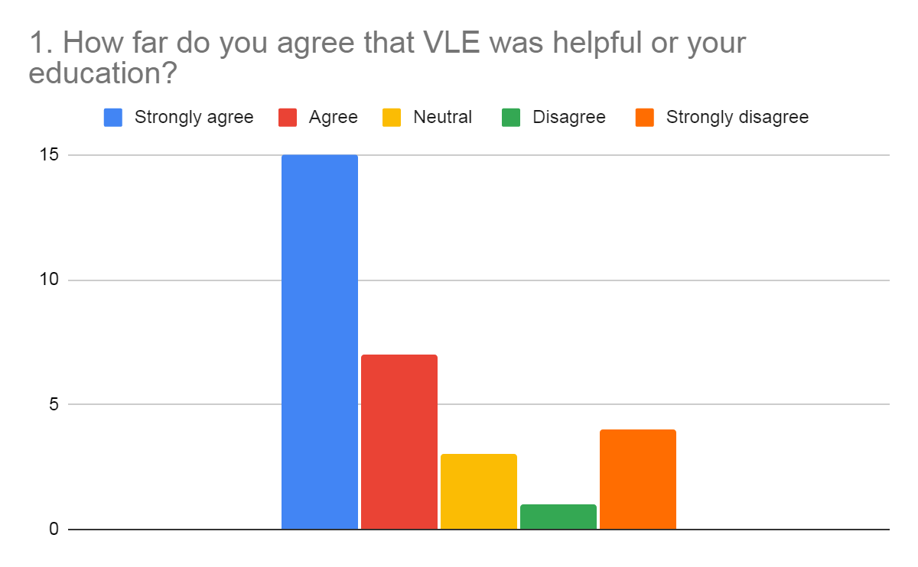
Figure 1: Questionnaire 1
(Source: Created by self)
Above is the graphical representation of how far people agree with the helpfulness of VLE in education.
2. How far do you agree that VLE has changed your whole education system?
Strongly agree | Agree | Neutral | Disagree | Strongly disagree
10 | 10 | 2 | 6 | 2
Table 2: Questionnaire 2
(Source: Created by self)
In the next question the participants were asked whether they agree that VLE has changed the whole education system or not. With respect to this question it has been seen that the majority of the people agree that it has changed the whole education system. However, there are still some people who do not agree with such statements. Hence, it can be stated that they have different opinions regarding this particular concept.
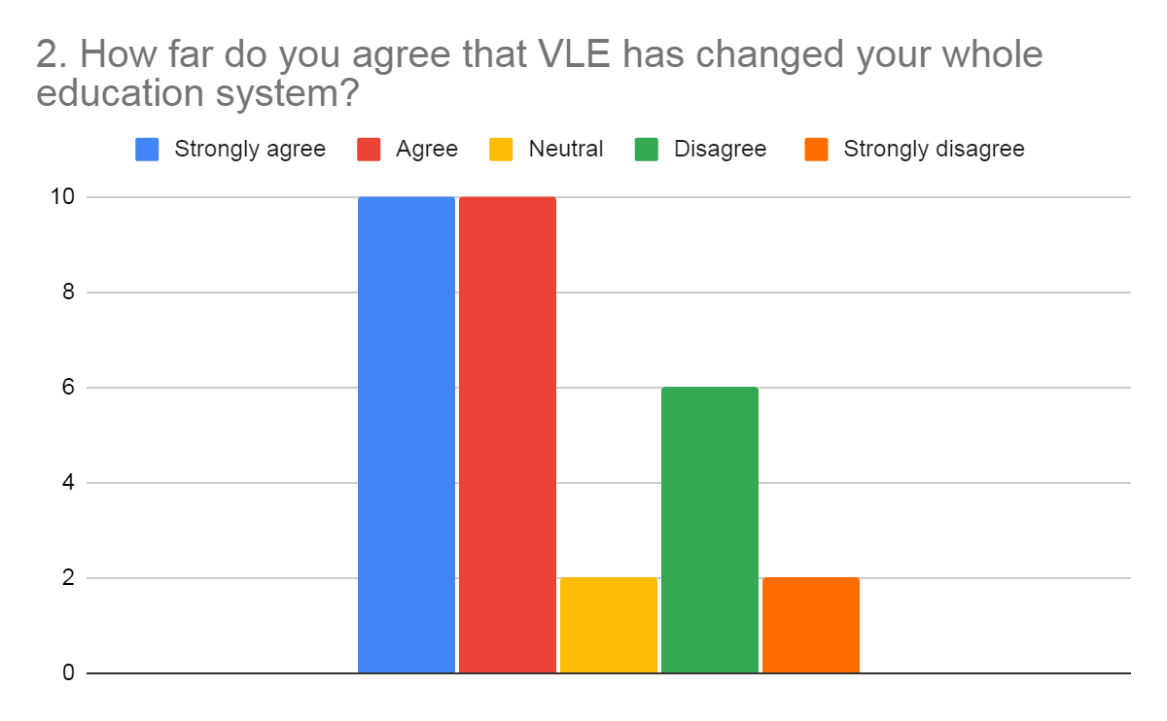
Figure 2: Questionnaire 2
(Source: Created by self)
Above is the graphical representation of how far people agree with the changes brought in the education system by VLE.
3. How far do you agree that VLE has impacted your daily lives?
Strongly agree | Agree | Neutral | Disagree | Strongly disagree
7 | 10 | 3 | 5 | 5
Table 3: Questionnaire 3
(Source: Created by self)
In the third question the participants were asked whether VLE has made an impact on their daily life’s or not. It has been found that most of the people agree that VLE has made a significant impact in their daily life. However, behind the majority of the people there are still some people who feel that VLE has made no impact on their daily lives. Hence, in order to determine the reasons of these people further research will be conducted through secondary data collection.
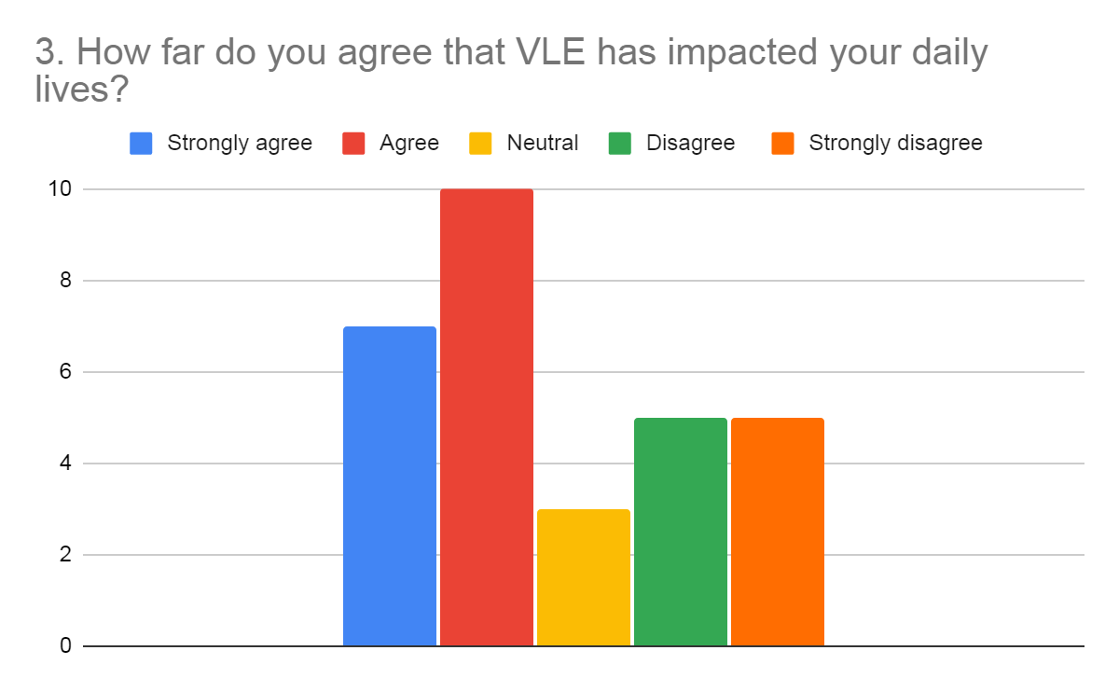
Figure 3: Questionnaire 3
(Source: Created by self)
Above is the graphical representation of how far people agree with the impact of VLE on their daily lives.
4. How far do you agree that VLE can become the future of education?
Strongly agree | Agree | Neutral | Disagree | Strongly disagree
15 | 5 | 0 | 2 | 8
Table 4: Questionnaire 4
(Source: Created by self)
In the fourth question, respondents were asked whether VLE can become the future of the education system. From the obtained data it can be seen that most people agree that it can become the future of the education system. However, there are still some people who do not agree with his idea. It can be stated that these people believed that the traditional way of education is way better than the virtual.
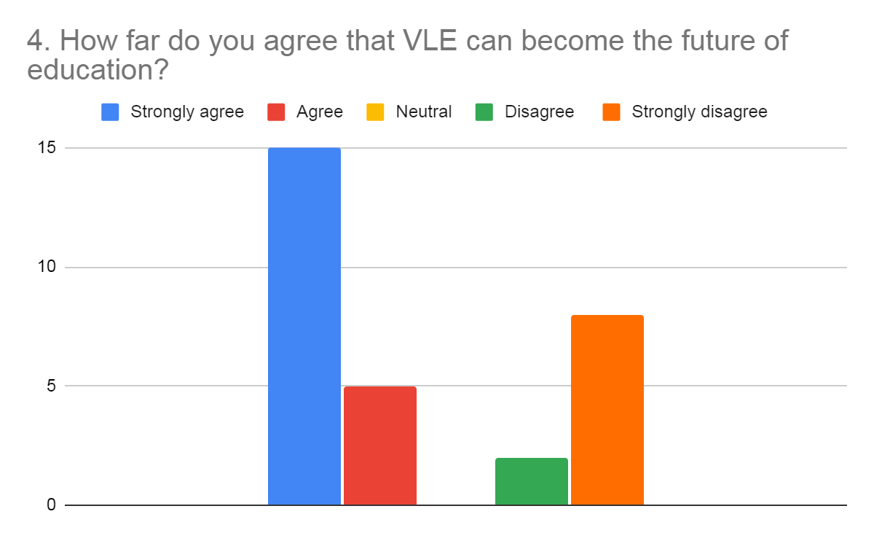
Figure 4: Questionnaire 4
(Source: Created by self)
Above is the graphical representation of how far people agree the VLE can become the future.
Secondary data
In order to gather secondary data thematic analysis will be conducted that will be more helpful in analyzing the collected data.
Theme 1: Helpfulness of VLE in education
It has been found that with the implementation of VLE in the educational institution it is proved to provide an efficient platform to improve the quality of learning and teaching. It has been seen that with the new way of learning such as online learning has taken place in the mainstream school and other educational institutions. However, since the pandemic caused by COVID-19, it has been seen that all the school and educational institutions have been forced to take help of online learning and teaching. Implementation of VLE in the education system has allowed easy interaction and collaboration among students and teachers. Apart from these benefits it has been found that many of the people are not able to adapt to such changes due to which they are having issues with this (Awang et al., 2020).
Theme 2: Changes made in the education system by VLE
It has been seen that the adoption and implementation of VLE has made significant changes in the education system. It has been seen that the teachers have faced significant challenges due to the introduction of VLE in the education system. To be more specific the senior teachers were facing more challenges than the younger teachers. It has been found that younger teachers are able to use this new innovative technology for the purpose of providing education in a better way in comparison to the senior teachers. Most of the senior teachers have stated that this new innovation has made significant changes due to which they are even having difficulty in teaching students with these new systems as this has changed the traditional education system (Shazali and Hashim, 2018).
Theme 3: Impact of VLE in daily lives of the people
It is believed that technology has become an important part of human lives. Ye life of people are now becoming technologically driven because of the presence of electronic gadgets and ICT. The impact of technologies can be seen on people of every age group. One of the technologies that have been identified is VLE. This technology allows students to just login into the software and get the relevant educational data that was provided by the educational institution. It has been found that both parents as well as the students have agreed that it was the easiest way to get all the information regarding learning that has made their life easier (Saruji et al., 2017).
Theme 4: The future of VLE in education system
It has been found that VLE will be really helpful in the future for students as well as other people. It has been stated that VLE will play an important role in the future learning activities. It is believed that with the use of VLE even in the future it will be convenient for the students to take on learning activities for the professional as well as personal development (Al-Azawei and Al-Masoudy, 2020).

Conclusion
From the above discussion it has been seen that VLE is significantly important in the today’s life of the people. It has been seen that due to the sudden change in the situation the demand of VLE has increased extremely. From the research, it has been found that implementation and adoption has made significant benefits in the lives of the people as well as the education system it has be seen that many of the people including students and teachers are really benefited with VLE however, certain disadvantages has also been identified of VLE and also has been discussed. However, it can be stated that the implementation of VLE has been more beneficial and the disadvantages of VLE is too less in comparison to its advantages. Hence, it has a positive impact to the society.

References
Al-Azawei, A. and Al-Masoudy, M., 2020. Predicting Learners' Performance in Virtual Learning Environment (VLE) based on Demographic, Behavioral and Engagement Antecedents. International Journal of Emerging Technologies in Learning (iJET), 15(9), pp.60-75.
Awang, H., Aji, Z.M., Osman, W.R.S., Al-Mashhadani, A.F.S. and Deli, M.M., 2020. Exploring Teachers’ Satisfaction toward Virtual Learning Environment: Malaysian Perspective. Solid State Technology, 63(3), pp.3023-3043.
Bonacini, L., Gallo, G. and Patriarca, F., 2021. Identifying policy challenges of COVID-19 in hardly reliable data and judging the success of lockdown measures. Journal of Population Economics, 34(1), pp.275-301.
CIF Training. 2021. The Advantages and Disadvantages of Virtual Learning | CIF Training. [online] Available at: <https://ciftraining.ie/2018/01/advantages-disadvantages-virtual-learning/?> [Accessed 5 April 2021].
Global.oup.com. 2021. Oxford University Press | Online Resource Centre | Learn about Virtual Learning Environment/Course Management System content. [online] Available at: <https://global.oup.com/uk/orc/learnvle/> [Accessed 5 April 2021].
Herrera Mosquera, L., 2017. Impact of implementing a virtual learning environment (VLE) in the EFL classroom. Íkala, revista de lenguaje y cultura, 22(3), pp.479-498.
Saruji, M.A.M., Hassan, N.H. and Drus, S.M., 2017, April. Impact of ICT and electronic gadget among young children in education: A conceptual model. In Proceedings of the 6th International Conference on Computing and Information, Kuala Lumpur (pp. 25-27).
Shazali, S.S. and Hashim, H., 2018. Challenges in using frog VLE in teaching english to ESL learners: a review of past studies. Journal of Counseling and Educational Technology, 1(1), pp.1-4.
Surkhali, B. and Garbuja, C.K., 2020. Virtual learning during COVID-19 pandemic: pros and cons. Journal of Lumbini Medical College, 8(1), pp.154-155.

Appendix
Research questionnaires
1. How far do you agree that VLE was helpful or your education?
Strongly agree | Agree | Neutral | Disagree | Strongly disagree

2. How far do you agree that VLE has changed your whole education system?
Strongly agree | Agree | Neutral | Disagree | Strongly disagree

3. How far do you agree that VLE has impacted your daily lives?
Strongly agree | Agree | Neutral | Disagree | Strongly disagree

4. How far do you agree that VLE can become the future of education?
Strongly agree | Agree | Neutral | Disagree | Strongly disagree

