Module code: LCBB4005
Module Title: The Global Business Environment - Assessment 1

Analysing the major forces of the global business environment and evaluating the impact of the Covid-19 pandemic on the fashion industry

Student’s name: Catalina Maxim
Student’s ID: 2011531
Lecturer’s name: Dr John-Paul Okeke

Table of contents
Introduction ……………………………………………………………………………. 3
- The impact of Covid-19 on the fashion industry ………..………….….…...…. 4
- Major forced that shape the global fashion industry …………………………... 5
- SWOT analysis of the British fashion industry ……….…….……...………….. 8
- Methods of fashion industry’s rehabilitation to the new business environment ………………………………………………………………………………….. 9
Recommendations …………………………………………………………………….. 10
Conclusion …………………………………………………………………………….. 11
Reference list ………………………………………………………………………….. 12

Table of figures
Figure 1.1 ………………………… …………………………………………………… 4

Introduction
The modern industry of fashion constantly registers financial loss due to multiple social and macroeconomic factors. Among the most impactful issues are the Covid-19 pandemic, changing consumers preferences, globalisation, distorted information and now even more actual, the global health and economic crisis (McIntosh, 2020).
This essay has the purpose to analyse and evaluate the major forces that lay at the foundation of the global fashion industry, such as digitalisation, demographics, rivalry, political factor and “The Green Revolution” (Bawden, 2020), through PESTLE analysis of the mentioned industry.
In addition, the investigation fell on what are the potential threats and opportunities that surround the global fashion giants and how those forces affected or stimulated those companies, amid the Covid-19 outbreaks and what was their innovative ways of succeeding through the challenging times.

- The impact of Covid-19 on the fashion industry
The Covid-19 pandemic affected unforeseeable the global fashion leaders, which resulted with enormous profit loss, store closures and uncertainty of the industry’s future.
For instance, The Guardian (2020a) reported about Inditex, one of the global largest garment retailers, that had sales down 44% to £2.9bn between the first quarter of the 2020 financial year and a net loss of £390m. In the same period, H&M recorded an income sinking by 88.2% (£174.4m) and a gross profit shrinking of 23.6% (£8.15 billion) until November, 2020 (Retail Gazette, 2021).
Other conclusive examples are Primark garment retailer, with a drop of revenues by 75% to £800m (The Guardian, 2020c) and Gap, the San Francisco based company, with a revenue fall of £738m during the first quarter of 2020 financial year (The Guardian, 2020b).
The fierce global pandemic had a negative impact not only on the big brands and retailers, but has triggered a chain reaction upon the lower levels of the hierarchy as well, like stakeholders and dependant parties.
According to Fashion Revolution (2020), the global brands owners were paying their suppliers weekly or monthly after delivering the manufactured goods. In another train of thoughts, the most affected in this situation are the suppliers, that usually paid upfront for the raw materials and after producing and delivering the final goods, they were receiving their profits.
Despite of huge workforce and investments engaged, none of the major brands and retailers wanted to assume the responsibility and risk during the Covid-19 outbreak, therefore many orders were cancelled and payments blocked for already placed orders. This resulted with over £12.3bn debt to the garment suppliers worldwide (The Guardian, 2020d).
Bloomberg (2020) states that only in Bangladesh, due to cancelled orders, about 1,089 apparel manufacturing suppliers scored a financial loss of $1.5 billion. As a result, many factories have been shut down immediately, lots of employees have lost their jobs and woke up in the situation where they are unable to manage their expenses and nurture their families.
The suppliers had to quickly reinvent their business models and their product mixes, in order to survive the global economic crisis. In consequence, 20% of the global garment manufacturers network started producing the personal protective equipment (PPE) and other 23% diversified their sale channels, focusing on online commerce (Barrie, 2021).

- Major forces that shape the global fashion industry
“The macro-environment is the extensive business climate which influences organizations across industry and geographical placement. It refers to the national or international business climate as a whole, which is usually dependent on regional economies and societies and which impacts the businesses of all sizes” (Bush, 2020).
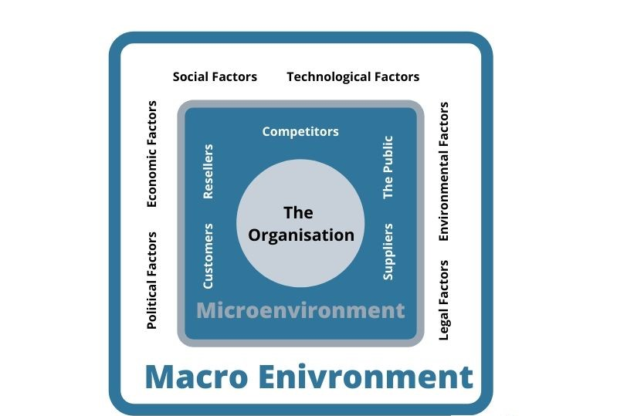
Figure 1.1 Global business environmental forces
Source: Oxford College of Marketing (2021)

Therefore, in the present report were applied the PESTLE principles with the purpose to understand and measure the major factors that affect the global fashion industry:
Economic Factor
According to Statista (2021a), Europe is considered the most profitable garment and footwear market worldwide. Size of the global apparel market consisted 1.5tr USD in 2020, which increased compared to 0.35tr USD for the same period in 2019.
The same source states that among the leading European countries, the most valuable clothing industry belongs to Germany, which counted in 2020 somewhere 6.17 billion U.S. dollars. The largest revenue resulted from sales of women and girl apparel ammounting approximately 39% of the global clothing market.
Statista (2021b) related that the online clothing market is gaining territory in the European retail market with accelerated steps. However, such companies like Zalando reached revenues of £6 billions in 2019, double as the British retailer ASOS, that increased their revenues to £3.26 billion in the 2020 financial year by exploring the e-commerce (Statista, 2021b).
Demographic force
China remains the primary source of cheap workforce for many global and local fashion organisations, thus some companies risk to become too attached to those suppliers. Beyond China, a big lucrative potential is concentrated in other countries like India, Southeast Asia, the Middle East and Russia (McKinsey&Co, 2020).
On one hand the annual turnover rates have in generally enhanced in last years, but on the other hand employment in the fashion industry has reduced remarkable, going down “from around two million employees in 2009 to an estimated 1.54 million employees in 2019” (Statista, 2021c).
Technological factor
According to McKinsey (2020) the macroeconomic environment is challenging, and fashion companies have to transform their business models in order to value creation and gain the customers’ attention. Digitisation remains critical, therefore the companies must address increasing consumer concerns over sustainability, efficient implementation of actual social media platforms and tools, optimisation of their store networks and experiences and transition of the fashion industry into environment sustainable one.
As follows the fashion companies are expected to provide justified changes across the value chains, as well as in other areas while managing uncertainty and striving to keep up after the pioneers’ innovations.

Political factor
Alongside the major forces listed above, the legal and political factors are affecting the fashion industry in equal measure. For example, the industry was often shaken by issues like worker’s rights and children exploitation laws. The potential strikes against their employers, might come from activists and workers from apparel manufacturing plants, especially if their wages or medical benefits are lower than workers from related industries. As a result, the retailers will confront with delays in getting collections timely.
The negative publicity may have a big impact on a small clothing business' profitability. Also, “a trade embargo against another company's imports would force clothing wholesalers to find different suppliers. Political factors affecting the textile industry could include an election determining import/export policies as well as commodity taxes” (Chron, 2020).
Social and cultural forces
According to Djordjevic (2020) the main figures that force the fashion companies to adhere to inclusivity and diversity, in the fashion industry, are the employees and consumers. In the apparel industry, more and more companies are setting that as a top priority, anchored throughout the company and management positions.
According to the Global Fashion Agenda (2019) is forecasted an increase of garment consumption from 62 million tons nowadays to 102 million tons in 2030. Its main concern is that if the society continues to produce and waste in the same rhythm, will increase both the environmental and social pressures that will affect tragically the growth of the fashion industry.
Ecological factor
The ecological force comprises the consumer's concerns and interest towards the inclusivness and diversity of all disadvantaged classes, sustainable manufacturing and eco-friendly alternatives that impact directly the fashion industry decision-makers. While the size of the fast fashion market keeps growing, more and more consumers and fashion companies are looking at the environmental and ethical dimensions of sustainability (Djordjevic, 2020).

- SWOT analysis of the global fashion industry
The goal of the SWOT analysis is to study what are the main factors that influence global fashion leaders in conjuncture of Covid-19 pandemic and understand what are fields to be explored both locally and globally, in conditions of more fashion-pretentious consumers, for whom their apparel and footwear is rather necessity than just acquiring habit (McKinsey, 2020).
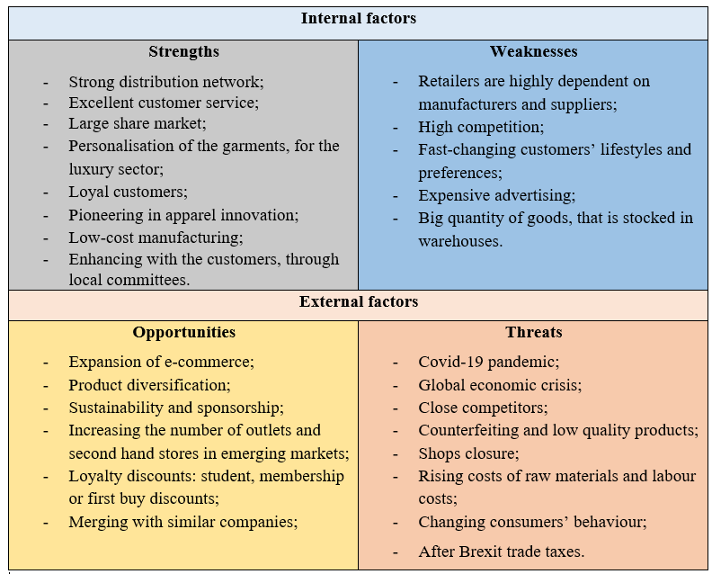
recycling;

Strengths: During the Covid-19 outbreak, the main fashion industry’s strengths are remaining the same, focusing mainly on the excellent customer service, well-organised distribution network, customers’ loyalty and low-cost manufacturing, in order to satisfy the customers base and increase the incomes.
Weaknesses: The global pandemic brought in light some prominent fashion industry’s weaknesses, the global fashion retailers being sensible at the big amounts of goods, that have been left as outdated overstocks in warehouses and the high dependence on the suppliers and manufacturers. A big concern is the cancellation of the placed orders and debts towards the suppliers, amid the Covid-19 kick.
Opportunity: Luckily, the affected by Covid-19 global fashion retailers, dispose of unexplored opportunities, that can be capitalised to revive their businesses. Among the most valuable are the business digitalisation and focus on e-commerce, product diversification, sustainability, sponsorship and recycling during the supplying chain in order to achieve new segments of market share.
Threats: Although in the past, the main fashion industry’s threats were the close competitors, counterfeiting and the rise of the raw materials/ workforce expenses, since the pandemic installed, the Covid-19 outbreak remains the main major threat, causing huge income loss, shops closures and global economic crisis.
(McKinsey&Company, 2020)

- Methods of fashion industry’s rehabilitation to the new business environment
Notwithstanding the challenging times, the big fashion brands and owners had to readapt their business models, trying to avoid the insolvency and to become great again.
The global fashion leaders, such as Burberry, Inditex, Nike, H&M Group, Asos, Marks&Spencer etc. will have to focus their efforts on four long-term strategies:
- Market research – the fashion giants used in past to offer their customers the fashion trends, but now they will have to inspect what are their preferences and needs. The main advantages of predictive analytics are efficient producing of the needed quantity of goods, reducing the waste and balance between demand and supply (Forbes, 2020a).
- Sustainability – researches showed that consumers became more conscious amid Covid-19 outbreak, thus 88% of consumers are interested in buying eco-friendly products. Shopping for pre-owned goods is expected to reach $64b by 2024 (Forbes, 2020b). Such companies as H&M Conscious and Levi’s are highly engaged in the recycling and sustainability process.
- Going digital – alongside the Covid-19 influence, consumers become more and more enthusiastic of the convenience and promptness of e-commerce. The future of online shopping is concentrated around the digital shopping experience, providing tools like virtual fitting rooms, virtual showrooms, augmented reality and sizing tools, that meant to reduce return rates by 36%. Retailers like Burberry, Adidas and Macy’s embraced the technology mainstream and offer virtual dressing rooms to their customers (Forbes, 2020a).
- Simplicity first – this strategy is also a result of the Covid-19 impact and it supposes to reduce the money spent on new collections each season, marketing campaigns and fashion shows. The benefit of this approach is focused on reducing waste and eco-friendliness, making possible to reinvest money in customer-centric and sustainable projects (Forbes, 2020a).
However, not every company will be able to rethink its business model and rehabilitate to the new market conjuncture, thus this will be a breaking point for the small and helpless businesses, making the global fashion lions even more powerful and rich.

Recommendation
This research topic brought in light the assiduous work done by the global fashion leaders regarding the communities, environment and countries they belong to, in the context global economic crisis and huge income loss.
As a recommendation addressed to those companies would be to maintain the investments in digitalisation of their businesses, as this is the future, into the innovative recycling technologies, produce durable garment and footwear and promote its rewearing, rethinking of their business models, transparency of their activity, as well as the highly engagement with the stakeholders regarding other actual challenges the modern society collates with.

Conclusion
To conclude, the impact of the Covid-19 pandemic on the global fashion industry will be felt long time ahead, as the customers refocused their preferences towards the e-commerce.
Although, fashion industry is still suffering and going through a hard filtering process, there is room for reviving the fashion retail business, by adjusting it to the new business environment.
The main directions, companies have to cover in order to maintain their market share, are digitalisation, customer-centric manufacturing, sustainability and strong relationships with their stakeholders.
Reference list
Barrie, L., 2021. Garment manufacturers remain hardest hit by Covid-19. [online] Just style. Available at: https://www.just-style.com/news/garment-manufacturers-remain-hardest-hit-by-covid-19_id140606.aspx [Accessed 1 May 2021].
Bawden, T., 2020. H&M may have kick-started a green fashion revolution with a new dress made from old clothes. [online] i news. Available at: https://inews.co.uk/news/environment/fast-fashion-hm-kick-start-green-revolution-recycling-515209 [Accessed 29 April 2021].
Bush, T., 2020. What Is Macro Environment? 2 New Examples You Can't Miss. [online] PESTLE Analysis. Available at: https://pestleanalysis.com/macro-environment/#The_Scale_of_the_Macro_Environment [Accessed 17 April 2021].
Chron, 2020. The Macroenvironmental Factors Affecting the Clothing Industry. [online] Available at: https://smallbusiness.chron.com/macroenvironmental-factors-affecting-clothing-industry-37254.html [Accessed 14 April 2021].
Bloomberg, 2020. European Retailers Scrap $1.5 Billion of Bangladesh Orders. [online]. Available at: https://www.bloomberg.com/news/articles/2020-03-23/europe-retailers-cancel-1-billion-of-bangladesh-garment-orders [Accessed 28 April 2021].
Djordjevic, M., 2021. 40 Breathtaking Fashion Industry Statistics for 2021. [online] SaveMyCent. Available at: https://savemycent.com/fashion-industry-statistics/ [Accessed 16 April 2021].
Fashion Revolution. 2020. The impact of COVID-19 on the people who make our clothes - Fashion Revolution. [online] Available at: https://www.fashionrevolution.org/the-impact-of-covid-19-on-the-people-who-make-our-clothes/ [Accessed 29 April 2021].
Forbes. 2020a. The Fashion Industry Is Ready For A Makeover: 4 Changes We’ll See In The Future. [online] Available at: https://www.forbes.com/sites/blakemorgan/2020/12/03/the-fashion-industry-is-ready-for-a-makeover-4-changes-well-see-in-the-future/?sh=3d0a20dd914a [Accessed 1 May 2021].
Forbes. 2020b. 11 Fashion Companies Leading The Way In Sustainability. [online] Available at: https://www.forbes.com/sites/blakemorgan/2020/02/24/11-fashion-companies-leading-the-way-in-sustainability/?sh=5fee96906dba [Accessed 1 May 2021].
Global Fashion Agenda, 2019. Pulse of the Fashion Industry 2019 update released. [online] Available at: https://www.globalfashionagenda.com/pulse-of-fashion-industry-2019-update-released/ [Accessed 27 April 2021].
Griffiths A., Stuart W., 2011. Economics for business and management 3rd ed., Harlow: Financial Times Prentice Hall. Available at: https://r2.vlereader.com/Reader?ean=9780273762409 [Accessed 16 April 2021].
McIntosh, S., 2020. Coronavirus: Why the fashion industry faces an 'existential crisis'. [online] BBC News. Available at: https://www.bbc.com/news/entertainment-arts-52394504 [Accessed 19 April 2021].
McKinsey&Company, 2020. The state of fashion. [online] Available at: https://www.mckinsey.com/~/media/mckinsey/industries/retail/our%20insights/the%20state%20of%20fashion%202020%20navigating%20uncertainty/the-state-of-fashion-2020-final.pdf [Accessed 25 April 2021]. [Accessed 17 April 2021].
Retail Gazette. 2021. H&M "significantly affected by pandemic" as profits drop 88% - Retail Gazette. [online] Available at: https://www.retailgazette.co.uk/blog/2021/01/hm-significantly-affected-by-pandemic-as-profits-drop-88/ [Accessed 1 May 2021].
Statista. 2020. Revenue of the apparel market worldwide by country 2019 | Statista. [online] Available at: https://www.statista.com/forecasts/758683/revenue-of-the-apparel-market-worldwide-by-country [Accessed 17 April 2021].
Statista. 2021a. Topic: Clothing and apparel market in Europe. [online] Available at: https://www.statista.com/topics/3423/clothing-and-apparel-market-in-europe/ [Accessed 17 April 2021].
Statista. 2021b. Textile & clothing industry turnover in EU-28 2019 | Statista. [online] Available at: https://www.statista.com/statistics/417688/eu-european-union-textile-clothing-industry-turnover/ [Accessed 16 April 2021].
Statista. 2021c. Topic: Clothing and apparel market in Europe. [online] Available at: https://www.statista.com/topics/3423/clothing-and-apparel-market-in-europe/ [Accessed 17 April 2021].
The Guardian. 2020a. Zara owner to close up to 1,200 fashion stores around the world. [online] Available at: https://www.theguardian.com/business/2020/jun/10/zara-owner-to-close-up-to-1200-fashion-stores-around-the-world [Accessed 1 May 2021].
The Guardian. 2020b. Gap reports $932m quarterly loss after Covid-19 shutdown. [online] Available at: https://www.theguardian.com/business/2020/jun/05/gap-reports-932m-quarterly-loss-after-covid-19-shutdown [Accessed 1 May 2021].
The Guardian. 2020c. Primark loses £800m in Covid-19 lockdowns. [online] Available at: https://www.theguardian.com/business/2020/jul/02/primark-loses-800m-amid-covid-19-lockdowns [Accessed 1 May 2021].
The Guardian. 2020d. World’s garment workers face ruin as fashion brands refuse to pay $16bn. [online] Available at: https://www.theguardian.com/global-development/2020/oct/08/worlds-garment-workers-face-ruin-as-fashion-brands-refuse-to-pay-16bn [Accessed 1 May 2021].

