  Component One:  What are the key skills required when working in the housekeeping team? 750 words (+/- 10%)  Contribution to Overall Module Assessment: 25% | Student No: | 2212646
 | Module Title: | Operation Hotel Facilities
 | Module Code: | BMIH4006
 | Lecturer: | Chris Wilkin
Your efficiency and effectiveness as a member of a housekeeping team are directly linked to your possession of a number of important abilities. Here are some crucial skills to consider:

Integrity and Trustworthiness: Visitors should be aware that housekeepers have regular access to their lodgings as well as their personal belongings. It is vital to have a high degree of honesty, professionalism, and reliability in order to protect the privacy and safety of guests (Soltani and Wilkinson, 2010).

Communication Skills: When working in a workplace that requires collaboration from several people, clear and concise communication is essential. You will be needed to speak with other members of your team, as well as managers, and even clients on occasion. According to Singh and Jaykumar (2019), communication that is both clear and succinct helps to ensure that responsibilities are understood, that feedback is offered, and that concerns are promptly managed.

Problem-Solving Abilities: Housekeepers are constantly confronted with unanticipated events, such as accidents, property damage, and special demands from guests. When it comes to resolving difficulties and assuring the happiness of passengers, the ability to think quickly, make judgements, and seek solutions that are both realistic and practical is vital.

Teamwork and Collaboration: Because maintaining house is so often a group endeavour, it is necessary to have good people skills, to treat others with respect, and to be able to successfully communicate (Enz and Siguaw, 2000). The success of the housekeeping team as a whole is dependent upon a number of factors, including the coordination of duties, the support of team members, and the upkeep of a good working environment.

Attention to Detail: Housekeepers need to have a great eye for detail in order to guarantee that each and every area is well cleaned and sorted. This includes being able to recognise and address even the most little issues, such as discoloration, accidents, and objects that have been overlooked.

Adaptability: It is very uncommon for cleaning to take place in dynamic settings, with constantly changing objectives and unanticipated challenges (Whiting and Symon, 2020). It is very necessary to be adaptive and flexible in order to accommodate a wide variety of circumstances, timetables, and requirements.

Physical Stamina: The chore of housekeeping may be rather strenuous on the body since it requires prolonged periods of standing, bending, lifting, and carrying. It is vital to keep one's physical stamina and strength up in order to efficiently carry out the responsibilities and stay accident free.

Cleaning and Sanitization: It is vital to have a comprehensive understanding of various cleaning methods, the proper use of cleaning equipment, and different types of cleaning products. This includes the capacity to cleanse places, remove stains, and maintain a high degree of cleanliness across a variety of surfaces.

Time Management: Time management is very important in the maintenance industry since there are typically several tasks that need to be completed within a certain period of time (Olimovich, Bakhtiyorovich and Salimovna, 2020). You can keep your productivity up and ensure that you meet deadlines by carefully prioritising activities, arranging the workflow, and working as diligently as possible.

Knowledge of Safety and Hygiene: It is crucial for the health of both visitors and staff to have an understanding of the safety standards, the right management of cleaning chemicals, and the requirements for health and safety. To reduce the likelihood of mishaps or other dangers, it is critical to maintain one's knowledge of current safety protocols (Marneros, Papageorgiou and Efstathiades, 2020).

Organisational Skills: Housekeepers need to have strong organisational skills in order to do their responsibilities and handle their supplies in an efficient manner. This involves the management of inventory, making certain that there is an adequate supply of cleaning materials, and structuring equipment and tools so that they are easy to reach. A well-organized plan not only saves save time but also ensures that activities will run efficiently.

Time Flexibility: The position of housekeeper often demands working rotating shifts, which may include early mornings, late nights, weekends, or holidays. It is crucial to be able to change one's work schedule and work hours in accordance with shifting priorities (Escortell, Baquero and Delgado, 2020). This versatility guarantees that janitorial services are provided on demand and that both the needs of the business and those of its customers are satisfied.

Customer Service: Housekeepers are expected to give excellent customer service in addition to their primary responsibilities of cleaning and maintaining the property. During the course of their work, they may have the opportunity to engage with visitors, react to guest requests, and answer guest complaints in a quick and professional way. It is possible to contribute to the delight of visitors and to promote the reputation of the institution by displaying a nice and helpful attitude.

Word Count | 790

Component Two:
Contribution to Overall Module Assessment: 25%
In this scenario – You have just been promoted to team leader for a floor within the hotel. A guest complains that on their arrival, their room had not been properly cleaned. Create an action plan and answer the following questions.

Problem | Why did it happen? | What are you going to do? | How will you prevent this from happening in the future? | What measures would you introduce to improve team effectiveness?
Dirty or Unclean Surfaces | On surfaces such as counters, tables, and floors, there could have been obvious filth, grit, or stains. | Implement a stringent quality control method, in which a selected member of the team or supervisor inspects each room after it has been cleaned to verify that it satisfies the sanitation requirements that have been set (Faraj et al., 2021). During this step, it is possible to immediately repair any spots that were missed or surfaces that were not thoroughly cleaned. | - Emphasise surface cleaning in cleaning training.  - Before cleaning and inspecting surfaces, provide housekeepers guidelines or visual aids.  - Perform quality control checks to ensure surface cleanliness and give fast feedback and adjustments. | - Train staff in surface cleaning, lavatory cleaning, linen handling, and amenity management.  - Training on industry best practises, cleaning products, and equipment should be continual.  - Cross-train team members so they can master numerous duties.
Uncleaned Bathroom | It is possible that the bathroom was in an inadequate condition, with uncleaned fixtures, unclean lavatories, or trash cans that had not been emptied. | In order to make improvements to the supervision practises, each shift need to have a designated supervisor or team leader. This person would be in charge of supervising the cleaning process, monitoring the work completed by other members of the team, and ensuring that the cleaning standards are met (Afsar, Masood and Umrani, 2019). In order to retain responsibility and consistently improve performance, it is important to routinely review the team and give feedback. | - Provide full lavatory cleaning instruction, including disinfection and detail.  - Clean and disinfect bathroom fixtures, surfaces, and amenities using a bathroom-specific cleaning routine.  - Before finishing, have specialists inspect each bathroom. | - Standardise cleaning methods and protocols for each activity to ensure team members follow the same rules.  - Use cleaning charts or diagrams to help team members understand and remember each cleaning duty.  - Based on visitor comments, hygienic needs, and standards, update methods often.
Bed Linen and Towels | It is possible that the visitor noticed filthy or badly cleaned sheets, pillows, and comforters throughout their stay. In a similar vein, it is possible that they came upon linens that looked unclean or worn out. | Make sure to get in touch with the customer who reported the issue so that you may apologise for the trouble it caused and reassure them that the problem has been fixed (Ye et al., 2020). Make a genuine apology, explain the efforts that have been done to address the problem, and give any appropriate compensation or benevolent gestures, such as an upgraded accommodation or free services. | - Establish a stringent linen and towel policy, including washing and replacing between guest visits.  - Check bed linen and towels regularly for cleanliness, folding and discolouration.  - Use tracking or color-coding to cycle and replace linens. | - Open communication channels encourage team members to communicate ideas, concerns, and recommendations.  - Hold frequent team meetings or huddles to address challenges, best practises, and protocol changes.  - Promote a friendly and collaborative team culture where teammates can help one other and solve difficulties.
Trash or Debris | It is possible that the visitor discovered trash or other debris in the room, which is an indication that the room was not cleaned adequately. | Assign a member of the cleaning staff to clean the room in a timely manner and attend to the particular hygiene concerns raised by the visitor. This includes cleaning the surfaces, disinfecting the lavatory, changing the bed sheets and eliminating any waste or debris that may have accumulated (Eşitti and Kasap, 2020). | - Emphasise cleaning up throughout training.  - Establish a routine for examining and emptying garbage cans in each room, replacing them with clean ones.  - Encourage team members to search every area, especially under furniture and in crevices, to find and remove any missed debris. | - A thorough quality control approach ensures constant cleanliness standards. Periodic inspections, peer reviews, or supervisory checks may indicate opportunities for improvement.  - Create a feedback loop so team members may comment on procedures, equipment, and challenges they face. Implement their suggestions.  - Survey or comment card visitors to assess satisfaction and suggest areas for improvement.
Unattended Amenities | It is possible that the visitor noticed that some of the amenities, including coffee supplies, toiletries, or other goods were missing or running low. | Increase the lines of communication between shifts to ensure a smooth handoff of room assignments and instructions for cleaning (Wu and Chen, 2019). It is important to use methods of communication that are clear, whether they are digital or textual, in order to lessen the risk of misunderstandings and unfinished business. | - To restock facilities, improve maintenance-supply management communication.  - Use a checklist or procedure to make sure each room's amenities are stocked before visitors arrive.  - Check facilities regularly. | - Recognise and reward team members who do well and go above and beyond.  - Feedback and mentorship help team members improve.  - Give team members leadership training and specific cleaning certificates.

Component Three:
Contribution to Overall Module Assessment: 50%
Your task is to create and prepare a presentation following the detailed scenario provided below.

As the floor housekeeping manager and given the recent guest complaints you need to put together a basic training presentation for your colleagues within the housekeeping team to get the best out of them, ensure that brand standard is being achieved and that Health and Safety procedures are also being followed.

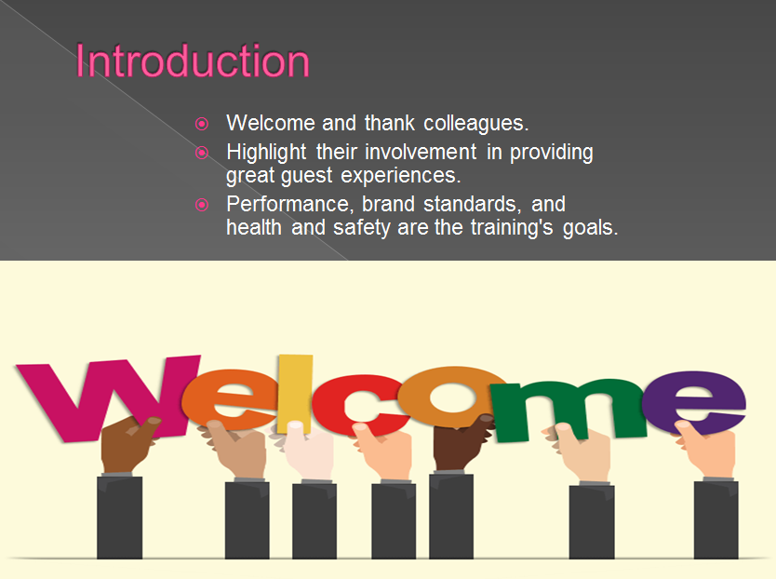

Training Notes: It is the responsibility of the sanitation department in the hotel business to ensure that hygienic standards are met and that guests have a positive first experience. As a result, this department plays an essential position in the hospitality sector. The hotel's commitment to providing guests with an experience of the highest possible quality is evident in the significance it focuses on maintaining a clean environment. It is important to recruit and educate staff with the necessary skills and expertise to successfully manage sanitation problems in order to fulfil these criteria. Meeting these requirements will demand that you meet these requirements. During this training, our primary focuses will be on improving the abilities of our sanitation personnel, meeting brand standards, and placing a higher priority on health and safety, all of which are necessary in order to provide outstanding experiences for our guests.
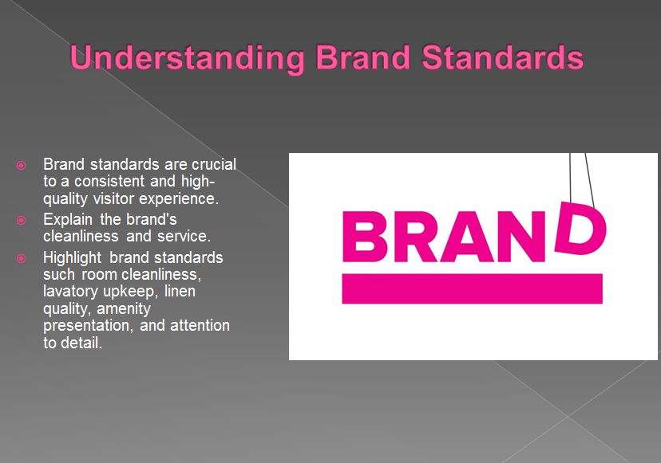

Training Notes:
The establishment of standards for a brand serves as the foundation for maintaining both consistency and excellence. They are what give the hotel its distinctive character and distinction. Our customers have come to expect an experience that is in line with what we represent as our brand. Key areas of brand standards are:
- Room cleanliness
- Bathroom maintenance
- Linen quality
- Amenity Presentation

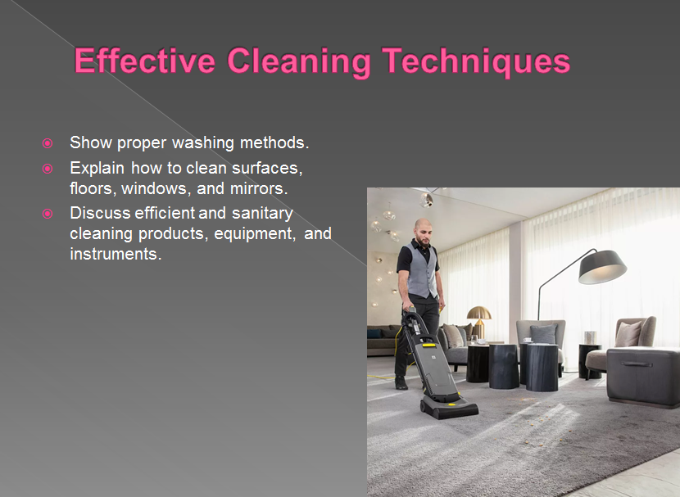

Training Notes: When using effective cleaning methods, surfaces get a comprehensive cleaning as well as a complete sanitation. They help to keep the area clean and maintain its pleasant appearance for those who come to visit. Following industry standards and best practises boosts productivity and efficiency, which in turn saves both time and effort (Bhatnagar and Dheeraj, 2019). Examine and stress the relevance of the need of using the correct cleaning procedures for the different sites. To guarantee the reliability and standardisation of the cleaning processes, specific instructions should be provided.

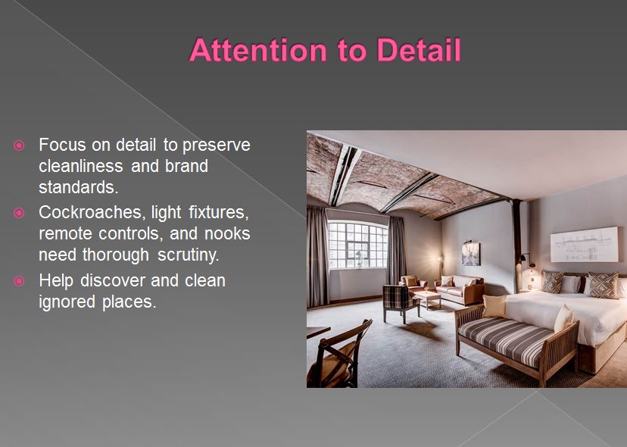

Training Notes: Care that focuses on the smallest of details guarantees that each and every component of hygiene is addressed to. It improves both the uniformity and overall quality of the experience for the guests (Reddy, n.d.). Through meticulous attention to detail, we are able to sustain brand standards and surpass the expectations of our guests.
Consider the likelihood that remote controllers contain germs and other potentially harmful organisms. Show how to properly clean and disinfect a remote control by demonstrating the correct procedures (Leeniwa, 2020). To guarantee the health and safety of your guests, be sure to stress how important it is to clean remote controls on a regular basis.

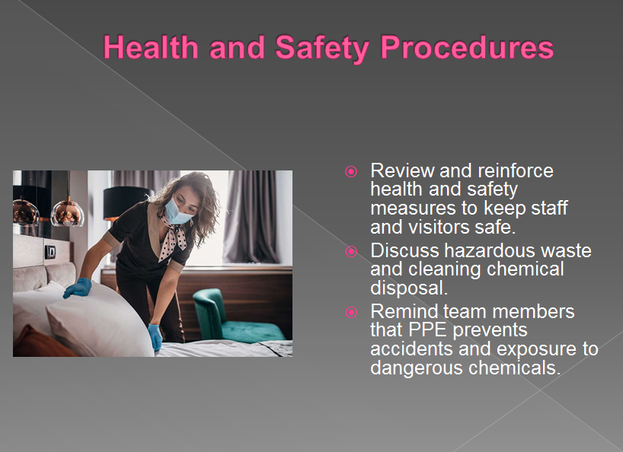

Training Notes: The personnel as well as the tourists are protected by the health and safety precautions. The maintenance of an environment that is safe and secure depends on one's adherence to the standards governing health and safety. Put an emphasis on the hotel's commitment to putting health and safety ahead of anything else (Chaudhari, 2021).

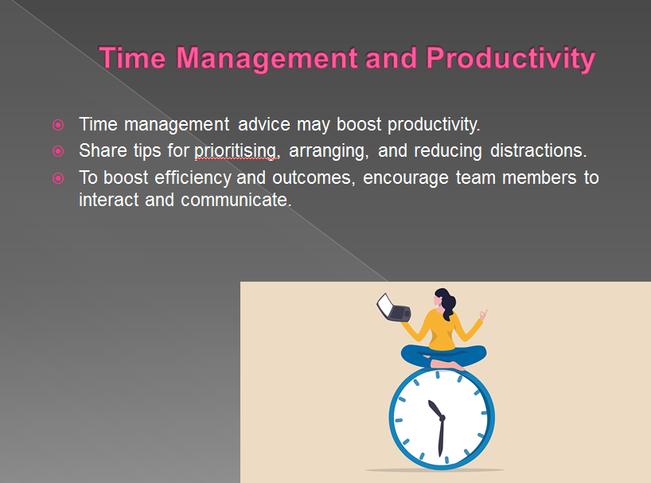

Training Notes: Productivity is increased, and the attainment of objectives is made easier, with good time management. When responsibilities are prioritised and structured in an efficient manner, one makes the most efficient use of their time. Encourage members of the team to put into practise effective time management skills for the benefit of both themselves and the team as a whole (Cobbett, 2022).
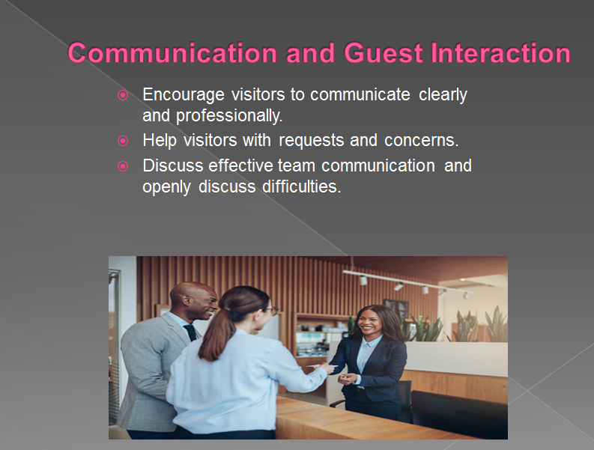

Training Notes: Customer satisfaction is increased, and connections are strengthened, when effective communication is used (Cunha and Oliveira, 2021). A communication style that is unambiguous and well-handled sets the stage for a pleasurable encounter for the visitor. Collaboration, problem-solving, and total production are all improved when there is effective and clear communication within a team.
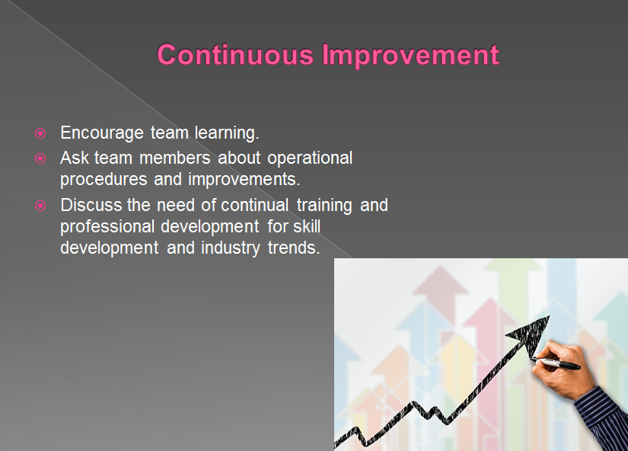

Training Notes: Bring to the attention of visitors the necessity of attentive listening and the requirement for understanding. Discuss methods for communicating in a clear and succinct manner while using the appropriate language and tonality (Khymdeit, 2022). In order to guarantee a complete knowledge of the visitor's needs and concerns, it is important to encourage team members to ask clarifying questions. Discuss other approaches that might be used to manage the inquiries and concerns of guests in a fast and professional manner. Place an emphasis on the relevance of empathetic talents, tenacity, and the ability to solve problems. It would be helpful if you could provide some guidance on how to actively interact with visitors in order to fulfil their needs and go above their expectations (Vishal et al., n.d.).
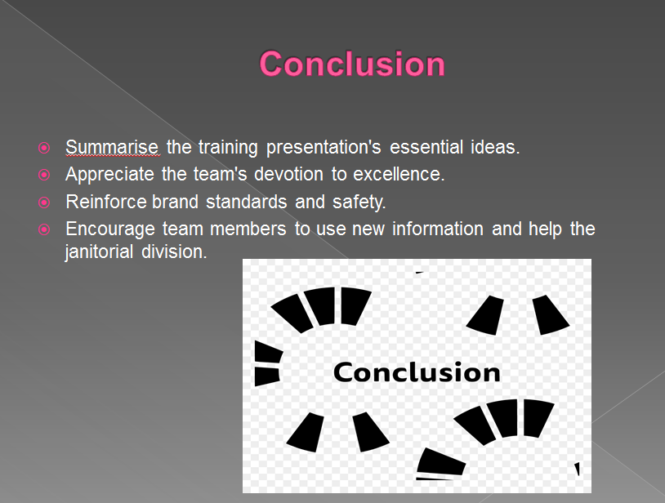

Training Notes: Learning that is centred on teams encourages cooperation and creativity in the workplace. The sharing of knowledge and experiences improves both the efficiency and effectiveness of operational processes.
Education that is ongoing enables the team to remain current on advancements in the business as well as best practises. Encourage other members of the team to submit comments and recommendations about the operating method.
Bring to their attention how important their involvement is in determining where chances for improvement lie. Establish a setting that encourages open conversation and conversation that leads to productive action. Bring attention to the benefits of having a culture that encourages learning, such as improved motivation and engagement. Please provide some instances of successful businesses that place a high priority on continuing education. Motivate people of your team to take ownership of their own professional growth and development.

References
Afsar, B., Masood, M. and Umrani, W.A., 2019. The role of job crafting and knowledge sharing on the effect of transformational leadership on innovative work behavior. Personnel Review, 48(5), pp.1186-1208.
Bhatnagar, E. and Dheeraj, N., 2019. Impact of housekeeping services and practices on customer satisfaction and repeat business. Prabandhan: Indian Journal of Management, 12(8), pp.46-57.
Chaudhari, M.P.S., 2021. Hotel Housekeeping Services And Customer Satisfaction. Ilkogretim Online, 20(1), pp.5837-5844.
Cobbett, A., 2022. The English Housekeeper: Or, Manual of Domestic Management. DigiCat.
Cunha, A. and Oliveira, M., 2021, May. Human Resources in the Housekeeping Department: A Case Study. In ICTR 2021 4th International Conference on Tourism Research (p. 158). Academic Conferences International.
Enz, C.A. and Siguaw, J.A., 2000. Best practices in human resources. Cornell Hotel and Restaurant Administration Quarterly, 41(1), pp.48-61.
Escortell, R., Baquero, A. and Delgado, B., 2020. The impact of transformational leadership on the job satisfaction of internal employees and outsourced workers. Cogent Business & Management, 7(1), p.1837460.
Eşitti, B. and Kasap, M., 2020. The impact of leader–member exchange on lodging employees’ dynamic capacities: The mediating role of job satisfaction. Tourism and Hospitality Research, 20(2), pp.237-244.
Faraj, K.M., Faeq, D.K., Abdulla, D.F., Ali, B.J. and Sadq, Z.M., 2021. Total Quality Management And Hotel Employee Creative Performance: The Mediation Role Of Job Embeddedment. Faraj, KM, Faeq, DK, Abdulla, DF, Ali, BJ, & Sadq, ZM (2021). Total Quality Management And Hotel Employee Creative Performance: The Mediation Role Of Job Embeddedment. Journal of Contemporary Issues in Business and Government, 27(1), pp.3838-3855.
Khymdeit, J., 2022. Project work on entrepreneurship topic: Housekeeping.
Leeniwa, J., 2020. Competency of Hotel Employees Supporting the Development of Excellent Service Quality in Pattaya, Chonburi Province. Managing Editor, p.105.
Marneros, S., Papageorgiou, G. and Efstathiades, A., 2020. Identifying key success competencies for the hospitality industry: The perspectives of professionals. Journal of Teaching in Travel & Tourism, 20(4), pp.237-261.
Olimovich, D.I., Bakhtiyorovich, T.M. and Salimovna, N.G., 2020. Improving of personnel training in hotel bussines. Academy, (2 (53)), pp.18-19.
Reddy, A.S., Training And Development As A Factor Of Operational Excellence In The Hotel Industry.
Singh, A. and Jaykumar, P., 2019. On the road to consensus: key soft skills required for youth employment in the service sector. Worldwide Hospitality and Tourism Themes.
Soltani, E. and Wilkinson, A., 2010. What is happening to flexible workers in the supply chain partnerships between hotel housekeeping departments and their partner employment agencies?. International Journal of Hospitality Management, 29(1), pp.108-119.
Vishal, R., InaKakal, K., Anusha, Y. and Shruthi, M.N., Productivity Improvement of Shopfloor Process Through Lean Management.
Whiting, R. and Symon, G., 2020. Digi-housekeeping: the invisible work of flexibility. Work, employment and society, 34(6), pp.1079-1096.
Wu, C.M. and Chen, T.J., 2019. Inspiring prosociality in hotel workplaces: Roles of authentic leadership, collective mindfulness, and collective thriving. Tourism Management Perspectives, 31, pp.123-135.
Ye, B.H., Tung, V.W.S., Li, J.J. and Zhu, H., 2020. Leader humility, team humility and employee creative performance: The moderating roles of task dependence and competitive climate. Tourism Management, 81, p.104170.

