LEVEL- 7
SEMESTERS: 1
MODULE CODE: LCMB7001
NAME: PRIYA PRABAKARAN
STUDENT NUMBER: 1913958
MODULE TILE: MARKETING MANAGEMENT
ASSIGNMENT TITLE: MARKETING MANAGEMENT-ASSESSMENT 1
MODULE LECTURERS NAME: TUSHARA BALENDRAN

INTRODUCTION
This report discusses the innovative marketing strategy created by Sports Direct International plc. The communication model, stages of integrated marketing communication, a new promotional strategy designed to create awareness about its brand. Relating it to Keller’s brand equity model, advantages and disadvantages of the brand equity model, managing and evaluating the customer journey and customer touchpoints of sports direct with total engagement model, using different communication channels that ensure the current and future stakeholder’s expectations.
COMMUNICATION
Communication is the process of distribution of data by transferring information. Marketing communication is transferring a piece of adequate information about an excellent, service, or an idea targeted at stakeholders and consumers within the target market segments. Marketing communication focuses on a promotional mix that includes advertising, public relations, personal selling, sales promotion, direct mail, sponsorship, and the internet (Dibb, 2012). The company concentrates on the principal recipient with a promotional message. The product adoption process is awareness, interest, evaluation, trial, and adaptation.
COMMUNICATION MODEL
The Shannon and Weaver communication model consists of a sender, transmitter, channel, reception, destination, noise, and feedback. A sender (organization) which intended to convey a message to its customer through an advertisement. The reception (receiver)is the one who decodes the message; the organization needs to understand the customer’s behaviour and try to express their products attractively. The transmitter conveys the message from the organization to the receiver, e.g., radio, television, mobile phone, the internet. The signals have converted into concepts or ideas; the signal must translate in the right way to reach effectively. For example, The KFC made a big mistake when launching their business in China their product slogan “Finger Licking Good “it translates in the Chinese language as “Eating fingers off” created a bad image. (Paul Dana, 1999). Noise is the interruption cause while transmitting the signal or may be unfamiliar to the consumer. The receiver’s response is the feedback; this will take some time while direct communication the sender can receive immediate feedback. In terms of digital communication, it is hard and takes time to recognize the feedback, observing in sales volume, customer’s attitude, awareness, or through a survey. The recognition of products has detected through product adoption process awareness, interest, evaluation, trial, and adoption. (Dibb, 2012)
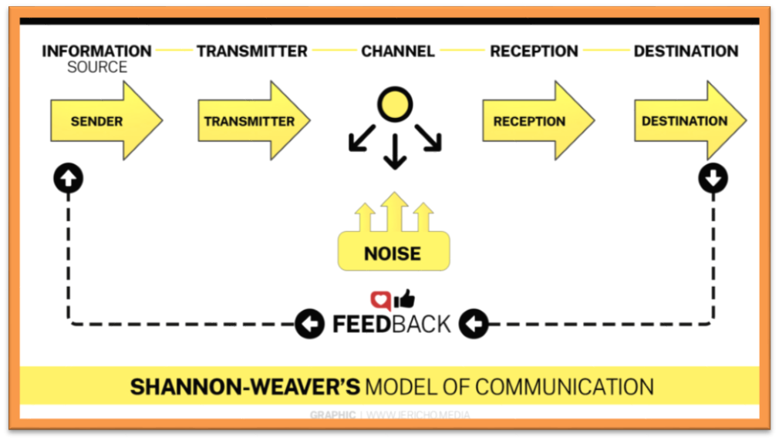
INTEGRATED MARKETING COMMUNICATIONS
Integrated marketing communication is the collective combination of all communication tools. It is using all openings and sources into a united programme for marketing communication activities for the development. This program has developed in order to minimise the impact on consumer, businesses or target audience at low cost. It avoids wastage and duplication because it is controlled by separate managers or through different agencies. The IMC supports to give clear clarity to customers, marketing channel members, employees and suppliers at minimum cost, influence on marketplace gains a competitive advantage, increase sales, profit and create brand awareness. (Dibb, 2012)
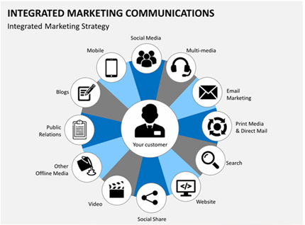
STAGES OF INTEGRATED MARKETING COMMUNICATION
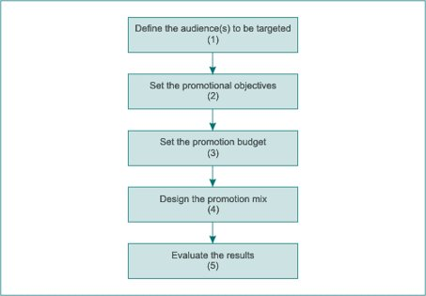

TARGET AUDIENCE
Market research is essential while targeting the audience and fix the goal. According to the information and analysis develop a campaign and establish the marketing products. Advertisers analyse target audience for the campaign concept, the information used for the campaign includes age, income, ethnic origin, sex, education, consumer attitude, competitive products, lifestyles, buying behaviour, and media habits. (Dibb, 2012) This profile helps to understand the consumers’ expectations and their views of the product as advertised. The actual information discovered by the organisation depends on the product helps to know the levels of brand awareness, characteristics of the target and the type and amount of competition. If the target not analysed and identified precisely, the campaign will not succeed.
PROMOTIONAL OBJECTIVES
The promotional objectives involve the organisational target and hope to achieve in the campaign. It supports to communicate with the target audience, and develop brand awareness, progress the excellent image of the brand, improve the sales of the product, boost the customers to buy the product. (Dibb, 2012). The objectives should be stated clearly, measurably and exactly. The exact and measurable terms help to estimate the success and judge at the end of the campaign. For example, the company should mark the current level of sales and the amount of sales increased after promotion to be noted to analyse the progress. All the campaigns not designed to increase the sales quickly, sometimes to create brand awareness and for the organisations unbeatable long run.
PROMOTIONAL BUDGET
The promotional budget is the total amount of money allocated by the marketer for promoting its brand for a period. The amount of money used for advertising is not measured because the effectiveness of spending cannot get immediately. The environmental area, distribution of buyers, plays a vital role in making the decision. Considering the available resources and designing the strategies and plan for the promotional budget is necessary. The organisation must plan its budget according to its size and capability. Most of the amount will spend on personal selling, direct mail and trade show. (Dibb, 2012)
PROMOTIONAL MIX
The promotional mix has a combination of communication tools such as advertising, sales promotion, public relations, personal selling’s that helps to establish the organisations objective.

ADVERTISING
Advertising is the method of communicating indirectly through a mass medium about an organisation and its product targeting to get the attention of the audience. The organisation pays the promotion of the advertisement. Through a medium such as television, radio, newspaper, magazines, direct mail, public transport, cinema, outdoor display, and on the internet. (Dibb, 2012). The advertisements aim to reach a massive audience.
Sports Direct International plc advertises in posters, gift cards, Bags, company vehicles, London taxi advertising (stevens, 2017)
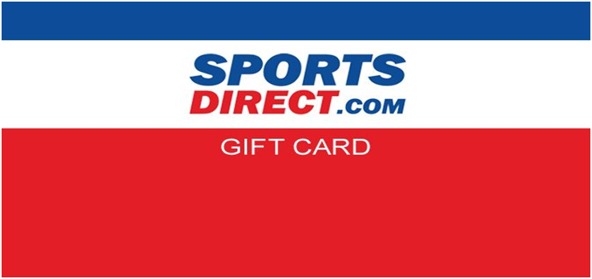

The direct sports pay around £2million a year for billboards advertising at Newcastle United (Douglas, 2019)
DIFFERENTIATING ADVERTISING AND SALES PROMOTION
Advertising is the paid promotion by the organisation to reach a massive audience through a mass medium such as television, radio, newspaper, social media, and magazines. It develops long term sales, and it strengthens the brand image of the company. It also helps to encourage loyal customers.
Sales promotions are a short-term strategy used by the organisation to promote sales in a short period; it offers coupons, free samples, special events, and discounts. It supports to know about products and the brand. (Dibb, 2012)
SALES PROMOTION
Sales promotion acts as a direct influence on consumers by offering discounts or added value to promote the rate of sales in a short period. It offers coupons, on-pack deals, bonus and contest to boost the sales of the product. The sales promotion is also a part of advertising, personal selling, public relations, publicity, sponsorship, direct mail, the internet and direct marketing. Marketers design this sales promotion to gain immediate and short-run sales. Marketers use this strategy irregular or seasonal; they use sales promotion more than advertising. Popular techniques used by marketers are buyback allowance, temporary price reductions, incentives and gifts. (PAHWA, 2019)
PUSH AND PULL STRATEGY
The advertising approach that push the product to the customer, the quick way to move the customer from product awareness to purchase. The push policy influence directly on the customer to create demand through advertising, sales promotion, direct mail, sponsorship, websites and packaging to attract the customer in order to maintain demand and market share. where pull strategy pulls customers towards products to create strong consumer demand and tries to make a relationship with the brand. (Dibb, 2012).
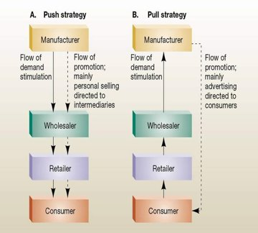

PUBLIC RELATIONS
The public relations acts as a connector that manages and controls the reputation of the organisation. It will influence on the company’s sustainability and leading towards success. The company’s reputation later becomes its assets and reflects on standing out of the market. Public relations play a vital role because of the available source of information online and increased digital communication through social media. The company uses its webpages, press release, conference, interview, articles and workshops to create a right image and build a relationship. They also use third party endorsement to develop trust and respect. (Dibb, 2012). The organisation prepared to obtain reputation and maintain goodwill, build up understanding among the public.
PUBLICITY
Publicity refers to a non-personal communication through newspapers, magazines, radio or article that describes the product or the organisation that attracts the intention of the public through the mass medium at no cost. sometimes the publicity is pre-planned and implemented with the encouragement of the organisation, it cannot be controlled at some extend. (Dibb, 2012)
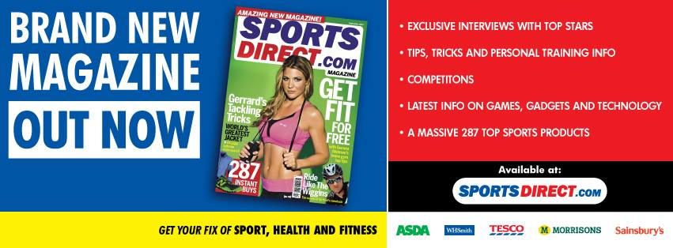
SPONSORSHIP
The monetary or quantifiable funding given by an organisation to conduct an event, team, activity or an individual is called sponsorship. Sponsorship creates brand awareness, publicity and reputation of the organisation. (Dibb, 2012). The frequent display of a product, brand or organisation impact on public and creates awareness.
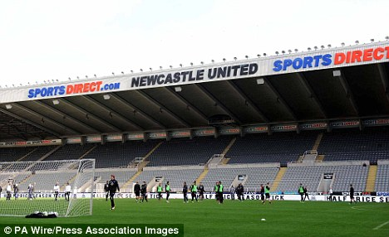
DIRECT MARKETING
Direct marketing deals directly with customers through email, text messages, websites, online advertisements, database marketing, fliers, catalogue distribution and promotional letters. (Dibb, 2012)
Sports Direct uses marketing strategies by sending direct mail to customers, online advertisements, sales promotion, websites.
OUTLETS
It is operating with 367 stores in England, 37 in Scotland, 28 in Wales and 17 in Northern Ireland with 35 other fascia’s including USC. They are investing in opening more new generation stores and developed four different store formats small, medium, large and extra-large. The outdoor advertisements such as New Castle stadium, banners, tourist spots adverts like (Piccadilly circus) will attract more people to buy their products. (Sports Direct,2020)
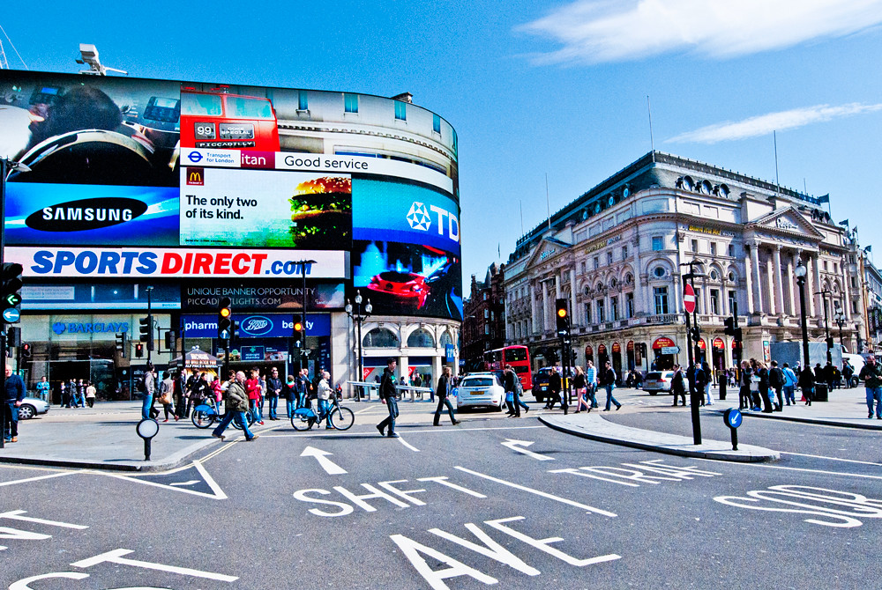
E-MAIL
Sports direct send promotional discount code to customers mail, information is about a new product launch, keep on sending e-mails from the stage of purchase to delivery and tracking shipment facility. (Sports Direct,2020)
ONLINE ADVERTISEMENTS
Sports direct use online advertisements and they have YouTube channels, Face Book, Twitter, Search engines like yahoo, Google. Keep on remained customers about its discounts with attractive online advertisements to engage more online shoppers to buy its products. (Sports Direct,2020)
SALES PROMOTION
The sports direct offers discounts which are seasonal summer, winter, spring and autumn discounts which are planned to increase the sales rate. (Sports Direct,2020)
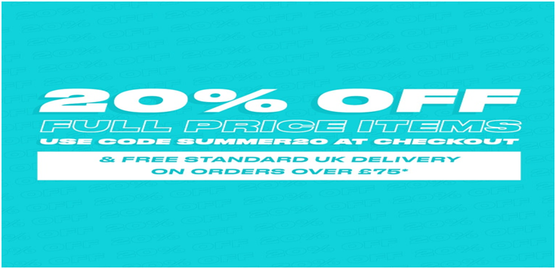
DATABASE MARKETING
Sports direct uses the customers information (name, addresses, phone numbers, e-mails, purchase history) through applications forms, subscriptions and newsletters. This helps them to communicate and target customers according to similar products purchase, wish lists and new promotion. (Sports Direct,2020)
DIGITAL MARKETING
The digital marketing targets the customers through digital channels such as search engine, websites, social media, e-mail and mobile apps. This medium is cost-effective and reach the public effectively. (Barone, 2020)
SPORTS DIRECT DIGITAL MARKETING
It uses all the sources of digital marketing like search engines, websites, social media, e-mail and mobile apps. Unique mobile application created by sports direct helps to view all product catalogue with high definition images gives customers an exciting shopping experience. (Sports Direct,2020)
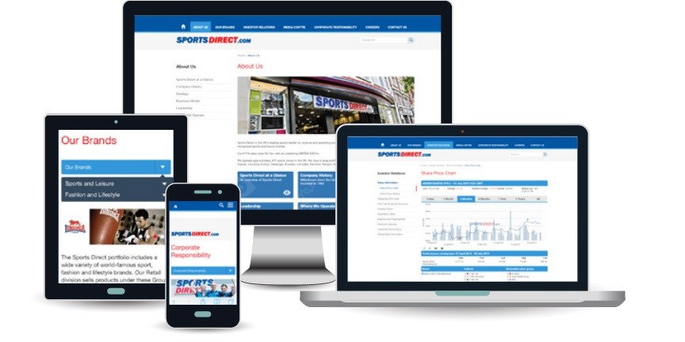
EVALUATING THE RESULTS
The evaluation of results helps to measure the performance and understand the effectiveness of the strategy. According to the initial and final stage survey, the firm can identify its improvement in sales, product awareness, brand awareness and communication level. The firm has to know the effectiveness, productivity and value for money achieved through the campaign. While evaluating the company needs to analyse its expectation, actual situation, effects of its communication, the reason for its success or failure, learning from the campaign and the organisation’s expectation to happen in future. (Pickton, 2004)
PROMOTIONS ONLINE
The Sports Direct can provide premium offers for regular customers like free delivery with discounts. The promotional strategy for existing customers and new customers is the same; they can adapt separate strategies to hold existing customers from switching. They are selling the third-party brand; they can promote their brand. Using celebrity endorsement in advertisements will reach more people.
PROMOTION OFFLINE
The sports direct can offer self-checkout facilities for customers to avoid waiting in queues and wastage of time. They can implement duty-free stores in airports and mobility stores (near beach areas to sell summer clothing) to improve sales. In posh areas, they can offer outlets stores with high brands and reduce low quality to attract high-class customers. They can use more environmentally friendly products, promote recycling and care nature.
DISCUSSION
Sports Direct offers discounts, even introducing a new product in stores, people may discourage of promotional advertisements says 30% off but real discount after analysed by the customers is 5% (Graham, 2018). Now a day’s public are aware of marketing strategy, price comparison with other companies. Misleading customers using unfair marketing practice will create a lousy image about the company. The outlet’s promotions like close sales are not a sensible method to attract customers when advertising as UK’S NO 1 sports retailer. Some of the offers are applicable only for online buyers and not in outlets, exchange of any products from online cannot be replaced in-store the customer has to post it back. The staff turn over issues, and Zero hours contract problems lead to negative impressions, and newspapers projections every day will direct customers to lose their trust and quality on the brand (BBC, 2017). The sports direct must consider and modify its marketing strategy to be more productive.
BRAND EQUITY
The brand value created by the company through the products increases creditable name compared to its competitive companies. Every organisation creates brand equity to build a special memory, more accessible identity, emphasis the quality and trustworthiness. (Hayes,2019)
KELLER’S BRAND EQUITY MODEL
The customer-based brand equity models took the shape of a pyramid, that emphasis establishing a good relationship with the customer is the foundation that will make the organisational brand more powerful. It must influence customers in a right path of feelings, opinion, awareness and good thoughts. If the organisation established it successfully, the customers become more loyal, buys more products and started spreading the right image about the company’s product. The reverse order of the pyramid has four levels they are identity, meaning, response and relationship. The frequently asked customer-based questions present in the pyramid helps to build a successful brand. (Kapferer, 2012)
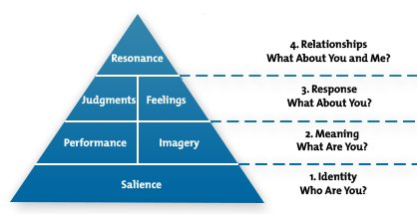

IDENTITY
The main aim of the brand identity is to create brand awareness and ensure that customers familiar with the product and aware of it. In the beginning, the organisation must understand the type of customers, learn by analysing the market and know how customers see the brand. Comparing the brands of competitors decide whether the organisations product satisfies the group of people. Understanding the needs and wants of customers and design the product to attract them. Communicate with customers and know how the products satisfy their needs. Communications helps to identify the issues and enhance the service, designing products, and the way of communication to establish a strong identity among customers. (Kapferer, 2012). For example, Luxury clothing which superior emphasis quality, high price and standard.
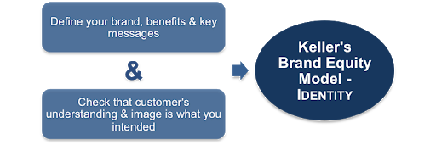

MEANING
It demonstrates what the organisations brand means; its goal is to identify and communicate with customers about the performance and develop a good impression of the brand. The brand meaning will create loyal customers when they understand how well the brand meets the needs of customers in social and psychological level. (Kapferer, 2012) The organisation can add features like eco-friendly, best customer service, superior quality, value for money, recycling the materials, support social cause and care for the environment will create the right meaning about the brand.
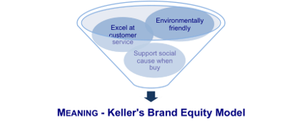
RESPONSE
The customer’s judgement and feelings after the purchase or usage of the products determines the response. The quality, believability, considering the uniqueness and advantage of using the product, while comparing to other competitors. (Kapferer, 2012). The response shows how the product full fill the expectations of the customers.
RELATIONSHIP
The final stage of the model relationship tends to create an emotional connection with the brand. If a brand successful creates the emotional bond customers become loyal, they do not think about substitute products in the market. (Kapferer, 2012). Then they start purchasing it regularly, love the brand, sense of community may create, and they started following in social media, events and outside activities related to the brand.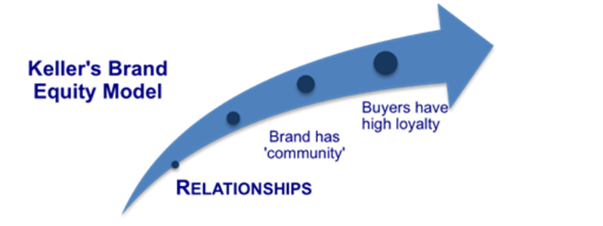
ADVANTAGES OF KELLER’S BRAND EQUITY
This brand analysis helps to predict the marketing strategy, and enhance the communication by building a strong relationship, implement a strong brand image, understand the expectation of customers and providing excellent service. (Keller,2009). The four levels support to identify and modify the plan, attract and target audience, supports to increase the sales and generate the right brand image. When the brand is familiar and offers benefits to the customers memory, it will build substantial brand equity.
DISADVANTAGE
According to Kuhn et al. (2008), the feelings do not play any role in creating brand equity, so the Keller’s model needs modification to be more productive. The personal selling (one to one communication) also develops a good relationship and build brand equity, so this element must be added to the model (Zubak, 2017).
CONCLUSION
It is hard to create a brand equity in a short period and significant challenge for start-up companies, once they identify the marketing strategies, modify and apply it. That offers enormous opportunity to establish brand equity, achieve the target market and the organisations goal.
CUSTOMER JOURNEY
The total experience gained by the customer while interacting with the company and its brand. The journey starts when the customer comes to know the product, investigate it, make a purchase, benefited by the product and adapting it, become the supporter of the product or brand and started spreading the goodness of the product by word of mouth. (Zubak, 2017)
STAGES OF CUSTOMER JOURNEY
The stages of the customer journey help to understand the customer’s needs and wants and perfecting the customer experience gains more positive thoughts comparing the competitors. So, the company needs to enhance itself from the initial stage of interaction that involves awareness, consideration, purchase, retention and advocacy. (Zubak, 2017)
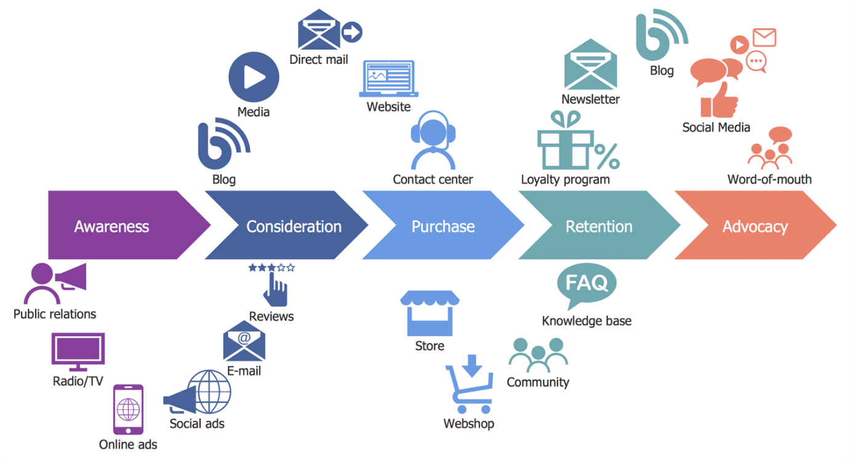
AWARENESS

It is essential to create awareness about the product and existence of the company to the public. The company needs to understand the problems and needs of the customer and make a promotion according to it. When the customers search for a credible resource, they aware of this product and the first impression of the company creates a memory. Awareness can be created through public relations, radio, televisions and online advertisement. (Zubak, 2017).

CONSIDERATION

In the second stage, the customer is aware of the products and research to compare the products and its service with the substitute products. They start to learn more about the price, online reviews and the substitute products available in the market. So, the company should position itself comparing its competitors and added value given to its product description and ensure the best solution for their needs. (Zubak, 2017).

PURCHASE

In this stage, the customer finalises the product and believes that it will work for their problem and make a purchase. Most of the times, the customers decision is influenced by the reviews. Making available of customers testimonials, good reviews in the websites will influence them to purchase the product. Offering free trials, live demo, and free consultations help to know more about the company and its products. (Zubak, 2017).

RETENTION

It is hard to hold the existing customer and to prevent from switching. The company has to take many steps to build trust and make loyal customers. Survey by getting feedback from customers, requesting testimonials and service satisfaction. (Zubak, 2017)

ADVOCACY

It is quite hard to satisfy the customers in all aspects and make them speak about the product. Once the company reach this stage, the customers become loyal and do not think about switching to substitutes. The company should ensure the quality, results and provide excellent service. The customers will become ambassadors and started suggesting the products to their friends and family, share their experience and results. The company can encourage word of mouth marketing among the customers to reach its target audience. (Zubak, 2017).

CUSTOMER TOUCHPOINTS

The customer touchpoint can happen anytime when the customer comes in contact with the brand or the product it can happen before, after or during purchase. The organisation must identify its touchpoints, and ensure that the customers are satisfied, make practical improvements to keep them happy. (PAHWA, 2019)
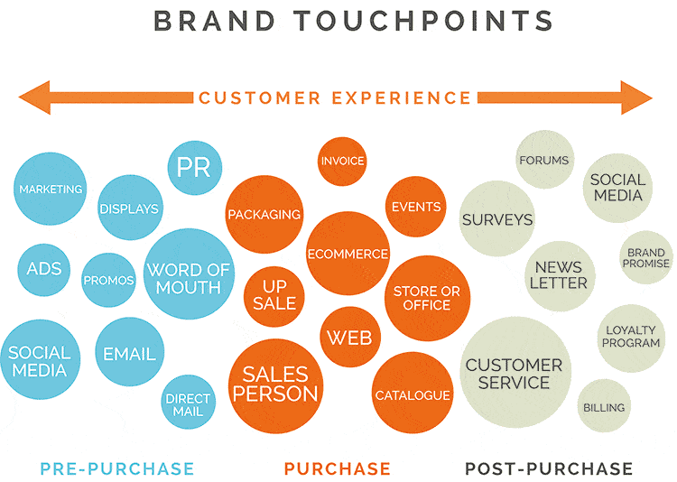

TOUCHPOINTS BEFORE PURCHASE

In the beginning, the customer need to aware of brand or product in order to meet the needs and wants through many mediums like social media, e-mail, promos, displays, word of mouth before purchasing the product. (Keane, 2016)

SOCIAL MEDIA

The sports direct international plc uses all social mediums to communicate with people and make aware of its products. They have individual accounts on Facebook, Twitter, YouTube and website to know the customers’ expectations and reviews about the company’s product. (Sports Direct,2020).
Sports direct got 2,579,177 likes and 2,579,446 follows in YouTube for its clothing brand.
ONLINE ADVERTISEMENT

The online advertisements target to attract online shoppers, particularly young males, who are interested in sporting. It attracts new customers to try the products. (Sports Direct,2020)
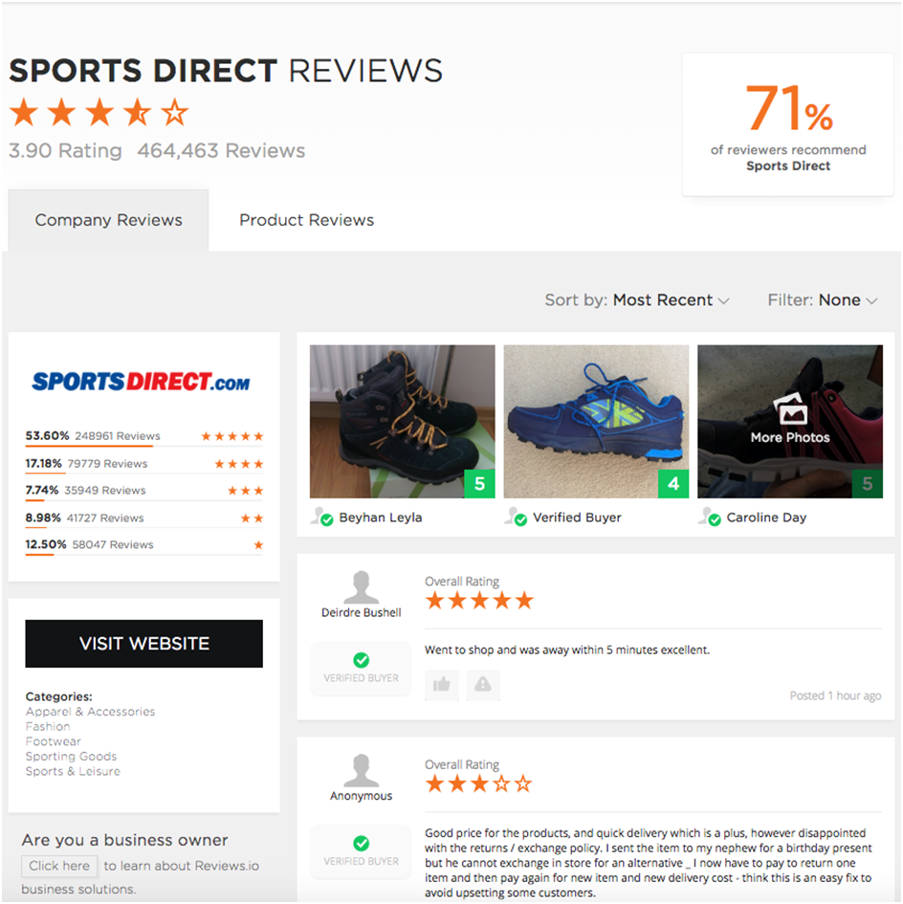

DIGITAL MARKETING CONTENT

The digital marketing content is design to attract and distribute values, relating to company strategy, defined and targeted to engage customers. It uses the specific set of strategies, policies and tactics to create brand awareness, engagement, sales, nurturing, customers retention and loyalty, improve up-selling and cross-selling and encourages word of mouth.
Sports direct uses sales vouchers, coupons, gift card, promoting through blogs, podcast, videos and social media. (Sports Direct,2020).

COMPANY EVENTS

The Sports direct recently raised funds for the children’s cancer unit charity, friends of ash lea school, narcolepsy UK, The salvation army, Lighthouse educational foundation, Tiggy winkles, St. Andrews Chorus. They officially sponsor and conducted race to raise funds for ‘race for life’ cancer research and comic relief. (PMA, 2020).

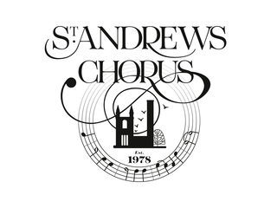
PEER REFERRAL

The peer referral plays a vital role by influencing the people to purchase. The sports direct is described by fans as secure, reliable, good value and offers good deals. (YouGov, 2020).

TOUCHPOINTS DURING PURCHASE

When the customer is satisfied with the demos/reviews, and they will purchase the product online or in stores. The impression created in the stores by the environment, employees made an impact on customers. The positive approach will create a good memory and tends to purchase again (Grohawk, 2019)

CONVERSATIONS WITH COMPANY REPRESENTATIVE

The experience gained from the sales representative will impact on customers. The well-organised, pleasant environment and classy looks create positive thoughts about the company. (HAYES, 2019)

​PRODUCT CATALOGUES

The product catalogues include all range of products and its specific details, information’s, images, specialisation and price. It has to be maintained with quality and updated frequently; it helps customers to view and purchase products. (HAYES, 2019)

PRODUCT REVIEWS

Products reviews are a helpful resource that shows the positive or negative results about the products by the familiar people supports customers to get an idea about the product. These product reviews impact on customers to buy and try out the product. (HAYES, 2019)

WEBSITE

In this improved marketing culture, all the companies use websites with updated version software which has all information about the company and its products. Some companies offer promotions, discounts for those who buy their products through online. These websites help customers to know all information is about the products(ingredients) and its background. (HAYES, 2019)

POINT OF SALES
​
Point of sales refers to the place which is utilised by customers for making payments for products/service usually at the ends of the stores which allows the customer to view all the products and make a purchase. Now, customers have facilities to pay online using credit cards and mobile banking and Google pay. (HAYES, 2019)

TOUCHPOINTS AFTER PURCHASE

When the purchase is over, the company still follows the customer to know whether they are satisfied or expecting more. They experience they got from the beginning, during purchase, after purchase, service provided by the company, interaction with the sales representative, stores environment all plays a significant role in building the relationship with the customer. if the customer is satisfied and happy, they started spreading the experience to everyone around them. (Grohawk, 2019)

THANK YOU LETTERS

The Thankyou letters are planned approach giving by the company to customers after purchase to create a positive image about the company and its small effort to make them happy. It is sent through e-mail, letters or text messages to impress the customers. (Bernazzani, 2019)

PRODUCT FEEDBACK SURVEYS​

The product feedback surveys used to measure the satisfaction level of customers about the product or to identify the issues. These are a set of questions design to understand the customers. It helps to know the positive and negative side of the product and suggests things to be improved. (Bhat, 2018).

UP-SELLING / CROSS-SELLING

Up-selling encourages customers to buy high range products that show the comparison pricing of products available in the market tends customers to get the offer immediately. Where, cross-selling suggests customers to buy products related to their search or corresponding to it. That is satisfactory with an additional value like buying a phone with a headset at the same price. Both are beneficial for customers. (Bigcommerce, 2017).
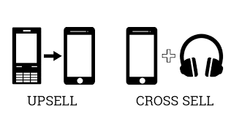

SUBSCRIPTION RENEWAL

When a customer already purchased the product and benefited by it, they paid for a period when time is expired; the customer needs to renew the subscription to use it continuously. If the company provides some discounts or combo offers for existing customers, it engages customers to use it continuously. (CAMPBELL, 2020)

CUSTOMER JOURNEY MAP

The photographic representation of customers experiences when they interact with the organisation or products or brand demonstrates the customer journey mapping. It explains all the stages of customers experience and gives hope for a long-term relationship with the company. (Salesforce, 2016).

BENEFITS OF CUSTOMER JOURNEY MAP

The customer journey map provides sources which helps the organisation to view customers perspective, modify and improve the strategies to meet the expectations of customers. The adaptive measures will attract and fulfil the needs of customers and shows growth in sales. Customers wants the organisation to understand, remember, notice their behaviour and needs. The customer journey map assistances to know through which medium the customers interact with the company helps to concentrate on a specific group of customers at different stages in the purchasing process, supports to analyse the customer’s journey phases in the perfect direction, screening the outside perceptive of the sales process, displaying the differential distance between the expected customer experience and the received ones, emphasising to develop priorities, suggestions to concentrate on the issues in order to maximise effectiveness. (Salesforce, 2016).

Sports Direct Customer Journey Map

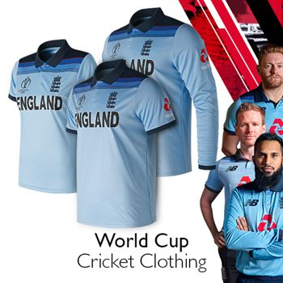

(Sport direct) England Cricket world cup t-shirt 2019
Customer journey map | Awareness | Discover | purchase | use | bond
Website |  | Review of world cup start day 2 |  | Review of additional services 6
Store |  | Trial of t-shirts 4 | Purchase of t-shirts 5
Call Centre
Face book
Web Forums
Word of Mouth | Heard from school friends about cricket world cup 1 |  |  |  | Express positive feedback 7
E-mail |  | Review t-shirts realising day 3
Post

STRENGTHS OF CUSTOMER JOURNEY MAP

This customer journey map helps to connect customers with the sports direct; it helps to identify and understand the needs and expectations of customers using this survey. Providing customer’s service and touchpoints helps to build bonding with customers. It helps to rectify issues and modify strategies to provide service in the expectation level. The cricket t-shirt selling creates brand awareness, new customers who are interested in sporting and fitness keep on purchasing equipment’s because of the availability of a massive range of products. The customers word of mouth marketing is beneficial; it will reach efficiently and improves sales. The reviews in the online help to guide customers. (SportsDirect,2020).

WEAKNESS

The customers want, and needs will change based on the environment, it keeps on changing. The organisation cannot use the same strategy all the times. The world cup t-shirts will not be kept for sales all the times even though it creates publicity. Sports direct competitive marketing strategy requires time to do marketing analysis before displaying the price. Investing too much in researching. (SportsDirect,2020)

RECTIFYING WEAKNESSES

The customers behaviour should be watched frequently to understand their needs to make them happy. The organisation has to create an innovative marketing strategy and implementing it to reach success. The perfect planning for implementing short term sales (cricket world cup t-shirt). Planning and organising teams for the research and allocating funds. (SportsDirect,2020)

THE TOTAL ENGAGEMENT MODEL

If the organisation agrees to delivers a well-defined value proposition and customer experience to generate engagement of customers. Brand value indicates the value proposition of the company and the internal culture which engage the employees. The total engagement model diversifies its area to engage the customers and employees to be more productive. The organisation has to make sure its strategy, marketing plan and its pathway clearly to engage employees and work together for success. When the employees are engaged, they are more productive, involved and dedicated. It is essential to establish a strategic and collaborative connection between customers and employees to build a long-term relationship. The key elements are brand advertising, culture, customer experience, customer value proposition.
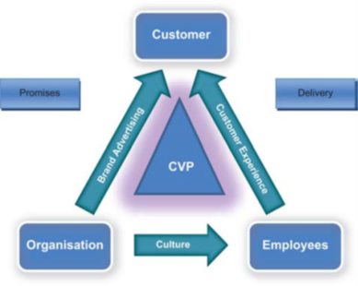

BRAND

Brand says the collective value of the company, quality and its standard; it does not merely mean the symbol or the name. The value proposition plays a significant role for the brand. (Roberts, 2010)

CULTURE

The culture refers to the subjective nature of the company that is marketing strategies, principles, ethics, behaviour and goals. This working environment designs the employee’s nature and reflect in delivering the company’s value proposition and customer experience. (Roberts, 2010)

CUSTOMER EXPERIENCE

When the customer encounters the brand, product or company they had experience, later it builds emotional and physical bonding. Customers will determine the standard of the company according to the service delivered. (Roberts, 2010).

CUSTOMER VALUE PROPOSITION

The promised quality, standard and value delivered by the company controls the customer value proposition. When the products meet the customer’s expectation, they tend to repurchase it even though. Customers come across substitutes. (Roberts, 2010).

CONCLUSION

The sports direct international plc applies competitive strategic marketing principles to improve sales and make profits. It has a vast range of products available for all age groups, operating 400 stores in the UK with unbeatable long run. However, the increased staff turn-over and zero-hours contract controversy will create a bad image for the company. It has to implement unique value proposition, standard quality and maintain trustworthiness. Too many third-party brands available in sports direct will leads to confusion. Considering the drawbacks and modify strategies according to it will help for the company’s long run.

RECOMMENDATIONS

- Sports direct can collaborate with other organisations like (Debenhams) to get advantages from them and to provide benefits to customers (if they link with a petroleum company, implementing shops in a petrol station and it is easy for customers to shop)
- .Alternative benefits like shoe repair, clothes alteration available in the same place.
- Offer ethnic products according to the majority of the population present in the county will encourage people to buy.
- Implement more eco-friendly products and avoid plastics, improve usage of paper bags instead of polythene, recycle plastics and care for nature engage customers contribution.
- Should include offers which are applicable both in online and in stores. Stock availability in outlets should improve according to customers purchase history.
- Provides self-checkouts like supermarkets will be time efficient.
- Sports direct can implement its brand instead of using third-party brands.
- It can develop strategies to target all age group to improves sales.
- Improves staff well-being and create the right working conditions and implement strategies to treat everyone equally.

.

References
Kotler,P. 2009' Marketing Management'. Pearson Education M.U.A.[e-book].Available at: https://www-dawsonera-com.ezproxy. uwtsd.ac.uk/ read online/ 9780273718819. [Accessed:2May2020].
André Bühler, G. N, 2010. 'Relationship Marketing in Sports’. Amsterdam; London: Butterworth-Heinemann. [e-book]. Available at: https://www-dawsonera-com.ezproxy.uwtsd.ac.uk/readonline/9780080942339. [Accessed:1May2020]

Barone, A., 2020. 'Digital Marketing'. [Online]
Available at: https://www.investopedia.com/terms/d/digital-marketing.asp
[Accessed 13 May 2020].
BBC, 2017.' Sports Direct 'broke promise' to axe zero-hours contract's. [Online]
Available at: https://www.bbc.co.uk/news/business-41160746
[Accessed 9 May 2020].
Bernazzani, S., 2019. 'How to Write Thank You Letters to Your Customers to Show Them You Care'. [Online]
Available at: https://blog.hubspot.com/service/thank-you-letter-customer
[Accessed 4 May 2020].
Bersin, J., 2015. 'Deloitte Insights. Becoming irresistible: A new model for employee engagement', 27 January , Issue 16, p. 3.
Bhat, A., 2018.' FEEDBACK SURVEY: DEFINITION, WHY IT MATTERS, HOW TO CREATE, AND ADVANTAGES'. [Online]
Available at: https://www.questionpro.com/blog/feedback-survey/
[Accessed: 6 May 2020].
Bigcommerce, 2017. 'What is the difference between upselling and cross-selling'?. [Online]
Available at: https://www.bigcommerce.co.uk/ecommerce-answers/what-difference-between-upselling-and-cross-selling/
[Accessed :1 May 2020].
CAMPBELL, P., 2020. 'UNDERSTANDING SUBSCRIPTION RENEWAL: REVERSING FAILED PAYMENTS AND RENEWING SUBSCRIPTIONS'. [Online]
Available at: https://www.profitwell.com/blog/subscription-renewal
[Accessed: 3 May 2020].
Chernatony, D., 2010. 'Creating Powerful Brands. Oxford; : Routledge Ltd.[e-book].Available at: https://www-dawsonera-com.ezproxy.uwtsd.ac.uk/ read online/9781856178501. [Accessed:4may2020].
Dana, P., 2019. '-Cultural Mistakes by Renowned Brands – Evaluating the Success and Failures of Brands in Host Nations'. [Online]
Available at: https://www.ijtsrd.com/papers/ijtsrd20268.pdf.[Accessed:8May2020]
Dibb, S., 2012.' Marketing concepts and strategies'. Andover : Cengage Learning.[e-book].Available at: https://www-dawsonera-com.ezproxy.uwtsd.ac.uk/readonline /9781408071144. [Accessed:8May2020].
Direct, S., 2020. Store Portfolio – Sports Stores – UK incl. Northern Ireland. [Online]
Available at: https://www.sportsdirectplc.com/about-us/where-we-operate.aspx
[Accessed 14 May 2020].
Douglas, M., 2019. The amount Sports Direct pays for advertising at St James' Park revealed for the first time. [Online]
Available at: https://www.chroniclelive.co.uk/sport/football/football-news/sports-direct-newcastle-united-advertising-16653604.[Accessed:9May2020].
Edwards, S., 2020. What are customer touchpoints?. [Online]
Available at: https://www.makeitclear.co.uk/what-are-customer-touchpoints/
[Accessed 13 May 2020].
Graham, H., 2018. "Misleading" Sports Direct ad banned by advertising watchdog after prices drew customer complaint. [Online]
Available at: https://www.chroniclelive.co.uk/news/north-east-news/misleading-sports-direct-ad-banned-15002105
[Accessed 10 May 2020].
Grohawk, 2019. What are Customer Touch Points?. [Online]
Available at: . https://www.grohawk.com/what-are-customer-touch-points/
[Accessed 6 May 2020].
HAYES, A., 2019. Marketing Essentials. [Online]
Available at: https://www.investopedia.com/terms/b/brandequity.asp
[Accessed 12th May 2020].
Hooley, G. J., 2014. Marketing Strategy and Competitive Positioning. s.l.: Financial Times/ Prentice Hall - M.U.A.[e-book].Available at: https://www-dawsonera-com.ezproxy.uwtsd.ac.uk/readonline/9780273740940. [Accessed:9May2020]
Kapferer, J. N., 2012. The new strategic brand management advanced insights and strategic thinking. In: 5th ed. s.l.:London ; Philadelphia : Kogan Page, p. 152.
Katherine N. Lemon, P. C. V., 2016. Journal of marketing. Understanding Customer Experience Throughout the Customer Journey, November, 80(6), pp. 60-96.
Keane, L., 2016. Why Brands Need to Understand the Customer Journey. [Online]
Available at: https://blog.globalwebindex.com/marketing/consumer-buying-process/
[Accessed 11 May 2020].
Kotler, P., 2019. Principles of Marketing. Harlow: Pearson.[e-book]Available at: https://www-dawsonera-com.ezproxy.uwtsd.ac.uk/readonline/9781292269603. [Accessed:8May2020]
Martin Christopher,B., 2013. 'Relationship Marketing'. s.l.: Routledge Ltd.[e-book].Available at: https://www-dawsonera-com.ezproxy.uwtsd.ac.uk/readonline /9780080516042. [Accessed:11May2020]
Michael John Baker, M. S., 2010. Marketing Theory. s.l.: Sage Publications Ltd.[e-book].Available at: https://www-dawsonera-com.ezproxy.uwtsd.ac.uk/readonline/9781446211045. [Accessed:12may2020]
PAHWA, A., 2019. What are Customer Touchpoints? Analysis, Mapping, & Examples.. [Online]
Available at: https://www.feedough.com/customer-touch-points/
[Accessed 13 May 2020].
Pickton, 2004. Integrated marketing communications. In: s.l.:Prentice Hall Fiancial Times[e-book] .Available at: https://www-dawsonera-com.ezproxy.uwtsd.ac.uk/readonline/9781405870931. [Accessed:13May2020]
PMA, 2020. Sports Direct. [Online]
Available at: http://www.pmamarketing.com/pma/sports-direct
[Accessed 6 May 2020].
Roberts, C., 2010. Total customer engagement: designing andaligning key strategic elements to achieve growth. Journal of Product & Brand Management, 3 November, Volume 19, p. 200.
Rosenbaum, M. S., 2017. Business Horizons. How to create a realistic customer journey map, Feburary, Issue 1, p. 143.
Salesforce, 2016. What is Customer Journey Mapping & Why is it Important?. [Online]
Available at: https://www.salesforce.com/uk/blog/2016/03/customer-journey-mapping-explained.html%E2%80%8B%E2%80%8B
[Accessed 13 May 2020].
SportsDirect, 2020. SportsDirect.com offers, voucher codes and free donations. [Online]
Available at: https://www.giveasyoulive.com/stores/sportsdirect
[Accessed 8 May 2020].
stevenr, 2017. Sports Direct London Taxi Advertising. [Online]
Available at: https://londontaxiadvertising.com/client/sports-direct/attachment/sports-direct-london-taxi-advertising/.[Accessed:14May2020]
YouGov, 2020. Sports Direct. [Online]
Available at: https://yougov.co.uk/topics/consumer/explore/brand/Sports_Direct
[Accessed 7 May 2020].
Zubak, J., 2017. How to Deliver Value at Every Stage of the Customer Journey. [Online]
Available at: https://powerdigitalmarketing.com/blog/how-to-deliver-value-at-every-stage-of-the-customer-journey/#gref
[Accessed 13 May 2020].

