LEVEL 4

MODULE CODE: LCBB4004

MARKETING FUNDAMENTALS

ASSESSMENT TYPE: ASSIGNMENT
ASSESSMENT: 2
ASSIGNMENT TITLE: E-BAY
LECTURE’S NAME: REXON NTING
NUMBER OF STUDENT: 1817472
NAME STUDENT: IULIANA-MARINELA RADU

Contents Part 1: Essay

Introduction 4
Marketing Process 4
Role of the marketing environment 5
Role of marketing research 6
Role of the marketing mix 7
Value chain model 8
Stakeholder matrix 9
Conclusion 10
Part 2: Reflection 11
References 13
Appendix I: E-BAY business model 15

E-BAY: An Unconventional Marketer

Introduction
Marketing is a process of managing profitable customer relations meeting the needs and wants of the target customers sustainably as mentioned by Zhou, et al. (2019). The scope of marketing starts far before production and ends up with the customer retention for further purchase as per the illustration of Chaffey and Ellis-Chadwick, (2019). According to Kotler and Armstrong, (2019), No business can survive or be successful without the appropriate strategic management of its marketing and communication activities. Klink and Athaide, (2019) stated that 70% of the small and medium enterprises in the UK demolishes in the first year of their establishment only because of the unplanned marketing. The following discussion is going to discuss the success story of E-BAY for their unconventional marketing strategy.
E-BAY is an unconventional marketer in the C2C market that has connected the customers with a platform in order to create exchange among them with a unique marketing strategy as opined by Bradley and Porter, (2019) (See Appendix I for the business model of E-Bay). Neto, et al. (2019) demonstrated that this multinational e-commerce company has commenced on its journey back in 1995 as Auctionweb and later on it has changed its name to E-Bay in 1997. Katkar and Reiley, (2019) stated its success mentioning that the company is in operation in approximately 36 countries across the world managing online auction and shopping websites.

Marketing Process
In spite of being an irregular retailer or distributor, its marketing strategy follows the core marketing process but in a quite different way. As stated by Brassington and Petitt, (2019), the marketing process sims at creating customer value and build a lucrative customer relationship that ultimately results in capturing value from the customer in return. Cabral and Hortacsu, (2019) opined that the marketing process of E-BAY has started with the understanding of the customer need of having a platform of bargaining and competing for selling or purchasing the expected products; such innovative findings has got a new height with the integration of the internet to create such platform without the physical presence of the bidders and sellers.
Lam and Wu, (2019) supported that E-BAY has designed a customer-driven marketing strategy with an appropriate selection of target market with undifferentiated marketing strategy, and defining its value propositions with the limitless inventor of every product, amalgamating the buyers and sellers from beyond the border, and preparing the global e-commerce hub. Then according to the demand of the market and the available resources, the band has designed its marketing program offering the platform of B2C and C2C transactions as explained by Bajari and Hortaçsu, (2019).
Hagiu and Wright, (2019) opined that the profitable relationship is managed by the customer relationship management program that comprises the loyalty program of E-BAY and its customer support team. The successful completion of the marketing program results in the revenue of over S10.75 billion with a 64% customer satisfaction rate capturing 13% global e-commerce market share as delineated by Lucking‐Reiley, et al. (2019).

Role of the marketing environment
As per the illustration of Armstrong, et al. (2019), the marketing environment refers to the forces and factors that directly and indirectly affect the business activities of the organization and shapes the marketing program. Lilien, et al. (2019) explained that the direct forces that shape the business and marketing program are considered as the micro-environment of the organization whereas the factors that affect the marketing decision indirectly without direct monetary interest with the organizational activities.
According to Javalgi, et al., (2019), Micro-environmental elements should be satisfied with marketing practices; in E-BAY, the customers and the suppliers play a major role in the business model as they are conducting the business practice. has no intermed E-BAY iaries but business partners like PayPal, BillMeLater, StubHub, etc. who help the organization to hasten the order fulfillment process. The public has restricted its operation to a certain degree to prevent market monopoly and unfair competition. Ou, and Davison, (2019) mentioned that with the integration of technology in auction platform has contributed to making the competition irrelevant with blue ocean strategy; Amazon, Ali-Baba, and local e-commerce are its indirect competitors but its unique business model has helped the brand to assure its market growth by 12.7%.
Douglas and Craig, (2019) discussed the role of macro-environment in marketing practices that before entering into a new market, the organization has to be concerned about the political, demographic, economic, natural, cultural, and technological environment of the country as they shape the design of operational activities and marketing offers too. Baron, (2019) stated that the political environment provides the business with the government support and subsidiary to conduct business operation; E-BAY is an online platform and to promote such a platform, the political power of almost all 30 countries has interrupted the brand the least with tax rate and trade barrier. The economic factors of the country assess the feasibility and compatibility of the product designed with the solvency of the target market whereas E-BAY managed the bidding process to assure a bargaining platform assuring flexibility to avoid the fluctuation of the purchasing power of the potential consumers.
Bajari and Hortaçsu, (2019) mentioned that the technological development of the countries is affecting the business practices of E-BAY strongly as it has to follow the digital divide. Lam and Wu, (2019) opined that the natural environment affects the logistics services and the availability of the raw materials; E-BAY is a retail platform, therefore, for the supply of raw materials, it does not need to rely on the natural environment but for the logistics system, the brand considers third party logistics system in order to avoid the risks of transportation decline for the natural environment.

Role of marketing research
Malhotra, et al. (2019) mentioned that the success of marketing practices and overall, the business practices rely on the efficiency of marketing research in understanding the market gap, the requirement of the target market, changes in the dynamic business environment, and the feasibility of the taken marketing decision. Douglas and Craig, (2019) opined that the marketing research contributes to managing profitable customer relationship understanding considering the power and interest matrix of consumer, employees, suppliers, and shareholders while designing the organizational policy. Zhou, et al. (2019) Illustrated that the controllable marketing variables and decided with the outcome of the marketing research practices in order to minimize the market gap with appropriate market offerings that assures the goal of the marketing program.
The uncontrollable environmental factors including economic, technological, social, and cultural environment are assessed with the marketing research to understand the degree to which they are going to design the marketing practices in order to avoid the risks arisen from these factors and enjoy the opportunities evolve as per the illustration of Neto, et al. (2019). The major role of the marketing research is to penetrate the success rate of the decision taken by the marketing manager assessing the required information, providing them to make marketing decisions regarding to segmenting the market, designing the target market selection strategy, constructing marketing programs, and scheming performance and controlling program. According to Katkar and Reiley, (2019), E-BAY is using the undifferentiated marketing strategy to serve the target consumers with the auction with free to bid for the expected products considering the total controllable and uncontrollable marketing variables and the contribution of the customer group.

Role of the marketing mix
Kotler and Armstrong, (2019) opined that the marketing mix includes the tools that are controllable by the business organization in response to the factors and forces of the marketing environment along with the organizational ability. Lilien, et al. (2019) mentioned that this e-commerce retailer has a completely unconventional marketing mix considering the demand and acceptability of the market. Javalgi, et al., (2019) explained that the product mix of E-BAY includes the marketplace service, classified service, logistics service, customer support, and the website and server. Baron, (2019) opined that these creative services have penetrated the B2C and C2C transaction opportunity for the customers and suppliers providing them with a trusted platform to bring their products on auction. The organizational success relies on the trust and reliance of the sellers and buyers on the interface and owner.
the brand is following the dynamic pricing strategy where the customers themselves select the price bidding and bargaining among them as demonstrated by Neto, et al. (2019). Katkar and Reiley, (2019) explained that the dynamic pricing and the freedom of the customers to select the price encourages the shoppers who love bargaining and set their affordable price according to the perceived quality of the goods. Cabral and Hortacsu, (2019) the brand is promoting them with innovative promotional media with 68% concentration on the interactive medium of the digital marketing platform using banners, interactive advertisement, social media marketing, and other newer format of digital marketing with the integration of artificial intelligence.
Lam and Wu, (2019) appropriate integration of the communication channels assures commonality, complementarity, clarity, and cost-efficiency in order to communicate the brand promise to the target audience. Hagiu and Wright, (2019) mentioned that the marketing channel assists the marketer to deliver the products to the target market using the appropriate format. Because of the uniqueness of the market strategies of E-BAY, its distribution channels are completely based on digital mediums like mobile applications, websites, social networks, and digital stores. Such unique distribution channels have created a competitive advantage for the organization with interactive communication facilities.

Value chain model
The value chain model of the organization shows a structure of operation reflecting the stages to go to create the expected value for the target market as defined by Brassington and Petitt, (2019). Lilien, et al. (2019) explained that Porter has introduced a universal value chain model that comprises two sets of activities including primary activities and the secondary activities; the primary activities directly produces the value for the target customers of E-BAY including the inbound logistics with the integration of the data about the sellers and buyers, in the operation stage, the brand creates an interaction between sellers and buyers with the interface; the outbound logistics of E-BAY is concentrated on amalgamating the products of the sellers to the warehouse as demonstrated by Javalgi, et al., (2019). The marketing and sales of E-BAY are focused on communicating the business promise to the target audiences to take part in the auction to purchase their expected products and improving traffic on the website. The dedicated team of customer service and the loyalty program of the e-commerce giants are keen to retain the customers increasing the customer retention rate.
The supporting services of the brand include firm infrastructure that is highly secured to protect data and evidence of the sellers and the buyers to maintain their privacy; it is operating such crowd at the website and the mobile application with 14,000 creative employees who are dedicated to serving the brand with 76% satisfaction rate as per the explanation of Zhou, et al. (2019). Cabral and Hortacsu, (2019) emphasized the technology development mentioning that the total interface is based on the internet and the site is compatible to low to high internet speed too. Marketing and sales are at the fourth stage of the value chain but define the brand contributing in all the stages and even in supporting activities with the marketing research and market audit information as discussed by Katkar and Reiley, (2019).

Stakeholder matrix
The key stakeholders of E-BAY include customers, suppliers, payment partners, logistics partners, owners, employees, government, media, competitors, and the public. Categorizing them with the power and interest matrix, their impact on the marketing activities of E-BAY can be defined as discussed by Lam and Wu, (2019). The latent of E-BAY are the owners and payment and logistics partners who have high power to take part in the decision-making process of marketing practices but low interest if the marketers can fulfill their interest adequately as examined by Bajari and Hortaçsu, (2019). With the contracted share of commission and consistent growth in dividend, disbursement has contributed to the profitable investor relationship and partnership management. The promoters include the employees, buyers. and sellers who are directly running the marketing activities and the brand is managing them closely. E-BAY is monitoring the movement of its competitors to avoid fierce competition and the media to avoid social risks as delineated by Chaffey and Ellis-Chadwick, (2019). However, the government and public are considered defender for E-BAY as they merely interrupt the marketing practices designed.

Conclusion
The above discussion has dealt with the fundamental marketing principles and theories and their application on E-BAY considering its innovative marketing practices and disruptive business model. The assessment has found that the uniqueness of the business model and integration of the resources in a single platform has played the role of major competitive advantages leading it to the organizational success. The marketing process, marketing environment, marketing mix of E-BAY, stakeholder analysis, and value chain analysis have been described to meet this purpose.

Part 2: Reflection
The above essay has discussed the fundamental elements of marketing considering the major tools, models, and techniques in the marketing program of an organization. To examine the practical application of these theories and concepts, an unconventional marketer has been chosen to define the appropriateness and universality of the theories in an application for any sort of business model. However, the learning and experiences of the illustration are going to explain with Gibb’s reflective cycle (See Appendix VIII).
The illustration has started with the identification of the appropriate organization and the moderators have approved E-BAY for me. I have used the marketing process delineated by Kotler and Armstrong (2019) and other models like marketing environment, marketing research model of Chaffey and Ellis-Chadwick, (2019), marketing mix program, value chain analysis, and stakeholder matrix to illustrate fundamentals as per the suggestions of the module. Using secondary resources and applying my critical analysis skill to examine the models on E-BAY that is certainly an unconventional business with completely different models from the traditional one.
It was a great feeling to apply my academic knowledge on the practical scenario and finding interesting content evaluating the innovative business model of E-BAY apply the universal theories of marketing. I have to struggle at a point when I have found my skill gap in written communication as in some case, I stumbled with my vocabulary funds. However, going to the lines repeatedly, I have minimized the gap to make the writings successful.
Throughout the essay, I have learned the practical application of the marketing theories and tools along with their contribution to the success of a business. I found the interconnection among the business practices while considering the role of marketing research, marketing audit, and the application of marketing mix program. I learned that marketing and sales are a vital element and the boundary spanner in the value chain of E-BAY. The completion of this essay has developed my time management skills, critical analysis skill, and research skill. The major limitation of my academic and professional skills evaluated is the communication skill that I have to amend as soon as possible to reduce the struggle for the next assignment.
The essay could be more representative if I could elaborate the discussion further with the thorough assessment of the marketing tools and techniques on E-BAY but the limitation of the words has enforced me to precise my discussion. I should have reduced my skill gap in communication to reflect my academic knowledge on the critical assessment.
I have to work on my communication skills and numeracy skill further to enhance my academic and professional skills meeting the requirement of the expected career path. I will take part in the different written competition and assessment games in mobile and website in order to enhance my written communication skill that is going to enrich my competency in presenting my knowledge to the audience.

References
Armstrong, G., Adam, S., Denize, S. and Kotler, P., 2019. Principles of marketing. Pearson Australia.
Bajari, P. and Hortaçsu, A., 2019. The winner's curse, reserve prices, and endogenous entry: Empirical insights from eBay auctions. RAND Journal of Economics, pp.329-355.
Baron, D.P., 2019. Private ordering on the Internet: The eBay community of traders. Business and Politics, 4(3), pp.245-274.
Bradley, S.P. and Porter, K., 2019. eBay, Inc.
Brassington, F. and Petitt, S., 2019. Principles of marketing. London, NY: FT Prentice Hall.
Cabral, L. and Hortacsu, A., 2019. The dynamics of seller reputation: Evidence from eBay. The Journal of Industrial Economics, 58(1), pp.54-78.
Chaffey, D. and Ellis-Chadwick, F., 2019. Digital marketing. Pearson UK.
Douglas, S.P. and Craig, C.S., 2019. International marketing research (p. 192). Englewood Cliffs, NJ: Prentice-Hall.
Hagiu, A. and Wright, J., 2019. Do you really want to be an eBay?.
Javalgi, R., Cutler, B. and Todd, P., 2019. An Application of an Ecological Model to Explain the Growth of Strategies of Internet Firms:: The Cases of eBay and Amazon. European Management Journal, 22(4), pp.464-470.
Katkar, R. and Reiley, D.H., 2019. Public versus secret reserve prices in eBay auctions: Results from a pokémon field experiment. The BE Journal of Economic Analysis & Policy, 5(2).
Klink, R.R. and Athaide, G.A., 2019. Implementing service learning in the principles of marketing course. Journal of Marketing Education, 26(2), pp.145-153.
Kotler, P. and Armstrong, G., 2019. Principles of marketing. Pearson education.
Lam, H.W. and Wu, C., 2019, May. Finding influential ebay buyers for viral marketing a conceptual model of BuyerRank. In 2019 International Conference on Advanced Information Networking and Applications (pp. 778-785). IEEE.
Lilien, G.L., Rangaswamy, A. and De Bruyn, A., 2019. Principles of marketing engineering. DecisionPro.
Lucking‐Reiley, D., Bryan, D., Prasad, N. and Reeves, D., 2019. Pennies from eBay: The determinants of price in online auctions. The journal of industrial economics, 55(2), pp.223-233.
Malhotra, N., Hall, J., Shaw, M. and Oppenheim, P., 2019. Marketing research: An applied orientation. Pearson Education Australia.
Neto, J.Q.F., Bloemhof, J. and Corbett, C., 2019. Market prices of remanufactured, used and new items: Evidence from eBay. International Journal of Production Economics, 171, pp.371-380.
Ou, C.X. and Davison, R.M., 2019. Technical opinion Why eBay lost to TaoBao in China: the Glocal advantage. Communications of the ACM, 52(1), pp.145-148.
Zhou, X., Gandhi, S., Suri, S. and Zheng, H., 2019, September. eBay in the sky: Strategy-proof wireless spectrum auctions. In Proceedings of the 14th ACM international conference on Mobile computing and networking (pp. 2-13).

Appendix I: E-BAY business model
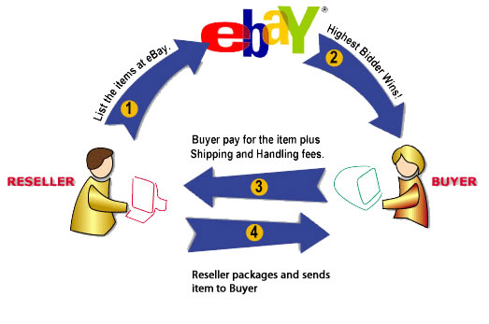
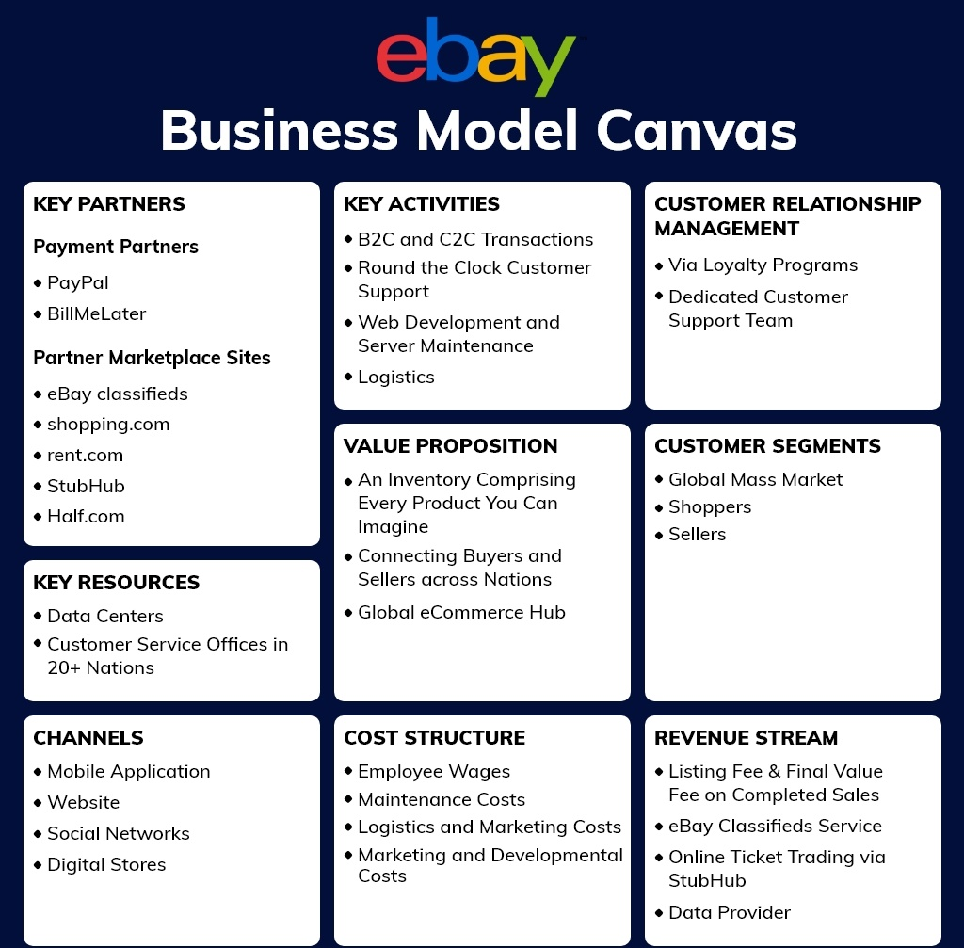
Source: (Bradley and Porter, 2019)

