Task 1 - What Is the Most Effective Way to Motivate Staff?

Academic and Employability Skills
BMSW4001

Iunsiya Hussain

2024760

Rebecca Stewart

Table of Content

Title …………………………………. Page 1
Table of Content …………………... Page 2
Introduction ………………………… Page 3
Recognition and Awards ……….… Pages 4-5
Pay ……….………………….……. Pages 5-6
Additional Holidays ……………….. Page 6
Great Working Conditions ………... Page 7
Conclusion …………………………. Page 8
References ………………………… Pages 9-10

This report will include all the ways staff can be motivated to have a greater work performance in any place of work. Different rewards will be discussed and explained how they allow staff to feel motivated at their place of work. A conclusion will be formed of which reward method, motivates staff members the most. A company having staff motivation is essential as it allows the managers to ensure the company is thriving and reaching their goals. This is important for a company to grow and continue being successful. Making certain that employees within the organisation are motivated can take up time and effort however in the long run when management make this a priority, they are setting the business up for a great output by having successful employees that are motivated.’ An employee’s motivation is a direct result of the sum of interactions with his or her manager’ (Heryati) This is a quote by Bob Nelson, this shows the importance of having approachable management within the workplace. Employees having a good relationship with their management will increase their motivation and productivity within the workplace.

Motivation within the workplace will allow an organisation to thrive, the reasoning behind this is because if an employee is motivated it will further them to perform greater within the workplace which will increase production. There are many ways a member of employee can feel motivated, it can differ between individuals. Some ideas are of motivation are on the image below.
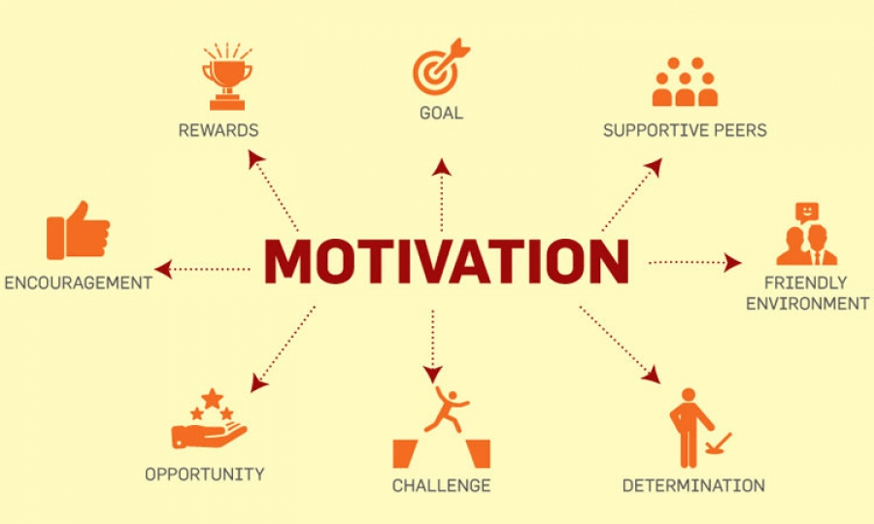
(Source: The Dubrovnik Times)

Employees that are disciplined in their work ethic, a reward system or even incentives may have no affect on their performance. This is not a problem as employees that are already disciplined within themselves want to perform at their highest ability in their role as it grants them a feeling of accomplishment and achievement which furthers their motivation. ‘These individuals perform productively for the sake of the personal challenge their work provides’. (Ijetmas, 2014). Recognition and appraisal for these types of employees will work best as it will boost their work ethic further. A way of appraisal can be to participate in employee of the week / month. Yearly extensive appraisals and quarterly appraisals for all employees. This will acknowledge their strengths and accomplishments and areas to improve on which they will take on board. A recognition simple such as a ‘thank you’ to an employee could be enough. Being vocal and thanking them for their hard work will motivate them to continue working hard, reaching the goal the company has set. Publicly appraising staff members can give them that feeling of recognition, making known their hard work to their team members and other members of the organisation can boost their productivity and keep them determined.
(Source: Personnel Today)
Pay is another factor that can motivate staff within the workplace. Poor pay may be demotivating to employees as they may be working hard however feel they are not receiving any recognition for their efforts through their wage given by the company. This can affect the performance of an employee, leading them to regress within their work. Increasing wages could be positive as it can be understood by an employee that their hard work is being recognised and due to this their wage has increased, there can be a negative to increasing wages as it can have an opposite impact to motivation. Employees may begin to feel entitled and over ecstatic about their increased wage that they no longer feel they need to be productive. This can become a cycle of an employee’s needs never being fulfilled, this can fuel when an organisation uses pay as a reward and recognition system. Causing unwanted behaviour within the company.
‘You want to reward and encourage people who attain the goal—but you don’t want it to become the goal. You don’t want to hear people saying, “I’m just here for the money.”’ (Witt, 2011). Money can be a motivator to employee’s however for an organisation this is not what
is wanted for their employee’s perspective, organisation’s want their employees to be driven within their roles to achieve the goal of the organisation and not just for a pay increase. An alternative for employees that are motivated by money can be to give out not regular bonuses as it will allow the employee to feel thanked for their hard work, this is great for employees that feel recognised through pay. Bonuses that are not regular can increase productivity unlike a pay increase as it is great for the first month or two and then it becomes the next average pay for an employee and will easily become forgotten, once this occurs the employee will feel entitled to their next increase. Bonuses are more significant especially when they are paid not regular, this allows morale within staff to increase. Benefits and discounts can work just as well with motivating staff.
In 2014, Sir Richard Branson, Boss of Virgin removed all limits on how many days a year his staff could take of annual leave. It’s believed to increase creativity and productivity in staff members. This is not something all organisations can afford to participate in however they can in giving additional annual leave as it allows employees to take that extra break if needed. Rejuvenating and refreshing employees, allowing them to return to work distressed. Having that break allows staff to become motivated and then want to throw themselves at their work. As their productivity has increased. Employees may perform better at work, when given additional holidays to spend away from work, they will feel they are not just a number, their life out of work is seen just as important as their work life to their employer. Additional holidays for an employee may give them time to think, being away from work can allow them to become creative when their brain is not under workload stress and they have switched off, this can be great for an organisation as their employees can bring their creative ideas back with them to the company.
Offering more annual leave can benefit employees and employers in great ways, some areas listed below:
- ‘Reduction of stress which reduces the risk of anxiety and depression.
- Improvement in mood of individuals which will assist in improving social and businesses interactions
- Improvements to the immune system as those who regularly take time away from the pressures of work are less likely to succumb to illness.
- Overall team morale is improved as happier individuals will deliver happier teams.
- Improved productivity as employees are well rested, healthy and motivated.
- Lowered turnover of staff reducing the costs associated with recruitment and the stress of training new appointees.
- Decreased absenteeism as your team are getting the balance in their lives that they need.’ (HRstaffnstuff, 2019)

The condition of work environment plays a big factor in staff motivation. Making the work environment a place where employees want to spend their time is very important. ‘Most Employees will be at work for at least 7 hours a day’. (Bowen, 2018) Employees spend a huge portion of their day at work, it is motivating if it is in a good atmosphere. For employees that work in an office, having good technology such as computers, laptops and latest software will give them the ability and motivation to complete their work to the highest standard. Providing employees that work at a desk with efficient space and a chair that provides them with support will allow them to feel comfortable and give them the space to organise their work. Regardless of the occupation, any job role an employee has, they should be provided with good equipment they will need to get their job done. Having a clean, tidy, vibrant and an updated interior space will drive work to come and complete their roles.
Employers ensuring the workplace is a safe place and that there is no presence of hazard is vital, it is important employees are working in good working conditions. Below are some of the reasons why having great working conditions are important for staff motivation:
- ‘A poor work environment can have a detrimental impact on employee motivation, performance, and wellbeing.
- Providing a variety of workspaces can encourage new ways of working and enable staff to work in an environment that best suits them and the task at hand.
- Organisations should consider areas that can contribute to the wider employee experience, such as spaces that allow staff to relax, recharge, exercise or socialise with colleagues.’ (Fordham, 2017)

All ways discussed in this assignment are effective ways to motivate staff. Pay, recognition and awards, additional holidays, and good working conditions. Pay is a great way to motivate staff, discussed previously. Staff may feel motivated when their wages are increased as it may allow them to feel appreciated for their hard work which will further their motivation at work however the negative impact of this is that staff members may feel become entitled to having regular pay increase. Using pay increases can have an opposite impact of motivation as wages becomes the main goal instead of work and this would make increasing wages an ineffective method to motivate staff.
Appraisal is another good way to motivate staff as it is a way for employees to feel appraised for their role they carry out for the company and how their hard work contributes to the growth. Appraisals are often carried out annually, for this reason it may not be the best for employee motivation as an appraisal once a year can easily be forgotten and cause employees to become demotivated in their job role. Unless staff are having appraisals on a regular basis, appraisals can be an ineffective method of motivating staff if not completed with employees several times a year.
Additional holidays for employees are a great way to motivate staff as it allows them to take extra days off on top of their usual annual leave. This can motivate staff to perform better within the workplace as having extra time away from work can allow them to become creative and think of new ideas that they can bring back to the workplace with them. Another reason why additional holidays are great is because it allows employees to refresh themselves, on return they will have more productivity. The only downsize to additional holidays is that not all company’s can afford to allow their employees to take extra annual leave. This is a way to increase motivation amongst employees however there is another recommendation which will motivate staff the most.
Good working conditions is the recommendation that will motivate the staff the most. Having a good work environment will motivate staff to perform their best. Having enough space to carry out their job role will motivate staff to complete their tasks to the best of their abilities. Organisations should consider areas that can contribute to the wider employee experience, such as spaces that allow staff to relax, recharge, exercise or socialise with colleagues.’ (Fordham, 2017) Simply having a good work environment where employees work is the most important way to motivate staff as this is where they spend most of their day. Having the best equipment and technology to help carry out their tasks smoothly will encourage and motivate employees.

References
Annual leave - should you offer more? HRStaffnStuff. Available at: https://www.hrstaffnstuff.com.au/blog/should-you-offer-more-annual-leave (Accessed: November 24, 2022).
Are bonuses better than pay rises for employee morale? (2017) Cintra Payroll Services Are bonuses better than pay rises for employee morale Comments. Available at: https://cintrapayroll.co.uk/are-bonuses-better-than-pay-rises-for-employee-morale/ (Accessed: November 23, 2022).
Bowen, N. (2018) 10 ways to motivate staff without a pay rise, Reward and Employee Benefits Association (REBA). Available at: https://reba.global/content/10-ways-to-motivate-staff-without-a-pay-rise /(Accessed: November 24, 2022).
Faragher, J. (2014) Minimum wage rises to £6.50 from 1 October, Personnel Today. Available at: https://www.personneltoday.com/hr/minimum-wage-rises-6-50-1-october/ (Accessed: November 23, 2022).
Fordham, L. (2017) The role of the workplace in employee motivation, Employee Benefits. Available at: https://employeebenefits.co.uk/issues/motivation-themed-week-september-2017/workplace-motivation/ (Accessed: November 24, 2022).
Ganta, V.C. (2017) Motivation in the workplace to improve the employee performance Vinay Chaitanya Ganta, Academia.edu. Available at: https://www.academia.edu/34093564/MOTIVATION_IN_THE_WORKPLACE_TO_IMPROVE_THE_EMPLOYEE_PERFORMANCE_VINAY_CHAITANYA_GANTA (Accessed: November 23, 2022).
Home The Dubrovnik Times. Available at: https://www.thedubrovniktimes.com/ (Accessed: November 23, 2022).
Sylvester, J. (2014) Extra holiday for your employees? HRZone. Available at: https://www.hrzone.com/community-voice/blogs/johnsylvester/extra-holiday-for-your-employees (Accessed: November 24, 2022).
Townsend, J. (2019) Why employee motivation is important &amp; how to improve it, Ezzely Blog. Available at: https://blog.ezzely.com/why-employee-motivation-is-important-how-to-improve-it/#:~:text=According%20to%206Q%2C%20we%20should%20prioritize%20employee%20motivation,increased%20employee%20commitment%20and%20employee%20satisfaction.%20More%20items (Accessed: November 23, 2022).
Witt, D. (2011) Employees feeling entitled? it might be your fault., Blanchard LeaderChat. Available at: https://leaderchat.org/2011/10/13/employees-feeling-entitled-it-might-be-your-fault/ (Accessed: November 23, 2022).

