

Kevin Mazuera salazar (1906238)

Effective Teamworking and Communication

MODULE: BMSW4002

Kevin Mazuera Salazar, Student number: 1906238

6 January 2020

CONTENTS

Contents……………………………………………. Pag1

- Introduction………………………………………… Pag 2
- Types of communication…………………………… Pag 3
2.1Verbal Communication………………………….Pag 3
2.2 Non-Verbal Communication……………………… Pag 3
- Theories of communication…………………………. Pag 3
3.1 Shannon-weaver model of communication………... Pag 3
3.2 Berlo’s model of communication………………….. Pag 4
3.3 Shcramm’s model of communication……………… Pag 4
4. Conclusion…………………………………………... Pag 5

- INTRODUCTION

Teamwork could be defined as the mutual collaboration of different individuals in order to achieve successfully a particular result, as this article from wisestep states (https://content.wisestep.com/top-advantages-and-disadvantages-of-working-in-a-team/). From this perspective, teamwork can refer to certain sports, to cooperation for economic or social purposes, to initiatives taken jointly in the area of politics. Teamwork turns out to be fundamental in many areas of life and its success lies in knowing how to add individual talents.
A team work satisfactorily when its members wok in the same direction, when they are capable and when they respect the guidelines that have been opportunely considered. In most cases, it is important to have a charismatic leader who is a role model for the rest and who as such knows how to lead the team as a whole towards success. A good leader knows how to motivate his teammates to make the best of them and thus achieve the desired end, this is a perfect example why communication is crucial when working in teams.
Communication is simply the basis of all our interpersonal relationships, and at work it is a matter to which we must pay due attention. Good communication speeds up all work procedures. It allows to inform ideas, objectives and opens the appropriate channels for new ideas, projects and techniques. Proper communication at work avoids misunderstandigns and allows the entire team to function as a well-oiled machine and all elements towards a common goal and with full knowledge of its surroundings. Open, transparent and comprehensive communication to all members of the team minimizes misunderstandings, misapplications of techniques and also prevents rumours or attached comments. It could even help to the incorporation of new employees.
Petare is a small company founded by a marriage. They gave it that name since it is the same of a small poor neighbourhood in Venezuela where they grew up and met. Petare is a restaurant that is gaining a lot of popularity lately for its exquisite recipes. This restaurant aims to bring the flavours of Latin America by giving a small twist to the palate of a public not only focus on Latinos.
The specialty of the house is fried chicken with a secret guava glazed and garlic mayo, also Arepas, which consists of a dip fried bun stuffed with different ingredients. The Arepas are well known in South America but mostly Colombia and Venezuela. I was offered a job and I as a Colombian decided to take it because I wanted to be a part of the project and thus help make our food more known and give people another point of view on Latin America leaving aside the clichés. A good communication in my work influences in several ways, mainly because we are exposed to people and apart from being of great help to establish a quick relationship with the client, we are serving food and we should be able to know and deliver the different types of allergies that the products we offer can cause on people. Another of the reasons why it is necessary to have good communication is because a kitchen must be carried by the entire team, meaning if one the pieces fails, it will cause the other to also start to fail and this can lead to the frustration of team members and clients.

2.0 TYPES OF COMMUNICATION
Communication is an indispensable element in our life since it is the way through which we transmit from our emotions to our feelings and, ultimately our thoughts to people and even animals. There are types on communication; we find the auditory, visual, tactile, or oral among others. At the present, the communication barrier is becoming thinner in the presence of technological equipment.

2.1 VERBAL COMMUNICATION

Verbal communication is the communication that is carried out through the use of words, so that this is the resource used between the sender and the receiver. It should be noted that we find two types of verbal communication that are; oral, that is based on oral signs and spoken words, also including sounds such as laughter and even crying. Secondly, we have written communication that is the one that is done by means of written signs, among which we highlight of course the alphabet, but there are also others of lesser use but equally important as the logos can be.

2.2 NON-VERBAL COMMUNICATION

Non-verbal communication is a type of communication that is carried out without the need to use spoken or written words, so very often it is a type of communication that we do unconsciously. Basically, the postures, the gestures, the way that we look at people, the movements we make with the body, the way we sit or even the way we walk would enter into non-verbal communication.

3.0 THEORIES OF COMMUNICATION

Communication models refer to those theoretical schemes of the communication process, which are elaborated to facilitate their analysis and understanding. Continuing with this point, I will explain three of communication model such as Shannon-weaver’s, Berlo’s and Schramm’s.

3.1 SHANNON-WEAVER MODEL OF COMMUNICATION

Communication is a process that begins with the choice of the information that is intended to be issued. This information must be encoded by a transmitter so that it can be broadcast on a channel that puts the transmitter in contact with the receiver. Likewise, the receiver, once the information has been received, decodes it, ending the process with a destination.
One of the most important elements in this model is the message, which has three characteristics: It is objective and can be transmitted from one place to another, regardless of context and time. Its main functions are to persuade, stimulate and inform. This communication model has a social sense, because exposure to messages generates a meeting point between senders and receivers.

Received signal
Signal
Message
Message
Destination
Receiver
Noise Source

Transmitter
Information source
An example of Shannon’s model applied to my workplace could be anytime my colleagues or myself receive a call from a client trying to make an order for delivery. Given that our restaurant is a few meters down the floor level, signal sometimes can be faulty and may cause calls to be difficult to hear sometimes.

3.2 BERLO’S MODEL OF COMMUNICATION

David Berlo proposed a model that emphasizes how the attributes of the four main elements (Source, message, channel and receiver) affect communication. Berlos’s model also specifies the need for decoders and encoders in the communicative process. The encoder is responsible for expressing the main purpose in the form of a message. It also describes some personal factors that could affect the communication process. These elements are communicative skills, attitudes, knowledge or even culture of both the source and the recipient.
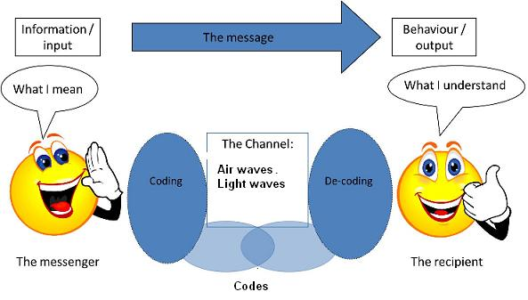
In this picture above we can see the four elements that this model is based on.

An example of the Berlo’s model at my workplace could be the time when I am attending customers. It is my duty to understand what the customer wants by decoding the message and interpreting it.

3.3 SCHRAMM’S MODEL OF COMMUNICATION

Schramm states that, communication is a process established by sharing. That is, by determining links between individuals who have three components in common, such as:
- The source (Can be an individual, a television network or a newspaper)
- The message (Verbal or nonverbal; different forms of expression).
- Destiny (The individual who listens or receives the message).

The model also focuses on encoding and decoding which happens before sender sends the message and before receiver receives the message respectively.
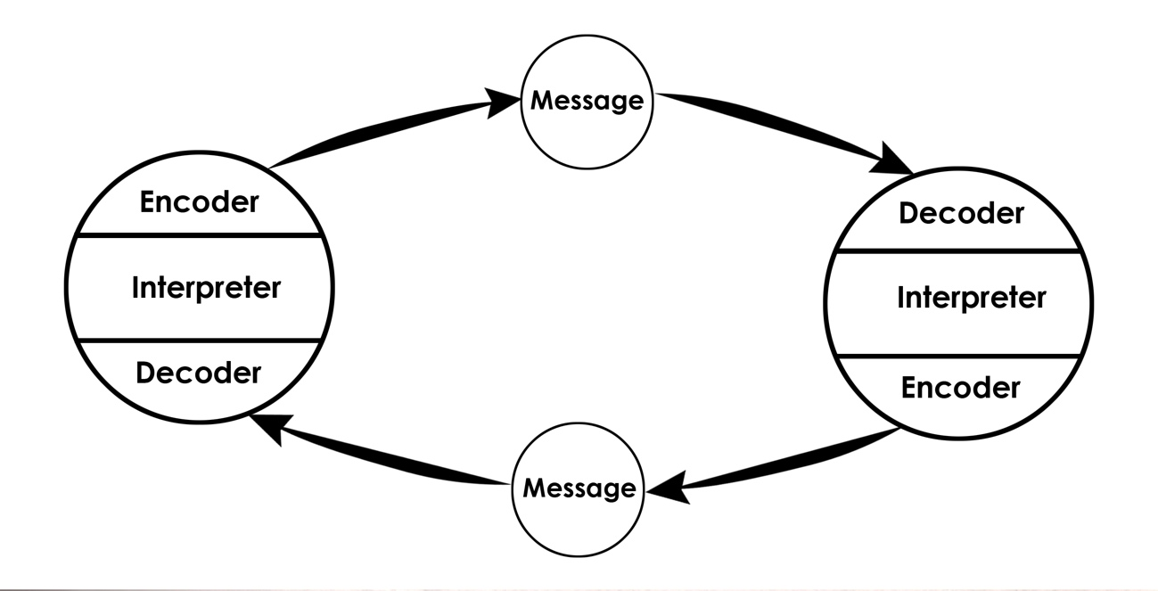

Schramm model is simpler to explain giving that its whole purpose is to understand the message and to make your understood. A simple conversation between two individuals could be a perfect example of how this communication model works.

- CONCLUSION

In conclusion, I will say Schramm’s model of communication is the most accurate out of all the three that I have explained. These models reflects how there is always a continuous approach to sender from receiver back and forth. However, finishing this assignment has helped me understand in a deeper way the importance of good communication. As mention before, good communication in the work place helps minimize misunderstandings and conflicts, not only that but will also increase the efficiency of the teamwork. Keeping in mind that communication is not only what we say and the way we say it, it is also the way we reflect the message that we are trying to get across with our expressions, looks, sights or gestures. Now that I understand it’s importance, it will be easier for me to put it to work and improve not only my experience working with other but also anyone else that struggles with communication at the workplace.

