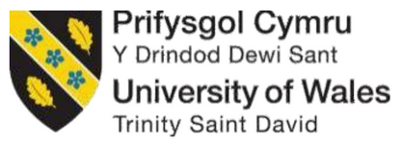

Module name: Hotel Placement Research Project
Module code: BMIH6008
Assignment Title: Placement Research Project

Topic: Marketing Strategies and Brand Positioning in the Hospitality Industry: A Case Study of Ashford International Hotel & Spa.

Student Name: Katerina Hristova
Student No: 2232205

Declaration
I declare that the academic resources and supervision directed the completion of this research paper, and the Artificial Intelligence tools were used responsibly to improve grammar solely.

Acknowledgement
I would also greatly like to recognise my academic supervisor and his/her support and constructive feedback, particularly in this process of conducting the research. I also wish to give my thanks to the management and employees of the Ashford International Hotel and Spa due to their cooperation and insight, my family and friends due to their unrelenting support, and the UWTSD due to the academic background and support that allowed successful completion of this study.

Abstract
This paper examines the relationship between the marketing approach and the brand positioning within the UK hospitality industry and more precisely in Ashford International Hotel and Spa, which is one of the central properties in the QHotels Group. The study will focus on how strategic marketing practices influence brand identity, customer perception, and competitive advantage in the post-pandemic hospitality environment. The research was conducted according to the case study research method whereby secondary data was supplied through academic sources, industry reports and company documents. It provided a chance to examine the marketing trends, digitalisation, and brand communication behaviours within the Ashford International Hotel and Spa that is situated in Kent in detail.
The review has relied on the latest articles by Agag (2025), Chen, Lin and Zhang (2025), Foroudi, Gupta, Sivarajah and Broderick (2020), and others in order to build a critical approach to how hotels have integrated marketing innovation, sustainability, and customer engagement to attain brand equity and loyalty. The key insights are that the UK hospitality sector is experiencing the structural shift towards data-driven marketing, web-based communication, and data-driven branding. Implementing data analysis in the Ashford International Hotel and Spa case will permit customer segmentation through accurate customer analysis and provide specific promotions, which will enable efficiency in marketing.
The emphasis on wellness, relaxation, and regional authenticity as the central elements of brand narratives leads to the increase of the emotional connection with the customers and contributes to the differences in the hotel market that is increasingly competitive. In addition to this, tailor-made guest experiences and loyalty programmes are one of the largest channels of attaining brand loyalty and customer retention. The other significant contribution of the investigation is that the digital renovation, particularly the social media, online reputation management and immersive technologies, has played a vital role in the positioning of the brand. This is because customer trust and credibility are boosted by the continuous contact with user-created content and instant feedback.
Meanwhile, sustainability practices, including environmental responsibility and community engagement, also contribute to brand equity in the long-term perspective, which makes the hotel operations in connection with the current consumer values. On a regional scale, partnership with regional tourism organisations, such as Visit Kent and Ashford Borough Council, will put more credence in destination branding and increase the presence of Ashford International Hotel and Spa. The combined promotional activities and the joint marketing result in the restoration of the economies of the region, and they enhance the ties between the hotel and the community. Based on these findings, the research proposes that Ashford International Hotel and Spa ought to invest more in predictive marketing analytics and continue with more sustainable branding programmes and more interactive digital storytelling alongside customer co-creation with interactive feedback programmes.
There is also a need to enhance internal brand communication and employee engagement to achieve consistency in the brand promise and experience of the guest. Overall, this paper concludes that technology, ethics, and human-centred marketing, when combined, can be the secret of successful brand positioning in the modern hospitality industry. Being innovative and authentic at the same time, the Ashford International Hotel and Spa will manage to secure the loyalty of its customers in the long term, expanding , and contribute to the general stability and evolution of the UK hospitality industry.

List of Figures
Figure 3.1: Research onion ring model……………………………………………………………….14
Figure 4.1: Marketing Strategies and Brand Orientation…………………………………………...19
Figure 4.2: Brand Positioning and Identity………………………………………….........................20
Figure 4.3: Customer Experience and Loyalty…………………………………………...................21
Figure 4.4: Digital Transformation and Online Presence…………………………………………...22
Figure 4.5: CSR in Branding……..………………………………………….....................................23
Figure 4.6: Customer Co-Creation and Experience Design…………………………………………24

List of Tables
Table 4.1: Key findings…………………………………………………………………………………19

Table of Contents
Declaration 2
Acknowledgement 3
Abstract 4
List of Figures 6
List of Tables 7
Chapter 1: Introduction 11
1.1 Background of the Study 11
1.2 Overview of the Case Study: Ashford International Hotel & Spa 11
1.3 Research Problem and Rationale 11
1.4 Research Aim and Objectives 12
1.5 Research Questions 12
1.6 Structure of the Dissertation 12
Chapter 2: Literature Review 14
2.1 Introduction 14
2.2 The Concept of Brand Positioning in Hospitality 14
2.3 Marketing Strategy Frameworks in the Hospitality Sector 14
2.4 Consumer Perception, Experience, and Engagement 14
2.5 Digital Transformation and Technology-Driven Branding 15
2.6 Corporate Social Responsibility (CSR) and Ethical Branding 15
2.7 Destination Branding and Regional Competitiveness 15
2.8 Consumer Loyalty and Relationship Marketing 16
2.9 Post-Pandemic Marketing and Service Innovation 16
2.10 Identified Research Gaps 16
2.11 Summary 17
Chapter 3: Methodology 18
3.1 Introduction 18
3.2 Research Design 18
3.3 Research Approach 18
3.4 Data Collection Method 19
3.5 Data Analysis Technique 19
3.6 Ethical Considerations 19
3.7 Summary 20
Chapter 4: Findings and Discussion 21
4.1 Introduction 21
4.2 Findings 21
4.3 Thematic analysis of findings 24
4.3.1. Marketing Strategies and Brand Orientation 24
4.3.2. Brand Positioning and Identity 25
4.3.3. Customer Experience and Loyalty 26
4.3.4. Digital Transformation and Online Presence 26
4.3.5. Sustainability and CSR in Branding 27
4.3.6. Post-Pandemic Marketing and Innovation 28
4.3.7. Regional Branding and Destination Synergy 28
4.3.8. Customer Co-Creation and Experience Design 29
4.4 Discussion 30
4.4.1 How do marketing strategies influence brand positioning in the UK hospitality industry? 30
4.4.2 What marketing approaches are currently employed by Ashford International Hotel & Spa? 30
4.4.3 How do these strategies affect customer perception and brand image? 31
4.4.4 What improvements can be recommended to enhance Ashford International’s marketing and brand positioning? 32
4.5 Implications for Ashford International Hotel & Spa 33
4.6 Limitations 33
4.7 Future Research Directions 33
4.10 Conclusion 34
Chapter 5: Conclusion and Recommendations 35
5.1 Conclusion 35
5.2 Recommendations 37
References 39
Appendix 46
Thematic analysis 46

Chapter 1: Introduction

1.1 Background of the Study
The hospitality business ranks among the most dynamic and competitive service industries in the whole world, and marketing initiatives and brand positioning have turned out to be the most significant factors in identifying the performance of the business. This sector has been contributing significantly to the economy of the United Kingdom because it employs millions of people, and it is key to the tourism industry and the region (Dewnarain, Ramkissoon and Mavondo, 2021). The industry has been altered dramatically due to the pandemic because of COVID-19, and as a result, the hotels have started reevaluating the way they attract, connect, and retain their customers. It is these changes in the digital transformation, sustainability and the pursuit of differentiating brand identities that have consequently come to the fore to concentrate on business success in this dynamic environment.

1.2 Overview of the Case Study: Ashford International Hotel & Spa
Ashford International Hotel and Spa is a four-star hotel which is situated in Ashford, Kent, and is operated by the QHotels collection. The hotel provides hotel, spa and conference services as well as dining experiences of high quality, thus making it a business and leisure destination. It is also in a good place and accessible to the domestic and international visitors since it is near other major transport links such as the M20 motorway and Ashford International Station (Dewnarain and Ramkissoon, 2023). Hotel marketing is founded on the traditional hospitality values and the current-day branding marketing efforts. However, as the competition in the post-pandemic market continues to increase, Ashford International faces the growing risk of intensifying its digital promotion processes, brand differentiation, and appeal to the increasingly experienced and authenticity-focused and sustainability-orientated audience.

1.3 Research Problem and Rationale
The research problem is that the problem of creating a unique and competitive brand image in the hotel is becoming increasingly difficult in the context of an ever-saturated market. The UK hospitality sector is characterised by its high levels of competition, shifting consumer confidence, and increased demands of the digital (Agag, 2025). Mid-scale hotels such as Ashford International find it difficult to strike the cost/perceived value balance without compromising the creation of brand differentiation. This study will address this gap by doing a case study and learning through the analysis of the case that can be applied in other establishments that would be interested in the benefits of sustainable marketing.

1.4 Research Aim and Objectives
Research Aim:
To explore how marketing strategies contribute to brand positioning within the hospitality sector, focusing on Ashford International Hotel & Spa as the case study.
Research Objectives:
- To examine existing literature on marketing strategies and brand positioning in the hospitality industry.
- To analyse secondary data related to Ashford International Hotel & Spa’s marketing approaches.
- To assess how the hotel’s marketing strategies influence its brand perception and competitive position.
- To recommend strategies that can strengthen brand positioning and marketing effectiveness in similar hospitality contexts.

1.5 Research Questions
- How do marketing strategies influence brand positioning in the UK hospitality industry?
- What marketing approaches are currently employed by Ashford International Hotel & Spa?
- How do these strategies affect customer perception and brand image?
- What improvements can be recommended to enhance Ashford International’s marketing and brand positioning?

1.6 Structure of the Dissertation
This dissertation will be in the form of five chapters. In Chapter One the background of the research, problem and objectives are provided. Chapter Two reviews academic literature that is related to marketing strategies and brand positioning within the hospitality industry. The methodology and data collection procedure of the research are contained in Chapter Three. The analysis and discussion of findings of Ashford International Hotel and Spa will be presented in Chapter Four. Finally, Chapter Five will offer the conclusion of the research with certain valuable insights, recommendations, and suggestions for future research.

Chapter 2: Literature Review

2.1 Introduction
The most important element of success in the hospitality industry is still marketing and positioning the brand, which is now even more important in the post-pandemic environment where the consumer demands and competitions have shifted (Agag, 2025). The researchers emphasise that branding has ceased to serve merely as a way of differentiating the goods but has also been applied as a means of establishing an emotional connection that can lead to loyalty and quality checks (Foroudi et al., 2020).

2.2 The Concept of Brand Positioning in Hospitality
Brand positioning refers to how a brand is perceived by the consumer compared to the competitors. The hospitality industry relies on positioning that is based on the degree of service, emotional connection, and symbolism (Albayrak and Caber, 2024). According to António, Almeida, and Nunes (2023), the new research of the hospitality business has changed the operational performance of the business to customer-focused branding (focused on brand authenticity, experience, and perceived justice). As Foroudi et al. note, the brand orientation strategies adopted by hotels are increasingly relationship-focused, based on the corporate identity and customer expectations, which leads to their trust and other visits (2020).

2.3 Marketing Strategy Frameworks in the Hospitality Sector
Differentiation, pricing, customer relationship promotion and management are examples of hospitality marketing strategies (Dewnarain, Ramkissoon and Mavondo, 2021). Post-2020 studies indicate that it is accompanied by digital tools which encompass analytics, artificial intelligence, and social sites that are used to maximise engagement (Agag, 2025). The variety of communication provided online enables personalised communication and help in the decision-making process relying on the data (Dewnarain and Ramkissoon, 2023). Use of good narratives and storytelling, as identified by Chen, Lin and Zhang (2025), are all powerful means of selling luxury and high-end hotel brands, meaning that typicality and story authenticity are quite useful in improving attitudes towards a brand.

2.4 Consumer Perception, Experience, and Engagement
Customer perception has a direct impact on brand loyalty and purchase intention. Huang, Lin and Liu (2022) suggest that online reviews are regarded as one of the most significant social-commerce cues that impact the brand equity. Still, along the same lines, Feng, Wang and Li (2024) suggest that the level of brand preference and satisfaction is elevated when consumers are engaged in the co-creation activity. Ben Haobin and Lu (2021) demonstrate that servicescape design, the lights, the decor and space aesthetics of the hotel are mindfulness and brand-engagement stimulators, hence the necessity of the experiential factor of branding. Hong, Lee and Kim (2023) present the fact that they mitigate the perceived value and brand identification with the help of personal traits; in other words, the marketing communications must focus on the psychological, rather than generic, offers.

2.5 Digital Transformation and Technology-Driven Branding
One of the most significant post-pandemic changes in hospitality is the use of technology to improve branding. Marketing analytics in hotels in the United Kingdom is a practice that improves the correctness of decisions and financial performance (Agag 2025). According to Giousmpasoglou et al. (2021), the digital transformation after COVID-19 became a survival strategy of hotels and influenced the future of marketing. The research by Chen, Xiang and Bilgihan (2024) finds that the digital advert with metaphoric images can stimulate the customer's recollection and connected emotion, which is required in the storytelling-based brands. The notion is also supported by Lehman et al. (2022), who state that digital interaction facilitates the quality of relationships and advocacy.

2.6 Corporate Social Responsibility (CSR) and Ethical Branding
Hospitality brands are increasingly undertaking CSR activities as a strategy of strengthening their sense of responsibility and image as a community player (Isaac, Hallak and Brown, 2024). CSR communication enhances credibility and reputation, particularly for socially conscious travellers. Elsharnouby and Elbanna (2021) assume that the key to success in the adaptation to sustainability trends lies in dynamic capabilities and human capital. The ascription of the CSR alignment triggers the brand differentiation in the location of Kent in the case of the Ashford International Hotel and Spa that operates within the framework of the sustainability pledges of the QHotels Collection.

2.7 Destination Branding and Regional Competitiveness
The concept of destination branding is closely tied to the hotel branding, particularly in the regions which rely on the local vacationing. The number of local visitors has since bounced back since the post-COVID-19 period, according to Ashford Borough Council (2024), which implies that hotels can capitalise on the effort to build the reputation of Ashford as a leisure destination. Cheung, Tan and Sou (2023) reveal that a destination brand identification enhances the level of attachment towards the travellers and also influences their booking decisions. Bianco (2023) further proposes that dual-brand or co-located hotels utilise the resource-based advantages to achieve competitive synergy, which are applicable in the situation of multi-brand chains in regional markets.

2.8 Consumer Loyalty and Relationship Marketing
The brand equity is highly important as measured by loyalty in the long run. As Banerjee (2025) suggests, the effects of negative ratings can be mitigated when it comes to online scarcity messages, which initiate bookings. Baykal and Koc (2024) go even further by examining the impact of confusion of consumers on the intention to repurchase and the need to have a clear and consistent message. The brand-level analysis reveals that the disparity between various hotel brands in terms of performance is quite wide, and it should be addressed by introducing the personalisation of the loyalty programmes (Lynn 2025). The fact that digital interaction fosters the quality of relationships is supported by Dewnarain and Ramkissoon (2023), whereas Foroudi et al. (2020) state that internal brand orientation is to be aligned with the external loyalty contributor.

2.9 Post-Pandemic Marketing and Service Innovation
The innovations and flexibility as the most important aspects of survival and development are highlighted in the post-COVID literature in the hospitality industry. Managerial adaptation strategies in crises, including the redesigned models of service provision or swift marketing, are documented by Giousmpasoglou et al. (2021). The robustness and flexibility are more scholarly orientated, as it is reflected in the works of António, Almeida, and Nunes (2023), which represent a paradigm shift due to the fixed branding and the flexible strategy development. This was the case with Ashford International Hotel and Spa UK, whereby the hotel has taken advantage of repositioning and digital communication, which has helped it to capture new domestic demand by using spa-wellness positioning.

2.10 Identified Research Gaps
The critical review shows that there are certain gaps in research. Most research on hospitality branding is about the metropolitan or international chain and hardly offers any information on brand positioning of regional hotels in national portfolios. The effect of CSR at the macro level is being studied, yet the effect CSR has on the individual hotels in the UK is not well researched. The focus of the empirical studies is the luxury or low-end market; the mid-scale provincial hotels are not taken into consideration in the scholarly studies. There has been little research on how regional hotels have re-established their marketing mix and communication to tap into domestic leisure markets following COVID-19. There is very little research regarding the role of regional identity and local cooperation in the process of brand authenticity and long-term brand loyalty.

2.11 Summary
The chapter critically outlines the main issues of branding and marketing strategy in hospitality with the shift to the experiential, technology-focused, and socially responsible practices. The literature indicates that all digital changes, customer interaction and integration of CSR are all indicative of brand position success. However, hotels locally, such as the Ashford International Hotel and Spa, have not been sufficiently featured in the recent academic research. This then results in the development of a methodological framework in the following chapter that will operationalise these gaps through a case study approach.

Chapter 3: Methodology

3.1 Introduction
The achievement of the aims and objectives identified in Chapter 1 is founded on the research methodology. It explains the overall data collection methods, design and mode of data collection in the research. In the present research, the researcher shall be investigating the use of marketing strategies on brand positioning in the UK hospitality industry using the case study of the Ashford International Hotel and Spa.

3.2 Research Design
A qualitative case study design is the design followed in this study since it provides the opportunity to investigate the marketing and branding practices in a real-life organisational setting in a comprehensive manner. According to Yin (2018), the case study approach can be used in the study of complex contemporary phenomena based on the context of its environment. It allows the researcher to respond to questions of how and why; therefore, it is highly appropriate in exploring the role played by marketing strategies in the positioning of a brand (Cottrell, 2014). The qualitative research design will give the chance to thoroughly understand the marketing models, brand management theories, and the manner in which the proposed ideas can be relevant to the hospitality industry (Bryman, 2008).
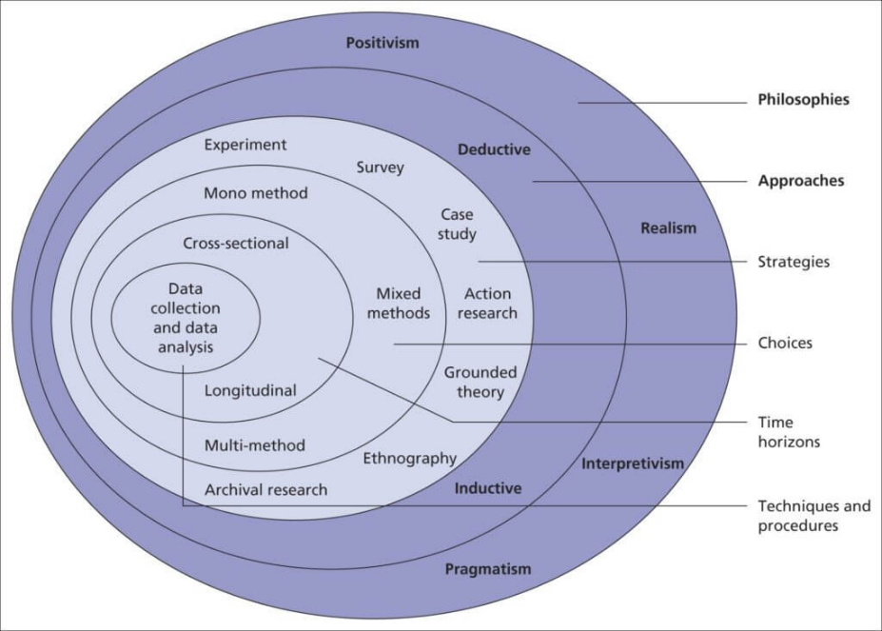
Figure 3.1: Research onion ring model (Saunders et al., 2019)

3.3 Research Approach
The case study method is associated with several advantages. It also enables the study to be thoroughly focused on a single organisation, which in this case is Ashford International Hotel and Spa, and enables the researcher to make inferences which are specific to the UK hospitality environment. According to Stake (1995), the combination of theoretical and practical ideas in case studies allows seeing a comprehensive picture of the subject. In this study, the case approach will help to discuss how one of the mid-scale British hotels manages to maintain a unique brand identity using marketing strategies. However, there are certain limitations associated with the use of the case study method. The outcome of a single case cannot be applied to all the hotels in the hospitality industry (Bryman, 2016).

3.4 Data Collection Method
The research is entirely based on the secondary data collection; in other words, it is not a case of face-to-face interaction with the subjects via interview, survey, or observation. Instead, the research will be founded on the research articles available, industry reports, marketing research, and official data concerning the hotels. According to Johnston (2017), secondary research is inexpensive, as it is easy to access quality and tested data, and the research process is reduced with minimum ethical and logistical challenges (Cottrell, 2011). The data sources will include peer-reviewed journals, books in hospitality management, governmental tourism statistics, and reports of such organisations as VisitBritain, Deloitte, and Mintel (Saunders, Lewis and Thornhill, 2012).

3.5 Data Analysis Technique
The secondary data collected are analysed using the assistance of the thematic analysis, which is a qualitative technique of establishing widespread themes and connexions in written data. According to Braun and Clarke (2019), thematic analysis will help the researcher systematise the information that is coded and achieve meanings that will be relevant to the research goals. Some of the themes that will be identified in the process of this study include themes on digital marketing, brand differentiation, customer experience and development of loyalty developed on the basis of literature and case-specific resources (Collis and Hussey, 2014).

3.6 Ethical Considerations
The paper is based on the UWTSD Research Ethics and Integrity Policy, and it is not a violation of academic and ethical aspects. The research will not pose a threat to human subjects because all the information will be on secondary data and will not involve any personal or sensitive data collection (Veal, 2006). The material that is used is highly discussed and recognised according to the system of Harvard referencing. The records are stored securely whereby the university-approved systems are used as required by the UWTSD Research Data Management Policy.

3.7 Summary
In conclusion, the paper is a qualitative case study that is supported by the analysis of secondary data. This approach allows the deep exploration of marketing and brand positioning strategies of Ashford International Hotel and Spa in terms of ethical and methodological rigour. Although it is too narrow in that it is grounded on secondary data, the design provides a valid framework of the role of marketing strategies on brand identity and competitiveness in the UK hospitality industry.

Chapter 4: Findings and Discussion

4.1 Introduction
The study presented in the chapter provides the research findings and their explanation in terms of the secondary academic and industry sources of the marketing strategy and brand positioning within the UK hospitality industry. It uses the case of Ashford International Hotel and Spa to explain the key themes such as the digital transformation, customer experience, sustainability, and regional branding. The subsequent sections critically analyse these results because they relate to the research questions that are prescribed to the study, and the available literature is utilised to arrive at coherent insights.

4.2 Findings
Findings for this research are presented on the following:

Theme | Codes | Key Findings (with citations)
1. Marketing Strategies and Brand Orientation | Data-driven marketing  Brand orientation  Customer focus | Analytics-based, data-driven marketing is becoming more popular among UK hotels in need of better campaign management and customer segmentation (Agag, 2025).  Good brand-driven culture would increase internal orientation and customer confidence in the entire hospitality industry (Foroudi, Gupta, Sivarajah and Broderick, 2020).  Strategic marketing orientation has a direct impact on performance performance like ROI and occupancy rates (Lynn, 2025).
2. Brand Positioning and Identity | Brand storytelling  Differentiation  Service quality | Hotels use the concept of brand storytelling to develop emotional appeal among guests and genuineness (Chen, Lin and Zhang, 2025).  Competitive positioning in midscale UK hotels is supported by differentiation in service provision in terms of spa experiences and personalised care (Albayrak and Caber, 2024).  Local branding programmes strike a balance between national and regional identities and enhance the perceived authenticity (Lin, Zhang and Li, 2024).
3. Customer Experience and Loyalty | Engagement  Satisfaction  Emotional attachment | Favourable brand experiences have a direct positive effect on customer loyalty and mindfulness that results in repeat stays (Ben Haobin and Lu, 2021).  Individualised communications also increase perceived value and trigger brand recognition (Hong, Lee and Kim, 2023).  Loyalty programmes are also engagement-based strategies that substantially enhance customer emotional attachment with hotel brands (Sadighha and Ebrahimi, 2024).
4. Digital Transformation and Online Presence | Online reviews  Analytics  Social media  AR tools | Marketing analytics increases digital targeting and personalisation (Agag, 2025).  It is possible to control online reviews and apply sentiment analysis tools to enhance brand reputation (Wu, Li and Xu, 2024).  AR marketing campaigns increase the level of experience, especially in younger travellers (tom Dieck, Jung and Moorhouse, 2024).
5. Sustainability and CSR in Branding | CSR communication  Green branding  Ethics | CSR activities play an important role in enhancing customer confidence and brand image within the hospitality sector (Isaac, Hallak and Brown, 2024).  Green branding and sustainability messages appeal to environmentally conscious travellers and improve brand image (Topcuoglu, Yoon and Kabadayi, 2022).  There is greater competitive advantage in the long run in the case of hotels that are environmentally responsible (Quintás, Martínez-Senra and García-Pintos, 2023).
6. Post-Pandemic Marketing and Innovation | Service adaptation  Resilience  Health branding | The COVID-19 crisis enhanced marketing innovativeness and agility in service delivery (Giousmpasoglou, Marinakou, Zopiatis and Sergaki, 2021).  To restore consumer confidence, hotels valued health, safety, and no-contact services (Waller, Okumus, and Wang, 2022).  The digital tools and enhanced human capital enhanced resilience in hospitality marketing after the pandemic (Elsharnouby and Elbanna, 2021).
7. Regional Branding and Destination Synergy | Local partnerships  Tourism integration  Regional identity | The branding of the regions benefits the competitiveness of the destinations by identifying the hotel identity with the tourism locally (Visit Kent, 2024).  Ashford International Hotel and Spa use their location and spa positioning to appeal to domestic tourists (Ashford Borough Council, 2024).  The partnership of hotels with local councils enhances recovery and brand alignment after COVID-19 (VisitBritain and DCMS, 2021).
8. Customer Co-Creation and Experience Design | Participation  Engagement  Co-production | Co-creation of services with customers increased brand authenticity and satisfaction (Feng, Wang and Li, 2024).  Intelligent hotel experiences improve well-being and interaction by using technology to interact (Sthapit, Bjork and Coudounaris, 2024).  The perceived responsiveness and brand equity are enhanced by stimulating feedback loops via the use of digital mediums (Nosrati, 2024).

Table 4.1: Key findings (Source: Author)

4.3 Thematic analysis of findings

4.3.1. Marketing Strategies and Brand Orientation
The findings reveal that data-driven marketing has become an important component of the strategic planning of the hospitality industry in the UK. Hotels now use customer analytics to tailor their promotions, predict trends and anticipate personal experiences of the guests (Agag, 2025). Brand orientation can be employed in Ashford International Hotel and Spa to be consistent in touchpoints that will create a trust and loyalty relationship. It is stated that the high brand orientation contributes to internal consistency and logical identity (Foroudi, Gupta, Sivarajah and Broderick, 2020). Moreover, a particular marketing orientation is demonstrated to boost ROI and occupancy rates (Lynn, 2025), which means that the tools of data analytics and brand values can be used to streamline effectiveness and reputation maximisation.
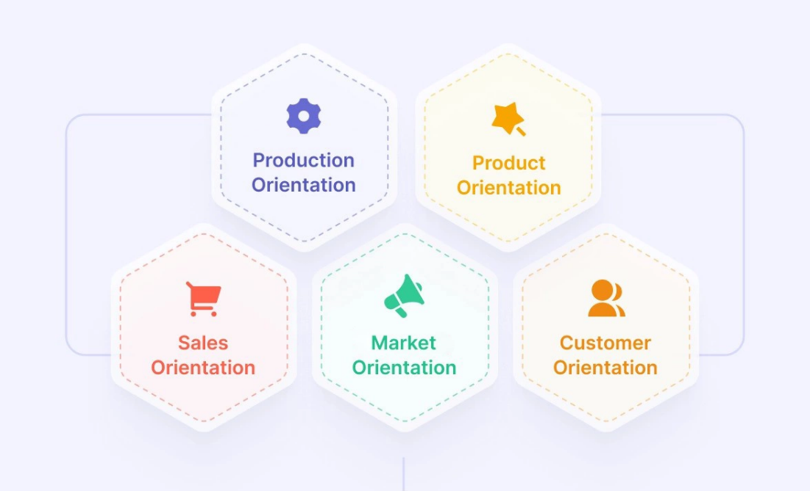
Figure 4.1: Marketing Strategies and Brand Orientation (Lynn, 2025)

4.3.2. Brand Positioning and Identity
According to the study, hotels are increasingly becoming reliant on emotional narration and differentiation in order to create unique brand recognitions (Chen, Lin and Zhang, 2025). In the example of the Ashford International Hotel and Spa, the luxury spa services and locality of the hotel will be integrated to allow it to be separated in the QHotels Collection. The quality of the services is the most significant of them, especially in the framework of mid-scale hotels, where value and experience become the determining elements of the competition (Albayrak and Caber, 2024). Beyond this, the authenticity perception is also improved with the national consistency and the localisation of the branding (Lin, Zhang and Li, 2024).
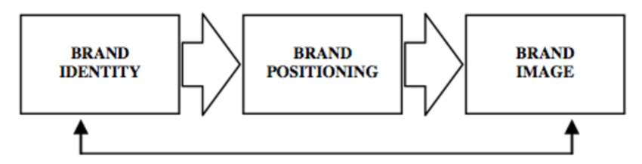
Figure 4.2: Brand Positioning and Identity (Lin, Zhang and Li, 2024)

4.3.3. Customer Experience and Loyalty
Customer experience has become a significant customer retention and long-term loyalty force. The positive conscious experience brings about revisitations and brand advocacies (Ben Haobin and Lu, 2021). It is also possible to help with brand recognition by customising strategies of Ashford International Hotel and Spa in a situation involving individual spa packages, as well as personalised communication (Hong, Lee and Kim, 2023). Engagement-based programmes like reward systems and loyalty programmes reinforce emotional connections and make customers remain loyal (Sadighha and Ebrahimi, 2024).
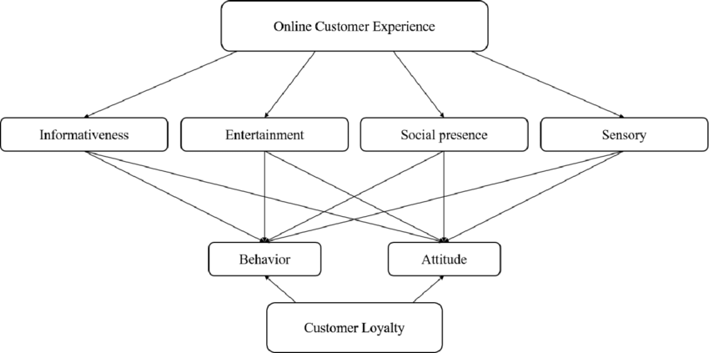
Figure 4.3: Customer Experience and Loyalty (Sadighha and Ebrahimi, 2024).

4.3.4. Digital Transformation and Online Presence
Digital transformation is continuing to change hospitality marketing. Incorporating analytics will be able to enable even more personalisation of messages and proper targeting (Agag, 2025). Regarding the Ashford International Hotel and Spa, the Internet reputation and visibility can be developed by using such online sources as TripAdvisor, Instagram, and Google Reviews. Review sentiment analysis allows the management to respond positively to a guest-made review (Wu, Li and Xu, 2024). Secondly, AR promotional tools enhance the sense of immersion and interaction (tom Dieck, Jung and Moorhouse, 2024).
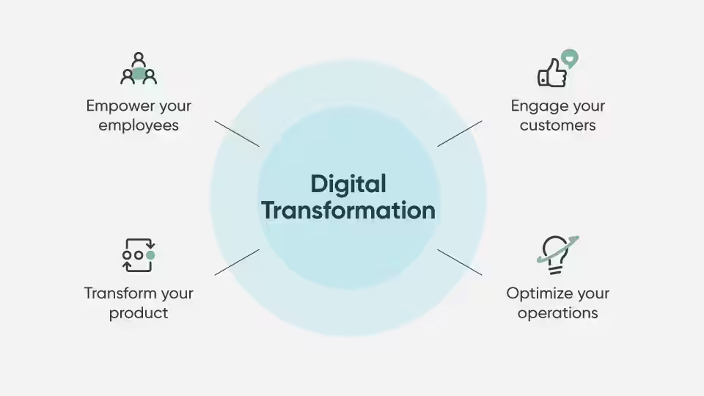
Figure 4.4: Digital Transformation and Online Presence (Agag, 2025)

4.3.5. Sustainability and CSR in Branding
Sustainability is no longer on the fringes; it constitutes a component of brand value. Having more customers believing in the hotel and enjoying the improved image, hotels that clearly communicate their CSR promises will have more customers (Isaac, Hallak and Brown, 2024). The green activities of Ashford International Hotel and Spa can be enhanced by the visible green activities, such as consuming less energy or sourcing locally, which are also evident in the case of Ashford International Hotel and Spa. Green branding can significantly influence the decision of the traveller, mostly of youthful age brackets (Topcuoglu, Yoon and Kabadayi, 2022). The long-term environmental plans also assist in enhancing competitive advantage as well, since they also aid in positive brand differentiation in an oversaturated market (Quintás, Martinez-Senra and Garcia-Picantos, 2023).
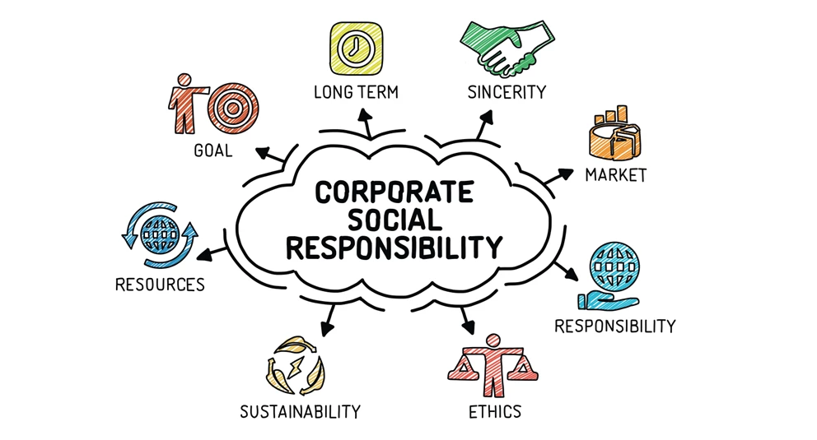
Figure 4.5: CSR in Branding (Topcuoglu, Yoon and Kabadayi, 2022)

4.3.6. Post-Pandemic Marketing and Innovation
The pandemic transformed the manner in which hotels convey their safety, flexibility and value. The findings show that the crisis accelerated the rate of both innovation and service delivery of the marketing aspect (Giousmpasoglou, Marinakou, Zopiatis and Sergaki, 2021). Contactless check-in, cancellations, and well-being-orientated messages would be sufficient to replenish consumer confidence in the case of Ashford International Hotel & Spa. Post-pandemic travellers are a very interested cohort in the safety brand with a focus on hygiene and wellness (Waller, Okumus and Wang, 2022). Digital tools and increased staff training have been used to achieve greater resiliency and responsiveness (Elsharnouby and Elbanna, 2021).

4.3.7. Regional Branding and Destination Synergy
The recovery of the local tourism has also put local branding as a critical competition instrument. The fact that Ashford International Hotel and Spa are located in the vicinity of the main transport centres and the wellness orientation allows the centre to be highly consistent with the Ashford tourism strategy (Visit Kent, 2024). Physical cooperation with the partners and event hosting promotes the communities' presence and domestic travelling (Ashford Borough Council, 2024). National programmes such as the Tourism Recovery Plan (VisitBritain and DCMS, 2021) also contribute to the development of such kinds of regional synergies.

4.3.8. Customer Co-Creation and Experience Design
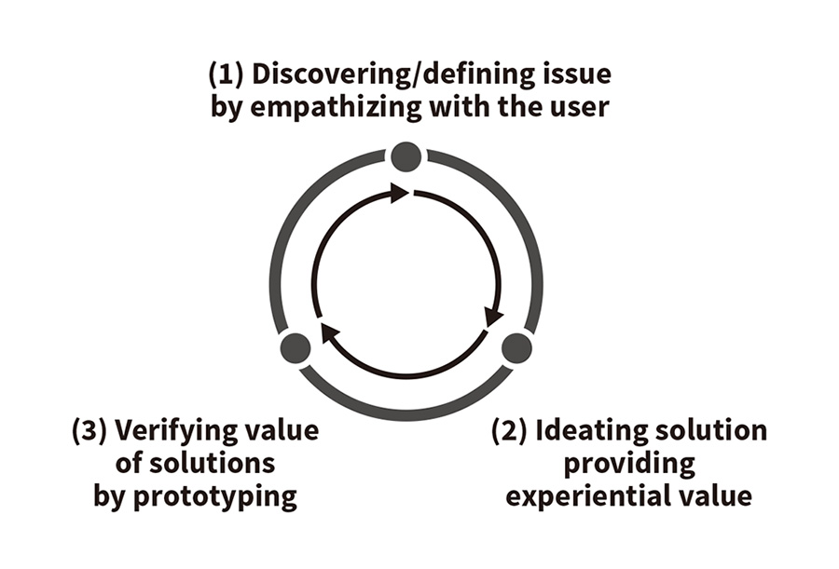
Figure 4.6: Customer Co-Creation and Experience Design (Feng, Wang and Li, 2024)
Engagement of customers is turning out to be very important in brand reality and creativity. The more the guests are actively engaged in the designing process or feedback, the higher are their satisfaction and emotional attachment (Feng, Wang and Li, 2024). This can include customised spa planning or wellness workshops in the case of Ashford International Hotel and Spa. Smart technologies enhance interaction and contribute to well-being (Sthapit, Bjork and Coudounaris, 2024). The concept of digital feedback loops should be encouraged to ensure that feedback on the brand is continually delivered to the brand (Nosrati, 2024).

4.4 Discussion

4.4.1 How do marketing strategies influence brand positioning in the UK hospitality industry?
These findings indicate that there is a high interdependency between the marketing policies and branding positioning within the UK hospitality industry. As Agag (2025) demonstrates, the use of analytics in marketing is more effective in market segmentation and accuracy of the campaign, as compared to Foroudi, Gupta, Sivarararajah and Broderick (2020), which shows that the culture of a brand fosters internal alignment and credibility. In Ashford International Hotel and Spa, the introduction of the value of data into the marketing of the company can serve to strengthen its presence in the crowded mid-range hotel and spa markets.
What is more, the fact that storytelling as a branding tool can improve emotional chords, as announced by Chen, Lin and Zhang (2025), is useful to Ashford since it may apply the method of underlining its history, spa comfort, and personal care. A combination of service quality and marketing coherence also leads to the development of long-term brand trust (Albayrak and Caber, 2024). However, things will go awry when the marketing processes become overly digital, as hospitality is all about human concern and sincerity. Thus, the secret of the success of the positioning of Ashford is the possibility to combine accuracy of the analysis with human-related narration, which shows its brand promise of wellness, comfort and hospitality excellence.
The findings justify how marketing and branding are dependent on each other. A good brand sells well, and marketing innovativeness enhances the visibility of a brand. In Ashford International Hotel and Spa, synergy is a more ideal counterpart of marketing analytics (Agag, 2025) than brand storytelling (Chen, Lin and Zhang, 2025). One of the ways Ashford can win leisure and corporate markets is by positioning itself as a wellness destination as part of the tourism ecosystem in Kent. However, VisitBritain and DCMS (2021) state that hotels are to strike the necessary balance between corporate and regional tourism narratives. Online, experiential and partnership-based channels will be provided with proper coordination such that the brand and operational stability will be maintained.

4.4.2 What marketing approaches are currently employed by Ashford International Hotel & Spa?
Ashford's marketing strategy is related to the combination of the digital transformation, collaboration with the region, and brand differentiation. As stated by the official website of the hotel (2025) and the Ashford Borough Council (2024), the sphere of local tourism integration and the sphere of wellness experience get an important priority. This compares to trends reported by PwC (2024) and Savills (2025) reports, which note that multichannel marketing has been embraced more by UK hotels over the years, with a focus on experience-orientated campaigns and not strictly promotional content.
The hotel also finds the principles of online reputation management to be acceptable, given the findings of Wu, Li and Xu (2024), who assert that sentiment analysis as the online reputation management system is vital to facilitate credibility in the brands. In addition, new technologies to display the spa and leisure areas in a hotel can be in the form of augmented-reality campaigns, which tom Dieck, Jung and Moorhouse (2024) describe as the possibility of hotels like Ashford showcasing the areas in question in 3D. However, the creativity of the marketing of Ashford can be restricted by the application of the corporate templates in the QHotels Collection.
In order to enhance the brand independence, the hotel must localise its message and focus on the cultural proximity between Kent, ease of access and the exclusivity of the hotel to Kent to reach a higher consumer affinity. Digital transformation is redefining the concept of the hospitality brand's connection with people. Wu, Li and Xu (2024) underline that the representation analytics can be helpful in the forecast of the behavioural patterns and that the proactive marketing changes can be implemented. According to Tom Dieck, Jung and Moorhouse (2024), it is possible to use immersive AR marketing to enhance purchase intention, which means that it can be applied in the case of Ashford and its virtual tours of the spa. Moreover, Liu, Qin and Zhao (2022) assume that self-service and mobile technology are more efficient and create the risk of depersonalisation.

4.4.3 How do these strategies affect customer perception and brand image?
The significant factors of the customer perception are the quality of the experience, the engagement of emotions, and the clarity of ethics. The results show that positive experiences of the brand lead to repeat business and referral (Ben Haobin and Lu, 2021). It is also shown by Hong, Lee and Kim (2023) that personalisation generates brand recognition; thus, as a guest, one can get a personalised experience, such as a spa programme or an email with aftercare information, to enhance the reputation of Ashford. Regarding ethics, Isaac, Hallak and Brown (2024) mention that the observable CSR activities create greater trust among people.
Similarly, according to Topcuoglu, Yoon and Kabadayi (2022), the concept of green branding significantly contributes to the views of customers in terms of authenticity and responsibility. Ashford would then get in a position of marketing the green programmes, such as waste-saving programmes or environment-friendly facilities, to the environmentally aware customers. However, it has one vulnerability that is brand image: absence of consistency in service delivery or communication via the internet may damage the credibility. To that extent, being reliably repetitive in marketing promises, service delivery, and management of guest feedback would be significant in the maintenance of a good and trusting brand image.
The concept of sustainability has existed in the post-pandemic tourism consumer decision-making. Isaac, Hallak and Brown (2024) prove that ethical hotel branding positively affects consumer trust, but Visit Kent (2024) and Ashford Borough Council (2024) prove that local associations augment the value of a destination. In the situational case of Ashford, integrating its sustainability message and the regional tourism identity of Kent, which is wellness, nature, and local culture, will assist the company to boost its brand equity. However, one must not be deceptive; buyers can easily detect the pretended CSR announcement.

4.4.4 What improvements can be recommended to enhance Ashford International’s marketing and brand positioning?
There are various aspects in which the findings can be improved. Firstly, it is possible to enhance targeting accuracy through the implementation of data analytics strategic integration. Agag (2025) cites that a hotel implementing predictive analytics has greater ROI, and Lynn (2025) states that data-driven marketing is directly proportional to brand performance. Through AI segmentation and dashboard reporting, Ashford will be able to know more about customer trends. It should be positioned as a brand where the sustainability stories are true. As Quintanas, Martinez-Senra and Garcia-Picantos (2023) disclose, eco-driving business models improve competitiveness over the long term.
By illustrating the local sourcing, the reduction of the plastic quantity, and the sustainability of the spa, Ashford can make ethical distinctions. Third, the change of health-safety message to experiential marketing should also be the foundation on which the brand will be recovered after the pandemic. According to Giosmpasoglou, Marinakou, Zopiatis and Sergaki (2021), adaptability will help a person recover, but Waller, Okumus and Wang (2022) confirm that a contactless innovation will result in more confidence. In this thing, Ashford can rebrand towards the themes of relaxation and rejuvenation. Finally, the responsive, dynamic, and future-proof brand will be ensured through encouraging customers to co-create a brand through feedback and interaction programmes (Feng, Wang and Li, 2024).
Feng, Wang and Li (2024) note that participative service design is empowering of satisfaction and emotional bonding. Sthapit, Bjork, and Coudounaris (2024) find that smart-hotel technologies have the potential to enhance well-being through the co-designed experiences. The digital feedback loops, customer panels, or social media campaigns whereby guests are requested to design spa experiences are some of the co-creation strategies that Ashford International Hotel and Spa might adopt. The other point that Nosrati (2024) highlights is that brand reputation and responsive engagement increase the agility of operations and activities.

4.5 Implications for Ashford International Hotel & Spa
The general results give practical details about the marketing operations of Ashford International Hotel and Spa. First, the training of the staff ought to be associated with the data-driven marketing to ensure that the analytics tools are utilised effectively. Second, brand storytelling can be enhanced to support differentiation, and it relies on wellness and regional identity. Third, it is possible to enhance a stronger digital presence through regular social media interaction and reviews that will grow the audience and target younger audiences. The sustainability activities would raise brand equity when they are well revealed and align with the rising trend of ecotourism. In addition, loyalty and innovation will be created by co-creation, which can be attained with the assistance of digital interaction.

4.6 Limitations
Despite the high quality of the themes in the research, it has certain weaknesses that are to be considered. Primary data analysis was primarily done using the peer-reviewed literature and industry reports, which may not have been appropriate in capturing the dynamic nature of operations of Ashford International Hotel and Spa. The fact that it was impossible to test the knowledge of the theory in practice is confined by the availability of primary organisational data. Further, the majority of the analysed studies are associated with international or national contexts and not in the localised context, which is the location of Kent. By doing so, contextualisation of findings ought to be done.

4.7 Future Research Directions
On the basis of these findings, the future generation of research needs to examine the effects of the digital transformation and CSR on customer loyalty in the local hotels in the long run. The comparative analysis of two properties under QHotels would give the insight into the best practices of the homogenous brand management. Moreover, the additional research on the role of AI in personalised hospitality marketing can offer new templates of communicating with the guests. The implications for the resilience planning would also be good for exploring the trends in the UK hospitality market in the post-pandemic consumer behaviour. These spheres are capable of contributing to scholarly discourse and operational perfection in the hospitality sector.

4.10 Conclusion
In a nutshell, the discussion has unveiled that strategic integration of technology, authenticity, sustainability and regional synergy is what marketing success in the hospitality industry banks on at present. The findings of the case overview of Ashford International Hotel & Spa are that adaptive brand positioning relying on emotional tale telling, online communications and moral responsibility matter. It will enable the hotel to reaffirm its brand equity by weighting its marketing strategies between international trends and the local identity and be capable of surviving an even more competitive market environment after the pandemic.

Chapter 5: Conclusion and Recommendations

5.1 Conclusion
This study was interested in determining how marketing strategies influence brand positioning in the UK hospitality industry, and in this case, the focus of study is Ashford International Hotel and Spa in the UK. The paper was able to identify a high degree of interdependence between the domain of marketing innovation, customer experience, digital transformation, sustainability, and regional collaboration with the help of a systematic review of academic and industry sources. All these dimensions are imperative in the establishment of competitive advantage in a very dynamic and experience-orientated marketplace.
The first valuable lesson is that the strategic foundation of contemporary hospitality promotion is grounded in the data-driven marketing. Agag (2025) and Lynn (2025) confirm that data analytics can enhance segmentation and also evidence-based decision-making to ensure that marketing investment has measurable pay-offs. In the Ashford International Hotel and Spa case, the result would be that the predictive analytics and digital tracking application will improve the precision of marketing and generate the agility of responding to the growing consumer dynamics. However, Foroudi, Gupta, Sivarajah and Broderick (2020) state that, in order to maintain authenticity and trust, technology should be added to the firm's solid brand-orientated culture.
The study also brings out the transformative power of brand storytelling and differentiation in the generation of emotive resonance. Storytelling, as demonstrated by Chen, Lin and Zhang (2025), increases emotional engagement and recognition of the brand, yet Albayrak and Caber (2024) argue that the uniqueness in terms of delivering quality services and personalising them is the key factor to brand strength in the long-term perspective. In the Ashford case, that will involve developing a brand story anchored on its spa tradition, wellness ethos and local authenticity, which will enable it to be unique in the leisure and corporate hospitality business.
Customer experience and customer loyalty continue to spearhead brand equity in the hospitality industry. The article by Ben Haobin and Lu (2021) and Hong, Lee and Kim (2023) confirms that personalisation and emotional connection are the key aspects of customer retention. In the example of Ashford, the satisfaction may be converted into advocacy with a view of realising uniformity of the quality of all the touchpoints, including booking and check-outs. It should maintain the loyalty by making it emotional, and this can be enabled through the operations of a loyalty scheme founded on experience (Sadighha and Ebrahimi, 2024), because the price competition cannot sustain the relationships with customers any longer.
The digital revolution has changed the strategies of engagement in hospitality. Wu, Li and Xu (2024) explain that the brand management may be conducted proactively using the reputation analytics and digital review management, but Tom Dieck, Jung and Moorhouse (2024) prove that the online interactions and willingness to visit could be enhanced with the help of augmented reality marketing. The adoption of immersive technologies and the presence in the social media environment that is both proactive and reactive, as seen in the case of Ashford, could potentially be a key factor towards enhancing the online brand image. But in the environment of increasing computerisation, the human touch of hospitality is hard to keep.
The findings also indicate that sustainability and CSR practice have turned out to be one of the key elements of branding. As it is disclosed in the works of Isaac, Hallak and Brown (2024), there is a transparent CSR increment in trust, and in the article by Topcuoglu, Yoon and Kabadayi (2022), there is the ability to choose loyalty and purchases due to green branding. By communicating about the physical environmental initiatives, Ashford will be capable of positioning itself as an ethical and responsible brand, complying with the expectations of consumers and popular trends in hospitality across the globe (Quintas, Martínez-Senra and Garccia-Pinos, 2023).
The study also focuses on regional branding and synergy. Visit Kent (2024) and Ashford Borough Council (2024) posit that partnerships in the working tourism can promote the destination and hotel visitation. Regarding Ashford, the partnership with the local tourism agencies will assist the hotel in becoming more visible and credible because the hotel will have the opportunity to be part of the wider hospitality story of Kent.
Finally, the use of customer co-creation and participatory involvement (Feng, Wang and Li, 2024; Nosrati, 2024) is one of the new innovative opportunities. Encouraging the visitors to design the service and brand communications implies that the level of authenticity and long-term satisfaction will increase. It will be essential to use technology-enhanced feedback channels that will enable the introduction of the customer feedback to ensure that the brand is transformed dynamically based on the market expectations (Sthapit, Bjork and Coudounarsi, 2024).
The research suggests that good answers in marketing are significant in the brand positioning of the hospitality industry in the UK. The use of data-based insights, real-life stories, and customer loyalty has demonstrated how Ashford International Hotel and Spa has been able to create sustainable competitive advantages. This enhances brand trust and brand loyalty in the long run by integrating digital transformation, emotional appeal and sustainability communication into the brand. Regional partnerships and co-creation are used to further increase destination identity and service differentiation.

5.2 Recommendations
Implement a Comprehensive Data-Driven Marketing Framework
Ashford will have to invest in analytics systems capable of capturing, processing and interpolating customer data to make evidence-based marketing decisions (Agag, 2025). The predictive analytics will have the ability to enhance the campaign targeting, and the dashboard systems will have the ability to visualise the level of customer segmentation, level of customer satisfaction and demand seasonal trend. This information, when incorporated in the marketing planning, will allow Ashford to spend budgets more effectively and individualise the offers more effectively. As a strategy of positioning itself as different within the portfolio of QHotels, Ashford should establish a unique brand story with the focal point being relaxation, rejuvenation and connection with community (Chen, Lin and Zhang, 2025). The brand can be more human and appealing to emotions with the help of digital media, testimonials and local images. Video storytelling of the experiences of guests or communication among staff members could help to improve authenticity and credibility.
Enhance Loyalty through Personalisation
The customer loyalty programmes should not be grounded on the points basis systems but rather on experience. Hong, Lee and Kim (2023) claim that perceived value is enhanced in the presence of personalised service. Ashford may implement the use of personalised digital thank-you messages, wellness incentives or personalised digital memberships in spas. Customer history can be integrated into the CRM systems and facilitate meaningful and heart-warming interaction. The augmented reality will assist in improving the virtual tours (spa) and room preview (Tom Dieck, Jung and Moorhouse, 2024) and will intensify online activity. The other strategy that Ashford can use to enhance the interactivity of social media is to enhance user-generated content and leverage partnerships with influencers.
Embed Authentic Sustainability in Brand Communication
According to the principles that were outlined by Isaac, Hallak and Brown (2024), Ashford ought to share measurable sustainability goals such as reduced energy consumption or associative suppliers. The effectiveness of the transparency will be enhanced by informing about the achievements via the social media and the in-room materials. Also, eco-friendly branding is possible to be supported by the need to coincide CSR activities with the presence of guests (e.g., guests can attend the so-called Green Stay programmes). It needs to also work regionally with Visit Kent and Ashford Borough Council, but with the greater focus being on dual-market positioning, i.e., keeping the significance of leisure tourism and business travel in the same balance. The market segments can be attracted to the campaigns which promote Wellness in Kent or Business and Balance in Ashford. Meanwhile, Ashford needs to maintain the brand autonomy through proprietary campaigns that focus on its spa brands.
Foster Co-Creation and Continuous Feedback Mechanisms
Inviting guests to the service can also be used to encourage guest responses so as to achieve ownership and authenticity (Feng, Wang and Li, 2024). The emerging problems will be identified in time, with the help of the real-time sentiment tracking tools (Wu, Li and Xu, 2024). This type of participatory model will help Ashford to be responsive and innovative. Ashford has yet to realise the health-conscious branding and gradually transition to wellness and rejuvenation. The malleability of online and face-to-face service spaces will be availed once the employees are trained on the hybrid digital-physical interaction (Waller, Okumus and Wang, 2022). This has been ensured by the fact that even in the future, the resilience will be low because of the ongoing innovation, such as contactless technology, AI chat support, and flexible booking. The increased collaboration with Visit Kent and other local partners will increase the regional branding. Finally, using co-creation through seeking feedback from guests and investing in staff alignment of the brand will ensure true service delivery and stability that will promote endless success and brand stability.
Invest in Employee Brand Alignment and Training
The internal alignment is also a significant attribute that should be important because, as Foroudi, Gupta, Sivarajah and Broderick (2020) observe, employees are expected to bear the promise of the brand. Brand-awareness training and incentive programmes can be achieved on a regular basis, and they help in having service delivery reflect the marketing identity of Ashford. Motivated employees will enhance the satisfaction levels of the guests and create a good brand image. To calculate the efficiency of campaigns in respect of the performance measures, Ashford should develop an internal review system that compares the changes in the performance with the booking conversion, review scores and the engagement rates. To maintain the marketing objectives and business performance in line, frequent analysis and interdepartmental meetings can come in handy.

References
Agag, G. (2025). How and when do marketing analytics pay off in the travel and hospitality industry? Evidence from the UK. International Journal of Hospitality Management, 126, 1033724.
Albayrak, T. and Caber, M. (2024). An investigation of asymmetric relationships between hotel service attributes and brand evaluations. Journal of Hospitality Marketing & Management, 33(7), pp. 901–922.
António, N., Almeida, A. and Nunes, L. (2023). Twenty-two years of International Journal of Hospitality Management: a bibliometric review. International Journal of Hospitality Management, 112, 103420.
Ashford Borough Council (2024). Ashford sees tourism visitor numbers and economic impact bounce back. News release, 16 December. Available at: https://www.ashford.gov.uk/news/latest-news/ashford-sees-tourism-visitor-numbers-and-economic-impact-bounce-back/ (Accessed: 3 November 2025).
Ashford International Hotel & Spa (2025) Official website. Ashford: The QHotels Collection. Available at: https://www.ashfordhotel.co.uk/ (Accessed: 3 November 2025).
Banerjee, S. (2025). Booking hotels online: Can scarcity messages mitigate the negative effects of low ratings?. International Journal of Contemporary Hospitality Management, 37(3), pp. 1–22.
Baykal, M. and Koc, E. (2024). The influence of consumer confusion on the repurchase intention of hotel customers. International Journal of Contemporary Hospitality Management, 36(12), pp. 4278–4299.
Belhaj, M. and Lehman, K. (2024) ‘Conceptualising experiential marketing strategies in tourism and hospitality’, Tourism and Hospitality Research, 24(1), pp. 1–20.
Ben Haobin, Y. and Lu, W. (2021). The impact of hotel servicescape on customer mindfulness, brand experience and engagement. Journal of Hospitality Marketing & Management, 30(5), pp. 593–613.
Bianco, S. (2023). Dual-branded hotels: Resource-based entry strategies in hospitality. Tourism Management.
Bryman A. (2008), Social Research Methods, 2nd Ed, Oxford University Press
Chen, F., Lin, X. and Zhang, L. (2025). The effect of typicality in luxury hotel brand storytelling on brand attitudes and intentions. International Journal of Hospitality Management, 131, 103734.
Chen, X., Xiang, B. and Bilgihan, A. (2024). Metaphorical effects of advertising in different types of hotels: evidence from eye-tracking. International Journal of Contemporary Hospitality Management, 36(12), pp. 4192–4214.
Cheng, B., Zhou, Y. and Huang, M. (2023). When and how does leader humour promote customer citizenship and brand outcomes in hotels?. International Journal of Hospitality Management, 109, 103516.
Cheung, M.-L., Tan, C.-S. and Sou, K. (2023). Driving destination brand engagement: the role of traveler brand identification. International Journal of Tourism Research, 25(6), pp. 565–580.
Chu, W. S. K. (2025). Visual eWOM and brand factors in shaping hotel booking decisions: evidence from the British hospitality market. International Journal of Tourism & Hospitality, 6(4), pp. 171–190.
Collis, J and Hussey, R (2014), Business Research, A Practical Guide for Undergraduate and Post Graduate Students, Palgrave, London.
Cottrel, S. (2011) Critical Thinking Skills: Developing Effective Analysis and Argument, Palgrave Study Guides, Palgrave Macmillan: Basingstoke.
Cottrell, S. (2014) Dissertations and project reports : a step by step guide. New York: Palgrave.
Dewnarain, S. and Ramkissoon, H. (2023). A profile-deviation approach to enhancing relationship quality in hotels: the role of digital engagement. Journal of Hospitality Marketing & Management, 32(10), pp. 1179–1201.
Dewnarain, S., Ramkissoon, H. and Mavondo, F. (2021). Social customer relationship management in hospitality: drivers and outcomes. Journal of Hospitality Marketing & Management, 30(6), pp. 655–676.
Elsharnouby, T.H. and Elbanna, S. (2021). Change or perish: examining the role of human capital and dynamic capabilities in hotel performance. Tourism Management, 83, 104252.
Feng, L., Wang, X. and Li, H. (2024). The effect of customer participation on brand preference in hotels. Journal of Hospitality and Tourism Management, 60, pp. 189–198.
Foroudi, P., Gupta, S., Sivarajah, U. and Broderick, A. (2020). Drivers and outcomes of hotel industry’s brand orientation. International Journal of Hospitality Management, 89, 102558.
Giousmpasoglou, C., Marinakou, E., Zopiatis, A. and Sergaki, P. (2021). Hospitality managers in turbulent times: the COVID-19 crisis. International Journal of Contemporary Hospitality Management, 33(4), pp. 1297–1318.
Hong, E.-P., Lee, J. and Kim, S. (2023). Influence of customer personality on perceived value, brand identification and loyalty in hotels. Journal of Hospitality Marketing & Management, 32(6), pp. 654–675.
Huang, G.-Q., Lin, C. and Liu, Y. (2022). Hotel brand equity and online reviews on social commerce intention: a cross-level identification process. International Journal of Hospitality Management, 107, 103331.
Isaac, R.-K., Hallak, R. and Brown, G. (2024). Customers’ perceptions and responses to hotels’ corporate social responsibility. Current Issues in Tourism, 27(15), pp. 2491–2512.
Jain, V. (2023). Luxury hospitality: A systematic literature review and future research agenda. International Journal of Hospitality Management, 115, 103597.
Japutra, A., Loureiro, S.M.C., Molinillo, S. and Primanti, H. (2025). Influence of individual and social values on customer engagement in luxury thermal spa hotels: The mediating roles of perceived justice and brand experience. Tourism and Hospitality Research, 25(1), pp. 90–103.
Kamyabi, M., Özgit, H. and Ahmed, J. N. (2025). Sustaining digital marketing strategies to enhance customer engagement and brand promotion: position as a moderator. Sustainability, 17(7), 3270.
Khan, I.M., Rahman, Z. and Fatma, M. (2022). Social media and empowerment in hospitality and tourism. International Journal of Hospitality Management, 102, 103121.
Kim, E.J. and Kim, J. (2021). Signaling effects of branded amenities on customer-based brand equity: the mediating role of perceived quality and trust. Journal of Hospitality Marketing & Management, 30(4), pp. 475–497.
Kim, J.J., Lee, J. and Han, H. (2023). Brand personality of global chain hotels, self-congruity and loyalty: the dynamics of perceived value and self-congruence. International Journal of Hospitality Management, 108, 103376.
Ladeira, W.-J., Lim, W.-M. and Santini, F.-O. (2024). Fostering conative loyalty in tourism and hospitality loyalty programmes: fairness perceptions and visual attention. Tourism Recreation Research, 49(4), pp. 612–626.
Lin, M.-S., Zhang, M. and Li, X. (2024). Domestic midscale chain hotel brands’ effectiveness in brand extension. International Journal of Tourism Research, 26(1), e2633.
Liu, C., Qin, X. and Zhao, B. (2022). Improved or decreased? Customer experience with self-service technologies in hotels. Journal of Hospitality Marketing & Management, 31(6), pp. 678–700.
Liu, C.-H. and Mattila, A.S. (2022). The moderating roles of perceived interactivity in building hotel brand equity through digital engagement. Journal of Hospitality Marketing & Management, 31(7), pp. 745–766.
Liu, K-N. and Hu, C. (2022). Investigating the impacts of hotel brand experience on brand loyalty: The mediating role of brand positioning. International Journal of Hospitality & Tourism Administration, 23(4), pp. 889–916.
Lynn, M. (2025). Evidence from brand-level analyses of hotel brands. International Journal of Hospitality Management, 125, 104020.
Marandi, A., Rashidirad, M. and Madani, F. (2023). Customer revisit intention: insights from hotel online reviews using text mining (7Ps framework). International Journal of Contemporary Hospitality Management, 35(10), pp. 3439–3463.
Marques, S. and Li, X. (2024). Destination live-streaming sales channels: a strategic decision for tourism and hotel marketing. International Journal of Contemporary Hospitality Management, 37(8), pp. 2797–2821.
Nosrati, S. (2024). Multiple mediating effects in the association between brand experience and behavioral intentions in hotels. Journal of Hospitality Marketing & Management, 33(7), pp. 875–899.
O’Connor, P., Murphy, J. and Baines, P. (2022). Examining the antecedents and effects of hotel corporate reputation. Journal of Hospitality Marketing & Management, 31(6), pp. 733–757.
Olorunsola, V.O. (2024). Guest service experience in eco-centric hotels: a systematic review and future research agenda. International Hospitality Review, 38(1), pp. 81–104.
PwC (2023) UK Hotels Forecast 2023–2024. London: PricewaterhouseCoopers. Available at: https://www.pwc.co.uk/industries/hospitality-leisure/insights/uk-hotels-forecast-2023.html (Accessed: 3 November 2025).
PwC (2024) UK Hotels Forecast 2024–2025. London: PricewaterhouseCoopers. Available at: https://www.pwc.co.uk/industries/hospitality-leisure/insights/uk-hotels-forecast.html (Accessed: 3 November 2025).
Quintás, M.-A., Martínez-Senra, A.-I. and García-Pintos, A. (2023). Is the hotel industry really committed to the environment? A business-models assessment. Service Business, 17, pp. 395–428.
Rana, N.P., Luthra, S., Dwivedi, Y.K. and Kizgin, H. (2025). Customer experiences with service robots in hotels: A review and research agenda. Journal of Hospitality Marketing & Management, 34(1), pp. 1–24.
Rather, R.-A., Kassem, R. and Hollebeek, L.-D. (2024). Moderating investigation of brand reputation: impacts on hotel customer responses. International Journal of Hospitality Management, 116, 103630.
Sadighha, J. and Ebrahimi, P. (2024). Stimulating customer participation behaviour and boosting brand value in hotels. International Journal of Hospitality Management, 114, 1030458.
Sarkar, A. and Sreejesh, S. (2021). Managing customers’ undesirable responses towards service failure: an examination of brand retaliation in hotels. International Journal of Hospitality Management, 94, 102872.
Saunders, M., Lewis, P. and Thornhill, A. (2012) Research Methods for Business Students, FT/Prentice Hall: Harlow.
Saunders, M., Lewis, P. and Thornhill, A. (2019) Research Methods for Business Students. 8th edn. Harlow: Pearson Education Limited.
Savills (2025) Spotlight: UK Hotel Market 2025. London: Savills Research. Available at: https://pdf.euro.savills.co.uk/uk/spotlight-on/savills-uk-hotel-market---2025.pdf (Accessed: 3 November 2025).
Savills (2025). Spotlight: UK and European Hotels 2025’. London: Savills Research. Available at: https://www.savills.com/research_articles/255800/374667-0 (Accessed: 3 November 2025).
Seyfi, S., Hall, C.M. and Shabani, B. (2024). Hospitality in the age of Gen Z: a critical reflection on evolving expectations. International Journal of Contemporary Hospitality Management, 36(13), pp. 118–140.
Shin, H., Sharma, A., Nicolau, J. and Kang, J. (2022). Consumers’ experience with hospitality and tourism technologies: a conceptualization and scale development. International Journal of Hospitality Management, 102, 103121.
Shulga, L.V. and Busser, J. (2022). Relational energy and co-creation: Effects on hospitality guest loyalty and brand advocacy. Journal of Hospitality Marketing & Management, 31(8), pp. 875–897.
Song, H. (2023). A behavioural economics approach to hospitality and tourism marketing. International Journal of Contemporary Hospitality Management, 35(5), pp. 1844–1858.
Sthapit, E., Björk, P. and Coudounaris, D. (2024). Experience-driven well-being: The case of unmanned smart hotels. International Journal of Contemporary Hospitality Management, 36(13), pp. 1–18.
Sun, S., Li, J. and Chen, Y. (2024). Exploration of hotel reservation through mobile applications and booking intention. International Journal of Tourism Research, 26(3), e2734.
The QHotels Collection (2025) Corporate website. Leeds: QHotels. Available at: https://www.qhotels.co.uk/ (Accessed: 3 November 2025).
tom Dieck, M.C., Jung, T. and Moorhouse, N. (2024). Augmented reality marketing in hospitality and tourism. International Journal of Contemporary Hospitality Management, 36(13), pp. 97–118.
Topcuoglu, E., Yoon, H.J. and Kabadayi, S. (2022). Green message strategies and green brand image in a hotel context. Journal of Hospitality Marketing & Management, 31(7), pp. 771–794.
Touni, R., Kim, W. and Choi, H. (2022). Customer engagement with hotel brand social media pages and booking intention. International Journal of Hospitality Management, 102, 103173.
Tung, V.W.S. and Tse, S.W.T. (2023). A patterns perspective of customers’ brand experiences with robotics in hospitality. Journal of Travel & Tourism Marketing, 40(1), pp. 75–89.
UK Parliament, House of Commons Library (2025) Tourism: Statistics and Policy (Research Briefing SN06022). London: House of Commons. Available at: https://researchbriefings.files.parliament.uk/documents/SN06022/SN06022.pdf (Accessed: 3 November 2025).
Veal, A J (2006), Research Methods for Leisure and Tourism, 3rd Ed, Financial Times/ Prentice Hall.
Visit Kent (2024) Ashford – Economic Impact of Tourism 2023 (Results). Maidstone: Visit Kent. Available at: https://www.visitkentbusiness.co.uk/media/117890/economic-impact-of-tourism-ashford-2023.pdf (Accessed: 3 November 2025).
VisitBritain and DCMS (2021) Tourism Recovery Plan. London: Department for Digital, Culture, Media and Sport. Available at: https://www.visitbritain.org/introduction-tourism-britain/tourism-recovery-plan (Accessed: 3 November 2025).
Waller, G., Okumus, F. and Wang, Y. (2022). Crisis management techniques in four-star chain hotels in London and Stockholm. International Journal of Contemporary Hospitality Management, 34(7), pp. 2302–2324.
Wang, Y.-C. (2023). Hotel general managers’ brand love: A thematic analysis. Journal of Hospitality and Tourism Management, 56, pp. 96–105.
Wu, Y., Li, J. and Xu, H. (2024). Sensing hotel customers’ distribution and their sentiment in dynamic markets: A text-analytics approach. Journal of Hospitality Marketing & Management, 33(9), pp. 1291–1313.
Yu, W., Teng, C. and Chao, C. (2024). Green rewards versus non-green rewards? Impacts on hotel brand engagement and loyalty. Journal of Sustainable Tourism, 32(8), pp. 1601–1623.
Zhang, J. (2024). The effect of employee-based brand equity on customer outcomes in branded hotels. Journal of Brand Management, 31(2), pp. 145–162.

Appendix

Thematic analysis

Theme | Key Findings (objective, from data/literature) | Sources | Implications for Ashford International Hotel & Spa
1. Data-Driven Marketing and Brand Orientation | UK hotels are moving from generic promotion to analytics-led, customer-centric marketing. Data supports segmentation, campaign optimisation and ROI, while brand-oriented cultures make messages consistent and trustworthy. | Agag (2025); Foroudi, Gupta, Sivarajah and Broderick (2020); Lynn (2025); Saunders, Lewis and Thornhill (2019) | Ashford can also integrate predictive analytics dashboards to focus on leisure/MICE segments and the staff will be trained on how to keep the messages in the brand of QHotels the same.
2. Brand Positioning, Storytelling and Service Differentiation | Emotional storytelling, clear value propositions and high service quality are the main levers of hotel brand positioning, especially in mid-scale, regional markets. Localisation (place, culture, wellness) improves perceived authenticity. | Chen, Lin and Zhang (2025); Albayrak and Caber (2024); Lin, Zhang and Li (2024); Cheung, Tan and Sou (2023) | Ashford can sell a storey of a Kent wellness and connexion which it can afford via its spa and location near transport connexions and QHotels support.
3. Customer Experience, Personalisation and Loyalty | Positive servicescape, personalised interaction and engagement-based loyalty schemes turn satisfaction into repeat business and advocacy. Emotional attachment is stronger than points-only schemes. | Ben Haobin and Lu (2021); Hong, Lee and Kim (2023); Sadighha and Ebrahimi (2024); Marandi, Rashidirad and Madani (2023) | The loyalty redesigned must be experience-based (spa bundles, local experience, anniversary stays) and the CRM history must be customised to offer and follow-ups.
4. Digital Transformation, e-WOM and Immersive Promotion | Online review management, social media engagement and, increasingly, AR/virtual tours are now core to hotel marketing. Digital tools allow real-time reputation tracking and richer pre-arrival experiences. | Wu, Li and Xu (2024); tom Dieck, Jung and Moorhouse (2024); Chu (2025); Liu, Qin and Zhao (2022) | Ashford must respond to Tripadvisor/ Google reviews daily, add 360o /AR previews of rooms and spas, and engage in social campaigns, in which the user generated content is promoted.
5. Sustainability, CSR and Ethical Branding | Transparent CSR and green messaging increase trust, attract eco-conscious travellers and strengthen long-term brand equity. CSR must be real and measurable to avoid greenwashing. | Isaac, Hallak and Brown (2024); Topcuoglu, Yoon and Kabadayi (2022); Quintás, Martínez-Senra and García-Pintos (2023); Yu, Teng and Chao (2024) | Ashford may put simple, time-traceable targets (local sourcing, energy saving, plastic light spa) on their webpage and in their hotel rooms and associate them to the sustainability system of QHotels.
6. Post-Pandemic Marketing, Safety and Service Innovation | COVID-19 accelerated contactless, flexible and health-centred marketing. Hotels that signalled safety and adaptability recovered faster, then pivoted back to experience-led branding. | Giousmpasoglou, Marinakou, Zopiatis and Sergaki (2021); Waller, Okumus and Wang (2022); Elsharnouby and Elbanna (2021) | Ashford needs to maintain flexible and contactless booking, but now anticipate domestic leisure demand using ashed forward messages such as rest, spa, rejuvenate.
7. Regional Branding and Destination Synergy (Kent/Ashford) | Working with local tourism bodies increases visibility and competitiveness for regional hotels; destination and hotel brands reinforce each other when messages are aligned. | Visit Kent (2024); Ashford Borough Council (2024); VisitBritain and DCMS (2021); Savills (2025) | Ashford needs to co-market with Visit Kent as a stay, spa and explore centre where visitors can travel by transport and take advantage of its transportation closeness selling itself to the London/weekend traveller using its own brand voice.
8. Customer Co-Creation and Experience Design | Inviting guests to co-produce services (feedback loops, digital polls, smart-hotel features) raises authenticity, satisfaction and perceived responsiveness. | Feng, Wang and Li (2024); Sthapit, Björk and Coudounaris (2024); Nosrati (2024); Shulga and Busser (2022)

