Contents
TASK 1: Comparison of Job Adverts 1
TASK 2: Self-Assessment and Evidence of Readiness 3
Self-Assessment using SWOT Analysis 3
Strengths 3
Opportunities 4
Evidence of readiness 4
Employment Goals and Personal Development Plan 5
Long-term goals (3-5 years) 6
References 8

TASK 1: Comparison of Job Adverts

Two job advertisements HR Manager at Marriott Hotel and HR Business Partner at Tesco were chosen to examine the competencies needed in the HR field. Both positions represent contemporary HR standards in big businesses.
The Marriott HR Manager position has a strong emphasis on operational HR duties like hiring, employee interactions, performance monitoring, and adherence to employment laws. Additionally, it emphasises leadership, conflict resolution, and interpersonal communication abilities. Like this, the Tesco HR Business Partner position concentrates on strategic HR participation, which includes workforce planning, organisational growth, and coordinating HR tactics with corporate objectives.
A comparison of the two advertisements indicates numerous critical skills and knowledge areas. These include the following:
Effective communication and interpersonal abilities
Understanding of employment law and HR policy
Capabilities for leading and managing teams
Ability to solve problems and make decisions
Data-driven HR practices (for example, HR analytics)
Both jobs place a premium on strategic thinking, demonstrating that HR is no longer only about administration but also plays an important part in corporate success (CIPD, 2023).
One common talent that jumps out is communication. This skill is essential because HR professionals act as a bridge between management and employees. Effective communication maintains policy clarity, helps to settle workplace problems, and promotes employee engagement. According to Armstrong and Taylor (2020), communication is critical to HR performance since it directly affects employee satisfaction and organisational culture. In the hotel sector (for example, Marriott), communication is critical for managing varied teams and sustaining service quality. It enables large-scale labour coordination and changes management in retail contexts such as Tesco. As a result, HR experts with good communication skills may help organisations perform better and their employees feel better.
In conclusion, both job postings emphasise that modern HR jobs need a combination of operational knowledge and strategic aptitude, with communication being a vital core strength. Furthermore, both job advertisements highlight the growing relevance of digital and analytical abilities in HR positions. Modern businesses, such as Marriott and Tesco, rely on Human Resource Information Systems (HRIS) and data-driven decision-making to boost efficiency and personnel planning. According to Marler and Boudreau (2017), HR analytics allows businesses to make evidence-based choices about recruiting, retention, and employee performance. This suggests that HR professionals are no longer expected to do only administrative tasks, but also to understand data and contribute to strategic results.
Another key similarity between the two professions is the emphasis on employee engagement and corporate culture. Both advertisements emphasise the need of promoting employee well-being, which has emerged as a top priority in modern human resource management. Employees that are engaged are more productive, driven, and devoted to the organisation's aims (Guest, 2017). In the hotel industry, this is especially significant since staff happiness has a direct impact on client service quality. Similarly, in retail businesses such as Tesco, good employee engagement lowers turnover and improves operational effectiveness.
Additionally, both professions need adaptability and change management abilities. Organisations now operate in extremely dynamic contexts shaped by technology breakthroughs, economic uncertainties, and changing worker demands. As a result, human resource professionals must be able to effectively manage organisational change. According to Ulrich (2017), human resource practitioners play a critical role in promoting transformation and assuring employee support during times of transition.
Finally, both job advertisements highlight the value of ethical and legal understanding. HR experts oversee ensuring compliance with employment regulations and fairness in organisational processes. This involves managing sensitive employee information, encouraging diversity and inclusion, and combating workplace discrimination. According to Armstrong and Taylor (2020), ethical HR practices help to develop trust and preserve a positive company reputation. Overall, this comparison demonstrates that HR positions need a mix of interpersonal, strategic, digital, and ethical skills. In today's competitive corporate world, these abilities are critical for promoting employee well-being as well as organisational performance.

TASK 2: Self-Assessment and Evidence of Readiness
Self-Assessment using SWOT Analysis
To assess personal preparation for a career in human resources management, a reflective self-assessment was performed utilising a SWOT framework.
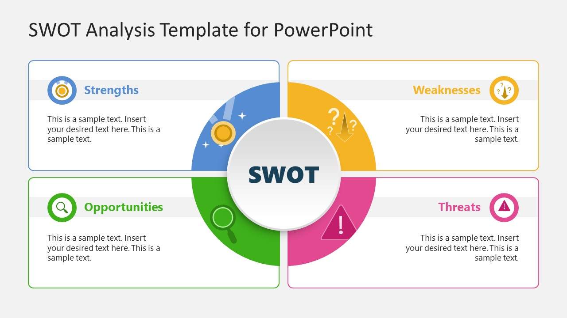
Figer 1: https://cdn2.slidemodel.com/wp-content/uploads/22717-01-swot-analysis-template-for-powerpoint-16x9-1.jpg
Strengths
Strong interpersonal and communication skills, which have been cultivated via academic presentations and group work, are a major strength. These abilities are critical in HR positions that demand engagement with employees at all levels (Bratton and Gold, 2017). Furthermore, I have strong organisational abilities, allowing me to efficiently manage many projects, which is critical in HR operations. Another asset is my academic knowledge of human resource topics such as recruiting, training, and performance management. This theoretical understanding establishes a solid foundation for practical applications.
Weaknesses
A major drawback is a lack of real HR experience. While academic knowledge is valuable, real-world experience is required to gain confidence in dealing with difficult employee relations challenges. Furthermore, I need to boost my confidence in making decisions under pressure, especially in conflict situations. Another area for improvement is strong HR analytics capabilities. With the growing use of data in HR decision-making, this is an essential skill (Marler and Boudreau, 2017).
Opportunities
Internships, part-time positions, and online HR certifications such as CIPD courses are among the growth prospects. These can help with practical knowledge and employment. Furthermore, networking on LinkedIn and attending professional events can give insight into market trends.
Technological improvements in HR (such as AI and HR systems) also enable opportunity to build digital skills, which are becoming increasingly relevant in current HR practices.
Threats
One significant concern is fierce competition in the employment market, particularly for entry-level HR positions. Many candidates have both academic credentials and professional experience. Another issue is the quickly changing nature of human resources owing to digital transformation, which necessitates continual learning.
Evidence of readiness
Academic achievements, transferable skills, and personal development initiatives all reflect my preparation for employment. Academically, I have successfully completed modules in business management and human resources that have increased my understanding of organisational behaviour, leadership, and employee engagement. These topics are crucial for HR professionals (Boxall and Purcell, 2016).
In addition, I have worked on group projects that needed cooperation, communication, and problem-solving. These experiences are modelled after real-world professional circumstances in which teamwork is vital. Feedback from peers has emphasised my capacity to participate effectively and explain ideas clearly.
Furthermore, I have participated in extracurricular activities such as volunteering and online learning courses, demonstrating initiative and a dedication to self-improvement. These experiences also assist to improve soft skills like adaptation and time management.
My digital abilities, which include the use of Microsoft Office and online collaboration tools, help me prepare for current HR responsibilities. As organisations rely more on HR information systems, digital literacy is becoming increasingly important (Stone et al., 2015).
Overall, while I identify areas for growth, my existing abilities, knowledge, and proactive approach to development indicate a great potential for employment in human resources. According to Stone et al. (2015), technology improvements are reshaping human resource practices, pushing professionals to adapt to new systems and methods. This emphasises the importance of ongoing learning and skill development to remain competitive in the employment market.
Emotional intelligence is another crucial facet of self-assessment that contributes significantly to efficient HR management. Emotional intelligence refers to the capacity to recognise and control one's own emotions, as well as those of others. This is especially critical in HR professions requiring dispute resolution, employee engagement, and leadership. According to Goleman (2017), emotional intelligence is a significant predictor of professional success, particularly in people-oriented jobs like human resources. Reflecting on this, I see the need to improve my emotional awareness and interpersonal sensitivity. Furthermore, obtaining practical experience with real-world HR problems is critical for closing the gap between theory and practice.
Personal growth relies heavily on feedback from peers and mentors. Constructive comments can help discover blind spots and opportunities for progress that self-reflection may not reveal. By aggressively seeking and implementing feedback, I can constantly improve my performance and professional conduct. Overall, this prolonged reflection indicates a keen understanding of both personal strengths and places for improvement. By matching my growth with industry requirements and consistently enhancing my abilities, I may better prepare for a successful future in human resource management.

Employment Goals and Personal Development Plan
Employment Goals
My short-term and long-term employment objectives have been determined in light of the vulnerabilities revealed in the SWOT analysis.
Short-term Goals (1-2 Years)
Secure an entry-level HR position or internship.
Obtain practical experience in recruiting and employee relations.
Obtain a CIPD Level 3 or 5 certification.
These objectives are crucial because they give foundational experience and professional recognition, both of which are required for career advancement in HR.
Long-term goals (3-5 years)
Become an HR Manager or an HR Business Partner.
Gain competence in strategic HR and organisational development.
Get leadership experience and manage HR projects.
These objectives are consistent with my professional ambition to contribute strategically to organisational success.
 | Action | Timeline | Resources | Measurement
  Development Area
Practical HR experience. | Apply for internships and part-time HR positions. | 6–12 months. | Job portals and LinkedIn | Job offers or interview success.
HR knowledge. | Enrol in the CIPD course. | 1 year. | Online learning platforms. | Finishing the certification process.
Communication skills.  Attend | workshops and practise giving presentations. | Ongoing. | University resources. | Increased confidence and feedback.
HR analytics. | Learn about fundamental HR data tools (Excel and HR software). | Six months. | Online classes. | Ability to assess human resource data.

In addition to the defined growth strategy, it is critical to take a proactive and introspective attitude to professional advancement. Setting specific and quantifiable objectives is critical for staying focused and motivated. The implementation of SMART objectives (Specific, Measurable, Achievable, Relevant, and Time-bound) can improve the success of the development strategy. By ensuring that each objective fits these requirements, progress can be tracked more efficiently and modifications made as needed. Networking is another important aspect of job success. Building professional ties on sites like LinkedIn, visiting career fairs, and interacting with industry leaders may all give useful insights into the HR business. According to Wilton (2019), professional networking is important for increasing employability and job success.
Finally, regular self-evaluation is required to measure progress and identify any obstacles that arise during the growth process. By evaluating goals on a regular basis and reflecting on successes, you can stay on track with your professional goals and make educated decisions regarding your future growth. This continuous process of reflection and development is critical for establishing long-term success in HR.

References

Armstrong, M. (2019) Armstrong’s Handbook of Performance Management. London: Kogan Page. [Assessed 15th March 2026]
Armstrong, M. and Taylor, S. (2020) Armstrong’s Handbook of Human Resource Management Practice. 15th edn. London: Kogan Page. [Assessed 15th March 2026]
Becker, B. and Huselid, M. (2016) ‘Strategic human resource management: Where do we go from here?’, Academy of Management Perspectives, 30(3), pp. 234–248. [Assessed 15th March 2026]
Boxall, P. and Purcell, J. (2016) Strategy and Human Resource Management. 4th edn. London: Palgrave Macmillan. [Assessed 15th March 2026]
Bratton, J. and Gold, J. (2017) Human Resource Management: Theory and Practice. 6th edn. London: Palgrave Macmillan. [Assessed 15th March 2026]
Brewster, C., Chung, C. and Sparrow, P. (2016) Globalizing Human Resource Management. 2nd edn. London: Routledge. [Assessed 15th March 2026]
Cascio, W.F. (2018) Managing Human Resources. 10th edn. New York: McGraw-Hill. [Assessed 15th March 2026]
Chartered Management Institute (CMI) (2022) Management and Leadership Skills Report. Available at: https://www.managers.org.uk [Assessed 15th March 2026]
CIPD (2023) The Profession Map. Available at: https://www.cipd.co.uk [Assessed 15th March 2026]
Dessler, G. (2020) Human Resource Management. 16th edn. Harlow: Pearson. [Assessed 15th March 2026]
Goleman, D. (2017) Leadership: The Power of Emotional Intelligence. Northampton: More Than Sound. [Assessed 15th March 2026]
Guest, D.E. (2017) ‘Human resource management and employee well-being: Towards a new analytic framework’, Human Resource Management Journal, 27(1), pp. 22–38. [Assessed 15th March 2026]
LinkedIn (2023) Global Talent Trends Report. Available at: https://www.linkedin.com [Assessed 15th March 2026]
Marler, J.H. and Boudreau, J.W. (2017) ‘An evidence-based review of HR analytics’, The International Journal of Human Resource Management, 28(1), pp. 3–26. [Assessed 15th March 2026]
Noe, R.A., Hollenbeck, J.R., Gerhart, B. and Wright, P.M. (2020) Human Resource Management: Gaining a Competitive Advantage. 11th edn. New York: McGraw-Hill. [Assessed 15th March 2026]
SHRM (2022) HR Competency Model. Available at: https://www.shrm.org [Assessed 15th March 2026]
Stone, D.L., Deadrick, D.L., Lukaszewski, K.M. and Johnson, R. (2015) ‘The influence of technology on the future of human resource management’, Human Resource Management Review, 25(2), pp. 216–231. [Assessed 15th March 2026]
Torrington, D., Hall, L., Taylor, S. and Atkinson, C. (2020) Human Resource Management. 11th edn. Harlow: Pearson. [Assessed 15th March 2026]
Ulrich, D. (2017) Human Resource Champions: The Next Agenda for Adding Value and Delivering Results. Boston: Harvard Business School Press. [Assessed 15th March 2026]
Wilton, N. (2019) An Introduction to Human Resource Management. 4th edn. London: Sage. [Assessed 15th March 2026]

