An Analysis of Water Privatisation in Developing Countries


Corporate Governance &Social Responsibility

Student Name:Jiazhu Wang

Student ID:1703858

Executive Summary 2
1.0 Introduction 3
2.0 Main Body 3
2.1 Definitions and Corporate Social Responsibilities of Privatized Water Companies 3
2.1.1 What are Privatized Water Companies? 3
2.2.2 Carroll’s Pyramid Model of Corporate Social Responsibility 3
2.2 Privatised Water Companies in Developing Countries 5
2.2.1 The Situation of Water Provision in developing countries 5
2.3 A Successful Operation Example of Privatised Water Companies 5
---The Cambridge Water Company in the United Kingdom 5
2.4 The Sustainability and Governance of Water 6
3.0 Recommendations 7
4.0 Conclusion 7
5.0 References 8

Executive Summary
This report delves in to the operating situation of privatised water companies in a perspective of corporate social responsibilities theories and practices. Firstly, a global outlook is given of water resources both concerning its supplying and conservation. Water scarcity has become a widely acknowledged concern by the global community, thus a great number of measures are being taken aimed at water crisis, and water privatisation is an important one among them. Then the concept of Corporate Social Responsibility is given based on the pyramid model of Carroll. This report also gives a comprehensive look of roles and current situations of privatised water companies in developing countries. A successful operation example is analyzed to offer suggestions and implications for privatised water companies operations. Also, the sustainability and governance of water issues in the future are introduced. At last, recommendations and conclusion are driven standing above analysis of the whole report.

1.0 Introduction
Water is considered as the most fundamental substance in our planet, which comprises a great proportion of the ecosystem. Water conservation and distribution is not only pivotal for basic needs of human survival, but also critical in maintaining and driving the economic development globally, since water has been taken advantaged of in various industrial uses, such as power generation. And it is worth noting that water scarcity has become an undeniable issue in the global community, especially during the period of continuously increasing population, which has been nominated as the most important feature of water security, the other two respectively access and vulnerability(Mukheibir,2010). Given the importance of water and urgency of its conservation,all societies are sparing no efforts to improve the water situation, and water privatisation has become an effective but controversial measure among them. Despite of that, it would be no doubt that if privatised water companies fully take the corporate social responsibilities(CSR),the issues of water scarcity would be largely ameliorated(Daniel,2012). This report stands on the perspective of theories concerning corporate social responsibilities, analyzes the situation of privatised water companies in developing countries.

2.0 Main Body

2.1 Definitions and Corporate Social Responsibilities of Privatized Water Companies

2.1.1 What are Privatized Water Companies?
Privatisation is the opposite as socialization, means that private investors would own all outstanding shares through purchase in a publicly traded company. Sometimes privatization can be also considered as an outsourcing services of governments or serves as functions to private firms, such as revenue gathering or prison operation(Chowdhury,2006).
As for privatised water companies, it is worth noting that increasingly attention has been shifted from public water utilities to private water sectors by many communities, and the reasons can be complex,including bureaucratic corruption, declining public revenue, a lack of public financing resources and a wider perception of the high operation efficiency of private companies(The Wall Street Journal,2012).

2.2.2 Carroll’s Pyramid Model of Corporate Social Responsibility
Corporate social responsibility(CSR) has been occupying an important status in business leadership and management, and it is closely connected to the operation of privatised water companies as well. Although many skeptics of CSR exist such as Milton Friedman, who argued that business people were only supposed to focus on improving profits instead of social concerns(Crane&Matten, 2014), there have been more attention on CSR and its significance has been widely acknowledged. A common definition is the one defined by Carroll in his pyramid model of CSR, which is “the social responsibility of a business encompasses the economic, legal, ethical, and philanthropic expectations that society has of organizations at a given point in time”(Carroll,1991). In the view of Carroll as well as Buchholtz(2003), the four corporate responsibilities are supposed to be seen as an integrated part instead of separated sessions (Seymur,2014).

Figure 1

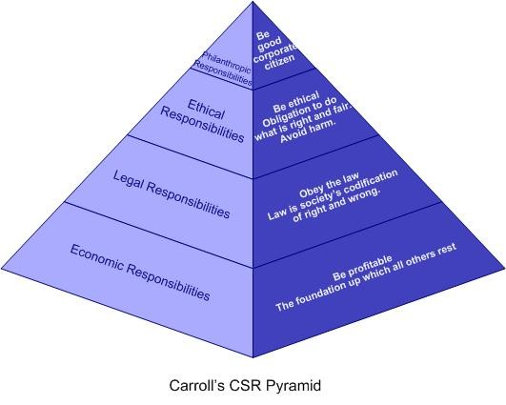
Source: https://www.linkedin.com/pulse/20140905115337-70750023-carroll-s-pyramid-of-corporate-social-responsibility

As is interpreted in the figure of Carroll’ CSR Pyramid model, economic responsibility is in the baseline, which indicates that business corporations should value the profitability as the foundation of any other social responsibilities. And it is reasonable since no company can survive in a competitive world without making profits, which is the source of capital as well as investments, not mention to conduct other good deeds for our society. Some might argue that economic values have little to do with social accountability, however, only a powerful corporation with strong financing abilities can be qualified and capable to take the most challenging social responsibilities. As for privatised water companies, they take economic social responsibility via supplying a range of job options(such as apprentices for local communities), providing dividends to shareholders and conducting investments on some influential projects of societies.

As for legal responsibility,which is the second layer of the pyramid model, it requires business corporations to conduct business decisions under the monitoring of legal rules and regulations. Legal responsibility has overlaps with ethical responsibility, the latter of which is directed by ethical theories. And the part which is neither clearly covered by these two social responsibilities is named gray area, where many business operations are struggling for more immoral commercial profits. As was defined by Carroll in 1991, “the key component of ethical responsibility is that it comprise of what are commonly expected by the public above economic and legal expectations”(Carroll,1991). For instance, privatised water companies have to obey the rules concerning sanitation, and those which abandon themselves in creating water pollution for commercial profits would be forced to close or even suffer more severe punishments. And they take ethical responsibility by an engagement in ethical standards, such avoiding harmful pollution which i not monitored by laws.

It can be noticed that philanthropic responsibility is located at the very top of this pyramid model, which puts more emphasis on luxurious things such as charity and other forms of generous assistance. Philanthropic activities can not only aid companies to set up a more renowned reputation via a list of deeds for social good, but also serve as a special way to conduct advertisements, since many citizens would be increasingly familiar with the companies which frequently conduct philanthropic activities, from a positive perspective. Privatised water companies usually take this responsibility through a range of charity or commitments with social projects to provide necessary and helpful aids.

An important focus of privatised water companies is economic values brought by various water products, that is also a fundamental characteristics of any privatised companies(Felipe,2007). Some experts argue that this “genes” of privatised companies has aroused doubt for the operation of privatised water companies, which have expressed appalling records of rate increase, poor system maintenance,faulty billing practices as well as other failures, sometimes even jeopardizing the security and safety issues of local citizens(Wenonah Hauter,2016).And due to an illegal or immoral pursuit of mere profitability fro some privatised water companies, a rang of ethical concerns have captured the attention by our societies, such as water pollution or sewerage problems. As a consequence, it would be urgent for privatised water companies to take the corporate social responsibilities, especially in terms of ethical and legal responsibility.

2.2 Privatised Water Companies in Developing Countries
Privatised water companies have been increasing in developing countries so as to address the problems of a lack of drinking water, since privatised water companies are perceived to enjoy a better operation efficiency(Gleick,2012). The extent to which privatised water companies develop in developing countries can vary with geographic features, water policies, climate patterns and cultural values. Whether privatisation is a powerful or even necessary way to distribute water resources remains hotly debated. However, it is for sure that some measures have to be taken aimed at the negative influences generated by water privatisation in some developing countries.

2.2.1 The Situation of Water Provision in developing countries
Developing countries do not have sufficient capital and skills in terms of water system managing, which have posed great challenges for the development of privatised water companies(Diane,2002). Apart from that, an increasing population and frequent natural disasters especially droughts, all contribute to an incremental demand for clean water of citizens. As is estimated by the World Bank, it is not incredible that by the year of 2035, 3 billion people might live under conditions of severe water pressure, and a great proportion of these people belong to developing countries, especially Africa, South Asia and the Middle East(Katherine,2006).

2.3 A Successful Operation Example of Privatised Water Companies

---The Cambridge Water Company in the United Kingdom
Cambridge Water Company was founded in the United Kingdom by the Cambridge University and Town Waterworks Act, 1853. It was privately owned until the year of 1996. Cambridge water company is responsible to provide drinking water of high quality to a big population of 300,000 and covers an area of 453 square miles(Corporate social responsibility report, 2017). It has enjoyed a good reputation and market recognition by inhabitants of the UK. Three main reasons for the success of Cambridge Water Company are: caring for the environment, working with the community and developing a suitable working environment for all employees.
Firstly, Cambridge water company actively takes the responsibility of caring the environment by adapting to overcome the problems generated by climate changes, ameliorating the negative influences of water abstraction, declining the carbon footprint, improving the efficiency of water uses. Secondly, Cambridge water company is devoted to working together with the community, such as offering scholarship and other financial assistance for local projects, constructing a corporation which is deeply respected by its frequent customers, providing protection for members in need. Thirdly,Cambridge water company actively develops a working environment where all employees can voice their ideas, be rewarded and promoted for excellent performances, as well as be encouraged and supported to achieve their personal pursuits.
(Source: The Official Website of Cambridge Water Company, accessed on www.cambridge-water.co.uk)

2.4 The Sustainability and Governance of Water
The crisis of water use has aroused global concerns, as argued by the U.N. environment program which explores and forecasts the water prospects in many regions,(Global Environmental Outlook,2001),
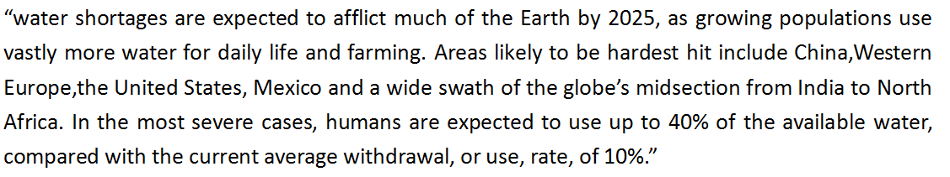

Figure 2
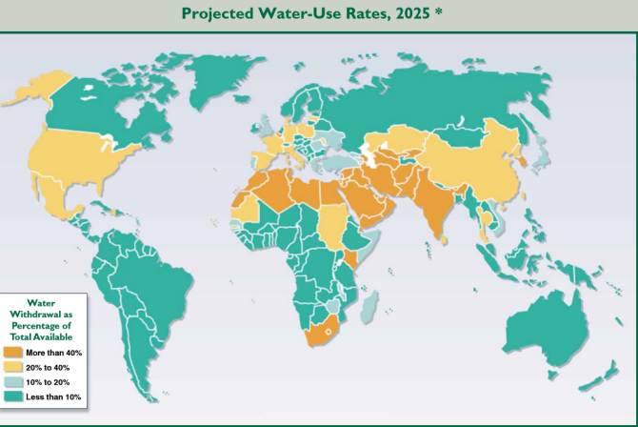

And the negative consequences of water shortages would be most dire fro the planet’s most poorest inhabitants, “for hundreds of millions of people fro whom getting through the day is already a struggle, this is going to push them over the precipice.”(Chris,2008)

Governance of water issues for the government can be hard, since water resources can be so valued that various confrontations are easily generated(Sharon,2007). Firstly, many regions are inherently disadvantaged in conserving and distributing water resources, due to an unfavourable geographical feature and climate pattern, thus it would be more challenging for the local government to govern water resources which are scare at the first place(Jill,2004). Secondly, although privatisation of water resources can be a way to improve running efficiency and raising funds, it would arouse other problems as well, for instance, many poor inhabitants are having difficulties affording for drinking water due to the high price brought by privatised water companies. In that case, it would take a lot of efforts for the government to regulate the privatised sectors(Frank,2007). Thirdly, given the significance of water resources,conflicts in military, culture and other dimensions can show up. For example, water resources might become an important media in the future for some terrorists to conduct dangerous behavior(Harris,2013).

3.0 Recommendations
The operation of privatised water companies has always been controversial, since it has been worried by many economists or politicians that privatised companies can not really serve for the public good given their pursuit for profits(Marq,1999). However, if water resources are fully operated by the government and no private sectors are given any rights in water business, other severe concerns would soon appear,such as corruption and low efficiency of political institutions. An effective solution might be the combination powers of public and private sectors concerning water governance, which can neutralize disadvantages and explore potentials of both sides.In this suggestion, the government can play a critical role in monitoring the operation of privatised water companies, while privatised water companies can take advantage of market forces to promote efficiency.

4.0 Conclusion
To summarize, water resources are so precious as mentioned in the report that a sustainable use of it is more than critical. Water privatisation thus is invented as a way to more effective distribute water resources. However, privatised water companies are not the only way to solve problems of water resources, especially in developing countries where capitals and skills are not mature and potent. Given the current water provision in developing countries, it would be urgent for the privatised water companies to take corporate social responsibilities as an innovative business strategy to get out of the dilemma. And the government can also play a role in this process,which is suggested to monitor the operation of privatised water companies more effectively, as well as raising funds to help build water privatisation project.

5.0 References
Carroll,A.B.(1991) The pyramid of corporate social responsibility:toward the moral management of organizational stakeholders. Business Horizons.

Chris O’Brien.(2008).Global Warming hits China.Forbes Press.

Crane,A.,Matten,D.,&Spence,L.J.(2014).Corporate social responsibility: readings and cases in a global context. London: Routledge.

Chowdhury,F.L.(2006). Corrupt Bureaucracy and Privatisation of Tax Enforcement. Pathak Samabesh,Dhaka.

Daniel,M.A.,&Sojamo,S.(2012).From Risks to Shared Value? Corporate Strategies in Building a Global Water Accounting and Disclosure Regime. Water Alternatives,5.

Diane. (2002). Water Wars. Business Press.

Frank.R.(2007). Asia-Pacific Water Summit.News Network.

Felipe.(2007). The Water Prospects. Research Networking Paper.

Gleick,P.H.(2012). The world’s water volume7. Island Press.

Harris,C.,(2013). Water Resources in the future. World Bank Research 68.

Jill.(2004). Empires of Light. Business research.

Katherine Sierra.(2006). Making water available for all. TAIPEI Times. Accessed on
http://www.taipeitimes.com/News/editorials/archives/2006/03/14/2003297311

Mukheibir,P.(2010).Water Access,Water Scarcity,and Climate Change. Environmental Management,45.

Marq.(1999) The Fate of our most precious resources.

Seymur,M.,(2014). Carroll’s pyramid of social responsibility. State Oil Company of the Republic of Azrbaijian.

Sharon,P.(2007).Dangerous Waters. Natural History.

The Official Website of Cambridge Water Company. (2018) Corporate Social Responsibility Report. Accessed on
www.cambridge-water.ac.uk

The Wall Street Journal.(2012). Are we better off privatizing water? Associated Press:Big Issues.

Wenonah Hauter.(2016) A Review on Privatised Water Companies.The Wall Street Journal.

World Meteorological Organization.(2001)Global Environment Outlook,U.N.Environment Programme,Earthscan.

