Janhara Bibi (2025745)

Case study report
MODULE: PSYCHOLOGY FOR HEALTH AND SOCIAL CARE (BMHP4003)

CONTENTS

Introduction ……………………………………………………………..………………… 2

Social Identity Theory .…………………………………………………………………… 3

Fundamental Attribution Error .………………………………………………………….. 5

Frustration Aggression Hypothesis ..………….………………………………………... 7

Conclusion ….……………………………………………………………………………... 9

Reference List ...………………………………………………………………………….. 10

INTRODUCTION
This report will be focusing on the case study provided regarding Norma and her family’s behaviour at the hospice. The case study focuses on Norma’s family and their aggression towards the hospice staff which include verbal abuse (swearing) and pushing. Understandably some of the hospice staff are struggling to offer full and effective care to Norma because of her family’s behaviour. This report therefore aims to help the hospice staff understand some of the possible causes of Norma’s family’s behaviour using psychological theories. The theories that will be discussed include social identity theory, fundamental attribution error and the frustration aggression hypothesis. It is hoped that this report will be used to and help develop training for the hospice staff to help them deal with similar behaviour in the future.

SOCIAL IDENTITY THEORY

One psychological theory that can be used to explain Norma’s family’s behaviour is the social identity theory. Social identity theory suggests that people’s behaviour is influenced by what social groups they identify as being a part of (Turner, 1982). For example, someone’s social identity may include them being British, a woman etc. There are three processes that are involved in the social identity theory, these are:
- Social Categorisation – this is when people are placed into categories based on different characteristics e.g., their gender
- Social Identification – this is when people begin to identify with the group that they have categorised themselves in
- Social Comparison – this is when people begin to compare their own social group to other social groups (Tajfel & Turner, 1979).

When someone takes on a specific social identity, they tend to become emotionally connected to it. This is because people may base their behaviour and attitudes on what the rest of their social group behaves and acts like. Inappropriate behaviour such as racism occurs when someone has a social identity that they believe is above every other social identity. Misunderstandings can also happen when people are not open to learn about the values that different social groups may have.

Social identity theory can clearly be applied to this case study and explain why Norma’s family is behaving in the way they are. Norma’s family is behaving aggressively towards the hospice staff because of the different social identities that they each have. This can be broken down into the three processes of forming a social identity explained before. For example:
- Social Categorisation – Norma’s family may have categorised the staff at the hospice based on their role, uniform, attitude etc.
- Social Identification – Norma’s family likely identified themselves with the patients rather than the staff as they have more in common (e.g. related, suffering in some way)
- Social Comparison – When comparing themselves to other people, Norma’s family would count other patient’s families as being in-group and the staff as being out-group.
As the hospice staff are considered as being an out-group to Norma’s family based on their social identities, they are more likely to clash in terms of their behaviour and attitudes. What could be suggested in the hospice staff’s training session is that there is a staff member who has dealt with a similar situation to Norma’s family (a sick relative) that is available to talk to the families. By talking to someone with a similar social identity who can properly explain the situation, Norma’s family may become more understanding and therefore their behaviour may calm down.
FUNDAMENTAL ATTRIBUTION ERROR

Another psychological theory that can be used to explain Norma’s family’s behaviour are Fundamental Attribution Errors. Fundamental Attribution Errors are a type of social behaviour where people blame the individuals closest to a problem and assume that they are the cause of it (the problem) (Ross, 1977). This error is thought to occur because people pay more attention and find it easier to identify (and therefore blame) known individuals (known as “internal attribution”) compared to other factors (e.g., time, place etc.) (known as “external attribution”) (Brown, 2006). Some psychologists believe the likelihood and extent that this error happens is influenced by different physical and social factors. For example, an experiment showed that mood has an influence on people making fundamental attribution errors (Forgas, 1998). This is most likely because people’s moods affects how their mind processes what happens around them.

Looking back at the case study, it is clear that Norma’s family are acting on a fundamental attribution error. They have made an internal attribution by blaming the nurses for not helping Norma and have made little effort to consider the situation as a whole and therefore make any external attributions. The diagram below is based on Heider’s (1958) work on attribution and has been applied to this case study to explain Norma’s family’s behaviour.
Norma’s family being aggressive to hospice staff

External causes
- Lack of sleep
- Disruption to daily life
- No wifi or reception
Internal causes
- Aggressive personality
- Racist attitudes
- Mistrust

Situational factors (poor wifi connection and phone reception)
The family may have racist and offensive attitudes

Norma’s family are taking out their aggression on the staff because they cannot contact other relatives
Norma’s family think the staff are not taking care of Norma properly because they are from a different background
There are many other internal and external causes that could be used to explain Norma’s family’s behaviour that were not mentioned in the diagram. Norma’s family being aggressive to the hospice staff because of fundamental attribution errors may make the staff feel helpless and reduce their quality of care. This is because they cannot easily change Norma’s family’s internal attributions which means that they will continue to receive the blame for Norma’s health issues getting worse.

Frustration Aggression Hypothesis
Another possible psychological theory that can be used to explain Norma’s family’s behaviour is the frustration aggression hypothesis. The frustration aggression hypothesis states that people who are frustrated by something are more likely to carry out aggressive behaviour (Dollard et al, 1939). This aggressive behaviour may be directed at the source of the person’s aggression or another object/person if the source is not accessible. Some psychologists suggest that there are stages involved in the frustration aggression hypothesis, these are:
- Frustration
- Negative affect – this refers to negative emotions/states e.g., irritation
- Aggressive inclinations – this refers to feelings of aggression but does not involve physically acting on them
- Aggressive behaviour (Breuer & Elson, 2016).
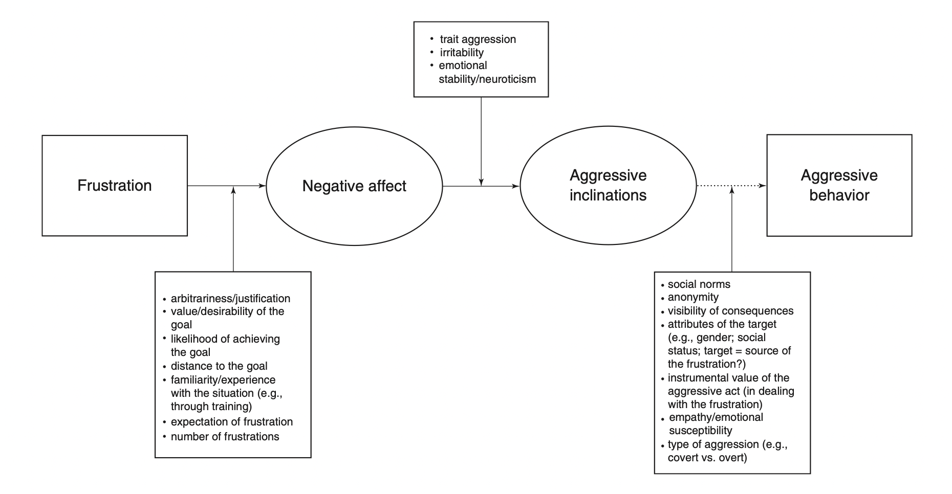
This can also be seen in the diagram below from the same source:

A frustrated person can show one of two types of aggressive behaviour. They may show hostile or instrumental aggression (Anderson & Bushman, 2002). Hostile aggression refers to unplanned aggressive behaviour with the intention of causing harm. Whereas instrumental aggression refers to planned aggressive behaviour that intends to achieve a goal rather than cause harm.

It is clear that the frustration aggression hypothesis can be applied to explain Norma’s family’s behaviour towards the hospice staff. Norma’s family likely feel very frustrated that Norma is unwell again and that they cannot do anything themselves to help improve her condition. They may also be frustrated with Norma herself for refusing any further hospital treatment that could have helped her. However, Norma’s family cannot behave aggressively towards Norma as she is in a fragile state and they most likely do not want to ruin their last moments with her. This may be increasing the aggression that they are subjecting the hospice staff to. This would suggest that Norma’s family are not directly frustrated with the hospice staff but as they are closely related with the situation, they are unfortunately receiving the effects of it. Despite some of Norma’s family’s actions (such as physically pushing staff), it is clear that they are experiencing instrumental aggression as they are not intentionally causing any harm to the hospice staff. Instead they are hoping that through behaving aggressively and therefore pressurising the staff, they are able to achieve their goal of helping Norma overcome her cancer.

Suggestions for how the hospice staff can deal with Norma’s family’s aggressive behaviour can be based on previous research looking at the frustration aggression hypothesis in A&E departments (Staines, 1999). It is important for the management of the hospice to support their staff and sit down with Norma’s family if any further violence or aggression is experienced. It is also important for the hospice staff to remain committed to treating Norma regardless of her family’s actions.

Conclusion
In conclusion, the aggressive behaviour that Norma’s family have been directing towards the hospice staff can be explained by all three of the psychological theories discussed in this case study report. Whilst these theories can be effectively applied to help the hospice staff deal with Norma’s family’s aggression as suggested throughout the report, they do not consider that Norma’s family might have anger issues that are not related to Norma’s condition. During the training sessions with the hospice staff, the most important thing to teach and highlight is that Norma’s family (and other families showing similar behaviour) are not angry with the staff directly but the situation that their loved one is in. The staff should therefore not feel bad about the care that they are providing and should continue doing their best to treat their patients.

References
Anderson, C. A., & Bushman, B. J. (2002) Human Aggression. Annual Review of Psychology, 53, pp. 27-51.

Breuer, J., & Elson, M. (2016) Frustration-Aggression. In: Sturmey, P. ed. The Wiley Handbook of Violence and Aggression. John Wiley and Sons, Ltd.

Brown, C. (2006) Social psychology. London: SAGE.

Dollard, J., Doob, L. W., Miller, N. E., Mowrer, O. H., & Sears, R. R. (1939) Frustration and aggression. New Haven: Yale University Press.

Forgas, J. P. (1998) On feeling good and getting your way: Mood effects on negotiator cognition and bargaining strategies. Journal of Personality and Social Psychology, 74(3), pp. 565-577

Ross, L. (1977) The intuitive psychologist and his shortcomings: Distortions in the attribution process. In: Berkowitz, L. ed. Advances in experimental social psychology. New York: Academic.

Staines, J. C. (1999) Violence and aggression in A&E: Recommendations for action. Accident and Emergency Nursing, 7(1), pp. 8-12.

Turner, J. C. (1982) Towards a cognitive redefinition of the social group. In Tajfel, H ed. Social identitiy and intergroup relations. Cambridge: Cambridge University Press.

