Monica Antonescu

Learning in the digital era

Learning In the Digital Era
Table of Contents
Introduction 3
“1. Preparation for Higher Education” 4
“2. Becoming a digital learner” 5
“3. Discussing my personal identity” 6
“4. Reflecting on my experience by following the Borton’s reflective tool” 8
Conclusion 9
References 10

Introduction
The main aim of this assessment is to focus on describe the various learning procedures that are being used in this digital age. The first part of this report has given a clear description of the topic that is known as ‘Preparing for Higher Education’. The second part focuses on developing a mind map that is based on the various stages that are needed to become a successful digital learner. The third part is a “two minute video presentation” that shows the personal identity of the one working on this report. This part will reflect on the individual’s set of beliefs and experiences that will help in explaining the ways to become an efficient team player. The last part has used the “Borton’s reflective tool” in order to reflect the experiences while attending the first day at the university.

“1. Preparation for Higher Education”
In order to prepare for higher education, one must not be dependent and they must be self motivated. The first step is to select an educational institution and checking the resources given to the new steps is crucial. Researching about the study skill lesson and workshop can help too but one must first focus on developing his/her academic skills (von Hoene, 2020). The second factor to focus on while preparation is to manage finances and developing student bank accounts is a wise choice. Applying for student finances and checking the eligibility criteria is crucial too, this will help in developing a budget and know whether one will be able to afford all the expenses of the university. Another factor that one must focus on while preparing for high education is to make sure that he has a wide knowledge and understanding about the subject that the individual will studying further. This means that the student must have a good knowledge about the topics that are being discussed in his/her present standard or class. Not having a good knowledge about his/her subject at present will surely fail to gain any knowledge when the individual moves on to higher studies (Johnston-Guerrero et al., 2022).
Another factor that the individual must focus on is to look after his/her mental health and well being. Referring to various guides in the internet can help as knowing the viewpoints of other regarding mental health will lead to generate a positive mindset. Thinking with a clear mindset is crucial for a student who thinks of continuing his/her higher studies. Preparing for higher education is crucial for an individual who wants to achieve success in his personal life as well as his career. This can easily be done if the student is determined and has a good knowledge about the subject that he is interested in (Cunha et al., 2022).
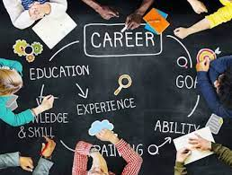
Figure No. 1: Steps to prepare for higher education
Source: (Wilson, 2020).

“2. Becoming a digital learner”
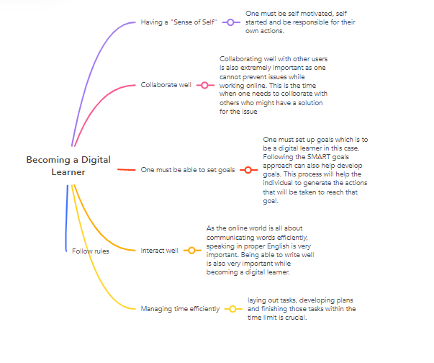
Figure No. 2: Developing a mind map to show the various stages of becoming a digital learner
(Source: Created by the learner).
The various steps that will help in becoming an efficient digital learner have been mentioned and described below:
- Having a "Sense of Self": One must be self motivated; self started and are responsible for their actions. Being interested in the topics that are being discussed online and not getting distracted while attending learning sessions is the first rule
- Collaborate well: Collaborating well with other users is also extremely important as one cannot prevent issues while working online. This is the time when one needs to collaborate with others who might have a solution for the issue
- One must be able to set goals: One must set up goals which are to be a digital learner in this case. Following the SMART goals approach can also help develop goals. This process will help the individual to generate the actions that will be taken to reach that goal (Creighton, 2018).
- Interact well: As the online world is all about communicating words efficiently, speaking in proper English is very important. Being able to write well is also very important while becoming a digital learner. Using the right words and answering politely to all individuals of the online community can help in maintaining relationships with colleagues in the online community.
- Managing time efficiently: Laying out tasks, developing plans and finishing those tasks within the time limit is crucial. Not being able to manage time can lead to failure, so one must always focus on doing the right task at the right time. Developing plans for the duration of the topics that need to be covered can help a lot in managing time.
- Follow rules: One must follow all the rules of the online community in order to maintain relationships in the online community. Not having a good relationship with people will only lead to issues while learning so one must focus on following all the rules (Black, 2020).

“3. Discussing my personal identity”
- My name is Monica Antonescu and I am a citizen of the United Kingdom who is currently a student who wishes to continue my higher studies in a well-renowned university.
- I was born in the United Kingdom and I have been studying in the United Kingdom since childhood.
- I am able to excel in my academic field since a small age and I think that it is all because of the support of my family.
- I want to become a successful entrepreneur when I grow up which is the main reason I want to study further and gain more knowledge about the things that an individual needs to do in order to become a successful entrepreneur.
- I have been working hard in order to have a better knowledge about the market such as how the market changes or how to know the existing trends, this can only be done if I do well in my education.
- I believe that hard work and determination are the two things that can lead to success. I value collaborating with others and respect the decisions and viewpoints of others.
- Without hard work and collabor6ation, one will not be able to focus on being a good team player.
- In order to have a good relationship with others, I think that being able to conduct tasks efficiently and helping others will lead to other teammates liking me.
- Being able to resolve conflicts instead of fighting can help but I must focus on this and focus on improving my behavior in order to work efficiently in a team.

“4. Reflecting on my experience by following the Borton’s reflective tool”
What
While I first started university, I was a bit nervous because I was doubtful whether I would be able to fit in or not but at the end of the day, I felt like it was the best experience. In the first day, I was scared that I would not be able to collaborate well with others but the other students were nice to me and I made some very good friends on the first day. I saw that the university provided a lot of online resources and most of the work had to be submitted online. I gained a good understanding about the topic.
“So What”
As I did not have a good technological knowledge at that time, I was doubtful but as the teacher handed out the assignments after the lesson I felt that I could do it. After the lesson, I gained an understanding about the online procedure to submit the assignments and as I was already familiar with the topic of the assessment I was confident that would do it I was able to have a good understanding about the benefits of online learning. I have been able to improve my team working skills and technical skills by working collaboratively more with others. It seems that I have a good behavior when it comes to work collaboratively with others but I need to focus more on team leading skills so that I can handle conflicts and be a leader. It shows that I have good collaboration and interaction skills (Veine et al., 2020).

“Now what”
We will be able to be good team workers if we continue collaborating efficiently. The entire team will face problems as they will need to do the tasks that I need to do and the task. I will be able to describe situations and explain topics more efficiently if I can tell about my experience. I must focus more on my behavior and try my best to speak up so that I can be able to motivate other by referring to my experience (Wong, 2022).

Conclusion
The first part of this report has given a clear description of the topic that is known as ‘Preparing for Higher Education’. The second part has developed a mind map that is based on the various stages that are needed to become a successful digital learner. The third part is a “two minute video presentation” that shows the personal identity of the one working on this report. The last part has used the “Borton’s reflective tool” in order to reflect the experiences while attending the first day at the university.

References
Black, G.C., 2020. Who Are Today's College Students?: Understanding the 21st Century Higher Education Digital Learner. In Handbook of research on developing engaging online courses (pp. 1-13). IGI Global.
Creighton, T.B., 2018. Digital Natives, Digital Immigrants, Digital Learners: An International Empirical Integrative Review of the Literature. Education Leadership Review, 19(1), pp.132-140.
Cunha, T., Martins, H., Carvalho, A. and Carmo, C., 2022. Not Practicing What You Preach: How Is Accounting Higher Education Preparing the Future of Accounting. Education Sciences, 12(7), p.432.
Johnston-Guerrero, M.P., Combs, L.D. and Malaney-Brown, V.K., 2022. Preparing for Higher Education's Mixed Race Future: Why Multiraciality Matters. Palgrave Macmillan.
Veine, S., Anderson, M.K., Andersen, N.H., Espenes, T.C., Søyland, T.B., Wallin, P. and Reams, J., 2020. Reflection as a core student learning activity in higher education-Insights from nearly two decades of academic development. International Journal for Academic Development, 25(2), pp.147-161.
von Hoene, L.M., 2020. From Orientations to Outcomes: Articulating a Comprehensive and Systematic Approach to Preparing Future Higher Education Instructors. New Directions for Teaching and Learning, 2020(163), pp.13-23.
Wilson, D., 2020. Developing Interactional Competence in discussions, through a Multimodal (Inter) action Analysis approach, for students preparing for higher education or employment.
Wong, J., 2022. Reflection in Student Learning in a Semantics and Academic Writing Module. In Integrating Content and Language in Higher Education (pp. 211-227). Springer, Singapore.

