Screenshot/photo 1
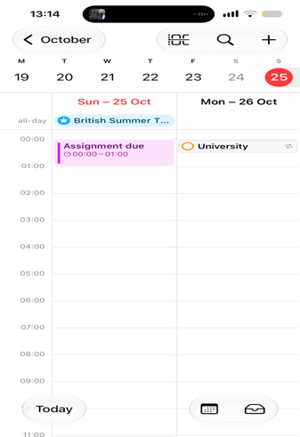
This shows I use calendar to make notes of when I have university and take note of when assignments are due.
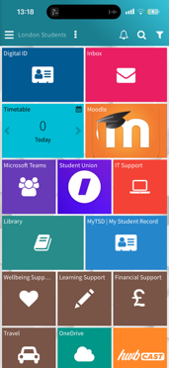
Screenshot/Photo 2

This shows I use Moodle to submit assignments and respond to university emails.
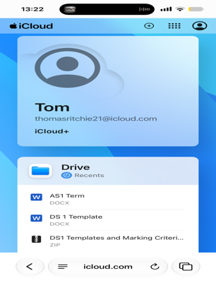
Screenshot/Photo 3

This shows I use iCloud to store files and transfer them onto my laptop.

Screenshot/Photo 4
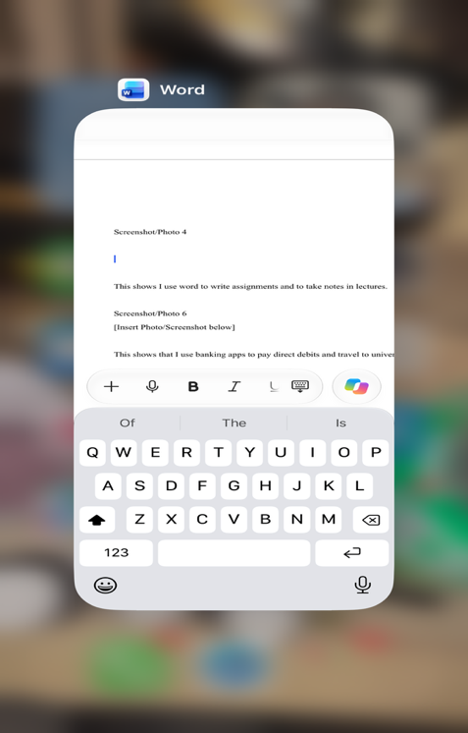

This shows I use word to write assignments and to take notes in lectures.

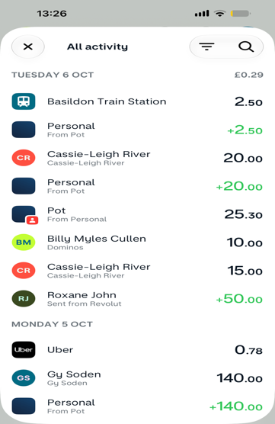
Screenshot/Photo 5

This shows that I use banking apps to pay direct debits and travel to university.

My Short Reflection

I use digital tools to be able to write assignments and to access resources on Moodle. I feel confident when I use Moodle because it lets me easily access everything in one place.
I want to improve my understanding of Microsoft word so I can complete my assignments easier. I often use these tools Moodle, iCloud, files, notes, and calendar these are essential for me.
I sometimes feel nervous about using iCloud incase I lose my finished assignment and must restart again. I hope this module will help me get a better understanding of digital skills because I lack
Confidence, Digital skills are important for me because because it helps me build a online portfolio and gives me better personal development.

