
Manufacturing Design & Technology – End Effector

June 17, 2022
University of Wales Trinity Saint David

Executive Summary

This report details the design and research of an end effector pneumatic gripper that will be mounted onto an articulated robot arm within Swansea University. Research into the best material and best design exercises was carried out to make sure that the design presented to Swansea University, was the best design that could be offered. The gripper is question would be designed to pinch a mobile phone assembly that would be static in position on the mobile phone storage rack. The gripper was designed to grip the phone from the sides, this was designed using pneumatic cylinders driving two jaws to open and closed positions. During the first stages of the design Lucas method DFA, FMEA and design for x were used. By using these techniques, a lot of problems were singled out during the start of the project. These techniques also reiterate that the design is the best it can be with the constraints set out. Using research carried out within the predesign phase it was decided that the best material to use on this design was 3D printed nylon. By choosing this fabrication method it gave the designer some opportunity to incorporate parts into the base plate of the gripper, which otherwise would have been separate. This would later result in a 65% design efficiency by limiting the number of non-essential parts within the design. The only non-essential parts that remained in the design were fixing nuts that were vital for the design to function. The idea being that the customer can purchase the base design including the pneumatic cylinders and switches, and they then have the option to interchange any internal parts as they wish. The design features magnetic reed switches that dictates to the PLC the two positions the gripper is set to. This would be either open or the closed position. After research it was found these reed switches are the most cost effective, but they are slow compared to competitors. For the function it was decided that the gripper did not require a fast-acting switch and the most cost-effective option was chosen. The initial design for this gripper was loosely base on an existing pneumatic gripper that could be purchased for £1800, the aim was to replicate the design but using more cost effective materials that would suit the application. The total cost for the gripper designed would be £183 excluding cost of 3D printing, this is a £1617 saving compared to the stock bought gripper that is over engineered for the application. For this reason, the design was the success as the University would receive a gripper that is engineered around their automated manufacturing line. This gripper can be updated in the long term, if need be, this gripper can also operate with out maintenance issues due to the simplified design.

Table of Contents
Executive Summary 1
Introduction 3
Research 4
Design 5
Function 8
Design For X 9
Failure mode and effects analysis 10
Material 11
Conclusion 13
Bibliography 14
Appendix 15

Introduction
Within this report it will be going into detail the design process for an end effector Pneumatic gripper that will be mounted onto an articulated robot arm within Swansea University. The gripper will be designed to pick up a mobile phone assembly that has been manufactured within a fully automated assembly line. The design intent when setting out on this project is that the gripper should be able to pick up the mobile phone assembly and place it on an automated mobile loaded which will be situated beside the robot arm stand. The gripper should be able to pick up the mobile phone from the bottom half of the phone to make sure the top plate doesn’t become detached. The report will include design analysis of the end product and also 3D design of the operational product.

Research

In order to arrive at the most effective design to be implemented into Swansea University research was carried out to gather information on the subject. Many types of material and fabrication methods were discovered using articles solving similar problems within engineering. Blok et al (2018) discusses a very interesting approach to 3D printing which altered the idea for the design to use 3D printing. The article investigates an 3D printing technique called Fused filament fabrication or FFF which alloys layer by layer build up using deposition of material. This technique has the potential to lower productions and fabrication costs and increase automation of the fabrication of the product. The article details the different types of material that can be used within 3D printing. Nylon is a good choice for this product due to the high amount of stiffness with thicker walls. The report shows results that nylon features a strength and stiffness of 55.3MPa. Another option is nylon infused with carbon which features a strength found to be 19.02MPa both of which could be useful within the design as the gripper will not encounter large forces.
Iwaya et al (2013) writes an article showing the benefits when designers change their outlook and start to think in a way that incorporates design for assembly. By carrying out examples such as Lucas method it gives the designer the chance to redesign before the product is fabricated. This method in essence gives the designer a safety net which covers what the potential problems could be and how to resolve them. If the designer would just send the product to fabrication, it could be included with problems which would have been missed due to not using design for assembly (DFA). Jack (2012) lists a number of advantages that are included when a designer uses Design for assembly methods such as shorter lead times, fewer production steps, smaller part inventory, more standardized parts, simpler designs and often lower costs. These are all advantages that will aid the process of designing a good quality product.
Moermond (2016) writes in an article the different type of cylinders and sensors that work best with which pneumatic set ups. He mentions that magnetic reed switches are the simplest and the most cost-effective sensor to send signals to PLC. Reed switches demand no standby power and can function with both ac and dc electrical loads. He details that these reed switches are relatively slow to operate but for what the gripper design dictates a fast-acting sensor is not needed. If the customer desires a faster acting sensor these switches are easily interchangeable. If the customer demanded a faster switch an Anisotropic megnetoresistive sensor (AMR) could be purchased and added to the design but at a cost, as these are far more expensive compared to normal reed switches.

Design

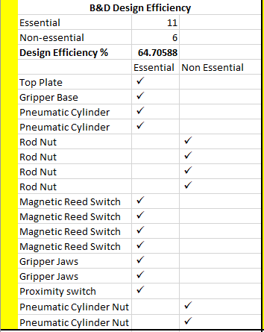
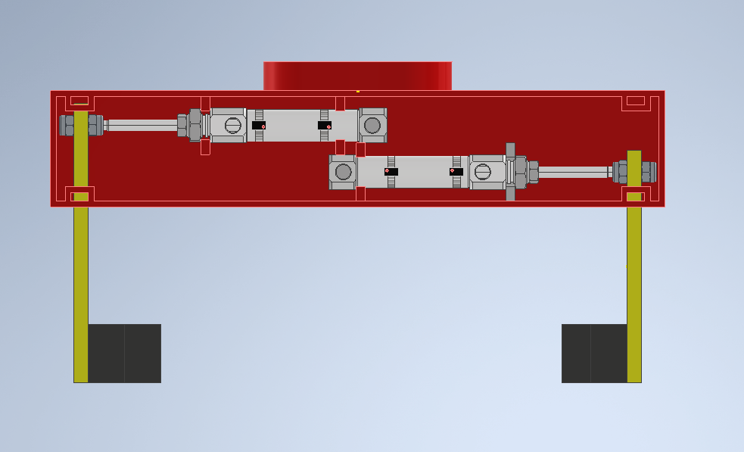
After research into the subject a design has been created within 3D CAD Inventor. The initial design has been made in a way that provides ease of installation for the operator operating the station. This was done using a design DFA which investigates design efficiency, manual handling index and also fitting index. These three exercises were carried out before the design was put into place to make sure that the design was as simple as possible in order to not present any issues for user error or functionality. As can be seen from Figure 1, 64% design efficiency was achieved. The only non-essential items left were fixing nuts which allowed for the design to function. Other ideas were put forward by removing these non-essential items, but it was decided that by implementing these fasteners it gives the customer freedom to full adjust or alter the design as they saw fit. By including these fasters, the jaws could be interchanged easily if they needed adjusting also the pneumatic cylinders could be changed if a longer stroke was needed to accommodate a new part being manufactured. The other parts such as the pneumatic cylinder are all essential for the design to function.
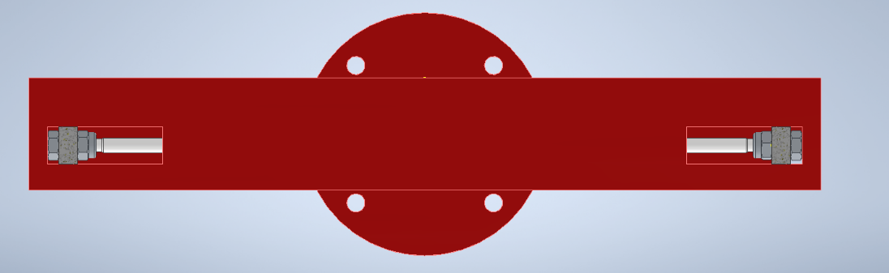
As can be seen in figure 2 the design has been set up in a very simplistic way in order to limit the number of parts to make up the assembly. The main body of the design is made up with two non-rotational double acting pneumatic cylinders. These cylinders which are placed in the 3D printed base assembly and then fixed using two M8 nuts. The two cylinders will be driving the gripper jaws which will be grabbing the mobile phone assembly. These cylinders were chosen for this design as they were perfect for what the design was set out to achieve. Non rotational cylinders were chosen so the rod had no chance to rotate and effect the home positions of the jaws. If the jaws axis were to change it could result in the jaws clashing into the wall of the mobile phone station. This would cause the jaws to bend as the magnetic reed switches would be set for the jaws to travel the amount of 22.5 millimetres. If there was an obstruction within the 22.5 millimetres, the cylinders would still extend/contract that full distance. For this reason, there has been two precautionary features added into the design to make sure that event does not occur. The first feature was the non-rotational cylinder included in the design, the second can be seen in figure 3. Within figure 3 it includes a half section view looking at the front view of the gripper design. There are two rectangular cut outs that guide the jaw arms in position. These cut outs will make sure that the jaws stay on the correct axis in order to successfully pick up the product.
Figure 2 Gripper Assembly Design
Figure 1 B&D Design Efficiency Table
Figure 3 Gripper Front View
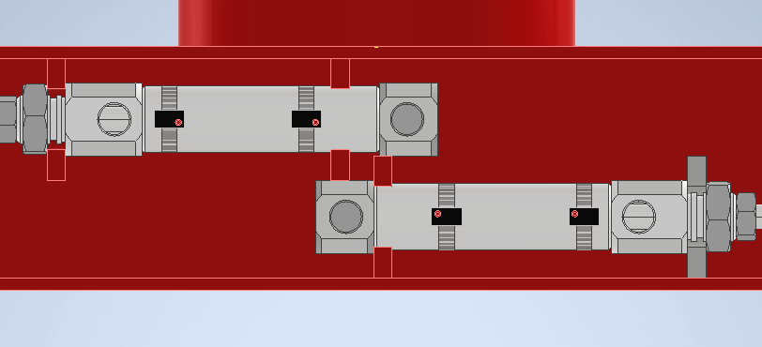
The gripper will have two positions which the pistons will be set to using magnetic reed switches. These reed switches are set 22.5 millimetres away from each other which is the thickness of the jaws that will be gripping the product. As can be seen in figure 4 the switches are strapped to the cylinders and when the cylinder rod hits the point of the switch it will stop till the PLC tells the cylinder to switch to the other position. This would be the open and closed position, when the gripper is open it give the gripper the ability to slot on the outside of the mobile phone guide rails. When in position the PLC will switch the cylinders into the closed position which will grip the part. The robot arm would then move the gripper up in the Y axis and move to the mobile loader. This function could be repeated an infinite number of times.
Figure 4 Gripper Plan View (Top Removed)
Once the gripper is assembled and 4mm air pipework is added into the pneumatic cylinders and the reed switches are connected to the PLC maintenance will be minimal for the component. The only moving parts in the assembly are the pneumatic cylinders, providing they are lubricated correctly the gripper would be able to function without any difficulties for long periods of time.
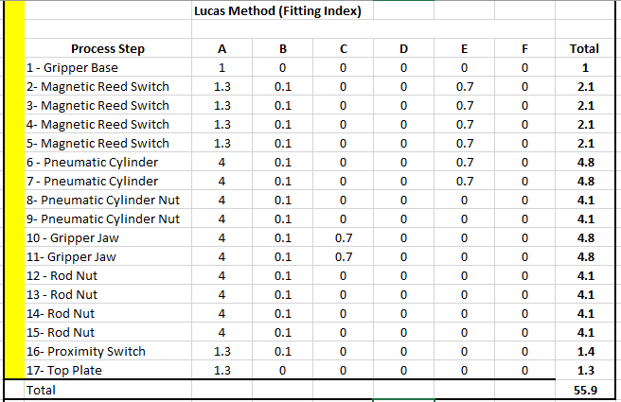
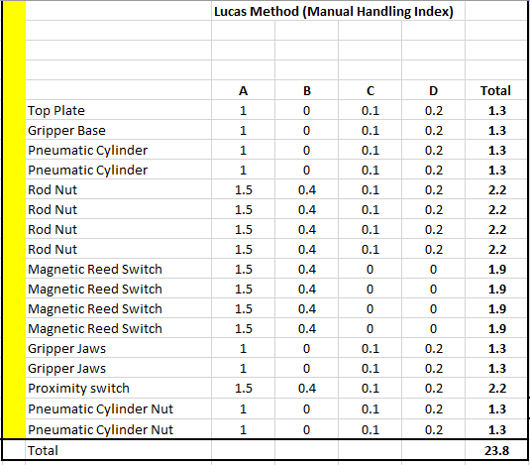
Using Lucas Method the design was able to be evaluated for ease of manual handling. The manual handling index table can be seen in figure 5. After carrying out this example it was found that all components are easy to handle with the only parts being difficult being the cylinder rod nuts. This is because the size of the nuts is M4 which are difficult to handle. The magnetic reed switches are also small and can be difficult to install. The switches are attached to the cylinder using a stainless-steel mounting strap which will need to be tightened at the correct position. When the gripper is issued to the customer a full manual to where the straps need to be placed in will be included.
Figure 5 Manual Handling Index
Using the same Lucas Method it was found that the assembly features a predominately easy fitting index. The assembly was designed that most of the parts featured within the design could be placed from the top of the base plate. Once the pneumatic cylinders are fitted all other parts will be installed horizontally onto the cylinder rods such as the gripper jaws. This could not be improved as the gripper operates along a horizontal axis. The design was adjusted in the first phase of the design, the initial idea was that the cylinders were to be housed and the rods would protrude out of the housing. This idea after carrying out the Lucas Method was scrapped as it made assembly far more difficult as the cylinders would need to be dissembled to fix the parts into the housing.
Figure 6 Fitting Index

Function
The function for this gripper was covered earlier within this report, it will be the primary assembly which will be picking up the mobile phone and placing it on the mobile loader. There will be two positions that the pneumatic gripper can take either open or closed as can be seen in figure 7 and 8. In figure 7 the gripper can be seen in its closed position, in this position the jaws will be pinching the mobile phone assembly and vertically lifting the product onto the loader. In figure 8 the gripper is in its open position; this is the position the gripper will be in to approach the product and eventually close. When the gripper is being fitted a small slot will need to be cut out of the existing guiding system for the gripper to be able to pick up from the side of the phone. The jaws are set up as an extrusion from the 5mm jaw struts, a 12.5mm block is added to the end of the jaw strut to make up the difference of pinching the part. The soft jaws that will be picking up the part can clearly be seen in figure 9. Figure 9 features a half section view of the full assembly; the jaws have been designed in a L shape this is to pick up the product in two ways. One way will be pinching the product from the side and then the bottom of the jaws will slide between the phone storage tray and the phone, this will then allow for the gripper to pick up the product from the bottom as well. This is to make sure that the gripper will maintain a conclusive grip which will result in less phones being dropped because of the design.
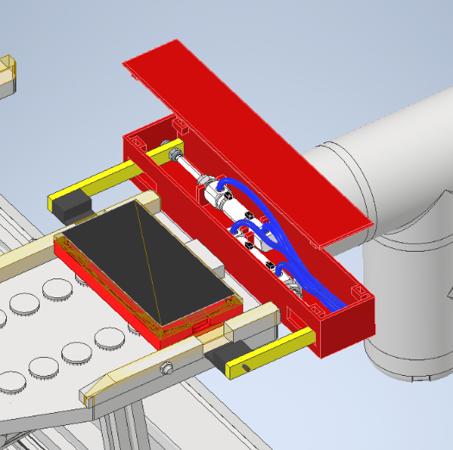
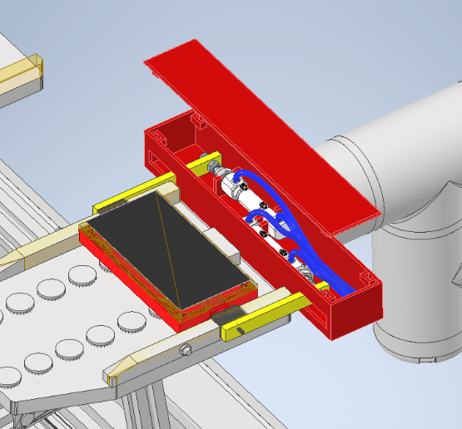

Figure 8 Gripper Open Position
Figure 7 Gripper Closed Position

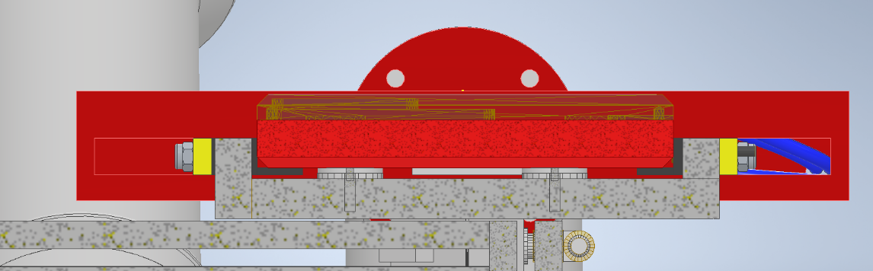

Figure 9 Half Section View of Assembly
The gripper will operate using compressed air to drive the pneumatic cylinders from the home position to the extended position. The speed of the cylinders can be dictated by the pressure of the air being fed into the cylinders. This can be altered depending on the customers requirements for the gripper. Once the PLC signals for the cylinder to extend the magnetic reed switch will stop the cylinder rod once it gets to the extended position. When the gripper is received into the lab in Swansea University the first point should be that a slot of 22x11mm will need to be cut out of the mobile guide in order for the gripper to function as intended.

Design For X

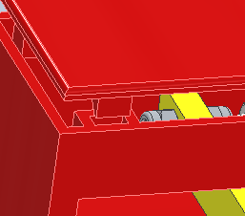
When deigning the gripper design for x was in mind. As the main body of the design is being 3D printed it gave the designer freedom to add custom parts to the main body which would normally be separate parts. For example, the cradles that the cylinder sit on would have been a separate part if the gripper was fabricated differently, but as the part of 3D printed the gripper could be designed in a way to eradicate these parts from the assembly process. Tabs were also added to the main body of the gripper so that the top plate could be easily snapped into place, this would be removing the potential of four fixing components which would have fixed the top plate originally which can be seen in figure 10. This gives the operator of the gripper the freedom to easily remove the top plate if any alterations would need to be changed within the housing. This fixing system will be made within the 3D printed model.
Figure 10 Top Plate Fixing

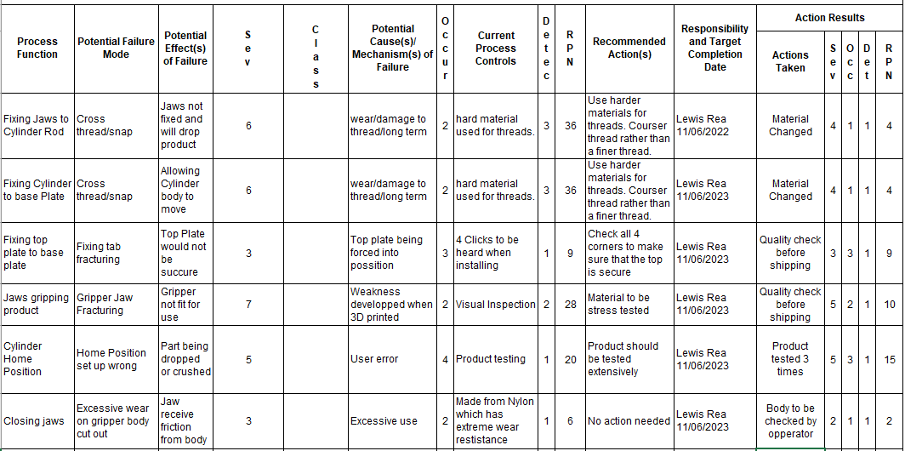
Failure mode and effects analysis
Figure 11 Failure mode and effects analysis
Failure mode and effect analysis is a great way of assessing what is good with a design and what could be improved. This analysis is carried out by detailing what potentially could go wrong within the design and how it could be counteracted before being sent into production. Due to the small design, there were a very limited number of problems that could potentially occur, some of which are detailed in figure 11. It can be seen a number of points were picked up within this process which resulted in change of the design such as material changes and procedure changes. One of which being the top issue, which was fixing the jaws to cylinder rod. Within this design there is a potential for cross threading the threads or damaging the threads on the cylinder rods. This would have only been eradicated if a clip was used on the rod which fixes the jaws to the rod. The draw back to the clip was that it protruded too far out and would rub against the housing of the gripper. As the design was set out to make a small streamlined looking gripper a stainless steel nyloc nut was the best option. Unfortunately, due to the rod being made from mild steel as well it could result in a problem. The material for cylinder was able to change to suit the nuts (stainless steel) which would result in a far less chance of this problem occurring, lubrication of the rod thread will also take place to prevent galling of the parts. By using the 5 whys method of creating a scenario in which a number of questions are asks about what could go wrong and what could cause them more issues were brought up. Such as an issue concerning the structural integrity of the gripping jaws. There is potential for the gripping jaws to fracture under extreme circumstances. This would deem the gripper obsolete if these jaws were not functional. This would only happen if there was a weakness developed when 3D printing which is extremely rare and would not be a result of the material used. Nylon tends to bend when exposed to extreme forces but if there was a weakness it could lead to the jaws fracturing. Unfortunately, in this situation it is impossible to predict if a weakness develops and the best that can be done is a detailed inspection before assembly. Ranganathan (2016) explains that using Sakichi Toyodas technique can be very advantageous during the design phase. He shows that root cause analysis using this technique can lead to a much higher level of effectiveness of designs compared to designs that have not used it. Shafiee et al (2019) writes a report showing the results of companies that use FMEA correctly. He shows that components that may have been overlooked will be brought into perspective using the technique. This can provide the designer with a well-rounded end product as the full design was explored. Granted there may still be issues concerning the design once fabricated, but the number of problems will significantly decrease.

Material
For this design research has been carried out to make sure that the most reliable material is used for the product. The housing and jaws for the gripper design have been designed in a way which makes them very simple to 3D print and mass produce. There will be four separate parts that will make up the assembly of the gripper 3D printed. These include the gripper top, gripper main housing and two jaws, these can all be seen in the screenshots below. The material chosen for these parts is nylon, nylon offers the design a vast amount of strength and durability. The material was chosen around the housing guide situated on the front of the housing. The jaws will be traveling up and down this guide constantly depending on the amount the gripper is used. Nylon offers extreme wear resistance when in contact with a nylon part. Martin (2020) mentions in an article written discussing the strengths of nylon, that the material ideal for moving parts, that is why nylon is often used for moving parts such as gears which are constantly touching one another. Martin (2020) also includes that nylons end product properties depend on the wall thickness picked out for the part. For this reason, the housing has been made with a 2mm wall thickness and the jaws with a thickness of 5mm. This will provide the strength needed within the design, as the gripper will only be picking up one 150-grams mobile phone assembly. The jaws have been designed to slowly grip the phone assembly and will not need much strength to pinch the part. As nylon is a plastic compound it will also act as a soft jaw for the gripper. This will make sure that the phone assembly is not damaged or scratched when loading or unloading the product onto the mobile loader.
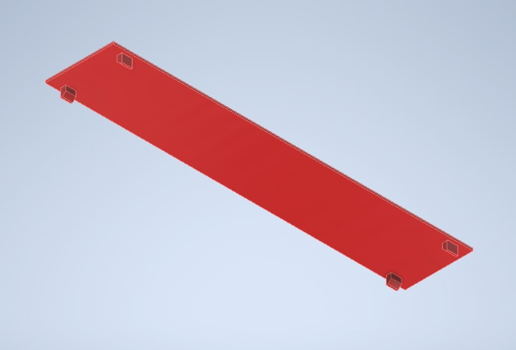
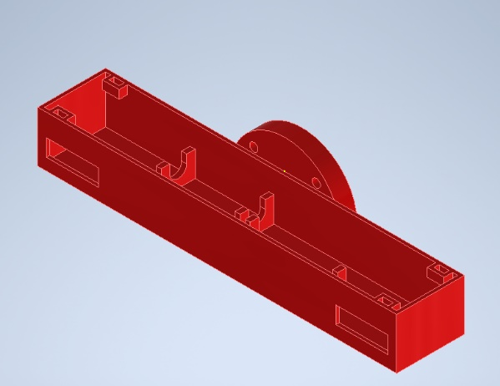

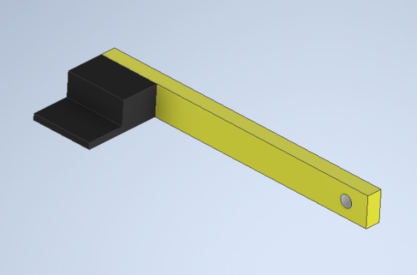
Figure 13 Gripper Base Plate
Figure 12 Gripper Top Plate

Figure 14 Gripper Jaw

Stress Analysis
After completing the design stress analysis was undertaken just to reiterate that nylon is more than strong enough for this design. The results were unsurprising with the design achieving a factor of safety of 15 and maximum deflection of 0.2mm. This can be seen in figure 14 which features the mesh view of the defection within the material. Figure 15 features the mesh view showing the factor of safety achieved by the design. This shows that the design will have no issue dealing with the forces asserted by the function of the gripper.
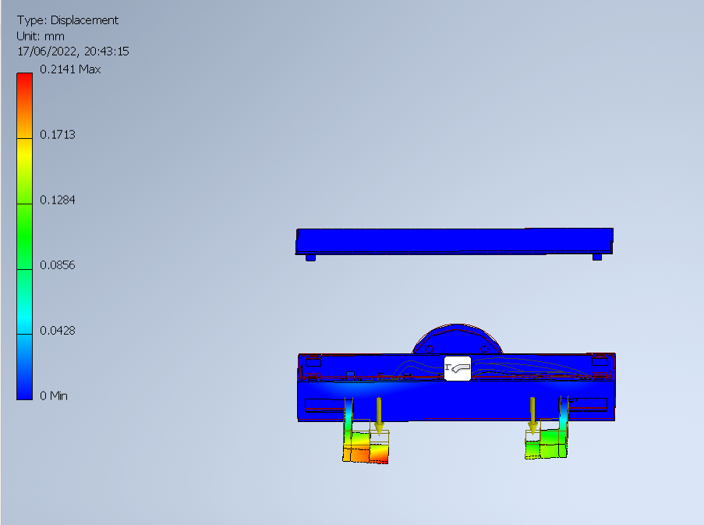

Figure 15 Displacement Stress Analysis
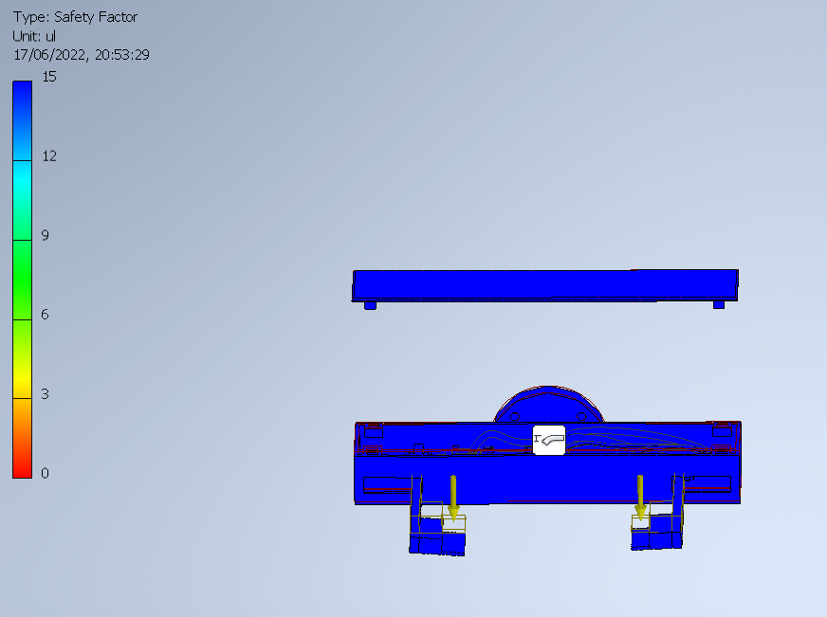
Figure 16 Factor of Safety Stress Analysis

Conclusion

With out the fabrication of the gripper it is very difficult to gauge if the product is a success or not. From the outlook of the design the gripper will meet the customers’ requirements of transporting the mobile phone. By carrying out design for x, FMEA and Lucas method the design was able to be streamlined into creating a good quality product which could easily be translated into a 3D printed model and all other parts need are all standard parts readily available. The design is very similar to an existing pneumatic dual cylinder gripper that is readily available. The draw back to this existing design is the fact that it costs £1800 to buy in. For this reason, the design this report has been set on was created, to make a cost-effective good quality product that is long lasting and adjustable. Swansea university are fully equipped to manufacture this gripper from scratch as they have 3D printing software and hardware available that print nylon parts. All internals would cost in total £183 pound, £45 each for the pneumatic cylinders, £36 pound for proximity switch, £13 for each magnetic reed switch and £5 for fixings. This is a £1617 pound saving assuming a in house 3D printer can be used. For £1617 less the university will be receiving a fully functional custom-built gripper that has been tailored to carrying out the task at hand. For this reason, the project is a success as there are no factors that have been brought up within the FMEA that could affect the functionality of the gripper.
If cost was not an issue the design could be made a lot differently, incorporating different sensors and other pneumatic cylinders that have a quicker reaction speed. This product would have been made differently if cost was not an issue, machined out of stainless steel to protect valuable internals within. This application how ever did not dictate the use of such material as the problem was purely to transport an item of a weight of around 150 grams from point A to point B. A gripper that would cost for example £1800 wouldn’t be considered viable for such a task, that is why the design was made as it was.

Bibliography
Michalos, G., Dimoulas, K., Mparis, K., Karagiannis, P. & Makris, S. 2018, "A novel pneumatic gripper for in-hand manipulation and feeding of lightweight complex parts—a consumer goods case study", The International Journal of Advanced Manufacturing Technology, vol. 97, no. 9-12, pp. 3735-3750.
Martin. “How to Choose the Best Nylon 3D Printer - Guide & List.” The 3D Printer Bee, 3 June 2020, the3dprinterbee.com/best-nylon-3d-printer/. Accessed 13 June 2022.
Iwaya, Leonardo H., et al. “A Design for Assembly Application with Dynamic Information Retrieval from Case Database*.” IFAC Proceedings Volumes, vol. 46, no. 7, 1 May 2013, pp. 186–191, www.sciencedirect.com/science/article/pii/S147466701535672X, 10.3182/20130522-3-BR-4036.00054. Accessed 14 June 2022.
Blok, L.G., et al. “An Investigation into 3D Printing of Fibre Reinforced Thermoplastic Composites.” Additive Manufacturing, vol. 22, Aug. 2018, pp. 176–186, 10.1016/j.addma.2018.04.039.
Kim, Y. (2020). Soft Pneumatic Gripper With a Tendon-Driven Soft Origami Pump. [online] Frontiers. Available at: https://www.frontiersin.org/articles/10.3389/fbioe.2020.00461/full [Accessed 15 Jun. 2022].
Chapman, Pal, A. K., Misra, M., & Mohanty, A. K. (2021). Studies on 3D Printability of Novel Impact Modified Nylon 6: Experimental Investigations and Performance Evaluation. Macromolecular Materials and Engineering, 306(2), 2000548–n/a.
Jack, Hugh. “Design for X - an Overview | ScienceDirect Topics.” Sciencedirect.com, 2012, www.sciencedirect.com/topics/engineering/design-for-x. Accessed 15 June 2022.
Moermond, Jack. “StackPath.” Www.powermotiontech.com, 30 June 2016, www.powermotiontech.com/technologies/cylinders-actuators/article/21885196/sensor-choices-for-pneumatic-cylinder-positioning. Accessed 15 June 2022.
Ranganathan, Swami. “5 Whys with Design Thinking.” Www.linkedin.com, 16 May 2016, www.linkedin.com/pulse/5-whys-design-thinking-swami-ranganathan/. Accessed 16 June 2022.
Shafiee, Mahmood, et al. “An Integrated FTA-FMEA Model for Risk Analysis of Engineering Systems: A Case Study of Subsea Blowout Preventers.” Applied Sciences, vol. 9, no. 6, 21 Mar. 2019, p. 1192, 10.3390/app9061192. Accessed 17 June 2022.

Appendix

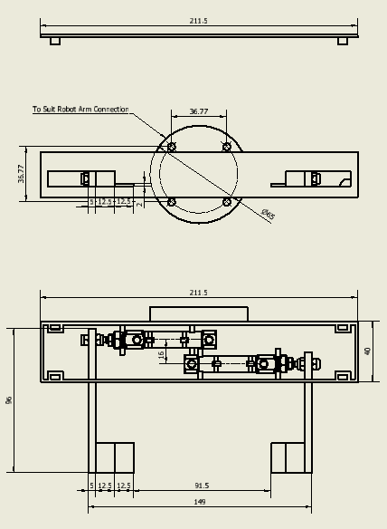
Appendix 1 Technical Drawing of Gripper

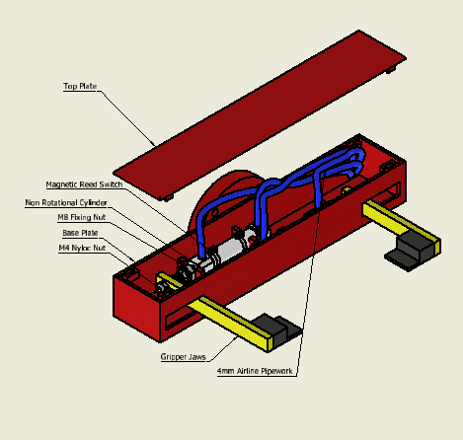
Appendix 2 Labelled Isometric View

