Olaudah Equiano
The Interesting Narrative of the Life of Olaudah Equiano, or Gustavus Vassa, the African (1789)
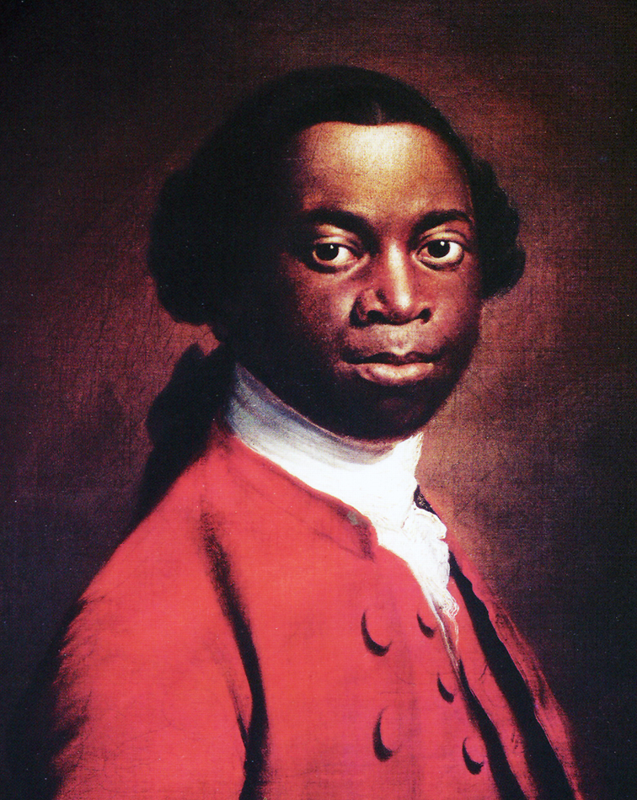

Claire Mann
1602593
HPHI5006 Routes and Roots of the Black Atlantic: Cultural Histories of the African Diaspora

Olaudah Equiano was born around 1745 in the Eboe region of the Kingdom of Benin, in the interior of the eastern part of modern Nigeria. Olaudah was the name given to him at birth and signifies vicissitude or fortune also: one favoured, and having a loud voice and well spoken.
Equiano reflects on the first scenes of his life and remembers a peaceful and pleasant upbringing, giving details of his early years within the Igbo tribe. He recalls a closeness to his mother, claiming he was her greatest favourite, spending all his time with her. The Igbo culture included many customs and traditions, religious beliefs, marriage and death rituals. Their manner of living was entirely plain and cheerfulness and affability were two of their leading characteristics.
Agriculture was the provinces main source of income and everyone engaged in it, including women and children. The land was rich and fruitful producing an abundance of food and other items. Vegetables and delicious fruits as well as cotton and tobacco were plentiful. Equiano recalls visiting the market regularly with his mother bartering such goods along with odoriferous woods, earth and the salt of wood ashes, for fire-arms, gunpowder and dried fish from the Oye-Eboe men who sometimes visited.
These fond memories Equiano recalls were soon to be shattered, one day when he was aged about eleven years old he and his sister were left to mind the house while the adults went to work. Two men and a woman climbed over the walls and without giving them time to shout or resist they were gagged and taken into the nearest wood.
The slave trade depended on African slavers to capture men, women and children from inland tribes, transporting them to the coast where they could be purchased by Europeans, embark on a journey known as the ‘middle passage’ and be sold onto the plantation owners in the Americas. For Equiano, his account would see him passed along a complex African trading nexus long before even meeting the Europeans.
With Equiano and his sisters hands tied they both were escorted until night came, they bedded down in a small house to rest till morning. He and his sister over powered with fatigue and grief, their only comfort, being in each other’s arms, bathing in each other’s tears. Though this wasn’t to last, his sister was torn from him, leaving them deprived of even weeping together. Equiano grieved terribly at the loss of his sister, not knowing if he would ever see her again. He was to continue his journey alone, changing masters as he went. Until he became the property of a chieftain and his family, he was treated well during his time there and found some comfort with the chieftain’s wife as she was similar to his mother. As time passed Equiano gained a little freedom and was able to wonder from the house, helping other staff with their jobs, during this time he was observing his surroundings to try and locate his father’s home and seize the opportunity to escape. While working on this plan his master’s daughter sadly died, and overcome with grief Equiano was once again sold. With his new owners he was reunited with his sister, in a mutual embrace, neither could speak just weep. The small relief her presence gave him from pain was soon gone as she was torn away once more, never to be seen again.
Such instances of hardship and cruelty continually occurred as Equiano travelled through different countries, He estimates it was some six or seven months from the date he was kidnapped until he arrived at the sea coast, and fails to relate all the incidents he endured during that time.
On arriving at the coast Equiano is astonished to see the slave ship, his astonishment is swiftly converted to terror as he is carried on board. Faced with a crew whose features he does not recognise and speaking a language he cannot understand he becomes over powered with horror and anguish as he realises he will be deprived of all chance of returning to his native country. He goes on to describe the poor conditions below deck, the filth and stench along with the violence he and his fellow slaves suffer, some slaves he found belonged to his own nation which provided him with a degree of comfort though he renders the whole scene one of unconceivable horror.
When the ship eventually arrived at Barbados they were faced with merchants and planters who came on board looking at what was on offer, some days later they would be transferred to a merchant’s yard where their sale would go ahead. The buying process described was not indifferent to that of the description Harriet Jacobs gave in Incidents in the life of a slave girl written by herself (1861) where they were treated as ‘merchandise’.
Equiano struggles with the whole experience; he questions the motives and the treatment they sustain and brandishes the whole process a new refinement in cruelty. The wretchedness that is called slavery.

Bibliography
Books

Olaudah Equiano, The Life of Olaudah Equiano, ed. by Paul Edwards (England: Longman Group Limited, 1988)
James Walvin, Slavery and the Slave Trade A Short Illustrated History (London: The Macmillan Press Ltd, 1983)
Harriet Jacobs (Linda Brent), Incidents in the life of a slave girl written by herself (1861) ([n.p.]: , 1861).

Olaudah Equiano, The Life of Olaudah Equiano, ed. by Paul Edwards (England: Longman Group Limited, 1988), p. 11.
Ibid, p15.
Ibid, p8.
James Walvin, Slavery and the Slave Trade A Short Illustrated History (London: The Macmillan Press Ltd, 1983), p. 44.
Olaudah Equiano, The Life of Olaudah Equiano, ed. by Paul Edwards (England: Longman Group Limited, 1988), p. 16.
Olaudah Equiano, The Life of Olaudah Equiano, ed. by Paul Edwards (England: Longman Group Limited, 1988), p. 25.

