
modelling industrial control systems in matlab
Ben Rowland-Jones

September 2, 2024
University of Wales Trinity Saint David

Table of Contents
1.0 Introduction 2
2.0 Main Findings 3
2.1 RenAM500 PLC System 3
2.1.1 PLC Cycle Time 5
2.1.2 Communication Protocols 5
2.1.3 Control System Software 6
2.2 Cruise Control System 9
2.2.1 Signal Encoding and Decoding 9
2.2.2 Feedback Controller Code 10
2.2.3 Bit Values 15
2.2.4 Sampling Times 16
3.0 Conclusion 17
4.0 Bibliography 18

Introduction

Industrial control systems (ICS) by definition is a system that allows for the control of industrial processes such as production, distribution and assembly manufacturing. ICS use the power of data acquisition equipment and programmable logic controllers (PLCs) to control any processes or equipment that is connected to the control system (Ross, 2012). They are integrated with hardware and software across a range of different industries including but not limited to automotive, aerospace, agriculture, manufacturing and robotics. They can be made up of embedded controllers, such as PLCs, real-time operating systems, data acquisition (DAQ) devices, transducers and sensors (Zhang, 2010).
This report aims to delve into control systems by first of all analysing a complex PLC found within the Renishaw RenAM500 additive manufacturing machine, which gets information from temperature and flow sensors and controls an array of solenoids, valves and mechanical hardware. The sampling times and delays will be reviewed and discussed, alongside the communication protocol between the various pieces of hardware connected to the PLC.
The second part of this report will be reviewing a PID controller used in a cars cruise control system and the MATLAB code that enables it to function correctly. An overview of the signal encoding and decoding gives an insight on how the signal within the system is changed during the course of the MATLAB script. Then the method of how the proportional, integral and derivative gains are calculated and eventually altered to bring down the steady state error in the system, which is displayed graphically using the MATLAB software. There will also be comments on using different bit rates for signal encoding and decoding and experimenting with different sampling times.

2.0 Main Findings

2.1 RenAM500 PLC System

The company Renishaw specialises in different areas of engineering including metrology, neurology and additive manufacturing and it is within the additive manufacturing (AM) product that the chosen control system resides.
The RenAM500 is an additive manufacturing machine that uses selective laser sintering in order to melt metal powder into the desired geometries. The machine uses an array of complex sub-systems that involve a powder and gas recirculation system, solenoids and sensors that are all controlled by a programmable logic controller (PLC). Below in Figure 1 is a photograph of the PLC that will be considered in this report:
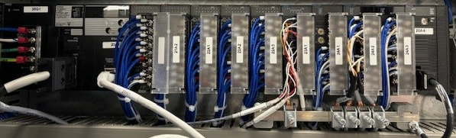
Figure 1, RenAM PLC (Rowland-Jones, 2024)
The first card on the PLC is the power supply, which connects the 24v power supply on the machine to the entire PLC. This card is connected to the processor, which controls the process and its operations as well as holding the memory of the system (Marian Engineering College, 2024). The following two cards after the processing unit are the input cards which are where all of the machines digital inputs are terminated into the PLC system which include:
- Powder level sensors
- Chiller data cable
- Capacitive sensors
- Contactor signals

The next four PLC cards are the three digital output cards and the input card that receives information from the temperature sensors across the machine. The output cards control multiple pieces of hardware in and around the RenAM machine and are responsible for controlling:
- Vent valves
- Argon valves
- Vacuum pump
- Gas pump cooling fan
The last four cards in the PLC rack are made up of three analogue input/output (I/O) cards and a position control unit that is connected to two servo drives which control the machines wiper and elevator. The three analogue I/O cards are connected to the following hardware:
- Pressure sensors
- Flow meters
- Load cell amplifiers
- Gas/powder recirculation pumps
Below in Figure 2 shows a block diagram taken from a wiring schematic of the PLC rack that is fitted onto the RenAM machines:
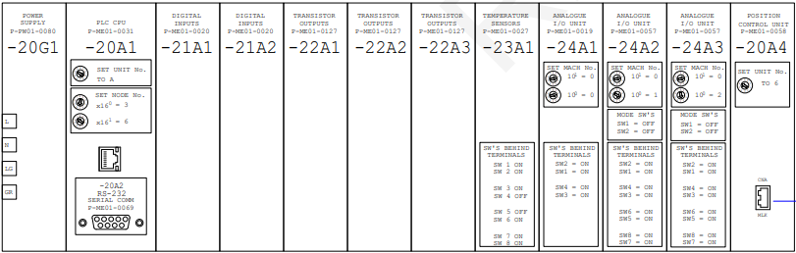
Figure 2, RenAM PLC Block Diagram (Rowland-Jones, 2024)

2.1.1 PLC Cycle Time

When a PLC is in run mode or is active, it is going through a scanning process which incorporates the reading and receiving of information from the inputs, program execution, communication tasks and diagnostic and finally an output scan where the outputs are updated (Lamb, 2016).
The cycle time on the RenAM500 PLC is set as standard to 1000ms, meaning that every 1000ms the input values are read, the PLC program is executed and communicated, and the outputs are read. The reason that the cycle time is so frequent is due to the nature of the machine; when dealing with high powered lasers that are printing complex parts by sintering metal powder, it is crucial that the control system has all the data it needs in case something goes wrong. Having the cycle time this frequently removes the risk of a time delay, which only occurs when the delay in control output is larger than zero but less than the control systems cycle time (Shin, 1995).

2.1.2 Communication Protocols

Communication protocols are extremely important in control systems as they are the rules or standards that determine how a given system communicates with each of its individual components and the protocol is the artificial language which denotes this communication system (Hercog, 2020). There are a number of different protocols used in industry, including but not limited to:
- Profibus
- Canbus
- Modbus
- Ethernet/IP
- TCP/IP
(Lin, 2018)
The RenAM500 machine PLC uses the Ethernet/IP communication protocol; which is due to the fact that this type of protocol offers a high speed connection with the components within its architecture. This protocol, along with the array of devices such as breakers and contactors within the machine will allow large data transfers for this particular control system (Warren, 2009).

The Internet of Things (IoT) describes a network of physical objects or components that are connected to the internet to be able to better communicate between these devices within a system (Rose, 2015). Since its inception, the idea of an industrial internet of things (IIoT) is a recognised Industry 4.0 principle looking to improve manufacturing efficiencies.
The idea of using IIoT in an industrial control system has a number of benefits, including protocol conversions across multiple wired communication (Ethernet/IP) devices. This would allow for different communication protocols to be used within the same system whilst also offering a “plug and play” level of installation (Anitha, 2022).

2.1.3 Control System Software

The control system within the RenAM500 uses an Omron PLC, which has its own programming software called CX-Programmer. The software, as seen in Figure 3, uses the ladder logic programming language to control the I/O and therefore the machines control system.
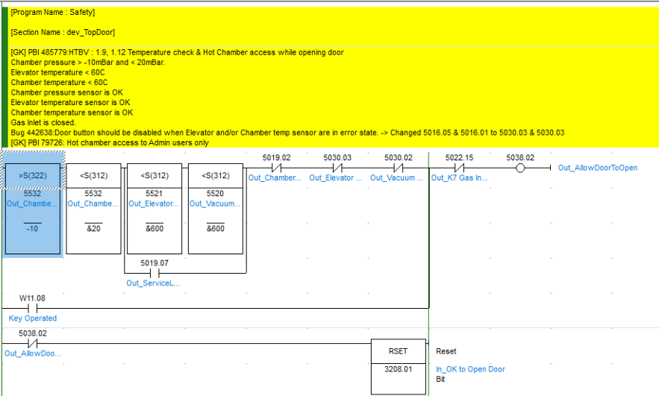
Figure 3, Top Door Ladder Logic (Renishaw plc, 2023)

From above, the ladder logic displayed is that of the top door safety logic, where certain criteria must be met in order for the top door of the machine to be opened by the user. It uses temperature and pressure sensors to monitor inputs, whilst also utilising a reset button and numerous inputs that form an OR gate and an AND gate before allowing the door to be opened.
This can be edited easily at any time, the only issue in doing so for these machines would be that you would have to manually update the PLC program for every machine that is in house or at a customer site; else there could be large amounts of machines that are running different control programs.
Renishaw has its own PLC simulation software called PLC Simulator (500Q), and in it you can use the RenAM500 machine software whilst also simulating a fully built PLC. This is very useful when trialling different limits and parameters as you don’t have to physically modify the machine to suit the development. Below in Figure 4 and Figure 5 are screenshots of the PLC simulator page and the machines HMI software page respectively:
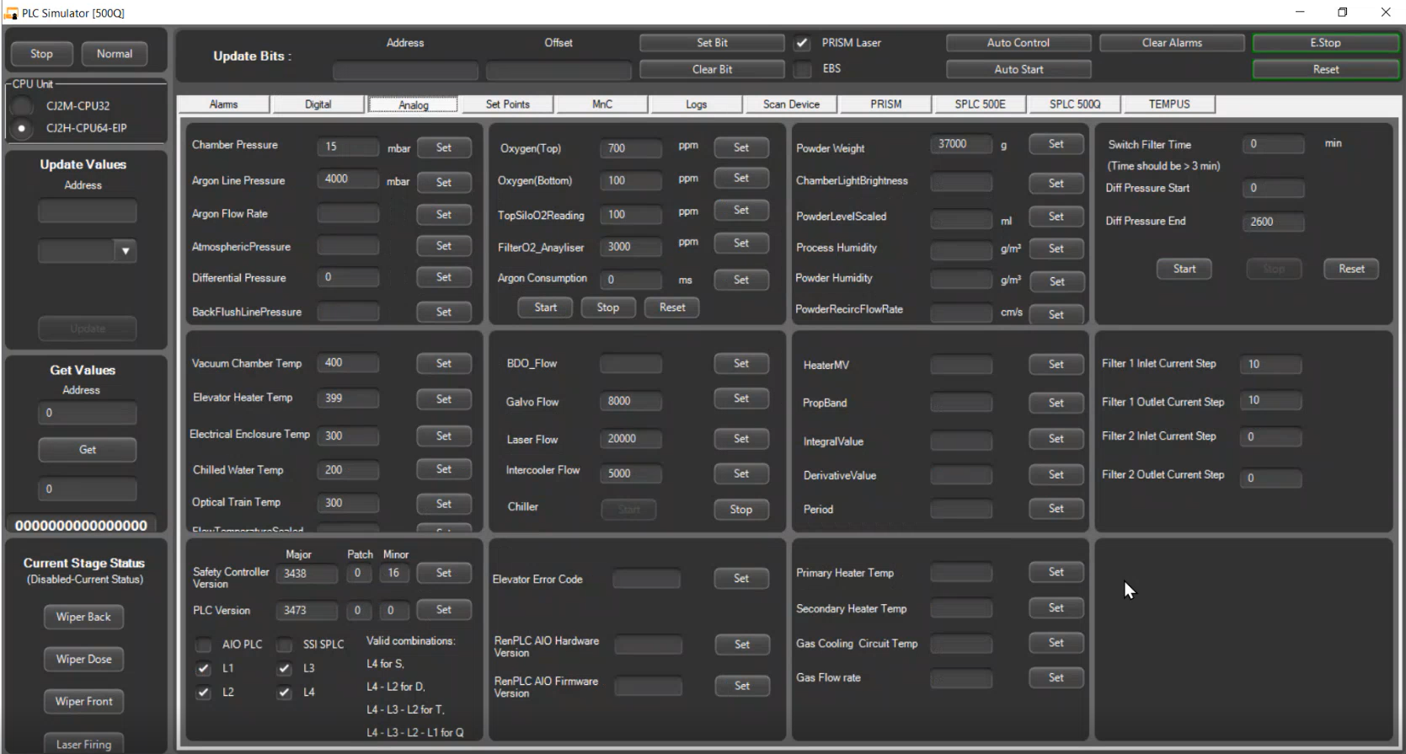
Figure 4, PLC Simulator (Renishaw plc, 2024)
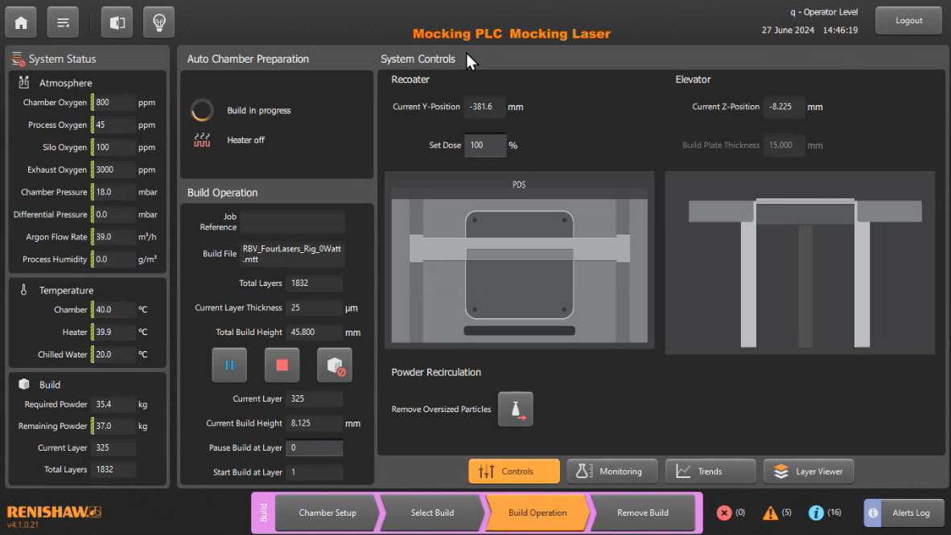
Figure 5, HMI Software Simulator (Renishaw plc, 2024)

2.2 Cruise Control System

Cruise control systems are available on most modern cars and have become a staple in the automotive industry due to its ease of use and for driver satisfaction, especially for people who travel long distances on motorways (Shaout, 1997). Within these cruise control systems will be a closed-loop system that houses a proportional-integral-derivative (PID) controller, which makes it possible to make a control system more stable and reduce variability by continuously monitoring process variables and making alterations based off of the difference or error between the desired setpoint and real world value.
To simulate a cruise control system, the software package MATLAB was used which is a coding software capable of carrying out complicated maths equations, developing algorithms and in this case, modelling and simulating a control system (The Math Works, 1997).

2.2.1 Signal Encoding and Decoding

One of the first things that is needed when simulating a cruise control system is the ability to use the encode and decode functions within the software. This is important as the first signal which is the speed manually inputted by the driver of the car is a binary signal, which cannot be used by the cars central processing unit (CPU). Therefore, a signal decode is needed which is written as follows:
((bin2dec(demand_raw)*(Max_demand-min_demand))/R)+min_demand

The “bin2dec” section is the MATLAB function which converts a binary signal to a decimal signal, using the numbers or strings that follow it. In this case, it uses an equation that includes the raw, minimum and maximum demand which is the number that is inputted by the driver of the car and the “R” value which is the number of bits in the actuator signal. The equation used can be seen below:
$$demand_{raw} × \frac{(\max_{demand}- \min_{demand})}{R}$$
This allows for the inputted speed from the driver to be used by the cars CPU to accelerate or decelerate car depending on driver demand. Once the CPU has made its adjustments, the decimal signal must be encoded back to a binary signal in order for the car to increase or decrease its speed in the real world. The signal encoder used as written as follows:
dec2bin(((control-min_ControlSig)/(Max_ControlSig-min_ControlSig))*R)

The “dec2bin” section is the MATLAB function that converts the decimal signal into the binary signal needed to increase or decrease the cars speed, followed by an equation that includes the minimum and maximum control signal and the same “R” value from the decode function. The equation used in the signal encoder can be seen below:

$$\frac{control-{control signal}_{min}}{{control signal}_{max}- {control signal}_{min}} ×R$$

2.2.2 Feedback Controller Code

Steady-state error can be described as the difference in the input and output of any given system, once the response reaches a steady state (CTMS, 2024). To try and avoid any steady-state error in the cruise control system, a proportional-integral-derivative (PID) controller was implemented. The use of these controllers comes from the necessity to efficiently resolve control problems (Li, 2006).
For this specific case, lines of code needed to be written to apply proportional, integral and derivative gain to the error in the system in order to reduce the overall steady-state error. To do this, a separate MATLAB function was written called “CalcControl” which has the P, I and D equations along with the minimum and maximum control signal values (-100 and 100 respectively).
There are also “if” statements in this function that explain if the ControlOut value is larger than the maximum control signal, that value should remain at the maximum control signal value i.e. if the ControlOut signal was 104, it would actually show as 100. A screenshot of the function is show below in Figure 6:

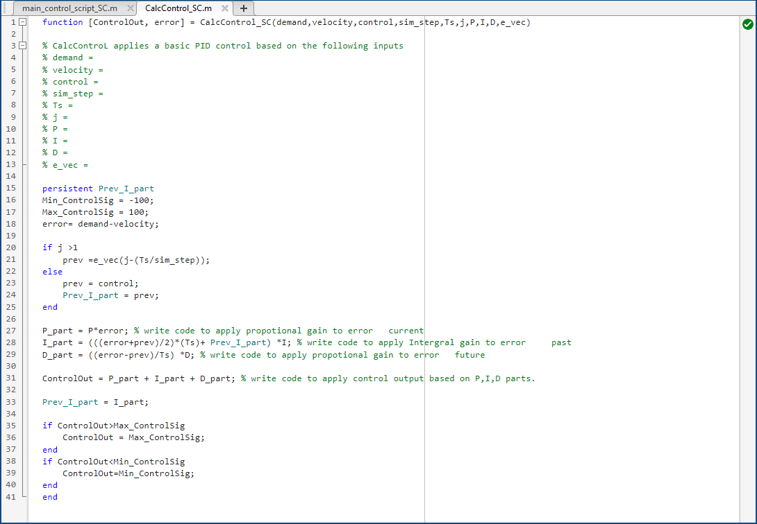

Figure 6, CalcControl Function (Rowland-Jones, 2024)

The code to apply the proportional gain is $P ×error$ where P is the inputted value found in the main control script and the error comes from the feedback from the system. This type of gain can be described as being proportional to the error in the system. A screenshot of where the P, I and D values are inputted can be seen below in Figure 7: 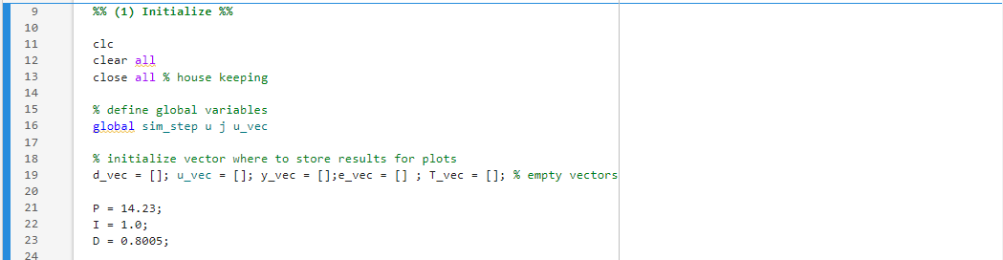
Figure 7, P, I and D Input Section (Rowland-Jones, 2024)

The equation used to determine the integral gain is $\left(\left(\frac{error+prev}{2}\right)×Ts\right)+(Prev I Part ×I)$ where “prev” is equal to the control or virtual speed, “Ts” is the sampling time which is set to 0.05 seconds, “prev I part” is equal to the previous control or virtual speed and “I” is the inputted integral value found in the main script. This equation is translated into MATLAB code as:

(((error+prev)/2)*(Ts)+ Prev_I_part) *I

The equation used to determine the derivative gain is $\left(\frac{error-prev}{Ts}\right)×D$ where “prev” is the virtual speed, “Ts” is the 0.05 second sampling time and “D” is the inputted derivative value found in the main script. This equation is translated into MATLAB code as:

((error-prev)/Ts) *D

Once all three of these equations were inputted into the CalcControl script, the gains could then be altered on the main script to try and reduce the amount of steady state error occurring from within the system. To achieve the lowest error possible, the P, I and D values needed to be changed in the section of the main script shown in Figure 8 below: 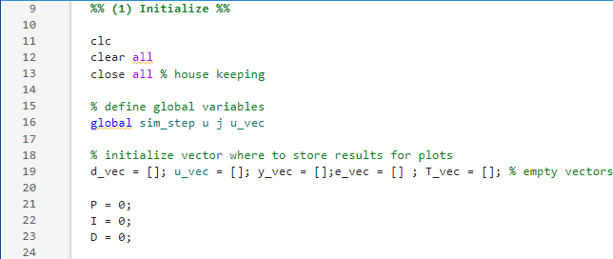
Figure 8, Zeroed P, I and D Inputs (Rowland-Jones, 2024)

The first value that was changed was the proportional gain (P), which was changed to a value of fifteen with the integral and derivative gain kept at zero. Once that value was inputted, the script was run for the first time and yielded the graph displayed in Figure 9:
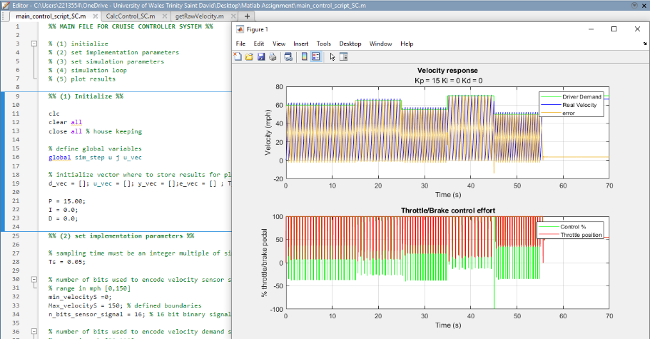
Figure 9, P(15) I(0) D(0) (Rowland-Jones, 2024)

From the top graph, the green line indicates driver demand and the blue line indicates actual velocity and the yellow line is the error in the system. As shown, there are frequent oscillations in the system that result in the current PID configuration being unstable. This could be due to the proportional gain being too high, but most likely because the integral and derivative values are set to zero so the main benefits of the I and D gains are not being used. The advantage of the I gain comes in the form of offset elimination, whereas the main benefit of the D gain increase would be minimising the change of error by analysing the change in error (Jones, 2024). The next step in reducing the steady state error was to introduce the integral and derivative gains, with the values being set to five and one respectively; the results of which are shown below in Figure 10:
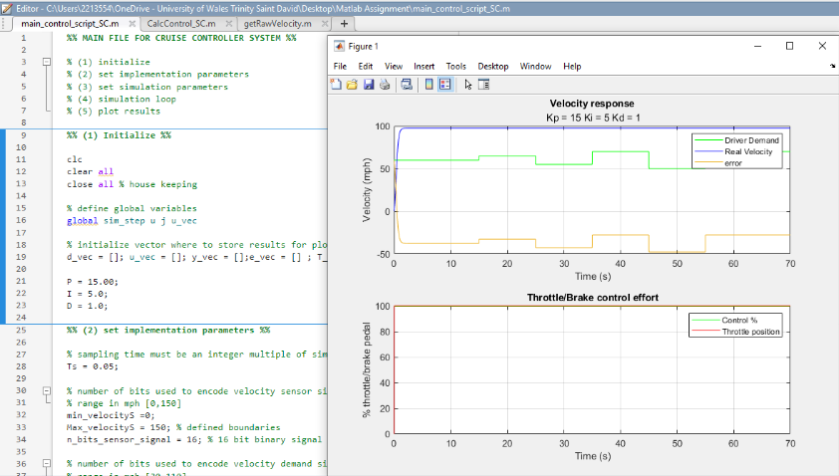
Figure 10, P(15) I(5) D(1), (Rowland-Jones, 2024)
There is a large amount of error in the system, displayed graphically in the top section of Figure 10. This shows the real velocity in blue overshooting the top limit of one hundred in the space of less than a second when the driver demand is sat at around sixty. This is due to the integral gain being too high which causes the system to destabilise so this value needed to be decreased.

After fine tuning the P, I and D gains, the configuration that showed the least steady state error was found. The final values for the proportional, integral and derivative gain are 14.225, 1.0 and 0.8005 respectively and the graphical representation of this configuration can be seen in Figure 11:
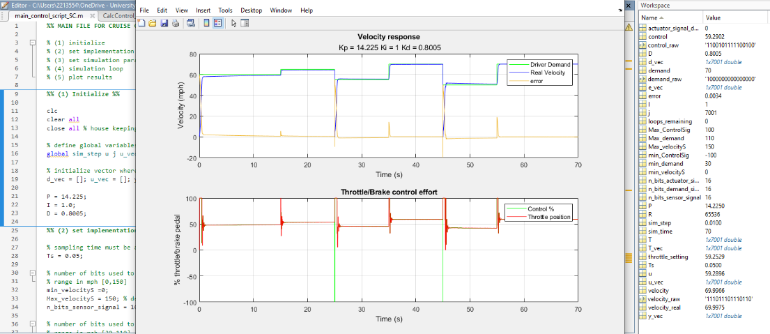

Figure 11, P(14.225) I(1) D(0.8005), (Rowland-Jones, 2024)

As shown, the steady state error has been reduced so much that the green and blue lines are overlapping in the top graph, denoting the driver demand and real velocity being nearly identical. Also from the top graph, the yellow line that denotes error is at zero for the majority of the cycle; with this graphical representation being backed up by the two values in red boxes in Figure 11 which shows the velocity demand and real velocity which has a difference of 0.0025 miles per hour.

2.2.3 Bit Values

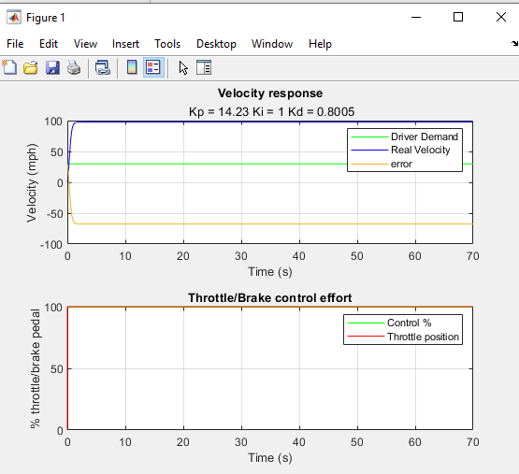
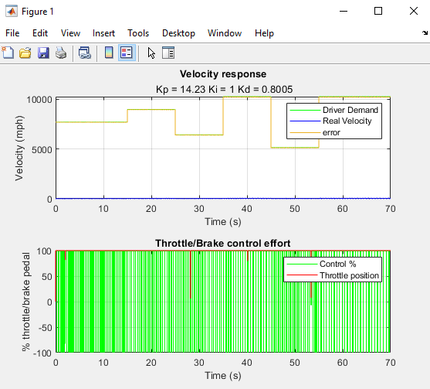
Another variable that can be altered in the main script of this cruise control system is the signal bit value, which directly affects how much data can be transferred or processed at any given time (Lenovo, 2024). The optimal bit rate for encoding the throttle/brake actuator signal is 16 bit, which is what is configured in Figure 11 above, but for the purpose of this report that value was tried at 8 bit and 32 bit; both of which are represented graphically below in Figures 12 and 13:

Figure 12, 8 bit (Rowland-Jones, 2024) Figure 13, 32 bit (Rowland-Jones, 2024)

As shown, when the bit value is lower the throttle/brake becomes uncontrollable, denoted by the green line in the bottom graph of Figure 12. When the bit value is higher however, the throttle/brake position shoots up to the maximum 100% value immediately and does not decrease at any point in the cycle. This is because experimenting with different bit values will affect the accuracy of the signal; the lower the bit value, the less information is processed which leads to a less accurate signal. The higher the bit value, the more strain is put on the system meaning the system is having to work harder to control the output which in this case is the throttle/brake pedal.

2.2.4 Sampling Times

Sampling time is the rate that control systems sample the inputs within their architecture, or the amount of time in between reading the input values (MathWorks, 2024). The optimal sampling time for this system is 0.05 seconds, which is an integer multiple of the simulation time step or sim_step.
Experimenting with this value would affect how often the cruise control system would monitor the demand given by the user, with the higher the value the higher the value resulting in an oscillating signal and increase in control effort to attempt to bring the system under control. This is displayed graphically below in Figure 14, where the sampling time is increased to 0.1:
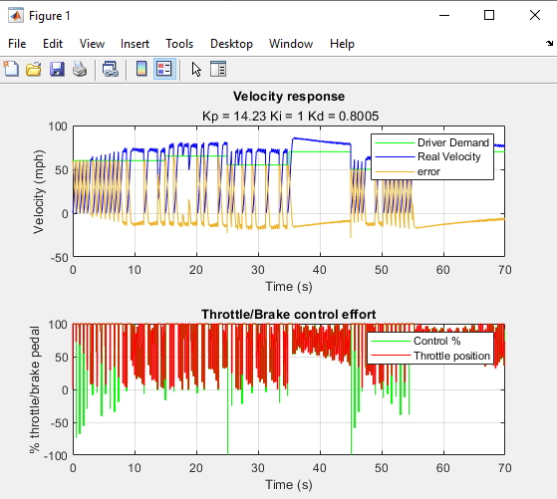
Figure 14 (Rowland-Jones, 0.1 Sampling Time, 2024)

3.0 Conclusion

The RenAM500 control system uses an Omron PLC to control its inputs and outputs, depending on the information from the temperature and flow sensors in order to calculate and execute demands to the solenoids, pumps and valves within the system. It runs using a 1000ms sampling time which is beneficial for removing any time delays in the system, thus optimising data acquisition and therefore overall build quality.
The PLC uses an Ethernet/IP communication protocol to talk to the components connected to it, although improvements could be made in the shape of a newer Industry 4.0 principle IIoT communication network, which could allow for multiple different protocols to be used within the same system.
The PID controller used within a typical car cruise control system uses a MATLAB script to ensure that the variables used in plotting the velocities are accurate. Variables such as actuator signal bit rate, simulation times and proportional, integral and derivative gains are controlled in the script, along with commands that encode and decode the signals within the system. The CalcControl script is where the minimum and maximum control signal parameters are pulled from, and it is also where the equations for working out the proportional, integral and derivative gains are stored.
Through this report, it is emphasised the important role that PID controllers and PLCs play in industrial control systems. By experimenting with their individual gains and system settings respectively, one can see the necessity for these devices as they give the opportunity to enhance and improve the robustness of any given system.

4.0 Bibliography
Anitha, T. (2022). A Review on Communication Protocols of Industrial Internet of Things. IEEE.
CTMS. (2024). Steady-State Error. Retrieved from Control Tutorials for MATLAB & Simulink: https://ctms.engin.umich.edu/CTMS/index.php?aux=Extras_Ess
Hercog, D. (2020). Communication Protocols. Ljubljana: Springer.
Jones, J. (2024). Lecture 1 - Closed Loop and Data. Swansea, Swansea, Wales.
Lamb, F. (2016). Ladder logic 105. Control Engineering.
Lenovo. (2024). What is 8-bit? Retrieved from Lenovo: https://www.lenovo.com/us/en/glossary/what-is-8-bit/?orgRef=https%253A%252F%252Fwww.google.com%252F
Li, Y. (2006). PID control system analysis and design. IEEE Control Systems.
Lin, Z. (2018). An inside look at industrial ethernet communication protocols. Texas Instruments.
Marian Engineering College. (2024). Module 6, Programmable Logic Controllers. Retrieved from Marian: https://www.marian.ac.in/public/images/uploads/pdf/online-class/eee/MODULE%206iia.pdf
MathWorks. (2024). What is Sample Time? Retrieved from Help Center: https://uk.mathworks.com/help/simulink/ug/what-is-sample-time.html
Renishaw plc. (2023). Top Door Ladder Logic. Miskin, Vale of Glamorgan, Wales.
Renishaw plc. (2024). PLC Simulator. Miskin, Vale of Glamorgan, Wales.
Rose, K. (2015). The Internet of Things: An Overview. The Internet Society.
Ross, R. (2012). Guide for Conducting. National Institute of Standards and Technology.
Rowland-Jones, B. (2024). 0.1 Sampling Time. Swansea, Swansea, Wales.
Rowland-Jones, B. (2024). CalcControl Function. Pontyclun, RCT, Wales.
Rowland-Jones, B. (2024). P, I and D Input Section . Pontyclun, RCT, Wales.
Rowland-Jones, B. (2024). PID Input Variation. Swansea, Swansea, Wales.
Rowland-Jones, B. (2024). RenAM PLC. Miskin, RCT, Wales.
Rowland-Jones, B. (2024). RenAM PLC Block Diagram. Miskin, RCT, Wales.
Rowland-Jones, B. (2024). Various Bit Values. Swansea, Swansea, Wales.
Shaout, A. (1997). Cruise control technology review. Computers and Electrical Engineering.
Shin, K. G. (1995). Computing Time Delay and Its Effects on Real-Time Control Systems. IEEE TRANSACTIONS ON CONTROL SYSTEMS TECHNOLOGY.
The Math Works. (1997). Matlab. Natick: The Math Works.
Warren, J. C. (2009). Ethernet/IP Applications for Electrical Industrial Systems. IEEE.
Zhang, P. (2010). Advanced Industrial Control Technologies. London: Elsevier.

