  Component One: What are the key skills required when working in the housekeeping team? | Student No: | 2210502
 | Module Title: | Operating Hotel Facilities
 | Module Code: | BMIH4006
 | Lecturer: | LISA BASSLER
A housekeeping team refers to such a team which deals essentially with cleanliness and ancillary services so that effective hospitality services can be provided. The housekeeping team is a relevant aspect of the housekeeping department present in a hotel which is responsible for maintenance, cleanliness, aesthetic keeps of rooms etc. (Alcalde-González, et al., 2021). The team ensures that all the duties and responsibilities with respect to vacuuming, sweeping, removing of waste materials, maintaining orderliness etc., are fulfilled. There are several relevant skills which are required while working in the housekeeping team which can be described as follows-
1. Time management skills- This is a very relevant skill which individuals working in the housekeeping team require. I need to possess effective time management skills so that I can complete all the tasks and responsibilities related to housekeeping effectively. This will help me to avoid all types of delays and activities like cleaning, waste disposal and management, organizing etc., can be efficiently performed by me (Dhaliwal and Misra, 2020).
2. Attentiveness- It is very important for me to possess high level of attentiveness in order to work in the housekeeping team. This will help me to perform the tasks such as floor cleaning, window cleaning, organizing of things etc., in a very specialized way and I will be able to pay attention to minute details. This will also help me to give close attention to all the needs and requirements of the guests and hence, it will help me to discharge my responsibilities efficiently (Espellita and Maravilla Jr, 2019).
3. High level of honesty- This is a very relevant skill which is to be possessed by me in order to work in the housekeeping team. This will help me to maintain transparency with my guests as well as immediate supervisor. This will help me to maintain strong relations with my team members as well. For example, while working in Hilton Hotel, a situation arose in which I damaged the expensive clothes of the guest. However, I honestly apologized for my mistake and accepted my fault which impressed my manager adequately.
4. Laundry skills- This is a very relevant skill which is to be possessed by me in order to work in the housekeeping team. All the activities such as washing of clothes, folding them, ironing them etc., are to be performed effectively. Systematic laundry related skills and procedures are to be followed to improve the skill further (Mistry, et al., 2022).
5. Communication skills- In order to work in the housekeeping team, I need to possess strong communication skills. This will help me to interact with several types of guests on a day-to-day basis effectively. It will also make me to complete my roles and responsibilities in the most effective manner. Moreover, I will be able to coordinate and cooperate with my immediate superior as well as other team members when I possess this skill.
6. Flexibility skills- I need to be highly flexible in order to work in the housekeeping team. Hence, I need to be completely agile in order to work as further changing rules and regulations of the hospitality organization. Also, I need to work as per the reeds and requirements of the guests which require high level of flexibility (Ng, 2021).

Application of the relevant theoretical knowledge to work in hospitality industry:
In order to work in the hospitality industry, theoretical application of knowledge is very essential. Individuals working in different departments and teams of the hospitality sector including the housekeeping teams needs to ensure that they apply relevant theories and concepts with respect to hospitality and management (Saraiva, et al., 2019). It helps them to demonstrate effective skills and knowledge to overcome all types of complex situations.

Relevance of the skills to individuals working in housekeeping team
All the skills which have been identified such as time management skills, honesty, attentiveness, laundry skills, flexibility skills and communication skills are very relevant in order to make an individual competent to work in the housekeeping team (Tiwari and Munjal, 2019). I have found that these skills are very important and they help in showing high level of effectiveness in fulfilling roles and responsibility in the housekeeping team. It also helps in effective compliance with organizational policies and rules. When these skills are possessed by individuals, they are able to showcase high level of effectiveness (Tra, 2020). In my opinion, I possess most of these skills. However, I need to work on improving these skills further and I need to develop new skills so that I can work in the housekeeping team efficiently.

Component Two:
Problem | Why did it happen? | What are you going to do? | How will you prevent this from happening in the future? | What measures would you introduce to improve team effectiveness?
Lack of cleanliness in the hotel rooms | This problem occurred due to lack of proper monitoring and fulfilment of responsibilities (Bridger, 2018). | I will resolve the issue with the help of all the team members. | By monitoring functioning of all the team members. | I would implement standards of cleanliness.
None of the housekeeping team members took the complain for lack of cleanliness seriously | This problem occurred due to lack of communication among the housekeeping team (Cottrell, 2019). | I will ensure increased cleanliness in the room (Mali and Mali, 2022). | I will ensure that there is proper communication among the team members. | I would try to use modern technology to monitor all the team members.
Problem related to dirty laundry services causing customer dissatisfaction | This problem occurred due to ineffective compliance with laundry related rules and regulations. | I will recheck and monitor the work of all the team members. | I will ensure that all the laundry related standards are followed (Mullins and Dossor, 2013). | I would improve the laundry services and provide more training to the team members.

Component Three:

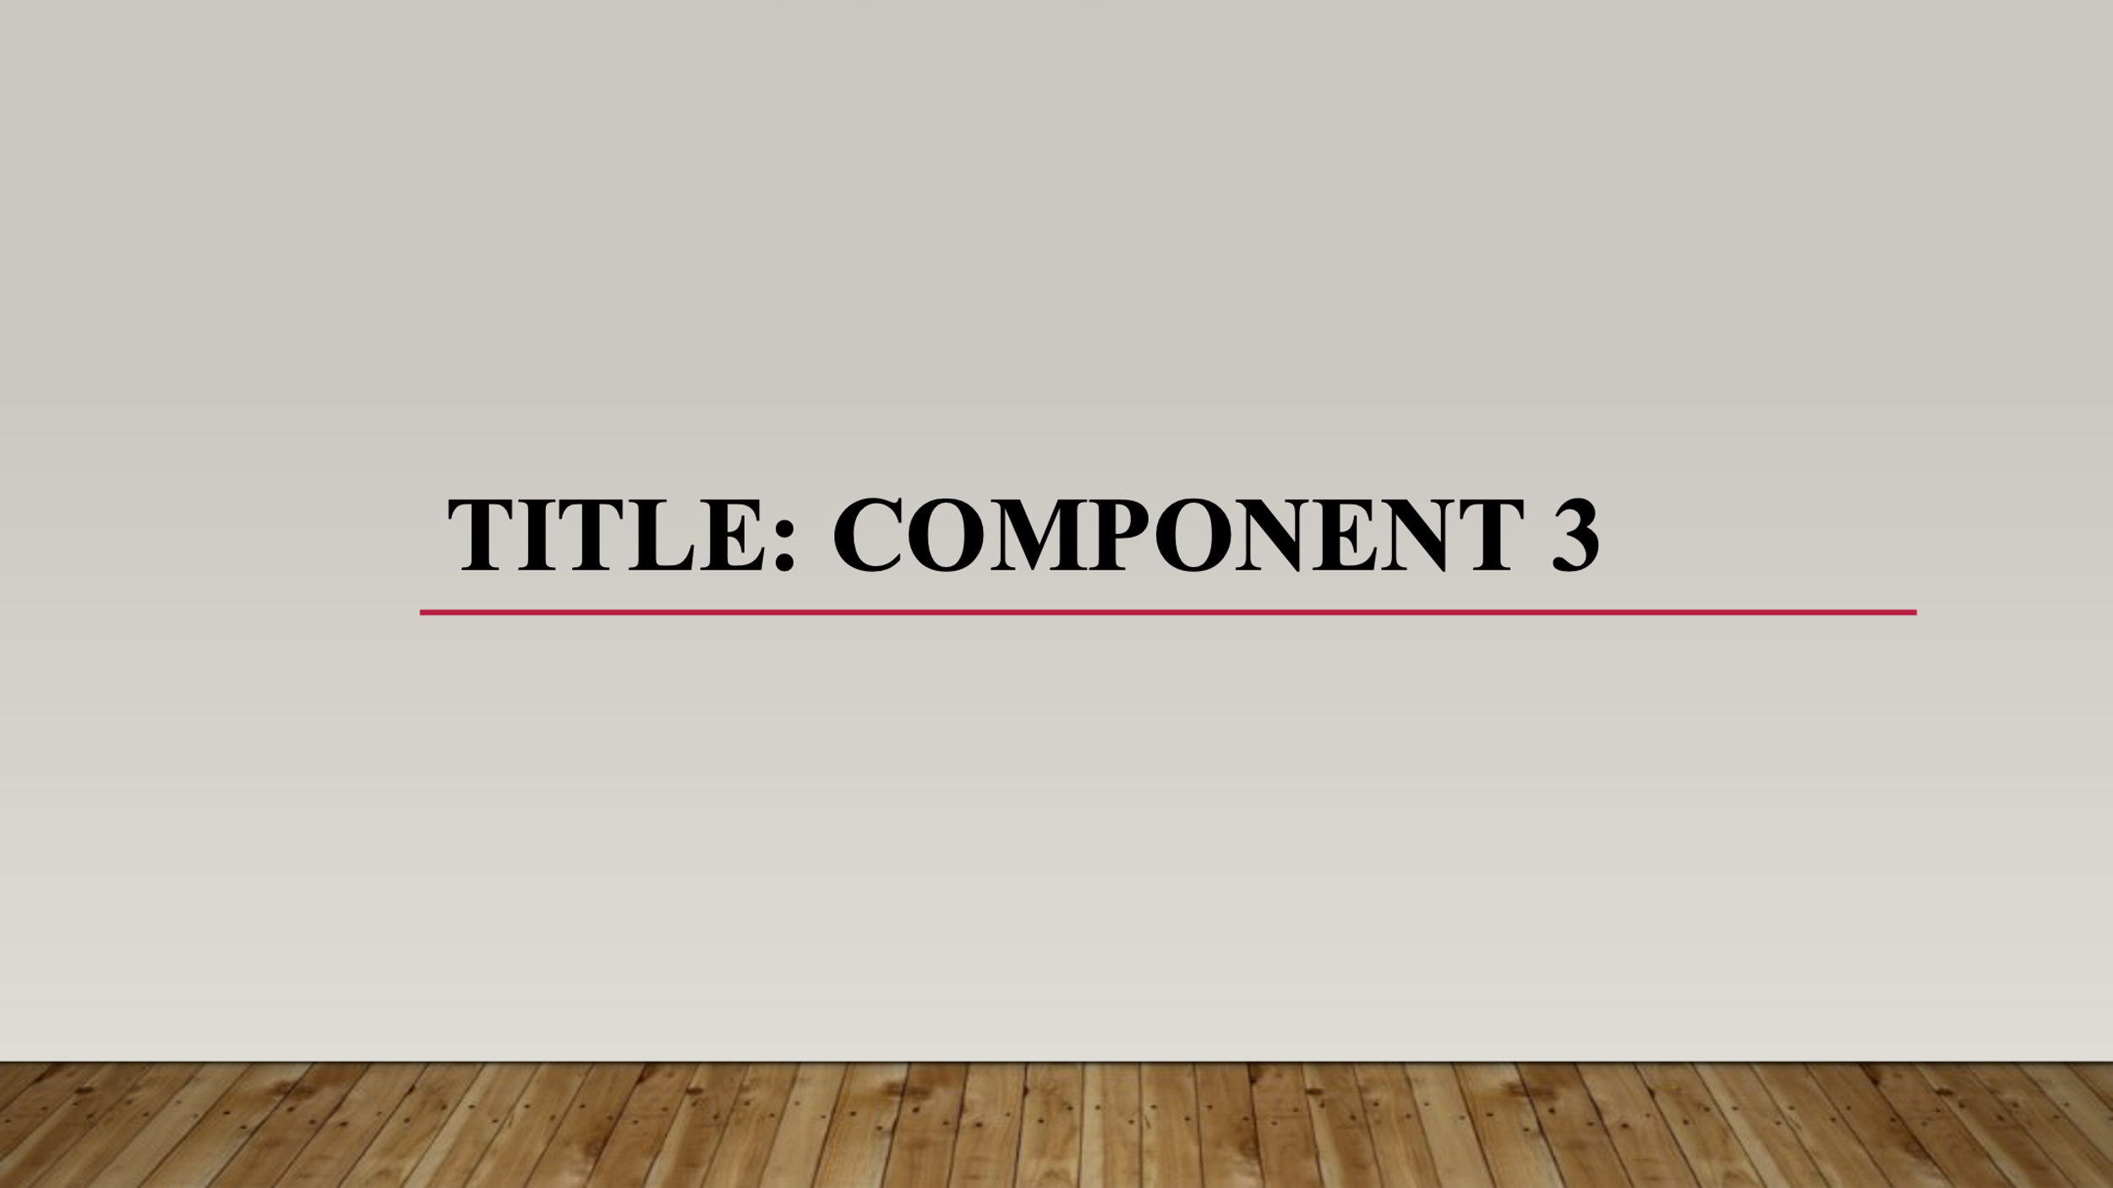
Introduction
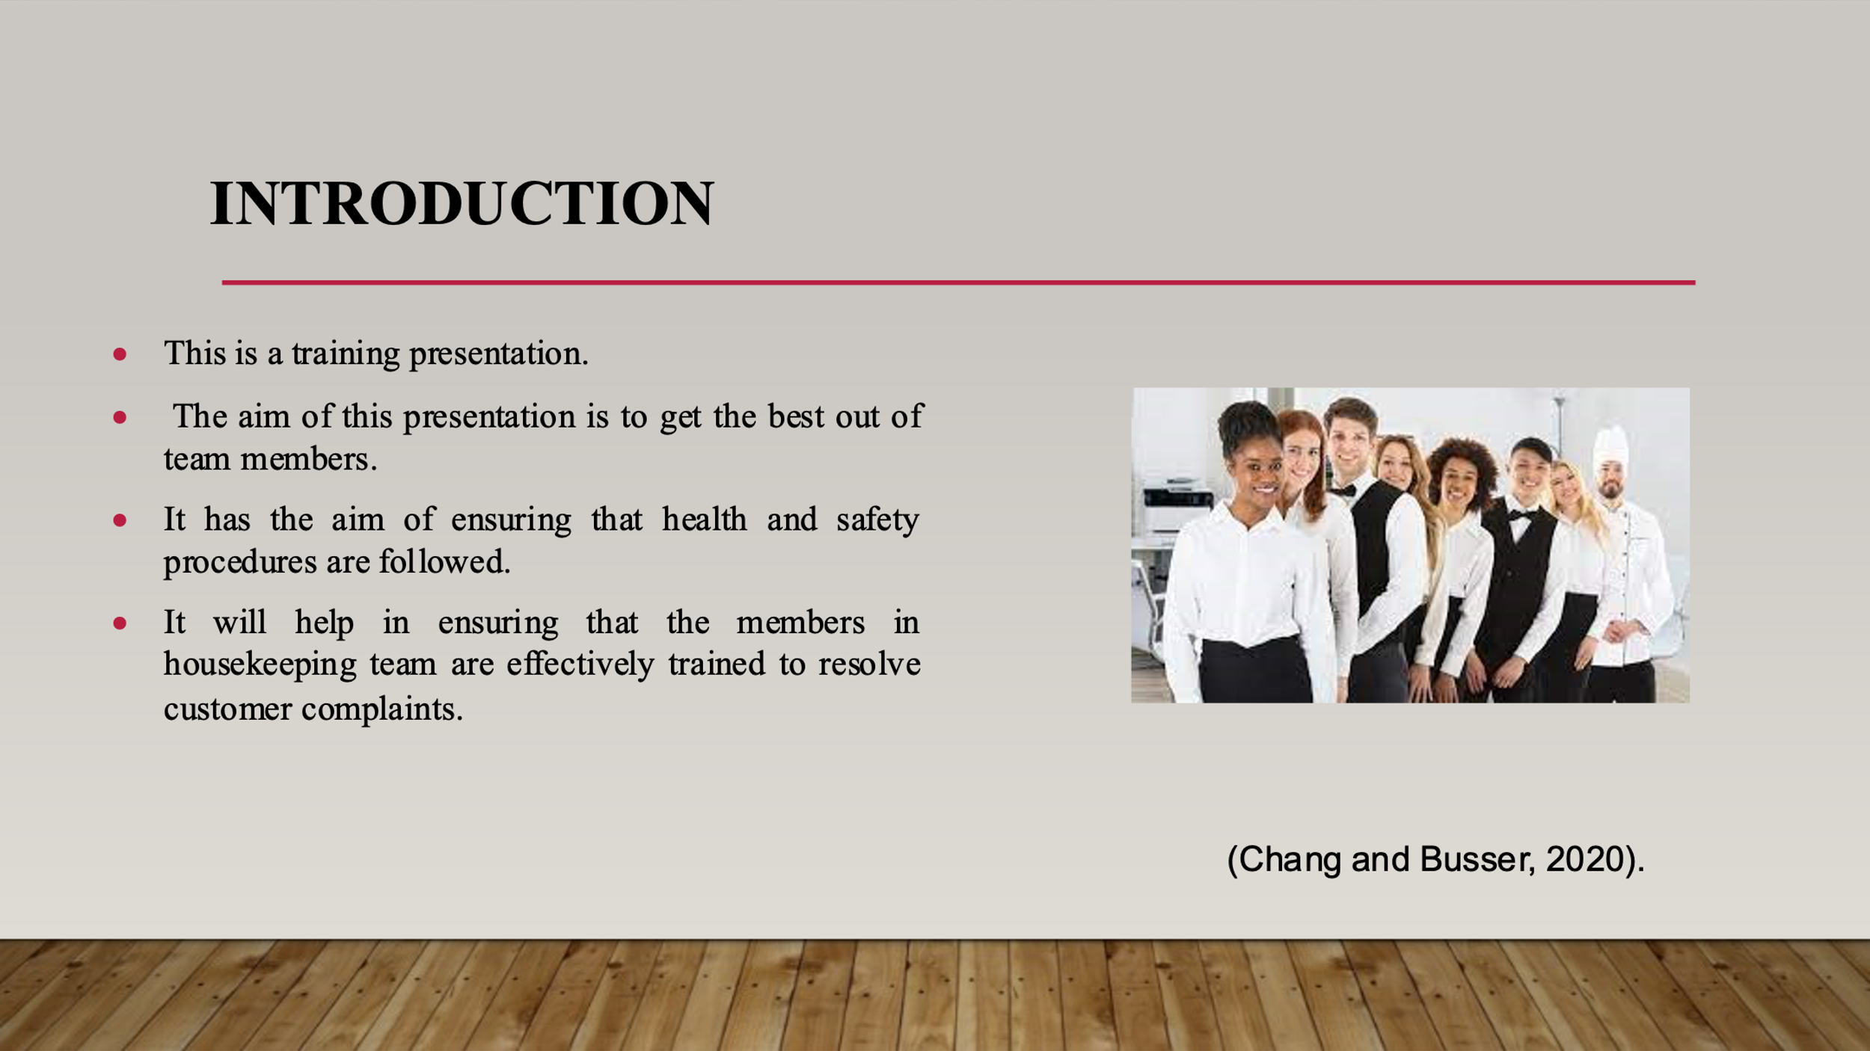
Training Notes: In this presentation, the major aim is to train the housekeeping team members so that they can resolve the guest complaints effectively. The presentation is prepared in order to train them so that they can provide their best services to the guests. It will also be made sure that relevant information and training is given to the team members about health and safety procedures and the ways of functioning.
Analysis of the guest problem
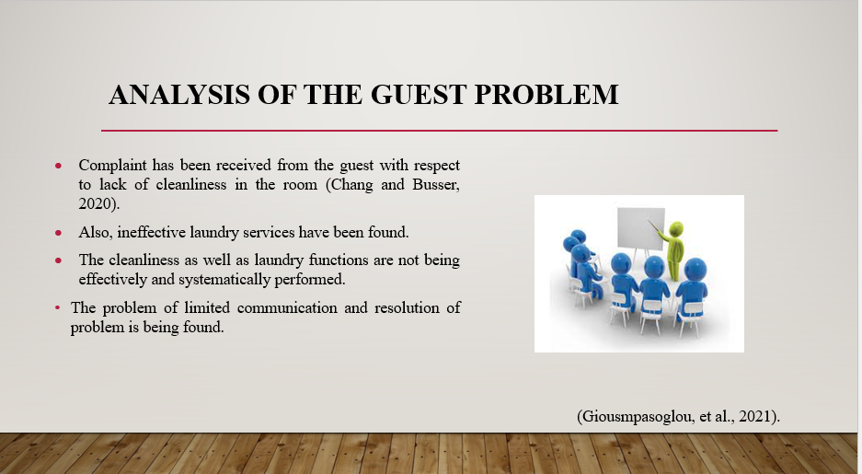
Training Notes: This slide discusses about the problem which the guest has faced in the hotel. A major problem has been faced with respect to untidiness of the room. Even after it has been communicated, relevant measures have not been taken by the housekeeping team to overcome the problem (Giousmpasoglou, et al., 2021). Hence, it has created huge difficulties and has led to guest dissatisfaction. Difficulties with respect to performing of cleanliness and laundry functions are found which is creating guest dissatisfaction to a large extent.
Analysis of the procedures for maintaining safety and health
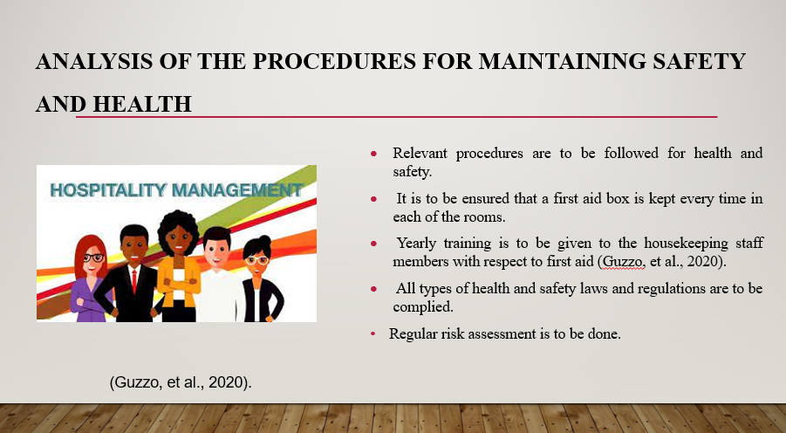
Training Notes: There are various procedures with respect to health and safety that are to be followed by the housekeeping staff members. They have to make sure that they comply with the health and safety related standards and laws. Also, in case of any accident, they need to ensure that the first aid is provided on time. A proper and well-equipped box of first aid is to be kept in each of the room so that policies of medical emergencies can be met on time. Adequate training facilities are to be provided to the housekeeping members so that they can provide effective medical facilities during times of emergency. They are to be effectively trained with respect to health, safety and other relevant aspects (Li, et al., 2021).

Overview of training facilities arranged
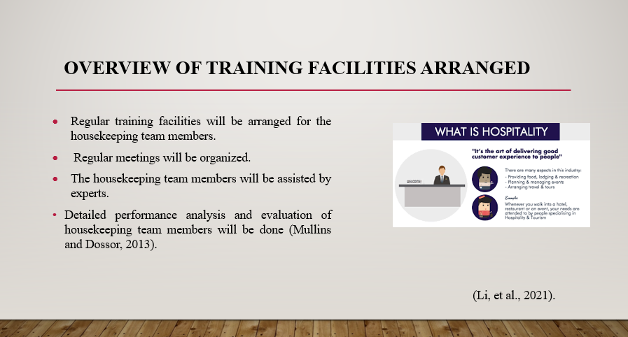
Training Notes: In this slide, discussion is made about the training facilities that will be provided to the housekeeping team members. The training facility will be provided by the hotel and it will be managed that regular training is given to them. Also, they will be assisted by seniors and experts to make them well trained. Proper education about health and safety, ways of functioning in the hotel, ways of discharging duties and responsibilities etc., will be given to them.
Measures for problem solving
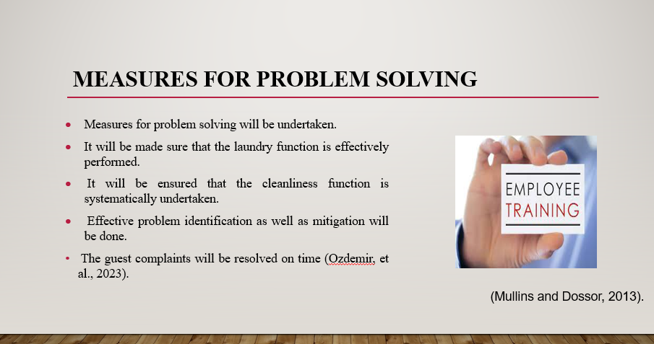
Training Notes: In this slide, discussion is made about various measures that will be undertaken in the hotel for problem solving. All these measures have to be followed by the housekeeping team members. It will be made sure that the laundry function is efficiently undertaken. Moreover, focus will be given on improving the cleanliness function (Pan, 2023). It will ensure that all types of problem identification are done on time and their mitigation is efficiently done. The guest problem will be identified and their complaints will be resolved on time.
Indicators for measuring the performance of the training facilities
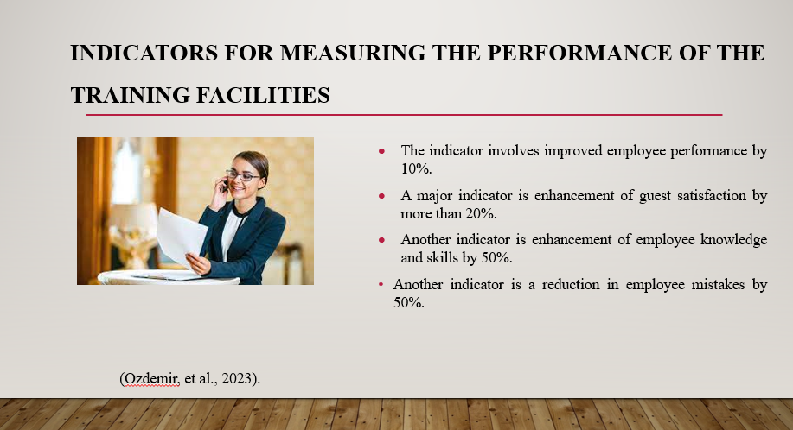
Training Notes: There are several indicators which will help in measuring the effectiveness and performance of training facility. This indicator is with respect to improved employee performance, improved guest satisfaction, enhancement of employee knowledge and skills as well as reduction of employee mistakes (Quick, 2020). When these indicators are attained, it will be ensured that the training facility is successful. Provision of training will help in minimizing employee mistakes and will improve their capabilities and skills to a large extent.
Linking an employee engagement model to a best practice industry example
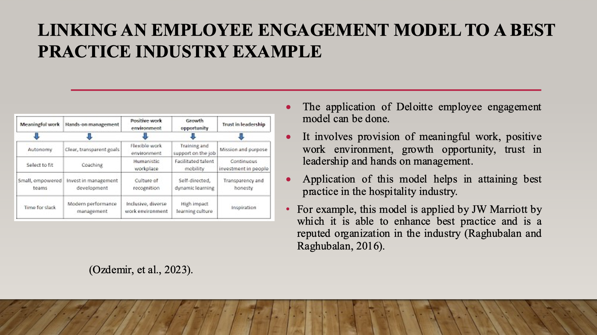
Training Notes: In this section, discussion is made about the employee engagement model known as Deloitte employee engagement model. It is a very relevant model and has various aspects such as provision of meaningful work, positive working environment, growth opportunities, hands on management as well as trust in leadership. The JW Marriott implements this model by which it is able to apply best practice with respect to employee engagement in the hospitality industry (Sharma, et al., 2020).
Conclusion
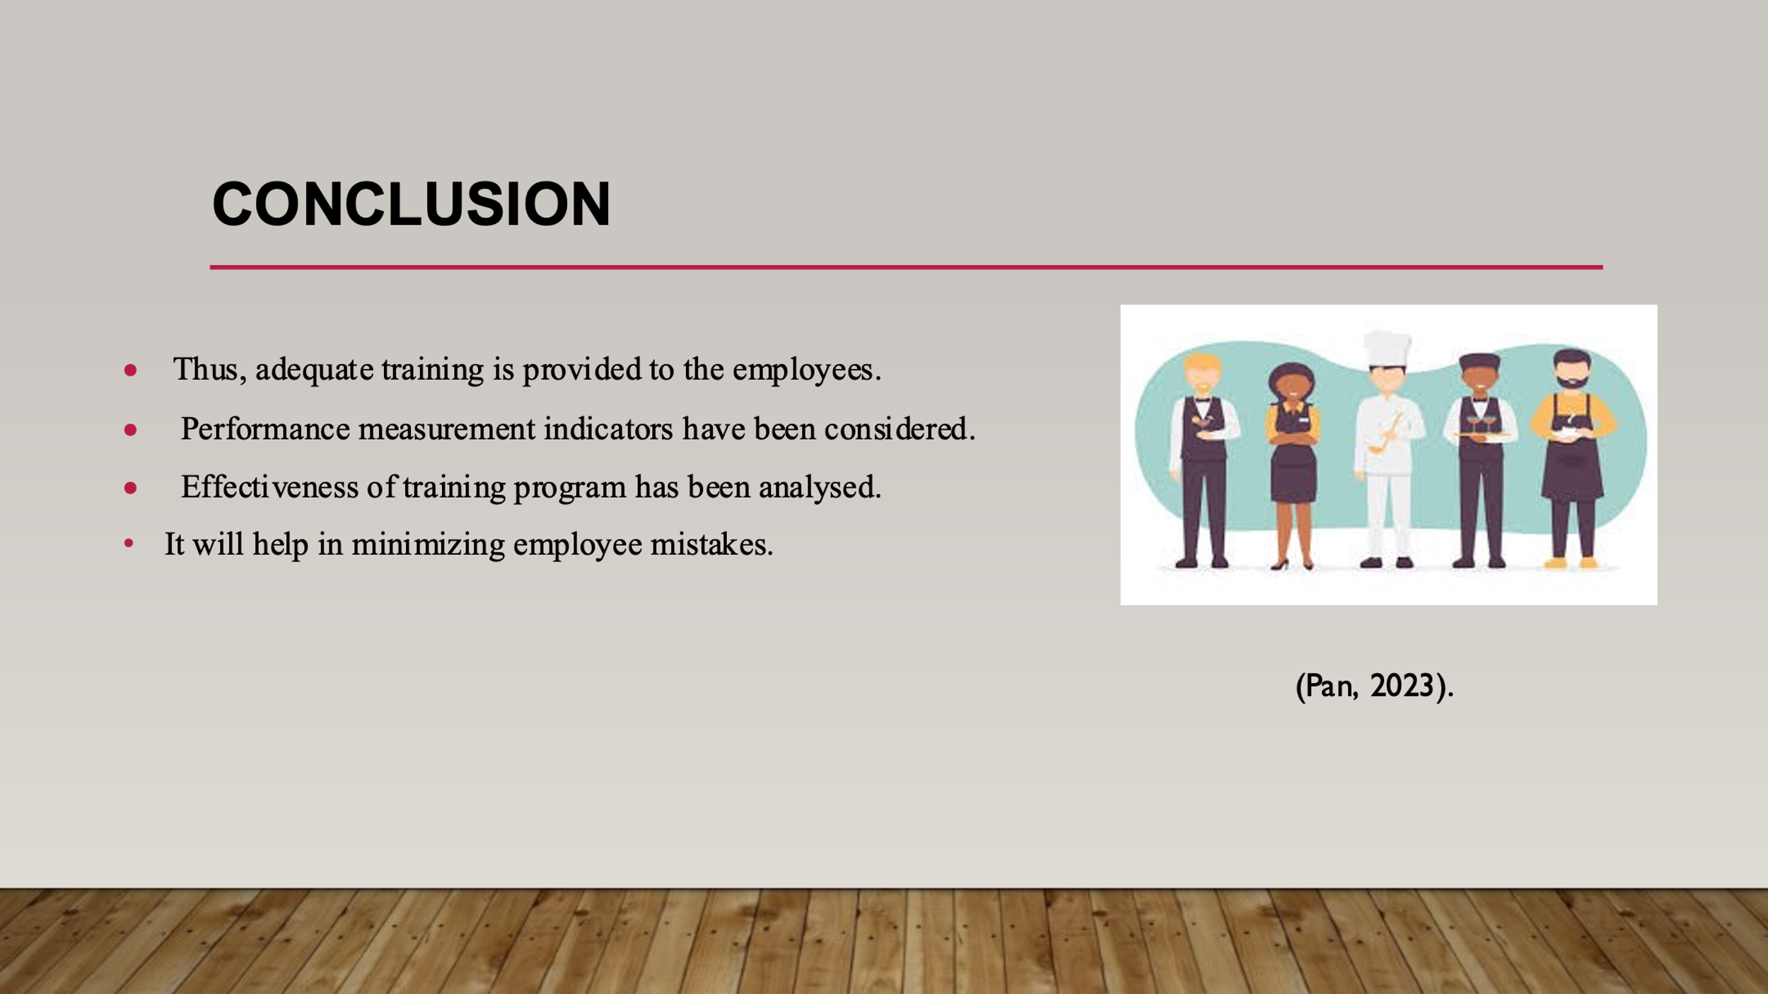
Training Notes: Thus, the presentation has discussed in details about the training facility which will be provided to the team members. It will help in overcoming all the problems that are created in the hotel. It will make the team members to provide best services to the guests. It will help in improving their performance effectively.

References
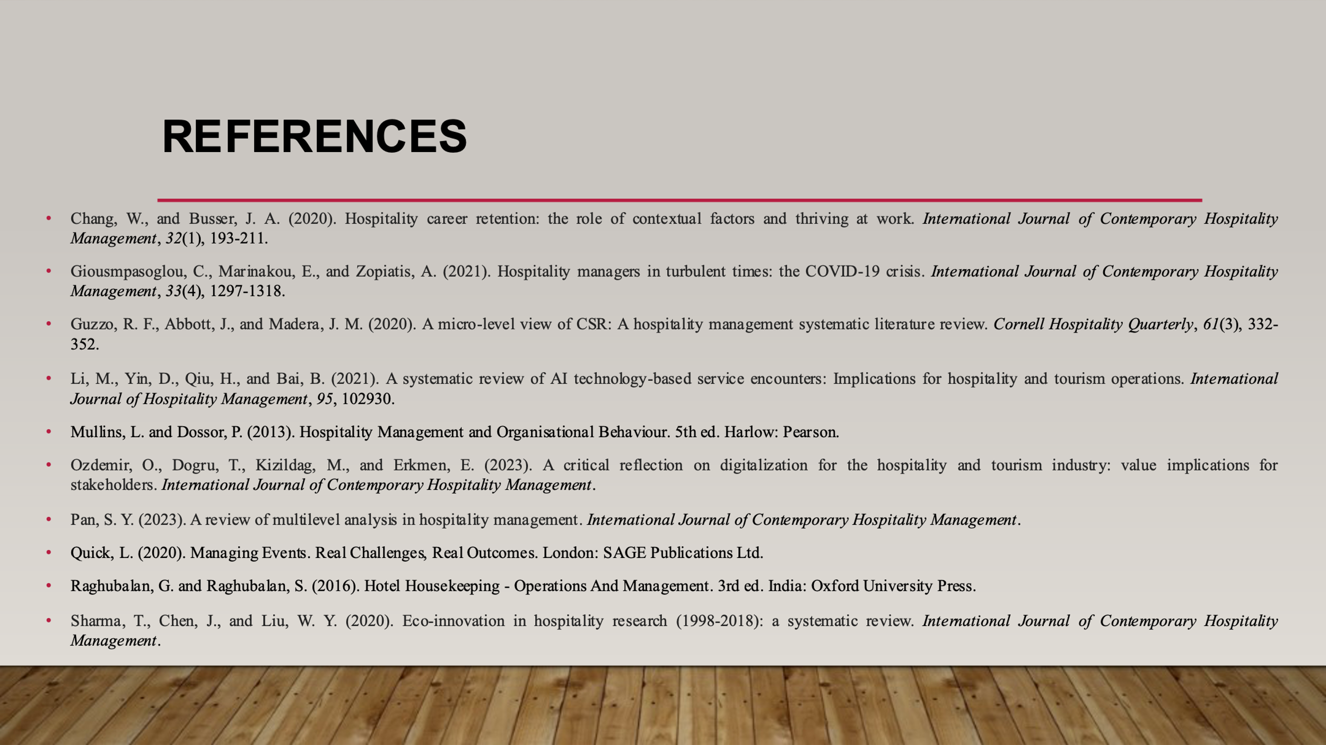

References

Alcalde-González, V., Mozo, A. G., and Bustos, A. V. (2021). No clean rooms, no hotel business: Subversion tactics in Las Kellys’ struggle for dignity in hotel housekeeping. Annals of Tourism Research, 91, 103315.
Dhaliwal, R. S., and Misra, P. (2020). Employability skills needed in hospitality industry: a scopious review. Asian Journal of Education and Social Studies, 10(1), 18-34.
Espellita, S., and Maravilla Jr, V. S. (2019). Employable Skills for Hospitality Graduates as Perceived Among Hotel Supervisors in Cebu City. Journal of Economics and Business, 2(2).
Mistry, T. G., Hight, S. K., Okumus, F., and Terrah, A. (2022). Managers from heaven: how do hospitality employees describe good managers?. International Hospitality Review, 36(1), 2-24.
Ng, A. M. L. (2021). Housekeeping Skills Training for Independent Living Among Malaysian Adolescents with Special Needs: A Case Study. Journal of Special Needs Education, 11, 30-50.
Saraiva, A. L. O., Pugen, B., and Chaves, V. D. S. (2019). Tourism and Hospitality Laboratory: improving skills in teaching, research and extension. Applied Tourism, 4(2), 11-18.
Tiwari, S., and Munjal, S. (2019). What are the key challenges that the Indian hospitality industry is facing in search of skilled labour?. Worldwide Hospitality and Tourism Themes.
Tra, T., (2020). Action plan for training new Housekeeping Employee: case: Hotel Indigo Helsinki.
Bridger, E. (2018). Employee engagement: a practical introduction. 2nd ed. HR Fundamentals. London: CIPD and Kogan Page.
Cottrell, S. (2019). The Study Skills Handbook. 5th ed. London: Red Globe Press.
Mali, R. and Mali, N.R., (2022). A Research To Determine The Job Satisfaction Of Housekeeping Staff In A Tertiary Hospital. Journal of Pharmaceutical Negative Results, pp.1471-1473.
Mullins, L. and Dossor, P. (2013). Hospitality Management and Organisational Behaviour. 5th ed. Harlow: Pearson.
Chang, W., and Busser, J. A. (2020). Hospitality career retention: the role of contextual factors and thriving at work. International Journal of Contemporary Hospitality Management, 32(1), 193-211.
Giousmpasoglou, C., Marinakou, E., and Zopiatis, A. (2021). Hospitality managers in turbulent times: the COVID-19 crisis. International Journal of Contemporary Hospitality Management, 33(4), 1297-1318.
Guzzo, R. F., Abbott, J., and Madera, J. M. (2020). A micro-level view of CSR: A hospitality management systematic literature review. Cornell Hospitality Quarterly, 61(3), 332-352.
Li, M., Yin, D., Qiu, H., and Bai, B. (2021). A systematic review of AI technology-based service encounters: Implications for hospitality and tourism operations. International Journal of Hospitality Management, 95, 102930.
Mullins, L. and Dossor, P. (2013). Hospitality Management and Organisational Behaviour. 5th ed. Harlow: Pearson.
Ozdemir, O., Dogru, T., Kizildag, M., and Erkmen, E. (2023). A critical reflection on digitalization for the hospitality and tourism industry: value implications for stakeholders. International Journal of Contemporary Hospitality Management.
Pan, S. Y. (2023). A review of multilevel analysis in hospitality management. International Journal of Contemporary Hospitality Management.
Quick, L. (2020). Managing Events. Real Challenges, Real Outcomes. London: SAGE Publications Ltd.
Raghubalan, G. and Raghubalan, S. (2016). Hotel Housekeeping - Operations And Management. 3rd ed. India: Oxford University Press.
Sharma, T., Chen, J., and Liu, W. Y. (2020). Eco-innovation in hospitality research (1998-2018): a systematic review. International Journal of Contemporary Hospitality Management.

