  Component One:  What are the key skills required when working in the housekeeping team? 750 words (+/- 10%)  Contribution to Overall Module Assessment: 25% | Student No: | 2121927
 | Module Title: | Operating Hotel  Facilities
 | Module Code: | BMIH4006
 | Lecturer: | L Blake
Housekeeping sector plays a major part for growth and development of different industries and in the hospitality and tourism division. It has become more important due to the nature of business. When an industry does business its a service than sector, the expectations for delivery of service and its quality very much matter. In this scenario, the housekeeping work as a backbone for the hospitality sector because it involves cleanliness activities, room service jobs, removing safety hazards and giving a overall better look to the venues to attract customers (Brody, 2016). A Housekeeping job is not a single play but consists of teamwork, being able to perform the job professionally and effectively these are the key skills required to work in the housekeeping team. The key skills are, time management, attentiveness, communication, interpersonal, flexibility, customer service, and hard-working skills. I have discussed these skills in detail with examples.
Time Management: Housekeeping staff perform their duties on their own and it is necessary for them to make a proper schedule for their work (Indeed, 2022). When their tasks get completed within the timescale it will be helpful for the hotel management to accommodate guests in rooms. The importance of time management can be explained with an example; in case any additional work is required in hotel a housekeeping staff can do if they have managed their main job on time (ManageMen, 2023).
Attentiveness: It is mandatory for a housekeeping staff to be attentive to details about their jobs. For example, in the cleaning process all windows and floors should be immaculately cleaned. When housekeeping staff pay full attention to their tasks, ultimately, they will be better at their jobs (Indeed, 2022). Attentiveness in others comes with housekeeping as being careful about customers’ belongings, sometimes guests forget their valuable items in rooms so it is the responsibility of housekeeping to inform the floor supervisor about this. In addition, alertness and attentiveness of housekeeping staff can save lives of guests because there is a possibility to find fainted guests in washroom areas or in the room.
Communication: An effective communication process is considered as a heartbeat of a hotel and housekeeping staff are part of this process (Miller ,2021). Housekeeping staff through the communication channel get to understand the expectations of guests, co-workers and supervisors, therefore, they must illustrate good communication skills at work (Indeed, 2022). If the communication process is not done properly, the housekeeping staff would not be able to understand what is expected and required to do their job properly.
Interpersonal: The nature of the job for housekeeping staff is to directly deal with guests in hotels and for this purpose they need to use their interpersonal skills. When staff members perform their jobs with dependability, teamwork, responsibility and positive behaviour, it is a result of better use of interpersonal skills (Indeed, 2022). The positive, calm and professional behaviour of housekeeping staff gives the impression to guests that they are at home away from home also improves business of the hotel (Rajak, 2018).
Flexibility: Working hours of housekeeping may vary because the hotel business is a 24-hour job and staff are required to work different shifts. Housekeeping staff’s flexibility is very much needed as they may have to wait until everyone leaves the office to start the cleaning process. Similarly, the housekeeping job may start very early morning and being flexible means, they are able to get more work and earn money (Indeed, 2022). The flexibility of housekeeping is more helpful when the operation is busy especially during the holiday seasons when more guests are expected in hotels. Therefore, it can be said that a flexible housekeeper is considered as an asset because they support the busy operation of hotels when it is needed (Miler 2021).
Customer service: In the service industry, effective customer service is mandatory to grow and survive. If the housekeeping staff interact with guests and get approval regarding their work, it will be beneficial for their performance and overall business of the hotel. It is to mention that leading hotels globally very much focus on customer service and they make sure that the standard of customer service would be the same either from the housekeeping or senior management (Miller, 2021). The similar and standardised customer service enhances the overall reputation of the hotel.
Hard skills: Hard skills refer to the main job of housekeeping in which carpet cleaning, sweeping, deep cleaning, mopping, window cleaning, vacuuming, dusting, bedroom and bathroom cleaning actions are done properly (Indeed, 2022). When housekeeping jobs are done to the level of perfection, it increases the overall service standard of the hotel. Understanding the main job is something progressive in the hotel industry as many housekeeping staff set an example, they have started their job from cleaning and rose to prominent positions (Rajak, 2018).

Word Count | 787

Component Two:
Contribution to Overall Module Assessment: 25%
In this scenario – You have just been promoted to team leader for a floor within the hotel. A guest complains that on their arrival, their room had not been properly cleaned. Create an action plan and answer the following questions.

Problem | Why did it happen? | What are you going to do? | How will you prevent this from happening in the future? | What measures would you introduce to improve team effectiveness?
Cleanliness of room | Staff had not cleaned the room properly | I will review the log sheet to see which staff members were on duty before the arrival of the guest. I will call the Executive Housekeeper, Floor supervisor and Room attendant to ask them why the cleanliness was not done to our standards. I will undertake all the relevant actions to investigate why this kind of negligence happened, either it is a mistake or they are facing problems like shortage of manpower or equipment. I will also discuss with the member of staff that was assigned cleaning this room why this room was not cleaned promptly and why mistakes like this should not acure. | I will design a checklist for housekeeping which needs to be filled before closing their shift. In the checklist different questions are asked about the jobs that have to be completed in the room before the check list is ticked off. The Floor supervisor would need to counter sign the checklist after checking the rooms and areas physically. This strategy will be helpful because responsibility is shared by the team in which the Floor supervisor holds more responsibility to monitor the progress. | I will call a general meeting with the housekeeping team and discuss any issues if they have them, it is my responsibility to discuss with my seniors about the issues housekeeping staff are facing. I will consult with the Executive Housekeeper about four major elements.  - Proper training of staff  - Availability of equipment and resources to staff  - Attendance and regularity of housekeeping staff  - Filling of designed checklist before closure of every shift
Carelessness of staff | The cleanliness of the room is not done due to inattentiveness of a staff member who was cleaning the room and the floor supervisor was also responsible because they did not check properly. | I will give a verbal warning to the responsible staff also recommend one-day training for them to refresh them on the basics of housekeeping. I will also give a verbal warning to the Floor supervisor as the room was not checked by them physically. | I will advise the Executive Housekeeper to observe progress of the housekeeping team moving forward. I will design a questionnaire related to housekeeping on a monthly basis which needs to be filled by the housekeeping team. | The strategy to take strong action on negligence, of those staff members found inefficient will give a powerful message to the housekeeping team to be careful at work. The re-training of inefficient staff, filling of checklist and after shift closure and answering the questionnaires about housekeeping will familiarise staff about their job role and the importance of it.
Shift rotation | In the meeting it was also identified that the staff who was responsible for the complaint was continuously working on the same shift for two months and tried to make up on some sleep whilst at work. However, the policy of housekeeping in the hotel is to do a shift rotation of housekeeping staff on a weekly basis. | I will check the duty register and make an inquiry as to why shift rotation is not taking place accordingly. Looking into the duty supervisor to see if they were forced not to change duty of that cleaner or the system of shift rotation is mishandled.  I will discuss the complete scenario with responsible stakeholders who would be the Executive Housekeeper, Floor supervisor, Duty supervisor and Room attendant. I will give a written warning to the duty supervisor as they have not performed their job role accordingly. | I will re-design the shift rotation registers on a weekly basis and implement with effect from the next day. I will hold a briefing for the housekeeping team to go over their responsibilities and working shifts. | When thorough checks are in place the overall performance improves. The room that was not cleaned to the required standard, the problems that may have led to this were lack of carelessness of the housekeeper, inattentiveness of the floor supervisor, and lack of supervision by the duty supervisor. In this scenario, designing a checklist, providing re-training for the responsible staff to refresh their knowledge of what's required of them, and implementing a shift register that will have a positive outcome in the overall performance of the housekeeping department.

Component Three:
Contribution to Overall Module Assessment: 50%
Your task is to create and prepare a presentation following the detailed scenario provided below.

As the floor housekeeping manager and given the recent guest complaints you need to put together a basic training presentation for your colleagues within the housekeeping team to get the best out of them, ensure that brand standard is being achieved and that Health and Safety procedures are also being followed.

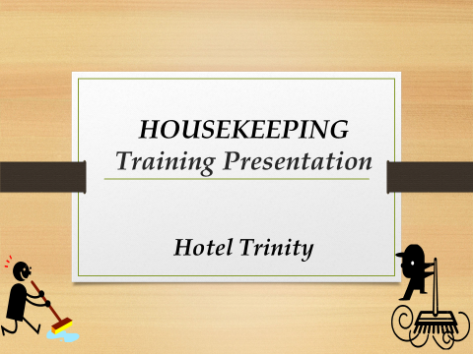

Training Notes:

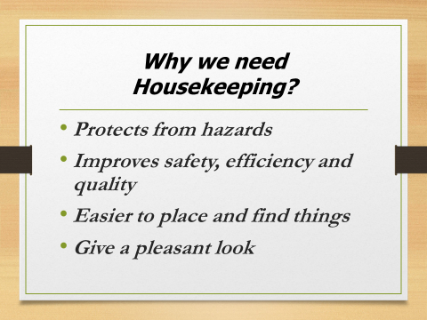

Training Notes: Housekeeping gives protection from hazards because any kind of rubbish, waste and dirt may contain bacteria which are harmful for our health. Therefore, housekeeping needs to improve safety at the workplace, make the environment better and comfortable to work. When housekeeping is done to the highest standard in a room it will give a high class look, it is also very helpful as if something was misplaced it would be a lot easier to find appose to it being incredibly difficult in a messy or dirty room.

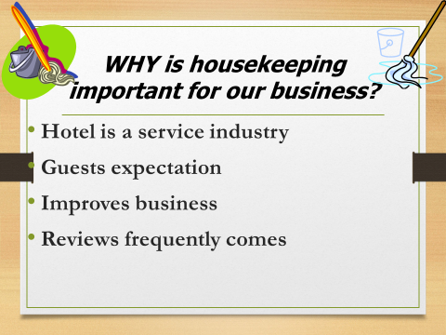

Training Notes: In the service industry the main concern of clients is how they are served and in this case housekeeping gives the first impression to the guests. When guests enter the hotel through the lobby, corridor, and concierge, they will have a very good impression about the cleanliness at this point. When the guests enter their rooms and check the bathrooms, they will have the idea of the housekeeping and overall standard of the hotel. Consequently, good housekeeping makes it possible for hotels to increase their businesses. Generally, on websites views about hotels must include housekeeping standard as guests like to mention when they stayed whether their room was found clean and if the housekeeping staff where cooperative.

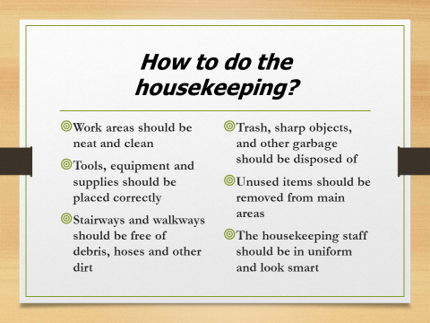

Training Notes: To discuss how housekeeping needs to be done the following points are needed. Cleanliness is top priority, and all the work areas must be neat, clean and tidy. If tools, equipment and supplies are not placed correctly, it would be classed as bad housekeeping because it’s giving the wrong impression to the guests. Stairways and walkways give a beautiful look to the hotel and if they are not free of debris, hoses and dirt it leaves a bad impact on guests. Trash, sharp objects and similar products would become hazardous if not removed from main areas where guest and staff move. Similarly, unused and unwanted items are not required in main areas. Housekeeping staff must be well dressed in their uniforms, approachable and professional at all times.

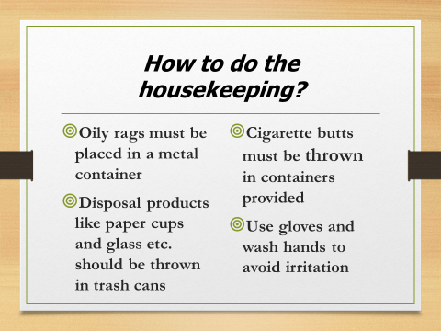

Training Notes: Housekeeping is all about keeping the place tidy and removing useless stuff from the main areas. Oily rags, disposable products and cigarette butts should be removed from the site to ensure the workplace is clean. Housekeeping staff may use various cleaning products, their work includes the use of chemicals which may cause irritation or infection. Therefore, it is necessary to wash hands frequently and use gloves to protect hands from any kind of irritation.

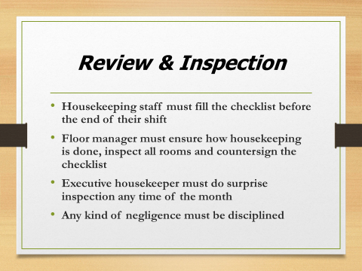

Training Notes: The administration of housekeeping has an important role to review and inspect the performance of staff. The newly designed checklist must be filled by the housekeeping team and countersigned by the floor manager to ensure that work is done properly. The responsibilities are shared and the housekeeping team are always engaged through this because their job is interrelated. The head of housekeeping should do a surprise inspection to monitor the progress of the department and work for improvement.

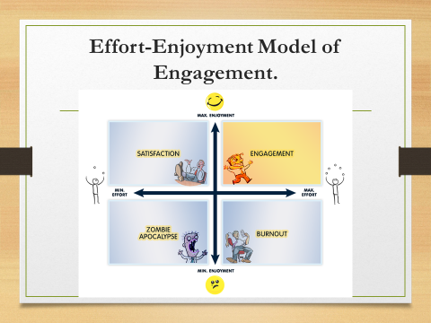

Training Notes: The model explains that if minimum effort and maximum enjoyment are combined it gives an employee satisfaction but leaves reasons to progress (Deal et al. 2010). When minimum effort and minimum enjoyment work together, the employee becomes a zombie apocalypse. If maximum effort and minimum enjoyment are included in work, then it results in disengagement. Therefore, the ideal situation where an employee receives engagement is maximum effort and maximum enjoyment (Deal et al. 2010). It is therefore recommended for housekeeping staff to do their work with full effort but don’t consider their job as a burden, enjoy it and it will give you a sense of engagement.

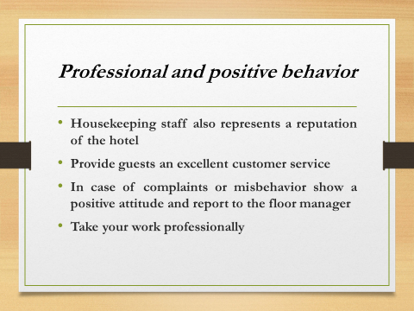

Training Notes: Housekeeping staff deal with customers on a regular basis this is why they are a representation of the hotel. Guests expect a quality customer service from the housekeeping staff. It is possible a guest can make a complaint of bad behavior in a very rude manner, but hhaving a good work ethic and always remaining calm and professional is key. It is wise to report any problems to the floor manager and other senior staff members before the situation escalates. Do not be verbally offensive and victimized take your work very professionally as you are representing the hotel.

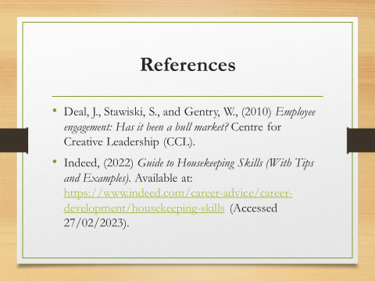

Training Notes:
Training Notes:

References
Brody, D., (2016) Housekeeping by Design: Hotels and Labor. Chicago: The University of Chicago Press.
Deal, J., Stawiski, S., and Gentry, W., (2010) Employee engagement: Has it been a bull market? Centre for Creative Leadership (CCL).
Indeed, (2022) Guide to Housekeeping Skills (With Tips and Examples). Available at: https://www.indeed.com/career-advice/career-development/housekeeping-skills (Accessed 27/02/2023).
ManageMen, (2023). The Importance of Time in a Cleaning Operation. Available at: https://managemen.com/the-importance-of-time-in-a-cleaning-operation/#:~:text=Having%20a%20set%20time%20to,MIT%20or%20Most%20Important%20Thing (Accessed 09/03/2023).
Miller, J (2021) Hotel impressions: The Complete Guide. Blog. Available at: Hotel First Impressions: The Complete Guide | Cvent Blog. (Accessed: 25/04/22)
Rajak, H., (2018) Role of Housekeeping in Guest Satisfaction and Repeat Business. Available at: https://hmhub.in/role-of-housekeeping-in-guest-satisfaction-and-repeat-business/ (Accessed 09/03/2023).

