

Strategic Implementation of Sustainable Supply Chain Practices in the Automotive Industry: A Case Study Analysis of TATA Motors

Name : Patni Akshay
Student Number : 2308227

Declaration
I hereby declare that this dissertation and overall research is conducted by me. This research is entirely my own work and has been submitted as a completion of my current degree course. I also acknowledge other author’s works here by using correct referencing and citation throughout the research to maintain originality and university data protection standards.

Signature Date
_______________________ ____________________

Acknowledgement

I would like to express my deepest gratitude and thanks to my advisor, …… Her guidance has been incremental to my research, she has provided me with support, encouragement and guidance.

Caroline, has provided me with an excellent learning environment. She is the one person who deserves my deepest thanks for her constant help and belief in my abilities over the past two years.

I am also grateful to all the other support I have received while undergoing this research project.

Abstract
In the introduction chapter the research investigation has develop a detailed overview of the efficiency and relevance of sustainable practice where it is identified that the main aim of the research is to cultivate the influence of SSCM (sustainable supply chain management) in the automotive industry. The investigation will undertake the case scenario of Tata Motors and delve into an analysis of their sustainability practices.
Table of Contents
Chapter 1: Introduction 7
1.1 Background 7
1.2 Problem statement 8
1.3 Research Rationale 9
1.4 Research Aim & Objectives 11
1.5 Research questions 11
1.6 Significance of the research study 11
1.7 Structure of the Dissertation 12
1.8 Chapter Summary 13
Chapter 2: Literature review 14
2.1Overview 14
2.2 Definition of Sustainable Supply Chain Management (SSCM) 14
2.3 Application of SSCM (Sustainable Supply Chain Management) practice in automotive organisations 15
2.4 Theoretical interpretation for sustainable supply chain practice for Tata Motors 17
2.4.1 Implementation of Transactional cost theory for supply chain practice 17
2.4.2 Incorporation of Life Cycle Assessment theory for sustainable supply chain practice 18
2.4.3 Evaluation of 3R model for sustainable business practice 20
2.5 Empirical Evidences 21
2.5.1 Significance of sustainable activity for maintain environmental substances 21
2.5.2 Social and economic approach to sustainability initiatives 25
2.5.3 Challenges faced by the industry in the implementation of sustainable SCM 26
2.5.4. Positive Outcomes of strategic implementation of sustainable Supply chain practices in the Automotive Industry 27
2.5.6 Effects of Automotive industry on sustainable supply chain practices on local communities 29
2.5.7. Economic Implications of sustainability initiatives for the automotive industry 30
2.6 Conceptual Framework 32
2.7 Literature Gap 32
2.8 Conclusion 33
Chapter 3: Research Methodology 34
3.1 Overview 34
3.2 Research Philosophy 35
3.3 Research approach 35
3.4 Research Strategy 36
3.5 Research choice 37
3.6 Research time horizon 38
3.7 Technique and Procedures 39
Data collection 39
3.8 Sampling 41
3.9 Ethical considerations 41
3.10 Validity and Reliability 42
3.11 Research Limitation 42
3.12 Chapter Summary 43
Interview Question 44
Chapter 4: Finding and Analysis 45
4.1 Overview 45
4.2 Analysis of primary data 45
4.2.1 Findings 45
4.2. Discussion 53
4.2.1. Evaluation of the data 53
4.2.2. Sustainable supply chain practices of Tata Motors 54
4.2.3.Employee training process of the tata company 55
4.2.4 Environmental practice of Tata company 56
4.2.5. Electric vehicle of Tata company 58
4.3 Chapter Summary 60
Chapter 5: Conclusion and Recommendations 61
5.1. Introduction 61
5.2. Conclusion 61
5.2.1. Key Findings 61
5.2.2. Implications for Tata Motors 62
5.2.3. How objectives are fulfilled 63
5.3. Recommendations 64
5.3.1. Enhancing Sustainability Challenges 64
5.3.2. Future Strategic Initiatives 65
5.3.3. Recommendations for further research 66
5.4. Final Thoughts 66
5.5. Concluding Remarks 67
Reference List 69

Chapter 1: Introduction

Background
The business of the automotive industry is ever-growing, and it is universally needed in recent times. It has been evident that in recent times, the practice of sustainability in the supply chain process become increasingly vital for this significant impact on the environment and social context in this industry. Here, it seems that multiverse areas are incorporated into these areas, like materials sourcing and recycling process. Energy efficiency, minimisation of carbon footprint, logistic sustainability and so on. A proper implication of sustainability practice attends the area of emerging eco-friendly materials and recycling programs alternatively (Jadhav, Orr and Malik, 2019). To be precise it is notable that Automakers are intended to prioritise the influence of sustainable materials like bio-based materials, low-impact metals and so on. Alternatively, the process of recycling activity for end-of-life as well as components to ensure that materials are reclaimed and reused the research investigation has undertaken the scenario of Tata Motors. It will precisely explore the context of carbon footprint minimisation, where it identified that automakers like Tata Motors have emerged certain values on reducing the greenhouse gas discharge across the entire supply chain.
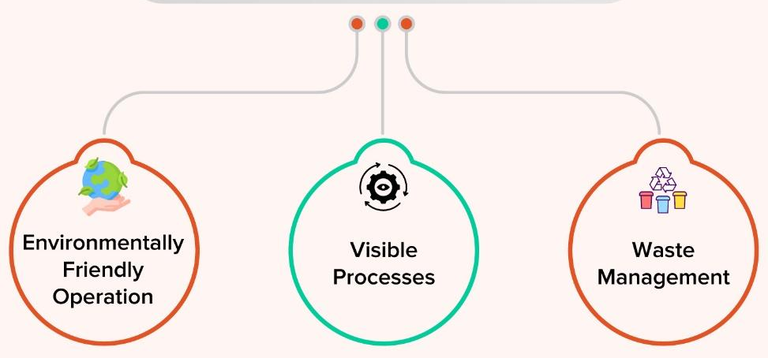
Figure 1:Key Elements of Sustainable Supply Chain
(Source: Zimon, Tyan and Sroufe, 2020)
Tata Motors has a focus on their route optimisation process during logistic services where they implement cleaner energy sources further. Here, it is notable that not only Tata Motors but also many automotive organisations have been involved in using electric and hybrid vehicles, which help in minimising reliance on fossil fuels. Other than these, in recent times, it is important to note that sustainable logistics is an important part of the automotive companies where they intend to streamline the logistics by improving fleet management by reducing fuel consumption further. Strategic sustainability practice involves different areas of concern where supplier collaboration and standards play a crucial role (Chowdhury and Quaddus, 2021). It is evident that the involvement of proper auditing in the areas of assuring that the suppliers adhere to all the environmental and social standards is crucial. Other than this, building partnerships with suppliers who are committed to maintaining sustainability fosters shared goals in green practice and is a top-tier priority.
The research investigation has attempted to explore a specific case scenario of Tata Motors in terms of evolving the sustainability strategy of the company. It is important to note that the company has specifically attended to the areas of GHG emission and circular economy practice for maintaining an eco-friendly approach in the business context for long-term efficiency (Negri et al., 2021). A detailed discussion about sustainable supply chain management practice has been evolved in the research which assembles different areas for developing asset proficiency along with guaranteeing social obligation. The shifting towards energy efficiency implementation and renewable materials for productivity and exemption has been referred in the report accordingly.

Problem statement
In the contemporary digitalisation context, it seems that the automotive industry plays a significant role as a contributor to the global economy activity. It seems that the entire business industry from multiple sectors is facing increased pressure to adopt sustainable supply chain practices practices for the growing environmental concerns, different regulatory requirements, and customers' demand for eco-friendly services (Yu, Khan and Umar, 2022). Though there are certain awareness has been established in terms of increasing the importance of sustainability practices, it seems that many times, it becomes difficult as the automotive industry may struggle with the strategic incorporation terms of sustainability practices in the supply chain context.
It is relevant to state that the automotive supply chain is considered to be extensive where fragmentation is a constant part, which makes the entire system difficult for enforce consistent sustainability standards as well as practices. It is important to note that due to the incorporation of sustainable practices, an organisation often needs significant upfront in terms of investing in new technologies, materials and others, which are considered as a barrier for the suppliers. Other than these, it is also notable that there is no such universal standardisation in terms of maintaining sustainability (Strielkowski et al., 2021). In this instance, it has explored that due to different aspects of standardisation, organisations are leading to varied interpretations and incorporation across different regions. It is intended to increase complexity to some extent while tracking as well as reporting further. It is important to note that accurate tracking of different sustainability metrics, such as carbon emission per vehicle, water uses per unit production, and resource incorporation per unit across a global supply chain for a company, is challenging. It allows the entire system to measure progress as well as maintain transparency further.
The main problem statement of the research is Automotive supply chain is extensive and intricate, where a fragmented supply chain, high-cost transition, and resistance to change make a vital impact.

Research Rationale
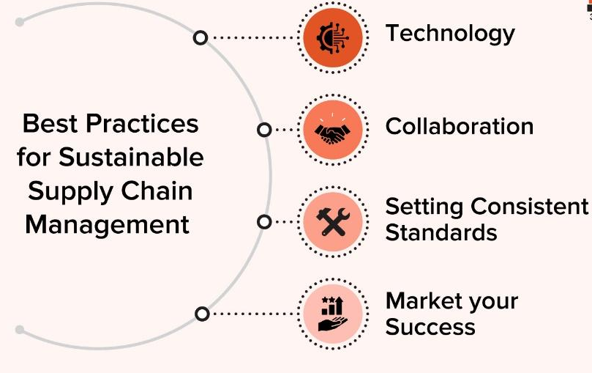
Figure 2:Efficient Practices for Sustainable Impact
(Source: Kamble et al., 2023)
Who will benefit from the research?
Sustainability practice is noted as one of the most impactful elements in the new automotive industry that is being implemented for maintaining long-term stability in the business process. It is important to note that by emerging different sustainability components in the business process, organisations can be able to create a better circular economy principle that is further effective in terms of designing products for longevity, repairability as well and recyclability that promotes a continuous reused of materials. In this research investigation, the researcher has precisely described the relevance of the concept in the new economic scenario and its significance for the future environmental balance accordingly (LU et al., 2020). The research study will emphasise the relevance of technology integration. By attending this research topic, it is noted that the researcher can portray a profound impact of sustainability practices and different strategic moves where automotive companies can increase their reliability in terms of improving environmental and social efficiency. By exploring the research, both the stakeholders and customers who are associated with the automotive industry can benefit by acknowledging all the areas of different sustainability approaches like resource utilisation, long-term benefits, employee sustainability, customer-driven approach and so on.
What can be the implication of the research?
It is recognised from the research investigation a competitive advantage can be grown that is intended to evolve a landscape of improving sustainability and long-term credibility in the automotive industry further. By emphasising a detailed understanding of SSCM (sustainable supply chain management), the audience can be able to understand a proper approach to employee satisfaction, utilisation of renewable energy, relevant consumption and so on. On the other hand, it is also seen that a better understanding can be evolved through incorporating sustainable practices, which has increased the credibility of automotive companies for increasing their potential in company scenarios (Adriana et al., 2020). It is important to note that effective strategy for sustainable practice intended to create a better understanding of customers interest areas where multiple local and global players are involved in the market. It has been evident that sustainability plays a pivotal role in the context of making an automobile company different from their core competitors as well as establishing a unique business efficiency for generating credibility in environmental and social perceptions. Successful research has the credibility of offering greater insight into the incorporation of sustainability practices in the supply chain to increase their individual competitive positioning.

Research Aim & Objectives
Aim: The key point of this paper is “To investigate the essential execution of sustainable production network rehearses at Tata Motors and assess their effect on natural, monetary, and social execution”.
Objectives:
- To investigate Tata Motors' current sustainable supply chain practices.
- To determine how Tata Motors' sustainable supply chain initiatives affect the environment.
- To survey the monetary advantages and difficulties related to Tata Motors' sustainability endeavours in the production network.
- To examine the social ramifications of Tata Motors' sustainable store network rehearses on neighbourhood networks and work conditions.

Research questions
- What specific sustainable practices has Tata Motors implemented in its supply chain?
- How have Tata Motors' manageable production network drives affected the climate?
- What challenges and advantages does Tata Motors' work on a sustainable supply chain bring to the economy?
- How are local communities and labour conditions affected by Tata Motors' sustainable supply chain practices?

Significance of the research study
Sustainable supply chain practices in the automotive industry are considered to be substantial for different reasons. It seems that an adverse environmental impact minimisation has been taken place through this. In an in-depth insight, it is important to note that the automotive industry takes part as a major contributor to greenhouse gas emissions (Mohtashami, Aghsami and Jolai, 2020). Here, it is notable that by incorporating effective, sustainable supply chain practices, different automotive companies like Tata Motors can precisely reduce the carbon footprint, which contributes to the global climate change modification efforts. Other than these, it is important to note that an effective sustainability practice intended to promote effective use of resources where different components such as sensible energy consumption, helping conserve biodiversity and others. For the instance of strategic implementation in the sustainable supply chain practice automotive industry is supposed to adhere to regulatory compliance where the firms can meet the increasing environmental regulation along with standards. The study will be going to evolve the relevance of proper regulatory compliance, which is further effective in understanding the importance of sustainable practices so that the research in this particular area can allow the companies to navigate complex regulatory scenarios.
Most importantly, the research study topic has precisely explained the economic benefits of sustainable supply chain practices where it seems that the process has a huge impact, which led to cost savings via improving efficiency and reducing waste with lower energy consumption. Through this research, a proper identification of the areas of savings can be realised (Paillé, Valéau and Renwick, 2020). It is important to note that a strong commitment towards attracting employees who are mainly motivated by environmental and social responsibility can emphasis a greater brand value and reputation further. With a concrete commitment towards sustainability, a brand can able to enhance its market image by offering positive public perceptions, which leads to enhanced client loyalty along with better stakeholder relations.

Structure of the Dissertation
Introduction- This chapter will precisely explore the main problem areas of the research topic and explore the agenda of developing the research investigation. With offering a strong aim and research objectives the researcher will emphasise a detail understanding of entire research investigation in regards of sustainability practice in supply chain process accordingly.
Literature review- This section is going to incorporate a multidimensional approach to the sustainable supply chain process. Different author's opinions and perspectives in regard to the subject matter have been interpreted in this section for generating a comparative analysis further. Here, a precise conceptual framework and literature gap will be established.
Research Methodology- The chapter has mentioned all the processes that are going to be used in the research investigation to optimise the research objective and evolve funding to meet the research aim accordingly. The section has illustrated vast detail in terms of data collection and analysis process for offering an impactful insight into the research questions accordingly.
Research finding and analysis- This section has generated a detailed analysis of various resources that has been gathered from both the primary and secondary data related to the subject matter. By optimising different perspectives collected from the resources multiple themes has been generated to interpret the research study in a methodical manner.
Recommendation and conclusion- It is the final chapter of the research study where an overview of the entire research context will be explained. Additionally, the final outcome by emphasising different sources of the research aim and a set of recommendation will be delivered further.

Chapter Summary
As the importance of sustainability increases, pressure is mounting on automotive businesses to adopt sustainable supply chain strategies. These protocols aim to lessen adverse environmental effects, boost resource efficiency, and promote social responsibility along the entire supply chain. One of India's top automakers, Tata Motors, offers an engaging case study on the tactical application of sustainable supply chain strategies. Various automotive companies have been successfully pursuing maintainability goals in order to improve their competitive edge and align with global natural principles. The chapter has developed research objectives for ascertaining a detailed discussion on emphasising a relevant study to optimise efficient findings.

Chapter 2: Literature review

2.1Overview
The section has mainly drive into assessing different perspective of sustainable supply chain approach and its credibility in the business practice and potentiality. By evolving different articles and scholars’ opinion a comparative analysis will be portrayed for meeting the research aim further. By optimising different perspectives through Tata Motors business interpretation and practices a well-established outcome will be portrayed.

2.2 Definition of Sustainable Supply Chain Management (SSCM)
The integration of environmentally and socially responsible practices within logistics operations of any business such as supply of raw materials and delivery of products is known as Sustainable Supply Chain Practices (SSCM). As opined by Ghosh et al. (2020), the ideology of SSCM is inseparable in regard to developing an efficient sustainability context in the automotive industry. It seems that by emerging SSCM in the sector, it can pay attention to different affecting areas, from environmental impact to economic aspects along with social responsibility and others, as per the evaluation of Alghababsheh and Gallear, (2021). SSCM practice focuses on reducing the carbon footprint which is further effective to optimise transportation routes as well as eliminating energy consumption further. Other than these, it is also efficient for incorporating green manufacturing in the automotive sector, which further helps in increasing production efficiency and waste management perspective accordingly. Vengatesan, Jayakumar and Sadasivuni (2024) stress the fact that SSCM emphasises efficient resource allocation like raw materials, water, energy implementation and others, which leads to minimising environmental degradation along with sustainable production procedures.

2.3 Application of SSCM (Sustainable Supply Chain Management) practice in automotive organisations
As per the analysis of Al-Amin et al. (2023), the automotive sector is one of the leading global industries that has the credibility to offer sustainable business practices for enhancing environmental efficiency. The importance of circular economics in the production network is emphasized by this sector in a wider manner. As an example, it can be stated that in recent times, the industry had reduced its reliance on virgin materials, limited the age of waste, and achieved a feasible reuse rate for its assembly waste (Jayakumar et al., 2022). This method reduces creation costs and keeps an eye on assets, demonstrating the financial viability of cost-effective techniques. The industry environmentally responsible supply chain, the organization makes sure that its suppliers follow strict guidelines (Nayak and Shinde, 2022). Automotive industry’s sustainability initiatives demonstrate a detailed process where they can emerge different policies which can result in both social and commercial benefits.
It is an integrated practice in the automobile industry where every company are interested to engaged it in certain ways for increasing sustainable practice further. Different companies like Tesla, BMW, Toyota and others have emerge this process in their business scenario over the years. Szász, Csíki and Rácz (2021), stress on the fact that Toyota has noted as a leader in encouraging SSCM process in operation as they have undertaken the environmental challenge to achieve zero carbon emission rate within 2050. In addition to this, BMW has also focused on integrating renewable energy in their manufacturing unit, reducing water consumption rate, evolve sustainable materials and so on. As an example, it seems that they have attend a critical emplacement on a closed-loop material cycle in their aluminum and steel products. This thing intended to maintain SSCM accuracy further.
2.3.1 Application of SSCM in Tata Motors
Tata Motors, as one of the leading companies in the automotive sector, has been involved in the practice and implementation of Sustainable Supply chain Management Practices (SSCM) in a significant manner.
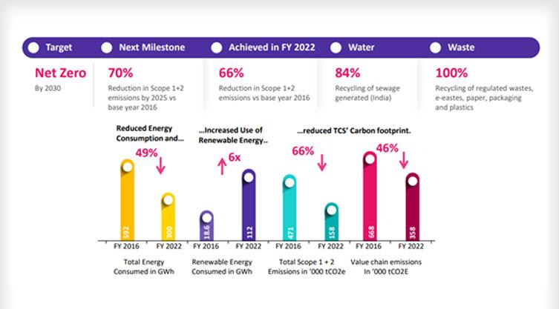
Figure 3: Green Development Approach of Tata Motors
(Source: Tata Motors, 2024)
Environmental sustainability
Green manufacturing activity: - Tata Motors has adhered to different green manufacturing practices in terms of reducing its environmental footprint in the manufacturing process (Malagihal, 2021). The practice included energy-efficient production, utilisation of renewable energies, continuous measuring of greenhouse gas emissions and others. To improve its green manufacturing abilities, Tata Motors has evolved rainwater harvest as well as wastewater recycling processes in the manufacturing unit for reducing water consumption and embracing water sustainability.
Sustainable Sourcing: - Tata Motors has consecutively exercised adequate sourcing of raw materials where they try to assess the environmental and social standard meeting of the materials. It is notable that Tata Motors has attended the areas of recycling plastics as well as eco-friendly elements in vehicle production (Devi, 2023). Similarly, the supply management system of the organization always explores the ethical visibility of their core suppliers in terms of responsibility efficiency in sourcing. It has been evident that by adhering to ethically responsible supplier collaboration, Tata Motors minimised the impact on natural resources.
Innovation and R&D: - Tata Motors has consistently invested in Research and development context of improving sustainability approaches. The organization has focused on improving electric vehicles, hybrid vehicles as well as other green technologies that can minimize environmental impact further (Al-Amin et al., 2023). Additionally, by making collaboration with ethically stable suppliers and partners, Tata Motors has improved its position in the competitive market (Devi, 2023). Tata Motors is involved in electrification, metaverse, intelligent enterprise, SCM sustainability program and so on.
Cost efficiency: - Tata motors has emerged lean manufacturing where they have optimized different supply chain operation which helps them to achieve cost efficiencies. Tata motors attends on minimizing waste and enhance overall operational effectivity further.

2.4 Theoretical interpretation for sustainable supply chain practice for Tata Motors

2.4.1 Implementation of Transactional cost theory for supply chain practice
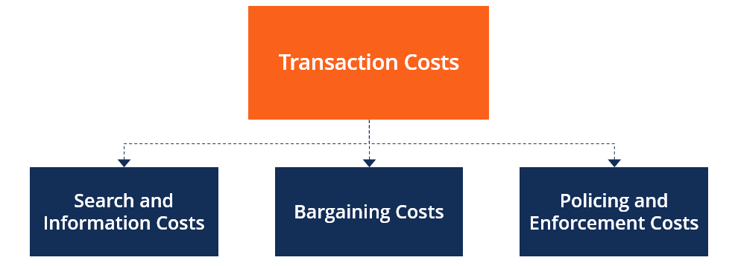
Figure 4: Transactional theory
(Source: Cuypers et al., 2021)
By evaluating this theory automotive organisations can be able to account for actual costs in terms of outsourcing production along with production and services. By evaluating this theory an automotive firm can internalise their specific transactions whenever any expenses occur. It is noted that by evolving this theory an organisation can focuses on an alternative variant of governance assumption. Even it is also seen that the overall cost areas such as searching, and information cost can cater into governance assumption (Rindfleisch, 2020). By optimising this framework automotive organisations can attend internal and external transaction consecutively which can improve their bargaining cost infrastructure so that the overall production cost get minimised.

2.4.2 Incorporation of Life Cycle Assessment theory for sustainable supply chain practice
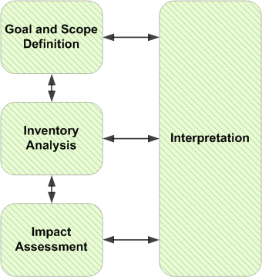
Figure 5: LCA theory
(Source: Heijungs et al.,2019)
Through incorporating this theory an automotive organisation can be able to assess the environmental impact that are associated with individual stages of life cycle of vehicles. There are mainly four stages are involved in this theory such as goal and scope, life cycle inventory analysis, life cycle impact assessment and interpretation.
Goal and scope- By using the 1st stage it seems that automotive industry can pay attention to minimise the waste context for improving sustainability practice (Kühnen and Hahn, 2019). It is noted that by evolving a proper minimisation through restricted the resources utilisation and developing waste recycling different organisations can improve their efficiency.
LCI- In the next stage the organisations can attend the logistic areas and focuses on streamline so that the inventory adopting logistic optimisation has an insightful and efficient transportation practice in the logistic networking for reducing carbon emissions (Virmani, Bera and Kumar 2021). It is noteworthy to state that by emerging a proper route optimization, utilization of fuel-efficient vehicles, as well as exploring any alternative transportation process like rail and sea freight for exporting or importing raw materials, Tata Motors has evolved a positive impact on the environment. In addition to this, they have also offered sustainable packaging solutions in terms of reducing any negative impact on the environment. As an example, it can be stated that they have emerged recyclable packaging materials that are intended to minimize landfall issues further.
LCIA- It can be explored by attending waste management context where they have precisely included recycling as well as reusing components so that it can able to minimize the concept of waste generation. Moreover, different Automotive can be attentive in regard to achieving zero waste for landfill status in their manufacturing sites (JIBY, SARASAN and JOSEPH, 2024). As an example, Tata Motors has deployed different programs such as ELV, which stands for the "End-of-Life Vehicle" program and others, which promote recycling as well as proper disposal of vehicles which has already reached their end of the lifecycle. Hence, the rate of scrap has been minimized, and it is purposefully utilised, which can eliminate waste management further.
Interpretation-by exploring different water reservation, scarp development and others and promoting recycling process the automotive organizations can able to improve their business sustainability accordingly.

2.4.3 Evaluation of 3R model for sustainable business practice
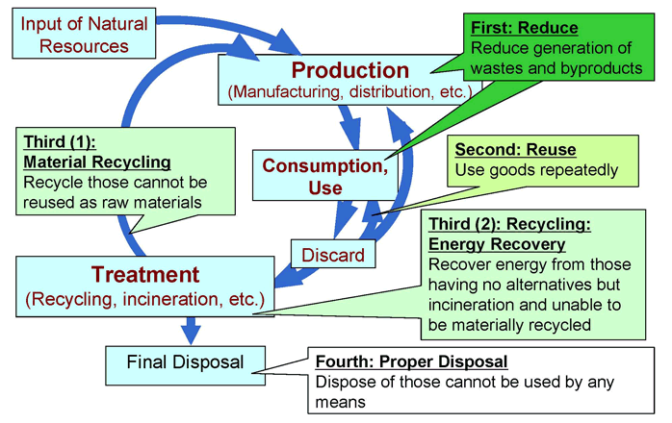
Figure 6 : 3R approach
(Source: Mohammed et al., 2020)
By incorporating this approach in the business framework, the automotive industry can be able to improve their business efficiency further.
Reduce- the element mainly indicates a proper minimization of waste and byproducts of the automotive industry. By eliminating the use of consumption, the automotive industry ca improve their sustainability efficiency. As an example, by evolving this element Tata Motors has taken different initiative and programs the organization has launched a new project named NEBULA for enhancing supply chain efficiency by developing the logistics of efficiency, minimization transportation emissions, as well as optimising the delivery routes accordingly. By evolving this project, Tata Motors has involved the usability of advanced analytics along with digital tools for monitoring and managing the supply chain process more evidently (Anand, 2023). Tata Motors has taken an active promotion event where they promote electric and hybrid vehicles, which have the credibility to reduce carbon emissions. In addition to this, it has evolved that Tata Nexon EV and Tata Motor EV can be considered a major example of Tata Motor's efforts in the sustainability context. By emerging ESG performance, Tata Motors publishes an annual report where they highlight their efforts along with achievements.
Reuse- By minimizing the uses of raw material automotive companies can improve their business efficiency. As an example, Tata Motors attend 95% reuse for garbage collection in 2022 has resulted in lower material and trash clearance costs, demonstrating how prudent measures can have a beneficial financial impact. By increasing its use of sustainable electricity to 21% of its total use by 2023, the firm has reduced its reliance on costly petroleum products and generated significant savings on energy expenses (Joshi, Jain and Choudhury, 2024). Different sustainability practices have been employed by the firm.
Recycle- it is relevant to state that by emerging recycling process natural worries can be eliminated, which can minimise administrative tension. The automotive industry can utilize this element to improve the SSCM practice more evident accordingly. The recycling process mainly deploys eco-accommodating practices while abiding by the moral values in the manufacturing unit and production efficiency (Singla and Bansal, 2022). Recycling process in SSCM involves a concrete application of proper store networking, natural substance optimization, assembling resources as well and conveying vehicles adequately. It is notable that by adhering this practice, an automotive organization could be able to decline natural effects and improve asset proficiency further. The concept is intended to refer to a proper shift towards maintaining ecological guidelines along with fulfilling clients' needs by penetrating green economy and green manufacturing.

2.5 Empirical Evidences

2.5.1 Significance of sustainable activity for maintain environmental substances
Tata Motors has involved various sustainable supply chain activities which has positive impact on the environment. By emerging these initiatives, the firm can make a great outcome in the environmental footprint in the operational unit.
Green manufacturing practice
Tata Motors has invested its capital in energy-efficient technology as well as the procedure where it can reduce energy consumption in the manufacturing unit. Even it is also seen that by improving the energy management process, Tata Motors has evolved positive outcomes for society and made a favourable balance between environmental stability (Virmani, Bera and Kumar, 2021). In addition to this, by attending the waste reduction process through the 3R approach like reduce, reuse and recycle, the organization has tried to improve the business sustainability and environmentally friendly practices further. It helps in developing the waste management process with minimal environmental impact. In addition to this, it seems that green manufacturing allows to generation of low carbon emissions in the production procedure where the energy and resource adoption get minimized.
Sustainable sourcing practice
Tata Motors has always prioritised sustainable as well as eco-friendly elements in their business practices. In this regard, it has been seen that by using recyclable and biodegradable materials, which have a lower impact on the environment, Tata Motors has tried to improve its business effectivity apparently (Ghadge, 2022). In addition to this, it seems that Tata Motors has a great collaboration strategy with its suppliers, where they work closely with its core supply management team, which ensures that they are only adhering to sustainable materials and practices (Baliga, Raut and Kamble, 2020). Here, it seems that a proper environmental standard has evolved where Tata has conducted regular auditing in terms of ensuring compliance.
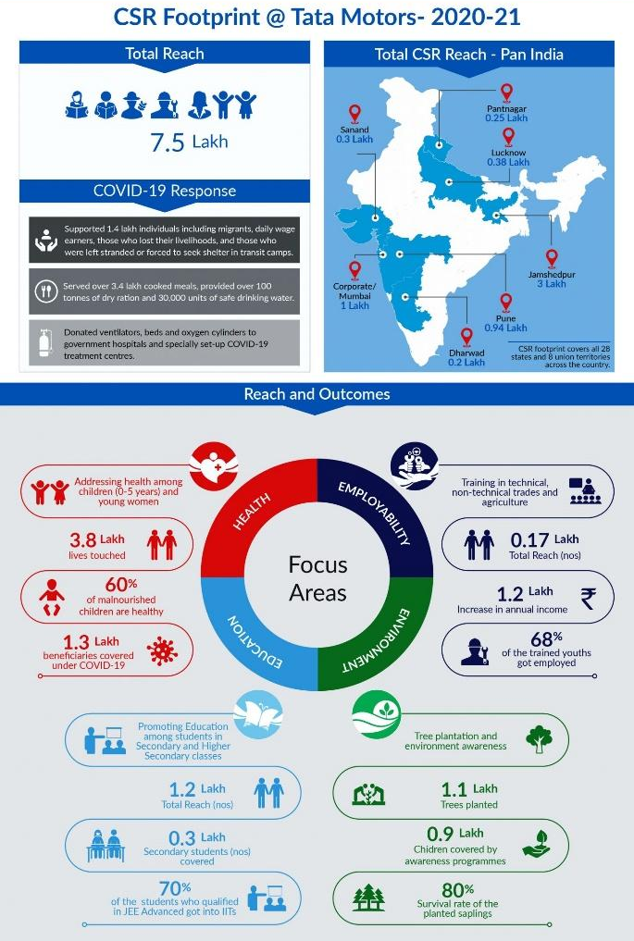
Figure 6: CSR Scenario of Tata Motors
(Source: Tata Motors, 2024)
Development of product lifecycle management
Tata Motors has encouraged EVM, where a system has been developed which focuses on the responsible disposal of vehicles at their end life. By assessing proper product lifecycle ideology, Tata Motors has mitigated the possibility of waste and scrap materials. It seems that their attention towards circular economy activity has promoted product longevity, repairability as well as recyclability (Yu, Khan and Umar, 2021). It has explored that by emerging circular economy practice, Tata has tried to extend their product lifecycle along with minimizing resource consumption further. Here, it is notable that the context of resource consumption gets wiser, and it makes a preferable balance between environmental sustainability and business potential.
Water management and carbon footprint minimization
Tata Motors has invested in advanced technology for controlling emissions so that it can minimize the environmental impact further (Umar et al., 2022). Here, it is notable that the process has been involved in developing where it can comply with stringent emission activity and promote an adoption where electric as well as hybrid vehicles can help to improve the market efficiency and control negative outcomes (Khan, 2020). With emerging renewable energy incorporation, Tata mainly focuses on renewable energy integration like solar and wind in the operation system, where it is seen that it can minimize the reliance on fossil fuels along with lowering the greenhouse gas discharge. Ghadge (2022) focuses on the water conservation process, where they implement water conservation measurement, they encourage rainwater harvesting, wastewater recycling and others. By following the zero-discharge policy, Tata Motor’s plants can ensure the fact that no untreated wastewater can be released into the environment. This thing passively helps in missing environmental impact. Tata Motors has also fostered a culture of less energy consumption and increased biodiversity practices where it can protect natural resources adequately.
It is noted that water protection is considered a major element in the ecological practice of Tata Motors; hence, by improving the procedure of water recycling practice, Tata Motors has portrayed a positive result where only 15% of freshwater consumption has been meeting in the last five years. It means that they have tried to minimize the water consumption rate in the manufacturing and operational units.

2.5.2 Social and economic approach to sustainability initiatives
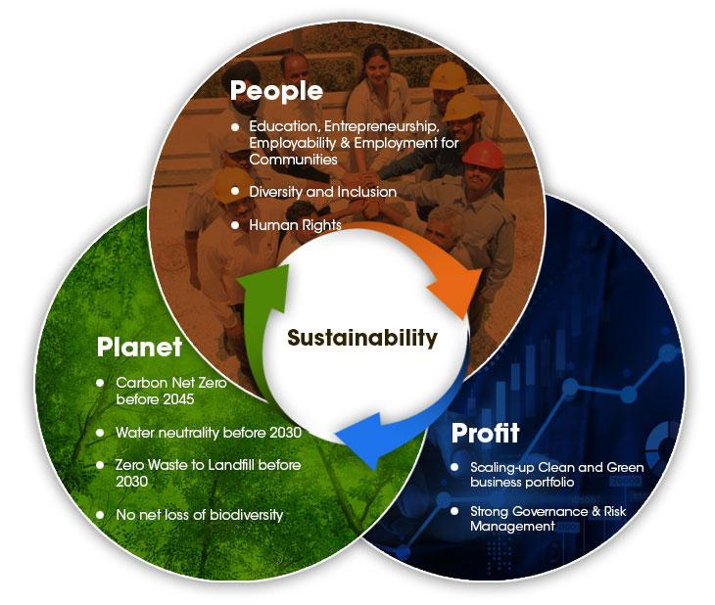
Figure 8: Sustainability Approach of Tata Motors
(Source: Apaydin et al., 2021)
From the opinion of Siltaloppi, Rajala and Hietala (2021), it seems that Tata Motors has undertaken different social activity that allows to improve the environmental stability and social appreciation of company performance. It is noted that they have already invested more than $10 million in various local activities and voluntary work. Even it seems that by adhering to different commitments towards sustainability practices, the organisation tries to develop economic performance with societal benefits accordingly (Akkucuk, 2020). By offering a positive work environment and cultural liberty, they drive into their fair wages practice and safe workplace practice, which helps in emerging a sustainability initiative further. Tata Motors has always relied on fair practice where they promote different social activities for the further beneficiary of society and meet their commitment towards the community.

2.5.3 Challenges faced by the industry in the implementation of sustainable SCM
The automotive industry globally faces various challenges while implementing sustainable supply chain practices for its strategic economic and social development.
Productive partnership: as per the analysis of Szász, Csíki and Rácz (2021), the automotive industry is powered by the global supplier relationship and management. For the manufacturing of the automotive industry, the industry is required to maintain long-distance relationships with the suppliers and face significant risk. The main challenges the automotive industry faces during the maintenance of productive relationships with global suppliers are inefficient communications actress the difference in business practices and varying standards. Sometimes, they face challenges like problematic software that is rendering even platforms and challenges in effective communication with the suppliers. Lacking transparency in communication with long-distance suppliers in the automotive industry leads to misunderstandings between companies and suppliers that can prevent the companies from the true benefits of partnership (Wellbrock et al., 2020). Supplier relationship management (SRM) is crucial to maintain the relationship with the suppliers for business progress in future.
Cost consideration: implementation of strategic sustainable practices involves the automotive companies in upfront investments in technology, supplier development and process reengineering. Tata Motors is cost-sensitive in nature, so the company face challenges in maintaining its balance in sustainability goals while considering cost. There is a critical relationship between sustainable practice goals and cost considerations. As per the analysis of Wolff et al. (2020), high investment in technology to maintain sustainability in the automotive industry increases the overall production cost, and that is a challenge for the cost-sensitive company Tata Motors. To maintain the quality of the products and services is challenging for the company while balancing sustainability and cost-effectiveness.
Data management and transparency: To improve the company's performance, managing sustainability data is crucial throughout the supply chain. So, data management in the automotive industry is changing during the implementation of sustainable supply chain practices in the business process due to the diversity of data sources and the high volume of data (Mathivathanan et al., 2022). The automotive industry faces challenges in data management due to the lack of standardised sustainability metrics and organised reporting frameworks. To address these challenges in the automotive industry, the investment in data infrastructures while fostering collaboration among the stakeholders is that the company can maintain effective communication with all stakeholders and ensure business success.
Environmental impact of manufacturing units in the automotive industry: reduction of environmental impacts is challenging for the automotive business as they address various needs such as reduction of pollutants in the environment, preserving resources and combating climate change. The adoption of environment-friendly methods in automated production is challenging for companies. Tata Motors aims to reduce greenhouse gas discharge by 25% by 2030 in their manufacturing process (Gohoungodji et al., 2020). The company faces challenges in adopting technology and various environmental policies to reduce its environmental impacts. Tata Motors faces challenges while the company changes their resources towards renewable energy sources by 21 % of the energy source of total energy consumption by 2025. The company focus on the development of technology-based products and addresses various challenges.

2.5.4. Positive Outcomes of strategic implementation of sustainable Supply chain practices in the Automotive Industry
Better risk management: sustainable supply chain actions in business, especially in the automobile industry, lead to improved safety standards in the workplace and allow to management of workplace risk efficiently and ensure the employee's safety during manufacturing and production process. It can support offering a safe work environment for the employees. Sustainable supply chain practice allows the company Tata Motors to offer better training programmes for employee development and gradually improved working conditions (Dumitrascu, Dumitrascu and Dobrotǎ, 2020). Implementation of a sustainable supply chain supports the company to lead to a more reliable supply chain through better risk management practices by maintaining a strong relationship with diverse suppliers globally.
Increased environment sustainability: as per the discission of Stawiarska et al. (2021), sustainable supply chain practice leads to the development of environmental sustainability to mitigate the environmental impacts of the manufacturing process. A sustainable supply chain allows the company to manage their resources effectively and allow to manage the waste efficiently through recycling, waste reduction practices, and composting. Sustainable supply chain practices increase the dependency on renewable energy sources and lead to resource conservation.
Resource Conservation: The prime importance of sustainable supply chain practices in Tata Motors is resource optimisation. It offers multiple financial and non-financial benefits to the company to maintain its brand position in the global market. Sustainable supply chain practices in Tata Motors lead to vehicular weight reduction while improving fuel efficiency and efficiently reducing waste generation. Sustainable practices in business processes lead to cost savings (Fraser, Müller and Schwarzkopf, 2020). With the practice of sustainable supply chain practices in the business process, Tata Motors can reduce their resource consumption in the financial years 2022-2023 compared to the previous financial years by 0.28 %, such as reducing the use of steel and ferrous alloy in their production and it can significantly be seen that the company can increase their production by 6% while reducing the use of resources. Tata Motors continuously optimises the use of metal in the manufacturing and recycling the resources to avoid virgin material consumption (Kaviani et al., 2020). With the sustainability initiative, the company focus on high-strength steel and finds alternate engineering solutions to address the needs if the manufacturing unit.
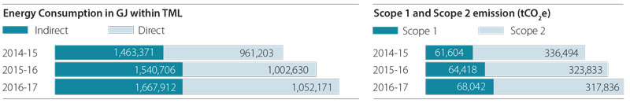
Figure 9: Minimising GHG emission in Tata Motors
(Source: Kaviani et al., 2020)
Water conservation: water consumption is one of the significant sustainable challenges for sustainable supply chain practices. The water demand in the manufacturing process at nearly all the company's operational locations is significant owing to several intensive processes. Tata Motors Limited uses a large quantity of water for non-industrial activities (Dieguez et al., 2020). With sustainable supply chain practices, the company can own water productivity with technology support. The company aims to achieve zero liquid discharge status at their Jamshedpur manufacturing sides. With the sustainable practice, the company focus on waste water treatment. Currently, the company can reduce water used per vehicle by 39% with water switch-off initiatives between the product line and vehicles.

2.5.6 Effects of Automotive industry on sustainable supply chain practices on local communities
Automotive industry is a global manufacturing industry. To consider their environmental concerns, automotive companies company implemented sustainable supply chain practices that can encompass social and economic impacts on local communities. Sustainable business practices have tangible effects on the development of local communities, fostering multiple positive outcomes and developing them sustainably. Multiple key effects on local communities are discussed below.
Employment opportunities: to improve sustainability in supply chain management, the company focuses on the development of healthy relationships with the local suppliers surrounding the manufacturing units. As per the discussion of Dieguez et al. (2020), Tata Motors focuses on local sourcing and supplier development and offers employment opportunities for the local communities based on their skill and experience. By offering employment opportunities to the local communities, the company supports boosting the local economy, improve the people's overall lifestyle of the people and engaging the people in skill development. It supports to improve the socioeconomic status of the local people by improving employment opportunities in various sectors such as support services, manufacturing, and logistics.
Community development initiatives: By implementing sustainable supply chain practices in the business process, the company focuses on developing its CSR initiatives. For local community development, Tata Motors focuses on the development of the educational system, infrastructure, and healthcare. In 2023, the company invested $10 million in the development of thousands of people (Staniszewska, Klimecka-Tatar and Obrecht, 2020). The company generates significant social benefits for the long-term success of the company and the well-being of the communities. Tata Group invest in several developments of local communities, such as building educational institutes schools, offering healthcare facilities to the local people and, developing road infrastructures and enhancing access to essential services and overall improving the quality of life of local people.
Environmental conservation: The company's sustainable supply chain practices directly improve the positive effects on local communities through various conservation efforts that can protect the environment. Tata Motors focuses on the development of resource efficiency, such as waste reduction, control of pollutants' emissions, and preservation of natural resources by promoting renewable energy sources. According to Goswami et al. (2020), Tata Motors limited effectively contributes to the development of a safe and healthier environment for local communities. It reduces the health risks of the local people through the improvement of quality lifestyles.
Social inclusion and diversity: By implementing a sustainable supply chain, Tata Motors emphasises social diversity and inclusion. The company fosters a culture of fairness and equality for the local people. To manage its business sustainably, Tata Motors collaborates with local suppliers and SMEs. The company promotes economic growth and employment opportunities for the local people.

2.5.7. Economic Implications of sustainability initiatives for the automotive industry
For Tata Motors, sustainability initiatives of the supply chain development carry significant implications so that the company can develop their business operations and improve its market presence. Tata Motors invests in sustainable technologies to reduce the enabled cost by the developed resource efficiency and operational optimisation. It supports the company to improve its competitiveness in the global market and reduce its production-and to gain a competitive advantage over the other automotive companies (Llopis-Albert, Rubio and Valero, 2021). It supports to improve the market differentiations and the brand value for the company. Sustainable initiatives support the brand to attract environmentally conscious consumers while driving customer loyalty. Sustainable initiatives in the supply chain business support the company to increase its market share and enhance annual revenue.
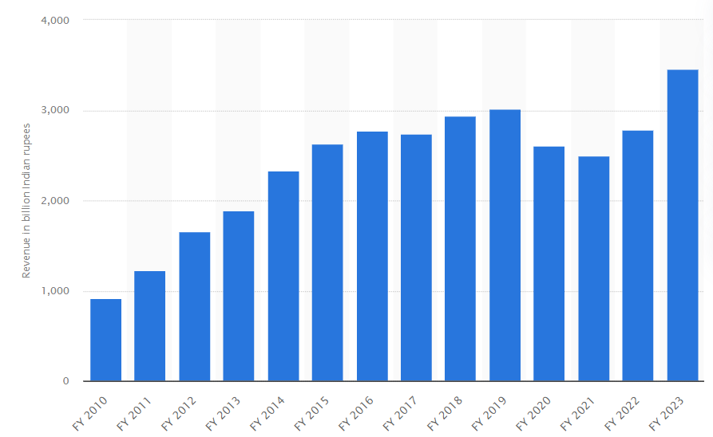
Figure 10: Annual revenue of Tata Motors
(Source: Statista, 2023)
Tata Motors has consistently invested in the Research and development context of improving sustainability approaches and economic development. Tata Motors focused on improving and developing electric vehicles, hybrid vehicles as well as other green technologies that can minimise environmental impact further. Additionally, by making collaboration with ethically stable suppliers and partners, Tata Motors has improved its position in the competitive market. Tata Motors is involved in electrification, metaverse, intelligent enterprise, SCM sustainability program and so on.

2.6 Conceptual Framework
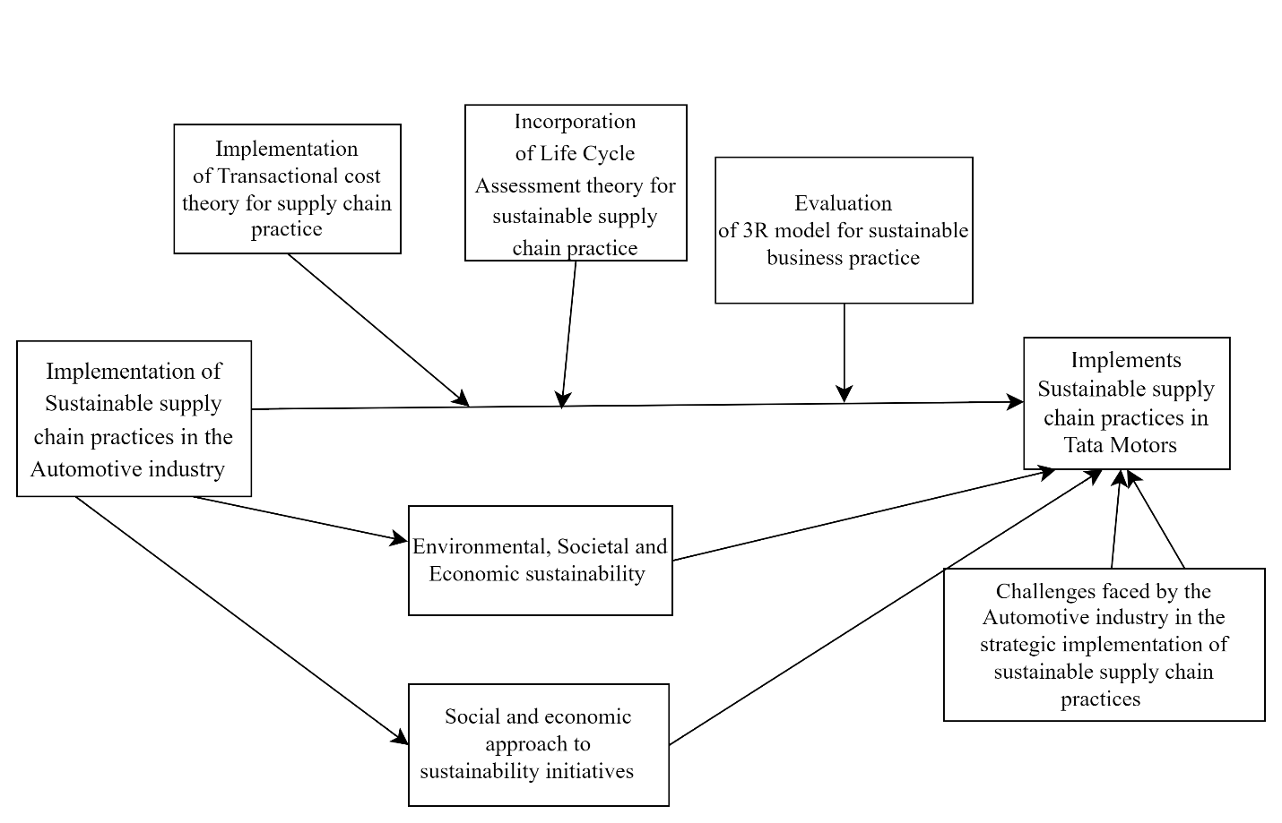

Figure 11: Conceptual Framework
(Source: Self-made)

2.7 Literature Gap
In former literature reviews, different previous authors mainly discussed the automotive industry's sustainability initiatives in multiple business areas to implement sustainable supply chain practices. Still, they did not focus on technical implementation for the development of sustainability in the automotive industry. The previous authors could not analyse corporate reports and did not highlight the company's sustainability efforts for the development of local communities. In this dissertation, the researcher has the scope to address industry policy to understand the societal, environmental, and economic impacts of the automobile industry.

2.8 Conclusion
After completing the entire literature review, it can be concluded that the implementation of sustainable supply chain practices in the automotive industry considers several challenges, such as technology adoption, data management, environmental impacts, etc., To address the challenges, the company required a holistic approach and maintained effective collaboration among the government bodies and stakeholders. Drive a systematic change towards a more sustainable automotive supply chain. It can be concluded that an automobile organisation can focuses on inclusive, effective, sustainable strategies to maintain its brand position within the industry.

Chapter 3: Research Methodology

3.1 Overview
By developing this chapter the researcher can able to produce a better understanding of assessing the sustainable supply chain approach by attending a specific case scenario of Tata Motors. To improve a research method with a systematic approach, an adequate set of research frameworks plays a crucial role. The Methodology section adopts the research onion framework for developing the research analysis to meet the research aim and objectives as research onion is a well-structured process that assures logical development of the research investigation. The research onion involves different layers for offering efficient research findings. By exploring individual layers of method and aligning the research aim with the process researcher can demonstrate efficient outcomes accordingly.

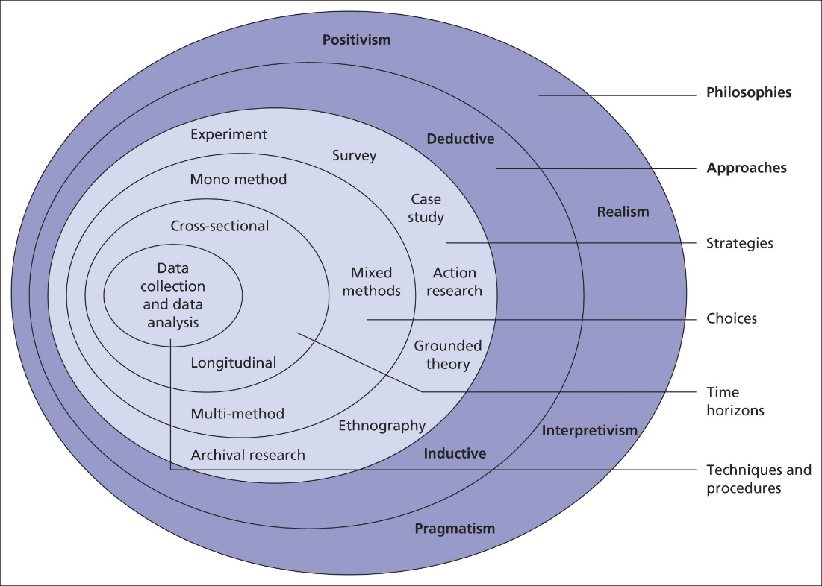

Figure 12: Research Onion
(Source: Saunders et al., 2009)

3.2 Research Philosophy
Research philosophy helps in developing a fundamental assessment relatable to the research topic that helps in assessing the sustainability of the supply chain context in the automobile sector. Research philosophy is mainly intended to improve an ideology for cultivating different natures and knowledge that can determine the way of research progression. Interpretivism research philosophy will be undertaken as it can rightly set a guideline for designing the research (Alharahsheh and Pius, 2020). It is mainly used for establishing the right opinion on a subject related to the study. Different social and historical approaches have developed with multiple viewpoints intended to gain an advantage for further findings in research.
By assessing interpretivism research philosophy, the researcher can be able to assess different assumptions, which allows to obtain subjective and socially constructed aspects. In addition to this, it is important that by assessing the assumptions of the social perspective, the scenario of Tata Motors and their application towards developing sustainability practice are observatory where interpretivism research philosophy is highly efficient to apply (Park, Konge and Artino, 2020). Through using this research philosophy, the researcher can be able to understand the reality through the experience and different observations further. It is intended to develop different outcomes from various perspectives of an individual's social aspects.
Justification: It allows us to assess a study where social contexts and multiple perspectives are involved. To be precise, it has been evident that the research topic is related to Tata Motor’s organisational practice in terms of applying sustainability practice where a complex social context is indicated (Ryan, 2018). Through interpretivism, researchers delve into different subjective experiences, beliefs and values of individuals as well as groups. Moreover, it is well suited for Qualitative research methods as it enables to collection of rich and detailed data which can capture depth and nuance in terms of social phenomena.

3.3 Research approach
The research approach gives legitimacy as well as offers scientifically sound findings. There are mainly two research approaches available such as inductive approach and deductive approach for research investigation. Through appropriate research design, the researcher is able to associate with interpreting the related data and improvise assumptions in terms of assessing the values and benefits. The research will adhere to the Inductive research approach in terms of assessing the research objectives accordingly (Casula, Rangarajan and Shields, 2021). By applying an inductive research approach, the researcher can be able to evolve a systematic analysis of data by identifying their patterns, themes and categories. In a nutshell, it can be stated that the process mainly involves grouping similar ideas along with identifying the relation between different components further. As it allows to recognise of the pattern or themes therefore, a detailed examination can be conducted in terms of specific cases to a theme, which may generalise to broader contexts (Vears and Gillam, 2022). Through optimising inductive research, the researcher can able to delve into rich insights and explore complex phenomena as well as context.
Justification: The main reason behind adopting the inductive approach is it allows several problem-solving areas by providing systematic as well as logical processes in terms of reaching a conclusion as per the given premises. As the research investigation mainly focuses on the relevance of sustainability, therefore, the inductive research approach works as an inference, which leads to adequate alignment with value deduction (Proudfoot, 2023). Other than these, it is also notable that the researcher can be able to collect rich and descriptive data which can be intended to reveal patterns and themes correspondently. Hence, it becomes easier to optimise different theory generations where researchers aim to uncover new insights and frameworks that are intended to explain the phenomena of the research subject accordingly.

3.4 Research Strategy
It is the next layer of the research onion framework. Through this layer the researcher can able to determine which process and techniques are appropriate in terms of addressing the research questions as well as objectives accordingly. It works as a roadmap in terms of selecting specific data collection methods that align with the research aim apparently (Welch et al., 2020). There are different research strategies available for developing research, such as archival research, grounded theory, case study, experiment and so on. The researcher will adhere to the Case Study research strategy for developing the entire research as it is seen that the descriptive approach has evolved for cultivating the research objectives and questions. On the other hand, it is important to note that the research paper has included different information which helps to develop the research improvement (O’Sullivan and Jefferson, 2020) by undertaking a qualitative research strategy and an in-depth understanding of of human behaviour accordingly. The interview has been focused on in the research paper, where the descriptive approach helps in establishing outcomes in a more accurate way. The topic contains different data which can optimise to assess the relevant output.
Justification: There are several compelling reasons involved in choosing case studies for this particular research investigation. As it is seen that the research topic is specifically intended to assess the sustainability practice of Tata Motors in their supply chain context therefore, it is favourable to choose case studies as they allow one to delve deeply in terms of assessing individual phenomena, content as well as situations (Martinsuo and Huemann, 2021). In this regard, it seems that by optimising case studies, the researcher can able to assess different attributes of Tata Motors in terms of their organisational policy, sustainability practice, supply chain process, technological implementation and others where situational analysis plays a crucial role. It goes hand in hand by adopting case study analysis. Moreover, this depth has high potential when the aim is to offer a comprehensive understanding of any complex scenario of the supply chain in Tata Motors. Relevantly, the case study analysis strategy offers contextual richness while offering detailed data which can capture contextual nuances of real-life situations.

3.5 Research choice
The layer of research choice in the Research onion framework refers to the selection of an overarching approach which guides the entire research procedure further. It is important to note that research choice mainly influences the methodological rigour of the research investigation as it assures validity, reliability as well as replicability further (Harrison, Reilly and Creswell, 2020). On the other hand, it is also seen that research choice needs to be ascertained as per the suitability of the research objectives. In an insightful manner, it is seen that the research choice intended to determine the method as well as techniques that have been applied in the data collection and analysis. The mixed method has been applied by the researcher, where it is noted that the research has approached on qualitative strategy for both the primary and secondary data collection (Dawadi, Shrestha and Giri, 2021). It seems that the qualitative research strategy is the main reason to adopt the Mixed method because these multiple data collection processes offer the opportunity in terms of achieving the research objectives by considering different knowledge that already exists and is accumulated further.
Justification: The mixed method allows to evolution of a comprehensive understanding where it is seen that through this, the researcher can be able to gain a detailed insight into complex phenomena. It has been evident that the qualitative method offers an in-depth insight in terms of the complex content and offers different experiences further (Rounsefell et al., 2020) as it is seen that qualitative methods are highly valuable in terms of exploring new phenomena and generating new understanding of social processes. Therefore, by adopting mixed methods, the researcher can enable the validity of findings via methodological triangulation, which strengthens the credibility of research outcomes by minimising biases.

3.6 Research time horizon
To conduct a research investigation, a proper timeline for conducting the entire process is required. By obtaining a proper time horizon, the researcher can be able to conduct their research process in a precise manner. It is important to note that it refers to the period over which a researcher intended to collect and analyse the research study apparently. The research time horizon has credibility in terms of shaping the scope as well as depth in an insightful manner for the research findings. There are mainly two research time horizons available for the researcher such as longitudinal time horizon and cross-sectional time horizon. In an insightful manner, it can be stated that longitudinal studies enable the researcher to observe changes as well as dynamics over time. It can offer insights into the procedure of changes and stability (O’Mahony, 2021). On the other hand, a cross-sectional time horizon mainly offers a snapshot of different phenomena at a specific moment, which is useful for exploring prevalence and comparative analysis among different groups. A cross-sectional time horizon will be adopted by the researcher for conducting the research study and accomplish it within a time scale. As the researcher has to complete the study within university university-mentioned timeframe, therefore, a cross-section study is adequate for this research. It is comparatively quicker and less resource-intensive, which helps in tracking the same subject over extended periods.
Justification: One of the main reasons for choosing a cross-sectional time horizon is that the researcher has to conduct the entire research investigation process within the time frame that has been mentioned by the university guidelines. Therefore, choosing a cross-section time horizon is wiser in comparison with the longitudinal time horizon. It has been evident that cross-sectional allows immediate data collection, where it is notable that the researcher is allowed to gather all the data relatively quicker and efficiently in terms of comparison to longitudinal studies (Sánchez-Pérez et al., 2022). In addition to this, it is important to note that longitudinal has been avoided in the research investigation because it often requires sustained data collection over an extended period of time. Therefore, it is not advantageous when time allocation is limited. On the other hand, it is also seen that cross-sectional analysis is intended to offer a snapshot which can offer insights into the prevalence and associations of variables. Therefore, it is useful in terms of focusing on the recent scenario and comparing it with the population further.

3.7 Technique and Procedures

Data collection
Data will be gathered from primary and secondary sources in combination. The secondary data will be gathered from several credible and publicly available sources, such as official organization documents, industry reports, and scholarly diaries (Beşirova et al., 2021). This strategy ensures a thorough understanding of current data and procedures related to a workable store network for car industry executives, with a focus on Tata Motors in particular. To collect primary data, semi-structured interviews with directors and officials of Tata Motors who are directly involved with store network executives and maintainability drives will be used to obtain vital information. Open-ended questions will be developed for the questionnaire (Taguchi, 2021). It has been evident that by using open-ended interview sessions, the researcher can create flexibility and adaptability where they can get into an unexpected topic as well as follow up on interesting opinions further. Moreover, open-ended interviews intended to facilitate a deep understanding of the cultural as well as social context of Tata motors, to be particular for this research matter. Through this researcher can able to explore the different shapes of the participants’ aspects as well as behaviour to provide context-specific interpretation of the data accordingly.
Justification: It has been evident that choosing both the primary and secondary data collection process is advantageous for the researcher as it gives a unique contribution to the research dimension. On the other hand, it is also seen that it can offer a comprehensive understanding by combining both primary and secondary data. In an insightful manner, it can be stated that secondary data helps in assessing the existing resources that give authentic insight. Similarly, primary data collection has the credibility of generating different new perspectives as it collects all the new opinions from first-hand resources (Khan and MacEachen, 2022). Therefore, the researcher can gain a comprehensive perspective while assessing both the data, and it helps in creating a broader overview for generating specific insights as well as tailoring all the current information through developing interviews. Alternatively, the main resonance behind choosing open-ended interview questions for collecting primary data is that it allows to researcher to gain rich and detailed data where participants can express their thoughts.
Data analysis
Thematic analysis will be ascertained while assessing the information collected from different secondary sources. Even it is also seen that by adhering to thematic analysis for interpreting the secondary collection, the research paper has evolved thematic analysis for evolving data apparently. A qualitative analysis will be followed to represent the data interpretation of the primary data collected through structured interviews (Xu and Zammit, 2020). It helps in systematically organising as well as summarising large amounts of qualitative data. Most importantly, different types of data, such as interviews, observations, and textual sources, are involved in it. The process enables to identification of the patterns and trends for exploring the data and categorising it into different themes and subthemes subsequently. Therefore, by evolving thematic analysis, researchers can be able to uncover recurring ideas and various experiences across various participants. It is intended to facilitate the exploration of commonalities accordingly.
Justification: One of the main reasons for choosing thematic analysis is that it enables the researcher to generate rich insight in terms of interpreting outcomes from qualitative data. By exploring the data and divided it as per there categories so that a better extraction can be committed which goes beyond descriptive accounts. The procedure intended to contribute to further theory development in regards of supply chain sustainability and formulation of nee conceptual frameworks accordingly.

3.8 Sampling
The researcher is going to adhere to Purposive sampling for the research investigation where it is seen that it has the relevance of meeting research objectives further. On the other hand, it is also seen that the process allows the researcher to select the respondents who have the credibility to offer rich and detailed insights that are related to the research objectives further (Andrade, 2021). On the other hand, it is also seen that through this sampling technique researcher can be able to assure that the collected data are directly aligned with research goals.
Justification: It is more time-efficient as well as cost-effective in comparison to probability sampling methods (Campbell et al., 2020). Other than these, it means that the researcher can gain credibility in terms of focusing on the resources to recruit the respondents who can meet the criteria rather than only attempting a large sample which is less relevant.

3.9 Ethical considerations
Ethical consideration is noted as one of the fundamental elements in the research investigation, which is intended to ensure that all the studies that have been conducted in the research paper are protecting the rights, dignity as well as well-being of the participants and the researchers. Throughout the data collecting and analysis process, the researcher must communicate openly and honestly. Ethical consideration mainly promotes research integrity by assuring that the studies are conducted in a transparent as well as accountable manner. In this regard, it seems that by adhering to ethical standardization the researcher can able to maintain credibility and trustworthiness in terms of fostering confidence among the research community as well as stakeholders. The investigator will provide all relevant details regarding the goals of the study and the methods for collecting, storing, and utilizing the data (Nii Laryeafio and Ogbewe, 2023). At any time throughout the interview, participants will have the option to end it. Since the data will be gathered anonymously, no private information will be combined with the study paper's data.
Participation protection plays a crucial role in the ethical context where it is seen that the researcher intended to maintain proper protection of principle in terms of the rights as well as the welfare of the participants. It included obtaining informed consent and assuring confidentiality. Minimization of discomfort during the interview session and offering a debriefing after taking part in the interview (Suri, 2021). It seems that ethical practice is intended to mitigate the risk associated with the involvement of the participant as well as uphold the dignity of the participants further. The researcher will use informed consent from the participants, where clear and understandable information in terms of the research purpose, research benefits, and research procedure will be provided. The consent assures that the participants voluntarily agreed to the research attributes and process where their involvement is entailed.

3.10 Validity and Reliability
- The research study’s validity is maintained by using structured interviews as well as secondary data analysis.
- Reliability of the investigation is mainly assured through using a systematic process and rigorous data evaluation. Moreover, the objectivity is maintained by eliminating the bias as well as presenting the outcomes in a straightforward manner accordingly.
It has been evident that the researcher obtained an insightful outcome by employing open-ended questions which can contributed to the trustworthiness of the study. Similarly, multiple data sources, such as literature reviews considered as a solid basis. The action of transparency in terms of gathering the data intended to develop the objectivity of the research study further.

3.11 Research Limitation
There are certain limitations involved in this research investigation process, as mentioned below.
Sample size and representativeness- In terms of collecting data it is considered as one of the most common limitations in the research. As it is seen that small sample sizes could limit the generalisability of research findings as well as non-representative samples can introduce bias and it may affect the external validation of the study further.
Sampling Bias- There is a probability in terms of selecting sample or participant groups that can create biasness in the research investigation. It is important to note that due to biases, sampling findings can be misleading.
Quality of Data- it has been evident that the researcher has gone through both the primary and secondary data collection process; therefore, the opinion of the participants is a major concern. Due to any biases towards the company could make a manipulated outcome further. Similarly, while collecting secondary data in certain cases, it may be outdated resources or inaccurate resources, which can lead to potential biases in conducting findings.

3.12 Chapter Summary
In a nutshell, it can be stated that the chapter employs a research onion framework where six different layers are included, which is supposed to develop the research investigation process in a systematic manner. On the other hand, it is also noted that the Qualitative study approach h has been ascertained while developing the research data and optimising a proper outcome for assessing the sustainability practice of Tata Motor’s supply chain management. It has been evident that a mixed research choice has been chosen in the research process so that the researcher can evolve a greater insight into the research investigation's outcome. In addition to this, for data analysis thematic process has been performed for obtaining a better insight. Most importantly, all the possible ethical guidelines of the research conduction process have been ascertained by the researcher to mitigate any sort of risk association.

Interview Question
- Can you describe the key sustainable practices that Tata Motors has implemented in its supply chain?
- How do you assess the environmental impact of Tata Motors' sustainable supply chain initiatives? Can you provide specific examples or metrics?
- What are the major challenges Tata Motors has faced in implementing sustainable practices in its supply chain?
- Can you elaborate on the economic benefits that Tata Motors has experienced as a result of adopting sustainable supply chain practices?
- How does the cost of implementing sustainable supply chain practices compare to traditional practices at Tata Motors?
- How are various stakeholders, including suppliers and customers, involved in Tata Motors' sustainable supply chain initiatives?
- Can you discuss the impact of Tata Motors' sustainable supply chain practices on local communities?
- How have labour conditions been affected by the sustainable practices adopted in Tata Motors' supply chain?
- What mechanisms are in place for monitoring and evaluating the effectiveness of sustainable supply chain practices at Tata Motors?
What future plans or strategies does Tata Motors have for further enhancing the sustainability of its supply chain?

Chapter 4: Finding and Analysis

4.1 Overview
The chapter has mainly delved into exploring different perspectives of sustainability practice incorporated by Tata Motors. By emphasising multiple areas such as employee treatment, environmental practice, energy consumption, ethical performance, and others, the research investigation has illustrated a detailed understanding of sustainability practice in the organisational development context further. By developing multiple themes and subthemes, the researcher has interpreted the research analysis in a significant way to ascertain favourable findings. The section has imposed a detailed evaluation of both the primary and secondary findings accordingly.

4.2 Analysis of primary data
Details of the Interviewees
The interviewees chose for this exploration are administrative workers of the tata company who are straightforwardly associated with the organization's maintainability drives and inventory network the executives. A Senior Manager from the Sustainability Department [Participant 1], a manufacturing advisor of the Tata company [Participant 2], and a sales marketing head [Participant 3] are the participants. The Senior Manager is liable for managing the turn of events and execution of maintainable practices across the organization, with a profound comprehension of Tata Motors' manageability methodologies.

4.2.1 Findings
All the questions have been asked by the researcher to participants during the interview, however all the interview was conduct separately but the questions remain similar.
Question 1: Can you describe the key sustainable practices that Tata Motors has implemented in its supply chain? Please be specific to the region or area that you have access to.
Participants | Area of discussion | Answers of participants
1 | Sustainability Measurement | Certainly. In recent years Tata Motors has highly invested in energy efficient technologies and process across all the manufacturing facilities. As an example, I can state that Tata motors has incorporated energy management system in our Mumbai branch which helps in reducing the overall energy consumption accordingly
2 | Ethical Development | I want to mention that in our site in Bangalore Tata Motors has highly invested in integrating renewable energy sources. In our operation unit we use solar power. Even multiple solar panels have been installed in the site for harnessing solar energy too use in our operation unit.
3 | Performance Efficiency | I would like to mention that water management is one of the most effective sustainable practices in our Jamshedpur site where the management has a struct observation on reducing water conservation along with enhancing water recycling. In our office rainwater harvesting system is used.

Question 2: How do you assess the environmental impact of Tata Motors' sustainable supply chain initiatives? Can you provide specific examples or metrics?
Participants | Area of discussion | Answers of participants
Participant 1 | Sustainability Initiatives | I feel Tata Motors is highly attentive about the Greenhouse Gas Emissions where it tracks through different scopes like direct, indirect and value chain emission. The metric included total CO2 emissions and the intensity of the emission like per vehicle produced CO2
Participant 2 | Emission Reduction | There are several factors involved in sustainable supply chain initiatives. Tata has a process of measuring energy consumption and the possibility of shifting towards renewable energy. I have noted about the fact that Tata Motors has undertaken a commitment of reducing carbon footprint and achieve carbon neutrality within 2040. For this initiative they are focuses on tracking the renewable energy sources in their manufacturing unit to track these minimisations.
Participant 3 | Resource Conservation | , I want to state that Tata Motors always pays attention to resource efficiency, where they have initiated a process of using more recycled materials in vehicle manufacturing as well as adopting a water recycling process in the production system. They have segregated specific amounts of raw materials that can be used per vehicle or product. Similarly, I have seen that the volume of water per unit in production is also maintained
Question 3: What are your personal views about the major challenges that Tata Motors has faced in implementing sustainable practices in its supply chain?
Participants | Area of discussion | Answers of participants
Participant 1 | Multiverse suppliers | I think Tata has involved generously in the sustainability practice which involves higher upfront cost for adoption. To be specific I want to mention that green technologies, sourcing sustainable materials, developing energy efficiency are offering long-term benefitted approach which can reduces operational costs. It can offset initial investment for which the financial strain can cause mainly for the extensive supply chains.
Participant 2 | Managing diverse network | I find that Tata Motor's supply chain process is vast and complex in nature. One of the main reasons is that it involves multiple suppliers and spans diverse countries. Managing a diverse network always necessitates continuous monitoring and collaboration with the suppliers. I personally feel it may lead to complexity and inconsistent practice for enforcing the sustainability aspects.
Participant 3 | Regulatory compliance | While working in the manufacturing team, I have realised that Tata Motors always involves new technologies like waste management and energy efficiency, which may face resistance in terms of operational disruption. I believe continuous transition to sustainable technology may create disruption through it is necessary for long-term gains.

Question 4: Can you elaborate on the economic benefits that Tata Motors has experienced because of adopting sustainable supply chain practices?
Participants | Area of discussion | Answers of participants
Participant 1 | Sales Development | I have realised that by involving CSR, Tata Motors has witnessed a great opportunity in terms of cost saving, which often leads to minimise consumption of resources and waste generation.
Participant 2 | Long-Term Cost Stability | I feel through this practice Tata Motors has drive into new technologies and products that are more effective and environment friendly which enhances competitive advantages in market scenario.
Participant 3 | Cost Reduction | I feel that Tata Motors brand reputation has been embraced due to the high sustainable practice as it always appeals to environmentally conscious clients which enhances sales and client loyalty.
Question 5: How does the cost of implementing sustainable supply chain practices compare to traditional practices at Tata Motors?
Participants | Area of discussion | Answers of participants
Participant 1 | Collaboration | sustainable supply chain practice is a long-term goal for which Tata Motors minimises consumption of resources and waste generation. It led to cost saving in long run. As an example, I can state that Tata utilises energy-efficient vehicle in logistic and manufacturing for reducing fuel costs and overall vehicle lifecycle expenses cost.
Participant 2 | Adaptability | I found Tata has incorporated sustainability in the SCM process as an initial cost for maintaining brand reputation and prioritise environmental responsibility. It led to enhanced sales, client loyalty and market share.
Participant 3 | Long-Term Financial Benefits | Tata Motors has utilised diversify suppliers in their sustainable practice which is further effective in comparison with traditional practice as the dependency rate on scarce spruces get reduced and the risk association with climate change can be resolved further.
Question 6: How are various stakeholders, including suppliers and customers, involved in Tata Motors' sustainable supply chain initiatives?
Participants | Area of discussion | Answers of participants
Participant 1 | Stakeholder Engagement | Suppliers has involved through ensuring supply of quality products and raw materials by promoting ethical practice and social accountability where client are involved in feedback mechanism, promotion of sustainable choices further.
Participant 2 | Customer Centricity | Tata has always attentive about their clients where it educates the customers about sustainable aspects like reducing emission, use of eco-friendly material and recyclability. Alternatively, Stakeholders are engaged to improving capacity of building collaboration where Tata engages different activity like training programs, workshops for sharing knowledge on source efficiency.
Participant 3 | Supplier Standard | Tata attends different stakeholders by offering them regular audits to identify suppliers’ compliance and sustainability criteria. Similarly, it helps in allowing the improvement by aligning Tata’s sustainability goals. Alternatively, for clients it involves product awareness and feedback mechanism
Question 7: Can you discuss the impact of Tata Motors' sustainable supply chain practices on local communities? Do you have any suggestions regarding this process?
Participants | Area of discussion | Answers of participants
Participant 1 | Community Engagement | I feel it increases environmental benefits of local community and by promoting this practice Tata can create community engagement where they can include participatory decision-making procedure, community consultation and so on.
Participant 2 | Participatory Decision-Making | Tata embraces environmental benefits with the practice, and they can emerge such measurement on reducing waste generation, resource conservation, lower emission and so on.
Participant 3 | Community Consultation | With Sustainable supply chain the community health gets embraced and for further development Tata can further allocate resources for different community development projects by aligning with Tata’s sustainability objectives
Question 8: How have labour conditions been affected by the sustainable practices adopted in Tata Motors' supply chain?
Participants | Area of discussion | Answers of participants
participant 1 | Employee Engagement | I feel a fair labor practice has emerged through proper sustainability practices in the supply chain because it precisely prioritise worker’s right where a fair wages and non-discrimination are involved.
Participant 2 | Employee Retention | I feel it enhances worker safety and health as sustainable practice often involved labor standardisation and regulations. Therefore, our overall working condition get benefitted.
Participant 3 | Employee Satisfaction | I found it is beneficial for embracing employee engagement and welfare which fosters a proper employee satisfaction and retention
Question 9: What mechanisms are in place for monitoring and evaluating the effectiveness of sustainable supply chain practices at Tata Motors?
Participants | Area of discussion | Answers of participants
Participant 1 | KPI Metrics | Tata is always focuses on different sustainability KPI metrics element like waste reduction target, carbon footprint minimisation, renewable energy consumption and so on.
Participant 2 | Supplier Scorecard | I feel both KPI metrics of sustainability in the supply chain supplier scorecard are the two main mechanisms for evaluating sustainability practices
Participant 3 | Waste Management | Tata has precisely attended supplier scorecards to track the performance on different sustainability metrics and other criteria. Different elements like social responsibility, quality, environmental impact and others are involved in this regard.

Question 10: What future plan or strategies does Tata Motors have for further enhancing the sustainability of its supply chain?
Participants | Area of discussion | Answers of participants
Participant 1 | Electric Vehicle | On the basis of our several team meeting I found that Tata motors are intended to focus on emission minimisation targets in their supply chain process which involves reduction of greenhouse gas emission in manufacturing unit and logistic.
Participant 2 | Cleaner Technology | I found in our workforce that team leaders and managers are always attentive about shifting towards electric mobility and for this they are likely to adopt electric vehicle.
Participant 3 | Emission Minimization | Tata is interested in minimising greenhouse gas emissions and encourages suppliers to adopt cleaner technology and practices

4.2. Discussion

4.2.1. Evaluation of the data
By emphasising the opinion of the participants, it has been emphasised that Tata Motors has developed a great involvement in sustainability practices by attending different areas both in their operational and functional activities. Participant 1 has stated that Tata Motors is immensely endowed in energy efficient techniques across all their manufacturing facilities. They also incorporated an energy management system, which allows them to reduce energy consumption. It refers to the sustainability practice of the company, highly evolved and the relevance of different initiatives. Alternatively, participant 2 has also agreed with the fact of attending sustainability initiatives in the supply chain process where he states the firm is involved in measuring energy consumption and trying to shift towards renewable energy. Moreover, Tata Motors has an initiative to eliminate its carbon footprint within 2040. This approach reveals that an overall environmental impact of the company is quite feasible and there is a possibility of future efficiency to maintain standardisation.

4.2.2. Sustainable supply chain practices of Tata Motors
Wherever three of the participants agreed with the fact that the sustainable supply chain practices of Tata Motors have a great influence on the community, in this regard, it seems that Participant 1 stated that Tata emerged different measurements on minimising waste generation, conservation of resources, along minimising lower emission. With the experience of seven years working in this company, the participant stated that Tata is always very attentive about their labour condition where they explore sustainable practices in a manner which intended to maintain worker safety and health context apparently by involving proper regulations in labour standardisation, wages and so on. Other than these, it has also been found that Tata is always focused on continuous monitoring of an effective supply chain where diverse KPI metrics and supplier scorecards where a precise interpretation of the usage of renewable resources, waste management practice and others have been exempted. Therefore, it has been realised from the participant's opinion that Tata Motors has precisely set a metric that is related to the sustainability context in terms of assessing the efficiency of their supply chain partners. It allows to cultivation of the probability of reducing carbon emissions in their individual manufacturing unit and collaborating with the suppliers closely to improve the sustainability procedure accordingly. Participant 2 stated that Tata Motors has been involved in implementing different forms of sustainability and considered it as an initial cost so that they can maintain their brand reputation and perceive environmental responsibility. It has been derived as a matter of fact that the incorporation of sustainability led to enhanced sales, client loyalty and market share.
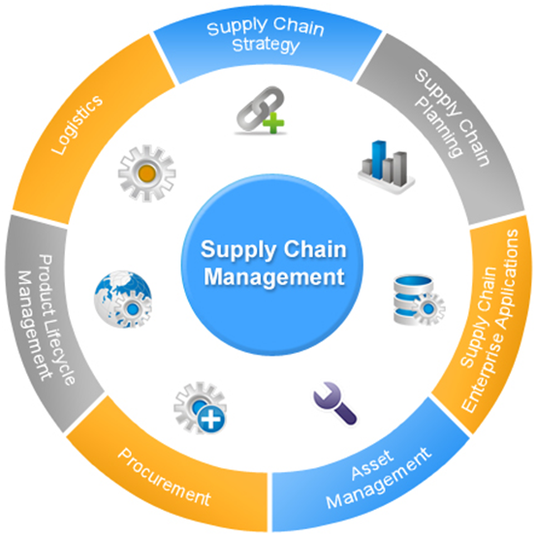
Source:- https:process.st.
Assessing different case strategies of Tata Motors reveals that Tata Motors has precisely evolved specific sustainable practices for maintaining an efficient SCM process. The case scenario of Anjum (2022), referred to Tata Motors emphasises sourcing of materials from the suppliers who adhere to ethical standardisation and maintain environmental sustainability. It seems that Tata Motors has always had its own suppliers who have a supplier code of conduct which assures that all the suppliers associated with Tata Motors are complying with environmental regulations, ethical practices and sustainability standardisation. Even it is also noted that Tata Motors has also undertaken an aim for achieving zero waste to landfills by incorporating recycling and waste reduction practices as it finds in the case scenario that Tata Motors intended to segregate waste into different categories like hazardous, non-hazardous, recyclable, non-recyclable waste and so on. By making segregation Tata Motors helps in managing and processing waste in a more efficient manner.
The case study of MISHRA (2020) accounted that Tata Motors are imposed effluent treatment plants for treating and managing industrial wastewater. It is important to note that treated water is reused in the production system or safely discharged, which is intended to minimise the impact on the environment. Some Tata Motors facilities are equipped with a zero-liquid discharge system, which assures that no liquid waste is discharged into the environment promptly. In this regard, it is also important to mention that in the manufacturing site of Tata Motors, wastewater is related as well as recycled back into the main production procedure.

4.2.3.Employee training process of the tata company
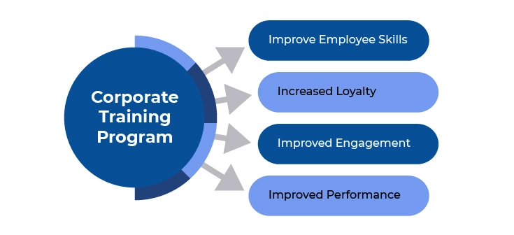
source :- https://api.edoxi.com/assets/studyhub/Corporate_Training_Program.webp
The case scenario of Bulla and Fogla (2023), refers to Tata Motors having emerged in a concrete process of training as well as developing multiple workshop programs. This thing intended to allow better employee awareness where Tata has committed to invest in the training process for their employees on waste management practices along with the significance of sustainability. It assures that the practices intended to meet legal requirements accordingly. Tata Motors has engaging lean manufacturing workshops where different training on lean tools like 5S, Kaizen, Value stream mapping, Jit production and others has been emphasised in the article. It reveals that Tata Motors has implemented workshops where they have incorporated cross-functional teams for addressing specific challenges in the respective areas (Bulla and Fogla, 2023). The aspect has established the statement of Participant 2, who states that Tata engages in different activities for their stakeholders in the supply chain initiatives where training programs and workshops are incorporated where the main aim is to improve the knowledge efficiency of the customers. To promote best practices in environmental management, Tata Motors has developed different training on environmental regulations, waste management, and workshops on sustainable product design where the firm has incorporated ISO standards that are related to environmental management.

4.2.4 Environmental practice of Tata company

Source:- https://www.tata.com
Many of the case studies of Tata Motors' environmental practice reflect the matter of fact that there are multiverse initiatives that have been undertaken by the company. In an insightful manner, author Das (2022) has accounted that Tata Motors has precisely measured the reduction of greenhouse gas emissions across their different manufacturing unit's supply chain process. For this instance, they have to pay attention to the areas of transportation and end-of-life disposal of the vehicles. The case study stated that by proper optimisation of transportation routes, it has been evident that the emission of carbon discharge has been minimised. This finding refers to the opinion of Participant 1 are evitable who has referred to Tata Motors' emerging metrics for assessing the CO2 emission along with the intensity of the emission on individual vehicles. Alternatively, the case study referred by Peshin, Sengupta and Azevedo (2022) mentions that Tata Motors always emerges effective metrics to calculate accurate CO2 emission and green gas discharge in their logistic operation accordingly. It is intended to calculate the energy use per vehicle produced or per kilometre the vehicle has travelled.
From the opinion of Slariya (2020), the case study has revealed that Tata Motors has precisely used green technology and different biodiversity conservation efforts in their organisational policy. In this scenario, it reveals that the application of electric vehicles has been encouraged, which aims to minimise greenhouse gas emissions along with reducing the dependency on fossil fuels accordingly. Here, it is also noted that Tata Motors has focused on its water conservation efforts, where they developed a water recycling system and have made proper measurements that are required for use per vehicle produced (Dev, 2024). This outcome from the case study has met the opinion of the 3rd participant who has taken part in the interview. He has stated that water management is considered one of the most impactful practices within the company's manufacturing unit, where a strict observation has been penetrated to increase water recycling. Even as a real-life example, it also seems that Tata has used rain harvesting in their production site.

4.2.5. Electric vehicle of Tata company
The case study accounted for by Singla and Bansal (2022) reveals that the promotion of electric vehicles by Tata Motors, like Nexon EV, has produced zero tailpipe emissions, which is intended to develop local air quality along with reducing the overall carbon footprint accordingly. This case study has recognised that the Tata Nexon EV has the potential to encourage the usability of clean energy sources such as electricity, which is intended to be sourced from renewable energy generation like solar or wind power (Hemand Chandran, Ajithkumar and Bahukhandi, 2022). Therefore, the statement of Participant 2 has been recognised to be effective. It indicates the promising approach of the opinion where the participant reveals that Tata motors integrated solar power in their manufacturing unit and installed multiple solar panels in the sites for harnessing sustainable energy. It has been recognised that the Nexon EV is mainly designed to optimise energy use via regenerative banking as well as the energy recuperation process, which is intended to enhance overall efficiency.
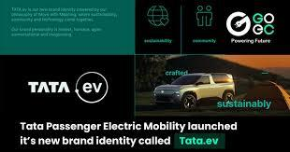
Source:- https://www.tata.com
Tata Motors has continuously made investments in R&D to advance sustainable practices and promote economic growth. Tata Motors concentrated on enhancing and creating hybrid and electric cars as well as other eco-friendly technologies that might further reduce their negative effects on the environment. Additionally, Tata Motors has strengthened its position in the cutthroat industry by working with partners and suppliers who uphold ethical standards. Electricity, the metaverse, intelligent business, the SCM sustainability program, and other initiatives are all undertaken by Tata Motors. Malagihal (2021), refers to the case scenario where it is noted that The company focuses on strengthening its connections with the surrounding local suppliers in order to increase the sustainability of supply chain management. Dieguez et al. (2020) state that Tata Motors places a high priority on the development of local suppliers and sourcing, offering qualified members of the community employment opportunities. By giving the community job opportunities, the company supports local economic growth, improves people's quality of life in general, and promotes skill development. Enhancing job prospects in many sectors, such as manufacturing, logistics, and support services, contributes to enhancing the socioeconomic status of the community.
The case study of Kidav (2022) reveals that Tata Motor is considered a leading Indian automotive manufacturer that has developed significant strides in terms of integrating sustainable practices in the supply chain process. It seems that Tata Motors has precisely paid attention to economic development, and it seems that they have always encouraged to involvement of local suppliers as well as incorporating community development projects further. It intended to stimulate local economies along with offering different funding for education, healthcare as well as infrastructure. It has revealed that Tata Motors encourages local community development where environmental stewardship plays a crucial role. From this perspective, it has been seen that Tata Motors has always indulged in fair labour practices throughout its supply chain, which included fair wages, safe working conditions, and mutual respect for workers' rights. The statement of Participant 1 referred here to be justified as he stated that a fair labour practice had been conducted by Tata Motors in the supply chain where they precisely prioritise workers' rights and non-discrimination perspectives (Khanna, 2021). Similarly, Participant 2 has also agreed with the fact that Tata Motors enhances worker safety through labour standardisation and regulations. The case study has revealed that Tata has always preferred a proper implementation of struct health as well as safety standards in the operation scene, which makes a strong commitment towards creating a safer workplace for both the suppliers and employees. It is intended to reduce accident risks as well as health issues.

4.3 Chapter Summary
By assessing the above-mentioned details, it has been explored that Tata Motors has a mass implementation in different perspectives of sustainability practices. It refers that Tata Motors emerges different environmentally friendly practices which intended to encourage the overall relevance of sustainability efficiency in a proper manner. Here, it is evident that the labour practice implementation of electric vehicles and others has been incorporated into the organisational context to optimise a better outcome eco-friendliness. The section has also revealed the matter of fact that Tata Motors has a great approach towards an emerging circular economy in terms of ascertaining profitability in a relevant manner.

Chapter 5: Conclusion and Recommendations

5.1. Introduction
This chapter provides a summary of the research on Tata Motors' sustainable supply chain practices and their effect on the environment, economy, and organizational performance. It offers an exhaustive synopsis of the main discoveries, assesses the results of these practices, and substantial ideas for further developing Tata Motors' supportability endeavours. By incorporating insights from the analysis, the purpose of this chapter is to provide strategic guidance for addressing the challenges that have been identified and increasing the efficiency of sustainable practices. The ideas are expected to help Tata Motors in accomplishing its sustainability goals and keeping up with its car industry advantage.

5.2. Conclusion

5.2.1. Key Findings
In their production network, Tata Motors has carried out various key reasonable practices, essentially influencing their ecological and monetary presentation (Kidav, 2022). Examples of these practices include increasing energy efficiency, making use of renewable energy sources, and improving waste management procedures. For instance, the company has implemented energy-efficient technologies throughout its manufacturing facilities and switched to renewable energy sources like wind and solar power. They have also put comprehensive waste management systems in place to encourage recycling and cut down on waste production. The environment suffers greatly as a result of these practices. As indicated by Slariya (2020), Tata Motors has effectively decreased its fossil fuel by-products and saved regular assets. Ozone harming substance emanations have diminished essentially, and asset effectiveness has improved, as indicated by key measurements. Tata Motors has made significant progress toward its environmental goals by increasing the use of renewable energy and enhancing production processes.
Nonetheless, Tata Motors has confronted a few difficulties in executing these reasonable practices. Significant obstacles have been managing a diverse supplier base, ensuring regulatory compliance, and covering the initial costs of new technologies (Gawusu et al., 2022). The intricacy of planning with providers across different districts and complying with various ecological guidelines has required powerful administration procedures. Tata Motors has benefited financially from a number of its sustainability initiatives. These include cost savings as a result of energy efficiency measures, risk reduction as a result of less reliance on resources that are not renewable, and improved brand reputation. The organization's obligation to sustainability has worked on functional effectiveness as well as reinforced its market position by lining up with purchaser assumptions for naturally dependable practices. Tata Motors' sustainability efforts have been successful because of the involvement of stakeholders (Khanna, 2023). The company encourages cooperation and commitment throughout the supply chain by actively involving customers and suppliers in its sustainability initiatives. This commitment has prompted better practices among providers and expanded client unwaveringness.
The effect on nearby networks has been positive too. Tata Motors' sustainability rehearses have added to work creation and upgraded local area commitment. Local efforts to conserve the environment have also been supported by the company's initiatives in energy efficiency and waste management. Enhancements in labour conditions are obvious because of the organization's emphasis on reasonable practices (Halme et al., 2020). Better representative government assistance and wellbeing principles have been focused on, adding to a safer and steady workplace. Tata Motors utilizes thorough checking and assessment components to survey the viability of its maintainable inventory network rehearses. Sustainability reporting, performance metrics, and regular audits are all examples of these. Looking forward, Tata Motors intends to additional upgrade its supportability endeavours by putting resources into trend setting innovations, extending environmentally friendly power use, and fortifying organizations with partners to drive constant improvement in their production network sustainability.

5.2.2. Implications for Tata Motors
Organizational Impact: The development of Tata Motors' organizational structure and the effectiveness of its supply chain have been significantly impacted by the adoption of sustainable practices. Operations have been streamlined and operational costs have been reduced by incorporating energy-efficient technologies, adopting renewable energy sources, and improving waste management practices. The emphasis on supportability has likewise further developed Tata Motors' market intensity by exhibiting a pledge to natural obligation, which upgrades brand notoriety and draws in eco-cognizant purchasers (Casemajor, 2023). Besides, the accentuation on work conditions and local area commitment has cultivated a positive corporate culture and further developed representative fulfilment, adding to higher efficiency and lower turnover rates.
Strategic Implications: The sustainability rehearses adjust flawlessly with Tata Motors' essential objectives of development and authority in the car business. Tata Motors is positioned as a forward-thinking leader in sustainable practices thanks to these initiatives, which not only support the company's commitment to environmental stewardship but also meet industry standards and regulatory requirements. Tata Motors increases its resilience against market and regulatory pressures by incorporating sustainability into its core strategy, ensuring long-term growth and viability (Kailay and Paposa, 2023). This arrangement with worldwide sustainability drifts likewise opens new open doors for organizations and market extension, supporting Tata Motors' essential situation as a trailblazer in practical car arrangements.

5.2.3. How objectives are fulfilled
Objective 1: Exploring Tata Motors' sustainable supply chain practices:
The report highlights important initiatives that show Tata Motors' dedication to sustainability, including waste management enhancements, the use of renewable energy, and energy efficiency. The results show the company's all-encompassing strategy for bringing these practices into line with its environmental objectives and meeting the growing demand for sustainability in the automotive sector throughout its supply chain.
Objective 2: Assessing Tata Motors' environmental impact:
The study emphasizes how improved production techniques and the utilization of renewable energy sources have significantly reduced greenhouse gas emissions and conserved resources. Tata Motors has demonstrated the beneficial environmental effects of its sustainable supply chain operations by lowering its carbon footprint and contributing to global climate goals through its environmental sustainability activities.
Objective 3: Evaluating the financial benefits and challenges:
The study describes how energy efficiency can lower costs, how reducing reliance on non-renewable resources can mitigate risk, and how improving brand reputation can help. However, it also highlights obstacles that Tata Motors must overcome in order to maintain long-term financial advantages while upholding its sustainability approach, such as high starting costs and difficult supplier management.
Objective 4: Examining the social implications:
The study illustrates the ways in which Tata Motors' sustainability initiatives have benefited nearby communities by generating employment opportunities, enhancing working conditions, and augmenting community involvement. Employees and the communities where Tata Motors operate gain from the company's sustainable supply chain processes, which also promote environmental awareness and a safer and more supportive work environment.

5.3. Recommendations

5.3.1. Enhancing Sustainability Challenges
Several suggestions can be made to address Tata Motors' sustainability issues and improve the sustainability of their supply chain:
- Strengthen Supplier Collaboration: Improve organizations with providers to guarantee they meet maintainability standards. Help suppliers adopt environmentally friendly practices by implementing training programs and support systems (Lăzăroiu et al., 2020). Customary reviews and assessments ought to be directed to screen consistence and energize consistent improvement.
- Invest in Technology: Put resources into trend setting innovations that can additionally diminish energy utilization and further develop asset proficiency. Operations can be improved and waste reduced with the help of IoT and AI-based predictive maintenance.
- Expand Renewable Energy Use: Increment the reception of sustainable power sources across all assembling offices. Think about long haul contracts with sustainable power suppliers and investigate open doors for on location age to lessen reliance on petroleum products (Wanapinit and Thomsen, 2021).
- Improve Regulatory Compliance: Foster a proactive way to deal with overseeing administrative consistence by drawing in with policymakers and remaining refreshed on administrative changes. Executing powerful consistence, the board frameworks can assist with exploring the intricacies of different guidelines.
- Address Upfront Costs: Investigate supporting choices and motivators for manageable speculations to moderate the forthright expenses related with new innovations. Government endowments, green bonds, and associations with monetary foundations can give the vital cash-flow to maintainability drives.

5.3.2. Future Strategic Initiatives
To progress Tata Motors' maintainability technique and cement their situation as a forerunner in supportable practices, the accompanying vital drives are suggested:
- Develop a Circular Economy Model: Design products for longer life cycles, repairability, and recyclability to move toward a circular economy. Execute shut circle frameworks for reusing materials and decreasing waste, which can upgrade asset productivity and limit ecological effect.
- Enhance Sustainable Innovation: Encourage new ideas for sustainable materials and technologies. Drive product development and operational efficiency by investing in eco-friendly alternatives like lightweight materials and energy-efficient components.
- Strengthen Global Partnerships: Extend cooperation with worldwide natural associations and industry gatherings to share best practices and drive aggregate sustainability endeavours. Participating in international sustainability initiatives may open doors to new market opportunities and technologies.
- Implement Comprehensive Sustainability Reporting: Adopt a sustainability reporting framework that is more comprehensive and transparent. Consistently distribute point by point investigates environmental, social, and governance (ESG) execution, and line up with worldwide principles like GRI (Global Reporting Initiative) and SASB (Sustainability Accounting Standards Board) (Busco et al., 2020).
- Promote Employee Engagement: Through training, awareness programs, and participation in decision-making processes, employees can be involved in sustainability initiatives. An organization's culture of sustainability can spur innovation and boost overall performance.

5.3.3. Recommendations for further research
- Impact of Emerging Technologies: Examine the ways that blockchain, AI, and IoT may boost resource management, efficiency, and transparency in automotive supply chains to further increase sustainability.
- Comparative Analysis of Sustainability Practices: To determine industry best practices and gaps, compare the sustainability initiatives of Tata Motors with those of other international automakers.
- Adopting a Circular Economy: Examine the possible advantages and difficulties of applying a circular economy model to the automotive industry, with a particular emphasis on product life cycle extension and recyclability.
- Consumer Influence on Sustainable Practices: Analyse the effects of growing consumer demand for environmentally friendly cars on the automobile industry's adoption and performance of sustainable supply chain methods.

5.4. Final Thoughts
The reconciliation of feasible practices into Tata Motors' production network addresses a huge headway in the organization's way to deal with natural and social obligation. Tata Motors has demonstrated a strong commitment to reducing its environmental footprint by successfully implementing energy-efficient technologies, adopting renewable energy sources, and improving waste management procedures, as highlighted by this research. These endeavours have added to ecological preservation as well as yielded significant monetary advantages, including cost investment funds and improved brand notoriety.
Regardless of the triumphs, difficulties, for example, overseeing assorted providers and exploring administrative scenes remain. However, Tata Motors' proactive approaches to resolving these issues and involving stakeholders demonstrate the company's commitment to sustainability. Looking forward, proceeded with interest in creative advancements and further mix of feasible practices will be vital for keeping up with this energy and accomplishing long haul maintainability objectives. In conclusion, Tata Motors' sustainability initiatives serve as a model for other businesses attempting to strike a balance between social and environmental responsibility and operational efficiency. Tata Motors is strategically situated to lead the car business toward a more feasible future by staying focused on these standards and consistently developing its procedures.

5.5. Concluding Remarks
As per the discoveries, Tata Motors has put forth critical attempts to integrate maintainability into its inventory network tasks. Tata Motors has shown an excellent obligation to decreasing its effect on the climate by executing energy-productive innovations, taking on environmentally friendly power, and working on squander the board. These initiatives, which have resulted in significant reductions in both carbon emissions and resource consumption, have improved the company's sustainability performance. The difficulty of achieving global supply chain sustainability is highlighted by the difficulties encountered, such as regulatory compliance and diverse supplier management. By the by, Tata Motors' methodologies for beating these difficulties and including partners show a ground breaking procedure that is in accordance with the goals of the association and industry standards.
The organization's continuous obligation to supportable practices and development will be critical for defeating current snags and accomplishing its drawn-out sustainability objectives. Farewell Motors' experience gives significant pieces of information to various affiliations importance to work on their regular and social commitment. All in all, the way that Tata Motors has taken toward maintainability is proof of the benefits of remembering natural contemplations for business methodology. The illustrations gained from this exploration can direct future endeavours in feasible production network the executives, setting a benchmark for industry peers and adding to a more maintainable worldwide economy.

Reference List

Adriana, L.T.D., Fahira, K.T., Nailissa’adah, M. and El Maula, H., (2020, May). A review the important of green human resource management practices toward employee green behaviour in organization. In Journal of international conference proceedings (Vol. 3, No. 1, pp. 124-135). https://www.researchgate.net/profile/Keke-Fahira/publication/341433298_A_Review_the_Important_of_Green_Human_Resource_Management_Practices_toward_Employee_Green_Behaviour_in_Organization/links/62388293e45bd504ab5393a8/A-Review-the-Important-of-Green-Human-Resource-Management-Practices-toward-Employee-Green-Behaviour-in-Organization.pdf
Akkucuk, U. (ed.) (2020) Handbook of research on sustainable supply chain management for the global economy. Hershey, Pennsylvania: IGI Global. Available at: https://doi.org/10.4018/978-1-7998-4601-7. https://librarysearch.uwtsd.ac.uk/permalink/44WHELF_UWTSD/11c0l68/alma99100333248702421
Al-Amin, A.Q., Khan, S.A.R. and Waqas, M. (eds) (2023) Emerging trends in sustainable supply chain management and green logistics. Hershey, Pennsylvania: IGI Global. https://librarysearch.uwtsd.ac.uk/permalink/44WHELF_UWTSD/11c0l68/alma99100559962402421
Alghababsheh, M. and Gallear, D. (2021) ‘Socially Sustainable Supply Chain Management and Suppliers’ Social Performance: The Role of Social Capital’, Journal of business ethics, 173(4), pp. 855–875. Available at: https://doi.org/10.1007/s10551-020-04525-1. https://librarysearch.uwtsd.ac.uk/permalink/44WHELF_UWTSD/1ir6fgh/cdi_proquest_journals_2581101042
Alharahsheh, H.H. and Pius, A., (2020). A review of key paradigms: Positivism VS interpretivism. Global Academic Journal of Humanities and Social Sciences, 2(3), pp.39-43. https://gajrc.com/media/articles/GAJHSS_23_39-43_VMGJbOK.pdf
Anand, V. (2023). An Insight of Corporate Social Responsibility Initiatives of TATA Motors Limited-A Case Study. Academic Discourse, 12(1), 86-96. https://iitmjp.ac.in/wp-content/uploads/2023/12/Revisiting-Management-and-Business-Practices-in-Dynamic-Era-Folio-30-11-23-1-to-34-chp-tak-28-11-23_compressed.pdf#page=60
Andrade, C. (2021). The inconvenient truth about convenience and purposive samples. Indian journal of psychological medicine, 43(1), 86-88. https://journals.sagepub.com/doi/pdf/10.1177/0253717620977000
Anjum, F. (2022). Diversification Strategies of Tata group of companies: A Case Study. International Journal of Scientific Research in Engineering and Management (IJSREM), 6(10), 01-16. https://www.researchgate.net/profile/Farha-Anjum-6/publication/367580655_Diversification_Strategies_of_Tata_group_of_companies_A_Case_Study/links/64293cba315dfb4ccec7d0d9/Diversification-Strategies-of-Tata-group-of-companies-A-Case-Study.pdf
Apaydin, M., Jiang, G.F., Demirbag, M. and Jamali, D., (2021). The importance of corporate social responsibility strategic fit and times of economic hardship. British Journal of Management, 32(2), pp.399-415. https://onlinelibrary.wiley.com/doi/pdfdirect/10.1111/1467-8551.12402
Baliga, R., Raut, R. and Kamble, S. (2020) ‘The effect of motivators, supply, and lean management on sustainable supply chain management practices and performance: Systematic literature review and modeling’, Benchmarking : an international journal, 27(1), pp. 347–381. Available at: https://doi.org/10.1108/BIJ-01-2019-0004. https://librarysearch.uwtsd.ac.uk/permalink/44WHELF_UWTSD/1ir6fgh/cdi_proquest_journals_2534584026
Beşirova, C., Akhtar, W., Shahzad, A., Üresin, U., Çelikel, S. and İrican, M., (2021, December). Analysis of Machining Process with Data Collection Using Industrial Edge Computing. In 11th International Congress on Machining, Istanbul. https://www.researchgate.net/profile/Cemile-Besirova/publication/358891034_Analysis_of_Machining_Process_with_Data_Collection_using_Industrial_Edge_Computing/links/621b35d56051a16582fc859a/Analysis-of-Machining-Process-with-Data-Collection-using-Industrial-Edge-Computing.pdf
Bulla, N. and Fogla, M.A.,(2023). The Impact of Lean Six Sigma on Organizational Performance. https://www.ijstm.net/paper/The%20Impact%20of%20Lean%20Six%20Sigma%20on%20Organizational%20Performance.pdf
Busco, C., Consolandi, C., Eccles, R. G., and Sofra, E. (2020). A preliminary analysis of SASB reporting: Disclosure topics, financial relevance, and the financial intensity of ESG materiality. Journal of Applied Corporate Finance, 32(2), 117-125. https://onlinelibrary.wiley.com/doi/pdfdirect/10.1111/jacf.12411
Campbell, S., Greenwood, M., Prior, S., Shearer, T., Walkem, K., Young, S., Bywaters, D. and Walker, K., (2020). Purposive sampling: complex or simple? Research case examples. Journal of research in Nursing, 25(8), pp.652-661. https://www.ncbi.nlm.nih.gov/pmc/articles/PMC7932468/
Casemajor, C. (2023). Strategies for Building Brand Awareness and a Competitive Edge in Social Media in a Cross-Field Industry: Establishing a Social Media Strategic Plan for Henua. https://www.theseus.fi/bitstream/handle/10024/816469/Casemajor_Charline.pdf?sequence=2
Casula, M., Rangarajan, N. and Shields, P., (2021). The potential of working hypotheses for deductive exploratory research. Quality & Quantity, 55(5), pp.1703-1725. https://link.springer.com/content/pdf/10.1007/s11135-020-01072-9.pdf
Chowdhury, M.M.H. and Quaddus, M.A., (2021). Supply chain sustainability practices and governance for mitigating sustainability risk and improving market performance: A dynamic capability perspective. Journal of Cleaner Production, 278, p.123521. https://opus.lib.uts.edu.au/bitstream/10453/142714/2/Sustainability%20scale%20proof%20read.pdf
Cuypers, I.R., Hennart, J.F., Silverman, B.S. and Ertug, G., (2021). Transaction cost theory: Past progress, current challenges, and suggestions for the future. Academy of Management Annals, 15(1), pp.111-150. https://ink.library.smu.edu.sg/cgi/viewcontent.cgi?article=7602&context=lkcsb_research
Das, J. (2022). Comparative life cycle GHG emission analysis of conventional and electric vehicles in India. Environment, Development and Sustainability, 24(11), 13294-13333. https://www.researchgate.net/profile/Jani_Das5/publication/357659321_Comparative_life_cycle_GHG_emission_analysis_of_conventional_and_electric_vehicles_in_India/links/63e7274ddea61217579df423/Comparative-life-cycle-GHG-emission-analysis-of-conventional-and-electric-vehicles-in-India.pdf
Dawadi, S., Shrestha, S. and Giri, R.A., (2021). Mixed-methods research: A discussion on its types, challenges, and criticisms. Journal of Practical Studies in Education, 2(2), pp.25-36. https://oro.open.ac.uk/75449/1/Dawadi%2C%20Shreshta%20and%20Giri%202021.pdf
Dev, A. (2024). Harmony in Practice: A Case Study Approach in Exploring the Intersection of Corporate Social Responsibility and Environmental Stewardship. Journal of Law and Legal Research Development, 13-19. https://www.jllrd.com/index.php/journal/article/download/4/4
Devi, A. J. (2023). TATA Motors Limited: A revolution in electric cars-a case study. International Journal of Case Studies in Business, IT and Education (IJCSBE), 7(2), 156-172. https://supublication.com/index.php/ijcsbe/article/download/23/20
Dieguez, T., Ferreira, L. P., Silva, F. J., and Tjahjono, B. (2020). Open innovation and sustainable development through industry-academia collaboration: A case study of automotive sector. Procedia Manufacturing, 51, 1773-1778. https://www.sciencedirect.com/science/article/pii/S2351978920321247
Dumitrascu, O., Dumitrascu, M., and Dobrotǎ, D. (2020). Performance evaluation for a sustainable supply chain management system in the automotive industry using artificial intelligence. Processes, 8(11), 1384. https://www.mdpi.com/2227-9717/8/11/1384
Fraser, I. J., Müller, M., and Schwarzkopf, J. (2020). Transparency for multi-tier sustainable supply chain management: A case study of a multi-tier transparency approach for SSCM in the automotive industry. Sustainability, 12(5), 1814. https://www.mdpi.com/2071-1050/12/5/1814
Gawusu, S., Zhang, X., Jamatutu, S. A., Ahmed, A., Amadu, A. A., and Djam Miensah, E. (2022). The dynamics of green supply chain management within the framework of renewable energy. International Journal of Energy Research, 46(2), 684-711. https://www.researchgate.net/profile/Sidique-Gawusu/publication/354650275_The_dynamics_of_green_supply_chain_management_within_the_framework_of_renewable_energy/links/6259d796709c5c2adb7dd7f5/The-dynamics-of-green-supply-chain-management-within-the-framework-of-renewable-energy.pdf
Ghadge, A., Mogale, D.G., Bourlakis, M., Maiyar, L.M. and Moradlou, H., (2022). The link between Industry 4.0 and green supply chain management: Evidence from the automotive industry. Computers & Industrial Engineering, 169, p.108303. https://www.sciencedirect.com/science/article/pii/S036083522200362X
Ghosh, P., Jha, A., and Sharma, R. R. K. (2020). Managing carbon footprint for a sustainable supply chain: a systematic literature review. modern supply chain research and applications, 2(3), 123-141. https://www.emerald.com/insight/content/doi/10.1108/MSCRA-06-2020-0016/full/html
Gohoungodji, P., N'Dri, A. B., Latulippe, J. M., and Matos, A. L. B. (2020). What is stopping the automotive industry from going green? A systematic review of barriers to green innovation in the automotive industry. Journal of Cleaner Production, 277, 123524. https://www.sciencedirect.com/science/article/pii/S0959652620335691
Goswami, M., De, A., Habibi, M. K. K., and Daultani, Y. (2020). Examining freight performance of third-party logistics providers within the automotive industry in India: An environmental sustainability perspective. International Journal of Production Research, 58(24), 7565-7592. https://www.tandfonline.com/doi/abs/10.1080/00207543.2020.1756504
Gupta, M. (2023). Corporate Sustainability Architecture: A Case-Study for Tata Steel (Doctoral dissertation, School of Public Policy Kautilya School of Public Policy, Gandhi Institute of Technology and Management). https://kautilya.org.in/wp-content/uploads/2023/11/Capstone-Report_Mayank.pdf
Halme, M., Rintamäki, J., Knudsen, J. S., Lankoski, L., and Kuisma, M. (2020). When is there a sustainability case for CSR? Pathways to environmental and social performance improvements. Business & Society, 59(6), 1181-1227. https://research.aalto.fi/files/28581061/Halme_et_al._Sustainability_Case_BAS_2018_1.pdf
Harrison, R.L., Reilly, T.M. and Creswell, J.W., (2020). Methodological rigor in mixed methods: An application in management studies. Journal of mixed methods research, 14(4), pp.473-495. https://www.researchgate.net/profile/Robert-Harrison-16/publication/338997993_Methodological_Rigor_in_Mixed_Methods_An_Application_in_Management_Studies/links/5f089a3b92851c52d626c1fe/Methodological-Rigor-in-Mixed-Methods-An-Application-in-Management-Studies.pdf
Heijungs, R., Guinée, J.B., Mendoza Beltrán, A., Henriksson, P.J. and Groen, E., (2019). Everything is relative and nothing is certain. Toward a theory and practice of comparative probabilistic LCA. The International Journal of Life Cycle Assessment, 24, pp.1573-1579. https://link.springer.com/content/pdf/10.1007/s11367-019-01666-y.pdf
Hemand Chandran, P.T., Ajithkumar, S. and Bahukhandi, K.D., (2022). Environmental Impact of Emerging Electro World with Special Focus on Electrical-Vehicles and Its Impact on Global Environment. In Environmental Pollution and Natural Resource Management (pp. 309-326). Cham: Springer International Publishing. https://www.researchgate.net/profile/Kanchan-Deoli-Bahukhandi/publication/362180866_Environmental_Impact_of_Emerging_Electro_World_with_Special_Focus_on_Electrical-Vehicles_and_Its_Impact_on_Global_Environment/links/634d3e556e0d367d91a5c423/Environmental-Impact-of-Emerging-Electro-World-with-Special-Focus-on-Electrical-Vehicles-and-Its-Impact-on-Global-Environment.pdf
Jadhav, A., Orr, S. and Malik, M., (2019). The role of supply chain orientation in achieving supply chain sustainability. International Journal of Production Economics, 217, pp.112-125. https://www.academia.edu/download/92574750/E9929-IranArze.pdf
Jayakumar, A., Madheswaran, D. K., Kannan, A. M., Sureshvaran, U., and Sathish, J. (2022). Can hydrogen be the sustainable fuel for mobility in India in the global context?. International Journal of Hydrogen Energy, 47(79), 33571-33596. https://www.sciencedirect.com/science/article/am/pii/S0360319922034061
JIBY, J., SARASAN, A. and JOSEPH, D.P., (2024). CONSUMER CENTRIC STUDY ON ELECTRICAL VEHICLES PRODUCED BY TATA MOTORS. http://136.232.36.98:8080/xmlui/bitstream/handle/123456789/5108/FINAL%20DRAFT%20PROJECT%20-consumer%20centric%20study%20obnn%20electrical%20vehicles.pdf?sequence=1&isAllowed=y
Joshi, M.I., Jain, P. and Choudhury, R.R., (2024). Unraveling The Trifecta of Governance, Sustainability, And Technological Advancements in India. Journal of Informatics Education and Research, 4(1). https://jier.org/index.php/journal/article/download/753/649
Kailay, M., and Paposa, K. K. (2023). Embedding sustainability towards the growth of the developing economy: a study on sustainable management practices of the leading corporates. International Journal of Indian Culture and Business Management, 30(4), 515-536. https://www.researchgate.net/profile/Manpreet-Kailay/publication/377644994_Embedding_sustainability_towards_the_growth_of_the_developing_economy_a_study_on_sustainable_management_practices_of_the_leading_corporates/links/65b9de031bed776ae31845db/Embedding-sustainability-towards-the-growth-of-the-developing-economy-a-study-on-sustainable-management-practices-of-the-leading-corporates.pdf
Kamble, S.S., Gunasekaran, A., Subramanian, N., Ghadge, A., Belhadi, A. and Venkatesh, M., (2023). Blockchain technology’s impact on supply chain integration and sustainable supply chain performance: Evidence from the automotive industry. Annals of Operations Research, 327(1), pp.575-600. https://link.springer.com/content/pdf/10.1007/s10479-021-04129-6.pdf
Kaviani, M. A., Tavana, M., Kumar, A., Michnik, J., Niknam, R., and de Campos, E. A. R. (2020). An integrated framework for evaluating the barriers to successful implementation of reverse logistics in the automotive industry. Journal of Cleaner Production, 272, 122714. https://www.sciencedirect.com/science/article/pii/S095965262032761X
Khan, S.A.R. (2020) Global perspectives on green business administration and sustainable supply chain management. Edited by S.A.R. Khan. Hershey, Pennsylvania: IGI Global. Available at: https://doi.org/10.4018/978-1-7998-2173-1. https://librarysearch.uwtsd.ac.uk/permalink/44WHELF_UWTSD/11c0l68/alma99100333247502421
Khan, T.H. and MacEachen, E., (2022). An alternative method of interviewing: Critical reflections on videoconference interviews for qualitative data collection. International Journal of Qualitative Methods, 21, p.16094069221090063. https://journals.sagepub.com/doi/pdf/10.1177/16094069221090063
Khanna, S. V. (2023). Corporate social responsibility: A case study of Tata Motors. Asian Journal Of Multidimensional Research, 12(12), 74-80. https://tarj.in/wp-content/uploads/paper/AJMR/2023/FULL-PDF/AJMR-DECEMBER-2023/12.14,%20Dr%20Sumedha%20Vikram%20Khanna.pdf
Khanna, S. V. (2023). Corporate social responsibility: A case study of Tata Motors. Asian Journal Of Multidimensional Research, 12(12), 74-80. https://tarj.in/wp-content/uploads/paper/AJMR/2023/FULL-PDF/AJMR-DECEMBER-2023/12.14,%20Dr%20Sumedha%20Vikram%20Khanna.pdf
Kidav, A. H. (2022). Supply Chain Risk Management Of Tata Motors (Doctoral dissertation, Dublin, National College of Ireland). https://norma.ncirl.ie/5823/1/amanhariharankidav.pdf
Kidav, A. H. (2022). Supply Chain Risk Management Of Tata Motors (Doctoral dissertation, Dublin, National College of Ireland). https://norma.ncirl.ie/5823/1/amanhariharankidav.pdf
Kühnen, M. and Hahn, R., (2017). Indicators in social life cycle assessment: a review of frameworks, theories, and empirical experience. Journal of Industrial Ecology, 21(6), pp.1547-1565. https://onlinelibrary.wiley.com/doi/pdfdirect/10.1111/jiec.12663
Lăzăroiu, G., Ionescu, L., Uță, C., Hurloiu, I., Andronie, M., and Dijmărescu, I. (2020). Environmentally responsible behavior and sustainability policy adoption in green public procurement. Sustainability, 12(5), 2110. https://www.mdpi.com/2071-1050/12/5/2110
Llopis-Albert, C., Rubio, F., and Valero, F. (2021). Impact of digital transformation on the automotive industry. Technological forecasting and social change, 162, 120343. https://www.sciencedirect.com/science/article/pii/S0040162520311690
Lu, Y., Khan, Z.A., Alvarez-Alvarado, M.S., Zhang, Y., Huang, Z. and Imran, M., (2020). A critical review of sustainable energy policies for the promotion of renewable energy sources. Sustainability, 12(12), p.5078. https://www.mdpi.com/2071-1050/12/12/5078/pdf
Malagihal, S. S. (2021). Strategic Options for Automobile OEMs of Indian Origin to have Sustained Competitive Advantage: A Case of Tata Motors. International Journal of Global Business and Competitiveness, 16(2), 139-152. https://link.springer.com/content/pdf/10.1007/s42943-021-00029-5.pdf
Malagihal, S. S. (2021). Strategic Options for Automobile OEMs of Indian Origin to have Sustained Competitive Advantage: A Case of Tata Motors. International Journal of Global Business and Competitiveness, 16(2), 139-152. https://link.springer.com/content/pdf/10.1007/s42943-021-00029-5.pdf
Martinsuo, M. and Huemann, M., (2021). Designing case study research. https://trepo.tuni.fi/bitstream/handle/10024/159134/Martinsuo_Huemann_2021_Case_study_research.pdf?sequence=1
Mathivathanan, D., Agarwal, V., Mathiyazhagan, K., Saikouk, T., and Appolloni, A. (2022). Modeling the pressures for sustainability adoption in the Indian automotive context. Journal of Cleaner Production, 342, 130972. https://www.sciencedirect.com/science/article/pii/S0959652622006072
MISHRA, A. K. (2020). WATER MANAGEMENT IN JAMSHEDPUR: UNDERSTANDING THE INSTITUTIONAL MECHANISMS AND CONSUMER SATISFACTION (Doctoral dissertation, Tata Institute of Social Sciences). https://www.academia.edu/download/67402520/UNDERSTANDING_THE_INSTITUTIONAL_MECHANISMS_AND_CONSUMER_SATISFACTION.pdf
Mohammed, M., Shafiq, N., Abdallah, N.A.W., Ayoub, M. and Haruna, A., (2020, April). A review on achieving sustainable construction waste management through application of 3R (reduction, reuse, recycling): A lifecycle approach. In IOP Conference Series: Earth and Environmental Science (Vol. 476, No. 1, p. 012010). IOP Publishing. https://iopscience.iop.org/article/10.1088/1755-1315/476/1/012010/pdf
Mohtashami, Z., Aghsami, A. and Jolai, F., (2020). A green closed loop supply chain design using queuing system for reducing environmental impact and energy consumption. Journal of cleaner production, 242, p.118452. http://myagric.upm.edu.my/id/eprint/21230/1/78bb03120b94b56a175b0cfa3a9b5987.pdf
Nayak, Y.G. and Shinde, R.M., (2022). Implication of Business Strategy in Indian Automobile Industry: A Case of Tata Motors. International Journal of Case Studies in Business, IT and Education (IJCSBE), 6(1), pp.126-138. https://www.supublication.com/index.php/ijcsbe/article/download/841/661
Negri, M., Cagno, E., Colicchia, C. and Sarkis, J., (2021). Integrating sustainability and resilience in the supply chain: A systematic literature review and a research agenda. Business Strategy and the environment, 30(7), pp.2858-2886. https://onlinelibrary.wiley.com/doi/pdfdirect/10.1002/bse.2776
Nii Laryeafio, M. and Ogbewe, O.C., (2023). Ethical consideration dilemma: systematic review of ethics in qualitative data collection through interviews. Journal of Ethics in Entrepreneurship and Technology, 3(2), pp.94-110. https://www.emerald.com/insight/content/doi/10.1108/JEET-09-2022-0014/full/pdf
O’Sullivan, T.A. and Jefferson, C.G., (2020). A review of strategies for enhancing clarity and reader accessibility of qualitative research results. American Journal of Pharmaceutical Education, 84(1), p.7124. https://www.ncbi.nlm.nih.gov/pmc/articles/PMC7055402/
Ogale, S. and Khoja, A., (2021). A Study Of Fundamental Skill Trainning Program Evaluation For Bargainable Operatives-Case Study Of Tata Motors, Pune. Journal of Science & Technology (JST), 6(Special Issue 1), pp.432-441. https://jst.org.in/index.php/pub/article/download/837/767
O'Mahony, T. (2021). Cost-Benefit Analysis and the environment: The time horizon is of the essence. Environmental Impact Assessment Review, 89, 106587. https://www.sciencedirect.com/science/article/pii/S0195925521000378
Paillé, P., Valéau, P. and Renwick, D.W., (2020). Leveraging green human resource practices to achieve environmental sustainability. Journal of cleaner production, 260, p.121137. https://www.sciencedirect.com/science/article/am/pii/S0959652620311847
Park, Y.S., Konge, L. and Artino Jr, A.R., (2020). The positivism paradigm of research. Academic medicine, 95(5), pp.690-694. https://journals.lww.com/academicmedicine/fulltext/2020/05000/the_positivism_paradigm_of_r%20esearch.16.aspx/%22
Patel, P. C. (2021). CSR Practices in India: The case study on CSR initiatives taken by TATA Group. Management & Industry 4.0, NHRG, 142-155. https://www.researchgate.net/profile/Pratik-Patel-35/publication/355808134_CSR_Practices_in_India_The_case_study_on_CSR_initiatives_taken_by_TATA_Group/links/617fa0113c987366c31045cb/CSR-Practices-in-India-The-case-study-on-CSR-initiatives-taken-by-TATA-Group.pdf
Peshin, T., Sengupta, S. and Azevedo, I.M., (2022). Should India move toward vehicle electrification? Assessing life-cycle greenhouse gas and criteria air pollutant emissions of alternative and conventional fuel vehicles in India. Environmental science & technology, 56(13), pp.9569-9582. https://chemrxiv.org/engage/api-gateway/chemrxiv/assets/orp/resource/item/619bf7fae0ea847d81a37104/original/should-india-move-towards-vehicle-electrification-assessing-life-cycle-greenhouse-gas-and-criteria-air-pollutant-emissions-of-alternative-and-conventional-fuel-vehicles-in-india.pdf
Proudfoot, K. (2023). Inductive/deductive hybrid thematic analysis in mixed methods research. Journal of mixed methods research, 17(3), 308-326. https://journals.sagepub.com/doi/pdf/10.1177/15586898221126816
Rindfleisch, A. (2020). Transaction cost theory: past, present and future. AMS Review, 10(1), 85-97. https://www.researchgate.net/profile/Aric-Rindfleisch/publication/334973258_Transaction_cost_theory_past_present_and_future/links/5d6ea5fa299bf16522f3072a/Transaction-cost-theory-past-present-and-future.pdf
Rounsefell, K., Gibson, S., McLean, S., Blair, M., Molenaar, A., Brennan, L., Truby, H. and McCaffrey, T.A., (2020). Social media, body image and food choices in healthy young adults: A mixed methods systematic review. Nutrition & Dietetics, 77(1), pp.19-40. https://onlinelibrary.wiley.com/doi/pdfdirect/10.1111/1747-0080.12581
Ryan, G. (2018). Introduction to positivism, interpretivism and critical theory. Nurse researcher, 25(4), 41-49. https://oro.open.ac.uk/49591/17/49591ORO.pdf
Sánchez-Pérez, P.A., Staadecker, M., Szinai, J., Kurtz, S. and Hidalgo-Gonzalez, P., (2022). Effect of modeled time horizon on quantifying the need for long-duration storage. Applied Energy, 317, p.119022. https://www.sciencedirect.com/science/article/pii/S0306261922004275
Saunders, M., Lewis, P. and Thornhill, A., (2009). Research onion. Research methods for business students, pp.136-162.
Shitole, M.V. and Duggal, M., (2023). SUSTAINABLE SUPPLY CHAIN MANAGEMENT FOR EVS IN INDIA. The Online Journal of Distance Education and e-Learning, 11(2). https://tojdel.net/journals/tojdel/articles/v11i02b/v11i02b-102.pdf
Siltaloppi, J., Rajala, R. and Hietala, H., (2021). Integrating CSR with business strategy: a tension management perspective. Journal of Business Ethics, 174, pp.507-527. https://link.springer.com/content/pdf/10.1007/s10551-020-04569-3.pdf
Singla, A. and Bansal, R., (2022). SUSTAINABILITY OF ELECTRIC VEHICLES. https://www.researchgate.net/profile/Radhika-Bansal-5/publication/357648886_SUSTAINABILITY_OF_ELECTRIC_VEHICLES_A_short_study_of_the_Indian_Electric_Vehicles_Market/links/61d80846b8305f7c4b28fd25/SUSTAINABILITY-OF-ELECTRIC-VEHICLES-A-short-study-of-the-Indian-Electric-Vehicles-Market.pdf
Singla, A. and Bansal, R., (2022). SUSTAINABILITY OF ELECTRIC VEHICLES. https://www.researchgate.net/profile/Radhika-Bansal-5/publication/357648886_SUSTAINABILITY_OF_ELECTRIC_VEHICLES_A_short_study_of_the_Indian_Electric_Vehicles_Market/links/61d80846b8305f7c4b28fd25/SUSTAINABILITY-OF-ELECTRIC-VEHICLES-A-short-study-of-the-Indian-Electric-Vehicles-Market.pdf
Slariya, M. (2020). Strategies Responding to Climate Change: Some Indian and Global Understandings. IOSR Journal Of Humanities And Social Science (IOSR-JHSS). 25 (2), 01-13. https://www.academia.edu/download/62459400/A250204011320200324-107568-i2q1ju.pdf
Slariya, M. (2020). Strategies Responding to Climate Change: Some Indian and Global Understandings. IOSR Journal Of Humanities And Social Science (IOSR-JHSS). 25 (2), 01-13. https://www.academia.edu/download/62459400/A250204011320200324-107568-i2q1ju.pdf
Staniszewska, E., Klimecka-Tatar, D., and Obrecht, M. (2020). Eco-design processes in the automotive industry. Production Engineering Archives, 26(4), 131-137. https://sciendo.com/article/10.30657/pea.2020.26.25
Stawiarska, E., Szwajca, D., Matusek, M., and Wolniak, R. (2021). Diagnosis of the maturity level of implementing Industry 4.0 solutions in selected functional areas of management of automotive companies in Poland. Sustainability, 13(9), 4867. https://www.mdpi.com/2071-1050/13/9/4867
Strielkowski, W., Civín, L., Tarkhanova, E., Tvaronavičienė, M. and Petrenko, Y., (2021). Renewable energy in the sustainable development of electrical power sector: A review. Energies, 14(24), p.8240. https://www.mdpi.com/1996-1073/14/24/8240/pdf
SURESH, M.Y. and RAO, R.S., A. (2021). STUDY ON EMPLOYEE RETENTION STRATEGIES OF AUTOMOBILE INDUSTRIES IN INDIA WITH SPECIAL REFERENCE TO TATA MOTORS, ANDHRA PRADESH. http://junikhyatjournal.in/no_1_Online_21/5.pdf
Suri, H. (2020). Ethical considerations of conducting systematic reviews in educational research. Systematic reviews in educational research: Methodology, perspectives and application, 41-54. https://library.oapen.org/bitstream/handle/20.500.12657/23142/1007012.pdf?s#page=59
Szász, L., Csíki, O., and Rácz, B. G. (2021). Sustainability management in the global automotive industry: A theoretical model and survey study. International Journal of Production Economics, 235, 108085. https://www.sciencedirect.com/science/article/pii/S092552732100061X
Taguchi, N. (2021). Application of Immersive Virtual Reality to Pragmatics Data Collection Methods: Insights from Interviews. Calico Journal, 38(2). https://files.eric.ed.gov/fulltext/EJ1297019.pdf
Tata Motors (2024) Tata Motors release 7th Annual CSR report for FY 2021 Availability at: https://www.tatamotors.com/press-releases/tata-motors-releases-7th-annual-csr-report-for-fy-2021/ [Accessed on June, 2024]
Tata Motors (2024), Growing With a Green Footprint Available at : https://www.tata.com/newsroom/business/tcs-net-zero-sustainability-aalingana [Accessed on June, 2024]
Teena Bagga, N. K. (2021). Achieving Environment Sustainability in Automobile Sector: Application of Circular Economy in India. International Journal of Environmental Sciences, 7(2). https://www.theaspd.com/resources/v7-2-1-2021-December.pdf
Umar, M., Khan, S.A.R., Zia-ul-haq, H.M., Yusliza, M.Y. and Farooq, K., (2022). The role of emerging technologies in implementing green practices to achieve sustainable operations. The TQM Journal, 34(2), pp.232-249. https://www.researchgate.net/profile/Muhammad-Umar-72/publication/356565893_The_role_of_emerging_technologies_in_implementing_green_practices_to_achieve_sustainable_operations/links/66389eac08aa54017ae02c1e/The-role-of-emerging-technologies-in-implementing-green-practices-to-achieve-sustainable-operations.pdf
Vears, D.F. and Gillam, L., (2022). Inductive content analysis: A guide for beginning qualitative researchers. Focus on Health Professional Education: A Multi-Professional Journal, 23(1), pp.111-127. https://search.informit.org/doi/pdf/10.3316/informit.455663644555599
Vengatesan, S., Jayakumar, A., and Sadasivuni, K. K. (2024). FCEV vs. BEV—A short overview on identifying the key contributors to affordable & clean energy (SDG-7). Energy Strategy Reviews, 53, 101380. https://www.sciencedirect.com/science/article/pii/S2211467X24000877
Virmani, N., Bera, S. and Kumar, R., (2021). Identification and testing of barriers to sustainable manufacturing in the automobile industry: a focus on Indian MSMEs. Benchmarking: An International Journal, 28(3), pp.857-880. https://www.researchgate.net/profile/Rohit-Kumar-156/publication/346985240_Identification_and_testing_of_barriers_to_sustainable_manufacturing_in_the_automobile_industry_a_focus_on_Indian_MSMEs/links/602f556192851c4ed5805f4b/Identification-and-testing-of-barriers-to-sustainable-manufacturing-in-the-automobile-industry-a-focus-on-Indian-MSMEs.pdf
Wanapinit, N., and Thomsen, J. (2021). Synergies between renewable energy and flexibility investments: a case of a medium-sized industry. Energies, 14(22), 7753. https://www.mdpi.com/1996-1073/14/22/7753
Welch, C., Piekkari, R., Plakoyiannaki, E. and Paavilainen-Mäntymäki, E., (2020). Theorising from case studies: Towards a pluralist future for international business research. Research methods in international business, pp.171-220. https://www.researchgate.net/profile/Karen-Orengo-2/post/How_can_I_analysis_multiple_case_studies_Using_primary_data_and_content_analysis_including_social_Media/attachment/59d63ad4c49f478072ea6dd3/AS%3A273735196577792%401442274964752/download/Theorising+from+case+studies+Towards+a+pluralist+future+for+international+business+research.pdf
Wellbrock, W., Ludin, D., Röhrle, L., and Gerstlberger, W. (2020). Sustainability in the automotive industry, importance of and impact on automobile interior–insights from an empirical survey. International Journal of Corporate Social Responsibility, 5, 1-11. https://link.springer.com/article/10.1186/s40991-020-00057-z
Wolff, S., Brönner, M., Held, M., and Lienkamp, M. (2020). Transforming automotive companies into sustainability leaders: A concept for managing current challenges. Journal of Cleaner Production, 276, 124179. https://www.sciencedirect.com/science/article/pii/S0959652620342244
Xu, W. and Zammit, K., (2020). Applying thematic analysis to education: A hybrid approach to interpreting data in practitioner research. International journal of qualitative methods, 19, p.1609406920918810. https://journals.sagepub.com/doi/pdf/10.1177/1609406920918810
Yu, Z., Khan, S.A.R. and Umar, M., (2022). Circular economy practices and industry 4.0 technologies: A strategic move of automobile industry. Business Strategy and the Environment, 31(3), pp.796-809. https://www.researchgate.net/profile/Muhammad-Umar-72/publication/355749200_Circular_economy_practices_and_industry_40_technologies_A_strategic_move_of_automobile_industry/links/66389e8706ea3d0b7429995b/Circular-economy-practices-and-industry-40-technologies-A-strategic-move-of-automobile-industry.pdf
Yu, Z., Khan, S.A.R. and Umar, M., (2022). Circular economy practices and industry 4.0 technologies: A strategic move of automobile industry. Business Strategy and the Environment, 31(3), pp.796-809. https://www.researchgate.net/profile/Muhammad-Umar-72/publication/355749200_Circular_economy_practices_and_industry_40_technologies_A_strategic_move_of_automobile_industry/links/66389e8706ea3d0b7429995b/Circular-economy-practices-and-industry-40-technologies-A-strategic-move-of-automobile-industry.pdf
Zimon, D., Tyan, J. and Sroufe, R., (2020). Drivers of sustainable supply chain management: Practices to alignment with un sustainable development goals. International Journal for Quality Research, 14(1). https://www.academia.edu/download/68128472/ijqr14.pdf

