Data Security, Governance and Compliance
(ACCA7028)

STUDENT NAME : NAVEEN DANDLA
STUDENT ID : 2406062

1.Abstract
In order to solve the urgent data security, governance, and compliance issues that NatureGarden (NG), a multinational company that specializes in healthy living goods, is facing, this research aims to develop a thorough and customized approach. Due to its extensive reliance on cloud and wireless networks, as well as the quick growth of the digital ecosystem, NG is now more vulnerable to cyberattacks. Through an extensive examination of globally accepted IT frameworks and security management models, such as ITIL and ISO 27000, this study pinpoints industry best practices for protecting vital information systems.The paper also presents a tailored security governance approach to address NG's particular issues, including controlling BYOD, safeguarding billions of dollars' worth of intellectual property, and guaranteeing adherence to moral and legal requirements. In addition, the study assesses how important it is for businesses to adjust to changing laws and new cybersecurity requirements in order to preserve stakeholder trust and operational resilience in a threat environment that is becoming more unstable. Last but not least, practical suggestions are made with an emphasis on enhancing NG's security posture, reducing risks, and encouraging an innovative and compliant culture.
Table of Contents
- Abstract
- Introduction
- Research on IT Frameworks and Security Models
- Design Approach for NatureGarden
- Critique of Evolving Standards and Regulations
- Assumptions
- Conclusion
- References

2. Introduction
With an extensive web presence and wireless network infrastructure, NatureGarden (NG) is a leading global provider of products for healthy living. Being a multinational corporation, NG faces serious security issues as a result of its reliance on personal devices and cloud services. Increasing the likelihood of data breaches, illegal access, intellectual property theft, and the requirement to adhere to numerous foreign rules are some of these difficulties. It is impossible to overestimate the significance of putting in place a thorough security governance architecture. The purpose of this report is:

• Examine pertinent security paradigms and IT architectures.
• Create a security governance strategy that is specific to NG's requirements.
• Examine critically the importance of changing rules and norms.
• Make doable suggestions to improve NG's security posture.
The paper gives NatureGarden a road map for securing its IT environment while maintaining operational effectiveness and compliance by tackling these goals.
3. Research on IT Frameworks and Security Models
3.1 IT Framework Overview
• Information Technology Infrastructure Library (ITIL): ITIL is a widely accepted methodology that emphasizes matching business goals with IT services. By placing a strong emphasis on ongoing improvement, it offers an organized method for managing services. The following are important elements:
- IT Service Strategy: Defines a precise vision and objectives for IT services that are in line with corporate goals.
- Service Design: This area focuses on creating effective and safe IT services while taking risk assessment and compliance into account.
- Service Transition: Reduces interruption by ensuring the seamless deployment of new or upgraded services.
- Service Operation: Oversees daily activities while guaranteeing optimal IT service performance and availability.
- Continuous Service Improvement: Encourages iterative improvements to procedures, guidelines, and technological advancements in response to user input and performance indicators.
By implementing ITIL, NG can guarantee that IT processes are methodically optimized to serve important security objectives, provide reliable value, and adjust to changing business requirements and threats.
• ISO 27000 Series: The ISO 27000 family of standards provide thorough instructions for setting up and keeping up an ISMS (information security management standard). The main standard, ISO 27001, describes how to recognize, evaluate, and reduce security threats. It places a strong emphasis on handling sensitive data in a methodical manner, encompassing people, procedures, and IT systems, in order to preserve data availability, confidentiality, and integrity. NG must create a security framework that includes risk assessments, security goals, and frequent audits in order to implement ISO 27001. Improved risk management, increased stakeholder trust, and adherence to international data protection regulations like GDPR are some of the main advantages. In order to secure its assets, lessen vulnerabilities, and promote a continuous security improvement culture, NG can employ a proactive and scalable strategy by utilizing ISO 27001's best practices. NG's overall security posture is further strengthened by the incorporation of ISO 27002, which offers comprehensive implementation instructions for controls.

Table 1: Important IT Framework Features
Name of Framework | Key Focus Area | Benefits
ITIL | Service Management | Aligns IT with business objectives
ISO 27000 | Information Security Management Systems | Enhances security posture
NIST | Cybersecurity Resilience | Risk-based security management
COBIT | IT Governance and Management | Value delivery and risk mitigation
Zero Trust | No implicit trust, identity verification | Reduces breach risks

3.2Models of Security Management

• NIST Cybersecurity Framework: This framework offers a thorough and risk-based method for taking care of cybersecurity. It is intended to assist businesses in determining which measures to take in order to successfully reduce risks. Five fundamental functions form the basis of the framework:
- Identify: Gain an organizational understanding of cybersecurity risks, including the identification of vulnerabilities, dangers, and important assets. For NG to have a comprehensive understanding of its present security posture, this step is essential.
- Protect: Put safety measures in place to guarantee the provision of essential services. In order to protect NG's network and data, this entails implementing solutions like firewalls, multi-factor authentication (MFA), and encryption.
- Detect: Create and put into place systems to quickly identify cybersecurity occurrences. This covers routine network traffic monitoring as well as intrusion detection systems (IDS).
- React: Set up procedures to address security events that are identified. NG can quickly contain and mitigate threats if it has a strong incident response plan.
- Recover: Put plans into action to bring back services or capabilities that were compromised by a cybersecurity incident. For ongoing development, this step incorporates post-event analysis and backup plans.
By using the NIST Cybersecurity Framework, NG can respond to cyber threats in a methodical and flexible way. By strengthening resilience throughout its worldwide IT infrastructure, it enables the company to handle intricate and changing risks and match security objectives with business goals. The flexibility of the framework also allows NG to tailor its deployment to company needs and legal requirements, like ISO 27001 and GDPR.

• COBIT (Control Objectives for Information and Related Technologies): This internationally renowned framework emphasizes enterprise IT governance and management in order to accomplish organizational objectives. It assists companies in striking a balance between the advantages and hazards of IT while guaranteeing alignment with more general business plans. Among COBIT's essential elements are:
- Principles of Governance: These principles guarantee responsibility, openness, and congruence between IT and corporate goals.
- Performance Metrics: COBIT places a strong emphasis on tracking and enhancing IT performance through quantifiable results.
- Process Optimization: Through the standardization and enhancement of IT procedures, COBIT helps businesses to reduce risks, boost productivity, and comply with regulations.
- Risk Management: The framework assists companies in proactively addressing any weaknesses by incorporating risk assessment into governance procedures.
- TheTo ensure a smooth integration of security measures with business processes, NG can use COBIT to optimize IT resources and fortify security controls. This strategy lowers operational risks while simultaneously improving decision-making skills and coordinating IT expenditures with long-range corporate objectives.

- Zero Trust Model: This model questions the conventional wisdom regarding implicit trust in a network. Instead, it enforces the least privilege principle by requiring constant user and device verification. By implementing zero trust, NG would reduce the dangers related to unauthorized access and the use of personal devices. No matter where it comes from, our architecture guarantees that each access request is verified and approved.
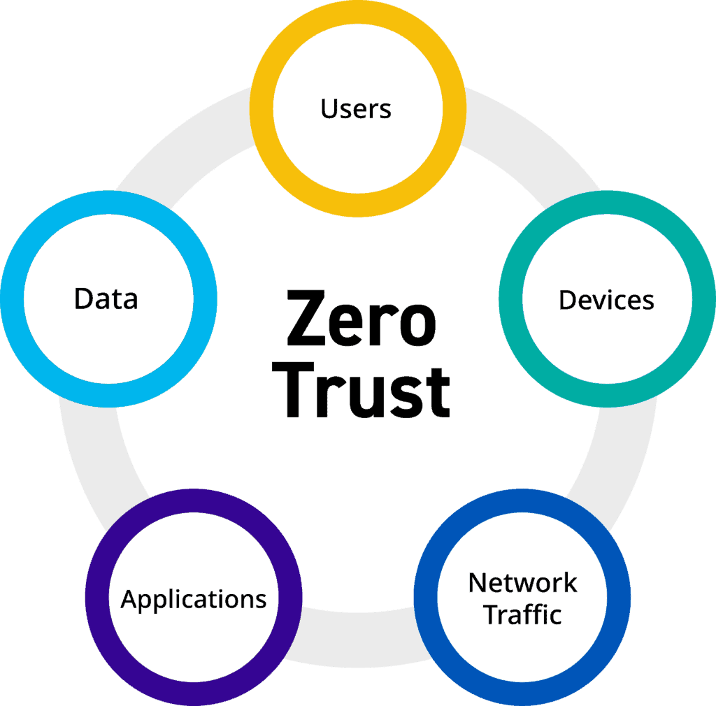
3.3 Justification for Models and Frameworks
The framework for coordinating IT services with organizational security objectives is provided by ITIL and ISO 27000. Managing a wireless network and personal device usage are two of the unique issues facing NG that are addressed by the NIST and Zero Trust models. These frameworks operate together to guarantee a thorough and proactive security posture that changes to meet NG's changing operational needs.

4. Design Approach for NatureGarden
4.1 Compliance (Laws and Ethics)
- Verify compliance with international laws, such as GDPR. Audits should be conducted on a regular basis to ensure compliance and close any gaps. Following the law lessens the chance of fines and harm to one's reputation.

4.2 Governance and Strategic Planning for Security
- Centralized Governance framework: Monitoring security policies and guaranteeing adherence require a centralized governance framework. Senior executives, IT managers, and compliance officers should form NG's Security Governance Board. This board will establish and oversee the implementation of strategic security goals.
- Clear Responsibility Chain: Accountability is ensured by outlining roles and duties for decisions pertaining to security. A structure that is hierarchical and has clear reporting lines improves communication and eliminates uncertainty. Giving leadership the ability to make decisions speeds up reaction times in urgent circumstances.

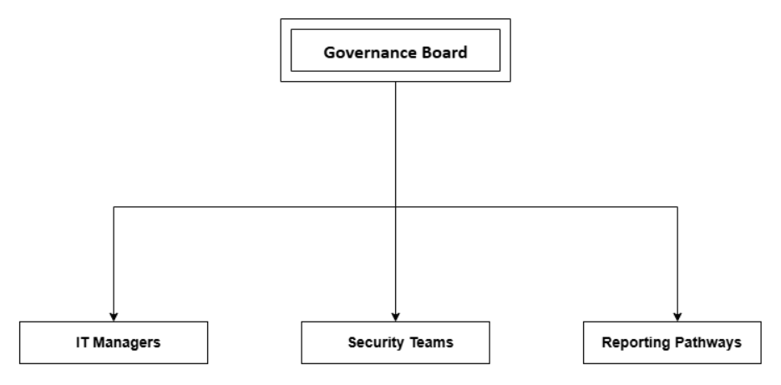

4.3 Security Policies
• Bring Your Own Device (BYOD) Policy: Clearly outline guidelines for using personal devices, including access controls, software upgrades, and encryption specifications. Provide guidelines for permissible use to reduce the risks involved in personal devices connecting to NG's corporate network.
• Encryption of Data: Require that sensitive data be encrypted while it is in transit and at rest. Even if malevolent actors manage to intercept data, encryption guarantees that it will remain safe.
• Awareness Training: Regularly hold training courses for staff members and clients to improve security awareness and reduce human error. Best practices for password management and phishing simulations should be incorporated into training sessions.

Table 2: Policy Matrix for BYOD
PolicyArea | Employee Responsibility | IT Team Responsibility
Encryption | Ensure device encryption | Provide encryption software
Updates | Regularly update applications | Monitor update compliance
Monitoring | Report suspicious activity | Conduct regular audits

4.4 Risk Management
• Frequent Risk evaluations: In order to find weaknesses in its cloud services and wireless network, NG must perform regular evaluations. Vulnerability scans and penetration tests should be part of risk assessments. By conducting these evaluations, NG will be able to proactively address threats before they become serious occurrences.
• Register of Risks: This document lists hazards that have been discovered, their impact, likelihood, and mitigation techniques. This tool makes sure that risks are systematically addressed by helping to track progress and prioritize risk management actions.
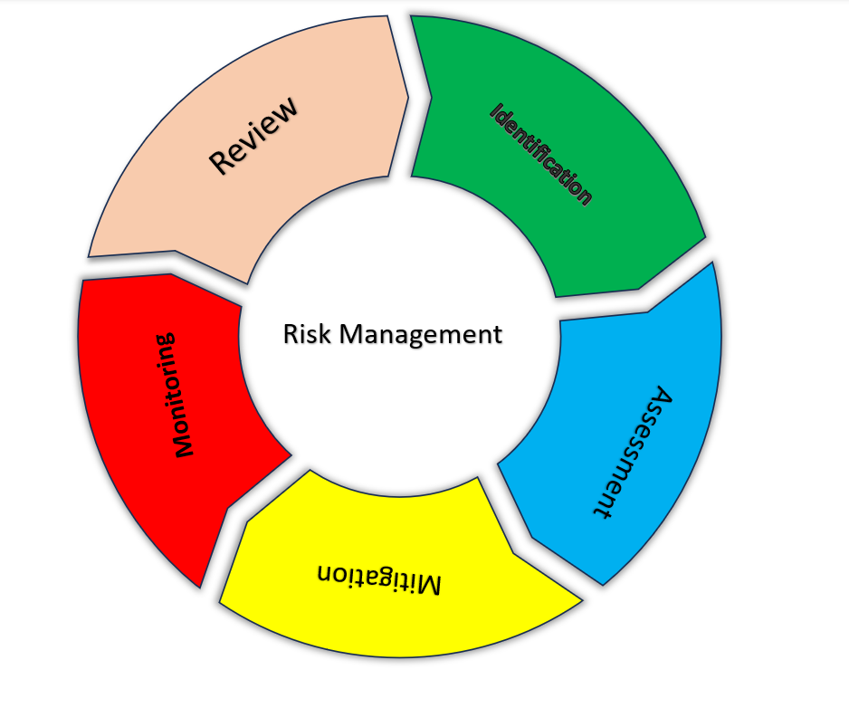

4.5 Security Management Models and Practices
• NIST Cybersecurity Framework: Implement guidelines for each of the following essential functions: Recognize, Protect, Detect, React, and Recover. This methodical approach guarantees thorough covering of every security-related topic.
• Zero Trust Model: Implement Zero Trust guidelines, such as network segmentation and ongoing observation. This method improves data confidentiality and reduces the attack surface.

4.6 Contingencies Planning
  - Incident Response Plans: These provide procedures for managing a range of security events, including service interruptions and data breaches. Regular simulation testing of these plans is necessary to find any weaknesses and enhance reaction capabilities.
  - Disaster Recovery Protocols: To guarantee data availability and integrity in the event of disruptions, NG needs to set up strong backup and recovery protocols. Redundancy measures and offsite backups must to be incorporated into the recovery plan.

4.7 Protection Mechanisms
  - Multi-Factor Authentication (MFA): Use MFA to protect sensitive information and systems. This system makes sure users authenticate using a variety of methods, including biometrics and passwords.
  - Intrusion Detection and Prevention Systems (IDPS): Use IDPS to keep an eye on network activity and spot harmful activity. By sending out real-time notifications, these tools help NG react quickly to new threats.

4.8 Service Level Agreement
- Create service level agreements (SLAs) with cloud service providers that include measurements for data security, incident response, and uptime. Accountability is ensured and dependable service delivery is guaranteed by well-defined SLAs.

5. Critique of Evolving Standards and Regulations
5.1 Importance of Updated Standards
New standards take care of new weaknesses and make sure that companies are able to withstand changing dangers. Following regulations like as GDPR and ISO 27001 is essential for NG to preserve stakeholder confidence and comply with the law. These guidelines offer a methodical way to handle risk mitigation and data protection management. For instance, the General Data Protection Regulation (GDPR) ensures that businesses respect the privacy of individuals by emphasizing accountability, openness, and user rights in data management. A thorough framework for an Information Security Management System (ISMS) is established by ISO 27001, in contrast, guaranteeing that every facet of security—from organizational policies to technical controls—is closely monitored. NG may improve its reputation internationally by following these changing standards, which will guarantee that its procedures stay current, protect against emerging cyberthreats, and show that it is committed to its moral and legal obligations.

5.2 Challenges of Implementation
New standard implementation may require a lot of resources and cause process disruptions. Rethinking data collecting procedures, storage policies, and permission procedures, for instance, is necessary to comply with GDPR and frequently calls for a large investment of resources. In a similar vein, following ISO 27001 calls for carrying out thorough risk assessments, revising policies, and making sure security measures are continuously monitored. Notwithstanding these difficulties, compliance has significantly more advantages than disadvantages. Along with lowering the chance of fines and data breaches, compliance also improves an organization's standing and stakeholder trust. In order to achieve this balance between operational effectiveness and adherence to changing security requirements, NatureGarden needs to allocate resources effectively, plan strategically, and have strong training programs in place to guarantee smooth implementation and ongoing compliance.
6. Assumptions
- NG has set aside enough funds to carry out the suggested actions;
- All employees and interested parties will work together to embrace new security procedures;
- The IT infrastructure of the business enables sophisticated security features like MFA and IDPS.
7. Conclusion
NatureGarden needs to implement a customized security governance strategy to handle its particular problems, such as handling the intricacies of a worldwide workforce, allowing employees to use their own devices (BYOD), and protecting billions of dollars' worth of intellectual property. By incorporating state-of-the-art frameworks and technologies into every facet of the company's IT infrastructure, this strategy should give top priority to fixing security flaws. By utilizing proven frameworks such as ITIL, ISO 27000, and the Zero Trust model, NG is able to implement a multilayered, proactive security strategy that prioritizes instantaneous monitoring, stringent access controls, and prompt incident response. Furthermore, compliance is guaranteed while lowering the risks of legal ramifications and brand harm by adhering to changing standards like GDPR and ISO versions. It is crucial to establish trust with stakeholders and consumers, and doing so is facilitated by putting in place clear rules and procedures that promote resilience and accountability. In a setting where threats are becoming more frequent, continuous improvement programs, bolstered by advanced analytics and recurring audits, help protect data assets and sustain the company's growth. By integrating security into all operational tiers, NG may establish itself as a pioneer in implementing strong cybersecurity plans designed to tackle global issues.

8. References
[1]ISO/IEC 27001:2013, "Information technology — Security techniques — Information security management systems — Requirements," ISO, 2013.
[2] ITIL Foundation, 2019; ITIL 4 Edition.
[3] NIST, National Institute of Standards and Technology, "Framework for Improving Critical Infrastructure Cybersecurity, Version 1.1," 2018.
[4] "General Data Protection Regulation (GDPR)," of the European Union, 2018.
[5] As study develops, more references will be included.

