University of Wales Trinity Saint David
Smoking
Brogan Haggett
Student Number - 2114264
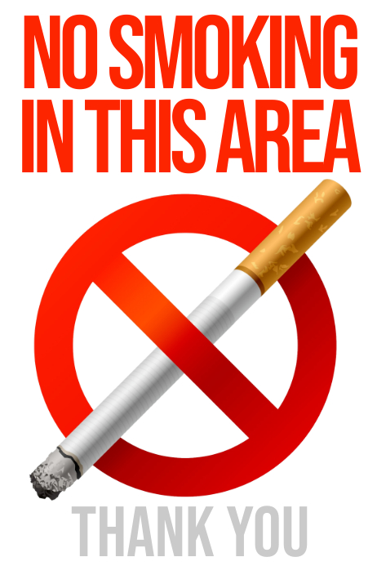

Table of Contents
Introduction 3
Smoking health risks 3
Progress in cancer care 6
Addiction 7
Medication to help stop smoking 8
Nicotine replacement therapy (NRT) 9
Bupropion 9
Varenicline (Champix) 9
Prevention measures of trying to stop people smoking 10
The gradual banning of tobacco advertising in the UK 10
Conclusion 10
Reference list 12

Introduction

The purpose of this report will be to examine the health implications of smoking, specifically looking at lung cancer. Data over the years will be presented in the report to illustrate the effects of smoking, smoking remains the number one preventable cause of death in the UK, despite being a world leader in tobacco control. The death rate from smoking in the UK is around 78,000 a year, which amounts to 200 deaths a day. Apart from the human cost of smoking, it also comes with a financial cost of £2.5 billion to the NHS (National Health Service).
The NHS (2018) outlines the UK has one of the highest smoking-related death rates and the highest smoking-related illnesses. Smoking can lead to more than 50 serious health conditions. The effects can be either fatal or long-lasting. You can become ill if you smoke (self-smoking) or if people around you smoke (passive smoking). According to the Royal College of nursing, nurses are in the perfect position to encourage their patients to stop smoking and should take every opportunity available to do so (NT Contributor, 2005).

Smoking health risks

The NHS goes onto say that it is estimated that smoking causes approximately 7 out of every 10 cases of lung cancer (70%). In addition, it causes cancer in many other parts of the body.
- mouth
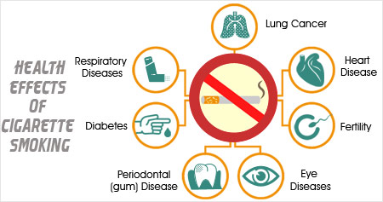
- throat
- voice box
- oesophagus
- bladder
- bowel
- cervix
- kidney
- liver
- stomach
- pancreas

Smoking damages your heart and your blood circulation, increasing your risk of developing conditions such as:
- Heart attack
- Stroke
- Coronary heart disease
- Cerebrovascular disease
- Peripheral vascular disease
Smoking also damages your lungs, leading to conditions such as:
- Pneumonia
- Chronic obstructive pulmonary disease (COPD) this includes bronchitis and emphysema

A smoker may also be more susceptible to respiratory conditions such as asthma, or to respiratory tract infections, such as the common cold. Smoking may also lead to impotence in men because it reduces blood flow to the penis. Smoking can also reduce fertility in men and women.

The content of this report will focus mainly on lung cancer, since smoking is by far the leading cause of this disease. Walser et al (2008) emphasis’s there are over 1 million lung cancer deaths annually worldwide, and the risk of lung cancer is attributed to cigarette smoking almost 90% of the time in men and 70 to 80% in women. Clinically evident lung cancers typically have numerous genetic and epigenetic abnormalities.

Lung Cancer Incidence rates by age group and number of new cases per 100,000, UK, 2016-2018.

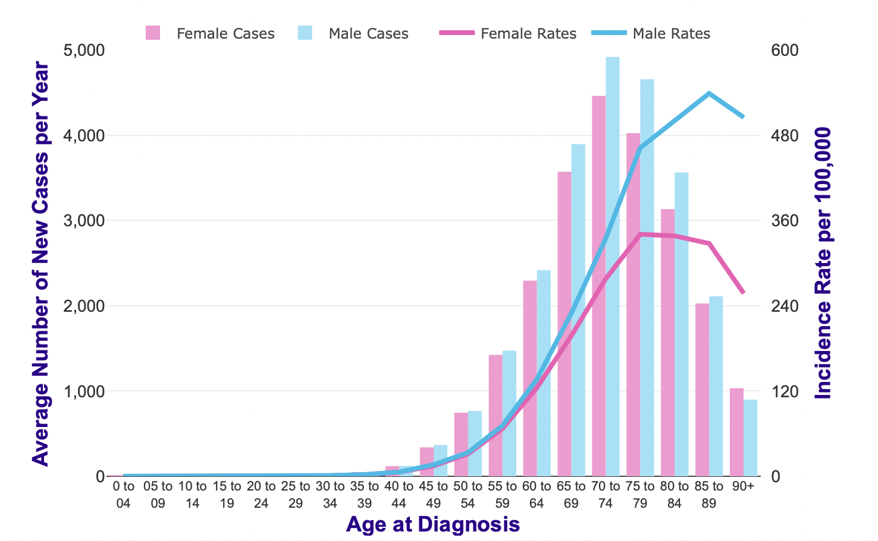

Age is a significant factor in lung cancer incidence, with older adults having higher rates. Between 2016 and 2018, more than four in ten (44%) of all new cases on average in the UK occurred in people aged 75 and older.

Rates for younger and older age groups rise sharply beginning around 45-49, but then drop off after that. For females, the rates are highest among those aged 75 to 79 and for males between 85 and 89. Cancer Research UK (2015) explains several mainly older age groups have significantly lower rates of female incidence of lung cancer compared to males.

A total of 35,419 people died from lung cancer in 2012, 6.2 percent of the total number of deaths and 31 percent of deaths caused by lung disease), with 19,333 male and 16,086 female (British Lund Foundation, 2012).
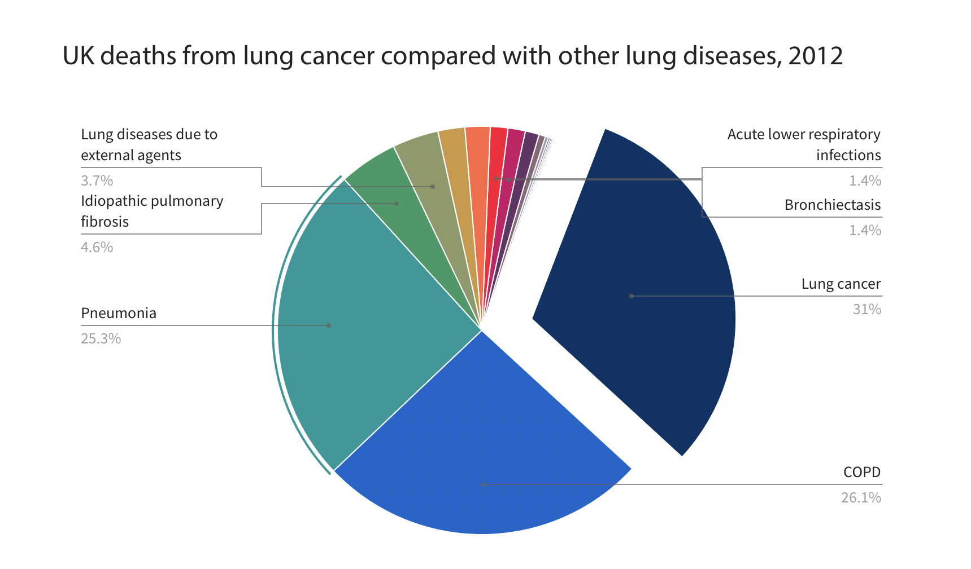

A significant difference is evident in the percentages of lung cancer compared with other lung diseases in this graph.

Progress in cancer care

Over the past 6 decades we’ve seen a dramatic transformation in how cancer patients are treated. NHS was in its infancy in 1952, and there was limited synchronisation in the treatment of cancer.
In the 1970s Cancer Research UK aided the establishment of the first cancer medicine departments in the NHS, where doctors and researchers would collaborate their efforts to fast forward advancements in treatment. Today, cancer patients are typically cared for by teams of professionals supporting all aspects of their care and treatment (Arney, 2012). Helping to ensure that each patients care, and treatment is synchronised across all levels. This joined up approach has supported significant developments behind the increase in survival rates we see today.
Arney (2012) goes on to say the cancer survival rates from all types of cancer have more than doubled in the last 40 years thanks to advances in diagnosis and treatment. Back in the 1950’s access to internal imagery was limited to just x-rays, cancer screening did not exist however there has been huge advancements in imaging technology, including medical ultrasound in the 50’s and CT, PET and MRI scanning in the 70’s.

Craig and Moellinger (2001) express although there’s no evidence to suggest smoking is good for you, decades ago smoking was in fact glamorised and promoted throughout the 40’s and 50’s, currently there is a tremendous amount of support and resources within the NHS to help people quit smoking that wouldn’t have been available in earlier decades.

Addiction
The addiction to smoking is strong, tobacco contains the highly addictive chemical nicotine. Much like heroin or other addictive drugs, tobacco in cigarettes quickly becomes habit-forming. A smoker eventually needs to smoke just to feel normal. The reason people smoke varies. Some start because it looks cool, others start because a family member or a friend smokes. Most adult tobacco users began smoking before they were 18 years old. That's why it’s easier to not start smoking than trying to quit (Kidshealth, 2016).
Schwarz (2005) highlights in a study looking at family influences on smoking habits, children whose parents smoked between the ages of 13 and 21 were more than twice as likely to start smoking cigarettes on a daily basis than those whose parents did not smoke.

Smoking is a difficult addiction to overcome and many individuals will relapse on several occasions before quitting long term. Receiving support to quit from an NHS smoking service makes it four times more likely that you will successfully overcome your addiction (NICE, 2018).

The World Health Organisation (2021) outline over 8 million people die every year as a result of the tobacco epidemic, and 7 million of those deaths are caused by direct tobacco use, with the remaining 1.2 million resulting from non-smokers being exposed to second hand smoking

Smoking is more common among men than among women. Overall, smoking has decreased in all ages since 2010, smoking among age 60 and older continues to be the lowest (ASH, 2021).

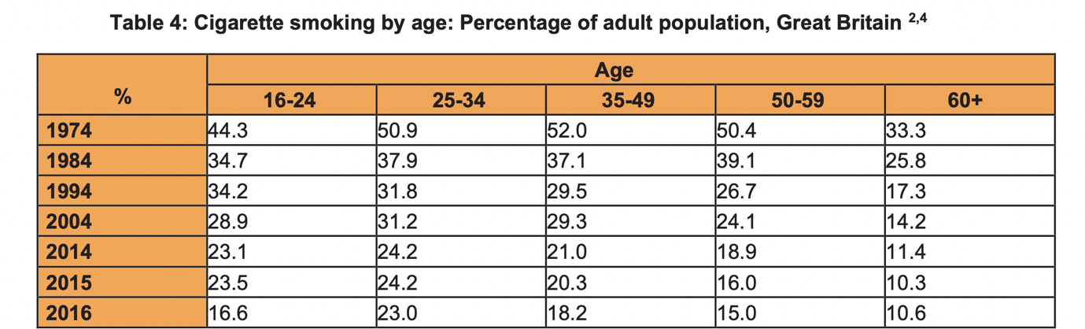

Medication to help stop smoking

Rosen et al (2018) advises should you decide to quit smoking there is a great deal of support and resources available offering a variety of different treatments. Treatments can be accessed from shops, pharmacies and on prescription to help you overcome your addiction and mitigate symptoms of withdrawal.

Smoking cessation is regarded as one of the most cost-effective routes in chronic disease management in current smokers. This is specifically important in COPD patients as this is the only pathway to slowing down the progression of the disease. The Human body can recover from the effects of smoking within as little as twenty minutes from quitting smoking.

According to the Royal College of Nursing (2022) the below table outlines the recovery process of the human body and the timeframe in which this happens:

- After 20 minutes blood pressure and pulse start returning to normal.
- After 24 hours carbon monoxide is eliminated from the body and the lungs start to clear out smoking debris.
- After 48 hours ability to taste and smell improves.
- After 3-9 months lung function improves up to 10%.
- After 5 years the risk of heard attack falls to about half that of a smoker.
- After 10 years the risk of lung cancer is halved, and the risk of heart ischaemia falls to that of someone who has never smoked.

Nicotine replacement therapy (NRT)

The main cause of smoking is the direct result of addiction to nicotine and therefore a treatment called NRT is provided, this medication provides you with a low dose of nicotine, minus the more harmful tar, carbon monoxide and other poisonous elements present in tobacco smoke. This treatment can help with the difficult withdrawal symptoms such as mood swings and cravings many of which you will experience when trying to quit smoking.
NRT can be purchased from a variety of different outlets including pharmacies and some shops. This treatment is also available via your GP or NHS Stop smoking service on prescription. NRT can come in many forms such as skin patches, chewing gum, tablets, lozenges, inhalers, nasal, and mouth spray. Your GP, pharmacist or stop smoking advisor can help you choose the best option for you and treatments be changed until the most suitable treatment is identified. Whilst there is no particular form of NRT identified as better than another it is common to use different forms together for more effective outcomes, e.g., patches and gum may be used in conjunction as one is slow releasing and the other faster to support immediate cravings. Treatment with NRT typically lasts 8-12 weeks, gradually reducing the dose before eventually stopping (NHS, 2019).

Bupropion

Bupropion is a treatment originally used to treat depression, but it has since been found to help people quit smoking. How it works lacks clarity, however it is believed to effect parts of the brain associated with addictive behaviour. Bupropion is exclusively available on prescription via your GP or smoking service advisor. It's taken once/twice daily as directed and this treatment begins two weeks in advance of your quit date commencing.

Varenicline (Champix)

Varenicline (Champix) is a treatment that was first made available in the UK in December 2006. It was developed to help smokers to stop smoking. Varenicline imitates the effect of nicotine in the body. Therefore, mitigating the impact of withdrawal symptoms and the urge to smoke through cravings. The primary purpose of varenicline is to disrupt the receptors in the brain that nicotine stimulates by partially stimulates theses receptors, therefore mimicking the effects of nicotine, to mitigate cravings and withdrawal symptoms when attempting to quit smoking. (Dr Tidy, 2018).

Prevention measures of trying to stop people smoking

The World Health Organisation (2003) suggests an increase in tobacco price can be one of the most effective ways to reduce cigarette smoking. If prices are raised to keep up with inflation, a price increase of 10% results in a 2.5% - 5% reduction in smoking, and perhaps as much as 10% over the long run. In comparison with older people, young people are two to three times more likely to quit smoking. In high-income countries, this level of response could lead to a reduction in smoking deaths of 500 000 to 2 million, while the reduction could reach 600 000 to 1.8 million in eastern Europe. It is estimated that some countries have raised taxes to 70–80% of the cost of cigarettes, which has resulted in a substantial reduction in smoking, though smaller tax increases may also be successful.

The gradual banning of tobacco advertising in the UK

Marketing of tobacco products through TV advertisement was banned in the UK in 1965 under the Television Act 1964, which was strengthened by an EU directive in the 1980s. Alternative marketing such as press and billboard, was overseen by a self-regulatory arrangement with the Government.
The Labour party vowed to ban tobacco marketing in its 1997 election manifesto stating: “Smoking is the greatest single cause of preventable illness and premature death in the UK. We will therefore ban tobacco advertising.” Under the Tobacco Advertising and Promotion Act 2002, tobacco marketing in the press and on billboards was banned from February 2003, whilst all direct marketing was halted from May 2003 (Politics.co.uk, 2021).

Conclusion

Despite the widespread understanding of the health effects of smoking, resulting in over 50 related health issues, ranging from fatal to long lasting, smoking continues to be the number one cause of preventable death in the UK, resulting in a tremendous human and financial loss. Smoking is a relapsing addiction, and it is no easy plight to quit smoking once addicted to nicotine. However, there is a tremendous amount of free support and resources available to support your efforts. Nurses are in a prime position to encourage their patients to stop smoking and they should endeavour to encourage them to do so whenever possible.

Reference list
Arney, K. (2012) Celebrating 60 years of progress. Available at: https://news.cancerresearchuk.org/2012/06/03/celebrating-60-years-of-progress/ (Accessed 17th March 2022).
ASH (2021) Smoking Statistics. Available at: https://ash.org.uk/wp-content/uploads/2019/10/SmokingStatistics.pdf (Accessed 10th March).

British Lung Foundation (2012) Lung Cancer Statistics. Available at: https://statistics.blf.org.uk/lung-cancer (Accessed 15th March 2022).

Cancer Research UK (2015) Lung Cancer Incidence Statistics. Available at: https://www.cancerresearchuk.org/health-professional/cancer-statistics/statistics-by-cancer-type/lung-cancer/incidence#heading-One (Accessed 15th March 2022).

Craig, S. and Moellinger, T. (2001) ‘So Rich, Mild, and Fresh’: A Critical Look at TV Cigarette Commercials 1948-1971. 25(1), pp 55–71.

Dr Tidy (2018) Varenicline (Champix) Available at: https://patient.info/healthy-living/quit-smoking-cessation/varenicline-champix (Accessed 10th March 2022).

Kidshealth (2016) Smoking for Teens. Available at: https://kidshealth.org/en/teens/smoking.html (Accessed 5th March 2022).

NHS (2018) What are the health risks of smoking? Available at: https://www.nhs.uk/common-health-questions/lifestyle/what-are-the-health-risks-of-smoking/ (Accessed 10th March 2022).

NHS (2019) Stop Smoking Treatments. Available at: https://www.nhs.uk/conditions/stop-smoking-treatments/ (Accessed 2nd March 2022).
NICE (2018) Stop smoking interventions and services guidance. Available at: https://www.nice.org.uk/guidance/ng92 (Accessed 9th March).
NT Contributor (2005) ‘Nurses’ role in promoting and supporting smoking cessation.’ 101(10), pp 26.
Politics.co.uk (2021) Tobacco Advertising. Available at: https://www.politics.co.uk/reference/tobacco-advertising/ (Accessed 12th March 2022).

Rosen, L., Galili, T., Kott, J., Goodman, M. and Freedman, L. (2018) ‘Diminishing benefit of smoking cessation medications during the first year: a meta-analysis of randomized controlled trials.’ 113(5), pp 805-816.

Royal College of Nursing (2022) As a nurse you are in an ideal role to encourage your patients to stop smoking and should make every contact count. Available at: https://www.rcn.org.uk/clinical-topics/public-health/smoking-cessation (Accessed 14th March).
Schwarz, J. (2005) Children whose parents smoked are twice as likely to begin smoking between ages 13 and 21 as offspring of non-smokers. Available at: https://www.washington.edu/news/2005/09/28/children-whose-parents-smoked-are-twice-as-likely-to-begin-smoking-between-ages-13-and-21-as-offspring-of-nonsmokers/ (Accessed 13th March 2022).

Walser, T., Cui, X., Yanagawa, J., Lee, J.M., Heinrich, E., Lee, G., Sharma, S. and Dubinett, S.M. (2008) ‘Smoking and Lung Cancer: The Role of Inflammation’, 5(8), pp 811–815.
World Health Organisation (2003) Which are the most effective and cost-effective interventions for tobacco control? Available at: https://www.euro.who.int/__data/assets/pdf_file/0004/74722/E82993.pdf (Accessed 2nd March 2022).
World Health Organisation (2021) Tobacco: key facts. Available at: https://www.who.int/news-room/fact-sheets/detail/tobacco (Accessed 3rd March 2022).

