

Assignment 1

2021

December 31

Mark O’Shea

Assignment 1
Assignment 1: The development of a strategic plan for a Major Crime Investigation Department.
Introduction:
In this paper I will outline how the theory of strategic management would support the development of a strategic plan to deliver major crime investigations within South Wales Police.
There is significant academic research that supports the view that strategic planning exercises within organisations provides clarity of purpose (Ferlie and Ongaro 2015) (Whittington 2019 p3) et al.
I will also discuss a countervailing view that strategic planning stifles innovation and transformation.
There is an emerging school of thought that ‘Positive Deviance’ provides an opportunity for innovative approaches versus the top-down management of a strategic plan (Herrington and Bartels) this theory will be discussed. I will also consider the emergence of third-party strategic planning and the role of the partner agency in police strategic planning (Braga and Weisburd 2006.)
This paper will seek to articulate the considerations for a business unit strategy for the Major Crime Investigation Team to deliver a public value outcome in line with the Mission, Vision and Values of the wider Organisation whilst considering if strategic plans add value to the organisation.

- Context of Police Strategic Planning Processes.
In the United Kingdom the requirement to provide a strategic delivery plan has been a Home Office requirement since 1998 (Policing Vision 2025, p7). There is a body of research that supports the view that Police strategic planning benefits the public and political overseers of police services, Plant, Ferlie et al. The theory espoused by proponents of Strategic planning within policing take the view that legitimacy is required to deliver a policing service within the common law paradigm and the strategic plan articulates the plan to deliver a policing service to a populace which grants permission to be policed by a uniformed arm of the State. To maintain the legitimacy of the police, a written plan on how policing will be delivered, strengthens the contract between the people and the police service providers whom they pay for through their taxes. In many ways this plan can be viewed as an equivalent to a contract with the public on how the policing service will be delivered and is a way of holding to account the Chief Executive Officers in their delivery of an effective police service.
In Walsh and Vito 2019 they argue that strategic planning ensures future threats and challenges are framed and organisational responses articulated. A Management Structure is required within the organisation to oversee the delivery of the plan with performance and process tracking mechanisms along with budget setting arrangements to ensure the plan is financially viable and delivered against agreed outcomes, (Plant 2009.) The performance framework cannot be allowed to be bureaucratic or onerous as this risks inertia within the organisation (Plant 2009.) The performance metrics should assist in budget and planning decision making and form part of the holistic planning process and review cycle.
The College of Policing Critical Incident framework identifies one of the 3 pillars to an effective response to any critical incident to be prior strategic planning. For a police service the old adage of fail to prepare, prepare to fail rings true.
Strategic planning done well, frames the priority of the organisation within the context of the Police Service Statement of mission and values (Policing Vision 2025, 1.1.) In the UK context, strategic planning should increasingly involve stakeholder engagement to gain consistency with wider public safety strategic priorities (Policing Vision 2025, p7) Whittington (2019) refers to this as an ‘Open Strategy’. In South Wales, the Wellbeing and Future Generations Act frames a multi-generational strategic intent of developing a healthier and more prosperous Wales. The Police strategic planning process naturally should sit alongside statutory partners to deliver the whole system response to crime and disorder. In reality, a lot of police planning is still done in isolation from the strategic planning of other public sector organisations and is still done by the executive group in a ‘top down approach’ (Whittington 2019.) An alternative model is considered by Whittington where what he refers to as a ‘meritocracy of ideas’ ripples through an organisation to formulate the strategy and he argues that the trajectory of strategic planning in recent decades has been toward more transparent and open planning processes as articulated by the following figure:
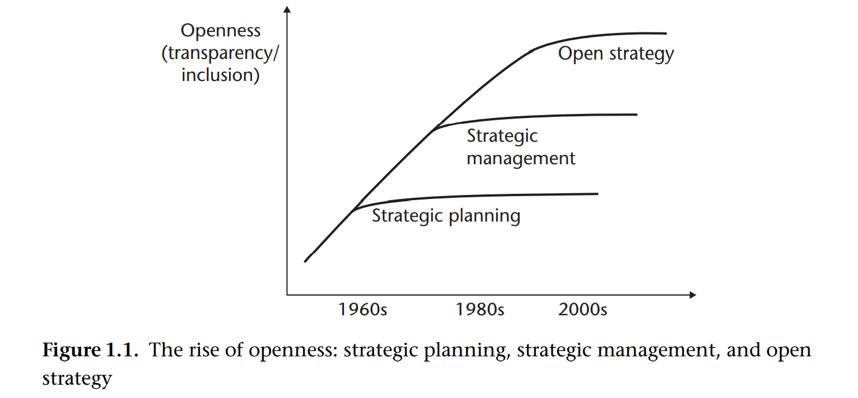
Table Source: Whittington 2019

Planning Models
Strategic planning is heavily reliant on models and tools, some of which are well tested and utilised in policing such as SWOT, PESTLE, Porters 5 forces (Whittington p.8 2019,) but as discussed in Whittington, the unregulated Strategic Planning ‘industry’ allows for a proliferation of models and tools which may not have proven value. Therefore, caution and due diligence should be applied to the selection of Strategic planning models and tools.
In looking at some of these models below I have chosen examples used by Government as well as private sector organisations to identify any synergy’s that could be used to devise a police strategic plan.
Examples of Strategic Planning Toolkits:
Strategic Policy stress testing can help to inform future strategic planning decisions and the Scientific Department of the UK Government tool kit advocates a series of workshops. Future proofing the plan and aligning it to the wider Mission, Vision and Values of the organisation. The concept of backcasting is explored in the toolkit and the schematic below outlines the method:
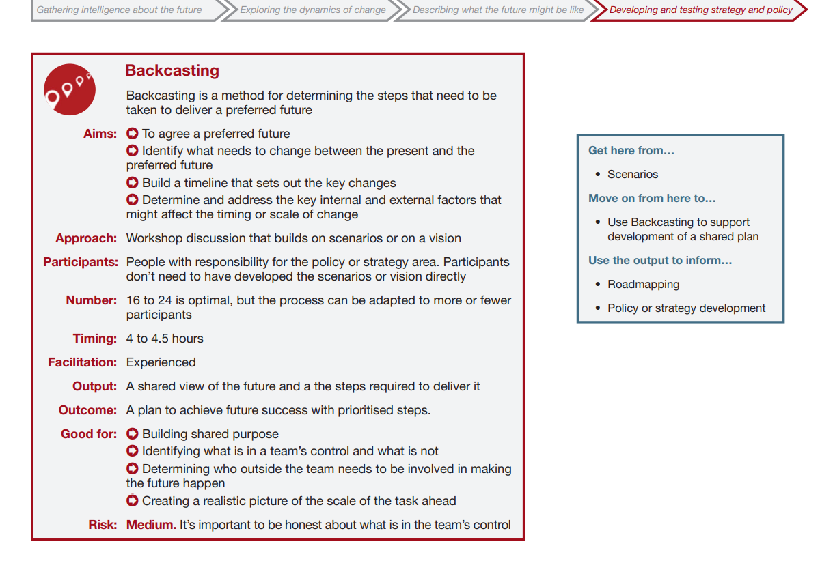

Another tool that can be used to develop a policing strategy is the road mapping exercise to a strategic outcome:
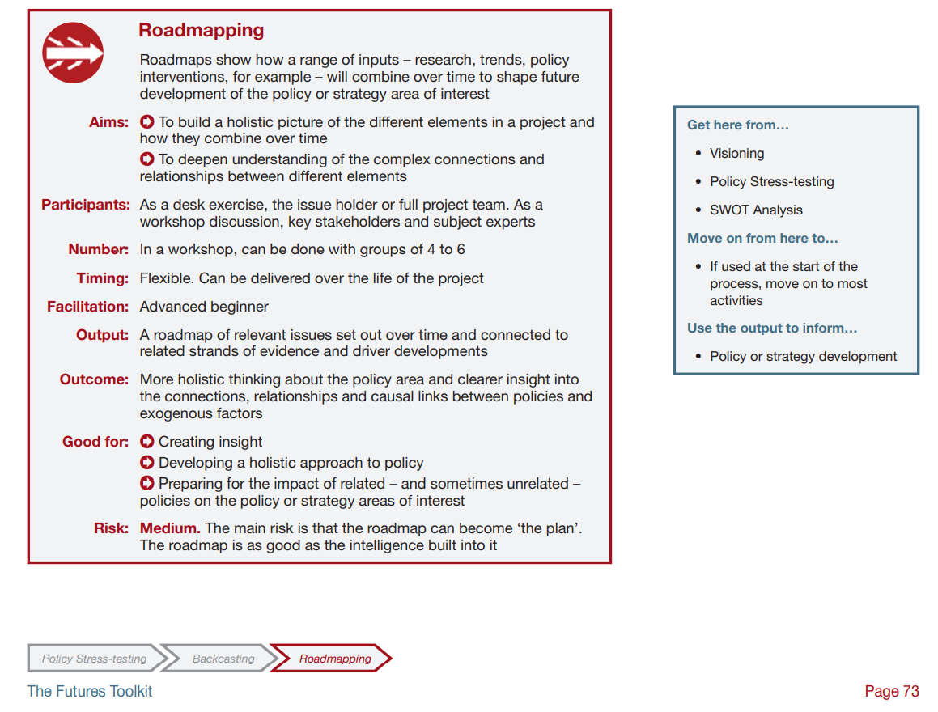

The Futures Wheel is another toolkit option that will be proposed in the preparation of a Strategic Plan for a Major Crime Team to ensure futures thinking is built into the planning stage:
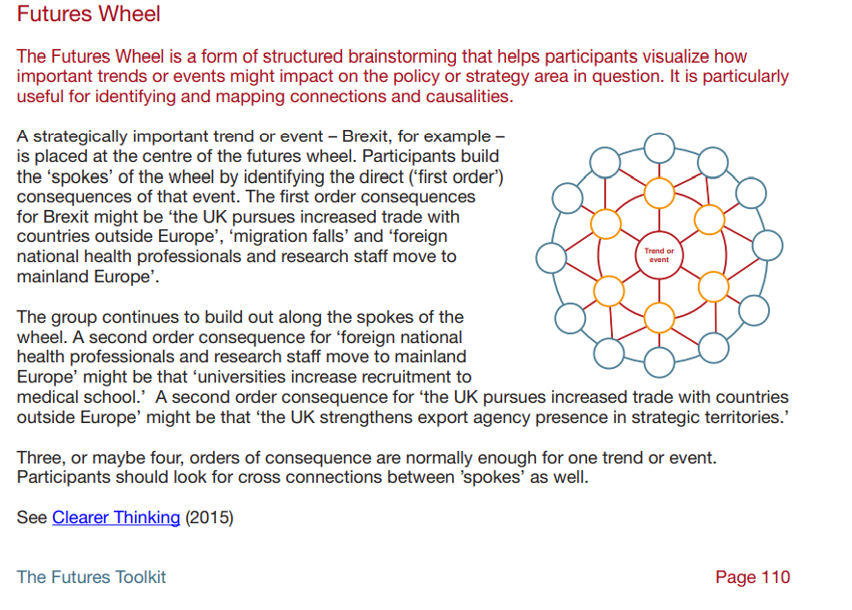
Taken from The Futures Toolkit, Government Office for Science, Edition 1, 2017

Strategic Mission:
Reduction in crime and disorder remains the ‘Peelian’ intent. The true measure of police success being the absence of crime and disorder. In formulating a Strategic Plan following the back casting and road mapping exercises the formulation of a futures strategy into a Strategic business plan is the next step.
- Strategy defines the long-term direction of the organisation, articulating what the organisation will do to achieve its mission.
- Strategic plans define how the organisation will realize its long-term ambitions. Functional strategic plans define the roadmap of initiatives and portfolio of investments required to achieve those strategic objectives.
- Operational plans deal with the execution of specific projects and changes, as well as any operational tasks not contained in the strategic plan.

(Gartner, A clear tie between strategy and strategic plans, gartner.com)

Formulation of the Strategic Plan:
The most effective Strategic planning exercise is said by Walsh and Vito to be one that has been framed by the public and partners who will be the actual receivers of the service.
A strategic plan should be a balanced statement on how that leadership cadre intends to lead the organisation to a stated goal (Mission) and the management or governance architecture that will support the leadership intent (Ferlie et al, 1996, 6.2). Within the leadership strand a clear statement of the ethical values of the organisation should be included to articulate how the organisational moral compass is set. Within South Wales Police all elements are governed by the Code of Ethics (College of Policing) the Policing Principles (College of Policing) and the NPCC Policing Mission and Values 2025.
In a policing context the view of public value as advocated by Professor Michael Moore of the Harvard Kennedy School is what the strategic plan will seek to deliver (Policing Mission and Values 2025 1.4) The policing organisation is established for the ‘public good’ and the value of what is done is the barometer that ensures continued legitimacy in providing that service. This is particularly important to Common Law policing jurisdictions where the principle of ‘policing by consent’ is a ‘Peelian’ doctrinal norm. (Policing Vision 2025)
The public value paradigm emerges from academic heritage that includes Harvard University’s Business Policy Model and the school of New Public management (Ferlie et al, 1996.)
In devising a strategic plan for the Major Crime Investigation Team one considers the strategic triangle (Where to for Public Value? Australian and New Zealand School of Government ANZOG, 2021)
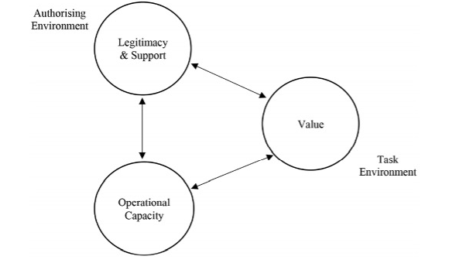

Time spent on devising a strategic plan is argued by some (Mintzberg) to be time well invested, however there is a countervailing view that a poorly devised strategic plan becomes nothing more than a document on a shelf that is never brought to life and delivered (Plant 2009.)

The Institute of Leadership and Management quote the Vice President of Gartner Risk and Audit Practice Matt Shinkman,
“According to Gartner’s research, executives believe that more than half the time they spend in strategic planning is wasted, and that the quality of their plans often fails to meet expectations. Indeed, the firm notes, incorrect strategic assumptions lead to stalled growth that can derail planned outcomes. Plus, organisations with poorly formed strategic assumptions typically produce a high number of projects that are not aligned with their stated objectives – and the time and budget required for executing key initiatives routinely exceed planned targets.”
The risk identified in the analysis by Gartner is two-fold:
- Strategic plans are often created and then forgotten until the next planning cycle begins
- The plan becomes outdated due to outdated strategic assumptions.

Risk management of future threats to devise a plan will involve horizon scanning tools such as PESTLE, SWOT and ‘Tapestry’ (TPESTRE) to help develop ‘futures thinking.’ Planning for future challenges forms part of the latest advisory template issued by the HMICFRS (Dec 2021) to Forces on how to prepare Force Management Statements.

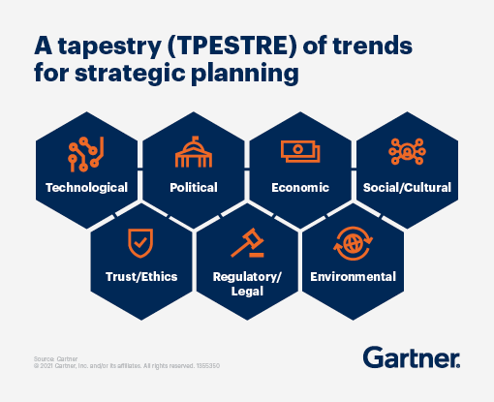

The approach advocated by Gartner is one of adaptive strategic planning or what Plant 2009 refers to as ‘holistic planning.’ This approach is postulated to be more responsive to a more dynamic risk environment like policing than the traditional rational planning approach identified by Ferlie et al in 1996. The frequency, velocity and volume of change in a digital age does indeed seem to require a more kinetic strategic toolkit to devise policing organisational strategy.

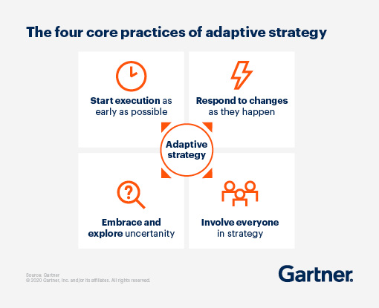

The organisational plan for the South Wales Major Crime Investigation Team will start with a visioning exercise involving key stakeholders both internally and externally. In Ferlie et al (1996) they offer the following list of issues to be addressed in such an exercise,
- • issue-spotting;
- • preventing and suppressing issues;
- • encouraging issue development;
- • challenging old assumptions and articulating new ones;
- • providing new data and perspectives;
- • providing new forms of analysis for strategy;
- • shaping decision-making;
- • making strategic choices.

In his best practice guide to Strategic Planning in an American Policing context Kurtz argues that ‘treating Police constituents as valued customers’ in a quasi-business philosophy will make the public the ultimate decision maker as to what constitutes effective and legitimate policing or what is often referred to a ‘public value’ (Moore et al.) He further argues that community engagement in the planning process engages the community’s own sense of responsibility for maintaining law and order. This is in line with the Public Value construct advocated by Benington and Moore (2011) where it is said that all public strategies aim to turn the public’s hard-earned money and freedoms into something more valuable, this includes their personal security for which the responsibility in the UK is assumed by the State, through a policing system paid for from local Council tax and UK Government tax levies. In a Welsh and English context the responsibility for policing is a retained power within UK Government, whereas in Northern Ireland and Scotland, Policing is a devolved matter. These governmental frameworks have a direct impact on strategic planning priorities.
In a Wales/England context where the tripartite framework of Home Office, Police Commissioner and Chief Constable exists, the strategic drivers for any delivery plan will be a reflection of the National Policing Boards Strategic Policing Requirement. The Purpose of the National Policing Board is set out in the following terms of reference:
“To Set the long-term strategic vision and direction across the law enforcement system, while also respecting existing strategies, with a focus on outcomes and decisions, including around strategic investment.” (National Policing Board Terms of Reference, 2021, Home Office)

Internal/External Engagement
This may include focus groups which would be structured in line with the College of Policing toolkit on managing focus groups, (College of Policing 2018.) The visioning exercise will also involve the Middle management of the organisation who will be Inspectors and Chief Inspectors as it is argued by Burgleman (1983) Phillis (2005) that middle managers have a critical role in the delivery of a strategic plan. In the context of Police delivery, the influence of the Inspecting ranks is critical to the tactical delivery of any plan particularly one that advocates change (Campbell and Kodz, NPIA, 2011.) Involving that middle tier of management in the formulation of a plan may obviate later divergent thinking. This internal stakeholder engagement ensures the workforce is allied to the strategic delivery plan (Walsh, Vito 2018 p.155) and by extension have an emotional investment in its conception and delivery.
The delivery of any policing plan should include a multi-agency consideration given the growing body of research highlighting the causative linkages between crime and disorder and public health indicators, (Barton et al, 2019, Public Health Wales.)
Constructing the Plan
The structure of the Plan should provide insight into the concepts that support the strategic mission and an outline of the tools and methodology for the delivery of the plans mission, this point is argued by Bryson (2004) Whittington (1993.) Strategic planning models and concepts from the private sector and widely adopted into public sector planning departments from the 1990’s onwards have on occasions according to Ferlie failed to deliver the intended public value,
“…useful theories are likely to be those that can take account of intersectoral difference as well as similarity. Indeed, theories which do not do this may be positively harmful and misleading, resulting in attempts to impose change which fail to root and which have subsequently to be unpicked.” (Ferlie et al, 9.2, 1996)
The South Wales Police MCIT Strategic Plan has to be aligned to other strategic planning documents such as the Chief Constables Delivery Plan, Commissioners Crime Reduction Plan as well as National Strategic planning documents such as the CONTEST strategy and the SOC Strategy.
There is a statutory framework within Wales that also applies to strategic planning in Policing. The Social Services Wellbeing Act 2014 places an obligation upon key partners to plan together to ensure adult social care needs are met and whilst the Police are not part of this framework in a statutory sense, it could be argued that policing is duty bound to have cognisance of these frameworks in their own strategic planning exercises. (Wellbeing Act)

Measurement:
The writing of a strategic plan requires agreed metric outcomes. It is argued by Bennington and Moore that you ‘can’t fatten a pig by weighing it,’ however public value needs to be a proven ‘thing’ to satisfy the tax paying public that there is value in the investment. The absence of crime is the purest ‘Peelian’ measure of successful policing activity (HMICFRS), however the journey and trajectory to that principled outcome is what needs measurement to establish if what is being done actually works and achieves the public value test. The police use of COMPSTAT in the 1990’s and into the early 2000’s was seen as one way of measuring some of the ‘pig.’ The Commissioner of New York Police Williams Bratton is quoted by Moore (2011)
“We created a system in which the police commissioner, with his executive core, first empowers and then interrogates the precinct commander, forcing him or her to come up with a plan to attack crime. But it should not stop there. At the next level down, it should be the precinct commander, taking the same role as the commissioner, empowering and interrogating the platoon commander. Then, at the third level, the platoon commander should be asking his sergeants… all the way down until everyone in the entire organization is empowered and motivated, active and assessed and successful. It works in all organizations, whether it’s 38,000 cops or Mayberry, R.F.D.”

In Bratton’s own opinion paper authored with Sean Malinowski he refers to COMSTAT Plus where the planning became a collegiate exercise with key stakeholders asked to agree and to define what the ‘problems’ were. Local Commanders were then asked/tasked with creating their own plan of action (P.263.) He says that under his command “the strategies and the results belonged to people doing the work. Compstat plus is simply a catalyst, a means to achieve an end.”
William Bratton heralds COMPSTAT in part to reducing homicide in Los Angeles from a rate of 2,000 in 1992 to 392 in 2007. The metrics are not what is important it is the accountability for the individual team’s contribution to the delivery of the strategic plan. The avoidance of the ‘GOTCHA syndrome’ is an important concept to understand according to Bratton (p263) as the most effective form of COMPSTAT is done in a collaborative environment that encourages problem solving discussions and discourse.
Whether COMPSTAT significantly reduced crime in Los Angeles and New York is still being debated but in a strategic planning exercise measuring outcomes of police activity has to have an element of statistical rigour and performance management.
The neighbourhood policing paradigm is a more complex area to measure than simply counting detections, arrests or stop and search data. There is more requirement now for Policing to problem solve and demonstrate ‘what works’ (Policing Vision 2025, HMICFRS Force Management Statement guidance) and in a Major crime context the UK Governments Serious Violence Strategy places emphasis on planning based around ‘what works.’ For example, hot spot policing is seen as an effective antidote to what the Cambridge University refers to as High Harm crime. Building into strategic planning an effective evidence based policing assessment through random control testing (RCT) is emerging as a policing discipline. The Society of Evidence Based Policing has toolkit examples of RCT’s that can be applied to local policing problems to inform delivery planning interventions.
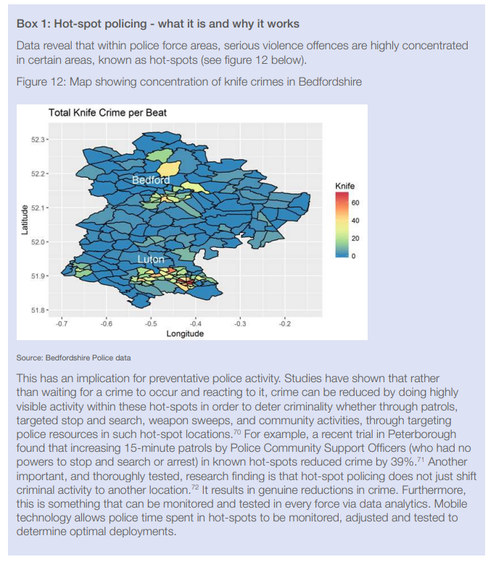
In the context of South Wales Police Major Crime, measurement of strategic success in delivering a public value imeasured using a balanced scorecard. One key measure of success is based upon the numbers of detected versus undetected homicides along with contributions to the reduction in homicide.
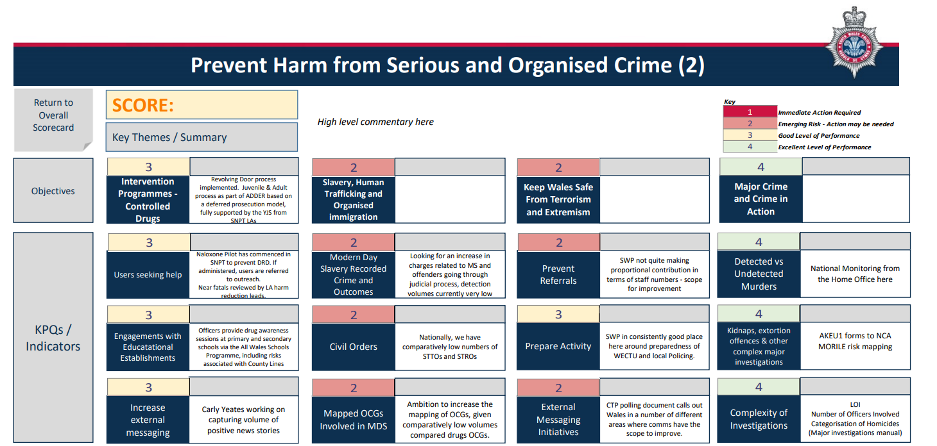

The organizational Architecture:

Mapping the organization in such a way that the architecture is aligned or congruous to the strategic aims is an important element in strategic planning, (HMICFRS 2021) (Phills 2005 p.160.) An example of Organizational architectural mapping for Major Crime Investigation is seen below:

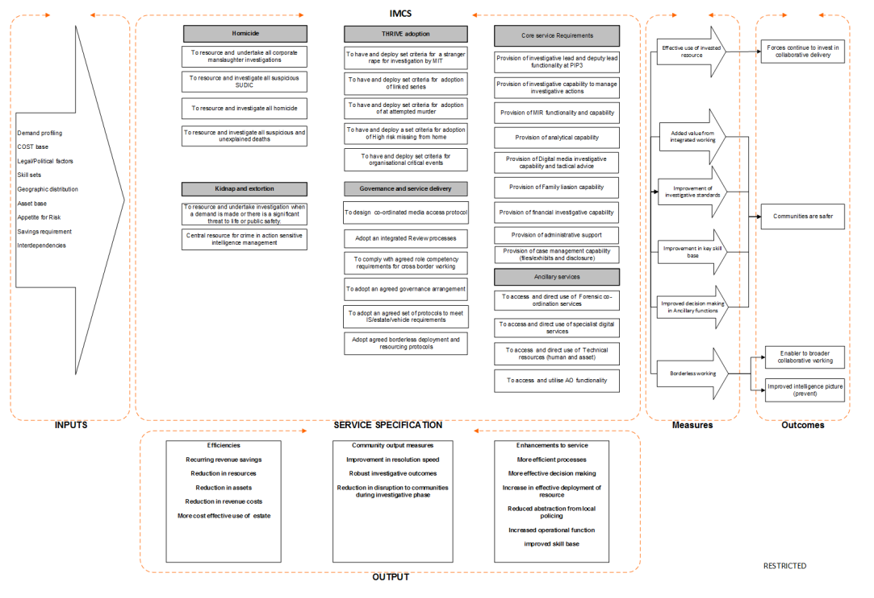

Interdependencies

Any strategic planning activity has to consider wider demand pressures to ensure that it is aligned within a whole systems approach and is therefore deliverable. However, the analysis of any system or organization within the strategic planning exercise has to be wary of what is referred to as analysis paralysis.
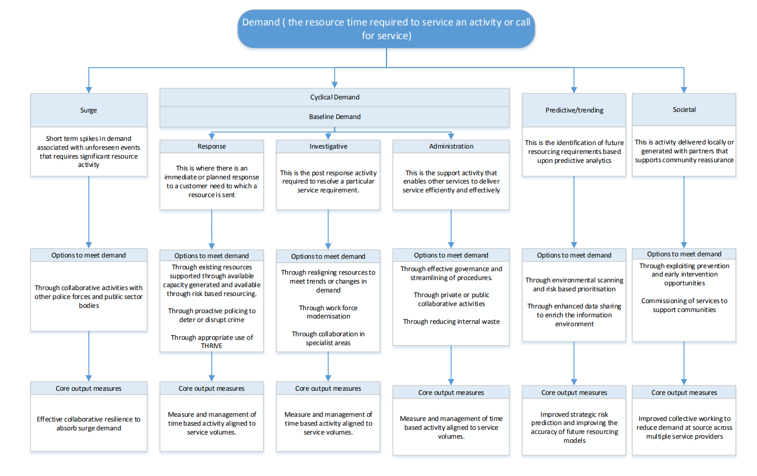
(NPCC 2017)

- Conclusions

Strategic Planning in the context of UK policing is useful in codifying the organizations intent and mission. This supports legitimacy in policing as it adapts to the changing demands of the public it seeks to serve. A strategic plan aligned to community concerns and linked to the national strategic intent and strategic ‘ask’ of the elected Police and Crime Commissioner ensures democratic accountability for the delivery of civil policing with the consent of the public. The bedrock of the UK policing system is the ‘contract’ often referred to as the Peelian principles between the public and the police.
In line with emerging research outlined by Kate Cooper the Head of Research and Policy at the Institute of Leadership and Management,

“A strategic assumption is a statement about what’s going to happen in the future – and the interesting thing about that, of course, is that we don’t know for sure…we need to get better at guessing the future, and refining our perspectives of which developments are likely and unlikely, or certain and uncertain. So that approach – which is very much rooted in a risk-management ethos – is held to be an improvement.” (ILM 2021)

There is an inherent danger in Police Strategic Planning that we are using yesterdays plan to fight todays battle. Delivery of more immediate live time information in a more user friendly format could enable policing to be driven more by data than by a strategic plan on a page. Live time data may allow quick time planning decisions on interventions that may be less linked to the strategic plan but more responsive to the kinetic situation unfolding in a socio-geographic locality. The theory of hot spot policing (Sherman, Bratton) advocates evidenced based approaches to solving long term crime problems. The historic reliance on intuitive policing tactics as a response to crime is increasingly being challenged (Policing Vision 2025) and the current National UK Policing Board’s Serious Violence Duty places a statutory duty on local partnership boards with completing a strategic needs assessment to better understand how violence is affecting their communities and this will place heavier emphasis on evidence. The police are identified as ‘duty holders’ along with Partners such as youth offending teams and probation services, health bodies and local authorities.
The legislation will require the ‘duty’ holders, to ‘develop and implement a strategy with solutions to prevent and reduce serious violence in their area, which will need to be reviewed every year.

The strategic planning landscape in policing may need to be more dynamic and aligned in the future to the public health model of strategic planning to maximize the opportunities to develop a more holistic strategic response to high harm crimes and particularly violent crimes. The underlying principles of a public health approach are that it is:

- focused on a defined population, often with a particular health risk in common
- done with and for communities
- not constrained by organisational or professional boundaries
- focused on developing long term as well as short term solutions
- based on data and intelligence to identify the burden on the population, including any inequalities
- rooted in evidence of effectiveness to tackle the problem

(gov.uk, Serious violence duty, 2021)

The Strategic framework advocated in the outline guidance document (Serious Violence Duty 2021) is known as the ‘5Cs’ approach it is likely to heavily influence future strategic planning for Major Crime Investigation Teams:

- collaboration
- co-production
- cooperation in data and intelligence sharing
- counter-narrative
- community consensus

The guidance requires ‘duty holders’ to use the 5cs framework in their development of strategic and delivery planning and to link the planning process into existing statutory safeguarding boards and strategic partnerships. Advocating a whole systems approach to strategic planning, the new governmental directed duty will start to frame a more integrated strategic planning approach to homicide, knife crime, gun crime and county lines drug dealing. By collaborating on data sharing protocols and information sharing agreements a Common Recognized Information Picture (CRIP) is hoped to emerge. This will provide a more integrated strategic overview of the violence problem and allow holistic intervention strategies to emerge in the planning of delivery interventions across a range of public service providers.

Applying the World Health Organization’s 10 guiding principles to strategic planning in order to reduce interpersonal violence; outlined below. We can see an emergence of a high level trans-national strategic planning paradigm that involves multisectoral and inter-governmental responses to interpersonal violence with a particular focus on a reduction of violence aimed at women, girls and children:

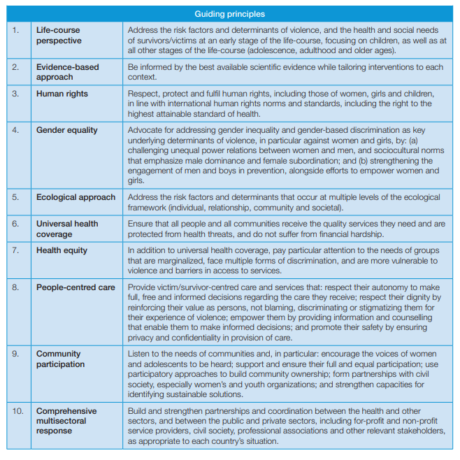

Within the UK Governments Serious Violence Strategy there is much discussion of risk factors and the multisectoral response which is illustrated below:

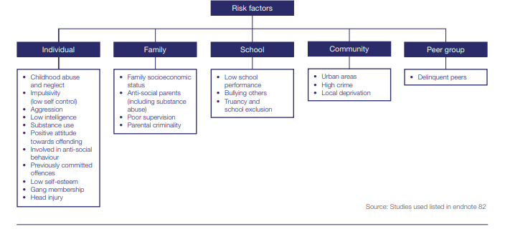
Source: Serious Violence strategy, p.37,HMG

The Violence Strategy (P.70) highlights the importance of effective local partnership planning.

- Recommendations:

The policing of high harm crimes as defined by Cambridge University’s High Harm crime Index (Sherman) will require more flexible strategic planning to meet the challenges of the 2030s and 40’s. There will be a requirement to plan for Specialist Capabilities to respond to crimes that at present cannot even be committed. For example, the emergence of artificial intelligence enabled drones and nano-bots programmed to kill and harm human beings.

To adapt to these challenges’ future strategic plans have to have the flexibility to adapt quickly to emerging threats. It is recommended that strategic planning for Policing Major Crimes becomes an area of academic research aligned to public health and technological areas of research.

The adoption of more meaningful collaborative approaches to strategic planning with Moore’s Public value aspiration as its central aspiration. The below table reproduced from Alford and Greve (2010) articulates Moore’s view of public value being produced within an environment of politically authorized norms and expectations. In a policing context public value is measured by low crime and disorder and safer neighborhoods within which to thrive and flourish (Wellbeing and Future Generations Act)

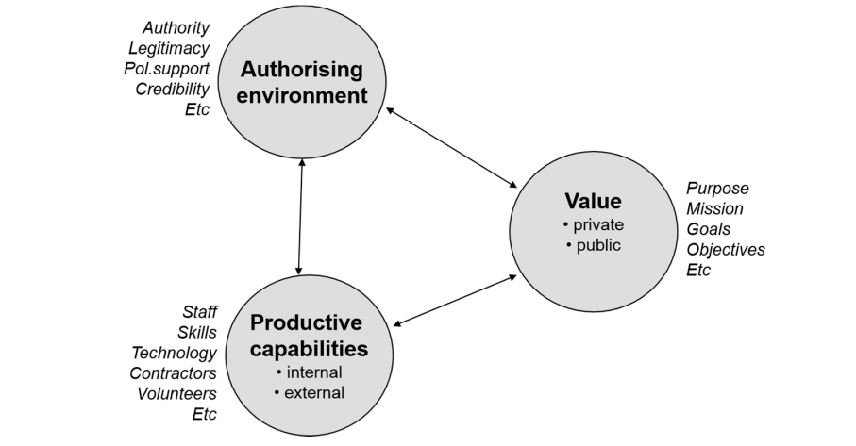

Along with measured outcomes by way of a balanced scorecard and framed with sound ethical values.

The visioning of the organization’s plans has to align to public expectations in a dynamic and easily adaptive way. This requires the organization to reflect on how accessible and responsive it is.

The link to the wider public safety ‘system’ is the complex arena that strategic planning is now shifting toward to manage risk. The whole systems approach and ‘systems thinking’ by way of complex partnership/stakeholder planning meetings may frame the future collegiate strategic planning to address high harm crime in communities. (Sherman)

The emergence of deviant organizational thinking within strategic planning may enhance opportunities to devise innovative solutions. The top down 3-5 year strategic planning structure may be too linear a model to respond to strategic challenges that are dynamic and ever changing in a digital age.

The transformation of the FBI’s performance post 9/11 is the subject of analysis in the McKinsey institutes paper where organizational health to deliver a strategy. Focusing on the wellbeing of the organization in order to deliver the strategic mission has to be an important element in strategic police management.

The FBI Involved middle management in the adaptation of organizational strategy as they responded to the changing threats to America post 9/11.

“Leadership reinforced that real-time changes to the strategy were necessary and encouraged teams to try pilots and proofs of concept in order to buttress and build a testing mindset.” (McKinsey)

How we articulate the strategic planning of the future in a digital communications age is a future challenge that planners will need to factor into the process of devising plans. The communication needs to be more ‘live time’ during its delivery to ensure the plan remains relevant and is delivering the ‘public value’ and doesn’t fall into trap of being ‘yesterday’s plan for today’s problem.’

Maintaining the legitimacy of any organizations plan requires the strategic leadership to blend three elements (Petris ANZOG 2010) and links back to Moore’s public value.

Summarized as:

- Substantively Valuable
- Legitimate and politically sustainably
- Operationally and administratively feasible.

The strategic plan therefore needs to have been devised by accurate sense making of the operating environment for the organization. To achieve this, key stakeholders need to be and more importantly feel engaged in the process. This ensures legitimacy of the mission. The wider political landscape (Commissioners and Ministers) who ‘frame’ much of the policing landscape needs to ‘sign off’ the plan to maintain democratic governance of policing and therefore legitimacy. (Five Reflections on Building a Mission Command Culture -Part 1, The Army leader, 2021)

The outcome of the strategic planning process is operational delivery which requires a tactical plan that can be measured. The measurement of public sector performance continues to occupy a controversial chapter in many academic discourses on public sector management and planning. The unintended consequences of public sector performance indicators are discussed in terms of a ‘performance paradox’ (Performance assessment in the Public Sector ANSOG 21.)

“Four factors cause the deterioration of performance indicators:
- Positive learning: As performance improves, indicators lose their sensitivity in detecting bad performance. In fact, everybody has become so good at what they do that the indicator becomes obsolete.
- Perverse learning: When organisations or individuals have learned which aspects of performance are measured (and which are not), they can use that information to manipulate their assessments.
- Selection: This refers to the replacement of poor performers with better performers which then reduces differences in performance. Only good performers remain, and the indicator loses its discriminating value.
- Suppression: This occurs when differences in performance are ignored.
The paradox is not about performance itself but about the reports on performance. This can be unintentional or deliberate.” (ANSOG 2021)
Analytical tools to measure performance and offer predictions for future demand can result in inherent bias to validate a strategic assumption. The measurement of stop and search for example created perverse incentives to reduce stop and search tactics, which had consequential impact on the operational use of stop and search. The Evidence Based Policing Society of England and Wales (Masey/Sherman) highlight the paradox of the disproportionality in stop and search figures juxtaposed with the high harm crime victimisation of black British youth particularly in London.
There have been a lot of Strategic planning assumptions on the negative impact of stop and search predicated on the question of legitimacy in recent times. This strategic assumption driven by political sensitivities particularly in recent years since the death of George Floyd and the emergence of the Black Lives Matter movement. However, this pressure to reduce stop and search is now thought by some, (Massey/Sherman 2019) to have contributed to an increase in high harm crimes in some neighbourhoods in London. The research shows that only 12% (579) out of 4765 census areas in London experienced any knife homicides between 2000 and 2010. The research conducted by Sherman et al demonstrates that targeted stop and search in certain neighbourhoods can have a positive impact on reducing high harm crime and particularly knife enabled homicide. They advocate that strategic planning in many ways should be more responsive to live time data and evidenced based policing decisions should form the basis for future strategic planning.

References

Alford J and Greve C, 2017, Strategy in the Public and Private Sectors: Similarities, Differences and Changes, MDPI.

Advice note on partnership working-implications for health boards and NHS Trusts from the Social Services and Well-being (Wales) Act 2014

Benington J and Moore M (2011) Public Value: Theory and Practice. Basingstoke: Palgrave Macmillan

Braga and Weisburd, 2006, Police Innovation and Crime Prevention: Lessons Learned from police Research over the past 20 years (Discussion Paper presented to the US national institute of Police Research Planning Workshop 28-29 November 2006)

Bratton, Malinowski, Police Performance Management in Practice: Taking COMPSTAT to the Next Level, 2008, Oxford University Press

COMPSTAT, What Works, College of Policing, CompStat | What Works Centre for Crime Reduction (college.police.uk)

David L. Kurz, Strategic Planning: Building Strong Police Community Partnerships in Small Towns, International Association of Chiefs of Police, U.S Department of Justice.
Available: BP-StrategicPlanning.pdf (theiacp.org)

Ferlie, Ashburner, Fitzgerald, Pettigrew, 1996, The New Public Management in Action, Oxford Scholarship.

Gartner, Accessed Dec 2021, Build a Better Strategic Plan for your Function, Available:
What is Strategic Planning? Templates, Steps & Process Guide | Gartner

GLOBAL PLAN OF ACTION to strengthen the role of the health system within a national multisectoral response to address interpersonal violence, in particular against women and girls, and against children, World Health Organization, 2020.

Herrington and Bartells, 2021, Leading for Failure, or Embracing the Power of Positive Deviance?
Available: ANZSEBP Conference 27-28 October 2021, Available: Leading for Failure | Australian Institute of Police Management (aipm.gov.au)

HMICFRS, Force management Statement, Template and Guidance for Forces,

Institute of Leadership and Management, How can Leaders Shake off outdated Strategic Assumptions?
Available: Changing Leadership Beliefs | The Institute of Leadership & Mgt (institutelm.com) 2021

Massey- Sherman, 2019, Forecasting Knife Homicide Risk from Prior Knife Assaults in 4835 Local Areas of London, 2016–2018, Cambridge Journal of Evidence-Based Policing

Moore, M. 1995. Creating Public Value: Strategic Management in Government. Cambridge: Harvard University Press.

McChrystal, Stanley, 2015, Team of Teams, Penguin.

McKinsey Institute, 2021, Government transformations in times of extraordinary change: key considerations for the Public Sector, Available https://www.mckinsey.com/industries/public-and-social-sector/our-insights/government-transformations-in-times-of-extraordinary-change-key-considerations-for-public-sector-leaders?cid=other-eml-alt-mip-mck&hdpid=646a167d-a261-4873-a11f-3af808cf0998&hctky=9255434&hlkid=c3d466415cf64f8eb4439a0b0cd0027e#

NPCC, 2017, Better Understanding Demand, Policing the Future, Available at:
078 17 CCC April 2017 24 Better Understanding Demand Policing the Future.pdf (npcc.police.uk)

National Policing Board Terms of reference, Home Office, National Policing Board - GOV.UK (www.gov.uk)

Phillis J, 2015, Integrating Mission and Strategy for Nonprofit Organizations, Oxford Scholarship on line

Petris, Stephen, 2010, Occasional paper no. 7 The nature of strategy in the public sector, Department of Sustainability and Environment, Australia and New Zealand School of Government

Plant, T, Holistic Strategic Planning in the Public Sector, Available:

Holistic strategic planning in the public sector (wiley.com)

PORTER, Michael: WHAT IS STRATEGY? Chartered Management Institute, Available: SEB_CMI_MYO_PorterWhatIsStrategy.pdf (switcheducation.com)

Whittington, Richard, 2019 Opening Strategy: Professional Strategists and Practice Change, 1960 to Today, Oxford Scholar ship online

Weisburd, Braga, 2007, Police Innovation and Crime Prevention: Lessons Learned from Police Research over the Past 20 Years, Oxford, Available: Police Innovation and Crime Prevention: Lessons Learned from Police Research over the Past 20 Years (ojp.gov)

Internet Articles:

Public Sector Performance Paradox, ANSOG, October 2021, The public sector performance paradox | ANZSOG

Serious Violence Duty, 28 May 2021, Strategic Needs Assessment Guidance, UK Home Office

Serious Violence Strategy, Hm Government , 2018 Home Office – Serious Violence Strategy, April 2018 (publishing.service.gov.uk)

Strategic Analysis Tools, 2007, The Chartered Institute of Management Accountants,

Strategy Explained, Strategy Explained - Institute For Strategy And Competitiveness - Harvard Business School (hbs.edu)

Wellbeing of Future Generations (Wales) Act 2015.

Where to for Public Value? Taking stock and moving on,

Available: Where to for public value? Taking stock and moving on | ANZSOG

The Army leader, Five Reflections on Building a Mission Command Culture – Part 1 - The Army Leader - Practical Leadership Tips and Advice

