Nasima khatun
[Email address]

BMSK4004
Maria Pitson
Problem solving and decision making Mangrmrnt Report
1709501

Executive Summary
In this report, you will see that I have done analysis on Ryanair. I have also used range of sources and strategic framework to obtain relevant information to allow me to research the key points and problem Ryanair are facing.
You will find detail about the current situation that Ryanair are facing, it will lead to show how the BREXIT has affected the situation and what effects it has hold for the airline. I will then write a report on how the airline has poor mismanagement and what other alternative transport are there. The fishbone will follow on to say about the benefits and what they are. I will then add stakeholder’s analysis of Ryanair, which will identify and analyse their needs. The last part if this report I will commence by a PESTLE analysis of Ryanair.

Contents

Executive Summary
Executive summary…………………………………………………………………………………………………………..……………… 2
Introduction 3
Main Body 4
Conclusion 5
Recommendations 6
Reference List 7
Appendix 8

Introduction
The largest low-fare European company was Ryanair which set up in 1985 by Christopher Ryan and Tony Ryan .The Company started working only with 25 members of staff in 1985.Ryanair was re-launched it in 1990 growing in nowadays to be the biggest low fare company with 7,118 of employees. (Corporate.ryanair.com, 2018)
The statistic of European Ryanair Low fare Airline (June 2009) The number of passengers was carried from June 2008 to June 2009 was 60,2 millions Ryanair became then became public in 1997.
Ryanair is offering flights to 26 European Countries in 150 destinations and it operates on 880 different routes daily with 1,200 flights a day. (History of Ryanair)
Ryanair Company has a larger market share, better and improved customer service than its competitors, good reputation and a strong image. Ryanair aims to be a leader in all airline industry and have a stable competitive advantage. (Corporate.ryanair.com, 2018)
Ryanair has very polite and friendly manner staff, Great hospitality and low cost tickets is what every passengers prefer and with this airline they have all together cheap and very cheerful. Ryanair has a very polite and hospitable.
ryanair has increased the cost of the hand luggage with travel with you in the cabin.
The low-cost airline said in January that only passengers who pay £5 for priority boarding will be able to keep their hold all or carry-on suitcase with them during a flight - everyone else faces having their bag put in the hold (free of charge).
The policy amounted to a £10 charge per return flight for anyone who wants to fly with their carry-on bag - with an eligibility to join the priority queue seemingly of secondary importance. This is a way for Ryanair wanting passengers to travel with their airlines.

Findings
Ryanair will have many problems like any other business face. To decide on the problem that are accrued, they can use a problem solving model firstly identify the problem by recollecting variety of questions and to specifically analyse the problem. Following the analyse find the problem find the development then plan the development ask the question what are the goals and how to achieve it what are the intervention plan and to address their goals. How will staff get monitored plan implementation, How will implementation integrity be ensured then plan an evaluation this is how they can overcome their problem by placing a plan.
Ryanair will need to know what type of problems they have, what are the key to solve the problem what benefits can come to the organisation and the team. They can share their problems and come up with solutions to their problems, improve their communication knowledge experience and team work. there are always problems, there are 3 categories to problems and they are

- Operational problems which are medium to short term problems
- Administrative problem which re short term problem
- Strategic problems that are longer terms problems.

Brexit
Britain as decided to leave the EU on the 23rd June 2016 in this term we call it divorce, the uk be leaving the EU officially on the 29th March 2019. Leaving the EU will be affecting a lot of business across the uk including Ryanair (BBC News, 2018) Uk will be able to strike its own trade deals and those deals will come in force from the 1st of January 2021.
The licence for Ryanair would guarantee the airline could continue in London, Ireland and Scotland otherwise they will known as foreign airlines. Ryanair has decided to bring own their ticket prices for summer 2019. If Ryanair does not get their licence agreement from Britain then the customers who ordered their ticket will not be valid from the sale price (Reuters, 2017)
Lot of customers that bought the ticket are unaware of the situation that are accruing, if the license does not happen then the tickets will be cancelling due to cancelling flights customer will not be happy and a bad name will be lick to Ryanair and media will have to talk about regard Ryanair and this will affect the organisation.

Stakeholders
First of all Ryan air’s stakeholders are shareholders who own the shares and have rights to claim dividends.
Employees are very important to the company as skills, loyalty and abilities provide success for Ryanair. Employees want to have satisfaction from job and various benefits from the Ryanair.
Customers are the biggest fact of income for Ryanair Company. Customers expect that the company meets their needs and wants to earn the profit. Suppliers and other company provide excellent service to gain their needs.
Competitors are also important stakeholders as they are used to compare the service and product quality with to increase competitiveness. Ryanair has to pay taxes and follow the rules and regulations set by the government. (Ryanair.com, 2018)

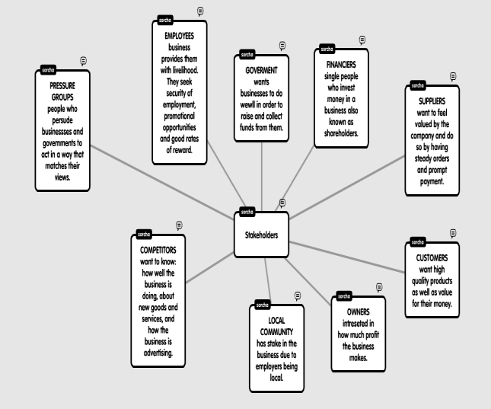

There are 3 categories in the stakeholders the categories are
- Internal
- External
- Connected (textbook)
Internal | External | connected
Irish air | Media | Aviation Authority
Trade agencies | political | Aircraft boing
Trade union | Economical | ordinary
Employers | Social | preferred
EU | press
Airports | technological
The ryans
Michael O’Leary
David Bonderman

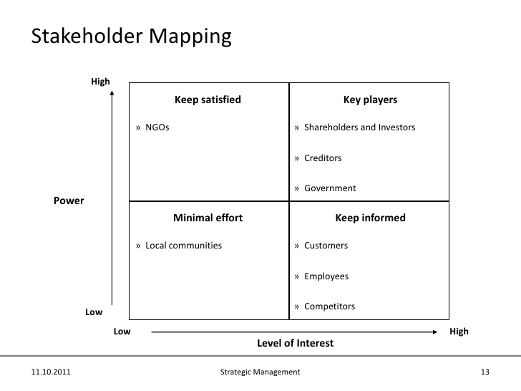
(Google.com, 2018)

PESTLE ANALYSIS
Political-
UK government put on enforced security and restrictions due to terrorism attacks on airline and airports.The political system in this country and their relationship with other countries has great impact on the airline business. There are still unknown details of the future regulations governing between the UK and EU.R This political outcome could reduce the EU airline access to the UK market. Ryanair is an airline registry in the Ireland (Ryanair, 2017) However as the airline maintains their large base in the UK. Brexit not only can negatively influence not just Ryanair but other low cost airlines in the UK.
Economic
It is unavoidable to mention that in this case the recession will occur in the UK and will effect the UK after complete leave of the EU. The low cost airlines earning potential in the UK market will get decline as there will be correlation between the economic performance and leisure travels. It is not expected that the U economic problems will notable influence the EU performance. Also the low cost airlines may be able to manage the Brexit economic

Social
The low cost airline expansion is mostly attributable to the indusial the income of the middle class and the accompanying lifestyle changes. Many people are afraid to travel due to Europe attack. Many people will struggle to buy tickets to travel with airlines as the price has gone up compare from 1997. Because of the low price for Tickets Company attracts a wide range of demographic group of consumers. Expansion of the market as the result of new member countries joining the European Union

Technological
In the reference to the social changes occurring the airlines industry there is growing evidence that only these airlines will survive are the channels into their distraction and marketing strategies. Customers have the desire to remain constantly connected with their social environment, which suggest that the airlines need to adopt a different communication strategy to reach to their targets. Ryanair is an environmental friendly, cleanest airline. Ryanair has digital check in machine which are the easiest to self check in instead of queering in the line for hours, Digital platform as smart phones and internet, Ryanair also have facilities in the airline which you can listen to music there are also books and have movies on air which makes the journey enjoyable for passengers. The business strategies which are the following
- Barrier to entry
- Supplier power
- Buyer power
- Availability of substitute

Legal

The legal challenge the European airline are facing revolves also around the Brexit Referendum. Flights between the UK and the EU countries will be subject to the restriction that could reduce the demands for the airlines travels between the UK and EU. (Bussinessteacher, 2017)

Environmental
The most recent concern for the industry is that when heat waves are becoming a frequent airline. Ryanair is also the using the modern, fuel-efficient, and growing regards the low cost airlines contributing to carbon emissions.

Alternative Transport Methods
Transport for the customers of Ryanair would consider Eurostars as it is high-speed train in the uk to Europe. Europe has been around for many years since 1994 Eurostars has carried over 150 million passengers. They take thousands people day to day across Europe. Eurostars are located at the heart of London. Eurostars has recently begun to run a new station call ebbs fleet international station in Kent. That is one of the best reasons to travel with Eurostars.

- Travels to city centre
- No shuttle bus
- Up to 18 trains a day that is in use
- Faster than flying
- Great value for money
- Fast and convenient check.
- Check in just 30 minutes for standard.
- Business class check in only done in 20 minutes
- Up to 80 percent carbon dioxide emissions than flying.

Eurostars can reach max of 300km per hour on the high seed lines in the UK, France and Belgium (Eurostars). 18 trains a day makes it easier to travel as there are different people who work different time and wish to travel at different times as allows customers to commute regularly and easily without missing their flights. It is environment friendly there is less pollution and the air will be fresher which is very healthy for people.

FISHBONE

Passengers
Founders of Ryanair
Media Unhappy customers

Shareholders
Bad reviews
Michael O’Leary

fees miscommunication
Huge waits for passengers
Dissatisfied
AIRPORT
STAFF

A Fishbone diagram is also known as a cause of effect diagram, there is another name for it called ISHIKWA diagram. In this Diagram you will find that the causes of the problem and if they need to identify the root of the causes. (Whatis.com. 1999)

Conclusions and Recommendations
The SPACE matrix (Rowe et al. (1989)) shows that company pursues an aggressive strategy. The company is the strong competitor in the market and is growing rapidly within the industry. Using the matrix it was identified that Ryanair could use its internal strengths to develop market penetration and market development strategy.
The critical issues facing Ryanair is identified as poor customer service and human management problems.
It is very important that Ryanair attends to these issues immediately as it cn get worse as days go by.
By improving customer service the media will get better as there will be positive feedback, employers will enjoy their work, employers and management could achieve better quality of work by attending training and achieve better feedback from media
In this I have research on Ryanair and the current problems they are facing which was created by EU. Brexit has played a crucial role in this as this has made Britain in a venerable situation with the other EU countries. I have written aa report on how things has changed how the current problems that Ryanair faced with their increase of price and the increase of price on baggage. The Brexit has major impact on Ryanair. I have also talked about alternative transports that could use like Eurostars, which is the fastest transport so far. Euro star is also affordable and travels city to city without any delays or cancellations.
I have also looked at the 3 different categories that I have used for the stakeholders which are external internal and connected. I have done an report on pestle on Ryanair which has 6 categories which has explained the problems which has cause Ryanair and the benefit of the airlines.

List of References
Anonymous(2009), Ryanair reveals record profits. DailyMail.co.uk.available online at
http://www.dailymail.co.uk/news/article-158288/Ryanair-reveals-record-profits.htmlaccessed 13.07.18
Boeing 737, products available online at http://www.boeing.com/commercial/737family/ accessed on 13.07.18
Box, Thomas, M, Byus, Kent (2007) Ryanair (2005):Successful low cost leadership, Journal of the International Academy for Case Studies, p2, available online at http://findarticles.com/p/articles/mi_qa5452/is_200705/ai_n21289700/pg_2/ accessed 17.07.18
Ethical Corporation (2004) available online at http://www.ethicalcorp.com/content.asp?ContentID=3132 accessed 13.07.18
European Low fares Airline Association (2009)available online http://www.elfaa.com/statistics_June2008.pdf accessed 16.07.18
Financial Analysis made easy Ryanair Plc financial report available online at http://www.fame.bvdep.com/version-20091130/cgi/template.dll?checkathens=1&kick=1&product=1&user=glpadyako10&pw=lZlaM78QFb6npNlJovi0%2fA%3d%3d accessed 17.07.18
Guardian news archive available online at http://www.guardian.co.uk/business/2009/dec/23/ryanair-jet-glasgow-prestwick-airport accessed 11.07.18
Hill, T and Westbrook, R(1997) SWOT analysis: It's time for a product recall, Long Range Planning volume 30, issue 1 pp 46-52
En.wikipedia.org. (2018). Ryanair. [online] Available at: https://en.wikipedia.org/wiki/Ryanair#History [Accessed 18 Jul. 2018].
Ryanair.com. (2018). Official Ryanair website | Book direct for the lowest fares | Ryanair.com. [online] Available at: https://www.ryanair.com/gb/en/useful-info/help-centre/faq-overview/Making-a-reservation/What-taxes-fees-and-charges-may-be-charged-by-Ryanair [Accessed 18 Jul. 2018].
Google.com. (2018). ryanair stakeholder mapping - Google Search. [online] Available at: https://www.google.com/search?q=ryanair+stakeholder+mapping&tbm=isch&source=iu&ictx=1&fir=g1H0_FcRcAxRsM%253A%252CLDqYgRdm_x5dwM%252C_&usg=__MJMHwL_z5exKbl0F-zyj4DazgyM%3D&sa=X&ved=0ahUKEwiMgqjMg6zcAhXqJsAKHWhKCZIQ9QEIPTAC#imgrc=g1H0_FcRcAxRsM: [Accessed 19 Jul. 2018].

