

Student Name: Onyemaechi Christian Meregini
Student ID: 2413001

Module Name: Changemakers Building Your Personal Brand
Module Code : BMHP5015LON
Lecturer Name : Caroline Salami

Topic:
Component 2
Personal Employability & Career Development Plan for a Registered Care Home Manager Role

Date Submitted:
Friday 07th August 2026

Table of Content
- Introduction……………………………………………………………….3

- Analyse the Personal Employability Required………………………..4

- Evaluate Your Own Skills……………………………………………….6

3.1 Critical Evaluation of My Current Skills………………………………..6

4. Building a Personal Brand & Professional Identity……………………..8

5. Action Plan & Timeline…………………………………………………..10

5.1 Personal Development Action Plan……………………………………10

6. Personal Development Timeline…………………………………………10

7. Conclusion………………………………………………………………….12

8. References…………………………………………………………………13

Introduction
This report is based on the CQC Registered Care Home Manager vacancy advertised by Vector Care Supported Living and Respite Services in Indeed recruitment agency, Harrow, North West London. See figure 1, Screenshot of the job description below. A Registered Care Home Manager is responsible for the overall leadership, governance, and day-to-day management of a residential or nursing care service, ensuring that high-quality, person-centred care is delivered in accordance with the standards set by the Care Quality Commission (CQC).
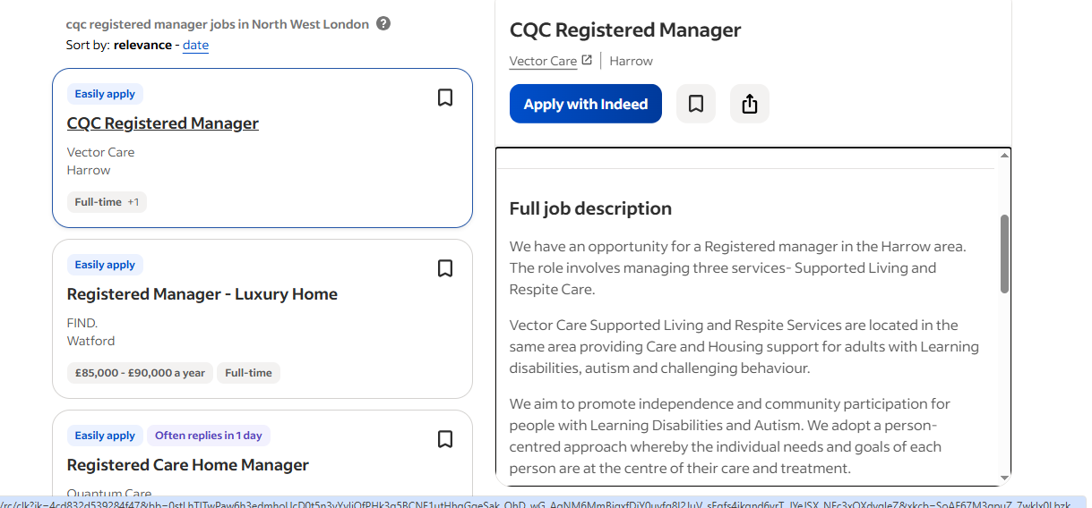
Figure 1, Screenshot: CQC Registered Care Home Manager Role

I have chosen this career because it aligns with my professional values of promoting dignity, independence, safeguarding, and improving outcomes for vulnerable adults. Having developed experience within adult Health & Social Care, I gained an appreciation of the importance of effective leadership, quality assurance, and multidisciplinary working in delivering safe and compassionate care. The role also provides opportunities to influence service improvement, support staff development, and ensure compliance with legal and regulatory requirements. These responsibilities match my skills in communication, problem-solving, decision-making, and person-centred practice, while supporting my long-term career goal of leading high-performing care services.
The key areas of evaluation in this report are as follows:
- Analyse the employability skills required by the job listed.
- Evaluate my own skills against the skills required for the job listed.
- Examine my personal brand and professional identity.
- Finally, present an action plan and timeline as follows:

Analyse the Personal Employability Skills Required
The role of a CQC Registered Care Home Manager requires a combination of professional qualifications, leadership ability, technical knowledge, and interpersonal skills to ensure the delivery of safe, effective, and person-centred care. The Registered Manager is legally responsible for ensuring that the care home complies with the Health and Social Care Act 2008 (Regulated Activities) Regulations 2014 and meets the standards established by the Care Quality Commission (CQC, 2023). Typical entry requirements include a Level 5 Diploma in Leadership and Management for Adult Care (or equivalent), relevant management experience within adult social care, and a thorough understanding of safeguarding, risk management, quality assurance, and regulatory compliance.
The employability skills required for the CQC Registered Manager Role at Vector Supported Living & Respite Services are: -
- Experience in managing services for adults with learning disabilities, autism, challenging behaviours and mental health need.
- Level 4 or 5 diploma in Health & Social Care
- Developing strong network with senior commissioning team and local authorities
- CQC knowledge
- 2 years managerial experience
- Involvement in budget management
- Implementing service-specific policies/procedures

The person specification for this role highlights strong leadership, excellent communication, decision-making, resilience, emotional intelligence, and the ability to lead multidisciplinary teams. Managers must also demonstrate integrity, accountability, and a commitment to continuous professional development while maintaining high standards of care and promoting a positive organisational culture (Skills for Care, 2024).
Communication is one of the most important employability skills for a Registered Care Home Manager. Effective communication enables managers to build trusting relationships with residents, relatives, staff, healthcare professionals, and external agencies. Managers must adapt their communication style to meet individual needs, particularly when supporting people living with dementia, sensory impairments, or learning disabilities. Poor communication can result in misunderstandings, safeguarding concerns, or reduced quality of care (Skills for Care, 2024).
Resilience is equally important due to the emotional and operational challenges associated with managing a care home. Managers regularly respond to safeguarding concerns, staffing shortages, inspections, complaints, and emergency situations while ensuring that residents continue to receive safe care. The ability to remain calm under pressure supports effective decision-making and helps maintain staff confidence during challenging circumstances
The Skills for Care Core Skills Framework identifies essential competencies including communication, person-centred care, safeguarding, health and safety, equality and diversity, digital skills, and continuous learning (Skills for Care, 2024). Digital literacy has become increasingly important as Registered Managers are expected to use electronic care planning systems, medication management software, incident reporting systems, and digital quality assurance tools. Accurate digital record keeping improves accountability, promotes continuity of care, and supports compliance during CQC inspections.
The 6Cs of Nursing—Care, Compassion, Competence, Communication, Courage, and Commitment—although originally developed for nursing, are equally relevant to care home management (Department of Health, 2012). For example, compassion enables managers to create a culture where residents feel respected and valued, while courage supports difficult decisions relating to safeguarding investigations, disciplinary procedures, or raising concerns about poor practice.
The STAR model (Situation, Task, Action, Result) provides an effective framework for demonstrating employability skills in practice. For example, a resident living with dementia became increasingly distressed and verbally aggressive towards staff following a change in routine (Situation). As the manager, the responsibility was to reduce distress while maintaining the safety of residents and staff (Task). The manager implemented a person-centred de-escalation approach by calmly communicating with the resident, identifying triggers through discussion with family members, reviewing the care plan, and providing staff with additional dementia care guidance (Action). Consequently, incidents reduced significantly, staff confidence improved, and the resident experienced greater emotional wellbeing (Result). This example demonstrates leadership, communication, emotional intelligence, and problem-solving skills.
The Employability Skills Framework highlights that employers increasingly value transferable skills alongside technical competence, including leadership, adaptability, teamwork, critical thinking, and lifelong learning. These competencies enable Registered Care Home Managers to respond effectively to changing legislation, workforce challenges, and increasingly complex care needs (CBI, 2023).
Similarly, Kolb's Experiential Learning Cycle explains how professional skills develop through experience (Kolb, 1984). Managers learn by reflecting on situations, analysing what worked well, identifying improvements, and applying new approaches in future practice. For instance, after managing a safeguarding incident, reflection during supervision may identify opportunities to strengthen staff training or improve reporting procedures. Continuous reflective practice enhances leadership effectiveness and contributes to ongoing service improvement, ensuring high-quality, safe, and person-centred care for residents.

Evaluate Your Own Skills

Critical Evaluation of My Current Skills
To assess my readiness for the role of a CQC Registered Care Home Manager, I have critically evaluated my knowledge, skills, experience, and personal attributes against the job requirements. I have used self-assessment methods including a SWOT analysis, a skills audit, feedback from managers and colleagues, and reflective models to identify my strengths and areas for improvement. This evaluation has helped me recognise that while I possess many of the competencies required for the role, there are areas where further development is necessary before I can confidently undertake the full responsibilities of a Registered Manager.
A personal SWOT analysis highlighted several strengths. My greatest strengths include communication, safeguarding knowledge, leadership, organisation, and decision-making. Working within Adult Social Care has enabled me to develop experience in completing Care Act assessments, Mental Capacity Assessments, safeguarding enquiries, risk assessments, and coordinating care with multidisciplinary professionals. These responsibilities have strengthened my ability to analyse complex situations, make evidence-based decisions, and communicate effectively with service users, relatives, healthcare professionals, and care providers.
My skills audit also demonstrated that I have well-developed interpersonal skills and the ability to build positive professional relationships. These are essential qualities identified within the Skills for Care Core Skills Framework (Skills for Care, 2024). Colleagues and managers have consistently provided positive feedback regarding my professionalism, reliability, and calm approach when managing challenging situations. During supervision sessions, I have been commended for producing thorough assessments, demonstrating person-centred practice, and effectively coordinating support for individuals with complex needs. This feedback has increased my confidence and reinforced my commitment to delivering high-quality care.
One practical example occurred during my work with an older adult whose needs had significantly changed following a hospital admission. I coordinated information from hospital staff, family members, and care providers to complete a comprehensive assessment and arrange an appropriate package of care. The positive feedback received from my manager highlighted my effective communication, organisation, and ability to work collaboratively across agencies to achieve positive outcomes for the individual.
Using Gibbs' Reflective Cycle (Gibbs, 1988), I reflected on a safeguarding investigation involving an older adult living in residential care. Initially, I felt challenged by the complexity of coordinating information from several agencies while ensuring that the individual's wishes remained central to decision-making. Through reflection, I recognised the importance of clear communication, effective record-keeping, and collaborative working. Evaluating this experience helped me identify improvements in my confidence when leading professional discussions and strengthened my ability to balance risk management with person-centred practice. As a result, I now approach similar situations with greater confidence and professionalism.
Despite these strengths, my self-assessment identified several needs for development. Although I have significant experience in adult social care, I have not yet held full operational responsibility for managing a regulated care home. The role of a Registered Manager requires expertise in financial management, workforce planning, regulatory compliance, quality assurance, and preparing for Care Quality Commission (CQC) inspections. These responsibilities extend beyond my current role and represent important areas for further professional development.
My motivation to progress into leadership can be explained using Maslow's Hierarchy of Needs (Maslow, 1943). To address my development needs, I intend to complete the Level 6 Diploma in Leadership and Management for Adult Health & Social Care by August 2027, participate in leadership and quality assurance training, seek mentoring from experienced Registered Managers, and gain greater exposure to CQC inspection processes, budgeting, and workforce management within 12 months.
Overall, my evaluation demonstrates that I possess a strong foundation of transferable skills, professional knowledge, and practical experience that align with many of the requirements of a CQC Registered Care Home Manager. However, I recognise that effective leadership requires continuous learning. By addressing the identified gaps in operational management and regulatory leadership, I will be better prepared to lead a care home that delivers safe, effective, caring, responsive, and well-led services while maintaining the highest standards of person-centred care.

Building a Personal Brand and Professional Identity
Developing a strong personal brand is essential for career progression within Health and Social Care, particularly for aspiring leaders such as a CQC Registered Care Home Manager. A professional identity reflects an individual's values, behaviours, knowledge, and reputation, enabling employers and colleagues to recognise their strengths and commitment to high-quality care. My personal values are centred on compassion, integrity, respect, accountability, and person-centred practice. These values closely align with the principles of the Care Quality Commission (CQC) and the ethical standards expected within adult social care.
My unique selling point (USP) is the combination of my frontline experience in Adult Social Care, my strong knowledge of legislation such as the Care Act 2014 and Mental Capacity Act 2005, and my ability to lead collaboratively while maintaining a person-centred approach. My experience completing complex assessments, safeguarding enquiries, multidisciplinary working, and risk management has strengthened my leadership and decision-making skills. These experiences distinguish me from candidates who may have management knowledge but less practical experience of statutory adult social care.
To promote my professional identity, I maintain an up-to-date curriculum vitae that highlights my qualifications, professional achievements, leadership experience, and continuing professional development. I also use LinkedIn to present a professional profile, detailing my current role, qualifications, specialist skills, and career aspirations. See figure 2, below.
Networking is another important aspect of building a professional identity. Social Capital Theory suggests that professional relationships create opportunities for learning, career progression, and access to valuable resources (Bourdieu, 1986). I intend to strengthen my professional network by actively engaging with Health and Social Care professionals through LinkedIn groups, attending leadership conferences, participating in Skills for Care learning events, and becoming a member of organisations such as the Chartered Management Institute (CMI) to further develop my leadership knowledge and management skills.

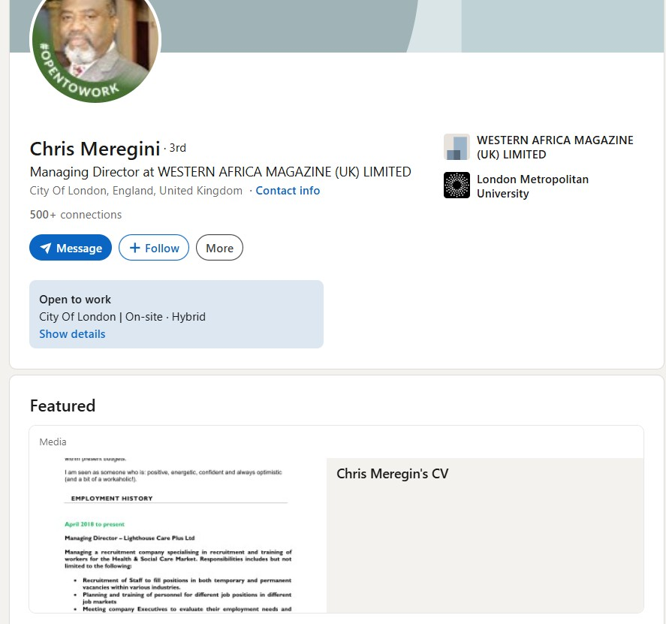
Figure 2, Screenshot: Chris Meregini’s LinkedIn Profile

Action Plan and Timeline

Personal Development Action Plan
To achieve my long-term ambition of becoming a CQC Registered Care Home Manager, I have developed a realistic action plan to strengthen my leadership, management, and regulatory knowledge. My plan is based on the principles of SMART goals (Specific, Measurable, Achievable, Relevant and Time-bound) (Doran, 1981), ensuring that each objective is clear, measurable and aligned with my career aspirations. I also draw on Bandura's Self-Efficacy Theory, which suggests that confidence in one's ability to succeed increases through experience, learning, positive feedback, and observing successful role models (Bandura, 1997). As I gain further leadership experience and complete additional training, I expect my confidence and competence to grow, preparing me for the responsibilities of a Registered Manager.

Personal Development Timeline
Timescale | SMART Goal | Activities | Resources Required | Success Measure
0–6 months | Increase knowledge of care home leadership and CQC regulations by January 2027. | Complete CPD courses on safeguarding leadership, quality assurance, CQC standards and medication management by January 2027. | Employer support, CPD funding, online learning platforms. | CPD certificates completed and evidence added to professional portfolio by January 2027.
6–12 months | Develop practical leadership and management experience. | Shadow an experienced Registered Care Home Manager for at least 20 hours by June 2027. | Mentor, management support and supervision. | Positive feedback from mentor and successful completion of leadership activities within 12 months
12–18 months | Strengthen operational management skills. | Gain experience in staffing, rota management, budgeting, recruitment, supervision and quality assurance processes by October 2027. | Access to management responsibilities and internal training. | Demonstrate competence through appraisal and leadership responsibilities.
Regular reflection will also form an important part of my development. I intend to review my progress every six months through supervision, appraisal, and reflective practice to evaluate whether I have achieved each SMART objective. Where necessary, I will revise my goals to reflect changes in legislation, organisational priorities, or personal development needs.
Overall, this action plan provides a structured pathway towards becoming a CQC Registered Care Home Manager.

Conclusion
This report has evaluated my suitability for the role of a CQC Registered Care Home Manager for Vector Care Supported Living and Respite Care, Harrow. By analysing the knowledge, skills, behaviours, and professional attributes required for the position. The evaluation has demonstrated that my current experience in Adult Health & Social Care, together with my communication skills, safeguarding, leadership, multidisciplinary working, and person-centred practice, provides a strong foundation for progressing into this role. However, it has also identified areas for further development, particularly in operational management, financial planning, workforce management, and leading regulatory compliance within a care home setting.
The action plan outlined in this report provides a structured and realistic pathway towards achieving my career goal. Through continued professional development, completion of leadership qualifications, mentoring, networking, and gaining practical management experience, I will strengthen the competencies required to lead a high-quality care service.
Setting SMART objectives and engaging in reflective practice will enable me to monitor my progress and adapt to the evolving demands of the health and social care sector.
Completing this report has enhanced my understanding of the skills, values, and leadership qualities required of an effective Registered Care Home Manager. It has encouraged me to critically reflect on my strengths, recognise areas for growth, and appreciate the importance of lifelong learning in professional practice within the health and social care profession. Undoubtedly, I currently meet some of the requirements for this role, but I need further leadership, budgeting, and CQC inspection experience before I can be fully prepared for this position.

References
- Bandura, A. (1997) Self-Efficacy: The Exercise of Control. New York: W.H. Freeman.
- Bourdieu, P. (1986) 'The Forms of Capital', in Richardson, J.G. (ed.) Handbook of Theory and Research for the Sociology of Education. New York: Greenwood Press, pp. 241–258.
- CBI (2023) Learning for Life: Skills for Employment. London: Confederation of British Industry.
- Care Quality Commission (CQC) (2023) Guidance for Providers on Meeting the Regulations. London: CQC.
- Department of Health (2012) Compassion in Practice: Nursing, Midwifery and Care Staff – Our Vision and Strategy. London: Department of Health.
- Doran, G.T. (1981) ‘There’s a S.M.A.R.T. way to write management’s goals and objectives’, Management Review, 70(11), pp. 35–36.
- Gibbs, G. (1988) Learning by Doing: A Guide to Teaching and Learning Methods. Oxford: Oxford Polytechnic.
- Holland, J.L. (1997) Making Vocational Choices: A Theory of Vocational Personalities and Work Environments. 3rd edn. Odessa, FL: Psychological Assessment Resources.
- Kolb, D.A. (1984) Experiential Learning: Experience as the Source of Learning and Development. Englewood Cliffs, NJ: Prentice Hall.
- Maslow, A.H. (1943) 'A Theory of Human Motivation', Psychological Review, 50(4), pp. 370–396.
- Skills for Care (2024) Core Skills Framework for Adult Social Care. Leeds: Skills for Care.

