University of Wales Trinity Saint David



School of Engineering

Motorcycle Engineering

Eoin Collins
P150380

Project planning:

Feasibility study of a 2022 Moto2 Entry

Date: 25/11/2019

Management, Innovation and Sustainability


M5X01176
Contents
Table of Figures 2
Table of Tables 2
1. Introduction. 3
2. Team members and roles within the team. 3
3 Group tasks and timeframe 5
4 Personal task description 6
5 Project milestones 10
6 Areas of concern 10
7 Project summary 12
Group Gantt chart. 12
Personal Gantt chart. 13
8 Appendices 14
References 26

Table of Figures
Figure 1: Belbin’s model Role Categories 3
Figure 2: Basic communication strategy 6
Figure 3: Can bus message signal 7
Figure 4: Basic circuit layout. 8
Figure 5: CAN Bus sniffer prototype 8
Figure 6: A current competing machine. 9
Figure 7: comprehensive group Gantt chart 12
Figure 8: Personal Gant chart 13

Table of Tables
Table 1: Team Member Table 3
Table 2: Group Task outlines with timeframe 5
Table 3: Brief Component description 7
Table 4: Bill of Materials 9

Introduction.
The Goal of this Project is to investigate the feasibility of a moto 2 entry from a team aspect, taking into account all the engineering roles required within the task of putting together the package required to compete at moto2. The success of this project will be measured by ultimately achieving the end goal of fielding a moto2 racing machine in 2020.
- Team members and roles within the team.

Table 1: Team Member Table
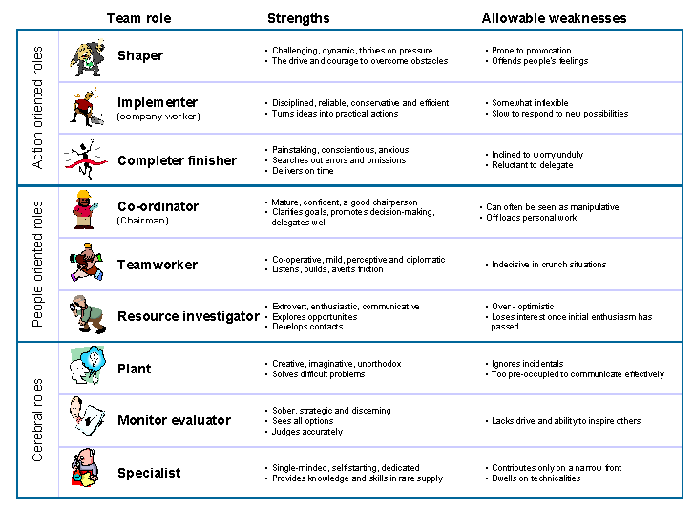
After analysing My role further within the team, I sat the Belbin`s self-Perception assessment which identified my personality Traits as being a strong Plant and a Monitor evaluator. These both Fall into the Cerebral Role Category of the assessment.

Figure 1: Belbin’s model Role Categories
As seen in figure 1 my Strengths and weaknesses can be identified below.
A brief description of My Results:
Strong Plant: “Tendency to be highly creative and good at solving problems in unconventional ways.” (Belbin, 1981)
Monitor evaluator: “Provides a logical eye, making impartial judgements where required and weighs up the team's options in a dispassionate way” (Belbin, 1981)

A further break down of the personality areas
Plant:
Strengths: Creative, imaginative, free-thinking, generates ideas and solves difficult problems.
Allowable weaknesses: Might ignore incidentals, and may be too preoccupied to communicate effectively.
Don't be surprised to find that: They could be absent-minded or forgetful.
Monitor Evaluator:
Strengths: Sober, strategic and discerning. Sees all options and judges accurately.
Allowable weaknesses: Sometimes lacks the drive and ability to inspire others and can be overly critical.
Don't be surprised to find that: They could be slow to come to decisions.
(Belbin, 1981)

From these results, I believe I can use these traits to my advantage to create new strategies in my project area. Creativity and fresh idea generation are very important within creating a performance improvement in engine management for example
- Intuitive Engine Mapping
- Alternate methods around common control issues in high pressure environments (common within racing situation)
The other personality traits that would be needed for my chosen area in my opinion
- Straight thinking
- Open mindedness
- Malleable thinking (Ability to think outside the box)
- Problem solving skills

Group tasks and timeframe
Table 2: Group Task outlines with timeframe

Personal task description

Control systems and Engine Management, my role within the team is to look after the engine management system, and the control systems/electronic communication strategies involved in a moto2 application. So from the start when we decided our target area after we compiled as a group and had a meeting to confirm our goals within this chosen area. I researched the regulation of the moto 2 Class to look at the Electronic limitations with in the class, as shown below
“Moto2 Ignition and Electronics
11. Only the official Electronic ignition/fuel injection control unit (ECU, with built-in datalogger), Inertial Measurement Unit (IMU), Dashboard, and Switch Panel as supplied by the official Supplier are allowed, and any ECU used on a Moto2 machine at a GP event must be registered with the Technical Director.
This ECU must remain unmodified in hardware and software as delivered by the official Supplier, with the exception of the normal tuning adjustments allowed only by the standard software ‘Setting Tool’ supplied as part of the Moto2 Kit.
The use of any additional device or module to modify the signals sent from the ECU to the actuators is forbidden. Injectors, bypass systems and ignition must be operated exclusively by the original and unmodified ECU signal.”
(Fim Technical, 2019)
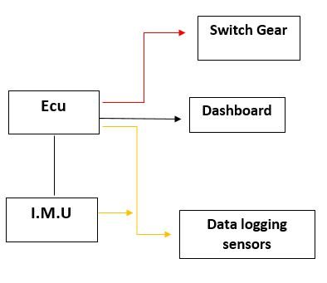
After in-depth analysis, I further broke down my area into smaller subject blocks to aid Learning the background knowledge and basic experience needed to successfully create a competitive engine management Strategy and efficient control system base needed to meet the demands of professional competition.
Figure 2: Basic communication strategy
Red Lines: analogue connection
Black Lines: CAN Bus communication
Yellow Lines: Dual communication across each individual sensor

Table 3: Brief Component description
Figure four shows the basic connection plan for the Moto 2 machine. From this you can see there is two main connection protocols used CAN Bus (Controller area Network) which is defined by the ISO 11898-2, ISO 11898-3 international standards.
Serial communication is also used to interface the ecu with the SP5 switchgear which can be set up to alter Maps and power management and the information displayed on the dashboard.
From this I conducted further research in to the background of Can Bus integration into racing motorcycles, after some time looking at CAN integrated systems. It was prevalent that can was steadily becoming the manufacturer chosen communication platform where necessary. This is because of two main reasons
- Logistics and packaging: Can bus reduces the amount of wires needed across the whole motorcycle platform reducing size and weight significantly.

- Simplification of maintenance: Because of the nature of can bus communication between components in the network through the use of some specialist equipment problems can be identified rapidly without the need to methodically fault find which in a traditional serial communication system can be very time consuming.

From this I decided get involved with CAN bus systems by Creating my own CAN Bus “Sniffer” – a device used to interpret Can channels and there information. 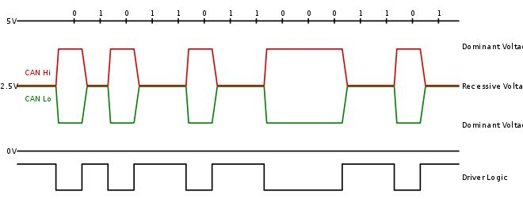
Figure 3: Can bus message signal
(speedometer, n.d.)
From this I created a circuit Diagram
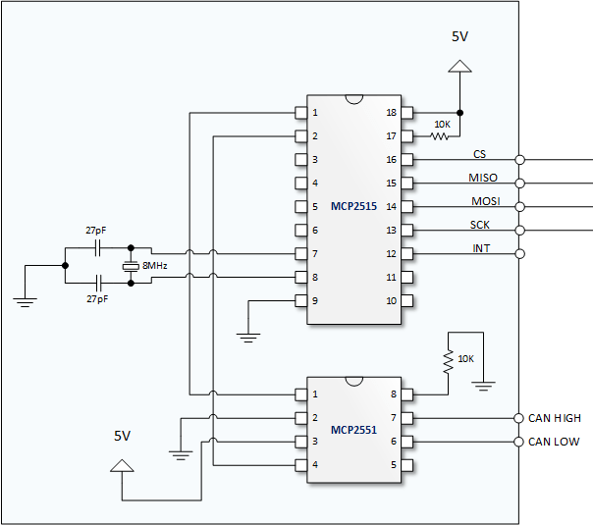
Figure 4: Basic circuit layout.

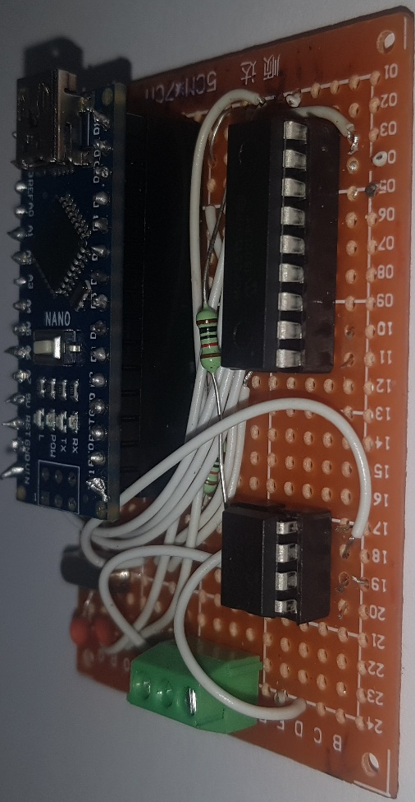

This is the completed board including microcontroller and usb interface.

Figure 5: CAN Bus sniffer prototype

After completing the CAN sniffer this provided me with a competent understanding of how can systems function. My next step was contacting Magnetti marrelli for the ECU management software and the data logging software to understand how I should go about creating maps and also to give myself a feel for the environment to which my engine management strategy and control/connection plan would be Implemented. The software needed for the engine management is SYSMA, this software is licence locked. And then for the motoring and data logging a separate piece of software is used called Wintax.
Next step is to analyse a current competing machine with a working Electronic strategy, from this I was able to see what’s needed for my package and from this I could create a bill of materials for the engine management and control systems side of the project.
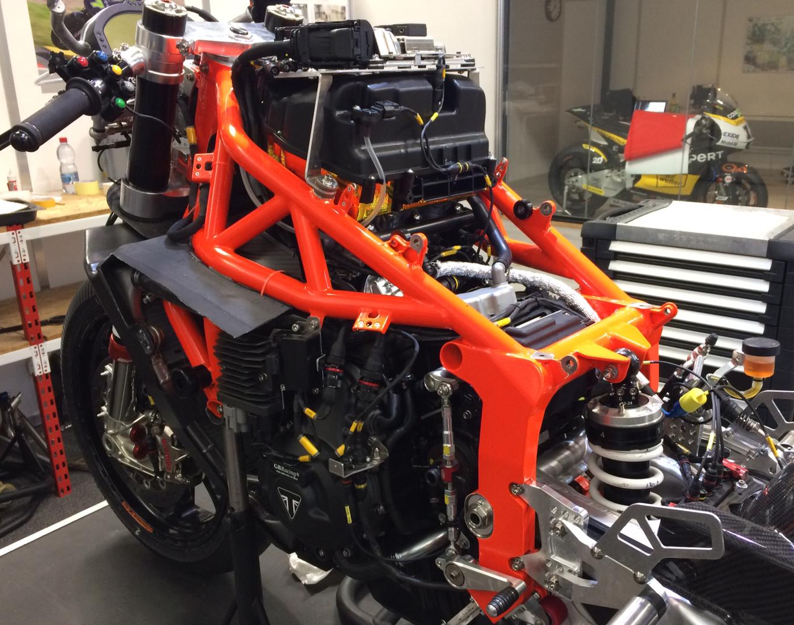
Figure 6: A current competing machine.
Table 4: Bill of Materials

Optional Specialist Equipment:
- DMG Deutsch connector crimping termination tool
- Picoscope automotive oscilloscope
- Weather proof high temperature wiring cover/sheathing.
- Concentric twisting rig for modular wiring looms.

Project milestones
Milestone group one;
Milestone One: better my understanding of communication systems within motorcycles
Milestone Two: Further investigate common can system messages on a motorcycle using an automotive oscilloscope.
Milestone Three: use the gained knowledge to develop a plan for the connections needed for the actual loom for the completion motorcycle.
Milestone Four: create a wiring diagram
Milestone Five: Start prototyping the loom and test it.
After the completion of the above five milestones that will lead to the first major Gateway,
Gateway One: Integration of prototype wiring harness into testing.
Milestone group Two;
Milestone 2.1: download SYSMA (ECU Engine management software)
Milestone 2.2: go through demos and tutorials
Milestone 2.3 set up a new workspace/User interface within SYSMA
Gateway two: Practice setting up engine management strategies in virtual environments using the parameters in an outside simulation in validation of the strategies.

Areas of concern
The two main areas of concern for me lie within Timeframe and financing, the main risks within these areas of concern within my area of the group project are:
Timeframe:
- The end goal is unachievable with in the given time frame given the time constraints of university in the next two years,(dissertation assignments vivas)
- Championship based concerns i.e. eligibility of wildcard entries ( these are only available for a specific time period each year, so if the team wasn’t ready this would delay it for the next season),changes in electronic strategy based regulation
Financing:
- Having the budget to fulfil the needed electronic package needed to be competitive at the chosen level.
- Meeting the sheer cost of hardware alone.
Human Safety.
- Having an appropriate fall back plan/fail safe procedure in the event of a total system failure
Mitigation methods:
The main methods of mitigation to keep minimum risk across my three areas of concern:
- Keeping a strict project progress plan with good communication amongst the group keeping an even work flow across all tem members maximizing time.
- Set up notification and alerts and join mailing lists from the chosen championship governing body to stay on top of the current affairs within the administrative side the championship.
- Keep an active cost tracker across the duration of the project, therefore allowing the group to seek sponsors with an accurate cost plan of the project.
- Carry out rigorous fault tests on the electronics system to a have a database of failure information for he use in the event of terminal failure so an accurate plan can be put in place across the motorcycle as a whole to protect the safety of the rider and the integrity and structure of the motorcycle itself.

Project summary

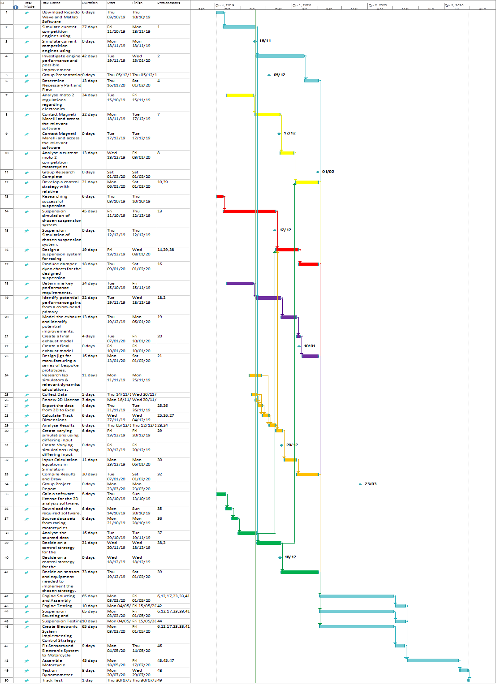
Group Gantt chart.

Figure 7: comprehensive group Gantt chart

Personal Gantt chart.
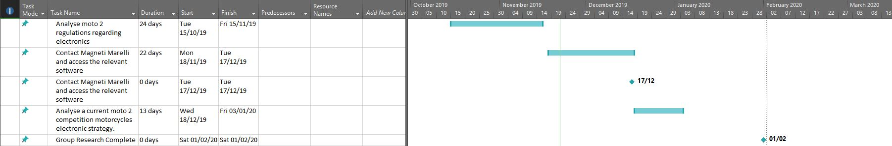

Figure 8: Personal Gant chart

Appendices

Group project meeting summary sheets

Engineering Management: Management, Sustainability and Innovation
Meeting: Meeting 1 Venue: Room 3, First Floor, Y Fforwm Date: 17/10/19
Attendees:
A/D/I (Action/Decision/Information
Name | Signature
Lee Stewart | 
Alexander Penny | 
Zachary Church | 
Emily-Kate Flewin | 
Eoin Collins | 
Jon Lloyd-Williams | 

No | A/D/I | Objective/Description | Who | When | Status
1 | I | Discussed individual interests that group members want to research into | All | N/A | Complete
2 | A | Found the course director to advise the group | All | N/A | Complete
3 | I | Discussed individual interests with the course director in order to form a group | All | N/A | Complete
4 | A | Created individual plans for each person in the group | All | N/A | Complete
5 | A | Accessed and downloaded the Moto2 regulations | All | N/A | Complete
6 | A | Created a WhatsApp group for the group project | Emily-Kate | N/A | Complete
7 | A | Created objectives to be completed by the next meeting | All | N/A | Complete
8

Engineering Management: Management, Sustainability and Innovation
Meeting: Meeting 2 Venue: Room 3, First Floor, Y Fforwm Date: 24/10/19
Attendees:
A/D/I (Action/Decision/Information
Name | Signature
Lee Stewart
Alexander Penny
Zachary Church
Emily-Kate Flewin
Eoin Collins
Jon Lloyd-Williams

No | A/D/I | Objective/Description | Who | When | Status
1 | I | Discussed the groups weekly progress | All | N/A | Complete
2 | D | Decided a specific time for the meetings | All | N/A | Complete
3 | A | Certain members of the group practiced opening the data software | Lee  Emily-Kate  Jon | N/A | Complete
4 | A | Practiced opening Matlab and went through tutorials | Zack | N/A | Complete
5 | I | Brainstormed certain deadlines for certain parts of the group project to be finished by | All | N/A | Complete
6 | A | Created deadlines for the project | All | N/A | Complete
7 | A | Created objectives to be completed by the next meeting | All | N/A | Complete
8

Engineering Management: Management, Sustainability and Innovation
Meeting: Meeting 3 Venue: Room 3, First Floor, Y Fforwm Date: 31/10/19
Attendees:
A/D/I (Action/Decision/Information)
Name | Signature
Lee Stewart
Alexander Penny
Zachary Church
Emily-Kate Flewin
Eoin Collins
Jon Lloyd-Williams

No | A/D/I | Objective/Description | Who | When | Status
1 | I | Discussed the groups weekly progress | All | N/A | Complete
2 | A | Created a combined word document for the report | All | N/A | Complete
3 | I | Discussed each other’s plans and progress to see if anyone needs help or guidance that another team member can offer | All | N/A | Complete
4 | I | Explained possible designs for the exhaust systems | Alex | N/A | Complete
5 | I | Explained the lap time simulator and what strategies are most effective | Jon | N/A | Complete
6 | A | Created objectives to be completed by the next meeting | All | N/A | Complete
7
8
Engineering Management: Management, Sustainability and Innovation
Meeting: Meeting 4 Venue: Room 3, First Floor, Y Fforwm Date: 7/11/19
Attendees:
A/D/I (Action/Decision/Information
Name | Signature
Lee Stewart
Alexander Penny
Zachary Church
Emily-Kate Flewin
Eoin Collins
Jon Lloyd-Williams

No | A/D/I | Objective/Description |  | Who |  | When | Status
1 | I | Discussed the groups weekly progress |  | All |  | N/A | Complete
2 | I | Discussed the price of the full project |  | All |  | N/A | Complete
No | A/D/I | Objective/Description |  | Who |  | When | Status
3 | I | Explained the suspension trace data to the rest of the group and getting suggestions on what the best design would be |  | Emily-Kate |  | N/A | Complete
4 | I |  | Discussed each other’s plans and progress to see if anyone needs help or guidance that another team member can offer |  | All | N/A | Complete
5 | I |  | Explained the powertrain data and showed the rest of the group the Matlab file whilst receiving suggestions on the best strategy |  | Zack | N/A | Complete
6 | A |  | Created objectives to be completed by the next meeting |  | All | N/A | Complete
7
8

Engineering Management: Management, Sustainability and Innovation
Meeting: Meeting 5 Venue: Room 3, First Floor, Y Fforwm Date: 12/11/19
Attendees:
A/D/I (Action/Decision/Information
Name | Signature
Lee Stewart
Alexander Penny
Zachary Church
Emily-Kate Flewin
Eoin Collins
Jon Lloyd-Williams

No | A/D/I | Objective/Description | Who | When | Status
1 | I | Discussed the groups weekly progress | All | N/A | Complete
2 | D | Changed the date of the next meeting | All | For the next meeting | Complete
3 | I | Explained the possible design and strategies for the control systems | Eoin & Lee | N/A | Complete
4 | A | Improved on the current objectives and time scales | All | N/A | Complete
5 | D | Changed individual plans to fit the new objective and timescales | All | N/A | Complete
6 | A | Created objectives to be completed by the next meeting | All | N/A | Complete
7
8

Engineering Management: Management, Sustainability and Innovation
Meeting: Meeting 6 Venue: Room 3, First Floor, Y Fforwm Date: 14/11/19
Attendees:
A/D/I (Action/Decision/Information)
Name | Signature
Lee Stewart
Alexander Penny
Zachary Church
Emily-Kate Flewin
Eoin Collins
Jon Lloyd-Williams

No | A/D/I | Objective/Description | Who | When | Status
1 | I | Discussed the groups weekly progress | All | N/A | Complete
2 | A | Created a combined PowerPoint presentation for vivas | All | 2/12/19 | Complete
3 | I | Brainstormed control strategy ideas for the motorcycle | All | N/A | Complete
4 | I | Considered the best control strategy for the motorcycle | All | N/A | Complete
5 | A | Checked that our plans/ideas fit the regulations | All | N/A | Complete
6 | I | Discussed each other’s plans and progress to see if anyone needs help or guidance that another team member can offer | All | N/A | Complete
7 | A | Created objectives to be completed by the next meeting | All | N/A | Complete
8

References
Belbin, M., 1981. Belbin. [Online]
Available at: https://www.belbin.com/
[Accessed 20 November 2019].
Fim Technical, 2019. Fim Live. [Online]
Available at: http://www.fim-live.com
[Accessed 21 November 2019].
speedometer, A., n.d. Atlanta speedometer. [Online]
Available at: https://atlantaspeedometer.com/CanBusApplications/tabid/6524/Default.aspx
[Accessed 24 november 2019].

