Using at least 3 examples, consider how image makers have utilised digital technology to explore one of the following: Conflict, Identity, the Surveillance State, the Technological World?

Thomas Ian Richards

P149671

1868 words

Paul Duerinckx

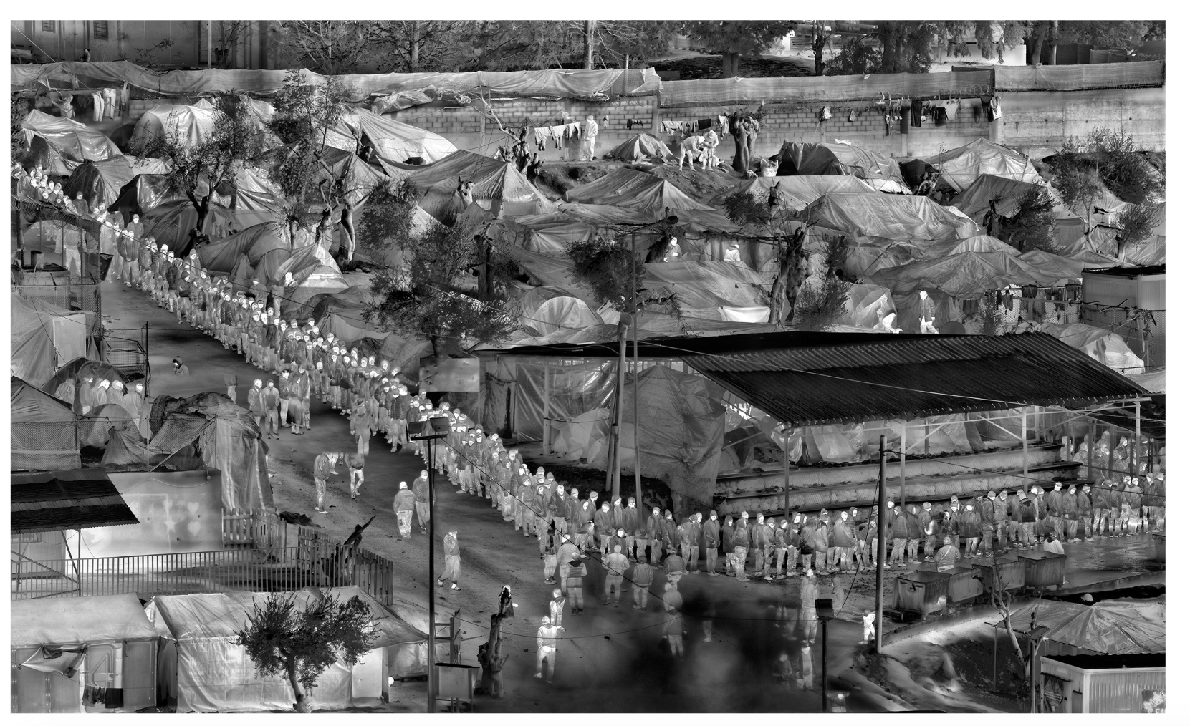
In this essay I will be focusing on the topic “the Surveillance State” and how image makers have utilised technology to explore this idea. I’ll be looking into how the use of surveillance technology has been re-appropriated by artists to create a piece that speaks on the mass surveillance that is omnipresent in society while the public remains docile to it all. In a news article published by the BBC on CCTV cameras it states that in the UK there are approximately “1.85 million cameras” (BBC, 2011, https://www.bbc.co.uk/news/uk-12641568) in operation, on average “70 times a day” (BBC, 2011, https://www.bbc.co.uk/news/uk-12641568) you are captured on them in places as simple as the workplace and in shops. This feeling of constantly being watched by some all-seeing entity is quite unsettling, creating a question about the actual state of privacy in the UK.
A very interesting photographer who utilises surveillance technology with their work is Richard Mosse. The image above is taken from Richards latest body of work titled ‘Heat Maps’, which looks into the difficult standards of life that millions of migrants have to deal with and how it is overlooked by so many of us. In the image shown above you can see a queue of refugees stretching the length of the image waiting in line to get into a shelter possibly suppling food and water for them. The shelter is situated amongst an estate of tents which are the homes of these refugee, I find it very reminiscent of the set up you would see in a music festive camp site where there is an estate of tents set up. The title for this image is ‘DETIAL OF MORIA IN SNOW’. Do you take this title in the literal sense of Richard Mosse is just saying this is a detailed image of this place covered in snow? Or if the snow a reference to the aesthetic appearance of the image because it is this grey scale heatmap image of the place. When viewing this piece of work, it raises many ethical questions for me, for example he is viewing these struggling communities from a distance which could be read as, is Richard just exploiting them for personal gain? In a video on his website where he discusses this body of work, he states that the camera used can “image the human body from … about 18 miles” (Paris Photo, 2017, http://www.richardmosse.com/projects/artist-statement) . The camera used Richard Mosse states that the camera was designed for “long range border enforcement” (Paris Photo, 2017, http://www.richardmosse.com/projects/artist-statement), this means he did not have to get up close and personal with the subject, he could just observe them from a very far distance. It is almost as if he was watching these people from behind a pane of glass, as if he is viewing them like animals in a zoo. By not interacting with the migrants personally for the photographs does that mean that he is capturing the story that is there fully? He will just have an outsider perspective coming from a developed first world country into this struggling climate with a perspective that is shaped by his media intake from home and bring that ideology he has been fed and applying that to this scenario. As once said by Robert Capa “If your pictures aren’t good enough, you’re not close enough” (Leary, 2007 ,
http://rising.blackstar.com/if-your-pictures-arent-good-enough-youre-not-close-enough.html) this quote applies in both senses to this body of work I feel. This is due to the fact that Richard isn’t getting in close and personal with these struggling people and I feel a disconnect with the hard ship that they are going through. I am an outsider looking in with information I have only received through my media intake. By viewing these people from a distance, I am left still not empathising with the people on the ground. So once viewing this work I am left not feeling a relationship between me and the people in the images, therefore after viewing this work I am left not really thinking of how these people are struggling. Furthermore, by Richard not getting close enough to these people I feel through these photographs don’t have quite as much impact as they could have.

Another artist I am interested in looking at who’s work also touches on the idea of surveillance state is Trevor Pagle and his body of work titled ‘Limit Telephotography’. In this body of work Trevor uncovers a series of classified military bases hidden amongst the American landscape. He says that “there is nowhere on Earth where a civilian might be able to see them with an unaided eye” (Trevor Paglen, 2018, http://www.paglen.com/?l=work&s=limit&i=1). It’s quite strange how much power governments have to see us and know how to find us so easily, but they spend so much money hiding themselves becoming this all-seeing entity that the majority invisible to us. I find it fascinating that he is spying on these people who can see us from every angle multiple times a day while we remain completely docile to it, once again showcasing that nothing is really private anymore no matter how hard you try.
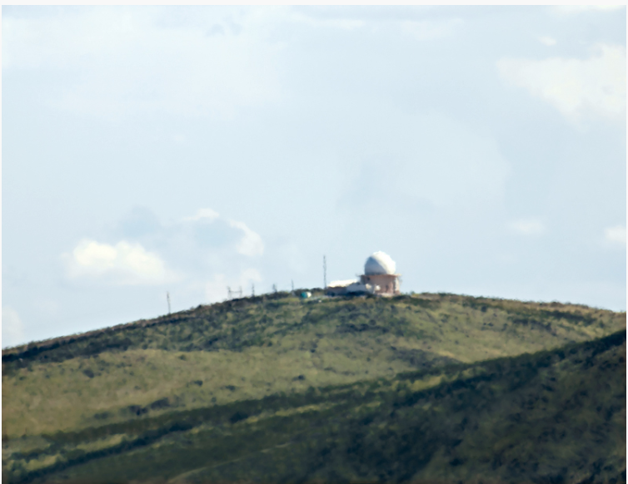

The image above is taken from the body of work I was just speaking about. In the image you see this low detail image of a building on the top of a hill completely isolated, with no other signs of life around. The building in the image is ‘National Reconnaissance Office Ground Station’ which has been taken using high powered telescopes, so this photography could be take from a long distance away. Taking photos this was is very similar to how Richard Mosse photographed his ‘Heat Maps’ project. It’s interesting how we are captured on surveillance technology from any distance without us being aware. Then when artists have access to this medium of surveillance technology, they choose to photograph in the same way we are represented on it. They remain elusive, observing the subject matter from a distance. They aren’t getting up close and personal with the subject creating this dethatched feeling between us the view and the subject matter. I feel that it would be interesting to see the juxtaposition between the fact normally you’re caught on surveillance from a distance flipped. So that you capture people close and personally seeing the stories behind these lifeless figures that are seen on surveillance cameras now.

With my photographic practice I like to take formal portraits of people to capture them in the rawest form highlighting who they are as an individual removing all distractions. I feel it would make an interesting investigation to photograph people in this style similar to how Renike Dijkstra photographs her subjects. Her style of photograph has really influenced my image taking recently, helping me to evolve into a more competent photographer. “As a photographer you enlarge a certain moment, making it another reality” (QUOTEMAN, 2018 , http://photoquotations.com/a/197/Rineke+Dijkstra) is a quote from Renike Dijkstra which I feel applies to this subject. The way in which we are seen as just objects in surveillance and not as people is creating this other reality which is disconnected with life and is just a world of shapes. By utilising the technology that creates this other reality you can break it down, exposing the shapes within it and transforming them into people who you can connect with.

Another artist I have I been looking into is the work of Italian artist Paolo Cirio and his body of work titles ‘Face to Facebook'. In this piece of work, Paolo Cirio collaborates with another Italian artist called Alessandro Ludovicio to look into how easily accessible our private personal information is to anyone online. In this project they used a method called ‘Data Scraping’ which is the process of importing information online onto a computer or to another website. So, they scraped Facebook of over 250,000 profiles that were publicly accessible to them, then transferred those profiles onto a dating website they created called ‘Lovley-Faces.com’. All the people used on the website were completely unaware they were being used on it and looking for love. This piece of work shows how easily your photo can be used without you knowing, making things like identity theft even easier for people because we are feeding them the tools by sharing so much of our information online to everyone and anyone.
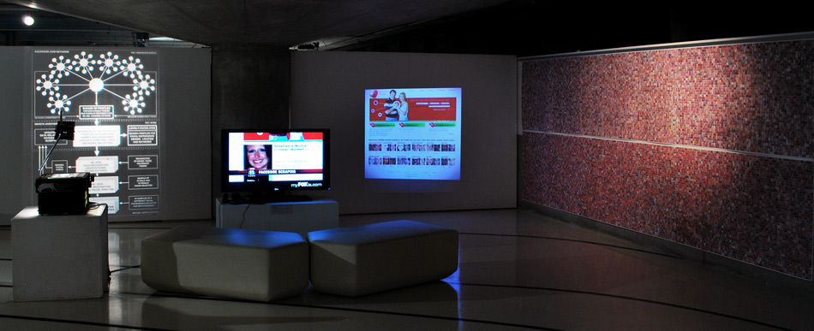
In the image above, you can see an exhibition of the project showcasing all the profiles used on the right, screenshots from the website on a screen and projector. Finally, on the left there is a projector showing how they categorised people on the dating website. Creating a project like this created a lot of controversy due to the fact people’s information was being taken from Facebook and appropriated in this different way. They faced legal action from Facebook for doing this, but nothing came of it due to the fact that the images are owned by the user not Facebook themselves. Doing this showcases to the public how vulnerable your information is online and how you can be seen any time of the day. Anyone can see your life as and when they please opening up a whole new realm of surveillance reducing what information you think is private to close relatives actually being accessible to the entire world. On average “350 million” (George, 2014 , https://mybilliondollarapp.com/how-many-photos-on-facebook-how-about-240-billion/) photos are uploaded to Facebook each day by its users, then broken down to each user they upload approximately “217 photos” (George, 2014 , https://mybilliondollarapp.com/how-many-photos-on-facebook-how-about-240-billion/). So, there is a vast amount of information that can be usurped on you making thing like identity theft even more accessible.

The state of surveillance on civilians nowadays I feel will only get more and more extreme as time goes on resulting in the advancement of technology. In an article by Vanity Fair they look into the current state of surveillance being used in China, talking about how this technology is likely to go global. Currently the Chinese Government they have surveillance technology that spot “an alleged thief in a 20,000-person crowd” (Kosoff, 2018 , https://www.vanityfair.com/news/2018/07/china-surveillance-state-artificial-intelligence) the thought of that is quite unsettling because that means they can recognise a specific individual whenever they are seen on camera. “By 2020, analysts estimate that China will have near to 300 million cameras” (Kosoff, 2018 , https://www.vanityfair.com/news/2018/07/china-surveillance-state-artificial-intelligence) so the power they will possess over the public will be enormous, the government publicise the images of people who commit certain crimes to help reduce crime rate. “That too embarrassing for people to take.” (Kosoff, 2018 , https://www.vanityfair.com/news/2018/07/china-surveillance-state-artificial-intelligence) So, the government publicly humiliate people to help reduce the crime rate which could only escalate further resulting in possibly the publication of private sensitive information being leaked by government to help keep control over the population. On the other hand, the advancement of this technology could have benefits to the safety of society and lower the rate of crime dramatically. Helping police to better spend their time going after more serious incidents than petty crimes that can be picked up on by CCTV cameras. I am interested in how surveillance is will evolve online, how much control will we be able to retain over our own personal data that we want to share. There is still so much unknow about who can see you online and what is being done with our information, I feel it is only a matter of time until we see how much we are surveyed online and what is monitored about us.

Bibliography

Leary,S. (2007) If Your Pictures Aren’t Good Enough, You’re Not Close Enough. Available at:
http://rising.blackstar.com/if-your-pictures-arent-good-enough-youre-not-close-enough.html (Accesses: 10th December 2018)

Trevor Paglen (2018) Limit Telephotography. Available at: http://www.paglen.com/?l=work&s=limit&i=1 (Accesses: 10th December 2018)

Cirio, P. (2011) Face to Facebook. Available at: http://www.paolocirio.net/work/face-to-facebook/ (Accesses: 10th December 2018)

Paris Photo (2017) Richard Mosse. Available at: http://www.richardmosse.com/projects/artist-statement (Accesses: 10th December 2018)

QUOTEMAN (2018) photoquoatations.com Available at: http://photoquotations.com/a/197/Rineke+Dijkstra (Accesses: 10th December 2018)

BBC (2011) CCTV camera estimates halved by police. Available at: https://www.bbc.co.uk/news/uk-12641568 (Accesses: 10th December 2018)

Kosoff, M. (2018) China’s terrifying surveillance state looks a lot like America’s future. Available at: https://www.vanityfair.com/news/2018/07/china-surveillance-state-artificial-intelligence (Accesses: 10th December 2018)

Mosse, R. (2017) Heat Maps. Available at: http://www.richardmosse.com/projects/heat-maps (Accesses: 10th December 2018)

George (2014) How many photos have we uploaded on Facebook? How about 240 billion. Or 217 each. Available at:
https://mybilliondollarapp.com/how-many-photos-on-facebook-how-about-240-billion/ (Accesses: 10th December 2018)

