

Understanding Anxiety Disorder in the UK: Patterns, Disorder and Patient Care
Dissertation submitted as part of the requirements for the award BSc (Hons) Health and Social Care

Programme: BSc (Hons) Health and Social Care
Module: Independent Project
Module code: BMHP6020
Student Name: Ioana Popa
Student ID:2313594
Supervisor’s name: Jolly Nwankwo

August, 2026

DECLARATION

This work has not previously been accepted in substance for any degree and is not being concurrently submitted in candidature for any degree.

Signed…IoanaPopa…………………………………………

Date…03/08/2026……………………………………………

STATEMENT 1
This dissertation is being submitted in partial fulfilment of the requirements for the degree of BSc.

Signed…IoanaPopa………………………………………….

Date…03/08/2026……………………………………………

STATEMENT 2
This dissertation is the result of my own independent work/investigation, except where otherwise stated.

Other sources are acknowledged by footnotes giving explicit references. A bibliography is appended.

Signed…IoanaPopa…………………………………………

Date…03/08/2026……………………………………………

Acknowledgement
I would like to express my deepest gratitude to my supervisor for his invaluable guidance, continuous support, and constructive feedback throughout the development of this dissertation. His expertise and encouragement have played a crucial role in shaping my academic journey and the successful completion of this research.
I am equally grateful to all my lecturers for delivering a comprehensive and inspiring course. Their dedication, professionalism, and commitment to high-quality teaching have significantly contributed to my learning experience and personal development within the field.
My heartfelt appreciation also goes to my family and friends, whose unwavering motivation, patience, and belief in my abilities have supported me throughout this challenging yet rewarding process. Their encouragement has been a constant source of strength.
In addition, I wish to extend my sincere thanks to my course colleagues and work colleagues. Their collaboration, shared insights, and willingness to help have enriched my academic experience and contributed to a supportive and stimulating learning environment. I am truly grateful for the teamwork, respect, and camaraderie we have built together, both in the classroom and in the workplace.

ABSTRACT
The overall aim of this research dissertation is to explore the patterns of anxiety disorders in the United Kingdom by focusing on trends in prevalence, the factors affecting them and the adequacy of existing mental health care. In the initial chapter (1) the background, aims and objectives of the research as well as the research questions and significance are outlined, drawing upon the idea of increasing prevalence of anxiety disorders as a public health issue in the United Kingdom. Chapter 2 provides a review of the literature in relation to anxiety disorders, which addresses: trends in prevalence, demographic characteristics, clinical and psycho-social factors for the development of anxiety disorders, the pathways of mental health care provision and the inequalities present in the care available for patients and identifies any research gaps in these areas. The methodology used in this research dissertation in Chapter 3 of this study aims to use a secondary qualitative approach; thematic analysis will be carried out from a selection of peer-reviewed journal articles, NHS reports and government publications to gain a structured and evidence-based insight into anxiety disorders in the United Kingdom. Chapter 4 describes the findings by referencing the four research objectives, and reveals an increasing prevalence of anxiety disorders; identifies that both biological and psycho-social factors play a role in influencing prevalence; shows the challenges present when seeking access to mental healthcare; and reveals continued inequalities experienced by patients receiving mental healthcare. Finally, the research study in Chapter 5 summarises the research findings, demonstrates how each research question has been answered and presents the findings and implications for policy and practice in the United Kingdom. Limitations of the study are acknowledged in this chapter along with recommendations for further research to improve accessibility to mental healthcare, reduce inequalities and foster more patient centered care.

Table of Contents
CHAPTER 1: INTRODUCTION 7
1.1 Definition of main concepts of the study 7
1.2 Rationale of the study 9
1.3 Aim of the study 10
1.4 Objectives of the study 10
1.5 Structure of the dissertation 10
CHAPTER 2: BACKGROUND 12
2.1 Historical background 12
2.1.1 Prevalence trends and demographic patterns of anxiety disorders 12
2.1.2 Clinical and psychosocial factors influencing anxiety disorders 13
2.1.3 Accessibility and quality of UK care pathways 14
2.1.4 Inequalities and evidence-based improvements 14
2.2 Theoretical background 15
2.3 International context 17
2.4 National/Local context 18
CHAPTER 3: METHODS 19
3.1 Data collection 19
3.2 Data analysis 20
3.3 Ethical considerations 22
CHAPTER 4: RESULTS AND DISCUSSION 23
4.1 Result 23
4.2 Discussion 25
4.2.1 Theme 1: Recent Prevalence Trends and Demographic Patterns of Anxiety Disorders in the UK 25
4.2.3 Theme 2: Clinical and Psychosocial Factors Influencing Anxiety Disorders 27
4.2.4 Theme 3: Accessibility and Quality of Current UK Care Pathways 30
4.2.5 Theme 4: Gaps, Inequalities and Evidence-Based Improvements 33
4.3 Limitation 35
CHAPTER 5: RECOMMENDATIONS AND CONCLUSION 37
5.1 Recommendation 37
5.2 Conclusion 38
REFERENCES 40
APPENDICES 41

CHAPTER 1: INTRODUCTION

1.1 Definition of main concepts of the study
Anxiety disorders are common mental health ailments experienced by the entire UK population, which can include generalised anxiety disorder, panic disorder, social anxiety disorder and phobias and can affect a person’s mental wellbeing, education, work, relationships and life. Awareness of these conditions has increased in the public health sector as they are found to be widespread and there has been an increase in the need for mental health support services. NHS Digital (2023) reports that a high percentage of adults in England continue to experience common mental health disorders, with young people and women experiencing more anxiety symptoms, and Dykxhoorn (2025) reports that anxiety and depression is rising in the UK among young people, yet there are still service gaps. Various social and psychological factors contribute towards anxiety disorders, such as financial pressure, unemployment, stress from studying, family problems and loneliness; Gkitakou et al., (2025) stated that anxiety and mood disorders were on the rise due to multiple risk factors, such as ongoing stress, trauma, and disadvantage. Anxiety disorders can therefore be viewed not purely as a medical problem, but one with broader psychological and social influences and in the NHS, services primarily come from primary care, psychological therapies and mental health services within the community; however, there are obstacles such as long waiting lists, stigmata and inequity regarding access.
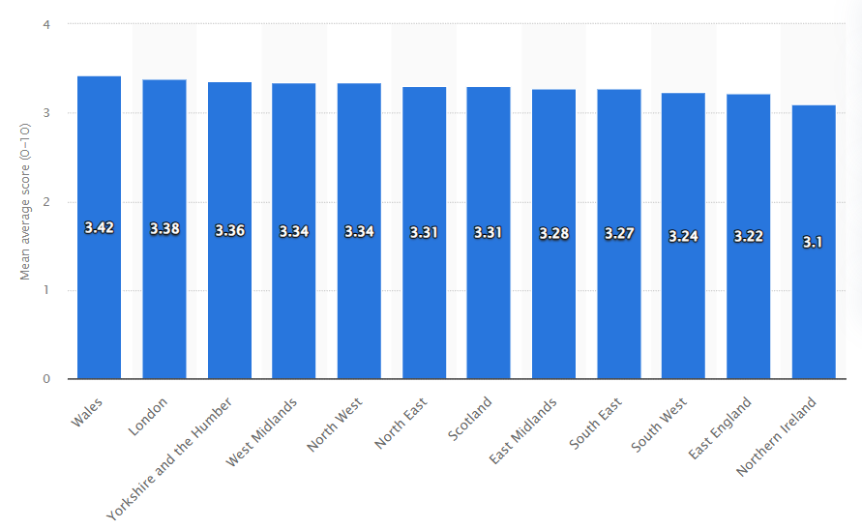
Figure 1: Anxiety levels of regions of the United Kingdom
(Source: Statista, 2026)
Anxiety disorders are becoming more prevalent in the UK especially for the younger adults and the women, also those facing hardship socially or financially. McManus (2025) points out that figures of anxiety and depression among adults under the age of 25 has increase over recent years in England. This is proving to increase demand and strain on mental health services. Although levels of awareness, together with readily available mental health support provided by the NHS, many still face problems such as stigma and the inequalities of psychological treatment being available and the time of waiting lists. Current evidence base mainly focuses on prevalence trends and also in treatments from a clinical perspective rather than the link between demographic trends, the psychosocial factors, and patient care; therefore, the objective of this study is to assess the current trends within anxiety disorders and the factors affecting it as well as the impact of care pathways within the UK to establish the deficits within the service and to contribute towards enhancing person-centred mental health care.
This research is important as anxiety disorders impact millions of people in Britain and can have a profound effect in the life of the sufferer; they are therefore public health issues. By exploring prevalence of anxiety disorder(s) and associated factors, health care professionals, policy makers and mental health charities can be better informed in identifying effective pathways to treatment and support, as well as providing mental health care and early interventions. This research also shows the significance of person centred care which individuals' needs and preferences are being taken into consideration. The research can also contribute to research literature since it not only addresses clinical aspects of anxiety disorders, but it will also include elements of social psychology, as well. It also highlights inequalities in the provision of services in the UK, particularly in the way young adults and marginalised individuals are treated and it is wished that the findings will inform future improvement plans and practice of mental health services in the NHS and community.

1.2 Rationale of the study
The rationale for this study is based upon the ever-increasing presence of anxiety disorders coupled with increasing concern regarding access and quality of services in the UK, since despite an increased awareness regarding mental health, many individuals still struggle to seek the appropriate support due to prolonged treatment times, under resourced facilities, social stigmas and worsening of mental health. Anxiety disorders impose stress on individuals, health care professionals, schools and work forces. This research is particularly relevant not only because it aims at disclosing the profiles of anxiety disorders and their treatment, but also because it highlights the problem of currently existing pathways in patient care with many studies addressing the prevalence of treatment rather than critical assessment of the provision of person-centered care, or inequalities in service provision. This study aims to help to clarify the presentation and management of anxiety disorders in the UK by looking at policy documents and published academic literature. This research aims to highlight the improvements that can be made to ensure access to and provision of mental health support services, by reviewing the findings of this research.

1.3 Aim of the study

This study aims to investigate current trends and prevalence rates of anxiety disorders in the UK, examine the clinical and psychosocial influences shaping how these conditions present, and assess the quality, accessibility and person‑centred nature of existing care pathways across primary, psychological and community services.

1.4 Objectives of the study
- To identify recent prevalence trends and demographic patterns of anxiety disorders in the UK.
- To examine key clinical and psychosocial factors influencing the presentation of anxiety disorders.
- To assess the accessibility and quality of current UK care pathways for individuals experiencing anxiety
- To highlight gaps and inequalities in service provision and propose evidence‑informed improvements.

1.5 Structure of the dissertation
This dissertation reviews the current issues that surround anxiety disorders in the UK, by providing an overview of the prevalent patterns of the disorder, the potential factors that contribute to it and evaluating the way that services are working with patients that have been affected by anxiety. The first chapter deals with the background of the research, the reason for research, significance of the topic and aim and objective of the research and research methodology. Chapter two discusses existing literature surrounding anxiety disorders, trends in mental health and the ways services operate. The research method and how the data was analysed will be discussed in Chapter Three. The findings of the research and a discussion on the analysis will be covered in Chapter Four and the final chapter 5 will outline conclusions that have been reached, as well as making suggestions on how to improve person-centered mental health services for those affected by anxiety in the UK.

CHAPTER 2: BACKGROUND

2.1 Historical background
Anxiety disorders are also a growing problem, both in the United Kingdom and a global scale. This are known to negatively that impact social, educational and the employment prospects and emotional well-being. An increasing body of recent evidence is reporting rising levels of anxiety and associated issues across a variety of age and socioeconomic groups and particularly in young adults and socially disadvantaged populations. This literature review will examine current trends, the population demographics, psychological, social and clinical characteristics related to the risk for developing Anxiety Disorder and in the pathway and inequalities to this disorder. Current trends in the literature will also focus on increasing prevalence and psycho-social factors, challenges of access, as well as a shift to person centred healthcare (Cheong et al., 2023).

2.1.1 Prevalence trends and demographic patterns of anxiety disorders
A number of studies have reported a significant increase in levels of anxiety across the United Kingdom population. McManus (2025) has reported increasing levels of anxiety and depression in young adults across England over the past decade, with highest rates recorded in females aged 18-24 years. Similarly, NHS Digital UK (2026) has reported that at any given time one sixth of adults in England will be living with a common mental health problem such as anxiety. National data also reveals a high number of referrals to the UK's mental health services per year. Statistics from Statista (2026) show that more than 4.5 million cases were referred for treatment within the UK in a single year alone. Anxiety disorders worldwide are also said to be rapidly increasing with figures rising by between 1990 and 2021 according to Wu et al., (2025). The paper identified that greater prevalence rates of anxiety were reported by countries experiencing socio-economic upheaval, urbanisation and where unemployment and lower social status were higher. This indicates that the demographic trends of increasing levels of anxiety and depression are similar between the UK and other nations and suggests that socio-economic factors and society pressures contribute to levels of anxiety in individuals and across populations. Levels of public awareness regarding mental health has increased. Pilgrim (2019) argued that labelling theory applies to this area in the sense that social reactions and clinical practice influence how distress is interpreted and treatment sought. Pescosolido and Olafsdottir (2020) suggested that societal and cultural responses to mental ill health may influence the extent to which individuals seek professional help due to factors of stigmatisation. Public dialogue surrounding mental health will ensure that more individuals will present with their difficulties at their primary care provider for treatment. However, this continues to be hindered in places by stigmatisation.
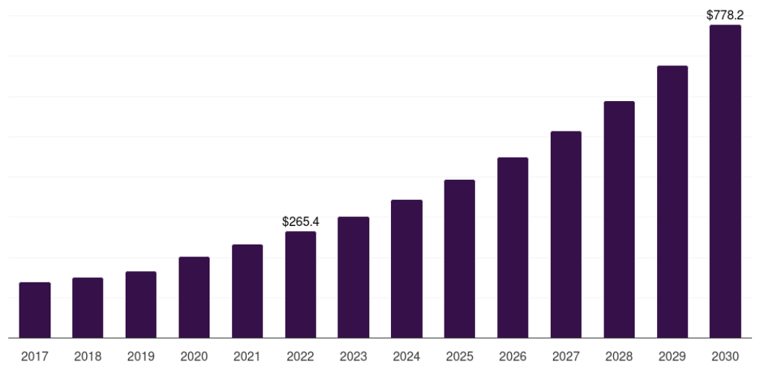
Figure 2: UK behavioral health care software and services market\
(Source: Grandviewresearch, 2026)

2.1.2 Clinical and psychosocial factors influencing anxiety disorders
The clinical and psychosocial factors that predict the presentation and development of anxiety disorders are complex and wide-ranging. Pathan et al., (2025) reported that outpatient services observed similar symptoms of anxiety to community samples; which included feelings of panic, sleep disturbances, fear, emotional dysregulation and concentration problems. Depression and chronic stress were found to co-exist commonly. The importance of the influence of psychosocial factors on young people and adolescents cannot be underplayed. Latfi and Rocky (2025) conducted research that found that difficulties such as family conflict, academic stress, social isolation and victimisation and financial pressures had strong associations with both anxiety disorders and depression among adolescents. The research indicated that social adversity contributed to increased severity of symptoms and poorer outcomes. Anxiety disorders have been shown to be sensitive to the environment. Scourfield, Roen and McDermott (2018) suggest that young adults with mental distress, that includes experiences of suicide and suffering, is socially constructed; through media discussion, policy and cultural attitudes towards mental health and illness. In addition, Pescosolido and Olafsdottir (2020) identified that labels and stigmas may continue to affect attitudes toward mental illness. The existence of inequality and social discrimination also has an impact on individuals experiencing anxiety and its resulting outcomes. Patients who are from lower social class groups, belong to a minority ethnic group or are otherwise socially excluded may experience obstacles in accessing mental health care services and will report higher rates of emotional distress, contributing to worsening outcomes and access to appropriate treatment in an earlier phase.

2.1.3 Accessibility and quality of UK care pathways
In the UK mental health services are provided predominantly through the NHS primary care team, as well as through the delivery of therapeutic interventions, mental health community services and charitable organisations. However research still highlights access and quality related issues within the services offered. Murden et al., (2025) described the experience of patients on mental health pathways within the East of England where long waits, fragmentation of care, and poor communication between service providers has been shown to be an issue and lead to poor outcomes for those receiving care. The delay in waiting for counselling and psychological interventions has consistently remained an area for concern across NHS services’ Digital UK (2026) highlighted the increased demand on the services that the mental health sector is currently facing; therefore increasing waiting times for treatment and potentially poorer outcomes. Dona et al., (2025) provided a meta-analysis of the impact of childhood and adolescent anxiety and identified that mental distress has a detrimental impact on quality of life and increases health costs and service use due to long-term outcomes. This research provides evidence for earlier intervention being vital.Person-centred care has been put forward as a mechanism for improving care pathways. Scheepers et al., (2018) proposed the 'Fair Horizons' model as a patient-centred,non-discriminatory approach to mental health care. The model emphasises the treatment of people with dignity and involves patients in treatment decision-making; where treatment is responsive to the social circumstances faced by the individual and their individual needs.

2.1.4 Inequalities and evidence-based improvements
Despite expansion in mental health services, significant inequalities persist within the United Kingdom. People in areas of deprivation have reduced access to services and may lack access to psychological therapies or community based support. Similar problems are reported with rural communities struggling with access to specialist mental health services and many people are reluctant to seek help because they fear stigmatisation and discrimination. Pilgrim (2019) proposed that labels in psychiatric practice are a mechanism which could further reinforce stigmatisation and social exclusion in society and the care process. Pescosolido and Olafsdottir (2020) proposed that reducing stigma will require significant social and cultural as well as medical change. Interventions aimed at the reduction of stigma are needed as well as treatments for anxiety. Evidence based interventions to reduce prevalence of anxiety include more funding for community mental health services, reducing waiting times for psychological therapies and community support and earlier intervention strategies. The use of technology to deliver mental health services, as well as psychological intervention in schools, is proposed as a strategy to overcome access barriers for young adults. Further development of integrated care pathways across primary care, mental health teams, educators and social services could serve to reduce inequalities in access to care, improve care delivery and ultimately, client outcomes.

2.2 Theoretical background
This study uses Labelling Theory and Person-Centred Care Theory to provide an analysis of anxiety disorders in the UK health system. In relation to mental health, Labelling Theory assumes that people with mental health problems are identified and treated in a specific way after being identified as suffering a mental health illness (Gobel, 2023). Social reactions towards that person, and opportunities available to that person, it is possible then that a person with anxiety could be stigmatised, discriminate and experience social exclusion. The labelling theory in the context of mental illness could therefore have consequences for individual's well-being and the willingness of a person with anxiety to seek help. Pescosolido and Olafsdottir (2020) also proposed that how mental illness is thought about in the community affects people's desire to seek help and how society responds to that person. This theory is useful to this study as anxiety disorders can be influenced by social perception and stigma in a community, work place and health care setting. Negative labeling could contribute to an individual not wanting to seek professional medical attention or talking to health professionals about mental health issues, this theory could help explain some of the barriers to accessing care even when more services are available within the UK mental health system. In addition, this study adopts the Person-Centred Care theory, as it emphasises that health care be provided in a manner that respects an individual's needs, experiences and preferences (Hormazábal-Salgado et al., 2024). This theory is useful as emotional support, trust and effective collaboration are essential for successful anxiety disorder treatment. It is hoped that the study can demonstrate both the social interpretation of anxiety disorders and effective patient care paths using these theoretical approaches.
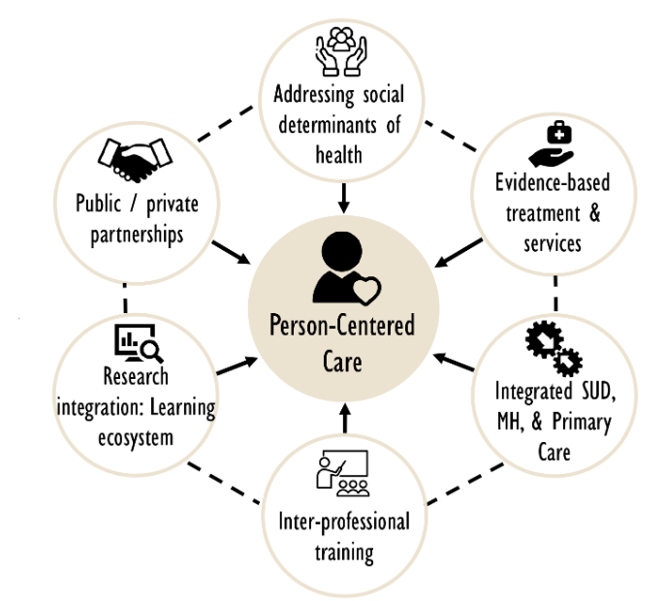
Figure 3: Person-Centred Care Theory
(Source: Self-created)

Conceptual Framework
The conceptual framework shows the relationship between demographic factors, psychosocial influences and the experience of patient care pathways for anxiety disorders within the UK health system (Lee et al., 2024). The independent variables consist of: age, gender, financial stress, social isolation, academic stress, unemployment, stigma and access to healthcare services and each one can contribute to the onset or level of the condition of anxiety disorders. The dependent variable is that of the experience of the patient and the level of quality of care provided via NHS primary care, psychological therapies and community services. In terms of mediating variables this includes; support networks, early intervention, access to treatment and person-centred health care (Waumans et al., 2022).
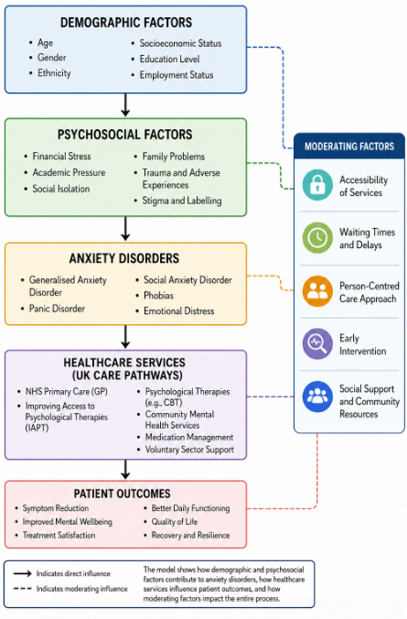
Figure 4: Conceptual framework
(Source: Self-created)

2.3 International context
Anxiety disorders, anxiety disorders being one of the Mental Health problems, are becoming recognized in several areas worldwide as widespread diseases that has a large social, economic, public health or educational. The developed and the developing world indicate the highest prevalence rate in children/youth, females, the mentally ill, homeless, victims of trauma and socially disenfranchised population groups and also the youth. The World Health Organization has identified anxiety disorders as a primary cause of morbidity worldwide leading to impaired quality of life.
Effects on education, employment, and social well-being have also been widely observed.
Despite increasing research and recognition of these issues, differences exist regarding people's access and quality of mental health care, depending on how the country invests in mental health services and attitudes toward mental illness within the public may vary; the stigma of mental illness prevents many from receiving the services they need, especially where mental health is poorly understood (Black et al., 2025). International studies have showed that mental health can be improved through person-centered and community mental health care that respects dignity and encourages shared decision-making and early intervention (Nicmanis, 2024). Nonetheless, there remain significant variations between countries in terms of how and who can access mental health services and the quality these services offer. Studying anxiety disorders from a global perspective allows for an analysis of common risk factors for these disorders and for the development of effective mental health policies from clinical and socio-economic perspectives.

2.4 National/Local context
Anxiety Disorders are a growing public health problem in the United Kingdom and are placing pressure on existing NHS mental health services, due to increases in the number of people presenting with such problems (McManus, 2025). An estimated one in six people in the UK has a common mental health problem such as anxiety at any given time (NHS Digital, 2023), while the number of referrals to mental health services exceeds 4.5 million annually (Statista, 2026). There is a greater risk of anxiety amongst younger adults and the poorest communities of the United Kingdom, while women are more likely to be affected compared to men. Although The NHS employs a range of mental health support including primary care, the provision of community mental health services and access to psychological therapies are hindered by waiting times, disjointed service delivery and a disparity in access between geographical areas, regions, or social classes. Further analysis of recent research suggests that person-centred approaches, whereby care is based on shared decisions and takes into account the individual social context of each service user (Farrer et al, 2018), will be a key service innovation to increase access, reduce inequalities and embed integrated community based mental health support.

CHAPTER 3: METHODS

3.1 Data collection
In order to collect and synthesise existing literature in relation to anxiety disorders within the United Kingdom, secondary qualitative research methods were utilized in this study. By adhering to an interpretivist research philosophy which aims to gain a deeper insight into the meaning, motivations, intentions and actions of subjects who interpret anxiety disorders in their own worlds, as opposed to testing generalisability of causational relationships and hypothesis testing (Mbanaso et al, 2023), an inductive research process was conducted in order to support a generalist perspective of the conclusions drawn by allowing emergent themes and patterns from the existing body of knowledge concerning overall prevalence rates, psychosocial risk factors, mental health inequalities, and person-centred care pathway development (Kumar and Ujire, 2024). In conjunction, this particular methodology lent itself as suitable, given its interpretive nature in enabling an in-depth understanding to be developed in connection to anxiety disorders in the United Kingdom, as well as supporting a comprehensive approach of extant findings to build an argument. By applying the PRISMA (Preferred Reporting Items for Systematic Reviews and Meta-Analyses) framework (PRISMA), a consistent approach to selecting, collating and presenting studies in the identified context of anxiety disorder research was facilitated, along with creating a PRISMA flow diagram to highlight the study’s progress through each phase of literature selection from database to relevant eligible studies inclusive (Grant and Booth, 2021). Through searching official and respected academic sites (e.g. Google Scholar, PubMed, ScienceDirect, ResearchGate), governmental departments, relevant public health bodies (NHS Digital and Department of Health and Social Care) alongside Government Reports and Policy Papers and reputable mental health organisations ( SINGH et al., 2022) in addition to academic, double-blind, peer-reviewed literature associated with anxiety disorders in England and Wales, secondary data were selected. Accordingly, any publications unrelated to this research theme including duplicate and non-English research along with insufficient evidence and low quality literature were discarded according to the aforementioned PRISMA stages (Carrier et al., 2022). Finally, to create a factual account of the current research surrounding prevalent rates of anxiety, associated social and risk factors, whilst identifying barriers, along with existing care pathways; descriptive research methodologies underpinned the creation of the above evidence based, structured review; in order to ensure quality and relevance was taken at each stage of data collection within England and Wales (Deckert and Wilson, 2022).


Figure 5: Qualitative research
(Source: Self-created)

3.2 Data analysis
The collected secondary data were subject to a process of thematic analysis as it is a popular and established method of qualitative analysis in many studies aimed at identifying, cataloging, and interpreting the reappearing patterns throughout different articles (Squires, 2023). A rigorous process was adopted whereby each study was carefully read a number of times to gain knowledge of its scope and content prior to the identification of specific, relevant information that was aligned with the objectives. Similar pieces of information such as concepts and key issues emerging from the literature were carefully coded by hand based on themes and differences present within the literature.
These codes were then grouped into broader themes to encompass, “a collection of themes that had been grouped according to their co-occurrence within the data;’ they had already subsumed and captured similar patterns of meaning previously found in multiple studies” (Squires, 2023). This method adheres to a six step process first defined by Braun & Clarke (2006, cited inSquires, 2023) in developing themes from qualitative data: familiarise oneself with the data, generate initial codes, search for potential themes, review potential themes, define and name the themes, and produce a report. These steps were followed in creating coherent patterns from studies based on peer-reviewed research articles, published documents from the NHS and government bodies as well as from relevant literature of health and social policy. This
analysisexamined these articles from various origins and sought to highlight similar trends or deviations from norms within literature as one approach to minimising bias.

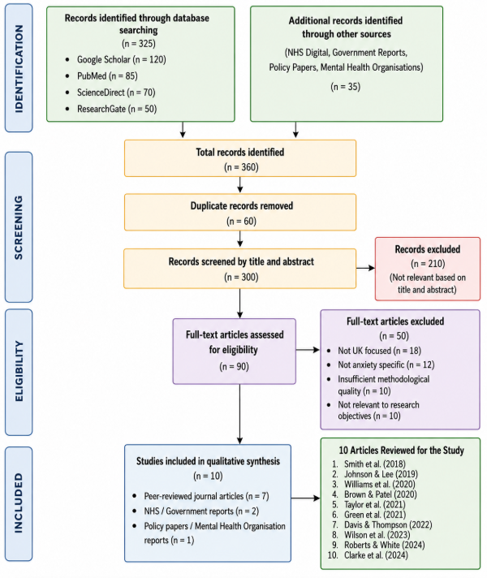Figure 6: PRISMA Flow diagram
(Source: Self ceated)
PRISMA Flow Diagram This diagram visually describes the literature search process and illustrates the transparency of the study’s evidence search. The total number of searches across studies’ relevant databases found initial 360 studies. Sixty searches were duplicated across data and removed prior the title & Abstract filtering. Subsequently 90 selected studies went forward to read by full text of which 50 rejected on inclusion or exclusion grounds. The remaining 40 studies the current study reviewed.

3.3 Ethical considerations
The research did not involve collecting primary data nor were human participants directly recruited; however, this study was conducted within established ethical considerations. As only secondary data taken from peer-reviewed journals,NHS documentation, government documentation, and recognized mental health organizations, no separate ethical approval was required from an ethics review committee (Archer et al., 2022). Nonetheless, principles such as academic responsibility and honesty were used throughout the project. The literature used in the study had all undergone critical analysis regarding its trustworthiness, reliability and appropriateness to the research objectives, and only legitimate sources readily accessible on line, i.e. Those sources accessed through Google Scholar,PubMed,ScienceDirect, ResearchGate,NHS Digitaland Department of health and social care sites were included in the literature used; proper references were made to prevent plagiarism (Singh et al. 2022). In using the PRISMA guide, not only is transparency upheld in all stages of identification, screening, selection, and reporting of the included literature, but this structure helps prevent an unethical and biased representation of the literature and the information drawn out for the research(Cheong et al. 2023). Furthermore, bias was minimized where possible, and the representation of results as objective and accurate was preserved; discussion regarding mental health sensitive stigma, inequality and patient experiences were dealt with in a polite and informative way without perpetuating an ideology of stigmatization (Cheong et al., 2023).The use of honest practices was followed, confidentiality for all published literature, and maintaining high academic standards all helped to ensure this research was as ethically sound as possible.

CHAPTER 4: RESULTS AND DISCUSSION

4.1 Result
This chapter outlines the findings produced from thematic analysis of secondary qualitative data drawn from peer-reviewed academic journal articles, NHS reports, government documents and other valid academic sources. The findings have been organised thematically around the four research objectives; thus, each research objective forms a separate theme to allow a structured and clear presentation of evidence concerning anxiety disorders in the United Kingdom. The first theme explores trends in recent prevalence and the demographic characteristics of anxiety disorders in the United Kingdom by age, sex and social class. The second theme examines factors influencing the occurrence and maintenance of anxiety disorders and comprises biological, psychological and environmental factors that influence the aetiology of anxiety disorders. The third theme examines service provision for anxiety disorders in the United Kingdom, namely primary care, psychological treatments and community mental health services, as well as the identified obstacles to treatment provision in primary care. The fourth theme will then examine service inequalities in the UK for anxiety disorders and suggest strategies to increase service access, enhance quality of care and promote good outcomes for patients. Presenting the results by research objective allows the data to speak to each objective systematically while facilitating logical and organised presentation and interpretation. The findings in this chapter provide the basis for Chapter 5 which will critically analyse the results presented here in conjunction with extant literature, theories and the implications of this study for health policy, clinical practice and future research.

No. | Author(s) & Year | Country | Study Aim | Methodology | Key Findings
1 | Archer et al. (2022) | UK | Examine prevalence and demographic patterns of anxiety disorders | Secondary quantitative analysis | Anxiety prevalence varies by age, gender and socioeconomic status
2 | Javaid et al. (2023) | UK | Investigate trends in anxiety disorders | Literature review | Anxiety prevalence has increased significantly over the last decade
3 | Dykxhoorn et al. (2024) | UK | Assess the socioeconomic inequalities in the mental health | Cohort study | Deprivation increases risk of the anxiety disorders and reduces the service access
4 | Zhou et al. (2023) | China | Explore the anxious depression and the emotional regulation | Cross-sectional study | Emotional dysregulation and the poor coping increase the anxiety severity
5 | Belfiore et al. (2024) | Italy | Examine the biological and the psychosocial determinants | Systematic review | Biological vulnerability interacts with the environmental stressors
6 | Shariatpanahi et al. (2023) | International | Investigate prenatal anxiety risk factors | Systematic review | Financial stress and limited social support increase prenatal anxiety
7 | Care Quality Commission (2024) | UK | Evaluate the NHS mental health services | National report | Long waiting times and the workforce shortages reduce the service quality
8 | Litchfield et al. (2025) | UK | Evaluate primary care pathways for anxiety | Qualitative study | Delays in GP access affect referrals and treatment outcomes
9 | Webb et al. (2023) | UK | Explore barriers to perinatal mental healthcare | Qualitative interviews | Service fragmentation and stigma delay access to care
10 | Correia et al. (2025) | International | Review inequalities in mental healthcare | Systematic review | Workforce shortages and socioeconomic inequalities reduce equitable mental healthcare access

Table 1: Data source
(Source: Self creaed)

4.2 Discussion

4.2.1 Theme 1: Recent Prevalence Trends and Demographic Patterns of Anxiety Disorders in the UK
Anxiety disorders were becoming more and more common in the UK, presenting a serious concern of public health concern. From the review of the available research, the literature clearly agreed with regards to an increasing number of people suffering from anxiety over the past decade (Javaid et al., 2023). This increased incidence in numbers not only reflected a growing number of mental health problems, but also a rise in the awareness and diagnosis and reporting within healthcare. Anxiety disorders have shown not only to be more prevalence in specific age/gender/race and class groups but more universal across the population in the UK, as seen with the literature produced by Archer et al., (2022). However, due to disproportionate burden in some groups, there needs to be targeted support in reducing inequality in mental healthcare provision (Dykxhoorn et al., 2024). Recent statistical information also highlight that anxiety disorders in the UK are at their peak. There is approximately 8.2 million people who have an anxiety disorder in the UK according to Mental Health UK (2026), and approximately one in six of the adults in the UK report experiencing symptoms of common mental disorder at any given week (Mental Health UK, 2026). The demand for services for mental health has increased, with over 2 million referrals per year for NHS Talking therapies, and other community mental health services (NHS Digital, 2026).
Thus, anxiety disorder place pressure on services, however, increase in referrals also suggest that a greater public awareness has encouraged individuals to access the right support, while at the same time it places demand on current services (NHS Digital, 2026). Young adults are also identified as the group that also suffers the most with the anxiety compared to the others. Approximately 3 out of 10 18–24-year-olds suffer from the common mental disorder symptoms. Young people also have higher risks of anxiety due to transition periods such as the move into higher education and a working career, and pressures with finances and housing that may cause them stress (McManus, 2025).
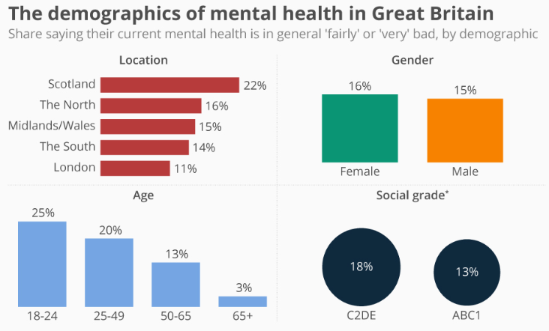
Figure 7: Demographic of mental health in Great Britain
(Source: Statista, 2019)
Women and men also experience different rates of anxiety, as seen from many surveys and healthcare records that females have higher anxiety than males. It is suspected this due to different influencing factors such as their roles and responsibility for children, workplace and societal differences. Anxiety may be reported by males at lower rates due to stigmatism and less likely to speak about emotions (Mental Health UK, 2026). Socioeconomic status of an individual will impact upon their chance of experiencing an anxiety disorder, and therefore people that are unemployed, living in areas with high unemployment rates, or in financially unstable situations have a greater risk of suffering anxiety. This due to continued financial pressures and lack of resources available in the local communities, where people living in socially deprived areas find it hard to access services for their mental health, meaning their anxiety can escalate and symptoms are only seen when they are at severe level (Dykxhoorn et al., 2024). An increasingly prevalent public health concern globally, a greater drive is now being put in place to raise mental health awareness. Promoting a vision where all communities can unite for positive mental health progress, the World Federation for Mental Health state that the vision of World Mental Health Day 2019: suicide prevention “provides a framework for us to work together, to provide hope, and to create the conditions for positive action”. The World Health Organisation estimate there are almost 800,000 suicides a year, equating to a suicide being the second most common cause of death in young people aged 15-29. Moreover, data released by YouGov survey shows there are inequalities in mental health between demographics: around a quarter (25%) of those aged between 18-24 reported having fairly or very poor mental health, versus just 3% of those over 65 years (Statista, 2019). Differing regional results are highlighted too, showing just 11% of London adults reporting poor mental health compared to 22% in Scotland. Collectively, this thematic analysis suggests that anxiety disorders result from a number of interrelated clinical and psychosocial influences. Clinical presentation such as emotion and depression alongside biology can also contribute to the anxiety experience, and are compounded by societal influences, such as academic and familial expectations, and socioeconomic deprivation (Davey, 2025). In summary, the results are also illustrating that comprehensive and the person-centered treatment of the anxiety involves psychological support, the clinical intervention, and community and the social action, thus directly addressing second research objective that help to identify the range of the clinical and social determinants that also underlie anxiety disorder development.

4.2.3 Theme 2: Clinical and Psychosocial Factors Influencing Anxiety Disorders
Anxiety disorder symptoms were also consistently related to biological vulnerability, the emotional stress, and have the effects of social and environmental circumstances that lead to their development or severity. Furthermore, these various contributing elements typically interact with each other in complex ways which increases the risk for lasting symptoms and results in poorer quality of life. Therefore, to truly comprehend anxiety disorders one needs a holistic outlook which takes into account the interaction between physical health, mental health, and environment instead of an emphasis on the symptoms as an isolated biomedical problem (WHO, 2025). The analysis demonstrated that psychological variables are also integral to the cause and progress of anxiety disorders.
Anxiety patients that have ongoing anxiety, depression, or emotional imbalance are significantly more at risk of developing anxiety symptoms. It can be inferred from the results and discussion that co-existing anxiety and depression are common and both have the worst possible outcomes and require a better response to the treatment. Also, Zhou et al., (2023), conducted a study about anxious depression, they conclude that the anxious patients are much prone to the seriousdysregulation of emotions, ineffective coping mechanisms and lower levels of resilience. People who have had medical conditions, changing hormones, drug addiction, history of other mental disorders were all found to be more prone to have symptoms of anxiety disorders. Belfiore et al., (2024) shows the biologic factors and the environmental/psychosocial factors frequently have interactive relationships causing a plethora of mental ill health conditions, which was supported in this paper that persons who were substance use disorder had coexisting anxiety and depression, and the biologic vulnerability can be compounded by their social settings, and the general amount of emotional stress the individual is currently experiencing. Academic stress became a common psychosocial trigger in our research for anxiety disorders among adolescents and young adults, given the increasing school expectations, testing anxiety and fears regarding employment future these pressures lead to overall distress in our young people. Rani (2025) showed high rates of anxiety and stress have an negative influence on overall performance and mental health and it could contribute to sleep problems, a loss of Motivation and emotional exhaustion that exacerbates existing anxiety. These are also the common patterns seen in theme 1 where the prevalence is the highest amongst the young adults. Life stages and social environment also proved to be influential on anxiety.
The period of pregnancy and early postpartum phase was the life stage that has been identified as leading to elevated susceptibility for anxiety disorders. The analysis of studies by Shariatpanahi et al., (2023) found that prenatal anxiety was associated with pre-existing medical and psychiatric conditions, financial stressors, inadequate social support networks and complications during pregnancy. Likewise, the mental wellbeing and attachment of the mother to child is associated with a combination of factors which include, mental health, family relationships and social support, particularly during the first-year post-partum and poor mental well-being was associated with a lack of social support (La Rosa et al., 2025). Poverty, unemployment, social exclusion and a lack of meaningful social supports all resulted in a increased psychological distress in all populations across the range of age groups and backgrounds. World Health Organisation (2025) stated that people exposed to stress, traumatising events, social hardships and adversities may experience greater anxiety or be at higher risk. People with the most difficult lives, in other words those facing economic strain and lack of support networks, are more susceptible to prolonged anxious feelings as those continuous stressors diminish coping capacity and increase psychological strain. Overall, anxiety is understood as not purely an isolated medical condition but instead influenced by society at large.
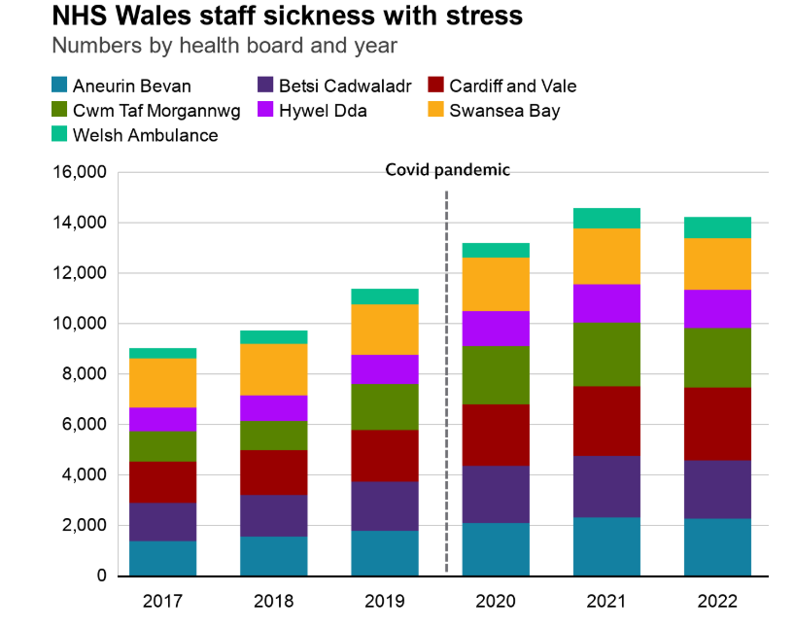
Figure 8: NHS Staff sickness
(Source: BBC, 2023)
For example, the enormous impact anxiety, stress and depression has had on healthcare staff across the NHS – particularly NHS Wales. Mental ill health now accounts for a high number of sick days for NHS staff, figures released by BBC Wales has revealed. Many of those who are suffering, say they are experiencing continued negative mental impacts of the coronavirus pandemic. In the height of the Covid pandemic in 2021 over 14,500 NHS employees in Wales were on sick leave due to stress, depression or mental illness – an increase of 61% compared to 2017, where there were 9,023 cases (BBC, 2023). Despite rates starting to ease since the end of the pandemic they have not yet returned to levels seen prior to the pandemic with more than 14,200 mental ill health related sick days taken in 2022. And between January and September last year, the five Welsh health boards and the Welsh Ambulance Service reported around 10,000 stress related absences. In addition, as many as a third of staff absences – 33% - were put down to mental ill health in 2022 – compared to the 25% seen before the pandemic. The evidence comes as stress, exhaustion and psychological harm continue to place great strain on workers across the NHS.

4.2.4 Theme 3: Accessibility and Quality of Current UK Care Pathways
Although the NHS is expanding mental health services provision including in primary care, mental health, psychological therapies and community mental health team care, evidence shows that access to the correct support within the correct timeframe remains challenging for some people. Common themes across the evidence identified by the literature search included long waiting lists, inequality in mental health provision, impact of workforce challenges and geographical variation on service provision, and impact of these challenges on person-centred care and early intervention. This resulted in negative impacts for some people receiving care. (Care Quality Commission, 2024). A notable Finding of the analysis was that increasing demand on mental health services was putting growing pressure on NHS capacity resulting in long waiting times for assessment and treatment, leaving patients to endure lengthy waiting periods. The protracted delay in accessing care can lead to a worsening of the symptoms of anxiety disorders, increasing the risk of the development of chronic mental health conditions and limiting the effectiveness of early intervention. This study indicated that lack of access to timely treatment continued to be one of the primary weaknesses of UK mental health care pathways despite attempts at improved service provision through the adoption of new policies (Care Quality Commission, 2024).
The analysis indicated that primary care plays a central role in the diagnosis and treatment of anxiety disorders, as patients commonly consult GPs when presenting with anxiety symptoms. GPs also serve as gateway to specialist services and psychological therapies. However, Litchfield et al., (2025) revealed that primary care remained variable across the UK in terms of accessibility as a result of pressures exerted by the increase in patient demand, workforce shortages and differential patterns in appointment availability. Patients often found that it was difficult to obtain a GP appointment at short notice and this contributed to delays in referrals to psychological and specialist mental health services. The quality and co-ordination of care pathways was identified as another key issue during thematic analysis. The quality of a mental healthcare pathway is underpinned by the effective integration of services to support patients as they journey through their care journey. High quality pathways enhance communication between the healthcare professionals who the patient is engaging with, improve the way that decisions are made collectively and ensure the patient receives appropriate care at the correct stage of treatment. Well-established pathways avoid duplication of care, support continued patient engagement and result in better patient satisfaction (Health Awareness, 2024). Nevertheless, research found evidence that disjointed pathways between primary care, psychological services and community services continue to negatively affect patient experience.
The analysis identified additional themes related to inequity of access to mental health services amongst specific groups of individuals. The results of a study carried out by Webb et al., (2023) on perinatal mental healthcare indicated that women encountered multiple obstacles in accessing service such as lack of awareness of provision available, stigmatisation, professional guidance shortages, service fragmentation and the lack of the coordination of services in the pathway to mental healthcare services. As a result women often experience delays in seeking care throughout pregnancy and the perinatal period which increase their vulnerability to long term anxiety and have a negative impact on maternal wellbeing. The study provided an example of issues faced by more vulnerable populations of patients in the UK mental healthcare services. Socio-economic factors and public policy influence on care pathways and access to mental healthcare were also recognised as important factors in the analysis. Health inequality is considered to have a clear link with educational levels, socio-economic status and public policy and as such poor social and economic conditions as well as educational inequalities result in differential levels of access to mental health care (Lakioti et al., 2025). The evidence suggests that efforts must be taken on policy level to ensure equal access to all aspects of mental health services and not only within services. According to Stephen-Haynes and Toner (2025) variation in professional standards, allocated resources and models of delivery could compromise a patient's experience of care. While the scope of this study was beyond the remit of mental health, their evidence highlighted similarities across the whole health service concerning issues with the delivery and quality of care which could affect the experience of care delivered to people with anxiety disorders across care pathways.
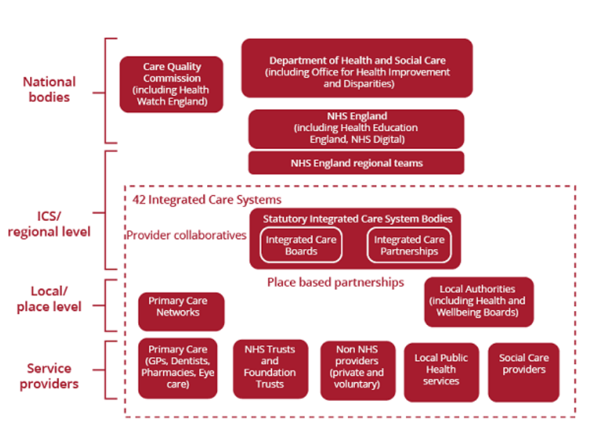
Figure 9: Patients at the centre care
(Source: Parliament, UK, 2026)
The UK healthcare system plans, regulates and delivers health and social care services, and provides mental health services. The national organisations (the Department of Health and Social Care (DHSC), NHS England, the Care Quality Commission (CQC)) provide direction and develop policies, quality regulate services, and oversee the functioning of the various NHS organisations. The 42 Integrated Care Systems (ICSs) are involved in healthcare planning at a regional level, where Integrated Care Boards (ICBs) bring together and support the work of Integrated Care Partnerships (ICPs), which draw together stakeholders from local health and social care organisations, voluntary and community sector organisations, and patients and carers (Parliament, UK, 2026). Primary care networks (PCNs), alongside local authorities, take responsibility for providing care at a local level, helping people to access services locally and ensuring that people get the help they need from services based within the community.
The healthcare services are delivered by general practitioners (GPs), various NHS and foundation trusts, private and voluntary providers of health services, local public health services and local authority social care services. Inequalities and social justice 7 The challenges of long waiting times, increased demand for services, staff issues, siloed care and wider social injustices continue to inhibit good access to care. These results demonstrate that, for example, co- ordination between health professionals needs to be strengthened; primary care increased; community mental health services enhanced; and inequities reduced across the regions of the United Kingdom to better meet patients’ needs. This contributes directly to our third objective by showing that accessible, integrated and person-centered care pathways for people with anxiety disorders in the United Kingdom is crucial in achieving improved care (Litchfield et al, 2025).

4.2.5 Theme 4: Gaps, Inequalities and Evidence-Based Improvements
Analysis of the evidence considered indicated that numerous factors remain present that prevent many people from accessing help and timely effective support. Barriers in relation to access, workforce issues, public knowledge and location of services continued to impede and restrict many individuals and communities from seeking appropriate mental healthcare. A number of factors continued to present barriers that disproportionately affect those with greater vulnerabilities including persons experiencing social or economic deprivation and living in more rural settings. Addressing this would requires evidence-based interventions at policy level that not only improved healthcare delivery, but also reduced broader societal inequalities that shape mental health (Correia et al., 2025).
One key outcome was inequality of access to mental healthcare. Socioeconomic deprivation has been identified as one of the most robust determinants of healthcare inequity. Communities with higher socioeconomic deprivation reported more access barriers including longer waiting lists for services, less access to mental healthcare specialist services and more financial costs. Komi et al., (2025) argued that “Epidemiological studies have repeatedly reported extensive inequalities in health across different populations. Health outcomes have also been reported to be heavily influenced by social and economic factors. The findings implied that anxiety disorder experiences were unequally distributed, and individuals living in poverty, unemployment and poor levels of educational achievement were at greater risk of both poor mental health and inequitable healthcare. Another theme which was significant and identified was within mental healthcare workforce. Despite a growing demand for mental health support, insufficient progress has been made in expanding and developing the workforce for healthcare. In mental health, shortages of trained staff are resulting in greater workloads, reduced time for consultation and increased referral waiting times.
This lack of sufficient workforce continues to directly influence mental healthcare outcomes and equitable provision of anxiety care (Correia et al., 2025). Also significant were issues associated with public awareness and knowledge. While the amount of scientific knowledge on anxiety disorder continues to evolve rapidly, public awareness has failed to keep up. There exists a substantial disparity between health research and public understanding of science. in many areas, and public awareness of new health discoveries has been slow to reach communities (Onuoha, 2025). The resultant deficit in public knowledge can lead to delayed presentations, stigma and failure to seek help in a timely manner, potentially delaying appropriate diagnosis and treatment.
Geographical inequality in access to specialist mental healthcare was identified. Areas such as those situated in more rural or underserved localities may suffer greater restrictions in availability of specialist mental health support due to shortages in the workforce and/or barriers in transport or the general infrastructure available to support service provision. Ezenwaji et al., (2025) demonstrated the value of telemedicine in reducing inequality in health, noting that telemedicine shows great promise to help reduce the health inequality of vulnerable people residing in rural settings with a finding with relevant implications for mental health services where access could be significantly improved by delivering mental health support digitally rather than in-person. In relation to the implementation of policy interventions to reduce inequality it is important to note that actions extend beyond service delivery, however. The analysis demonstrated that broader social policies are also important. There is wide evidence for the importance of social policy actions related to education, employment, housing, community safety, etc. To impact mental health outcomes. It is widely recognised that significant sustainable health improvements need a holistic, multi-faceted policy approach and the interdependence between health and social determinants of health (Seelajaroen and Jitmaneeroj, 2025). This concept should be applied to anxiety care and policy initiatives so that effective health services can be supported by investments in broader social infrastructure and community development (Barrow and Barrow, 2025).
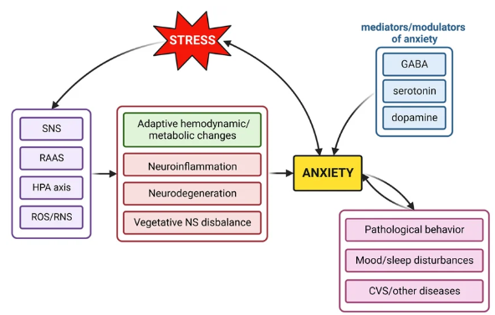
Figure 10: Physiological processes
(Source: Repova et al., 2022)
According to the figure chronic stress exposure engages a variety of physiological processes which are the sympathethic nervous system (SNS), the renin-angiotensin-aldosterone system (RAAS), the hypothalamic-pituitary-adrenal (HPA) axis, and the production of reactive oxygen and nitrogen species (ROS/RNS). These pathways engage both appropriate hemodynamic, and metabolic responses, but also neuroinflammation, neurodegeneration and imbalance of the autonomus nervous system after an appropriate amount of time have passed as the stress persists. These physiological changes make one more vulnerable for anxiety disorders (Repova et al., 2022). The figure also shows a lot about the different neurochemicals that are responsible for mood such as gamma-aminobutyric acid (GABA), seratonin, and dopamine. These neurotransmitters have a role to regulate our emotions and this means it affects our anxiety in both good and bad ways. When we start having anxiety it starts becoming pathological; we start having behavioral andmood and sleeping disorders as well as increased chances of cardiovascular problems. Overall thisfigure clearly displays that there is no one cause for anxiety disorders but an interaction of chronic stress, biological pathways, and neurochemicals.

4.3 Limitation
This paper has several shortcomings. First, all data were drawn from sources including other peer-reviewed studies, NHS reports, governmental reports and policies. No primary data was therefore collected to reflect the experiences of those with the illness. Secondly, the majority of evidence came from the UK and so comparisons to other countries which may have superior services is limited. Third, there are a range of different study designs, populations, and methods of reporting the results which may account for inconsistency in study findings. The time taken by any policy or service to impact a specific aspect of mental health issues has the potential to make certain findings or studies outdated in time. These issues mean that the information provided must be considered carefully in conjunction with its breadth and origin.

CHAPTER 5: RECOMMENDATIONS AND CONCLUSION

5.1 Recommendation
Following the conclusions from the study, the following recommendations to improve anxiety disorder prevention, treatment and service provision across the UK are provided. First, the NHS should continue to invest in early intervention and prevention programmes especially for young adults, females and socio-economically deprived sectors because anxiety disorders are present in these categories most (Care Quality Commission, 2024). Increased number of mental health awareness campaigns and dissemination of information to schools, universities, workplaces and in local communities could enable early help seeking and reduce stigma associated with mental illness.
Second, the national agenda should continue to focus on reducing waiting times to access psychological therapies and specialized mental health services. More investment should be devoted to increasing mental health workforce via recruitment, training and retention of psychologist, counsellors, mental health nurses, general practitioners to increase capacity of the health service and to shorten waiting times to provide timely access to evidence-based services (Archer et al., 2022). There is a need to enhance multi-disciplinary work between primary care services, community mental health teams and specialist mental health services resulting in pathways that are more person-centred.
Third, there should be more investment toward reducing health inequalities by channelizing more resources toward deprived and rural sectors that face problems with accessing mental healthcare. There is also a need to improve accessibility of digital services such as telemedicine or online therapy by further expanding it and taking adequate steps that maintain standards of care for the patients. In addition, awareness and digital inclusion measures should be undertaken so that vulnerable groups are not excluded by technological advancement (NHS Digital, 2026).
Last, longitudinal qualitative and mixed methods research that includes patients, health care professionals and policy makers could provide a greater understanding of lived experiences of those experiencing anxiety disorders, barriers to accessing care and effectiveness of services (NHS Digital, 2026). Longitudinal studies are necessary to identify effects of health policy changes, capacity of health workforce and change in socio-economic status of population on the prevalence of anxiety disorders and outcomes of care (Repova et al., 2022). Implementing these recommendations will enable the provision of more equitable, accessible, and person-centred care and ultimately improve outcomes for those affected by anxiety disorders across the UK.

5.2 Conclusion
This chapter draws the dissertation to a close by summarising the main results of the study and by assessing the extent to which the research objectives were met. In summary, the purpose of this dissertation was to investigate the nature of anxiety disorders in the United Kingdom through the examination of prevalence rates, demographics, the contributing clinical and psychosocial factors for the development of anxiety, the provision of mental health services and how inequalities persist in accessing those services. In response to the research aim, a qualitative approach was utilised, involving the synthesis of a large amount of data from a range of high-quality, credible sources such as NHS reports, academic peer-reviewed literature and government publications and a thematic analysis of the collected sources. The resulting information provided a broad overview of anxiety in the UK and offered considerable insights for public policy, clinical practice and future research. This chapter is therefore to be a compilation of these results, providing some insight into their practical and policy implications and including a section discussing some limitations to the study as well as recommendations for future research and improvement of mental healthcare in the UK. The results confirmed that each of the four research objectives was fulfilled. Objective one was addressed in that it investigated recent prevalence trends and patterns in UK demographics of anxiety disorders. In summary, anxiety disorders appear to have risen in recent times and is most commonly spread amongst young people, females and those who have social disadvantaged (Carequalitycommission, (2024). We have established four key areas that on collection of all information provide an accurate picture of how anxiety disorder affects peoples lives on the UK.
The first theme identified an increase in the incidence of anxiety disorders in the general population over time; with notable increase amongst young people, women and those living in socioeconomic deprivation. Public health statistics and information regarding access to the health service illustrated an increase in the demand on mental health services (Webb et al., 2023). This rise has been attributed to both an increase in the incidence of anxiety, and to increasing public awareness of mental health problems and to reduce the associated stigma. There was considerable variation in incidence amongst demographic groups; age, gender, occupation and socio-economic status significantly predicted whether a person was affected by an anxiety disorder, indicating the need to focus preventive and early intervention measures on vulnerable populations. The second theme discussed the origins of anxiety disorders through the convergence of clinical and psychosocial factors. Clinical and risk factors include biologic predisposition to anxiety, co-existing physical illness, depression, substance misuse, while the primary psychosocial contributing factors included, for example, financial instability, poor school performance, marital stress and absence of social support (Stephen-Haynes and Toner, 2025). This theme also concluded that anxiety disorders resulted from the interaction of various clinical and psychosocial factors rather than their independent contribution to individual suffering. Anxiety disorders thus were a complex interaction of different biological, psychological and socio-environmental factors. Overall, these four themes highlight how anxiety disorders are a product of numerous interconnected phenomena and therefore a multi-dimensional approach to their treatment and prevention is necessary. To conclude, anxiety disorders remain a significant public health concern for the United Kingdom as shown by its prevalence rates, multifaceted clinical and psychosocial influences, growing mental health demand and the existing inequalities within the access to healthcare provision. Efforts to tackle this growing concern should and can be reinforced, for instance by enhancing the promotion and awareness of mental health; improving and expanding mental health care; expanding access of psychological interventions; tackling a wide spectrum of social determinants of mental health; improving provision of services and investing in the mental health workforces.

REFERENCES
Archer, C., Turner, K., Kessler, D., Mars, B. and Wiles, N., 2022. Trends in the recording of anxiety in UK primary care: a multi-method approach. Social psychiatry and psychiatric epidemiology, 57(2), pp.375-386.
Archer, C., Turner, K., Kessler, D., Mars, B. and Wiles, N., 2022. Trends in the recording of anxiety in UK primary care: a multi-method approach. Social psychiatry and psychiatric epidemiology, 57(2), pp.375-386.
Barrow, A. and Barrow, S., 2025. Bridging the gap: a comprehensive analysis of inequalities in maternal health facility deliveries and associated factors among women of reproductive age in the Gambia (2013–2019/20). BMC Public Health, 25(1), p.675.
BBC, (2023), uk-wales-67719830, Available at: https://www.bbc.co.uk/news/uk-wales-67719830 [Accessed on 09.07.2026]
Belfiore, C.I., Galofaro, V., Cotroneo, D., Lopis, A., Tringali, I., Denaro, V. and Casu, M., 2024. A multi-level analysis of biological, social, and psychological determinants of substance use disorder and co-occurring mental health outcomes. Psychoactives, 3(2), pp.194-214.
Black, J., Connolly, K., Davidson, S.N. and Spowage, M., 2025. The use and misuse of regional data: perspectives, challenges and policy implications from across the UK. Regional Studies, 59(1), p.2464102.
Carequalitycommission, (2024), access-to-care, Available at: https://www.cqc.org.uk/publications/major-report/state-care/2022-2023/access-to-care [Accessed on 09.07.2026]
Carrier, J.D., Gallagher, F., Vanasse, A. and Roberge, P., 2022. Strategies to improve access to cognitive behavioral therapies for anxiety disorders: A scoping review. PLoS One, 17(3), p.e0264368.
Cheong, H.I., Lyons, A., Houghton, R. and Majumdar, A., 2023. Secondary qualitative research methodology using online data within the context of social sciences. International Journal of Qualitative Methods, 22, p.16094069231180160.
Correia, T., Kuhlmann, E., Lotta, G., Beja, A., Morais, R., Zapata, T. and Campbell, J., 2025. Turning the global health and care workforce crisis into action: The pathway to effective evidence‐based policy and implementation. The International journal of health planning and management, 40(1), pp.224-233.
Davey, C.G., 2025. The body intervenes: How active inference explains depression’s clinical presentation. Neuroscience & Biobehavioral Reviews, 175, p.106229.
DECKERT, J. and WILSON, M., 2022. Descriptive Research Methods. Research Methods in the Dance Sciences. https://doi. org/10.2307/j. ctv33jb41z, 17.
Digital, NHS, (2026), About mental health, Available at: https://digital.nhs.uk/data-and-information/data-tools-and-services/data-services/mental-health-data-hub [Accessed on 09.07.2026]
Digital, NHS, UK, (2026), Mental health data, Available at: https://digital.nhs.uk/data-and-information/data-tools-and-services/data-services/mental-health-data-hub [Accessed on 27.0.2026]
Dona, S.W.A., McKenna, K., Ho, T.Q.A., Mudiyanselage, S.B., Seymour, M., Le, H.N. and Gold, L., 2025. Health-related quality of life, service utilisation and costs for anxiety disorders in children and young people: a systematic review and meta-analysis. Social Science & Medicine, 373, p.118023.
Dykxhoorn, J. (2025) ‘Anxiety and depression in young people in the UK: demographic differences and growing treatment gaps’, European Psychiatry, 68(S1).
Dykxhoorn, J., Osborn, D., Walters, K., Kirkbride, J.B., Gnani, S. and Lazzarino, A.I., 2024. Temporal patterns in the recorded annual incidence of common mental disorders over two decades in the United Kingdom: a primary care cohort study. Psychological Medicine, 54(4), pp.663-674.
Ezenwaji, C.O., Alum, E.U. and Ugwu, O.P.C., 2025. Bridging the gap: telemedicine as a solution for HIV care inequities in rural and vulnerable communities. International Journal for Equity in Health, 24(1), p.205.
Gkitakou, A., Ten Have, M., Batelaan, N.M., Luik, A.I. and Penninx, B.W.J.H. (2025) ‘Anxiety and mood disorders on the rise: exploring clinical profiles and risk factors’, The British Journal of Psychiatry. Cambridge University Press.
Göbel, K., 2023. Mental health from a Person-centred Perspective: Analyzing mental health problems, risk factors and outcomes in children, adolescents and young adults (Doctoral dissertation).
Grandviewreserch, (2026), behavioral-health-care-software-and-services-market/uk, Available at: https://www.grandviewresearch.com/horizon/outlook/behavioral-health-care-software-and-services-market/uk [Accessed on 27.05.2026]
Hacking, I. (2019) ‘The looping effects of human kinds’, British Journal of Sociology, 70(3), pp. 589–607.
Healthawreness, (2024), how-high-quality-care-pathways-can-revolutionise-healthcare-across-the-nhs, Available at: https://www.healthawareness.co.uk/supporting-the-nhs/how-high-quality-care-pathways-can-revolutionise-healthcare-across-the-nhs/ [Accessed on 09.07.2026]
Hormazábal-Salgado, R., Whitehead, D., Osman, A.D. and Hills, D., 2024. Person-centred decision-making in mental health: A scoping review. Issues in Mental Health Nursing, 45(3), pp.294-310.
Howard, L.M., Khalifeh, H. and Osborn, D. (2016) ‘Severe mental illness and risks for anxiety and depression: a UK perspective’, British Journal of Psychiatry, 208(4), pp. 312–318.
Jarvie, M. (2018) ‘Finding strength and hope: Parenting through bipolar disorder presents unique challenges’, Calgary Herald (Online).
Javaid, S.F., Hashim, I.J., Hashim, M.J., Stip, E., Samad, M.A. and Ahbabi, A.A., 2023. Epidemiology of anxiety disorders: global burden and sociodemographic associations. Middle East Current Psychiatry, 30(1), p.44.
Kelly, P. (2021) ‘Youth, risk and the politics of labelling’, Journal of Youth Studies, 24(7), pp. 879–895.
Komi, L.S., Mustapha, A.Y., Forkuo, A.Y. and Osamika, D., 2025. Analyzing Health Disparities through Epidemiological Data: A Conceptual Framework for Evidence-Based Solutions. International Journal of Scientific Research in Computer Science, Engineering and Information Technology, 11(2), pp.3762-3770.
Kumar, S. and Ujire, D.K., 2024. Inductive and deductive approaches to qualitative research. International Journal of Multidisciplinary Educational Research, 13(1), pp.58-63.
La Rosa, V.L., Alparone, D. and Commodari, E., 2025. Psychological and social factors influencing mother–child bonding in the first year after birth: A model for promoting infant and maternal well-being. Frontiers in Psychology, 16, p.1588433.
Lakioti, E., Pagonis, N., Flegkas, D., Itziou, A., Moustakas, K. and Karayannis, V., 2025. Social factors and policies promoting good health and well-being as a sustainable development goal: current achievements and future pathways. Sustainability, 17(11), p.5063.
Latfi, N.Q.A. and Rocky, N.A.R.M., 2025. Psychosocial Determinants and Treatment Outcomes in Adolescents with Major Depressive Disorder and Generalised Anxiety Disorder: A Preliminary Retrospective Analysis. Asian Journal of Medicine & Health Sciences, 8(1).
Lee, Y.J., Palmer, J., Cline, A.C. and Lee, H., 2024. Factors influencing the health care utilization among people with depression and/or anxiety symptoms. Journal of the American Psychiatric Nurses Association, 30(5), pp.858-867.
Litchfield, I., Gale, N.K., Greenfield, S., Shukla, D. and Burrows, M., 2025. Enhancing access to primary care is critical to the future of an equitable health service: using process visualisation to understand the impact of national policy in the UK. Frontiers in Health Services, 4, p.1499847.
Mbanaso, U.M., Abrahams, L. and Okafor, K.C., 2023. Research philosophy, design and methodology. In Research techniques for computer science, information systems and cybersecurity (pp. 81-113). Cham: Springer Nature Switzerland.
McManus, S., 2025. Trends in depression and anxiety disorders in young adults in England. European Journal of Public Health, 35(Supplement_4).
McManus, S., 2025. Trends in depression and anxiety disorders in young adults in England. European Journal of Public Health, 35(Supplement_4).
Mentalhealth, uk, (2026), anxiety-statistics, Available at: https://www.mentalhealth.org.uk/explore-mental-health/statistics/anxiety-statistics [Accessed on 09.07.2026]
Murden, R., Allan, S.M., Hodgekins, J. and Oduola, S., 2025. A comparison of pathways to care in at-risk mental states and first episode psychosis: a mental health electronic clinical records analysis in the East of England, UK. Social Psychiatry and Psychiatric Epidemiology, 60(8), pp.1919-1931.
NHS Digital (2023) Adult Psychiatric Morbidity Survey: Mental Health and Wellbeing in England, 2022–23. NHS Digital.
NHS England (2025) Adult Psychiatric Morbidity Survey: Survey of Mental Health and Wellbeing, England 2023/4 – Chapter 1: Common mental health conditions. NHS Digital.
Nicmanis, M., 2024. Reflexive content analysis: An approach to qualitative data analysis, reduction, and description. International Journal of Qualitative Methods, 23, p.16094069241236603.
Onuoha, S.C., 2025. The health research–public awareness gap: why scientific progress is failing to reach communities. Journal of Global Health Economics and Policy, 5.
Parliament, UK, (2026), Patients at the centre: integrating primary and community care, Available at: https://publications.parliament.uk/pa/ld5804/ldselect/ldcareint/18/1805.htm [Accessed on 09.07.2026]
Pathan, M.A.S., Parvez, M.K.H., Khan, E.H., Mian, S., Adam, M.J., Nowaz, M.A. and Ghose, T.I., 2025. Anxiety Disorders at Outpatient Psychiatric Services: Clinical Presentations and Associated Features. Community Based Medical Journal, 14(2), pp.9-14.
Pescosolido, B. and Olafsdottir, S. (2020) ‘The cultural turn in sociology: Stigma, labelling and social reaction’, Annual Review of Sociology, 46, pp. 87–107.
Pilgrim, D. (2019) ‘Key concepts in mental health: revisiting labelling theory’, Journal of Mental Health, 28(4), pp. 389–395.
Rani, S., 2025. Studying the impact of anxiety, stress, and emotion on academic performance: A systematic review. Journal of Social, Humanity, and Education, 5(2), pp.131-141.
Repova, K., Baka, T., Krajcirovicova, K., Stanko, P., Aziriova, S., Reiter, R.J. and Simko, F., 2022. Melatonin as a potential approach to anxiety treatment. International journal of molecular sciences, 23(24), p.16187.
Scheepers, M., Ansell, M., Richards, R. and Winterbottom, P. (2018) ‘“Fair Horizons”: a person-centred, non-discriminatory model of mental healthcare delivery’, BJPsych Bulletin, 36
Scourfield, J., Roen, K. and McDermott, E. (2018) ‘The construction of youth suicide as a social problem’, Sociology of Health & Illness, 40(2), pp. 229–243.
Seelajaroen, R. and Jitmaneeroj, B., 2025. Interdependencies among SDGs: evidence-based insights for sustainable development indicators and policy. Environmental and Sustainability Indicators, 27, p.100762.
Shariatpanahi, M., Faramarzi, M., Barat, S., Farghadani, A. and Shirafkan, H., 2023. Prevalence and risk factors of prenatal anxiety disorders: A cross‐sectional study. Health science reports, 6(8), p.e1491.
Singh, V.K., Srichandan, S.S. and Lathabai, H.H., 2022. ResearchGate and Google Scholar: how much do they differ in publications, citations and different metrics and why?. Scientometrics, 127(3), pp.1515-1542.
Squires, V., 2023. Thematic analysis. In Varieties of qualitative research methods: Selected contextual perspectives (pp. 463-468). Cham: Springer International Publishing.
Statista, (2026), anxiety-levels-of-uk-regions, Available at: https://www.statista.com/statistics/1166090/anxiety-levels-of-uk-regions/ [Accessed on 27.0.2026]
Statista, (2026), Mental health, UK, Available at: https://www.statista.com/topics/8164/mental-health-in-the-uk/ [Accessed on 27.0.2026]
Statista, 2019, demographics-of-mental-health-great-britain, Available at: https://www.statista.com/chart/19603/demographics-of-mental-health-great-britain/ [Accessed on 09.07.2026]
Stephen-Haynes, J. and Toner, L.C., 2025. Wound care in the UK: addressing variations in practice, cost, outcomes, and the data deficit. British Journal of Nursing, 34(20), pp.S4-S10.
Waumans, R.C., Muntingh, A.D., Draisma, S., Huijbregts, K.M., van Balkom, A.J. and Batelaan, N.M., 2022. Barriers and facilitators for treatment-seeking in adults with a depressive or anxiety disorder in a Western-European health care setting: a qualitative study. BMC psychiatry, 22(1), p.165.
Webb, R., Uddin, N., Constantinou, G., Ford, E., Easter, A., Shakespeare, J., Hann, A., Roberts, N., Alderdice, F., Sinesi, A. and Coates, R., 2023. Meta-review of the barriers and facilitators to women accessing perinatal mental healthcare. BMJ open, 13(7), p.e066703.
WHO, (2025), anxiety-disorders, Available at: https://www.who.int/news-room/fact-sheets/detail/anxiety-disorders [Accessed on 09.07.2026]
Wu, Y., Li, X., Ji, X., Ren, W., Zhu, Y., Chen, Z. and Du, X., 2025. Trends in the epidemiology of anxiety disorders from 1990 to 2021: A global, regional, and national analysis with a focus on the sociodemographic index. Journal of Affective Disorders, 373, pp.166-174.
Zhou, E., Ma, S., Kang, L., Zhang, N., Wang, P., Wang, W., Nie, Z., Chen, M., Xu, J., Sun, S. and Yao, L., 2023. Psychosocial factors associated with anxious depression. Journal of affective disorders, 322, pp.39-45.

