
University of Wales Trinity of Saint David
School of Engineering

Ride, Handling and NVH

AWD Torque Vectoring

ACHA6003

Daniel Wilcox
1802007

Course: Automotive Engineering BEng

Abstract
This report reverse engineers and studies the systems of the Ferrari FF using patents, published values and assumptions. Torque vectoring, yaw inertia, clutch sizing, mass distribution and acceleration are all considered. These are calculated and reported. The FF uses torque vectoring between axles and on axles to have control of the dynamics of the FF for an array of surfaces.

Contents

1. Introduction 1
2. Research 1
2.1. Base Vehicle 1
2.2. Inertia 2
2.3. Torque Vectoring 2
3. Lumped Mass Model and Inertia 4
3.1. Lumped Mass Model 4
3.2. Moment of Yaw Inertia 5
3.3. Inertial Conjugate 5
3.4. Dynamic Index 5
3.5. Lumped Mass Results 5
4. Torque Vectoring 6
4.1. Torque Path 6
4.2. Clutch Sizing and Power Loss 7
4.3. Acceleration and Yaw Rate 8
5. Control Algorithms and Sensors 9
Conclusion 10
Abbreviations 11
Nomenclature 11
Bibliography 12
Appendices 14

Introduction
The Ferrari FF is a four-wheel drive, front engine V12 hatchback that seats four with a transaxle. This layout makes the FF unique. The FF is meant to be a sports car with a sports pedigree as it must feel like a Ferrari, but it also must be comfortable and stable at high speed as it is a grand tourer. Ferrari wanted the car to be usable in all seasons and be as capable as other GT cars like the Bentley Continental so added a four-wheel drive system. However, the Bentley Continental GT had a more traditional AWD system and at the time the Nissan GTR was seeing large success from their more advanced AWD system. To keep the engine lower than other GT cars, Ferrari added a second 2 speed gearbox and differential in front of the engine to become 4WD, a production car first.

Research

Base Vehicle
Table 2.1.1. Ferrari FF Base Vehicle Specification and Values from Research (Ferrari 2021)
Description | Value | Unit
Wheelbase | 2.99 | m
Mass | 1880 | kg
Front Track | 1.676 | m
Rear Track | 1.66 | m
4RM Mass | 40 | kg
Dry Transmission Mass | 120 | kg
Weight Distribution | 47:53 | F:R
Fuel Tank Volume | 91 | L
Crank Torque | 683 | Nm
Front Tyre | 245/35/ZR20
Rear Tyre | 295/35/ZR20
Steering Ratio | 11.5

Table 2.1.2. Ferrari FF Gear Ratios Including Front 4RM Gears (Car and Driver 2021) & (Austin 2011)
Gear | Ratio
1 | 3.4
2 | 2.19
3 | 1.63
4 | 1.29
5 | 1.03
6 | 0.84
7 | 0.63
RD | 4.38
F1 | 2.32
F2 | 1.37
FD | 4.38

The initial source for research was Ferrari (2021). Table 2.1.1 shows the result of features of the vehicle like centre of gravity, mass, wheelbase, track and even details like tyre dimensions. The steering ratio for the FF was not published however it was published for the F12 by Davis (2012) and is assumed to be the same on the FF. Gear ratios for the 7-speed transmission was available (Car and Driver 2021). However, the ratios of the 4RM were not published. A hint of the ratios within the 4RM system were mentioned by Austin (2011) as he said the first ratio is 6% longer than gear 2 and the second gear is 6% longer than gear 4. It is not mentioned if this is including the differential. It was assumed both included the final drive ratio and the front differential ratio equals the rear. Austin (2011) also stated the front can only handle 20% of the torque.

Inertia
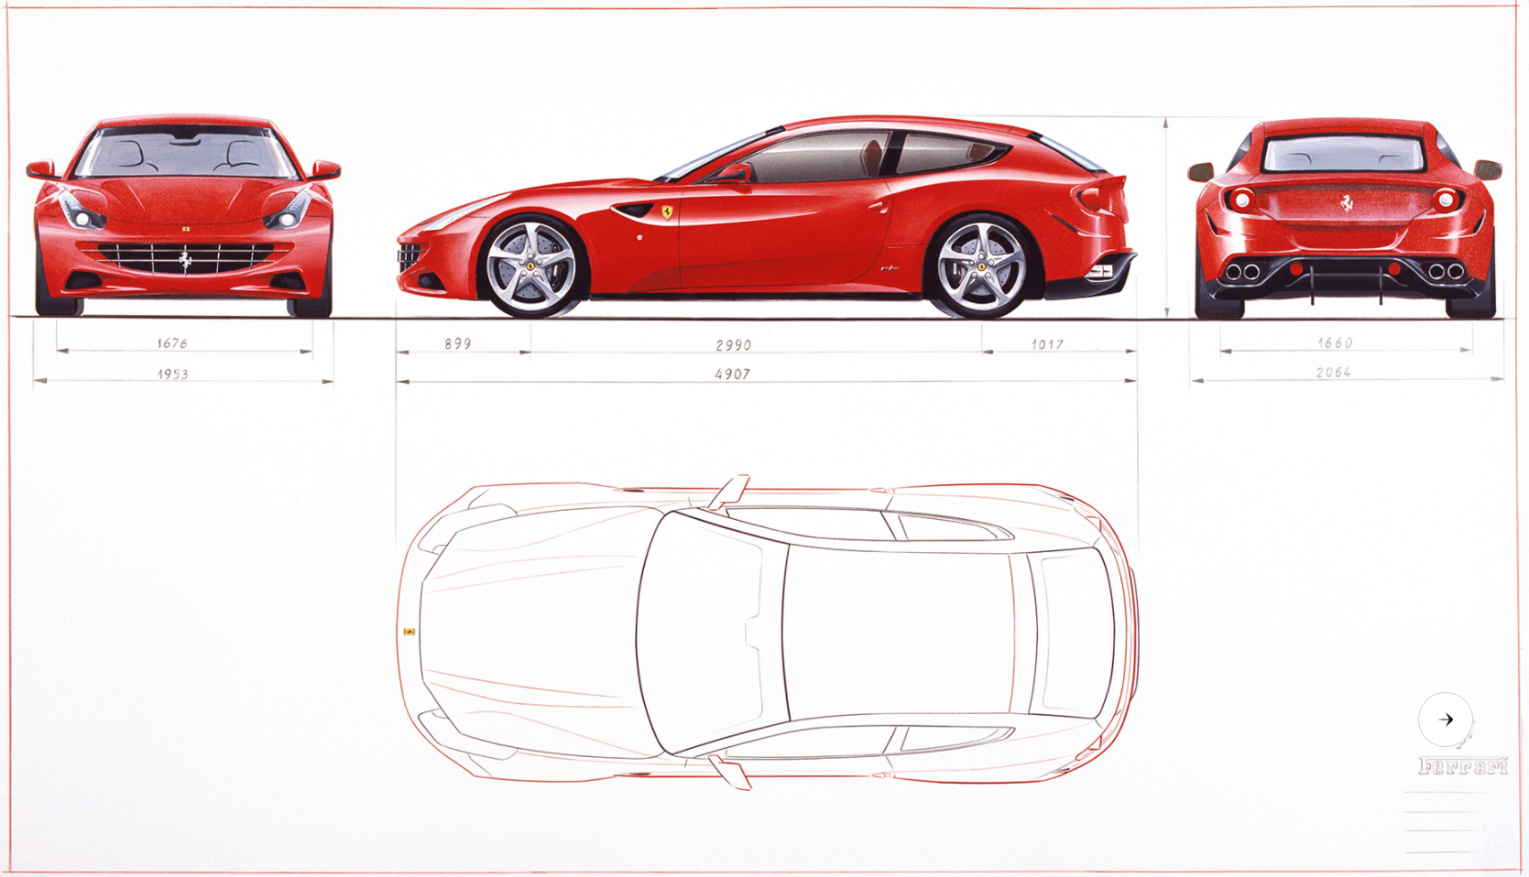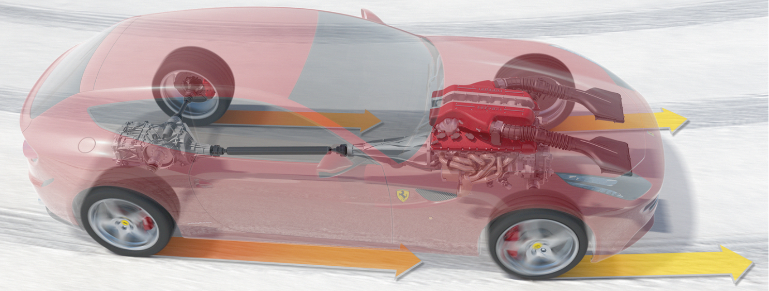
Figure 2.1.3. Ferrari FF Drawings and Cutaway image (Ferrari 2021)
To understand and compare values to the simulated inertia, research was conducted to find results of moments of inertia for road vehicles. Garrott (1993) created a database of light vehicle inertial parameters from the National Highway Traffic Safety Administrations. The sportiest vehicle in the list is a BMW 325i with a yaw inertia of 2027kg.m² (Garrott 1993). A more modern paper in the same format is available from Zagorski (2021). However, this does not include values of yaw Inertia. Bixel et al. (1995) published the yaw inertia of the 1994 Dodge Viper. This is a sportscar with a large engine, yet its yaw inertia was relatively small at 2272kg.m². Which is a DI of 1.02. Appendix 1.

Torque Vectoring
The benefit of controlling torque vectoring is more than just straight-line performance. With position sensors monitoring the requests from the driver of torque demand and hand wheel angle, the car knows the intention and can then apply greater torque to where it is needed. For example, if the driver is turning left and accelerating, with an open diff, the weight transfer lifts the inside wheel limiting the torque to the outside slowing performance. With torque vectoring in this scenario the clutch can be closed to send the torque to the outside wheel to tighten the radius of the turn. This produces an imbalance of torque on the axle generating yaw to help turn the car around the corner making the vehicle feel more agile and sporting. When driving straight the vehicle can operate as an open differential giving stable and balanced drive. This can even be applied to counteract yaw and stabilise a car which is naturally imbalanced with a low dynamic index. However, this could feel hesitant and could wear the clutch packs prematurely. Brake vectoring is using a similar control by making one wheel have less drive torque, but this is reducing performance as it is restricting the amount of torque it can put down but does allow for quicker turn in and can reduce understeer. Brake Vectoring and torque vectoring could be combined to increase yaw on an axle. The FF’s successor, the GTC4Lusso used rear wheel steering to counteract imbalance.
The FF features an E-Differential. This allows for a split of torque to either side of the vehicle. The E-diff is on the rear axle but what makes the FF more unique is the front diff which features a clutch pack alongside the differential. This allows slip in the pack which sends more torque to one wheel which is torque vectoring. Due to the different gear ratios front to rear, the clutches can bind generating a speed difference allowing front to rear torque vectoring as the front wheels spin faster. Cheli et al. (2009) discusses the development of the Ferrari FF AWD torque vectoring system for the Fiorano test track although at this point the vehicle is a mid-engine layout. Cheli et al. (2009) claims a 2.4 second saving in lap time with the torque vectoring system working for 14% of the lap time. However, Cheli et al. (2009) claims the aim is to be RWD as much as possible and only be AWD when the stability is compromised. Figure 2.3.1. shows the benefit of torque vectoring on oversteer management for the FF around Fiorano.
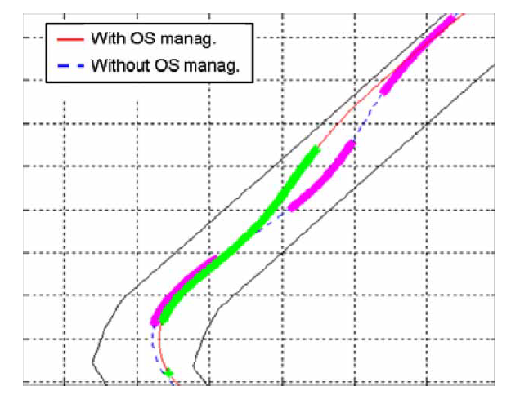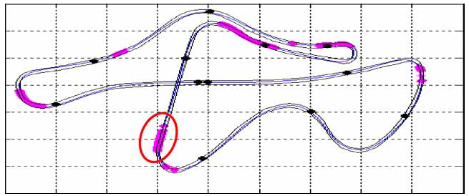
Figure 2.3.1. Activation of clutch and oversteer management around Fiorano (Cheli et al. 2009)
Torque vectoring is going to become more common in road cars with EVs using multiple motors. With more than one motor on an axle, splitting torque is simple. Kaspar et al. (2014) discusses the benefit of torque vectoring control using a simulation of different payloads for a Mini Countryman. A benefit of torque vectoring is being able to have stability control when the weight distribution can change drastically with full load capacity compared to just the mass of the driver.

Lumped Mass Model and Inertia

Lumped Mass Model
As found in section 2.1. the dimensions of the Ferrari FF were known. A lumped mass model was produced to represent the vehicle. To help with the lumped mass model, images from Ferrari (2021) were used as shown in figure 3.1.1. Further detail of mass and Location is shown in table 3.1.2.
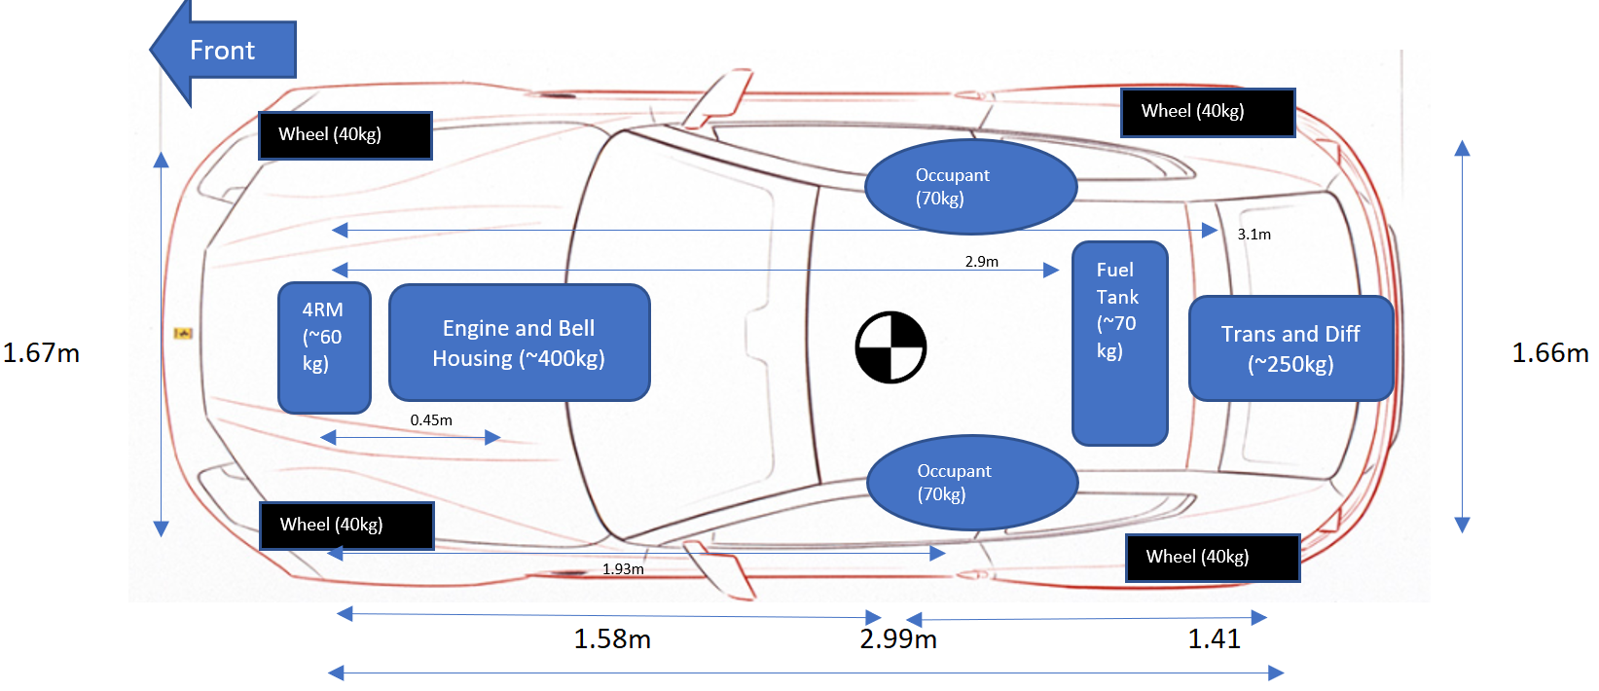
Figure 3.1.1. Simplified Lumped Mass Model Over Plan View (Ferrari 2021)
Table 3.1.2. Full Lumped Mass Model and Total Yaw Inertia.
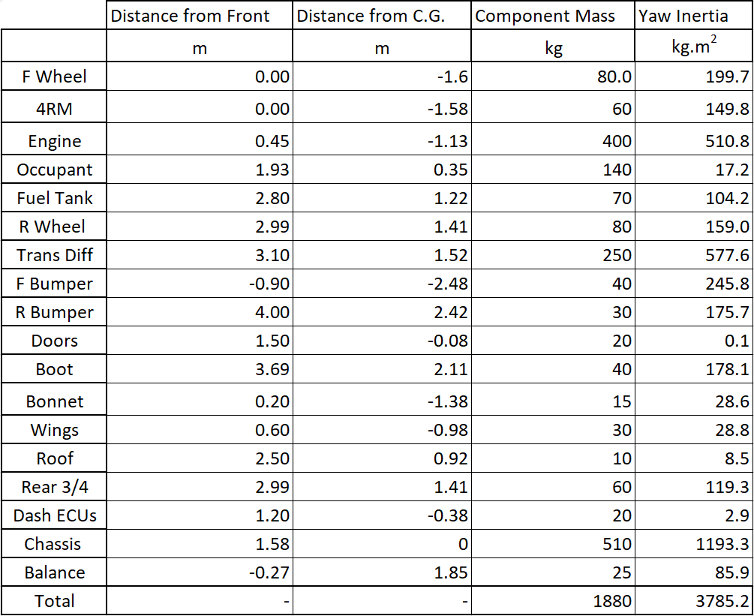
This led to a platform to begin assuming masses of components within the car. Car and Driver (2021) published a fuel tank capacity of 91L. Assuming a fuel density of 748kg/m³, then when fully fuelled, a lumped mass of 70kg is known. Scuderia Car Parts (2021) shows the fuel tank is behind the rear seats, so this masses position is known. The V12 engine with the bellhousing and auxiliary systems is assumed to have a mass of 400kg. The point mass is behind the front wheels but in front of the bottom of the windshield. The point mass is assumed 0.45m behind the axle. The gearbox is on the rear axle as it is a transaxle system as shown in figure 2.1.3. A mass is called balance to make the C.G in the correct position. The lumped mass model is shown in figure 3.1.1. Crolla (2009, p.477) claims a lumped mass model is an efficient and fair representation of a modern vehicle for simulation of vehicle handling.

Moment of Yaw Inertia
With a lumped mass model, the moment of yaw inertia can be calculated. The best way find the position of inertia is by measuring using an Inertial Parameter Measurement Device. This removes assumptions of position and mass but, this is expensive and complex. Using the lumped mass model gives a fair representation of inertia. Equation 3.2.1. shows the calculation of inertia from the masses and their position from the CG. The total yaw inertia is the sum of inertias for each mass.
$$I_{zz}=∑(m.r^{2})$$
Equation 3.2.1. Moment of Inertia Lumped Mass
$$I_{zz}=\frac{m}{12}\left(B^{2}+H^{2}\right)$$
Equation 3.2.2. Mass Moment of Inertia Rectangle (MacInnis, Cliff and Ising, 1997)

Inertial Conjugate
From the yaw inertia, an inertial conjugate can be calculated using equation 3.3.1. The inertial conjugate is the position of where the vehicle rotates around. As seen in equation 3.3.1. it is related to the position of the centre of gravity but also the radius of gyration.
$$k^{2}=\frac{Izz}{m}$$
Equation 3.3.1. Radius of Gyration
$$C=\frac{k^{2}}{a}$$
Equation 3.3.2. Inertial Conjugate

Dynamic Index
The dynamic index is calculated using equation 3.4.1. DI gives a value to understand the position of the inertial conjugate in comparison to the rear axle. If the DI is greater than one, then the inertial conjugate is behind the rear axle and the vehicle will therefore be very stable but hesitant to turn. Crolla (2009, P.477) discusses dynamic index.
$$DI=\frac{I_{zz}}{m×a×b}$$
Equation 3.4.1. Dynamic Index

Lumped Mass Results
Table 3.5.1. Results from Lumped Mass Model Calculations
Calculation | Value | Unit
Yaw Inertia | 3785.2 | kg.m²
Inertial Conjugate | 1.271 | m
Dynamic Index | 0.904 | -

Table 3.5.1. shows the yaw inertia is similar to that seen by Garrott (1993). However, due to the FF’s rear weight bias and hatchback design the yaw inertias from Garrott (1993) do not represent the FF’s layout so the yaw inertia can not be compared. The dynamic index however is low. The centre of gravity is known so the variable is yaw inertia and it is too low. For a DI of 0.95 which would be sporty but stable, a yaw inertia of 3977kg.m² is needed. This could be done by not considering the chassis and body as a balanced rectangle.

Torque Vectoring
As discussed in section 2.3, torque vectoring is the control of a differential to allow torque to be sent to either wheel instead of the torque being equal either side like with an open differential.

Torque Path
Torque from the crank shaft is sent through the bell housing to the transaxle. If the current gear selected is lower than or equal to 4th and traction is needed, the front clutch pack is engaged and torque is sent through the front half of the crank shaft to the 4RM system. Differentials at both ends allow torque to be split to go to the wheels. Figure 4.1.1. shows the torque path of the FF system. A plan view of the system was available in a later patent from Cimatti et al. (2010) and includes differentials on the axles and more clearly the idea of two wet clutches and two ratios at the front to control wheel speed as shown in figure 4.1.2.
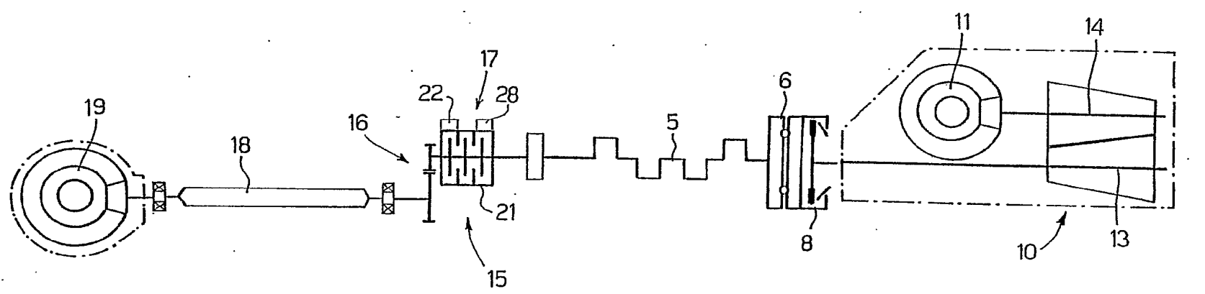
Figure 4.1.1. Layout of Drivetrain for the FF. (Cimatti et al. 2007)
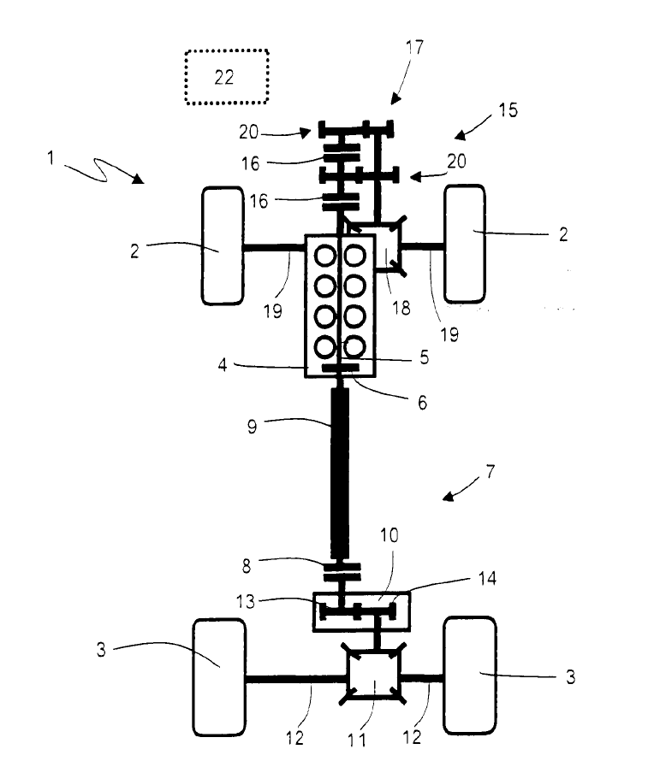
Figure 4.1.2. Ferrari FF Transmission Layout (Cimatti et al. 2010)

Clutch Sizing and Power Loss
The rear clutch pack needs to withstand 100% of the torque. As mentioned in section 2.1, Davis (2011) claims the torque split is maximum 20% at the front but this is at the wheels in first gear (Appendix 4). The front clutch off the crank may need to take more torque due to the ratios. The clutches on the front axle as part of the diff should withstand 20% of the torque but this is multiplied by the 4RM ratios. According to Ferrari (2021) torque can be sent only to the front wheels but this is in low traction scenarios so there will not be a high torque demand. Using the variables shown in table 4.2.1 and equation 4.2.3. clutch sizing was calculated for the front clutch, rear clutch and clutch packs on the front axle. For the clutch on the axle, torque is multiplied by the 4RM 1st gear ratio and the FD ratio and a 95% efficiency in both. See appendix 2. Clutch friction was assumed to be wet powdered metal on steel (Shigley 1986, p.610) and constant wear. See appendix 6 for r_{i}.size assumption
Table 4.2.1. Clutch Sizing Variables
Variable | Value | Unit
Max Crank Torque | 683 | Nm
Front Clutch Torque | 184.4 | Nm
Torque After 4RM Ratios | 1875 | Nm
Clutch Friction | 0.1 | -
Clutch Inner Radius | 50 | mm
Pressure on Plate | 5,000,000 | Pa
Front Clutch Number of Plates | 2
Rear Clutch Number of Plates | 3
Front TV Number of Plates | 8

$$τ=π×μ×r_{i}×P_{max}×(r_{o}^{2}-r_{i}^{2})$$
Equation 4.2.2. Constant Wear Clutch Sizing using Pmax

$$r_{o}=\sqrt{\frac{τ}{π×Pmax×f×r_{i}}+r_{i}^{2}}$$
Equation 4.2.3. Clutch Outer Radius Sizing
Table 4.2.4. Results of Clutch Sizing
Variable | Value | Unit
Front Clutch Diameter | 121.2 | mm
Rear Dual Clutch Diameter | 147.0 | mm
Front TV Clutch Diameter | 148.1 | mm

Efficiency of the gear transmission will be good as the system is an automated manual. Using a DCT is more efficient than torque converter systems of more traditional automatic transmissions. Losses are reduced in the FF as the front and rear are not linked. Compared to traditional 4WD cars, there are not the standard losses of a centre differential or viscous coupling. The 4RM can be disengaged from both ends when not used so there are no losses of turning over the system adding resistance. Losses are introduced however, when the front wheels are working and the clutches are slipping to meet the required speed. This will generate heat and will be energy not sent to the wheels. However, Ferrari believe this will be for short periods of time. The clutches would wear quickly if this were for extended periods of time figure 2.3.1. Gear efficiency of the transmission and the differential is assumed to be 95% separately.

Acceleration and Yaw Rate
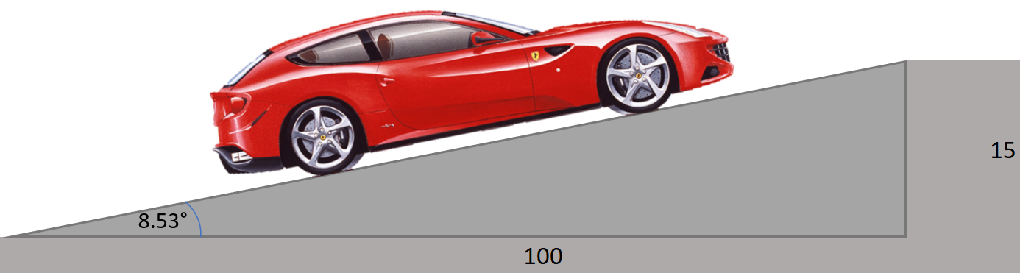Figure 4.3.1. Incline for Split-μ Scenario. (Ferrari 2021 [Image])

The scenario of the Ferrari FF on an inclined split-μ surface was simulated as shown in figure 4.3.1 and figure 4.3.2. The incline was 15 in 100 which is 8.53° and the left-hand side of the car has a friction coefficient of 1 but the right has 0.1. The C.G height was assumed to be 0.5m. The force downhill was therefore 2736N.
A comparison was made between using only the rear wheels to drive with an E-Diff compared to also using the 4RM system with torque vectoring on the front. With this, the weight transfer from the incline was calculated and its effect on force on each axle was calculated. The maximum acceleration was then calculated based on being 2WD or 4WD and was 1.3m/s² and 1.58 m/s², respectively. This was then converted to 0-62mph to understand the rate of acceleration assuming constant acceleration and no resistance. When only 2WD, the FF took 20.6 second to reach 62mph and when 4WD it took 17.5 seconds. It was 7.2 seconds before considering force taken away from the traction circle to steer. Ferrari (2021) claim 3.7 seconds to reach 62mph on a good surface.
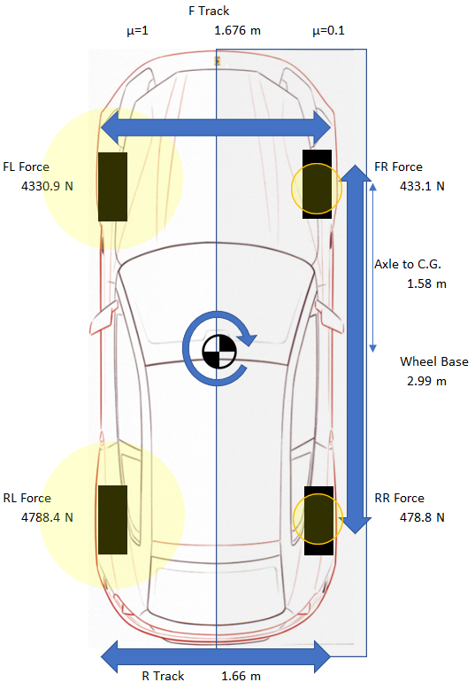
Figure 4.3.2. Split-μ Scenario. (Ferrari 2021 [Image])
With the E-Diff, a yaw moment is generated about the C.G. When operating as RWD, this moment is the difference in drive torque between the left and right on the rear axle multiplied by the half the track. This then must be counteracted by steering the front wheels. A tyre stiffness was assumed of 870N/degree which means degrees the front wheels must steer is found. Therefore, through the steering ratio in table 2.1.1, the hand wheel angle is calculated. This is shown in figure 4.3.3.
When the 4RM system is working, the moment is calculated as total force left- total force right. This is therefore a greater moment about the C.G. The steering required is calculated the same as before but this force to keep straight is force not accelerating the vehicle, so this increases the acceleration time. The results from the split-μ are shown in table 4.3.4. Acceleration on varying surfaces is shown in Appendix 5.
Table 4.3.4. Values Calculated for Split-μ Incline Full Acceleration.
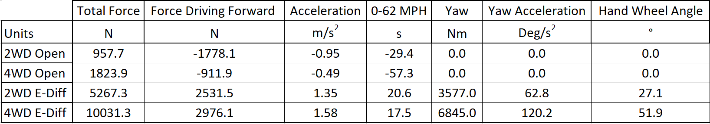
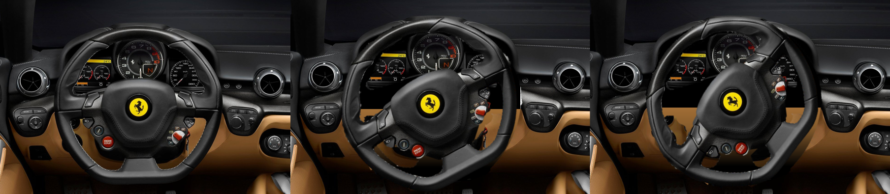
Figure 4.3.3. Visual Hand Wheel Angle to Correct Yaw. From 0°,27° (RWD) and 52° (AWD). (Ferrari 2021b)

Control Algorithms and Sensors
For the vehicle to understand the intentions of the driver and the cars current position, the computers can record the pedal positions and hand wheel angle to know the driver’s intention. The computers can also know the drive mode the driver has selected to know whether the driver wants a sporting and sharp response or a more stable and relaxed response if a comfort mode is selected. A comparison that more modern cars can make is the comparison of wheel speeds and compare against GPS velocity. This can show if wheels are spinning and even show if all the wheels are rotating. This comparison to GPS also allows a calculation of slip which can be optimised for the peak force with roughly 10% slip. Cheli et al. (2009) discusses power on and power off situations and highlights the valuable sensors to be wheel rotational speed, rolling radius and yaw rate to control whether to activate the clutches front to rear and left to right.
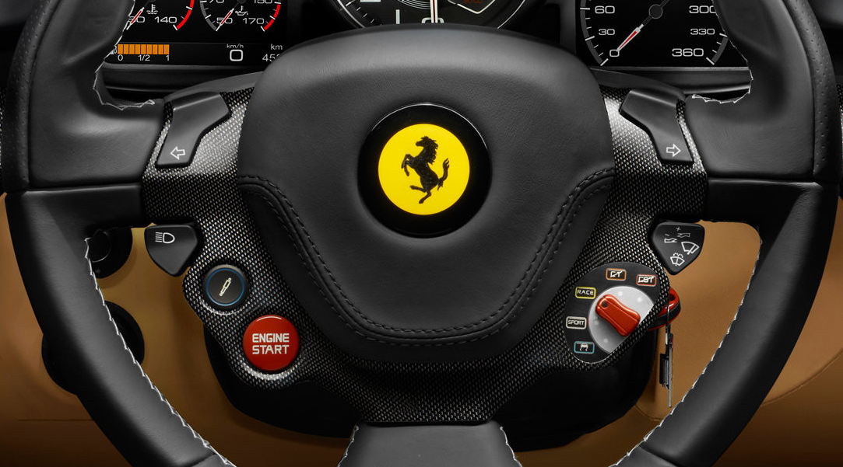
Figure 5.1. Ferrari Driving Mode Selection (Ferrari 2021b)
Another valuable sensor would be outside temperature and even whether the windscreen wipers are on. This would allow the computer to understand the conditions. This links to the driver mode as either snow or wet mode could be selected. As well as outside temperature, a valuable sensor would be clutch pack temperature to monitor the health of the clutches. Also, to know how much material is left on the clutches, a position sensor would be very valuable for the health of the vehicle.
There is also the question of how often should the sensors update. This would be less often for temperature sensors. However, for yaw and even wheel speed, the rate of the sensors should be at least 10 times per second.
Finally, a system that is starting to come is communication between vehicles. With this, if a vehicle passes a section of road and slips or senses something unusual, it could then report it to surrounding cars so they can prepare for this event. This could mean simply asking the driver to slow down. It could also adjust the drivetrain for what could be ahead, it may be a pothole so would soften the suspension or if the vehicle performed a sharp manoeuvre, the torque vectoring system could be ready to stabilise the vehicle.

Conclusion
The Ferrari FF is a unique vehicle in its audience and drivetrain systems. The vehicle was the sportiest in the AWD GT class and did this by combining a large V12 with the lightweight torque vectoring 4RM and more traditional E-Diff transaxle. This led to a traditional Ferrari RWD feel for the majority of driving, but when needed, the grip and control of torque vectoring to all four wheels was available in the time it takes to clamp the clutch pack.
The lumped mass model calculation of moment of yaw inertia and dynamic index showed reasonable correlation to understanding and research but point masses especially near the C.G. likely affected the results making the DI too low. Even if the DI was correct the FF uses torque vectoring systems which could reduce the yaw acceleration to make the car feel more stable on and off power.
On split-μ, the FF was able to accelerate swiftly up the incline. Using the E-Diff and torque vectoring, a large yaw moment was generated and the majority of the friction circle for the front wheels went to steering the FF instead of accelerating it. This made little difference in the acceleration times but, if the moment was not a concern the AWD system would accelerate far quicker than RWD. On the various μ surfaces, the front 4RM system could not produce enough torque to slip the front wheels on a μ of 1 surface.

Abbreviations

Abbreviation | Definition
AWD | All Wheel Drive
C.G | Centre of Gravity
DCT | Dual Clutch Transmission
DI | Dynamic Index
Diff | Differential
EV | Electric Vehicle
4WD | Four Wheel Drive
FD | Front Differential
FL | Front Left
FR | Front Right
GPS | Global Positioning System
GT | Grand Tourer
RD | Rear Differential
RL | Rear Left
RR | Rear Right
TV | Torque Vectoring

Nomenclature

Abbreviation | Unit | Definition
a | m | Distance Front Axle to CG
b | m | Distance CG to Rear Axle
B | m | Base (Rectangle)
c | m | Distance from CG of Inertia Conjugate
H | m | Height (Rectangle)
Izz | kg.m² | Moment of Yaw Inertia
k | m | Radius of Gyration
m | kg | Mass
μ | - | Coefficient of Friction
r | m | Distance from CG

Bibliography
- Austin M. (2011) Explaining the Ferrari FF's Two-Gearbox Four-Wheel-Drive System
Available at: https://www.caranddriver.com/news/a18736603/funky-four-explaining-the-ferrari-ffs-two-gearbox-four-wheel-drive-system/ (Accessed 14/04/2021)
- Bixel R. et al. (1995) Developments in Vehicle Centre of Gravity and Inertial Parameter Estimation and Measurement.
Available at: https://doi-org.imeche.idm.oclc.org/10.4271/950356
- Car and Driver (2021) Ferrari FF Features and Specs.
Available at: https://www.caranddriver.com/ferrari/ff/specs
(Accessed 14/04/2021)
- Cimatti F. et al. (2007) Connectable Four-Wheel Drive Vehicle. US Patent Office.
Patent Number US2007221427A1.
Available at: https://worldwide.espacenet.com/patent/search?q=pn%3DUS2007221427A1
- Cimatti F. et al. (2010) Optionally Connectable Four-Wheel Drive Vehicle. US Patent Office. Patent Number US20100206654A1
Available at: https://worldwide.espacenet.com/patent/search?q=pn%3DUS2010224431A1
- Cheli F, Cimatti F, Dellachà P, Zorzutti A. (2009) Development and Implementation of a Torque Vectoring Algorithm for an Innovative 4wd Driveline for a High-Performance Vehicle’ International Journal of Vehicle Mechanics and Mobility. 47(2) pp. 179-193
DOI: https://doi-org.imeche.idm.oclc.org/10.1080/00423110801935830
- Croft-White M and Harrison M. (2007) ‘Study of Torque Vectoring for All-Wheel-Drive Vehicles’ International Journal of Vehicle Mechanics and Mobility. 44(1) pp.313-320
DOI: https://doi-org.imeche.idm.oclc.org/10.1080/00423110600871400
- Crolla D, (2009) Automotive Engineering. 1st Ed. Oxford: Butterworth-Heinemann
- Davis M (2012) Ferrari F12 Berlinetta
Available at: https://www.autoblog.com/2012/09/13/2013-ferrari-f12-berlinetta-first-drive-review-video (Accessed 21/04/2021)
- Ferrari (2021) Ferrari FF.
Available at: https://www.ferrari.com/en-EN/auto/ff#specifications
(Accessed:14/04/2021)
- Ferrari (2021b) Ferrari F12 Interior
Available at: https://www.ferrari.com/en-EN/auto/f12-berlinetta
(Accessed 26/04/2021)
- Garrott W (1993) Measured Vehicle Inertial Parameters -NHTSA's Data Through September 1992. Available at: https://doi-org.imeche.idm.oclc.org/10.4271/930897
- Kaspar S. et al. (2014) ‘Robust Torque Vectoring Control’ IFAC Proceedings Volumes. 47(3) pp. 12023-12028. DOI: https://doi.org/10.3182/20140824-6-ZA-1003.02359
- MacInnis D, Cliff W & Ising K, (1997) A Comparison of Moment of Inertia Estimation Techniques for Vehicle Dynamics Simulation. Available at: https://doi-org.imeche.idm.oclc.org/10.4271/970951
- Scuderia Car Parts (2021) Ferrari FF Fuel Tank and Filler Neck.
Available at: https://www.scuderiacarparts.com/en-gb/part-finder/ferrari/ff/oe/173/2637/49533 (Accessed 20/04/2021)
- Shigley, J. (1986) Mechanical Engineering Design. 1st Ed. New York: McGraw-Hill.
- Viper Central (2021) Dodge Viper 1992- 1994 Specification.
Available at: http://www.vipercentral.com/specifications/ (Accessed 30/04/2021)
- Zagorski S. et al. (2020) Measured Vehicle Inertial Parameters - NHTSA’s Data through August 2020. Available at: https://doi-org.ezproxy.uwtsd.ac.uk/10.4271/2021-01-0970

Appendices
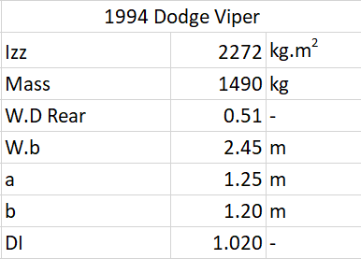
Appendix 1. 1994 Dodge Viper SR1 DI calculations with values from Viper Central (2021) and Bixel et al. (1995).

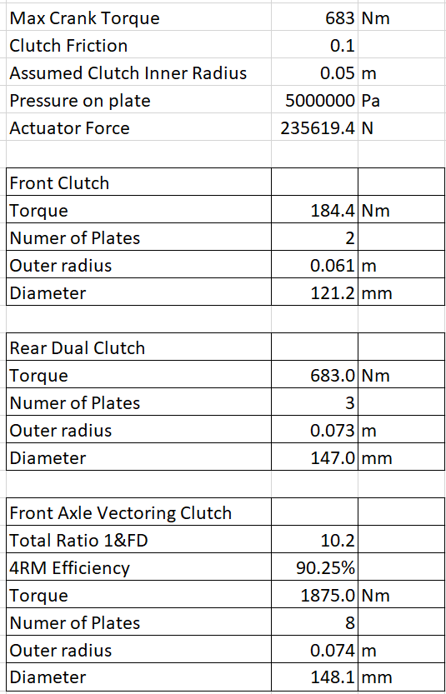
Appendix 2. Clutch Sizing Calculations.
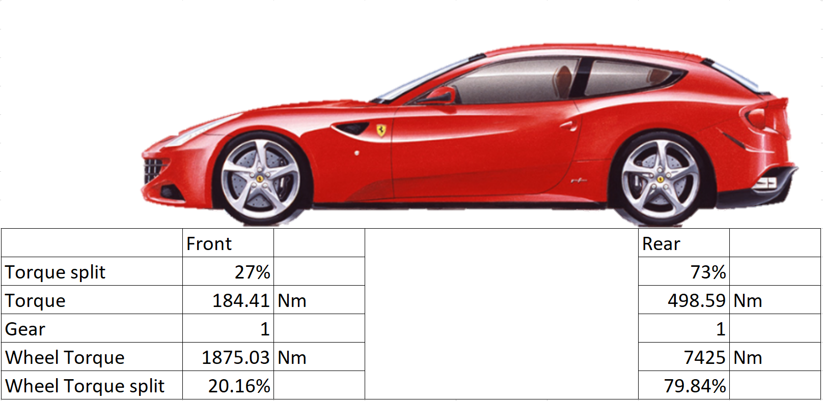
Appendix 4 Torque Split at Crank to get 20:80 Front Rear Split.
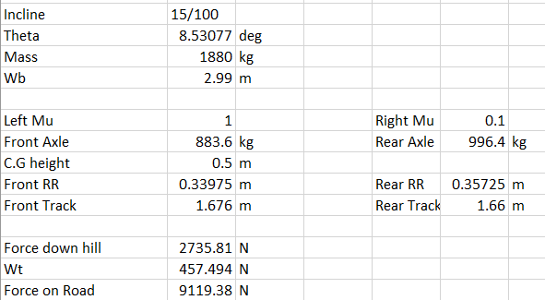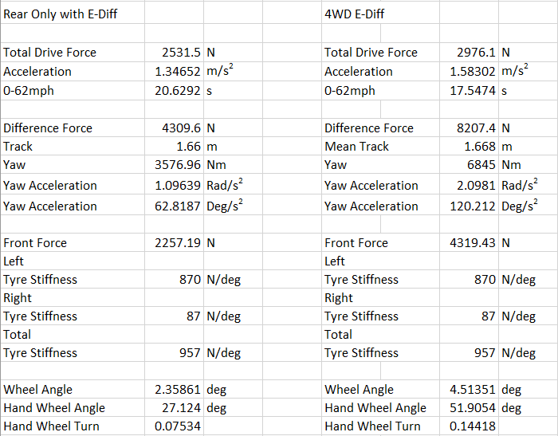
Appendix 3. Excel Split mu Calculations.

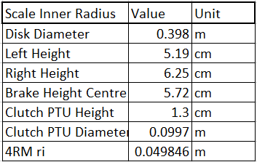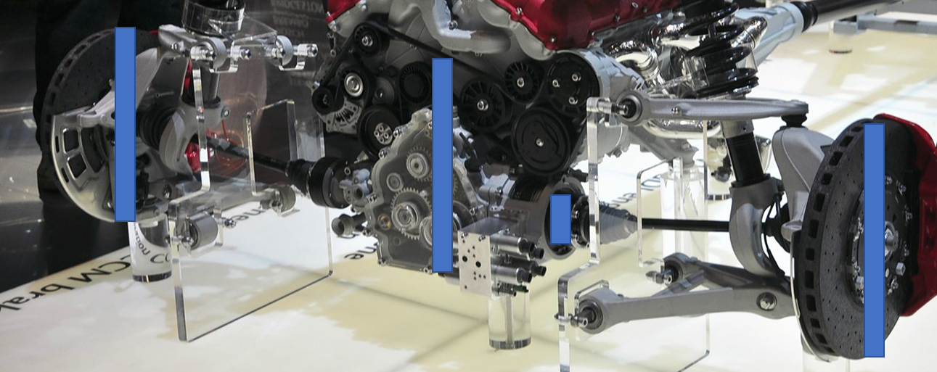
Appendix 6. Clutch in PTU Sizing from Image Scale of Brake Diameter.
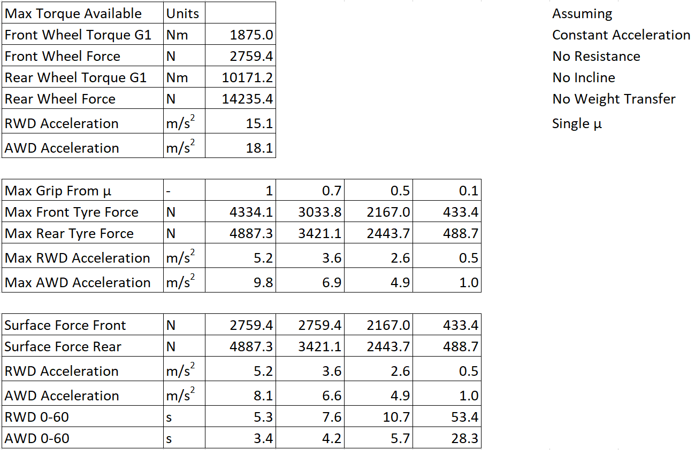
Appendix 5. Acceleration on Varying Surfaces including max torque from AWD.

