Component 2 Task – Individual Research Report
Student Name: Mohammad Shakil Ahmad
Student Number: 2233030
Lecturer Name: Mr Neale Haddon
LCHS4002_BIRM
Digital Skills and Research Methods

Contents
1. Introduction 3
2. Research design 4
2.1. Research Question 4
2.2. Method 5
2.3. Ethical Considerations 6
3. Results 8
4. Discussion 11
5. Conclusion 13
6. Reference List 13
7. Appendix A – A blank copy questionnaire. 14

- INTRODUCTION

In today's digital age, having strong digital skills and research methods is essential for success in many industries. Digital skills encompass a wide range of competencies, including proficiency in using software and digital tools, understanding how to navigate the internet, and having the ability to communicate effectively online. Meanwhile, research methods involve the systematic and thorough investigation of a topic or question, using various sources of information to gather data and insights. Together, these skills allow individuals to conduct in-depth research, analyse data, and present findings in a clear and compelling manner. In this rapidly evolving digital landscape, it is crucial for students to continually hone their digital skills and research methods to stay ahead of the curve and achieve their goals.

Digital skills refer to the abilities and knowledge that are required to effectively use digital technologies, such as computers, smartphones, tablets, and the internet. These skills can include basic computer literacy, proficiency in using specific software tools, social media management, digital marketing, coding and programming, data analysis, and cyber security. In today's digital age, having strong digital skills is becoming increasingly important in both personal and professional settings.

“Instead of using pen and paper, students nowadays use various software and tools to create presentations and projects.” (Abid Haleem et al. 2022).

We will research on the topic “which digital skill do UWTSD students think is most important?”

- RESEARCH DESIGN

Haider Th.Salim Alrikabi et al. (2022) states that Universities and other academic organizations have to think carefully to adapt on new digital skills what today’s student expect.

  - RESEARCH QUESTIONS

Q1: Are you happy to volunteer to fill out the survey?
- Yes
- No

Q2: Is Digital skills only for study aspects of life?
- Yes
- No

Q3: Should there be a limit on technology time?
- Yes
- No

Q4: Do you think Digital Skills improve the academic performance of Students?
- Yes
- No

Q5: Is it important to keep updating your Digital Skills?
- Yes
- No

Q6: Do you think only basic skills are needed in study in Digital skills?
- Yes
- No

Q7: Lists the most important Digital Skills being 1 most important 5 least important-
Office 365, Moodle, Microsoft Teams, One Drive, eLibrary?

- Option 1 – Office 365
- Option 2 - Moodle
- Option 3 – Microsoft Teams
- Option 4 – One Drive
- Option 5 - eLibrary

  - RESEARCH METHODS

“It is essential to define the purpose of the survey and to be as specific as possible in terms of the data to be collected” (Sinkowitz-Cochran, R.L. 2013).

Research method refers to the systematic procedures and techniques employed by researchers to collect, analyse and interpret data to obtain reliable and valid results. It involves the use of various strategies, tools, and techniques to investigate a problem, issue or phenomenon in order to gain new knowledge or validate existing knowledge. Examples of research methods include qualitative research, quantitative research, mixed-methods research, action research, case study research, experimental research, survey research, and observational research. The choice of a research method depends on the research question, objectives, and the type of data that needs to be collected. Each research method has its own strengths, weaknesses, and limitations, and requires a different set of skills, knowledge, and resources.

The quantitative Research method was used to gather information after the questionnaires. Quantitative Research looks data numerically answering questions such as how much, when and where. Qualitative research gives an in-depth analysis answering questions such as why and how did it happen etc.

We will conduct a survey with voluntary participating students of UWTSD who are still studying at different levels at Birmingham campus.

“It is essential to define the purpose of the survey and to be as specific as possible in terms of the data to be collected” (Sinkowitz-Cochran, R.L. 2013).

We will establish a tailor-made survey questionnaire with our research findings which will ensure serve our purpose more closely.

This is an online survey designed by us (group allocated by UWTSD) with 6 unique questionnaire to reach a conclusion.

The survey questionnaire will be created in “MS form” format and shared with the target students at “one drive” @ UWTSD hwb for the submission of their feedback.
We will analyse the result and come to the conclusion of our group research.

Regardless of the methodology chosen, it's important to ensure that the research is rigorous and unbiased. This might involve using randomized sampling methods, ensuring that surveys and interviews are conducted in a neutral manner, or using statistical techniques to control for extraneous variables.

Ultimately, the goal of researching digital skills is to gain a better understanding of how individuals and organizations can effectively develop and utilize these skills in an increasingly digital world.

  - ETHICAL CONSIDERATIONS

Research ethics refer to the guidelines and standards that govern the conduct of research involving human or animal subjects. Some ethical considerations in research include:
1. Informed consent: Participants should be well-informed about the study's objectives, risks, benefits, and their rights, and should give their voluntary and explicit consent to participate.

2. Confidentiality and privacy: Participants' personal information and data should be kept confidential, and personal privacy should be respected throughout the study.
3. Avoidance of harm or discomfort: Researchers should strive to minimize any potential harm or discomfort to participants, including psychological, physical, financial, or social harm.
4. Inclusion and diversity: The recruitment of participants should be fair and inclusive, avoiding any discrimination or bias based on gender, race, ethnicity, culture, religion, among others; and the research should acknowledge group differences and cultural influences.
5. Honest and transparent reporting: Researchers should report their results honestly and transparently, avoiding fabrication, falsification, or plagiarism; and should acknowledge any conflicts of interest.
6. Responsible use of resources: Researchers should ensure that their research is conducted in an appropriate and responsible manner, including the appropriate use of resources such as funding, equipment, or data.

As a group, we have ensured the followings:

- Participation of the survey is completely optional.
- We have taken permission of UWTSD students to participate voluntarily.
- Participating students were informed about the purpose of survey.
- The survey link straight send to students in MS Form and students also responded in MS Form.
- Participation on the survey will not hamper their ongoing study and course.
- We assure to be respectful, kind and fair with the upmost integrity.
- The outcome of the survey are not personally linked to the students.

- RESULTS

The below are the illustration of survey results in excel as per Participants response.

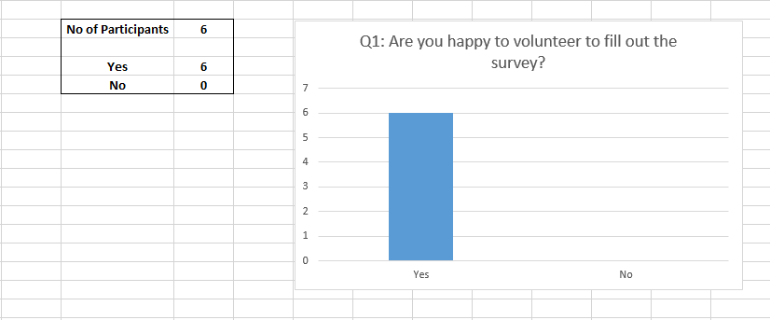

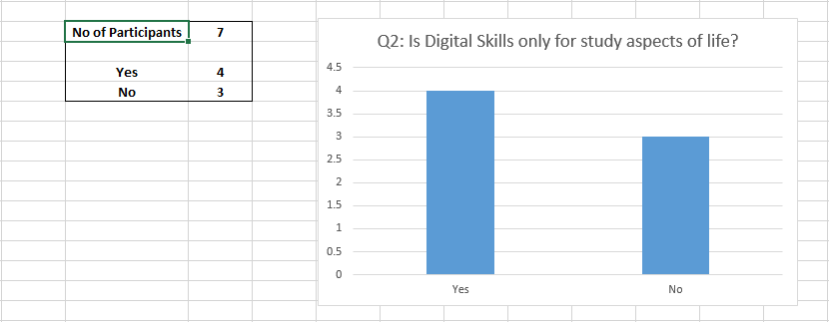

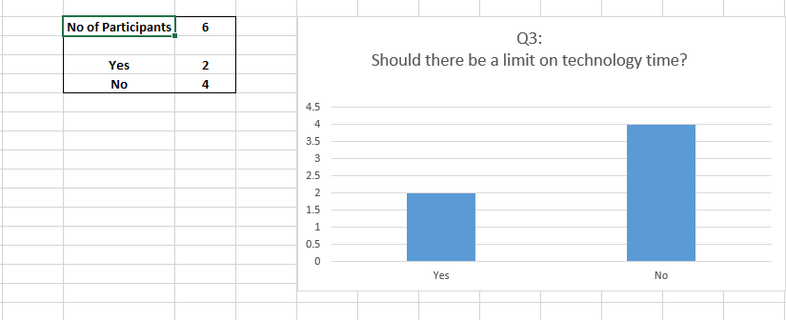
RESULT

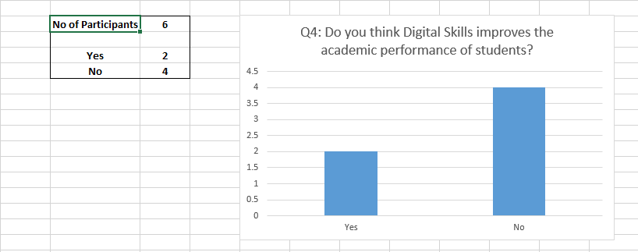

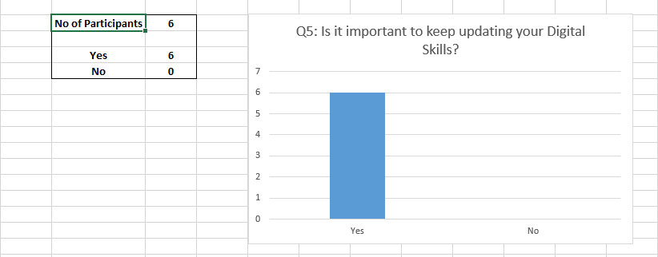

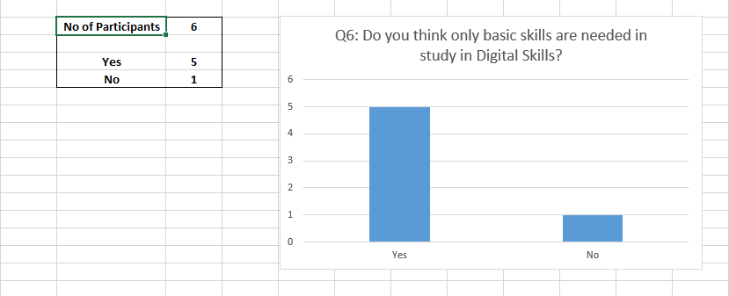

RESULT

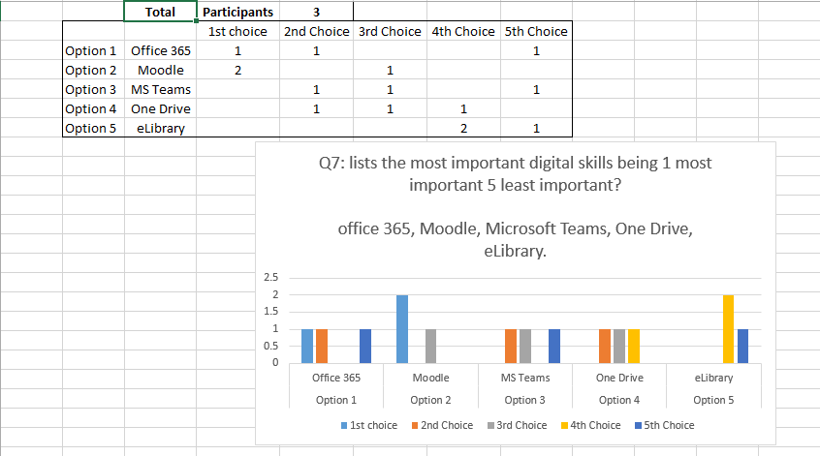

- DISCUSSION

Our research involves the collection of numerical data from UWTSD students in order to reach the survey outcome and discussion on that. As discussed earlier, it falls on Quantitative analysis, also known as statistical analysis, involves the collection and interpretation of numerical data.

In this study, a seven-item survey was created to gather information for quantitative analysis. The first questions was about consent because it’s important to get the participants permission before going ahead. All respondents agreed to take part in the study, ethical considerations are vital in a research study.

Teams to work with their peers because in their opinion it is quite easy to use. Most students regardless of their age, gender, degree of ability were comfortable MS Forms.

Our Hypothesis is
- Moodle is the heart of all communications which links with other digital channels at UWTSD.
- Most of the students use Moodle in classroom to see the study contents while Teacher delivering the same lesson.
- Moodle can be accessed via offline and can be downloaded any material without internet access irrespective of place, time and device.
- Moodle is cheaper option in compare to other licensing platform and user friendly than other components.
- That is why our Hypothesis on the most use of Digital Skill used by UWTSD student id Moodle.

Our survey results shows that there is no exception of the results. Moodle is the first choice which states that Moodle is the most important digital skills used by UWTSD students. Office 365 holds the second position as preferable option.

Moodle provides a centralized platform for students to find all course materials such as lecture notes, assignments and deadlines, feedback, and grades.

Here is our finding on Moodle, mostly used by UWTSD students and other students in higher studies.

Online Assessment: With Moodle, online assessments can be created and administered easily. Students can complete assessments remotely and receive their grades and feedback quickly.

Open Source Platform: Moodle is an open-source platform, which means that it is free to use and can be customized to meet the specific needs of a university.

Collaboration: Moodle provides tools for collaboration, such as forums, wikis, and chat rooms, which can help students to work together on projects and assignments.

Accessibility: Moodle is accessible from any device with an internet connection, making it easy for students to study, collaborate, and participate in class, on or off-campus.

Support: Moodle has an active community of developers and users, which means that there is plenty of support available for users who need assistance with using the software.

However, there may be instances where students find Moodle and other LMS platforms intimidating, and they may need additional support from instructors or instructional technologists to navigate the system effectively.

Some students may also feel that Moodle's online format does not offer the same level of engagement as in-person classes, and they may struggle with motivation and self-discipline to complete coursework.

Overall, Moodle provides a versatile platform that is convenient, user-friendly, and accessible to all types of students.

- CONCLUSION

In conclusion, Moodle operation is the most widely used digital skills by UWTSD students. The platform offers a variety of features that make it easy for students to manage their courses and track their progress. The use of Moodle allows students to access course materials anytime, anywhere, and provides a platform for communication and collaboration with their peers and instructors. Moodle's popularity among university students is a testament to its effectiveness in enhancing digital skills and improving academic performance. Therefore, institutions of higher learning should continue to invest in Moodle and other digital learning platforms to provide students with the best learning experiences.

Moodle is used most often by UWTSD students for peer cooperation, and they aare eager to use Moodle platforms to learn a range of subjects. Future studies can be conducted using responses from students from different universities in UK.

- REFERENCE
Abid Haleem et al. (2022) ‘Understanding the role of digital technologies in education: A review’, Sustainable Operations and Computers, 3, pp. 275–285. Available at: https://doi.org/10.1016/j.susoc.2022.05.004.
Haider Th.Salim Alrikabi et al. (2022) ‘Smart Learning based on Moodle E-learning Platform and Digital Skills for University Students’, International journal of recent contributions from engineering, science & IT, 10(1). Available at: https://doi.org/10.3991/ijes.v10i01.28995.
Sinkowitz-Cochran, R.L. (2013) ‘Survey Design: To Ask or Not to Ask? That is the Question’, Clinical infectious diseases, 56(8), pp. 1159–1164. Available at: https://doi.org/10.1093/cid/cit005.

- APPENDIX A- A BLANK COPY QUESTIONNAIRE





