MBA MARKETING MANAGEMENT ASSIGNMENT 1
Student Name- Janet Ogundayo
Student ID-1918674
Lecturer- Tushara Balendran
Course Code-LCMB7001

Table of Contents

Introduction 3
Organisational Background of Adidas 3
PESTLE Analysis 3
Porter’s Five Forces 6
SWOT Analysis Adidas 7
Segmentation, targeting and positioning of Adidas 8
4Ps of Marketing Mix from the context of Adidas 9
Conclusion 10
Recommendations 10
Reference List 12

Introduction
The study aims to conduct an analysis of internal and external business environment so that the drivers leading to business success can be identified properly along with the role of marketing in the business development of Adidas .Different secondary resources including journals, articles, books, annual reports are utilized for collecting different information related to internal and external environment and marketing strategy of Adidas, for example Adidas annual report are useful for collecting company related information. The analysis appropriate secondary information helps to determine conclusion of the study along with proper recommendation.

Organisational Background
Adidas stated through registering itself as GebrüderDasslerSchuhfabrik” in 1924. Then, AdiDassleragain reregister the organisation as “AdiDassleradidasSportschuhfabrik” as Adidas (adidas-group.com, 2020). Currently CEO of the organisation is Kasper Bo Rorsted. The headquarter of the organisation is Herzogenaurach, Bavaria, Germany. It is a public limited company whose market capital is $62.12 Billion on February, 2020. It has become third largest apparel brand in the world in 2019 with brand value of $16.67 billion (statista.com, 2019). The annual revenue of the organisation is EUR 21.9 Billion in FY 2018 and it earned profit of EUR 1.7 Billion during the same year. Adidas has a market share of 56.50% in the second quarter o 2020. The popularity of the brand has started after the Summer Olympic in Berlin where helped the associate Jesse Owens to win four gold medals running in Adidas boots.
Adidas mission statement is "to be the best sports company in the world”. In order to lead the way in the sportswear segment by creating unique products those satisfy the customer needs with a great level of satisfaction full of positivity (adidas-group.com, 2020). The corporate structure is robust with a strong team that manages its affairs.
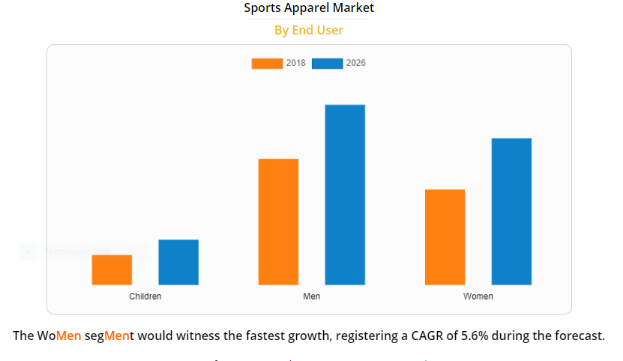
Source: Allied Market Research

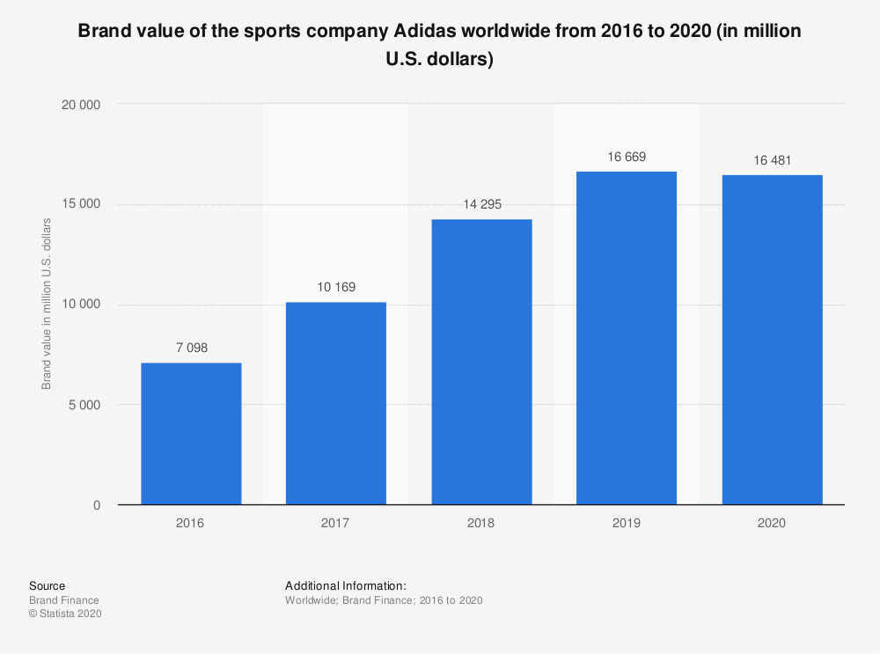
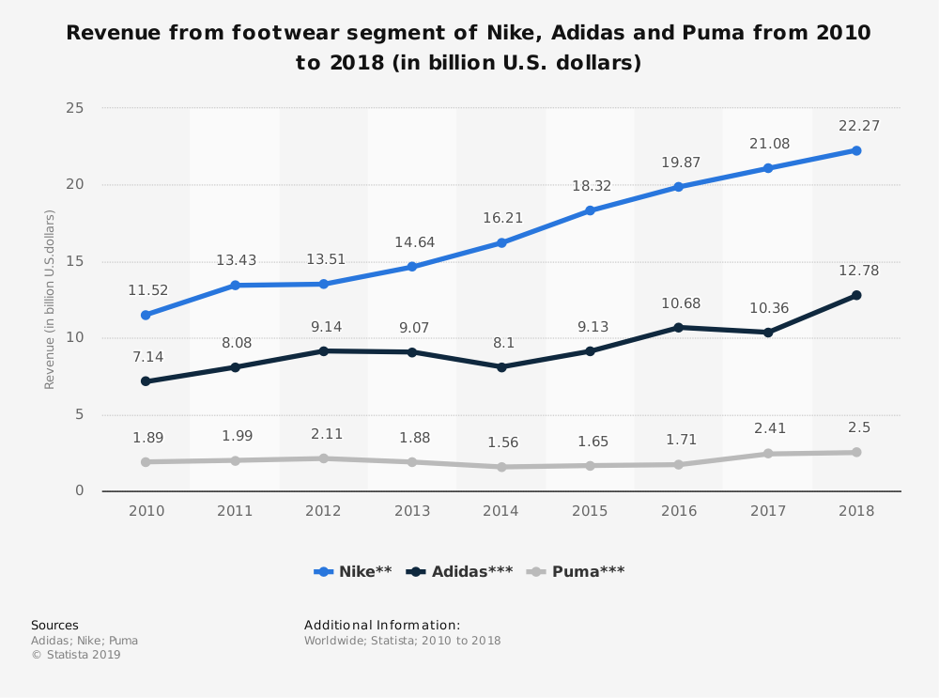

PESTLE Analysis

Factors | Finding
Political | - Stable political scenario  - Constitutional monarchy is in practice  - Government helps the businesses in development with various facilities
Economic | - UK has second largest GDP in the European Union  - 2018 says that the nation has inflation with 2.48% growth rate  - Economic growth has become slow from 2.5% to 1.5% after the Brexit Vote (Amadeo, 2020).
Social | - High GDP and income has made the lifestyle of the society high as they prefer to lead luxurious life  - Cheap labour is available as number of migrant is increasing due to easy migration policy  - COVID-19 pandemic has impacted the lifestyle of people
Technological | - UK is one of the fifth rank holder in terms of modern technology  - Availability of improved technology and transportation
Legal | - “The Employment Act 1996”  - “Equality Act 2010”  - “Fair Trading Act 1973”  - “Consumer Protection Act 1987”  - “Environmental Protection Act 1990”
Environmental | - Well managed waste disposal process  - “Environmental Protection Act 1990”
Table 1: PESTLE Analysis
(Source: Influence by Holtet al. 2017, p.220)

World population growth
The world population is growing at an explosive rate. Already in 2011, it reached 7 billion, while being expected to reach 8 billion by the year 2030. More than 70% of the expected world population growth in the next 40 years is expected to take place outside of the 20 richest nations on earth.

Changing age structure
The changing age structure of world population is another critical factor influencing marketing.. For example, India has one of the youngest populations on earth and is expected to keep that status. By 2020, the median age in India will be 28 years.

Geographic shifts in population
One – and the most important – element of geographic shifts is migration. By 2050, global migration is expected to double. This has a major impact on both the location and the nature of demand for products and services.

Economic forces in the Macro Environment

The global economy is collapsing due to the scenario of pandemic and it is expecting to create recession in the world economy. The global GDP rate has already fallen by 3.9%. It is an unfavorable factor for Adidas as the global sales of Adidas have been reduced by 19% in terms of Euro in 1st quarter of 2020 as 70% of the global stores are closed due to outbreak of coronavirus across the world.

Socio-Cultural forces in the Macro Environment
The Socio-Cultural forces factors that affect society’s basic values, preferences, and behavior. The basis for these factors is formed by the fact that people are part of a society and cultural group that their beliefs and values link to shape Adidas has followed the social trends in order to promote its products as Beyoncé launched the Ivy Park collection of the brand in Instagram. It helps to create brand awareness across the world as it promotes products through different social media influencers across the world. Adidas put global culture in its products through supporting different sports like Olympic, Rugby, gulf, football and others. The changing social cultural trend of using social media platforms are utilized by the brand for communicating with customers across the world. It helps Adidas to increase its sales by 6% in 2019, thus socio-cultural is favorable factors to Adidas.



(Source: Sultan, 2019)

Technological forces in the Macro Environment
Adidas has successfully utilized technical developments in its marketing strategy as it focused on influencer marketing strategy in order to enhance its social media presence which helps the organisation to increase its sales by 24.2% during 2015 to 2016 whereas Nike witnesses a decrease in sales by 9.1%. the brand launched a social campaign called “#MyNeo Shoot” in 2015 which combines both Instagram influencers and ordinary users. Thus, technology helps the brand to create awareness and engage the brand with Instagram users. In YouTube Nike has 59% mention whereas Adidas has 75% mention but Adidas can follow technical infrastructure of Nike because Nike has 24% mention whereas Adidas has 14% mention. But over the time, Nike is ahead of Adidas in terms of followers as Nike has 117 million followers whereas Adidas has 25.9 million followers in Instagram. The Nike social media campaigns like “#RiskEverything” featuring world’s famous footballers during world cup create more than 240 million YouTube views whereas Tango Squat Campaign of adidas creates 6,00,000 YouTube views.
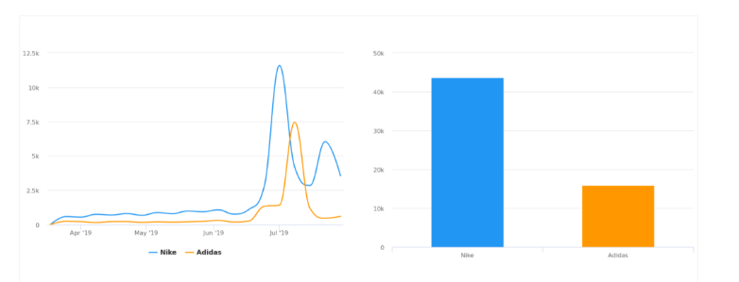
Figure 2: The most talk about brand
(Source: DOMINGUEZ, 2020)
Adidas segments the market into men, women, kids, teenager and toddler. The operation of Adidas is more focused on Europe. Online sales contribute 37% of the revenue during the seconds quarter of 2019 and the organisation is expecting increase in online sales as its contribution can touch 55% in 2020 (marketingweek.com, 2020). Online service the only consistent open store in the situation of pandemic. It has started “Hometeam:” campaign to enhance online sales.
Adidas has developed app in order to provide better service to the customers.
Adidas Shopping app
The app enables customers to get an instant access to seasonal fashionable clothes, new arrivals in sports or cloths according to the individual choice of various customers. Thus, the customers can virtually check any products of the brand including different offers (Play.google.com, 2020).
Adidas creators club
It indicates the membership of creator’s club program which enables customers to earn point with each purchase and reviews to the app. Further it provides facility of exclusive shopping and voting on apparels, trainers and others only to exclusive members under the program and they also get invitation for special offers or more great rewards. The brand can promote this program in order to increase the number of members.
Adidas app includes all benefits
It provides all the facility to the customers including offers, latest arrival, order tracking, shopping and others.
Join Home team
It indicates take caring of individuals through practicing yoga at homes which encourage customers to purchase more apparel for yoga or other home exercise like running. It encourages customers to stay at home during this pandemic scenario.
Visual search for faster finds
Visual search enables customers to upload a photo of an apparel item in order to search similar kinds of product in Adidas app. It enables customers to find out the product according to their choice or requirements.
Shop the best
The Adidas app enables customers to get inspiration from best Adidas creators like James Harden, Lionel Messi and Kylie Jenner. It also encourages customers to purchase legendary Predator or Nemeziz football boots.
Effortless sport style
Adidas app has personalized feature which enhance customer to build 3-stripes style with fresh collection of the organisation as the brad updates its collection from one season to another.
Discovering
The app allows customer to discover different kinds of products including Ultra boost running shoe, current pair of NMDs.
The Adidas app has different features but the app can add another feature that can enable customers to see which clothes is available in nearer store or the particular apparel items are available in the near store or not after pandemic scenario. It helps the app to improve more. Thus technology is an favorable factor for Adidas.

Ecological forces in the Macro Environment
Environmental factors are extremely important to the business of Adidas. Adidas must keep in mind the norms that need to be followed like environmental policies that could pose a threat to their business, if not implemented properly. The government is very strict to penalize a company if it does not adhere to the environmental norms. So, Adidas should abide by this and try to reduce their carbon footprints while carrying out their business. Ecological or natural forces in the Macro Environment are important since they are about the natural resources which are needed as inputs by marketers or which are affected by their marketing activities.
The ecological factor of the macro environment is a major concern to major manufacturers all around the world and Adidas is not exempted. At present the firm is concerned with the land fill and water pollutions and is currently working on new recyclable initiatives and innovative methods on how to use 50% of plastics collected oceans in producing high quality environmentally friendly sportswear and footwear products across all its market segments which will appeal to environmentally friendly conscious consumers. The organisation is developing products with recycled plastics under the brand Primeblue and Primegreen. However, the sustainable approach of adidas is criticized because its competitors like Nike are moving towards sustainable business at a faster speed (Danziger, 2020). It is a favorable factor for Adidas.

Political forces in the Macro Environment
Every business is limited by the political environment.Brexit creates an uncertain economic scenario in the UK and it slower the UK Adidas sales and as per the CEO of the brand Europe has taken the most unwise position from economic perspective in the past 20 years. The brand is concerned Brexit’s impact on European economy. It lowers Europe sales in 2018 (Clifford, 2019). That’s why it is an unfavorable decision for Adidas.

Porter’s Five Forces
In order to attain a proper business environment analysis, “Porter’s Five Forces” helps in analysing the attractiveness of the industry. With this tool, a proper analysis of industry attractiveness can be done considering five areas in a business (Mathooko and Ogutu, 2015). The very first force of the tool is “Threat of New Entrants”is low for Adidas as it is difficult for a new company to invest on R&D and marketing strategies like Adidas. According to Allied Market Research, the global active wear industry is expected to reach nearly $547 billion by 2024 as fast fashion brands continue to face off against traditional sportswear retailers for a slice of the market. The impact of this force seems high as the increasing market demand of sports and lifestyle product in the UK is attracting other businesses to enter in the market. “Threat of Substitutes” is high for Adidas because similar kinds of sport wear and shoes are also available under competitor’s brand like Puma, Nike and switching cost is not high. “Threat of Bargaining Power of Customers” and “Threat of Bargaining Power of Suppliers” are the other two forces which have a low impact on the business as the quality products of the business with high brand image can retain customer base whereas the global presence as well as geographic diversity has helped to maintain the power of the suppliers.Adidas has low bargaining power of suppliers as it builds long term relationship with suppliers across the world including Asia, America, Italy, Germany, France and others. The buyers bargaining power is moderate because the buyers prefer standardized products and buyer has knowledge related to the products. On the same time, “Threat of Rival Companies” is high as Puma, Woodlands and Nike are increasing its customer base with effective product design and business strategy by which the business can face difficulties in the market.
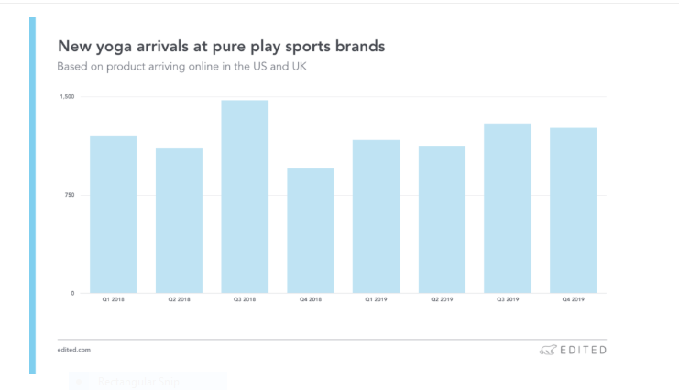

Figure 1: Porter's Five Forces Analysis of Adidas
(Source: Influenced by Mathooko and Ogutu, 2015, p.335)

Analysis: It can be found from the analysis of Porter's five forces that Adidas enjoys a good position in the market as the threat of new entrants is very low along with the bargaining power of the suppliers. This proves that they only need to focus on the changing market trends and the changing taste of the buyers in terms of their demands and needs. They need to establish themselves as brand which specialises in innovation throughout the time. This would significantly help them to cater to for their clients and stay ahead of the competitors.
The value chain model of Adidas helps to identify the primary and supporting activities of the organisation.
Primary activities
The inbound and outbound logistics are strength of the company as Adidas has effective supply chain management process (Distelhorset al., 2017). Asia, Europe and America are largest footwear source of the company. Cambodia is source 24% of the total apparel items of the brand. Operation of the organisation can be a weakness because it has limited product line and products are expensive, so decline in sport related product can generate risk for Adidas. Marketing and sales activity are strength of the company as it develops effective content marketing and influencer marketing strategy in order to engage with customers.
Supporting activities
Human resource management is the weakness of the organisation as black employees of the company criticized it due to lack of initiative for workplace diversity which leads towards resignation of Karen Parkin (bloomberg.com, 2020). Technology development is the weakness of the organisation as it lacks behind its competitors like Nike in its digital presence. But it has created more opportunities for the brand. Infrastructure of the organisation is a strength because it encourages organisation to reach customers across the worlds and manage them effectively.
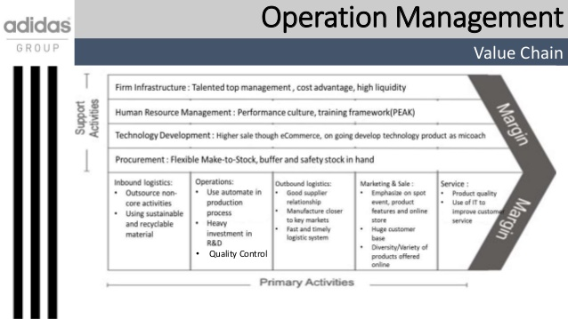
Figure 3: Value chain analysis
(Source: Mudambi and Puck, 2016).

Segmentation, targeting and positioning of Adidas
Segmentation: There are four distinct segmentations, Demographic, Geographic, Behavioural and Psychographic which are applied in this process. While demographic segmentation is based upon age, sex, income, socioeconomic status and family members etc. Adidas targets the market on the basis of age group including age group 20 to 29 years old and the next generation 14 to 19 years old (Ardianta, Praptonoand Sagita, 2019). It targets both male and female customers. Geographic segmentation is the distinctive market based upon the neighbourhood, cities, states and nations. In this case, the business has targeted Geographic location of the UK. The psychographic segmentation is essential for Adidas as it targets the upper middle class to the affluent class in the society as it determines its product pricing based upon these segments to keep its premium tag flourishing (Kang, 2017).
Targeting: The organisation has targeted athlete, sports person and the people who are interested in sports activities (Kiratidisand Leinweber, 2018). It targets the age group 20-29 years old who are passionate about sports as it considered being the strongest consumer market for the brand. It also targets the next generation of athletes who belongs to the age group 14 to 19 years old. From the analysis, it can be mentioned that Adidas focuses on concentrated targeting strategy as it targets a particular segment of the population group who act as the primary revenue generators for the company.
Positioning: Adidas portrays itself as "Creator Sports Brand" with its extraordinary campaign "calling creators - game changers, change makers and boundary breakers." This brand has witnessed revenue growth of 17.6% of average rate since 2015 whereas its prime competitor Nike has added average rate of 6.8% of growth (forbes.com, 2020).
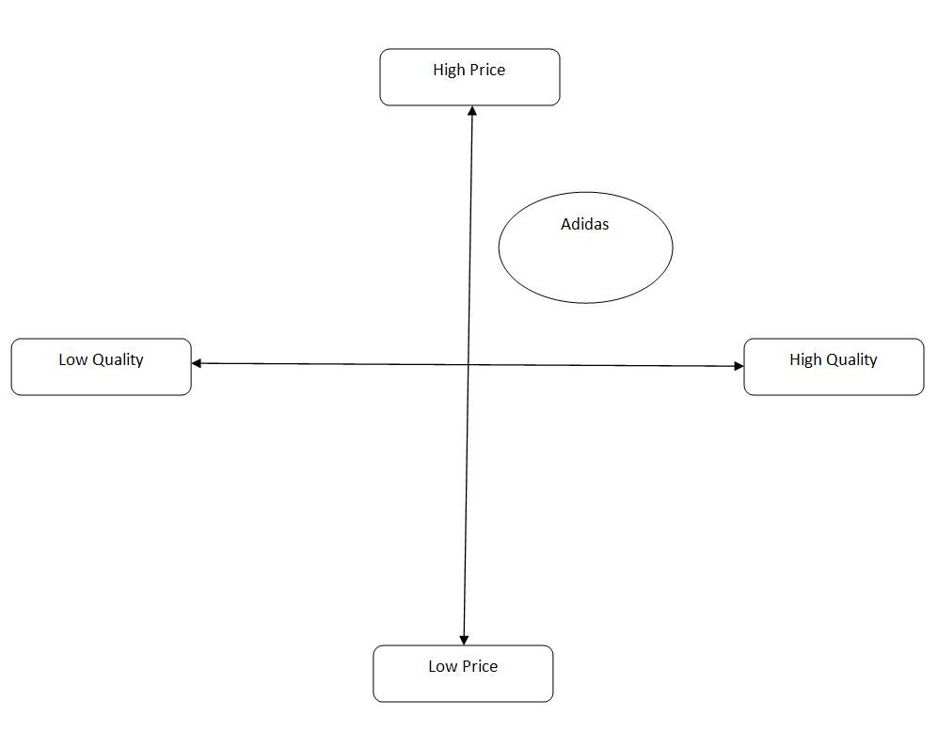
Figure 4: Perceptual Map
(Source: Created by learner)
It can be found from the perceptual map that Adidas mainly believes in producing high quality products at high prices. It has been their business strategy since the beginning and it has followed this strategy over the years to establish itself as a strong brand.

WHO IS ADIDAS’ TARGET MARKET TODAY?
After the company’s strategy and mission, comes the target market the company wants to focus on for the efforts that it wants to put in with a long history of providing high-quality athletic sportswear for athletes, Adidas target market is sports participants, including those at the highest level of their sport, as well as non-athletes who are inspired by or really love sports.
Positioning of Adidas

WHAT IS THE MARKETING STRATEGY OF ADIDAS?
After discussing the business strategy of Adidas, Adidas target market and Adidas competitive advantage comes the Marketing Strategy of Adidas.

Collaboration:
You must have surely heard of “Yeezy’s” and Adidas Pharell William sneakers, these were the major reasons for Adidas resurgence.
This Marketing strategy of Adidas worked so well for the brand that its competitors like Puma followed the same suite and signed-in famous personalities include popstar Rihanna for their line of sportswear.

Innovation:
Adidas, ranked No. 3 in global sales in the Apparel/Accessories category in Forbes World’s Largest Public Companies list, behind only Christian Dior/LVMH and Nike, just announced that by 2024 it would use only recycled plastics in all its shoes and clothing. Adidas is concerned towards environmental factors as it is shifting towards entirely recycling of polyesters by 2024 and it has developed Prime blue, a high-performance recycled item which contains 40% recycle products and Primegreen which eliminates the use virgin polyester. It has produces more than 11 million pair of shoes through recycling plastics wastes. The strategy to move to use recycled plastics for their shoes and clothing is because of the company’s vision to get rid of virgin polyester overall by 2024.

A New Strategy: Limiting Supply
Popular Adidas shoe models such as the “Stan Smith” and “Superstar” have been major contributors to Adidas’ massive revival over the past few years, which have been supported by the aforementioned endorsements and innovative marketing campaigns.

Social media:
Social media has been the focus of attention for the brand when it comes to interact and connect with the customers.
Adidas has active Facebook and YouTube channels where it uploads thousands of promotional videos for its products.
On Twitter too, the brand has several accounts active including Adidas original, Adidas US and Adidas football that it uses to stay connected with its fans and followers. The core focus of all its marketing efforts is to bring energy to sports and help athletes achieve.

4Ps of Marketing Mix from the context of Adidas
Product: Adidas sells its products in various categories that are identified by their unique styles and purposes. It has become the third largest brand in the world in 2019. The brand value was highest in 2019 in the past five years as it has reached $16,669 then it reduced in 2020 (statista.com, 2019). It can be said that Adidas implements 'product line extension' mode of branding strategy as it continuously extends their product portfolio to cater to their clients and their changing needs (Adidas, 2020).
Price: The pricing strategy is clearly based upon the market as it is natural to keep it competitive. Few of its products are unique therefore it has a premium tag as they are new items Total revenue of Adidas is 23,640 euros in 2019 which increased from 21,218 in 2018 (adidas-group.com, 2019).
Promotion: Adidas uses a variety of media channels to reach out and promote its products, like traditional media mix of television and radio along with the social media like Facebook, Twitter, Instagram, YouTube, etc. Marketing expense of adidas in 2018 $3.5 million which reflects 14% of the company’s revenue which was increased by 2% from 2017.The marketing expenditure includes both online and offline advertisements.
Place: The Company has a well-developed system that ensures production and sales management, supply chain management and retail management. Adidas has opened fewer stores as it has approximately 170 stores and it has more focused on e-commerce as prospectus of online sales is increasing with times. Adidas has both direct and indirect distribution channels. It's wholesale stores are its direct distribution channels whereas the online selling is done through indirect distribution channels. Adidas partners with numerous wholesale chains to carry out these activities. The launch of premium products or brand new products, however, is carried only through the direct distributive channel, where buyers can avail those products from its retail outlets only.

Conclusion
Adidas is a global brand in the sports and lifestyle product suppliers and the leader in the industry of sports products such as shoes, apparels and other accessories. On the concluding note it can be stated that the business organisation should develop proper strategies based on the identified threats of weaknesses such as premium pricing and increasing importing cost so that the business can focus on its development process.

Recommendations
Recommendations | Specific | Measurable | Attainable | Realistic | Time bound
Recommendation 1: To develop diverse marketing strategy that enables organisation to focus on India, Africa and Middle-east. Adidas is recommended to invest more on Africa and Middle-East for developing marketing strategy because it has long-term potential to grow. | It will provide competitive advantage to the brand | Increasing customer base | Yes | Yes | 6 months
Recommendation 2: To develop own manufacturing line up so that the import cost can be reduced by 15% within the next 8 months | own manufacturing line up for reducing import cost | Reduced import cost from Asian Countries | Yes | Yes | 8 months
Table 3: Future Recommendations
(Source: Created by Learner)

Reference List
adidas-group.com, 2020. adidas: Profile. Available at: https://www.adidas-group.com/en/group/profile/ [Accessed on: 30/06/2020]
adidas-group.com, 2020. adidas: Strategy. Available at: https://www.adidas-group.com/en/group/strategy-overview/ [Accessed on: 30/06/2020]
adidas-group.com.2020. history. Available at : https://www.adidas-group.com/en/group/history/[ Accessed: 13 July, 2020]
Amadeo, K., 2020. Brexit Consequences for the U.K., the EU, and the United States. Available at: https://www.thebalance.com/brexit-consequences-4062999 [Accessed on: 30/06/2020]
Ardianta, A.B., Praptono, B. and Sagita, B.H., 2019. AnalisaKelayakanProduksi Coach Jacket AbarelTerhadapAspekPasar, AspekTeknis, Dan AspekFinansial. eProceedings of Engineering, 6(2).
Bhasin, S., 2019. Adidas SWOT analysis – SWOT analysis of Adidas. Available at: https://www.marketing91.com/adidas-swot-analysis/ [Accessed on: 30/06/2020]

Bloomberg - Are you a robot? (2020). Available at: https://www.bloomberg.com/news/articles/2020-06-30/adidas-hr-head-karen-parkin-steps-down-amid-efforts-to-diversify (Accessed: 13 July 2020).

Clifford, T., 2019. Adidas CEO: Our biggest concern is Brexit's impact on the European economy, CNBC. Available at: https://www.cnbc.com/2019/01/22/adidas-ceo-says-biggest-concern-is-brexit-impact-on-european-economy.html (Accessed: 13 July 2020).

Danziger, P., 2020. Adidas Challenges The Fashion Industry In Sustainability, Pledging Only Recycled Plastic By 2024, Forbes. Available at: https://www.forbes.com/sites/pamdanziger/2019/07/18/adidas-challenges-the-fashion-industry-in-sustainability-pledging-only-recycled--plastic-by-2024/#798944541049 (Accessed: 13 July 2020).
Distelhorst, G., Hainmueller, J. and Locke, R. M. (2017). Does lean improve labor standards? Management and social performance in the Nike supply chain. Management Science, 63(3), 707-728.
DOMINGUEZ, L., 2020. Nike vs. Adidas. International Relations Journal 2020, (39), 37.
forbes.com, 2020. Adidas or Nike? Which Retail Giant is Winning The Sneakers War? Available at: https://www.forbes.com/sites/callyrussell/2019/08/22/adidas-or-nike-which-retail-giant-is-winning-the-sneakers-war/#45630ee112b7 [Accessed on: 30/06/2020]
Holt, J., Leach, A.W., MacLeod, A., Tomlinson, D., Christodoulou, M. and Mumford, J.D., 2017. A quantitative model for trade pathway analysis of plant pest entry and transfer to a host in European Union territory. EPPO Bulletin, 47(2), pp.220-226.
Kang, B.J., 2017. Role and policies of STP in the era of 4th industrial revolution from triple helix viewpoint. World Technopolis Review, 6(2), pp.90-101.
Kiratidis, A.L. and Leinweber, D.B., 2018. An aerodynamic analysis of recent FIFA world cup balls. European Journal of Physics, 39(3), p.034001.
Mathooko, F.M. and Ogutu, M., 2015. Porter’s five competitive forces framework and other factors that influence the choice of response strategies adopted by public universities in Kenya. International Journal of Educational Management, 29(3), pp.334-354.
Mudambi, R. and Puck, J., 2016. A global value chain analysis of the ‘regional strategy’perspective. Journal of Management Studies, 53(6), 1076-1093.

Play.google.com,2020. Adidas.Available at: https://play.google.com/store/apps/details?id=com.adidas.app&hl=hi (Accessed: 13 July 2020).

report.adidas-group.com.2020.Global Operations - adidas Annual Report 2019. Available at: https://report.adidas-group.com/2019/en/group-management-report-our-company/global-operations.html (Accessed: 13 July 2020).

Statista, 2020. The adidas Group's net sales worldwide 2000-2019. Available at: https://www.statista.com/statistics/268416/net-sales-of-the-adidas-group-worldwide-since-2000/ (Accessed: 13 July 2020).

statista.com.2019. adidas-brand-value.Available at: https://www.statista.com/statistics/632260/ adidas-brand-value /(Accessed: 13 July 2020)

statista.com.2020.Topic: Adidas (2020). Available at: https://www.statista.com/topics/1257/adidas/ (Accessed: 13 July 2020).
Sultan, L. 2019. Equality in the Workplace: A Fresh Approach to Sales Performance. [online] Sales Hacker. Available at: https://www.saleshacker.com/workplace-equality/ /(Accessed: 13 July 2020).

Vizard, S., 2020 Adidas hails effectiveness of #hometeam campaign but cuts spend in response to pandemic, Marketing Week. Available at: https://www.marketingweek.com/adidas-effectiveness-campaign-but-cut-spend/ (Accessed: 13 July 2020).

