Coping with change: exploring the lived experience of moving to a new university campus

Abstract
The purpose of this study was to explore participants lived experiences of coping with change, when moving to a new university campus. A literature review saw that changing school can be considered as a stressful life event (Holmes & Rahe, 1967). This study used a qualitative research method to explore three participants experiences. Data was collected by conducting semi-structured interviews relating to the topic area. Data was analysed using interpretative phenomenological analysis (IPA: Smith et al., 1999; Smith & Osborn, 2003). Results saw a mixture of themes and sub-themes, including; coping, comparison and population. Study limitations and future research suggestions are discussed.

Introduction
Change is a constant process throughout the lifespan. Whether these be small changes, or big lifestyle changes, change is inevitable. Change can effect individuals in different ways, for instance, what may have an impact on one, may be a simple thought to another. In some cases, the change could effect the individual’s mental health, for example, an individual may experience anxiety or high amounts of stress, as a result of the change or possibly before the change occurs. Stress has been considered a contributor to both physical and mental health, often due to a life event (Willard, Long & Phipps, 2016). Stress can be external and connected to environmental factors (Jones, Bright & Clow, 2003), however, it can also be a result of internal perceptions of a situation (Folkman, 2013)). The Social Readjustment Rating Scale (Holmes & Rahe, 1967) included a change in school as a stressful event.
Furthermore, in response to stress, individual’s use coping strategies in an attempt to revert back to a state of equilibrium (Uchino, 2009). Individual’s use one of two types of coping, adaptive or maladaptive coping. Adaptive copers use constructive coping strategies such as; seeking social support (Bannon, Feist & Updegraff, 2014) or taking positive steps to reduce the stress(Zeidner & Saklofke, 1996), whereas, maladaptive coping strategies such as; self-distraction or avoidance, can increase stress in the long term (Stoeber & Janssen, 2011; Zeidner, 1995).
In accordance with coping, this study will consider participants lived experiences. According to Berg and Lune(2012) qualitative research is able to provide an opportunity to explore descriptions of individual’s experiences which can be lost in quantitative research, and therefore, this method of data collection will allow for participants to openly discuss their experiences and so, this study will use qualitative research in order to gain a greater knowledge of individuals experiences of coping with change when moving to a new university campus.
Method
Participants
A total of three participants (2 male, 1 female) were selected to take part in this study. Participants were all 2nd year undergraduate psychology students from the University of Wales, Trinity Saint David. Participants were selected based on having experienced the move from the old Townhill campus to the new SA1 campus, Swansea. Participants were recruited via verbal invitation on campus.
Design
This study used qualitative research design, including semi-structured interviews to exploring the lived experience of moving to a new university campus. Discussions were transcribed and analysed using interpretative phenomenological analysis (IPA: Smith et al., 1999; Smith & Osborn, 2003).
Materials
Informative consent forms were designed to explain the study to participants and notify them of their right to withdraw at any point (Appendix A). An interview schedule (Appendix B) detailing that the interview would be recorded, and that all information would be anonymised and kept confidential at all times. This was prepared prior to the interviews. A series of four Semi-structured questions (Appendix C) were also designed prior to interviews. These questions were open ended, such as: What were your expectations about moving to a new campus?
These questions allowed the opportunity for change and/or use of prompts during actual interviews, depending on the participants responses. Questions were designed to stimulate discussion regarding their experience of coping with changing to a new university campus. Additionally, interviews were recorded via an audio recording application (APP), downloaded onto a laptop computer. A detailed debrief form (Appendix D) was developed in order to fully disclose information to the participants following their participation in the study.
Procedure
Participants were approached on the UWTSD SA1 Campus and verbally invited to take part in a short informal interview. Those who agreed were first asked to accompany the researcher to a private room in the psychology labs, located in the IQ building of the University of Wales, Trinity Saint David. where they sat in one of the four chairs provided. Participants were verbally introduced to the topic before being presented with a consent form, to read and sign if they were happy to go ahead with the interview. Once this had been completed, the researcher read a previously prepared interview schedule to the participants, this included; gaining verbal consent to record the interview, explained that all data collected would be anonymous and asked if they had any questions before starting. Additionally, participants were asked if it was ok for the researcher to start the recording, which was located on a laptop placed in the centre of the desk in the room. Interviews ran consecutively for five minutes each.
Following this, participants were again asked if they had any questions, after their response, the researcher asked the first question to simulate discussion; ‘What were your expectations before moving to this campus?’ The researcher continued asking questions at appropriate points throughout each interview and used prompts for elaboration were used following shorter answers or in moments of silence to gain further information.
On completion of the interview, participants were thanked for their time and the recorder was turned off. Following this, participants were given a verbal and written debrief form and again asked if they had any questions.
Results
An Interpretative phenomenological analysis (IPA: Smith et al., 1999; Smith & Osborn, 2003) was conducted on all collected data. Participants recordings were transcribed, and recordings deleted. All interview transcripts were reviewed multiple times and initial notes taken. Commonly occurring themes were identified in each individual transcript and overall key themes were identified across all transcripts as the analysis progressed. Comments were analysed in terms of the key study variables, such as; coping, coping strategies, experience of changing to a new environment.
Three main themes were identified across all participants interviews. This included coping with the move, a comparison to the old location and positivity towards the higher volume of people the new university. Additionally, a range of sub-themes were established from individual interviews, such as; moving with cohorts, updated technology and a negativity towards available green spaces. Overall, participants expressed a positive experience to moving to a new location.
Theme one: Coping
When asked how well they coped with the initial move, all participants expressed positivity and explained that they coped well (See appendices for full transcripts). Though responses to this question were somewhat short, body language and facial expressions displayed seemed to suggest contentment. A sub-theme relating to coping strategies was also noted, participants all stated that moving to the new campus with cohorts helped them cope better. Luke especially, expressed great pleasure in having his friends move to the new campus with him, making it an easier task (Appendix E).
What helped me adapt? Um, friends. Yeah friends on the course. because we've kind of
been wandering around together trying to find where to go and explore on the lovely new
campus together. Um, I think I would have been a mess trying to adapt on my own, it
definitely helped having them with me.
(Luke. Line:55)
The data collected suggests that the participants coped well with the move itself, however they all expressed how adapting to being on the campus could have been difficult had they not had their friends going through the same experience with them.
Theme 2: A comparison.
All participants mentioned the previous location and made a comparison between the two. They all stated positive changes at the new location compared to the previous campus and found this to be a positive experience. Additionally, within their comparisons a sub-theme of the updated technology was considered. Bridget explained that she was excited to see the new technology and went on to state how she enjoyed using it, as appose to the previous location that didn’t have much in way of technology (Appendix F).
yeah, I was looking forward to seeing the new building and all the new technology here,
cause I think, um, Townhill campus didn’t have much stuff like that. Um, I like that we
can all connect in the, the big lecture room, I um, find it helps with my work.
(Bridget. Line 48)
It would seem that all participants are particularly happy with the modern technology at the new location and look back in dismay at the previous campus.
Theme 3: More people, more friends.
Participants expressed their experience of having more people on this campus. They explained that it was easier to make friends due to the volume of students attending the campus at once. This was interpreted as a positive aspect for all participants. Norman explained that this was a helpful aspect in adapting to the new campus, for him, being able to engage in conversation with a variety of different people was important (Appendix G).
Um, I think that there are a lot of people here and it is easy to make conversation where
ever you are in the building. This helps me because, um, I like making friends and um,
having conversation different types of people.
(Norman, Line, 46)
Throughout all the transcripts there appears to be a pattern of positivity towards to the new location. As stated, the participants have expressed coping well with the move and in comparison, to the previous campus, seems to have been a better all-round experience.
Discussion
This study used qualitative research to explore coping with change when moving to a new university campus. Data was analyzed using Interpretative phenomenological analysis (IPA: Smith et al., 1999) in order to reflect participants experiences.
The study consists of personal accounts of individual experiences of moving to a new university campus. Each transcript provided a range of themes relating to coping, amount of people at the new location and a comparison between the two locations. Results also saw sub-themes identified, such as, updated technology and moving with cohorts. In support of the literature, participants appear to have used social support from peers, as a means of coping with the move. This suggests, that they were all pro-active with their coping strategies, which in-turn, enabled them to settle at the new location quickly.
The use of qualitative research has provided the opportunity for participants to openly discuss their experiences, however, there are some limitations to consider. For example, participants responses were relatively short resulting in only a small amount of detail being collected. In order to combat this, the use of more appropriate prompts to develop further conversation should be considered. Furthermore, participants were all members of the same course and year group, and so, differing experiences may be seen if experiences are explored throughout contrasting courses and levels of studies.
Additionally, whilst adequate information was gathered during this study, conversation tended to move away from coping with the change. Future research in this topic area could include more questions of this nature to gain a clearer perspective of coping with change when discussing the lived experience of moving to a new university campus.
References
Berg, B. L., & Lune, H. (2014). Qualitative research methods for the social sciences.
Harlow: Pearson.
Brannon, L., Feist, J., & Updegraff, J. A. (2014). Health psychology: An introduction to
behaviour and health. Boston, MA, USA: Cengage Learning.
Bright, J., Clow, A., & Jones, F. (2003). Stress: Myth, theory and research. Harlow: Prentice
Hall.
Folkman, S. (2013). Stress: Appraisal and Coping. Encyclopaedia of Behavioural
Medicine, 1913-1915. doi:10.1007/978-1-4419-1005-9_215
Holmes, T. H., & Rahe, R. H. (1967). The social readjustment rating scale. Journal of
Psychosomatic Research, 11(2), 213-218. doi:10.1016/0022-3999(67)90010-4
Smith, & Osborn. (2003). Interpretive phenomenological analysis. In J. A. Smith
(Ed.), Qualitative psychology: A practical guide to research methods. London: Sage.
Smith, J., Jarman, M., & Osborn, M. (1999). Doing interpretive phenomenological analysis.
In M. Murray & K. Chamberlain (Eds.), Qualitative health psychology. London: Sage.
Stoeber, J., & Janssen, D. P. (2011). Perfectionism and coping with daily failures: Positive
reframing helps achieve satisfaction at the end of the day. Anxiety, Stress & Coping, 24(5),
477-497. doi:10.1080/10615806.2011.562977
Uchino, B. N. (2009). Understanding the Links Between Social Support and Physical Health:
A Life-Span Perspective With Emphasis on the Separability of Perceived and Received
Support. Perspectives on Psychological Science, 4(3), 236-255. doi:10.1111/j.1745-
6924.2009.01122.x
Willard, V. W., Long, A., & Phipps, S. (2016). Life stress versus traumatic stress: The impact
of life events on psychological functioning in children with and without serious
illness. Psychological Trauma: Theory, Research, Practice, and Policy,8(1), 63-71.
doi:10.1037/tra0000017
Zeidner, M. (1995). Coping with examination stress: Resources, strategies,
outcomes. Anxiety, Stress & Coping, 8(4), 279-298. doi:10.1080/10615809508249379
Zeidner, M., & Saklofske, D. (1996). Adaptive and Maladaptive Coping (M. Zeidner & N. S.
Endler, Eds.). Handbook of Coping: Theory, Research, Applications, 505-531. Retrieved
March 20, 2019, from
https://www.scirp.org/(S(351jmbntvnsjt1aadkposzje))/reference/
ReferencesPapers.aspx?ReferenceID=1186097.

Appendices
Appendix A

School of Psychology
SA1 Campus
Swansea

Study Consent Form

I understand that this research study is being carried out by a 2nd year Psychology Student for the purpose of a module assessment, and that taking part in this study will involve participating in a short informal interview where a series of questions will be asked relating to the lived experience of moving to a new university campus. I acknowledge that my responses will be recorded for the purpose of this study and that this recording will be deleted within 24hours of being transcribed.
This interview will take approximately 10 minutes to complete.
I understand that participation in this study is entirely voluntary and I am free to withdraw participation at any time without giving a reason. I am aware that if I have concerns about the study I can discuss these concerns with the researcher or academic supervisor at any time during or after the study.
I understand that the information provided by me will be held confidentially, with any identifying information changed on transcription.
I also understand that at the end of the study I will be provided with a debrief form and the opportunity to discuss any issues with the researchers.

I, ___________________________________( NAME) consent to participate in the study conducted by Amy Locke. School of Psychology, University of Wales Trinity Saint David, Swansea under the supervision of Stacey Coleman.

Participant Signature:________________________________________________
Date:___________________
Name and signature of researcher taking consent
___________________________________________________________________

Appendix B

Interview Schedule
Hello (NAME), I’m Amy. Thank you for taking the time to take part in this interview. I will briefly explain the study to you in a moment but first I would like to check that you are happy for me to record this interview?
Just to confirm, everything said today will be confidential, your name and anything that will identify you will be changed. Also, the recording will only be listened to by myself and once I have transcribed the interview the recording will be deleted. Am I ok to carry on?
So, the aim of this interview is to explore the lived experience in moving to a new campus. Just to confirm you are aware, all data collected from the interview today will be used for a 2nd year psychology assessment and again, your identity will be confidential. Is that ok?
Also, before I continue, I would just like to make you aware that your name will be changed when I transcribe this interview to hide your identity.
Great, I am just going to start the recorder.
Do you have any questions for me before I begin?
Just to let you know, if you have any queries or questions during the interview don’t hesitate to ask and if you feel you need to stop or pause the interview at any time just let me know.

Appendix C
Interview questions – coping with moving to a new campus
1. What were your expectations before moving to this campus?
P. structure, access etc.
2. How well do you think you coped with moving to a new location?
P. were you nervous, anxious, excited?
3. What would you say helped you adapt to the new environment?
4. If you were going to describe this campus to someone who is considering studying here, what would you say?
That’s great, that’s all the questions that I have for you today. Again, just as a reminder, any information will be made anonymous and anything that may identify you will be changed.
Do you have any questions for me?
ok, great.
I’m going to stop the recording now and again, once I have transcribed this interview, the recording will be deleted.
Thank you for taking the time to take part in this interview. Have a nice day!

Appendix D
School of Psychology
SA1 Campus
Swansea

Study Debrief Sheet
Coping with change: exploring the lived experience of moving to a new university campus.

Thank you for taking part in this study.

The aim of this study was to explore the lived experience of moving to a new university campus by conducting a series of short informal interviews to find key themes across all experiences.
I particularly wanted to explore participants experiences of coping with the change.
All recorded responses will be transcribed within 24 hours from now and the recordings deleted. Any identifying information provided will be changed during transcription.
If you wish to withdraw your data from the study, you must tell the researcher now. After this point, all of your data will remain confidential.

If taking part in this study has raised any questions please speak to the researcher via email: 1705243@student.uwtsd.ac.uk
or contact the academic supervisor Stacey Coleman on Stacey.coleman@uwtsd.ac.uk.

Thank you once again for taking time to participate in this study.

Amy Locke

BSc Psychology

University of Wales Trinity Saint David, Swansea

Appendix E

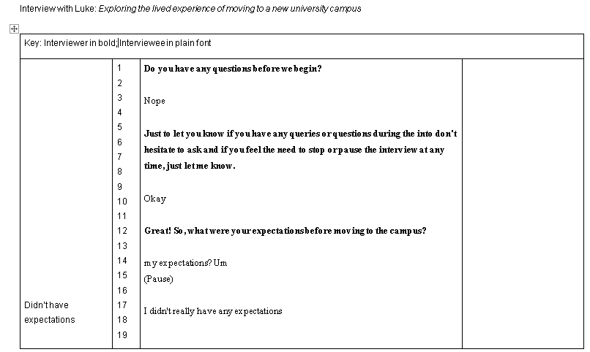

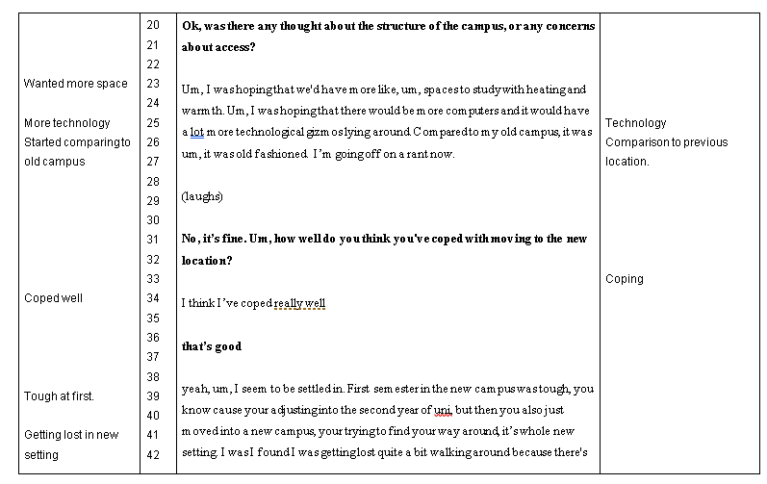
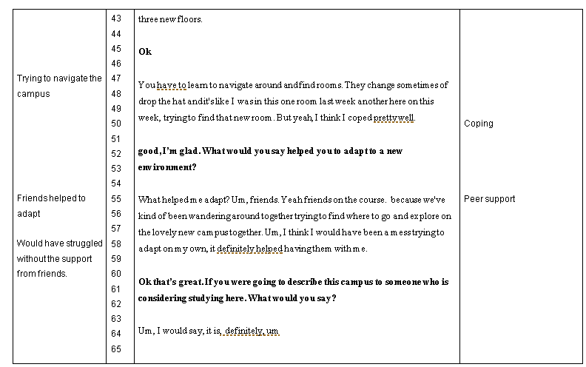
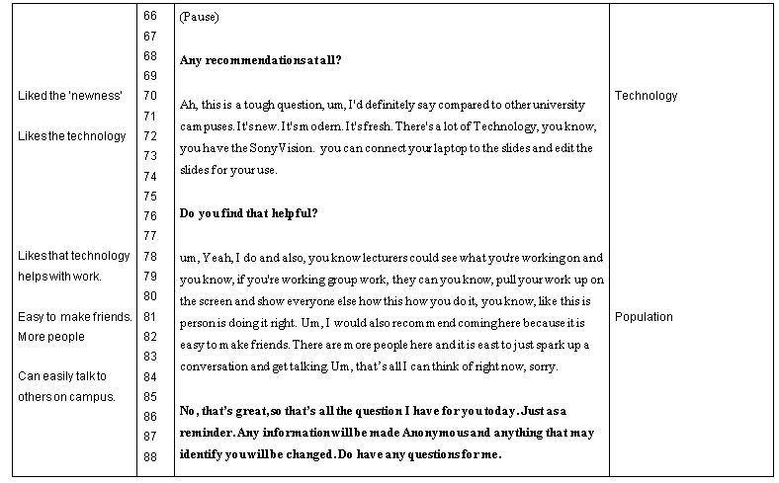


Appendix F
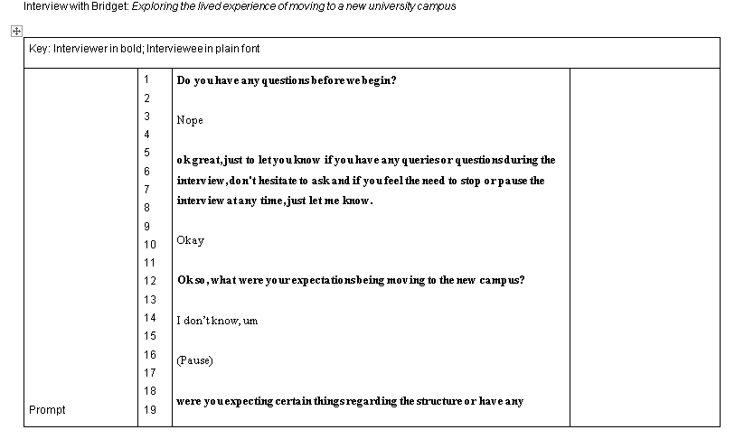
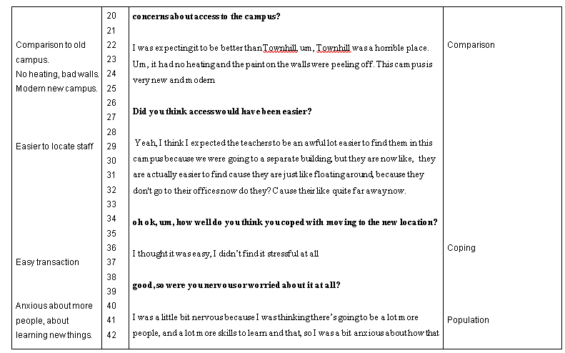
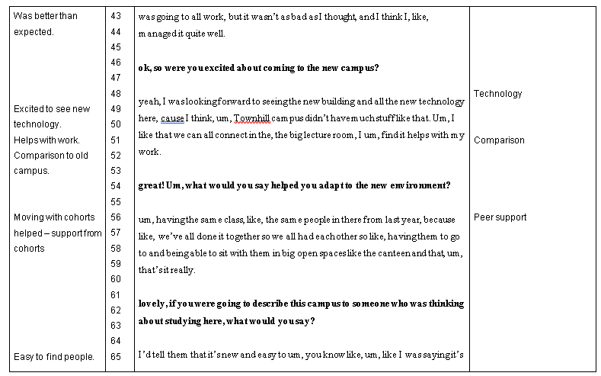
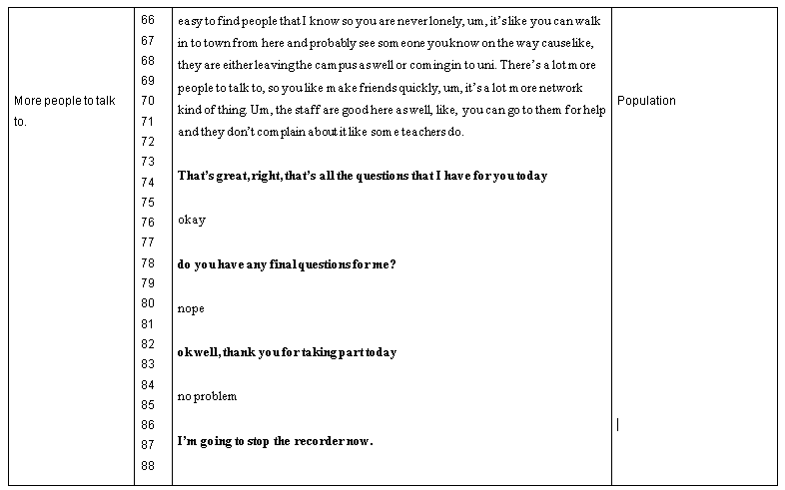

Appendix G


